Osayande Henry-Iyasere

Lab 3 Out of class assignment

Part1

Done

Part 2

**3)** $vi RealEstate.csv

**4)** :$

**5)** <ctrl> g

**6)**

/111 EAST

896,61

dd

**7)** :50

**8):**50,54s/,/:/g

**9)**

:50

V

Move cursor down to 54

Press y

:$

P

**10)**

:50

V

Move cursor down to 54

D

**11)** go to the desired line (line 1 ) and press<o> press <i> then type the desired text “Recorded in year  2008” and press ESC

**12):** wq

Part 3

**10)**

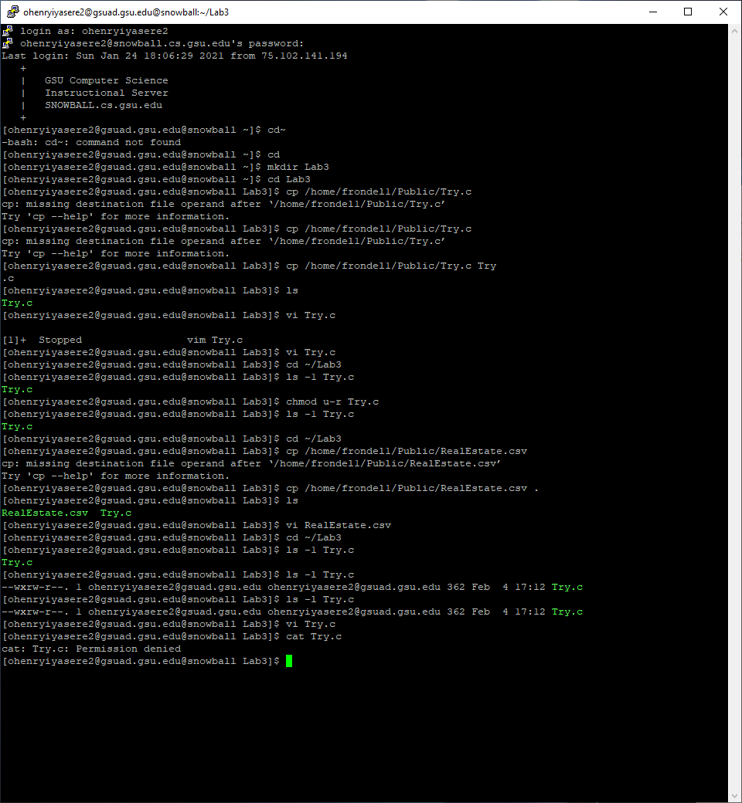

**15)**

E45: ‘readonly’ option is set (add ! to override)

q!

**16)**

chmod 222 Try.c

**17)**

W means to give write permission to the user group and others

Part 4

|  |  |  |  |  |  |  |
| --- | --- | --- | --- | --- | --- | --- |
| owners  Permission | ls  Read Contents | mkdir  create dir | cat  create file | rm  remove contents | cp  copy contents from | cd enter into directory |
| --- | N | N | N | N/A | N/A | N |
| --x | N | N | N | N/A | N/A | Y |
| -w- | N | Y | Y | Y | N | N |
| -wx | N | Y | Y | Y | N | Y |
| r-- | Y | N | N | N | Y | N |
| r-x | Y | N | N | N | Y | Y |
| rw- | Y | Y | Y | Y | Y | N |
| rwx | Y | Y | Y | Y | Y | Y |