Osayande Henry-Iyasere

Lab 4 in class

4) output all the lines containing the string CSC 3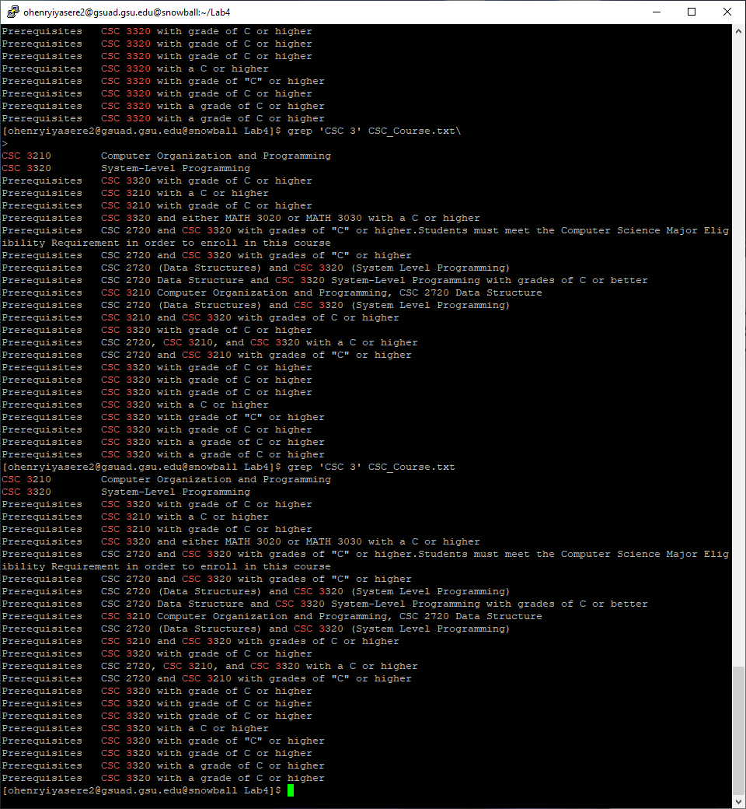

5)no result

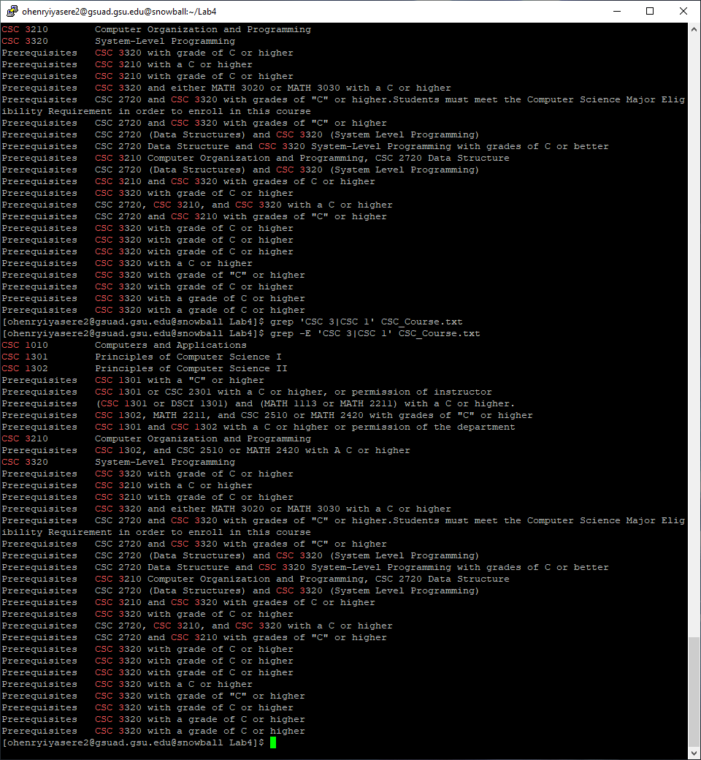

6)

Use extend regular expression



7)outputs all the lines containing strings CSC 3 OR CSC 1 . the entire string instead of regular expression

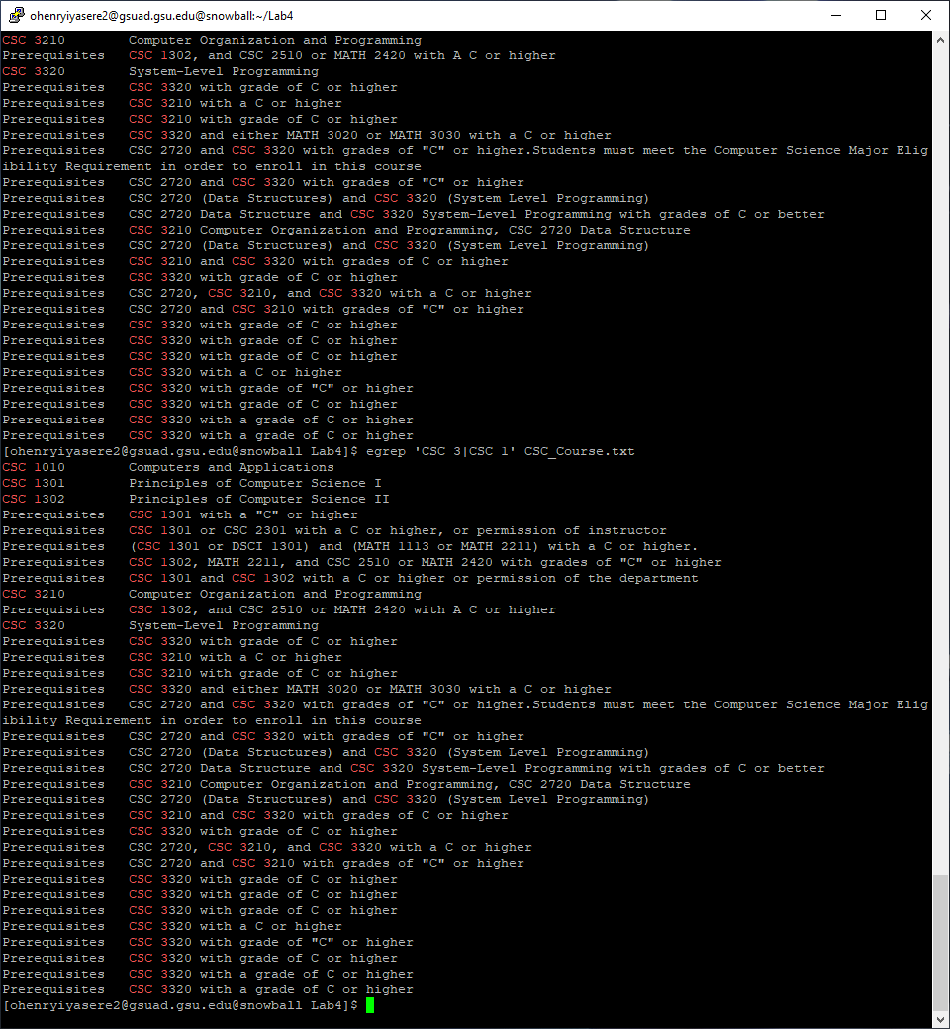

8) and 9) Only match the whole line  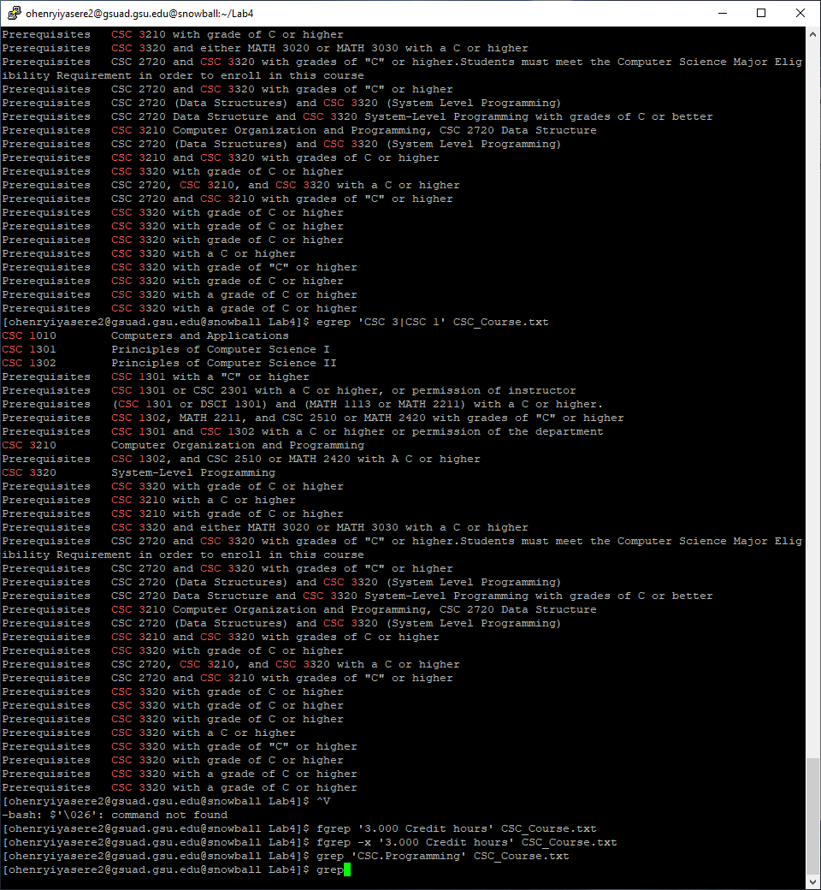

10)

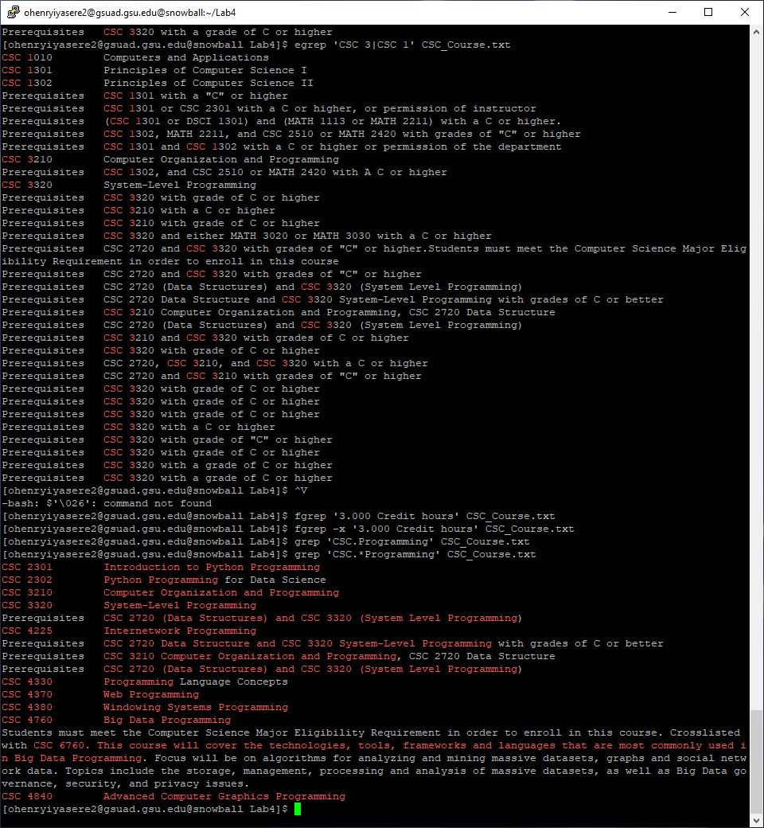

11)

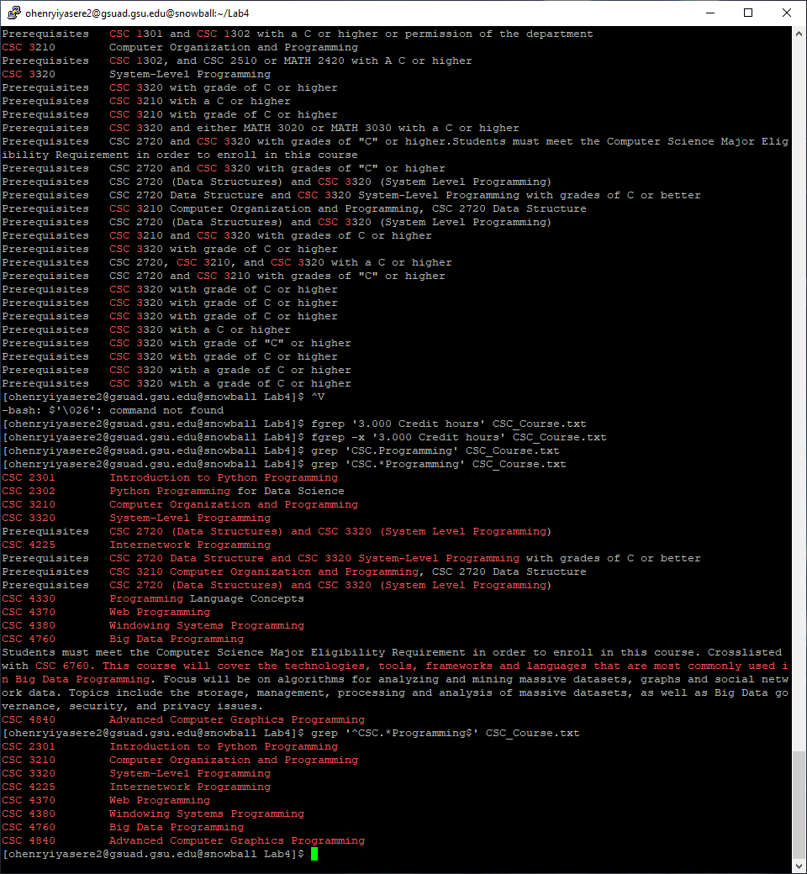

12) No result, {} is not a special character  and 13)  -w Select only those lines containing matches that form whole words.

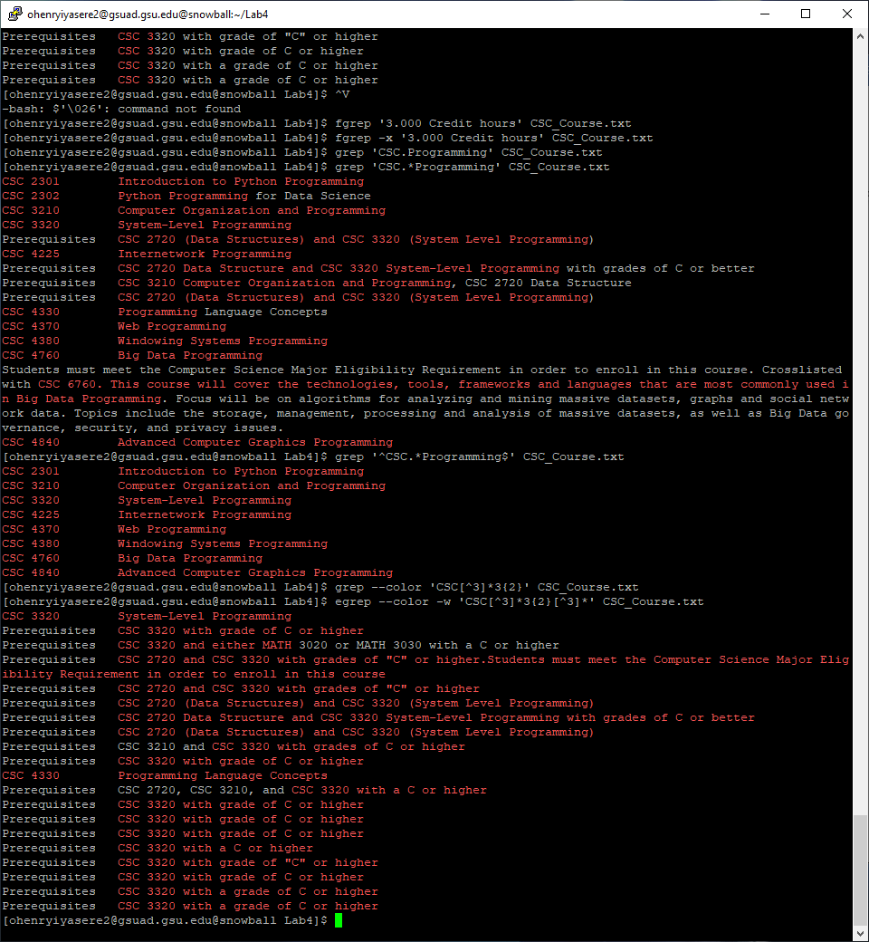

14)  + is not a special character in basic regular expression  and 15)  Convert +

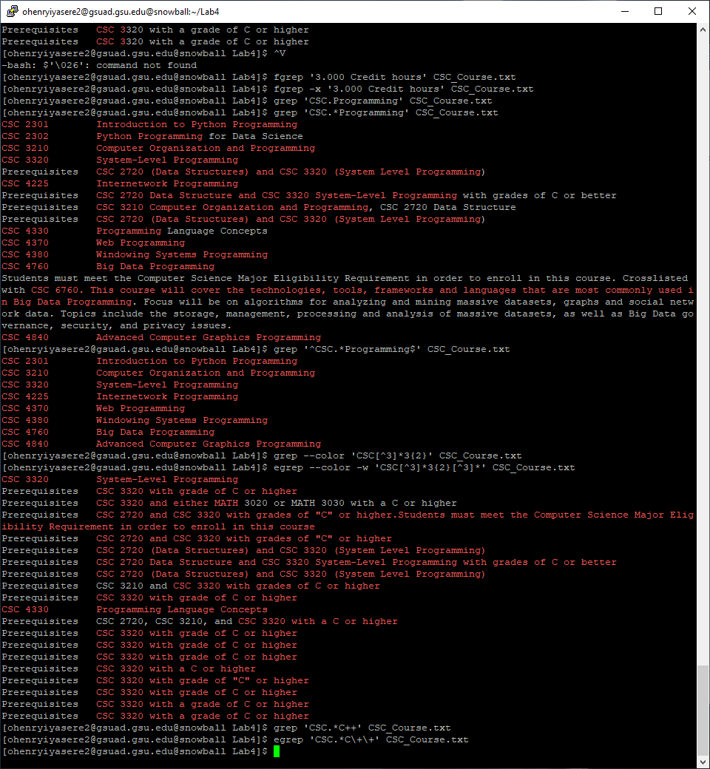

16)