Lab 4 out of lab

Osayande Henry-Iyasere

4a) 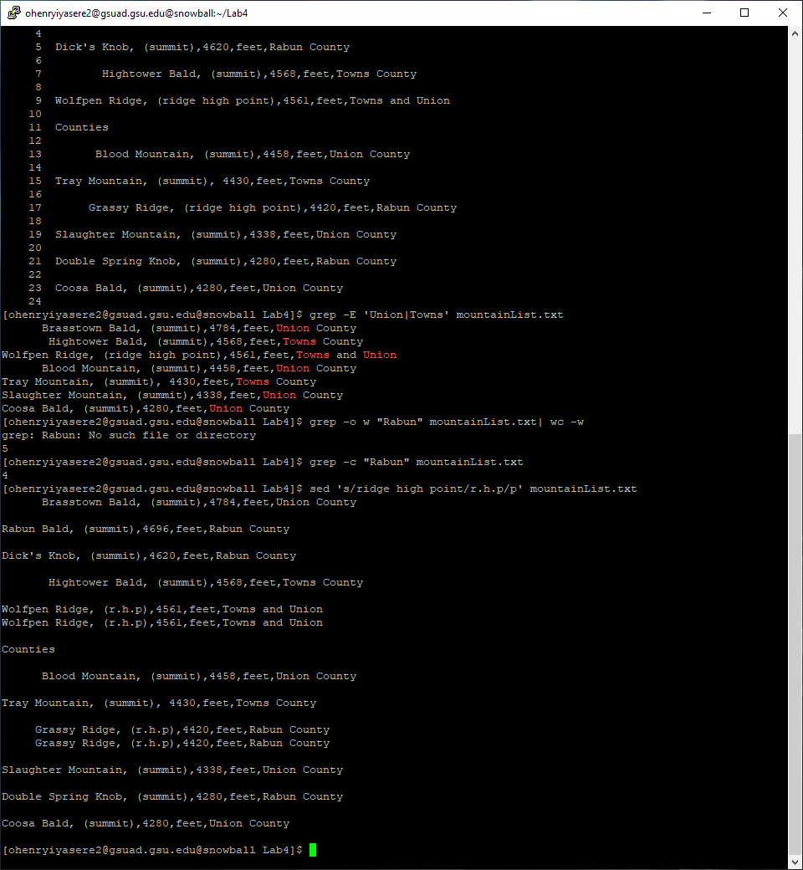

4b)

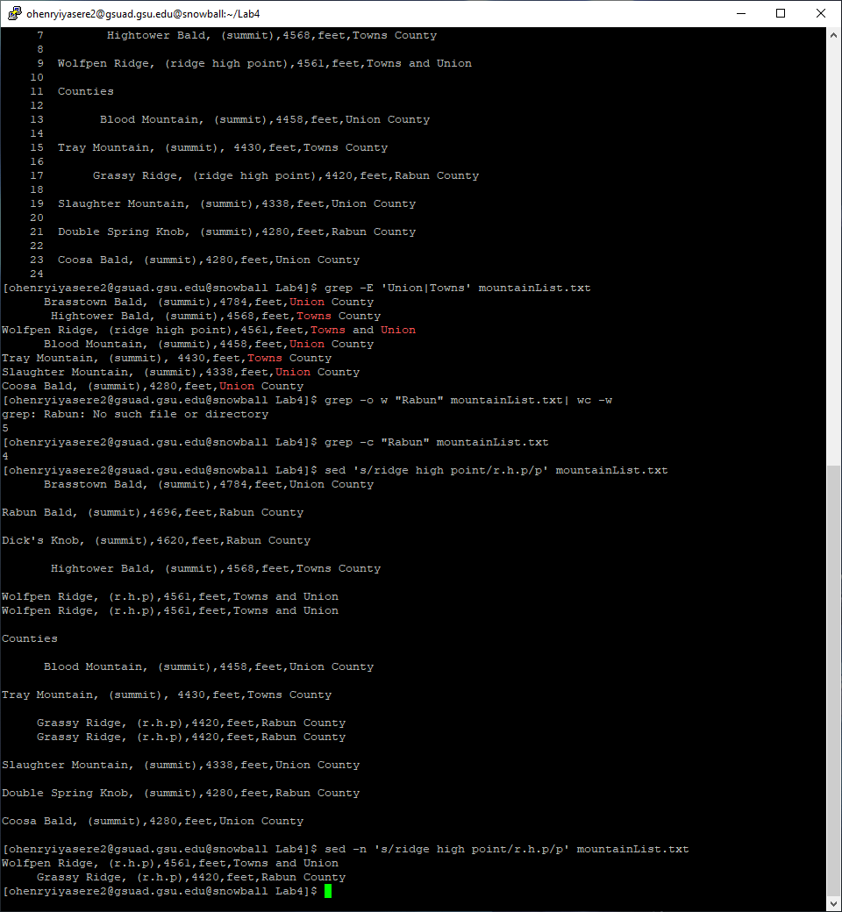

4c) suppress automatic printing of pattern space

4d) Outputs lines containing text 'ridge high point' by replacing this text with 'r.h.p' without printing pattern space

14) 