Introduction to Neural Networks

Neural networks are computational models inspired by the brain. A single artificial neuron

sums weighted inputs, applies an activation function (ReLU, sigmoid), and produces an

output. Stacking neurons into input, hidden, and output layers lets the system learn complex

mappings. When many hidden layers are used, the field is called “deep learning,” powering

modern image, speech, and language applications.

“Zoo” Concept - Focus Animal

For this assignment I selected the CNN Cheeta to represent the Convolutional Neural

Network (CNN)-the speed specialist of computer-vision tasks.

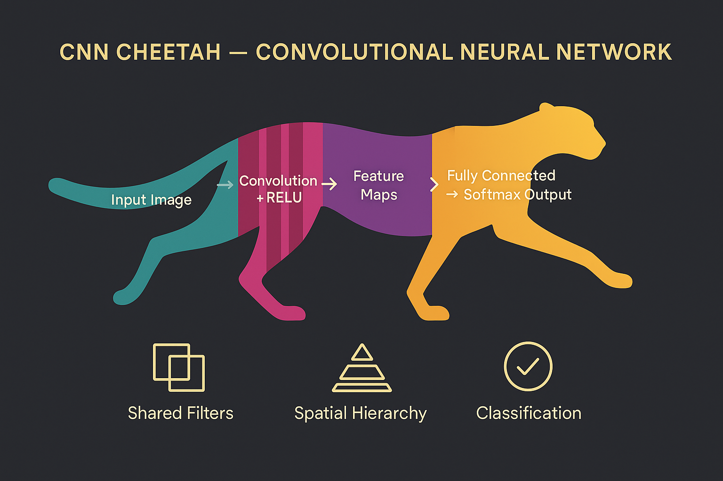

Key adaptations of the CNN Cheetah

* Shared filters (convolutions) detect local patterns efficiently.
* Pooling layers down-sample while preserving salient features.
* A growing spatial hierarchy captures edges -> shapes -> objects as depth increases.
* Fully connected + SoftMax layers convert learned features into class probabilities.

Typical habitats (applications)

* Image classification (ImageNet, medical imaging)
* Object detection and segmentation
* Real-time perception for autonomous vehicles and drones

Reflection

CNNs excel on grid-like spatial data but are less suited to sequential or graph-structured

inputs, where architectures such as RNNs, LSTMs, Transformers, or Graph Neural Networks

perform better. Selecting the right “animal” depends on the data’s underlying structure.