

ASE Lab assignment no: 4

**TOPIC:** Complete compilation of document.

**Group members:** Aliza Ansari ( coordinator )

Samar Haider

Osama Ansari

Zainab Ahmed

Musfira Zia

# INDEX

1: INTRODUCTION:

1.1 Explanation of requirement documentation.

1.2 Purpose of requirements.

1.3 Scope of the system

1.4 Success criteria of the system.

2: DISCRETE REQUIREMENTS:

2.1 [functional requirements](https://en.wikipedia.org/wiki/Functional_requirement) (e.g. what a product should do)

2.1.1 Logging in

2.1.2 Registration

2.1.3 Receptionist access

2.1.4 Manager access

2.1.5 Meal selection

2.1.6 Payment Management system

2.2 Nonfunctional requirements (also known as "quality requirements")

2.2.1 Usability

2.2.2 Accuracy

2.2.3 Security

2.2.4 Reliability

2.2.5 Flexibility

2.2.6 Data Integrity

2.3 External Interface Requirements

2.3.1 User environment

2.3.2 Software UI (DATABASE SERVER DEVELOPMENT END)

2.3.3 Hardware Interface

3: Tools & Techniques used in Hotel Management.

3.1 Development tools

3.2 Analysis tools

3.3 Designing tools

3.4Database tools

3.5 Project management tools

3.6 Documentation tools 4: Sequence diagram

5: Used-case diagram

6: UML daigram

7: References

8: Books

1. **Introduction :**

* 1. What is a Requirements Document?

A requirements document explains why a product is needed, puts the product in context, and describes what the finished product will be like. A large part of the requirements document is the formal list of requirements.

* 1. Purpose of the system:

The sole purpose of creating a villa management system is to overcome the fallacies that arise in the manual registration system of a booking firm where human error may be a big cause of financial culpability, that might in longer terms adversely threat the overall business of the firm.

* 1. Scope of the system:

The VMS project is intended to for the reservations of rooms and the deliverance of timely meals for the stay-in guests. It will be able to operate the various aspects of operations that are conducted in a tourism based villa. The management system will consist of a database that will keep the bookings recorder. Customers will be able to check rooms’ availability select their desired types of rooms and then obviously pay for them through their desired means ( cash or card ).Manager will be able to update or modify the booking details & and will be able to update the room info such as cost and category. The automation will help eradicate the drawbacks that used to come handling the bulky huge files having large customer information. Security of data, quick reservations & swift retrieval of information will be the sheer advantages of our project.

* 1. Success criteria of the system:

**Real-time reporting and business intelligence**, **quality system integrations,****data security,****ability to sell and market to guests efficiently,****pricing Intelligence;** A leading hotel management system should provide a platform that will help you monitor your comp-set in real-time. This includes the ability to be notified of pricing increases or decreases.

1. DISCRETE REQUIREMENTS:

* 1. Functional Requirements:
     1. Logging in:

The system should verify the admin and shall only allow the staff designated admin to get the access of the system.

* + 1. Registration:

The customer shall be able to get registered into the system with their details by the admin. Details should include;

* + - 1. Name
      2. NIC no
      3. Dob
      4. Gender
      5. Current Address
      6. Number of people accompanied
      7. Check in timings
      8. Check out timings
    1. Reservation:
       1. The system should check for availability of rooms.
       2. The system should display rates for all rooms types.
       3. The system should allow the customer to confirm or cancel the booking on demand.
       4. The system should record the booking details into the database.

* + 1. Receptionist access:

The system should allow the receptionist to update, add or delete the booking information.

It will be the duty of the receptionist to make record of the payment given by the customer ( via cash or check )

* + 1. Manager access:

The system should enable manager full modification access to customer bookings and room information.

* + 1. Meal selection:

The System should incorporate details regarding the meals and drinks served in the villa and their costs accordingly.

The customer shall be able to make orders and for dine in.

* + 1. Payment Management system:

The system shall record the payments made via cash or card, by the customers.

* 1. Nonfunctional requirements: (also known as "quality requirements")

* + 1. Usability:

The system should be usable by specified consumers to achieve quantified objectives with effectiveness, efficiency, and satisfaction in a quantified context of use.

* + 1. Accuracy:

The system shall be accurate in terms of calculations and timings recorded, for each and every customer.

* + 1. Security:

The system should be under surveillance of staff and no other member except of the designated ones shall be allowed to use the system under any means. The data of the customers shall be well-protected and should never leak out, keeping customer data integrity in the first place.

* + 1. Reliability:

The system shall be reliable to the customers, to gain their trust and acceptance.

* + 1. Flexibility:

The system shouldn’t be rigid to changes, it should always give space to sudden and unexpected modifications by user’s end or admin’s.

* 1. External Interface Requirements

* + 1. User environment:

The user shall be open to select the room number and the type of room they decide to stay in for as long as they reside in the villa, also they should be able to select and order for meals. Their environment shall be made as easy as possible for them to be easily be able to choose their items from them and it should contribute to making their stay convenient for them.

* + 1. Software UI (DATABASE SERVER DEVELOPMENT END):

Database Server:

MS Access.

DEVELOPMENT END:

C#, Visual Studios interface.

**Why has HMS become a requisite villa business component?**

Technology in the hotel industry continues to advance at a rapid pace and hotel management software (HMS) remains essential for hoteliers looking to improve the running of their business. With software, hotel operators can streamline their administrative processes and improve their overall hotel management system.

**What is a tool?**

A programming tool or software development tool is a computer program that software developers use to create, debug, maintain, or otherwise support other programs and applications.

**Common types of software used in villa/hotel business are:**

* word processing programs.
* business invoicing programs.
* billing programs.
* payroll software.
* database software.
* asset management software.
* desktop publishing programs

**Primary features of a villa management software are:**

* All-in-one platform
* Integrates easily with third parties and credit card processing
* Lots of features
* 24/7 customer support
* Easy-to-use interface
* Customizable availability calendar
* Data encryption on the ability to restrict user privileges

**Evaluation :**

As with many things in international development, the precise definition of an M&E system varies between different organizations. In most cases an M&E system refers to all the indicators, tools and

processes that you will use to measure if a program has been implemented according to the plan (monitoring) and is having the desired result (evaluation)

Evaluation process will critically examine our management process and will make sure if it's fulfilling the needs of pacing up with the market needs and efficiently collecting the visitor data and feeding it in with a sense of analyzing information about a its activities, characteristics, and outcomes. Its purpose is to make judgments about the system, give reviews, to improve its effectiveness, and/or to inform programming decisions.

**Technologies used:**

* [Property Management System (PMS)](https://www.cloudbeds.com/?utm_source=google&utm_medium=cpc&utm_campaign=hotel&utm_term=hotel%20management%20system&utm_content=262551612957&gclid=CjwKCAjw-8nbBRBnEiwAqWt1zTijpq0zQqo0NdfpIx1sK8WrwUBTU5ohWi8G3oLwixRPIM9C3BULSxoCs2kQAvD_BwE#feature-01-details)
* [Channel Manager](https://www.cloudbeds.com/?utm_source=google&utm_medium=cpc&utm_campaign=hotel&utm_term=hotel%20management%20system&utm_content=262551612957&gclid=CjwKCAjw-8nbBRBnEiwAqWt1zTijpq0zQqo0NdfpIx1sK8WrwUBTU5ohWi8G3oLwixRPIM9C3BULSxoCs2kQAvD_BwE#feature-02-details)
* [Mobile-Friendly Booking Engine](https://www.cloudbeds.com/?utm_source=google&utm_medium=cpc&utm_campaign=hotel&utm_term=hotel%20management%20system&utm_content=262551612957&gclid=CjwKCAjw-8nbBRBnEiwAqWt1zTijpq0zQqo0NdfpIx1sK8WrwUBTU5ohWi8G3oLwixRPIM9C3BULSxoCs2kQAvD_BwE#feature-03-details)
* [Business Analytics](https://www.cloudbeds.com/?utm_source=google&utm_medium=cpc&utm_campaign=hotel&utm_term=hotel%20management%20system&utm_content=262551612957&gclid=CjwKCAjw-8nbBRBnEiwAqWt1zTijpq0zQqo0NdfpIx1sK8WrwUBTU5ohWi8G3oLwixRPIM9C3BULSxoCs2kQAvD_BwE#feature-04-details)
* [Payment Processing](https://www.cloudbeds.com/?utm_source=google&utm_medium=cpc&utm_campaign=hotel&utm_term=hotel%20management%20system&utm_content=262551612957&gclid=CjwKCAjw-8nbBRBnEiwAqWt1zTijpq0zQqo0NdfpIx1sK8WrwUBTU5ohWi8G3oLwixRPIM9C3BULSxoCs2kQAvD_BwE#feature-05-details)
* [Guest Customer Relationship Management (CRM)](https://www.cloudbeds.com/?utm_source=google&utm_medium=cpc&utm_campaign=hotel&utm_term=hotel%20management%20system&utm_content=262551612957&gclid=CjwKCAjw-8nbBRBnEiwAqWt1zTijpq0zQqo0NdfpIx1sK8WrwUBTU5ohWi8G3oLwixRPIM9C3BULSxoCs2kQAvD_BwE#feature-06-details)

**Methodology used:**

The method being used in developing the hotel management system is the system Development Life Cycle (SDLC) The SDLC process includes project identification and selection, project initiation and planning, analysis, design, implementation and maintenance. The main reason SDLC model is chosen because in SDLC it is possible to complete some activities in one phase in parallel with some activities of another phase. The life cycle can also be interactive that is phase are repeated as required until an acceptable system is found.

**Business aspect:**

Villa Management is a part of the hospitality industry that deals with different range of aspects like front-desk office, catering, house-keeping, laundry and work-force management. Depending on the responsibilities, a trained management professional is designated different managerial positions namely: General Manager, Guest Services Manager, Executive Housekeeper, Director of Sales & Marketing, Director of Food & Beverage, and Director of Events & Catering, Hotel Controller, Director of Engineering, Director of Human Resources, Recreation Manager and Chief of

Security. The typical work activity of a Hotel Manager is to provide, clean, maintained and well-kept rooms to guests that fulfill their accommodation, catering and other hotel service’s needs. Front-desk office/ reception is related to customer enquiries about the company and its products or services, directing visitors, handling mails, telephone calls and recordkeeping. Some other activities may include security control, surveillance and employee verification.

**Technical point of view: -**

* The important point to be highlighted in a software should be a hotel reservation system.
* Hotel Reservation System accessed by processing secure online reservations made over a hotel’s website.
* The information is then passed onto a backend system, which can be used by hotels to monitor bookings.

Reason that why it is important aspect of a hotel management system is :

* It makes efficiency better as a business.
* It decreases probability of disorganizing reservations.

**2: TOOLS AND TECHNIQUES FOR HOTEL MANAGEMENT SOFTWARE:**

Finding the right software to run operations such as automated checkins and concierge services is a big key to hotel efficiency. Luckily, many tools create seamless data sharing between machines and people and open up a lot of opportunities when it comes to managing your business. Below you’ll find ten top hotel management software tools that are revolutionizing how hotels operate.

From overnight stays to vacation planning, hotel customers rely on up-todate information from a hotel's reservation system. Customers must know what types of rooms are available, the rates for those rooms and the available amenities. Software displays the same data as their websites. Any conflicts between the internal and external systems can cause confusion for hotel personnel and dissatisfaction for the prospective guest.

* Hotel management Software provides hotel reservation services, front desk operations, inventory management, resource distribution, sales, Housekeeping management and Profile management
* Rate management to maximize revenue through [seasonal rates](https://blog.capterra.com/ways-to-make-standout-spring-break-hotel/)
* Mobile application to receive reports on smartphone/tablet
* Personalized guest, company, and travel agent profiles that can be exported into [marketing](https://blog.capterra.com/independent-hotel-marketing-how-to-dominate-online-in-2016/) campaigns
* Data encryption on secure servers, and the ability to restrict user privileges
* Multi device booking engine
* Hotel management Software Can be hosted on the cloud or installed on Windows, iOS devices, and SaaS platforms
* Many hotel management software also incorporates multicurrency support which is an important aspect often overlooked in competing companies.
* It can be Integrated mobile housekeeping app • Single click” access to archived night audit reports
* City ledger and direct billing.
* PCI-compliant payment provider and information sharing capabilities across multiple platforms.

3.1 ANALYSIS TOOLS:

**Software analysis tools** and techniques can help tackle the costly, hard-to-find errors that frustrate and delay development, testing and deployment. They help to identify issues before they cause problems downstream or for the customer

Widespread prevalent analysis tools:

* Process Street: Frees regular workflow scheduling
* Abacus: There are 9 products & has different price based on its feature
* Jama: Jama tool is best for projects with waterfall life cycle.
* Fog Bugz: This tool is also used for agile project management

PAGE

Analysis tool used in our project: Process street.

3.2 DEVELOPMENT TOOLS:

**software development tool** is a [computer program](https://en.wikipedia.org/wiki/Computer_program) that [software developers](https://en.wikipedia.org/wiki/Software_developer) use to create, debug, maintain, or otherwise support other programs and applications.

Widespread prevalent development tools:

* NetBeans: Support for fast & smart code editing. It has easy & efficient project Management process. This IDE offers superior support for C/C++ and PHP developers & helps in writing error free code.

* Cloud9 IDE: [Cloud9 IDE](https://c9.io/) is an online integrated software development environment. It supports many programming languages like C, C++, PHP, Ruby, Perl, Python, JavaScript and Node.js.

* Zend Studio: [Zend Studio](http://www.zend.com/en/products/studio) allows software developers to code faster, debug more easily. It is next-generation PHP IDE designed to create apps for boosting developers' productivity. It scales according to the DPI settings of the underlying operating system.

* Visual Studio: [Visual Studio Online](https://www.visualstudio.com/team-services/) is a collection of services. It is fast and easy to plan, build and ship software across a variety of platforms. These software development tools allow the organization to create the perfect development environment.

Development tool used in our project: Visual Studio 2013.

3.3 DESIGNING TOOLS:

**Design tools** are objects, media, or computer programs, which can be used to **design**. They may influence the process of production, expression and perception of **design** ideas and therefore need to be applied skillfully

Widespread prevalent designing tools:

* Magic Draw: Lazy loading allows the specification of modules that should not be loaded into memory by default when a project is started

* Visual Paradigm: Visual Paradigm can run flawlessly with Eclipse/NetBeans/IntelliJ IDEA/Visual Studio. This allows you to perform software design and implementation within a unified environment.
* MS Visio: It is a diagramming and vector graphics application and is part of the Microsoft Office family.

Designing tool used in our project: MS Visio.

3.4 DATABASE TOOLS:

Database software is the phrase used to describe any [software](https://www.webopedia.com/TERM/S/software.html) that is designed for creating [databases](https://www.webopedia.com/TERM/D/database.html) and managing the information stored in them. Sometimes referred to as [database management systems](https://www.webopedia.com/TERM/D/database_management_system_DBMS.html) (DBMS), database software tools are primarily used for storing, modifying, extracting, and searching for information within a database.

Widespread prevalent database tools:

* Database Workbench: It has different database systems and also includes cross database tools.

* Oracle: Oracle Autonomous Database is the world’s first fully automated cloud database platform powered by machine learning.

* MySQL: MySQL Cluster enables users to meet the database challenges of next generation web, cloud, and communications services.

* MS Access: Microsoft Access is a database management system (DBMS) from Microsoft that combines the relational Microsoft Jet Database Engine with a graphical user interface and software-development tools.

Database tool used in our project: MS Access.

3.5 PROJECT MANAGEMENT TOOLS:

Project management software has been implemented as a program that runs on the desktop of each user. Project management tools that are implemented as desktop software are typically single-user applications used by the project manager or another subject matter expert, such as a scheduler or risk manager.

Widespread prevalent project management tools:

* Teamwork: For teams of all sizes that need more robust levels of security.

* LiquidPlanner: LiquidPlanner is a platform-independent, online project management system which features ranged estimates

* MS project Microsoft Project is standard tool for maintaining the project plan.

Project Management tool used in our project: MS Project.

3.6 DOCUMENTATION TOOLS:

A documentation generator is a programming tool that generates software

documentation intended for programmers (API documentation) or end users (End-user Guide), or both, from a set of specially commented source code files, and in some cases, binary files.

Widespread prevalent documentation tools:

* GitHub: If you’re using [GitHub](https://github.com/) to manage version control for your software, you have, at the bare minimum, a [README.MD](https://coderwall.com/p/fy05hq/how-to-make-beautiful-github-readme) file in the repository. To use GitHub for documenting your software, like millions of others have done in the past, just fill that README in with markdown.

* Dropbox paper: It’s a workspace that brings creation and coordination together in one place. Write and edit, brainstorm, review designs, manage tasks, or run meetings.

* Google docs: Google Docs is a free Web-based application in which documents and spreadsheets can be created, edited and stored online. Files can be accessed from any computer with an Internet connection and a full-featured Web browser.

Documentation tool used in our project: GitHub.

4: SEQUENCE DIAGRAM:

|  |  |  |  |  |  |
| --- | --- | --- | --- | --- | --- |
| |  | | --- | | Receptionist | | |  |  |  | | --- | --- | --- | | SYSTEM |  | ADMIN DATABASE | |

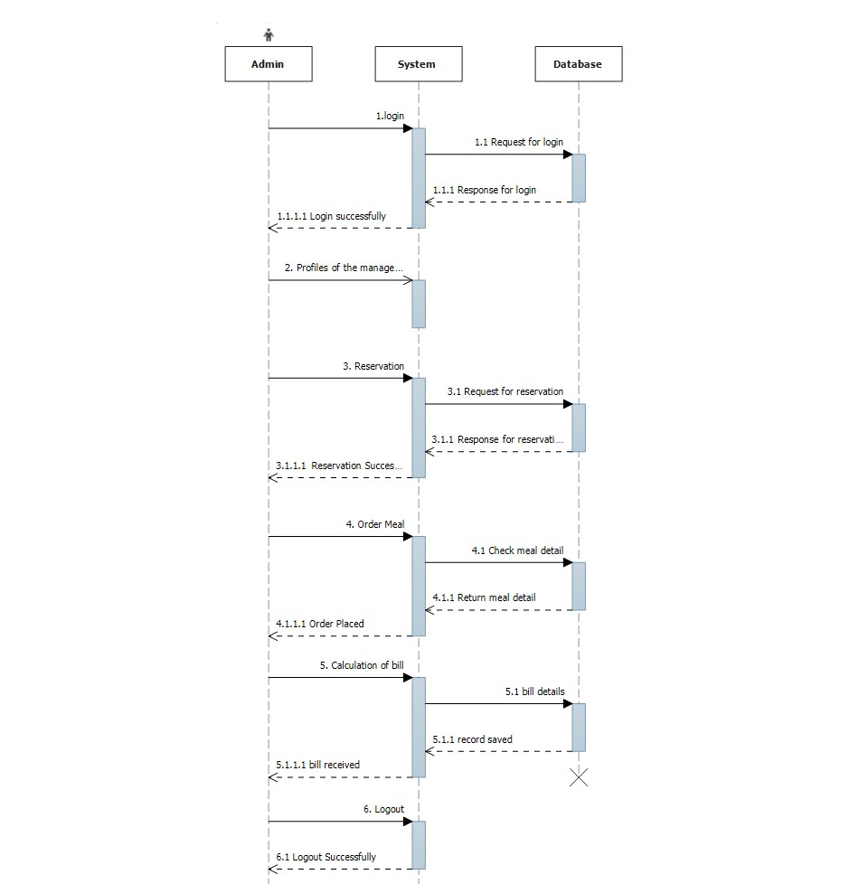

5: USEDCASE DIAGRAM:

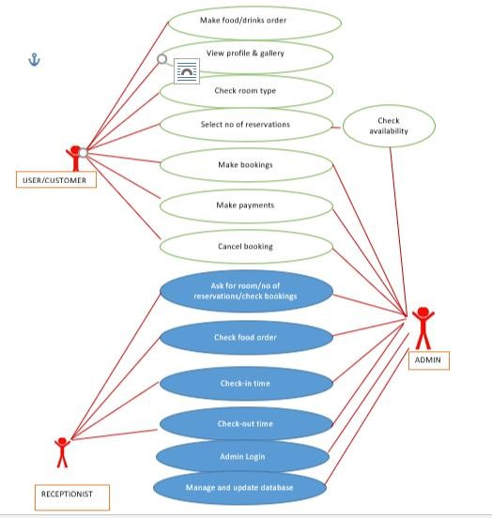

**6: UML DIAGRAM:**

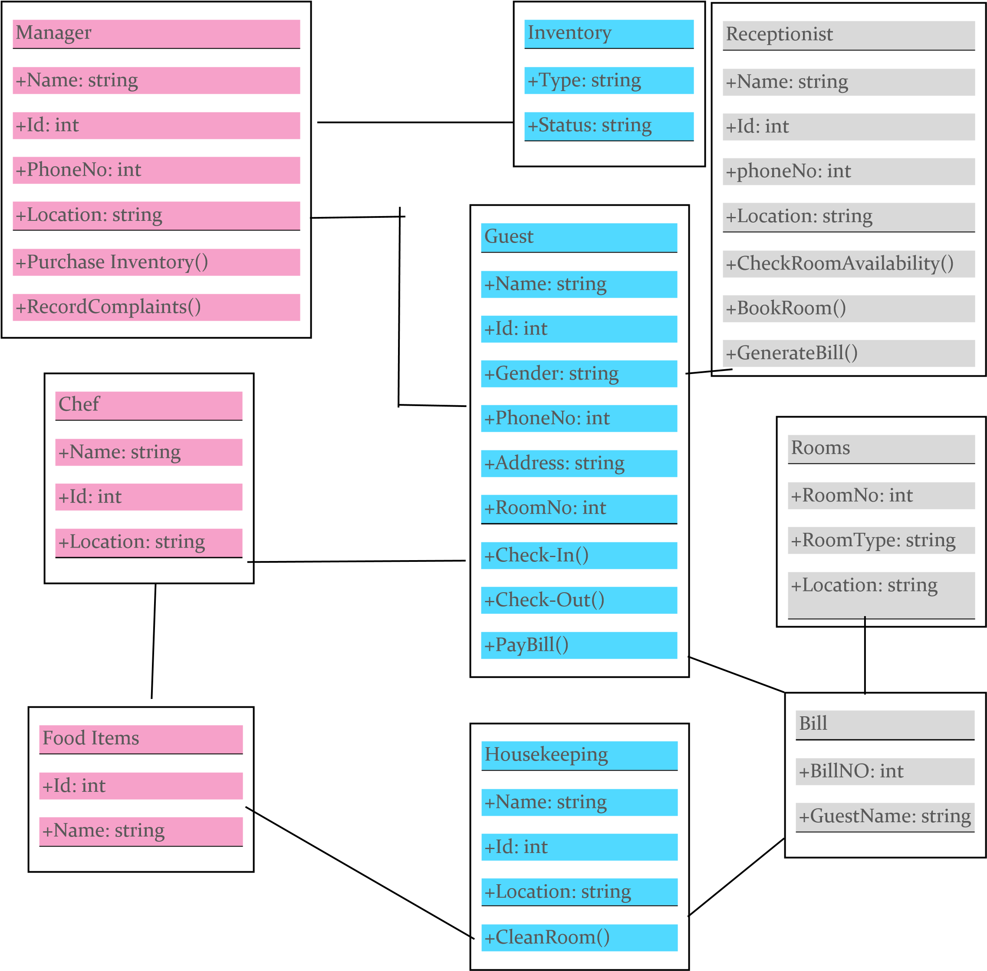

**7: References:**

[https://www.siteminder.com/r/trends-advice/hotel-management/10-books-hotelmanager-read/](https://www.siteminder.com/r/trends-advice/hotel-management/10-books-hotel-manager-read/)

[Guest Tracker: Reservation Software for Hotels, Motels, B&B's, and Resorts](http://guesttracker.com/index.html) Article by [*Dan Taylor*](https://blog.capterra.com/author/dtaylor/) *in* [*Hospitality Property Management*](https://blog.capterra.com/articles/hotel-management/hospitality-property-management/) <https://www.omicsonline.org/hotel-management-recent-research-articles.php>

**8: BOOKS REALTED TO THE HOTEL MANAGEMENT:-**

1: WITHOUT RESERVATIONS: HOW A FAMILY ROOT BEER STAND GREW

INTO A GLOBAL HOTEL COMPANY

WRITTEN BY J.W. “BILL” MARRIOTT, JR

-This book gives a specific example of a how a business can grow from something small to become a global leader in the industry.

2: BE OUR GUEST: PERFECTING THE ART OF CUSTOMER SERVICE WRITTEN BY THE DISNEY INSTITUTE AND THEODORE KINNI

-Hoteliers can never have enough tricks up their sleeve when it comes to understanding and pleasing their guests.