S25-043-D-Clear Frame

Project Team

Osama Ali 21I-0587 Talha Sohail 21I-0374
MuhammadHuzaifa 21I-2975

Session 2021-2025

Supervised by Mr.Majid Hussain

Co Supervised by

Dr. Zeshan Khan



Department of Computer Science

National University of Computer and Emerging Sciences Islamabad, Pakistan

Contents

Chapter 1 6

Introduction 6
1.1 Problem Statement 6
1.2 Scope 6
1.3 Modules 7
Text Extraction and Contextual Categorization 7
Cross Verification of Statements and Claims 7
Deep Learning for Narrative and Trend Analysis 7
Crowdsourced Verification 7
Plugin Interface and Web Dashboard 8
1.4 WorkDivision 8

Chapter 2 9

Project Requirements 9
2.1 Use-case/Event Response Table/Story-boarding 9
2.2 Non-Functional Requirements 19
2.3 Functional Requirements 19
2.4 Domain Model 22

Chapter 3 23

System Overview 23
3.1 Architectural Design 23
3.2 Design Models 24
3.2.1 State Transition Diagram 24
3.2.2 Activity Diagram 25
3.3 System Sequence Diagram 26
3.3.1 User Views a Post (Automatic Verification). 26
3.3.2 Crowdsourced Verification for Unverified Post 27
3.3.3 Gnn model based trend analysis 28
3.3.4 Verified Member login into system 29
3.3.5 Admin Verifies Members 30
3.4 Class diagram 31

Chapter 4 32

Implementation and Testing 32
4.1 Algorithm Design 32
1. MultiLingual Tweet Classifier 32
2. Tweet Extraction from Twitter 33
3. Cross Verification 33
4. Crowd Source verification 35
4.2 External APIs/SDKs 36
4.3 Testing Details 36
4.3.1 Unit Testing 36

Chapter5 42

Conclusions and Future Work 42
5.1 Conclusion 42
5.2 Future Work 42
1. Integration of Advanced Multimedia Forensics 42
2. Expansion to Additional Social Media Platforms 42
3. Personalized Misinformation Risk Profiling 43
4. Mobile Application for On The Go Verification 43

Bibliography 44

List of Figures

2.1 Use Case Diagram 10
2.2 Domain Model 23

3.1 Architecture Diagram 24
3.2.1 State Transition Diagram 25
3.2.2 Activity Diagram 26
3.2.3.1 User Views a Post SSD 27
3.2.3.2 Crowdsourced Verification for Unverified Post SSD 28
3.2.3.3 Gnn Model Based Trend Analysis SSD 29
3.2.3.4 Verified Member Login into System SSD 30
3.2.3.5 Admin Verifies Members SSD 31
3.3 Class Diagram 32

List of Tables

2.1 ClearFrame Event-Response Table For Real-Time Backend System ………..22

4.1 Test Case for Member Registration…………………………………………….35

4.2 Test Case for Duplicate Email Registration……………………………………...36

4.3 Test Case for Member…………………….……………………………………...37

4.4 Test Case for Invalid Login……………………………………………………...38

4.5 Test Case for Admin Approval of Member Request………………………………………….……………………………………...39

4.6 Test Case for Admin Rejection of Invalid Member Request…………………………………………..……………………………………...40

Chapter 1

Introduction

1.1 Problem Statement

The rapid spread of misinformation and disinformation across social media platforms has created an urgent need for reliable fact-checking mechanisms. Traditional fact-checking processes are time-consuming and struggle to counter viral misinformation in real-time. The absence of a centralized, automated verification system leads to confusion, manipulation, and potential harm to individuals and organizations.

With the increasing influence of social media on public opinion, false information can significantly impact political, economic, and social landscapes. There is a need for an AI-driven solution that can quickly and accurately verify the authenticity of news, claims, and statements shared on platforms like Twitter and Facebook.

1.2 Scope

The scope of Clear Frame encompasses the development of an AI-powered misinformation detection system that integrates Natural Language Processing (NLP), Graph Neural Networks (GNNs), Computer Vision, and Crowdsourced Verification to ensure fast and reliable fact-checking. The system will support Twitter and Facebook initially, with the potential to expand to other social media platforms in the future.

Clear Frame will:

● Automate the verification of news and claims by cross-referencing them with credible sources.
● Use deep learning models to analyze and detect misinformation trends.
● Implement a crowdsourced verification mechanism to allow users to contribute to fact-checking efforts.
● Provide a browser plugin and web dashboard for real-time misinformation detection and reporting.
● Support multiple categories of content, including political news, financial updates, sports news, and religious content.

By deploying these mechanisms, Clear Frame aims to significantly reduce the spread of misinformation and provide users with a trustworthy tool for verifying online content.

1.3 Modules

Text Extraction and Contextual Categorization

1. The system shall extract text content from posts, captions using OCR technology. 2. The system shall access tweets from Twitter using Twitter API v2.
3. The system shall access posts from Facebook using Graph API.
4. The system shall classify extracted content into predefined categories (Politics & Government, Sports, International Relations, Finance & Economy, Islamic Content).
5. The system shall filter out personal opinions, jokes, and general statements from categorization.
6. The system shall employ pre-trained language models (XLM-RoBERTa) for contextual analysis.

Cross Verification of Statements and Claims

1. The system shall extract key entities, claims, and contextual information from text using NLP models (XLM-RoBERTa).
2. The system shall perform semantic similarity analysis to match claims with statements from official sources.
3. The system shall maintain a Pakistan-specific database of official accounts, including politicians, celebrities, government officials, news channels, and fact-checking organizations.
4. The system shall integrate Google Custom Search API and web scraping to retrieve and validate information.
5. The system shall cross-check claims against the database and fact-checking platforms.
6. The system shall generate a verification report with source links and a credibility score.

Deep Learning for Narrative and Trend Analysis

1. The system shall represent social media interactions as a graph, with nodes representing users or posts and edges representing interactions.
2. The system shall incorporate node features such as user profiles, post content, and engagement metrics.
3. The system shall use GNNs to analyze the spread of news and narratives across the network.
4. The system shall identify key influencers and clusters of coordinated behavior.
5. The system shall detect anomalies in propagation patterns, such as sudden spikes in engagement or unusual retweet behavior.
6. The system shall classify nodes as sources of true, false, or unverified information based on their structural position and feature embedding.

Crowdsourced Verification

- The system shall allow users to flag suspicious posts, articles, or media for review.

2. The system shall provide an interface for users to submit evidence supporting debunking claims.
3. The system shall implement a voting system where users can rate the credibility of flagged content.
4. The system shall aggregate user votes to compute a crowdsourced credibility score

Plugin Interface and Web Dashboard

1. The system shall display a visual indicator (True/False/Unverified) alongside news posts or claims.
2. The system shall provide direct links to verified sources.
3. The system shall display a confidence meter indicating the verification level.
4. The system shall maintain a detection history log of all verified or flagged content. 5. The system shall track user participation in flagging content, providing evidence, or
voting on credibility.

1.4 WorkDivision

Name | Registration | Responsibility/Module
Osama Ali | I210587 | Module 2 ,3
Talha Sohail | I210374 | Module 1, 4
Muhammad Huzaifa | I212975 | Module 2, 5

Chapter 2

Project Requirements

This chapter describes the functional and non-functional requirements of the project.

2.1 Use-case/Event Response Table/Story-boarding

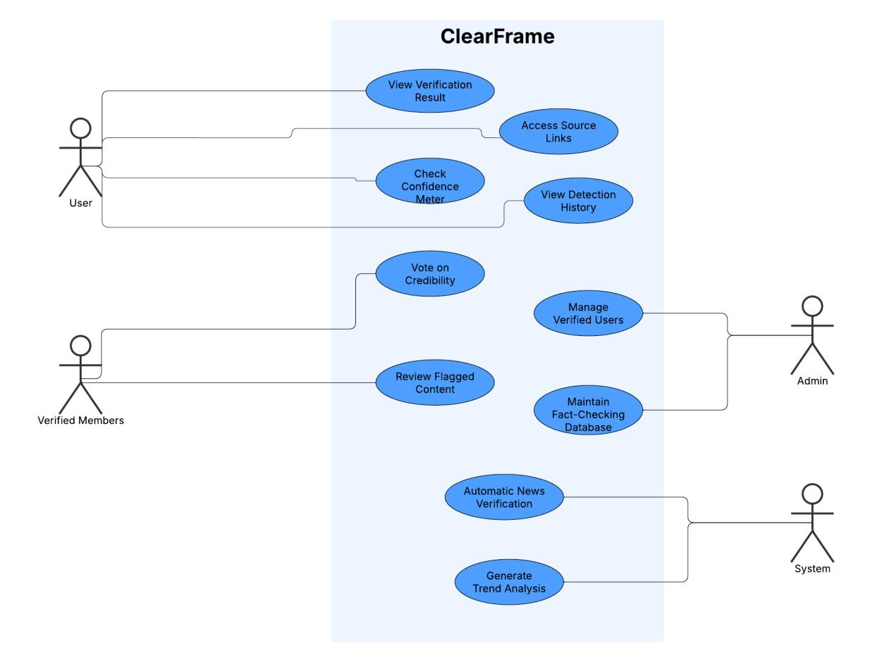

Figure 2.1: Use Case Diagram

2.1.1 Fully Dressed Use Cases

2.1.1.1 Use Case: View Verification Result

Primary Actor: User

Preconditions:

1. User has installed the Clear Frame browser extension 2. User is browsing social media (Facebook or Twitter)
3. User is viewing a post that contains claims or news content 4. The system has internet connectivity to perform verification

Post conditions:

1. The verification result (True/False/Unverified) is displayed to the user alongside the social media post
2. The verification is recorded in the user's detection history
3. The verification process data is stored in the system database

Main Success Scenario:

1. User encounters a news post or claim while browsing social media 2. The Clear Frame extension automatically detects the post content 3. The system extracts the text from the post using OCR if necessary
4. The system categorizes the content (Politics, Sports, International Relations, etc.) 5. The system cross-references the claim against the official source database
6. The system analyzes the claim using the GNN model for narrative detection
7. The system aggregates result from verification methods (database matching, GNN analysis)
8. The system factors in any existing crowd-sourced verification data
9. The system calculates a final verification status (True/False/Unverified) and confidence score
10.The browser extension displays a visual indicator (verification badge) adjacent to the post
11.The user views the verification result without needing to take any additional action

Alternative Flows:

1. If the post doesn't contain verifiable claims:

1. The system identifies content as opinion, joke, or general statement 2. System displays "Not a verifiable claim" message

2. If the verification process takes longer than expected:

1. System displays "Verification in progress" indicator
2. User can continue browsing while verification completes in background

3. If the system cannot determine verification status with high confidence:

1. System marks content as "Unverified" with appropriate confidence meter 2. System suggests user to check crowd-sourced verification or submit for
review

Exceptions:

1. If network connectivity is lost during verification:

1. System pauses verification process
2. System displays "Verification paused - check connection" message 3. Verification resumes when connectivity is restored

2. If the content is in a format not supported by the system:

1. System displays "Unable to verify this content type" message 2. System suggests alternative verification method

2.1.1.2 Use Case: Access Source Links Primary Actor: User

Preconditions:

1. User has installed the Clear Frame Chrome extension.
2. User is viewing social media content (post/news) on Facebook or Twitter.
3. The system has already processed and verified the content, generating source links.
4. Verification badge is visible to the user.

Post conditions:

1. User has access to the original sources used for verification.
2. User can make an informed judgment about the credibility of the content. 3. System logs the user's interaction with source links.

Main Success Scenario:

1. User views a social media post with the Clear Frame verification badge.
2. User clicks on the "View Sources" button or link within the plugin interface.
3. System displays a list of relevant source links used for verification, which may include:

1. Official social media accounts 2. Verified news outlets
3. Government websites
4. Fact-checking organization reports 5. Academic or research publications

4. For each source, the system shows:

1. Source name/title
2. Brief description of how it relates to the claim 3. Link to the original content
4. Date of publication/statement 5. Credibility rating of the source

5. User clicks on desired source link.
6. System opens the source in a new browser tab.
7. User reviews the source information to verify the system's assessment. 8. System records which sources were accessed for analytics purposes.

2.1.1.3 Use Case: View Detection History

Primary Actor: User

Preconditions:

1. User has installed the Clear Frame browser extension 2. User has an active account in the Clear Frame system
3. User has previously viewed content that has been analyzed by the system

Post conditions:

1. User has accessed their complete verification history 2. System has logged the history access event

Main Success Scenario:

1. User opens the Clear Frame web dashboard
2. User logs into their account using their credentials 3. System authenticates the user
4. User navigates to the "Detection History" section of the dashboard 5. System retrieves the user's verification history from the database
6. System displays a chronological list of all content the user has encountered that was analyzed by Clear Frame
7. For each item in the history, the system displays:

1. Date and time of verification
2. Source platform (Facebook, Twitter) 3. Content snippet or reference
4. Verification result (True/False/Unverified) 5. Confidence score
6. Category of content (Politics, Sports, etc.)

8. User can filter history by date range, verification result, or content category 9. User can click on any history item to see the full verification report including
sources

2.1.1.4 Use Case: Vote on Content Credibility

Primary Actor: Verified Member

Preconditions:

1. User must be logged in with a verified member account
2. The content (news/post) must have been processed by the system
3. The content must be accessible through the plugin or web dashboard
4. The content must not have been previously voted on by this verified member

Post conditions:

1. The user's vote is recorded in the system database 2. The overall credibility score of the content is updated 3. The verified member's voting history is updated
4. The content's verification status may change based on aggregated votes

Main Success Scenario:

1. The verified member accesses a news item or social media post through the Clear Frame plugin or web dashboard
2. The system displays the current verification status and existing credibility metrics 3. The verified member reviews the content and associated evidence
4. The verified member selects a voting option (True/False/Unverified)
5. The system prompts the verified member to provide reasoning or evidence for their vote
6. The verified member submits supporting evidence or rationale for their decision 7. The system validates the submission
8. The system records the vote along with the evidence in the database
9. The system recalculates the content's credibility score based on all votes 10.The system displays a confirmation message and the updated verification status 11.The system updates the verified member's contribution history

Alternative Flows:

If the content has already been voted on by this member:

1. The system notifies the member that they have already voted 2. The system gives the option to modify their previous vote

If the vote submission fails:

1. The system displays an error message
2. The verified member is prompted to try again

If the verified member's account is under review:

1. The system temporarily holds the vote
2. The vote is processed once the account review is complete

2.1.1.5 Use Case: Review Flagged Content

Primary Actor: Verified Member

Preconditions:

1. User has a verified member account with valid credentials 2. User has successfully logged into the system
3. Content has been flagged by regular users for review
4. User has necessary permissions to review flagged content

Post conditions:

1. Flagged content has been reviewed and properly categorized
2. Verification status (True/False/Unverified) has been updated in the system 3. Verification history is updated with review decision and evidence
4. Users who flagged the content receive notification of review completion

Main Success Scenario:

1. Verified member accesses the dashboard and navigates to the "Flagged Content" section
2. System displays a list of content flagged by regular users, sorted by priority/date 3. Verified member selects a specific piece of flagged content to review
4. System displays the content along with:

1. Original post/news item 2. Current verification status 3. GNN analysis results
4. Preliminary cross-verification results

5. Verified member examines the content and supporting evidence
6. Verified member cross-references the content against official sources in the database
7. Verified member can add additional evidence or sources to support their decision 8. Verified member makes a verification decision (True/False/Unverified)
9. Verified member provides a brief justification for their decision 10.System updates the verification status of the content 11.System records the verification activity in the database
12.System notifies users who flagged the content about the review completion

2.1.1.6 Use Case: Manage Verified Users Primary Actor: Admin
Preconditions:

- Administrator is logged into the system
- User account database is accessible
- Verification criteria and guidelines are established

Post conditions:

● Verified users are properly designated in the system ● Verification privileges are correctly assigned
● Verification activity logs are updated

Main Success Scenario:

1. Administrator accesses the user management dashboard
2. Administrator reviews pending verification requests from users
3. Administrator checks user's credentials, activity history, and verification qualifications
4. Administrator approves qualified users for verified status 5. System assigns verification privileges to approved users 6. System notifies users of their new verification status
7. Administrator sets verification contribution limits and voting weight for each verified user
8. System records verification status changes in the audit log
9. Administrator can view a list of all verified users with their contribution metrics 10.Administrator can revoke verification status if users violate platform guidelines

2.1.1.7 Use Case: Automatic News Verification Primary Actor: System
Preconditions:

1. User has installed the ClearFrame browser extension 2. User is browsing content on Facebook or Twitter
3. The verification database is up-to-date with official sources 4. The system's NLP models are trained and operational

Postconditions:

1. News/post is classified as True, False, or Unverified
2. Verification result is displayed to the user with confidence score 3. Source links supporting the verification result are provided
4. Verification result is logged in the system database
5. The processed content is available in the user's verification history

Main Success Scenario:

1. User views a post on Facebook or Twitter
2. System automatically extracts text from the post using OCR and API access 3. System categorizes the content (Politics, Sports, International Relations, etc.) 4. System filters out personal opinions, jokes, and general statements
5. System cross-references extracted claims against the verification database
6. System uses GNN to analyze propagation patterns and detect false narratives 7. System calculates a credibility score based on verification results

8. System displays a verification badge (True/False/Unverified) next to the post 9. System shows confidence meter and relevant source links
10.System logs the verification result in the database

Alternative Flows:

Insufficient Information:

1. At step 5, if the system cannot find matching information in the verification database
2. System marks the content as "Unverified"
3. System prompts verified members to contribute to verification

Ambiguous Content:

1. At step 4, if the system cannot clearly categorize the content
2. System performs general fact-checking without specific category constraints
3. System may assign lower confidence scores for ambiguous content

Content Already Verified:

1. After step 2, if the system finds the content already exists in verification history
2. System retrieves existing verification results
3. System updates the result if new evidence is available

Failed Text Extraction:

1. At step 2, if text extraction fails (e.g., content is only an image) 2. System displays "Unable to Verify" message
3. System provides option for user to manually flag content

Conflicting Evidence:

1. At step 5, if the system finds contradictory evidence from different sources 2. System marks content as "Disputed"
3. System displays contradictory sources with their credibility rankings

2.1.1.8 Use Case: Generate Trend Analysis

Primary Actor: System

Preconditions

● System has collected sufficient social media posts and user interactions ● Database of verified sources and fact-checked content is available
● GNN model has been properly trained on the FakeNewsNet dataset
● Graph representation of social media interactions has been constructed

Post conditions

● False narrative patterns are identified and stored in the system ● Propagation trends of misinformation are documented
● Anomalous spread patterns are flagged for review
● Trend analysis results are available for display on the dashboard

Main Success Scenario

1. System continuously collects new social media posts and user interactions
2. System constructs a graph representation where nodes represent users/posts and edges represent interactions
3. System applies GNN models to analyze propagation patterns across the network 4. System identifies key influencers and clusters of coordinated behavior in the graph 5. System detects anomalies in propagation patterns (e.g., sudden engagement
spikes)
6. System classifies nodes as sources of true, false, or unverified information
7. System generates a trend analysis report documenting patterns of false narrative spread
8. System stores trend analysis results in the database
9. System makes trend analysis available for administrative review and dashboard display

2.2 Non-Functional Requirements

Reliability:

1. The system shall maintain 99% uptime during operational hours.
2. In case of failure, the system shall preserve user data and resume normal operation without data loss.

Usability:

1. The plugin interface shall be intuitive enough that 90% of first-time users can successfully verify a news item within 2 minutes without training.
2. The web dashboard shall allow users to access their verification history with no more than 3 clicks.
3. Error messages shall be clear, indicating the problem and suggesting a solution.

Performance:

1. The text extraction and classification process shall complete within 5 seconds for a standard social media post.
2. The cross-verification process shall return results within 10 seconds for 95% of verification requests.
3. The system shall support concurrent processing of at least 1000 verification requests.
4. The web dashboard shall load within 3 seconds on a standard broadband connection (20+ Mbps).

Security:

1. User data shall be encrypted using industry-standard encryption protocols.
2. The system shall implement role-based access control for administrative function.

3. The system shall protect against common web vulnerabilities (SQL injection, XSS, CSRF).

2.3 Functional Requirements

Module 1: Content Intelligence Engine

- Extracts and classifies social media text into 5 Pakistan-relevant categories

- Filters out opinions and jokes using XLM-RoBERTa

- Supports Twitter API v2 and Facebook Graph API

Module 2: Cross-Verification System

- Matches claims with official sources via semantic similarity

- Maintains Pakistan-specific database of verified accounts

- Generates verification reports with credibility scores

Module 3: Network Analysis Engine

- Models social interactions as graphs using GNNs

- Identifies influencers and coordinated behavior clusters

- Detects anomalous propagation patterns

Module 4: Crowdsourcing Dashboard

- Allows users to flag content and submit evidence

- Implements voting system for credibility ratings

- Displays verification results with confidence indicators

ClearFrame Event-Response Table for Real-Time Backend System

Event | System Response | Components Involved
User views social media post | Extract text content  Classify content into categories Process through verification pipeline | OCR Module Twitter/Facebook API  Contextual Categorization Module
System detects claim for verification | - Extract key entities and claims Search database for matching official statements | XLM-RoBERTa NLP Model Cross-Verification Database Source Validation Module
GNN pattern analysis triggered | - Construct interaction graph Analyze propagation patterns  Detect anomalies in sharing behavior | Graph Neural Network (GNN) Propagation Pattern Analyzer FakeNewsNet Dataset (for training)
confidence meter | Retrieve confidence score  Display visual representation of score | Confidence Meter UI Component Web Dashboard Interface
User accesses source links | Retrieve all matched sources from database  Make sources available for direct navigation | - Source Database  Link Preview Generator Web Dashboard Interface
Verified member votes on content | Record vote in database  Update crowd sourced credibility score | Voting Mechanism Component Crowd sourced Verification Module
Admin manages verified users | - Process verification Update user privilege levels | User Management Module Privilege Control System
Admin maintains fact-checking database | Add new official sources Update existing source records | - Database Management Interface Source Record Manager
User views detection history | Retrieve user's viewed content history Compile verification results for each items | User History DatabaseHistory

2.4 Domain Model

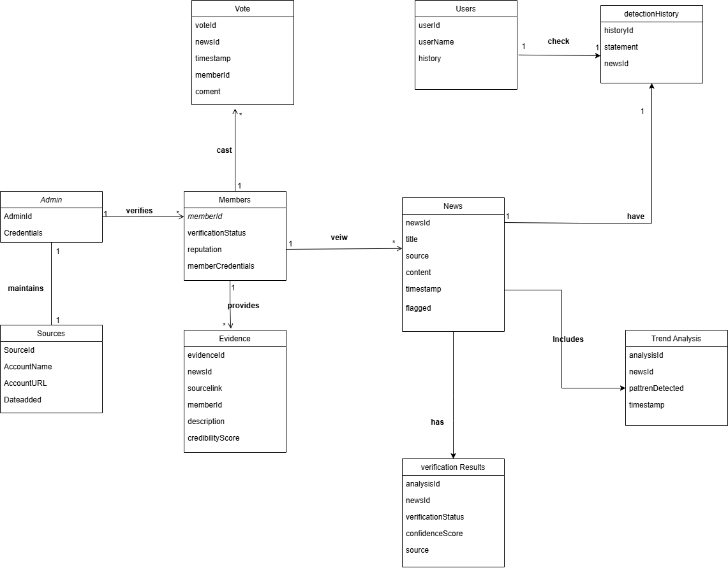

Figure 2.2: Domain Model

Chapter 3

System Overview

3.1 Architectural Design

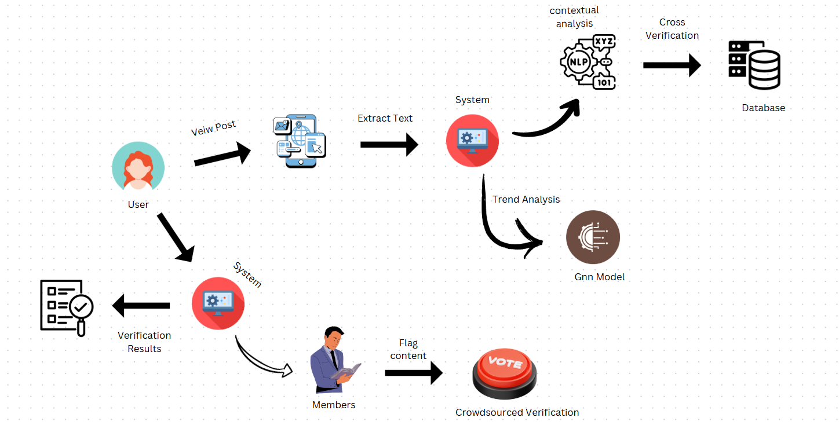

Figure 3.1: Architecture Diagram

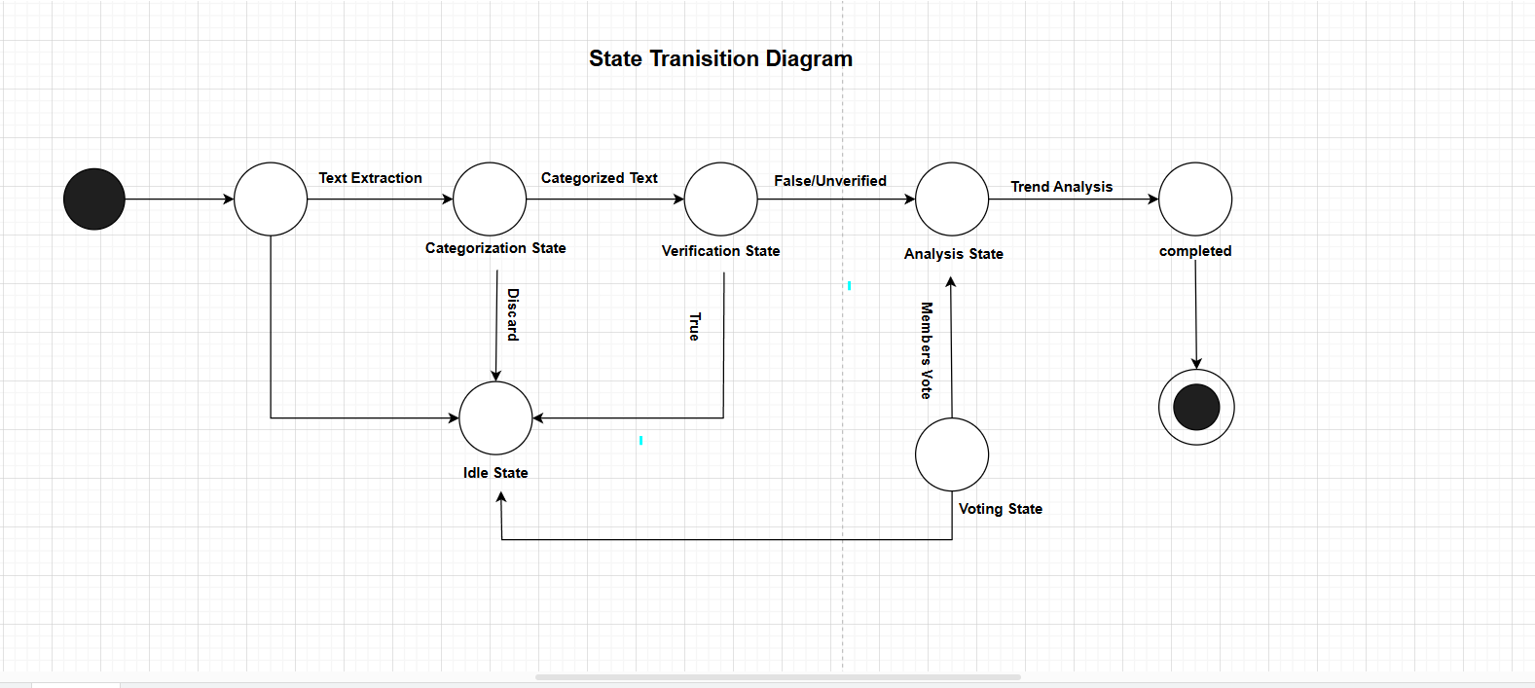

3.2 Design Models

3.2.1 State Transition Diagram

Figure 3.2: State Transition Diagram

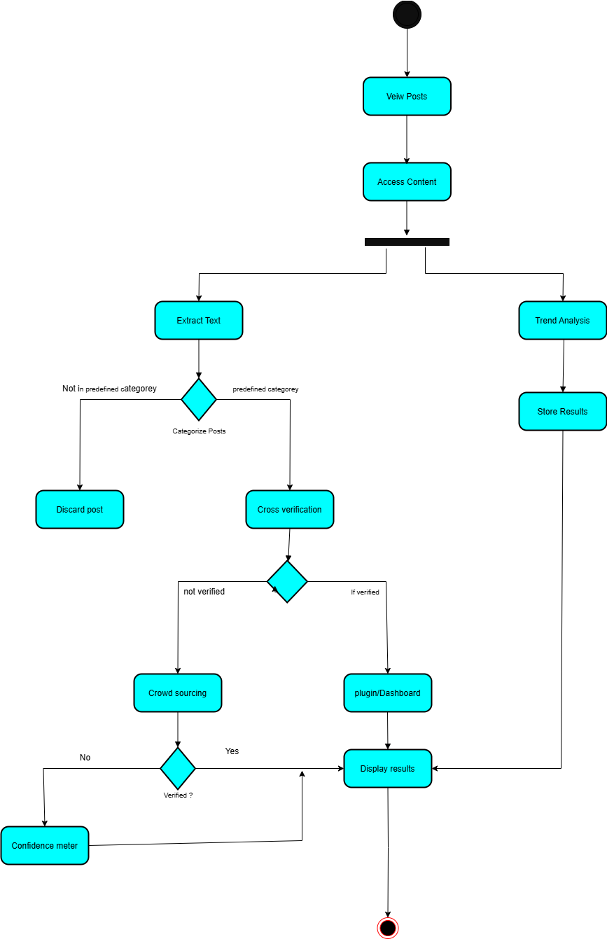
3.2.2 Activity Diagram

Figure 3.3: Activity Diagram

3.2 Design Models

3.3 System Sequence Diagram

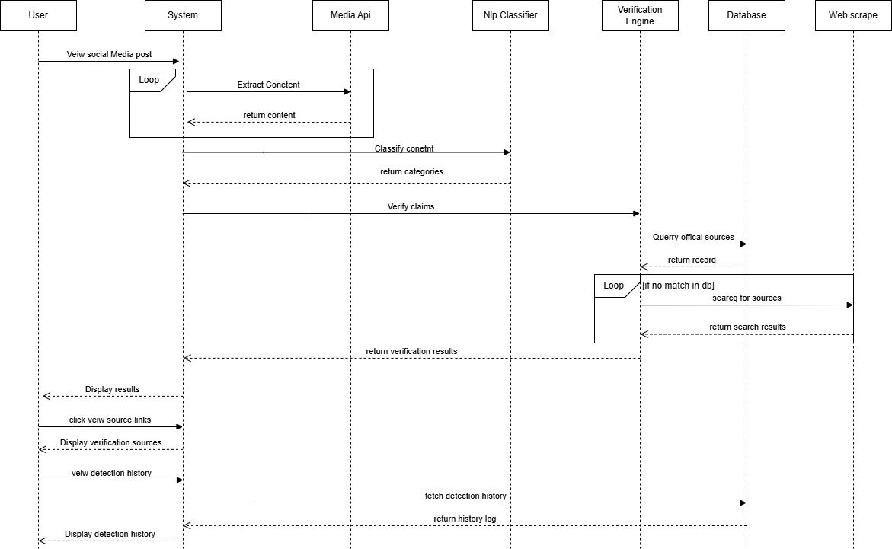
3.3.1 User Views a Post (Automatic Verification).

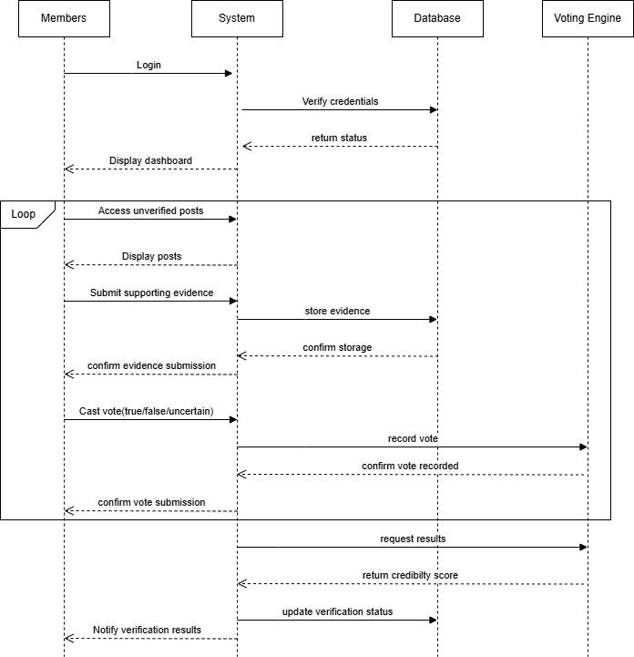
3.3.2 Crowdsourced Verification for Unverified Post

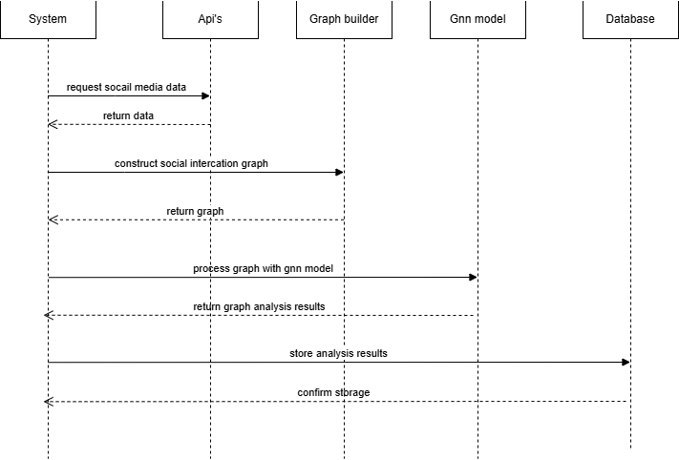
3.3.3 Gnn model based trend analysis

3.3.4 Verified Member login into system

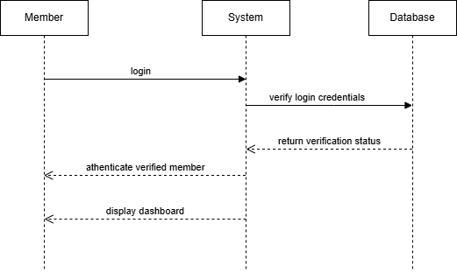

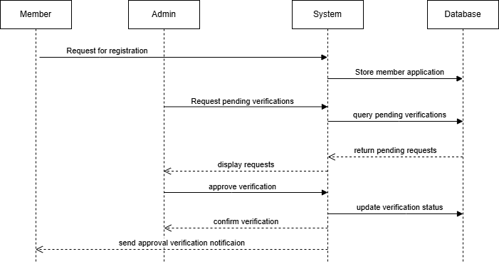

3.3.5 Admin Verifies Members

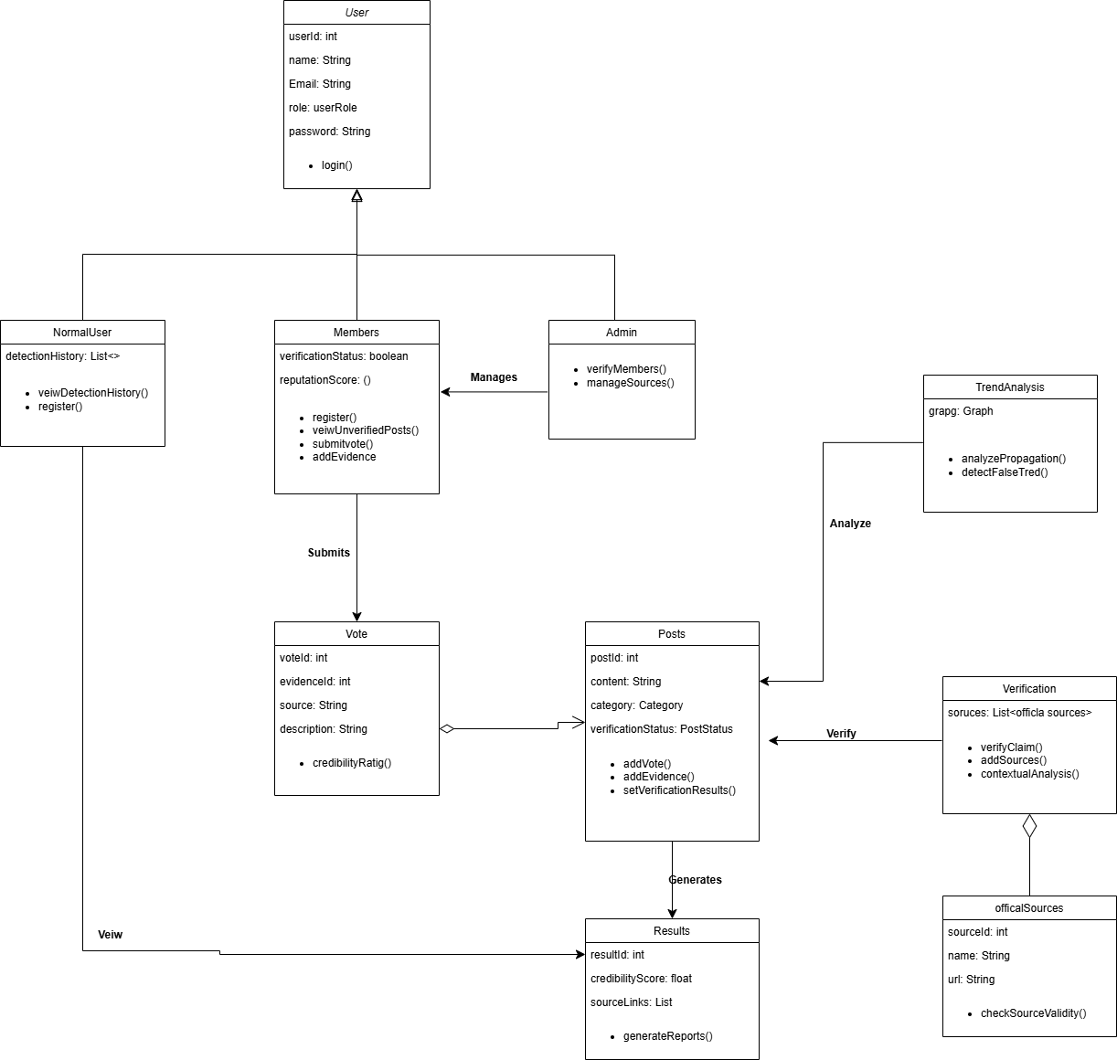

3.4 Class diagram

Chapter 4

Implementation and Testing

4.1 Algorithm Design

MultiLingual Tweet Classifier

The Chrome add-on enables users to verify a tweet by clicking on a "Check Tweet" button. The add-on takes the tweet text through DOM manipulation and passes it on to the backend server. The server applies an XLM-RoBERTa model to categorize the tweet into pre-specified categories. If the tweet falls under politics, sports, economy, or international relations, it goes for further processing. Else, the add-on informs the user that the tweet is irrelevant for verification.

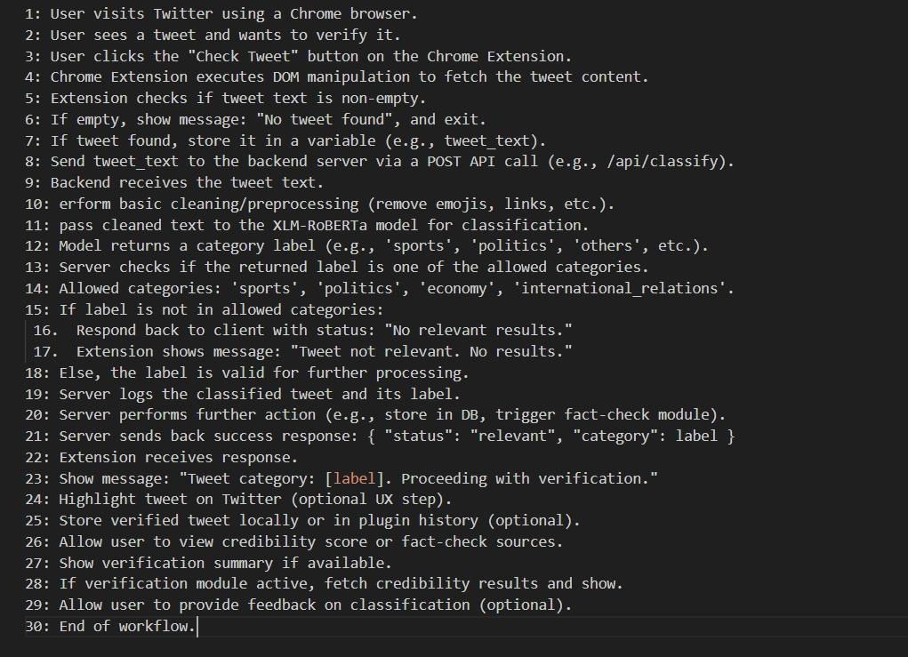

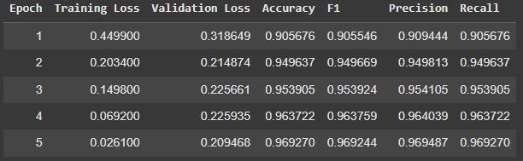

Tweet Extraction from Twitter

The extension extracts the tweet text from the Twitter page using DOM manipulation.
The extracted tweet is displayed in the popup and sent to the backend server for further analysis.

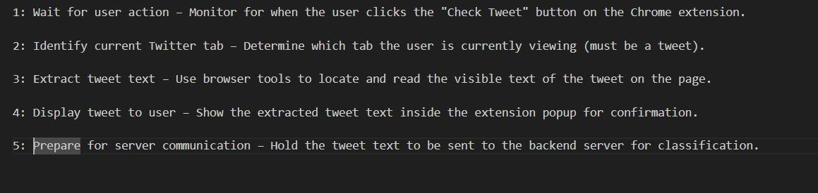

Cross Verification

In cross verification we developed pipeline to process incoming tweets and cross verify them with google search results.

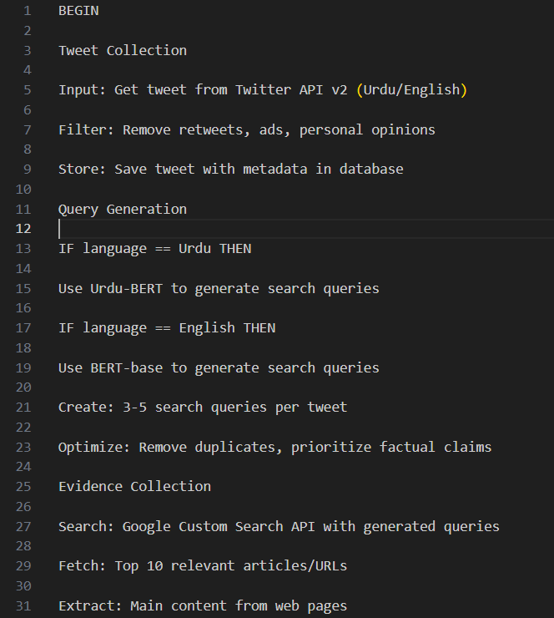
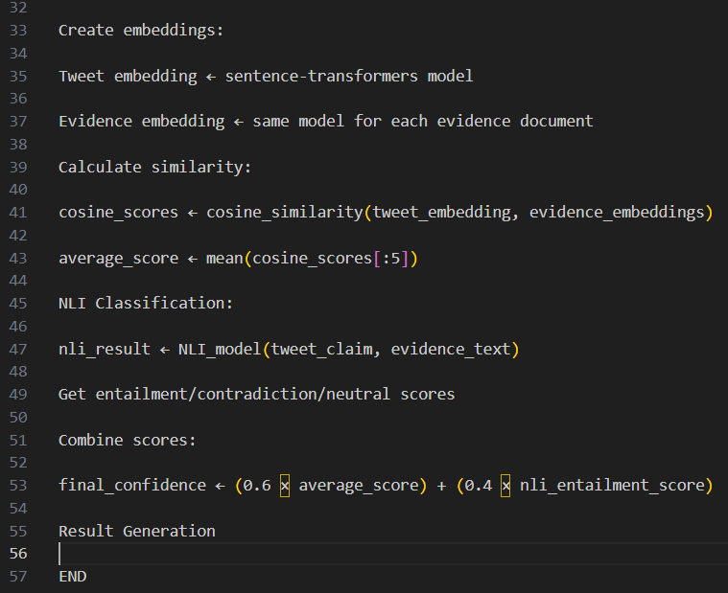

Crowd Source verification
In crowd source we implemented below system which accepts member votes to classify posts if they are true or false

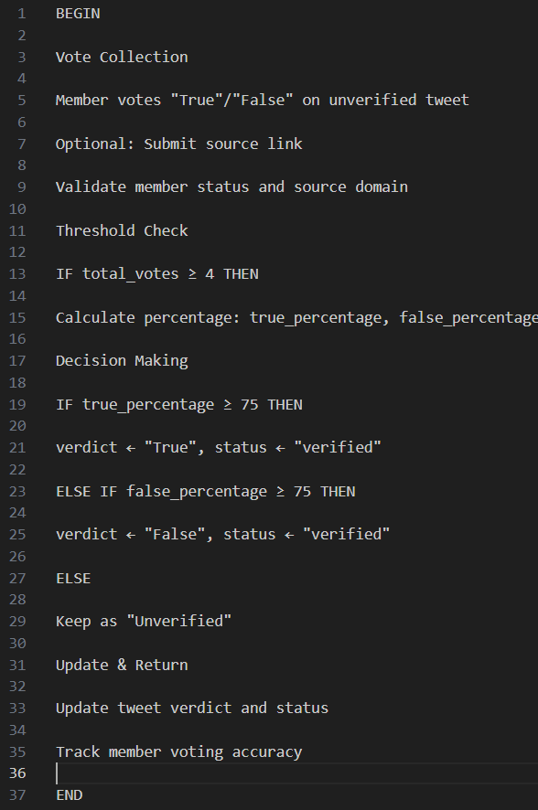

4.2 External APIs/SDKs
Google search api

4.3 Testing Details

ClearFrame current modules under implementation are being tested to identify any bugs and functionality issues. By performing manual unit testing, the working of each module is verified as intended

4.3.1 Unit Testing

Each unit test is designed to test a specific function or method independently from other com- ponents, helping to identify issues directly related to the functionality being tested.

Listed below are the test cases for ClearFrame

Field | Details
Test Case ID | TC001
Test Objective | Verify that a new member can register successfully.
Preconditions | 1. The system is online and accessible.  2. The email being registered is not already in use.
Steps | 1. Navigate to the registration page.  2. Enter the member details: Email Ad.  3. Click on the "Register" button.
Test Data | Email: osamajune17@gmail.com  Password: Password123
Expected Result | The system displays a message confirming registration success.
Post Condition | The member account is created and can be used for login in the future.
Actual Result | The member is registered.
Pass/Fail | Pass

Table 4.1: Test Case for Member Registration

Field | Details
Test Case ID | TC002
Test Objective | Verify that a member cannot register with an already existing email  address.
Preconditions | 1. The system is online and accessible.  2. The email address being registered is already in use by another  member.
Steps | 1. Navigate to the registration page.  2. Enter the member details: Email Address, Password.  3. Click on the "Register" button.
Test Data | Email: osamajune17@gmail.com  Password: Password123
Expected Result | The system displays a message stating that the email is already in use.
Post Condition | No new account is created.
Actual Result | The system displays an error message indicating that the email is  already taken.
Pass/Fail | Pass

Table 4.2: Test Case for Duplicate Email Registration

Field | Details
Test Case ID | TC003
Test Objective | Verify that a member can log in with valid credentials.
Preconditions | 1. The system is online and accessible.  2. The member is registered in the system.  3. The member knows their credentials (member name and password).
Steps | 1. Navigate to the login page.  2. Enter a valid member name and password.  3. Click on the "Login" button.
Test Data | Email: osamajune17@gmail.com  Password: Password123
Expected Result | The member is successfully logged in and redirected to the dashboard page.
Post Condition | The member session is active, and the dashboard is accessible.
Actual Result | The member is successfully navigated to the dashboard.
Pass/Fail | Pass

Table 4.3: Test Case for Member Login

Field | Details
Test Case ID | TC004
Test Objective | Verify that a member cannot log in with an incorrect password.
Preconditions | 1. The system is online and accessible.  2. The member is registered in the system.  3. The member knows their correct membername but enters an incorrect  password.
Steps | 1. Navigate to the login page.  2. Enter a valid membername and an incorrect password.  3. Click on the "Login" button.
Test Data | Email: osamajune17@gmail.com  Password: WrongPassword123
Expected Result | The system displays an error message indicating that the password is  incorrect or membername.
Post Condition | The member remains on the login page and is not logged in.
Actual Result | The system displays an error message stating incorrect password or  membername.
Pass/Fail | Pass

Table 4.4: Test Case for Invalid Login Attempt

Field | Details
Test Case ID | TC005
Test Objective | Verify that the admin can approve a member's request and successfully  add them to the system
Preconditions | 1. The system is online and accessible.  2. Admin is logged in.  3. Member has submitted a request with valid credentials and verified  social media accounts.
Steps | 1. Navigate to the admin panel.  2. Open pending member requests.  3. Review the submitted credentials and linked social media accounts.  4. Click on the "Accept" button
Test Data | Name: John Doe  Email: john.doe@example.com  Social Media: twitter.com/johndoe
Expected Result | The system displays a success message and adds the member to the  system.
Post Condition | Member is added to the system and appears in the member list
Actual Result | The system displays a success message and the member is listed in  the system.
Pass/Fail | Pass

Table 4.5: Test Case for Admin Approval of Member Request

Field | Details
Test Case ID | TC006
Test Objective | Verify that the admin is unable to approve a member request with invalid  or unverifiable credentials
Preconditions | 1. The system is online and accessible.  2. Admin is logged in.  3. Member has submitted a request with fake credentials or invalid social  media links.
Steps | 1. Navigate to the admin panel.  2. Open pending member requests.  3. Review the submitted credentials and linked social media accounts.  4. Click on the "Accept" button
Test Data | Name: Fake member  Email: fakemember@notreal.com  Social Media: twitter.com/fakemember (not valid)  Occupation : Student
Expected Result | The system displays an error message indicating invalid or unverifiable  information
Post Condition | No member is added to the system
Actual Result | The system displays an error message: "Unable to verify member details.  Request rejected."
Pass/Fail | Fail

Table 4.6: Test Case for Admin Rejection of Invalid Member Request

Chapter5

Conclusions and Future Work

5.1 Conclusion
The Clear Frame system provides a comprehensive, AIpowered solution to the rapidly growing problem of misinformation on social media. By combining NLP models and automated cross verification, the system offers real time, reliable detection of misleading content on platforms like Twitter and Facebook. The integration of a browser plugin ensures that users receive instant feedback while browsing, eliminating the need for manual fact checking or external searches. Clear Frame empowers users—ranging from general citizens to journalists and regulatory bodies—to access credible information quickly, thereby reducing the unintentional spread of false narratives.

In addition to automated verification, Clear Frame strengthens community involvement through a structured crowd sourced verification mechanism, enabling verified contributors to submit votes and evidence. The system’s Pakistan specific source database make it highly relevant and impactful for detecting coordinated misinformation within local digital ecosystems. With its modular architecture, intuitive interface, and scalable verification pipeline, Clear Frame represents a practical and effective step toward building a safer, more informed online environment.

5.2 Future Work

While Clear Frame successfully delivers real time misinformation detection using NLP, trend analysis, and crowd sourced verification, several enhancements can further strengthen the system’s capability, accuracy, and scalability in the future.

1. Integration of Advanced Multimedia Forensics

Future versions can incorporate deep learning models to analyze images, videos, and audio clips, enabling the system to detect deep fakes, doctored screenshots, and manipulated media. This would expand from text based verification to full multimodal fact checking.

2. Expansion to Additional Social Media Platforms

Currently focused on Twitter, Clear Frame can be extended to platforms such as Instagram and Facebook allowing misinformation monitoring across other major digital ecosystems. This expansion would make the system more comprehensive and widely adoptable.

3. Personalized Misinformation Risk Profiling

The system can introduce user level learning, where each user’s interaction history is used to provide tailored misinformation alerts, credibility scores, and recommendation level warnings. This would make the system more adaptive and intelligent.

4. Mobile Application for On The Go Verification

A dedicated mobile app can allow users to verify screenshots, forwarded messages, images, and URLs directly from their smartphone, especially benefiting Instagram and Facebook users in Pakistan.

Bibliography

[1] Arvind Narayanan. I set up a chatgpt voice interface for my 3-year-old. here’s how it went. https://aisnakeoil.com/p/i-set-up-a-chatgpt-voice-interface, 2024. AI Snake Oil.

[2] X. Chen, Y. Yang, and A. Rapp. Integrating chatbots in education: insights from the chatbot-human interaction satisfaction model (chism). International Journal of Educational Technology in Higher Education, 2022. Available at Springer Link.

[3] Ting Liu Honghu Yi and Gongjin Lan. The key artificial intelligence technologies in early childhood education: a review. Artificial Intelligence Review, 2022. Available at Springer Link.

[4] SoapBox Labs. Soapbox labs technology. https://www.soapboxlabs.com/technology/, 2024. Accessed: 2024-08-26.

[5] Maya Grigolia Lela Machaidze Lasha Labadze. Role of ai chatbots in education: sys-tematic literature review. International Journal of Educational Technology in Higher Education, 2022. Available at Springer Link.

[6] SpeechAce. Using the speechace api as voice ai for kids. https://speechace.com/using-the-speechace-api-as-voice-ai-for-kids/, 2024. Accessed: 2024-08-26.

