Assessment of Doppler Velocity Index (DVI) and Echocardiographic Parameters for the Diagnosis of Aortic Stenosis
Osama Ahmed Ibrahim
R version 4.5.1 (2025-06-13) was used to conduct the analysis. Continuous variables were summarized using mean (SD) when approximately normally distributed and median (IQR) when non-normal, while categorical variables were summarized as n (%). Normality was assessed using graphical methods (e.g., histogram/QQ plot) and formal testing (e.g., Shapiro–Wilk), and correlations were evaluated using Pearson or Spearman correlation depending on distributional assumptions. Agreement between DVI_LVOT and DVI_MV was assessed with Bland–Altman analysis, and diagnostic accuracy of DVI_MV was evaluated with ROC curve analysis, reporting AUC and selecting optimal cut-offs using the Youden index with corresponding sensitivity and specificity.

Table 1. Baseline demographic and clinical characteristics of the study cohort (N = 108).
Characteristic | N = 108¹
Age | 72 (11)
Sex
Male | 60 (56%)
Female | 48 (44%)
BMI | 28 (24, 32)
HTN | 79 (73%)
Dyslipidemia | 37 (35%)
DM | 45 (42%)
Coronary Artery Disease | 38 (35%)
Stroke | 13 (12%)
CKD | 25 (23%)
¹Mean (SD); n (%); Median (Q1, Q3)
Participants had a mean age of 72 (SD 11) years, and 56% were male. Common comorbidities included hypertension (73%), diabetes mellitus (42%), dyslipidemia (35%), and coronary artery disease (35%)

Table 2. Echocardiographic parameters and Doppler velocity indices in the study cohort (N = 108).
Characteristic | N = 108¹
Left Ventricular Outflow Tract Diameter (cm) | 2.05 (0.19)
Aortic Valve Mean Pressure Gradient (mmHg) | 13 (10, 22)
Aortic Valve Velocity Time Integral (cm) | 46 (36, 62)
LVOT Velocity Time Integral (cm) | 22 (6)
Mitral Valve Continuous Wave Velocity Time Integral (cm) | 23 (19, 28)
Doppler Velocity Index using LVOT | 0.47 (0.18)
Doppler Velocity Index using Mitral Valve | 0.52 (0.33, 0.65)
Aortic Valve Area (cm2) | 1.69 (1.10, 1.94)
Ejection Fraction | 55 (55, 60)
¹Mean (SD); Median (Q1, Q3)
LVOT diameter averaged 2.05 (SD 0.19) cm, while the aortic valve mean pressure gradient had a median of 13 (Q1–Q3: 10–22) mmHg. Doppler velocity index values were 0.47 (SD 0.18) using LVOT and 0.52 (Q1–Q3: 0.33–0.65) using the mitral valve, with median AVA 1.69 (Q1–Q3: 1.10–1.94) cm².

Figure 1. Distribution of aortic valve area (AVA) categories (≤1.0, >1.0–≤1.5, >1.5–≤2.0 cm²).
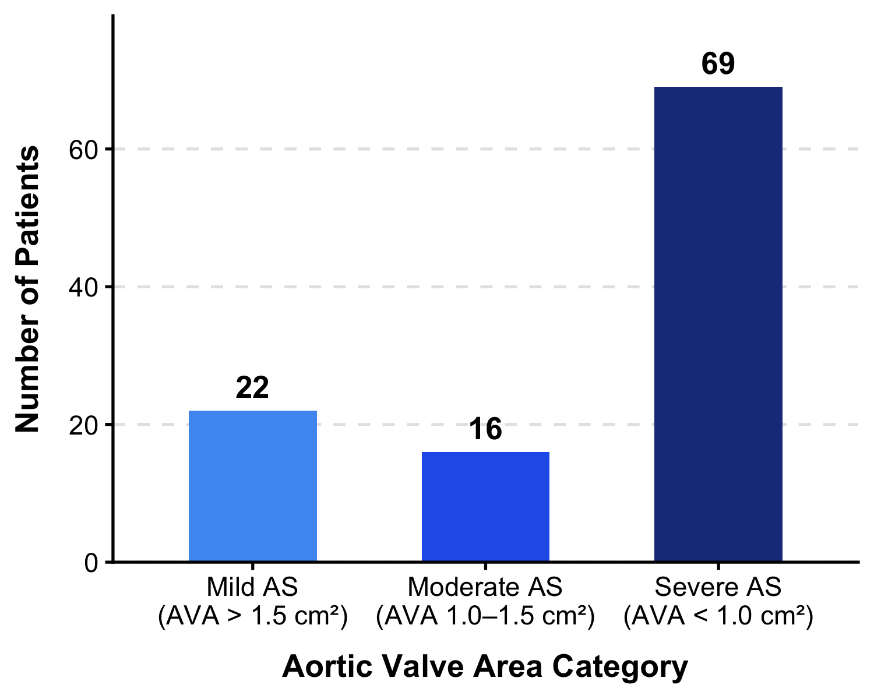
Figure 1 displays the frequency distribution of AVA after categorization into clinically relevant strata used in the analysis. In the cohort, AVA had a median of 1.69 cm² (Q1–Q3: 1.10–1.94), consistent with a substantial proportion of observations above 1.5 cm².

Figure 2. Bland–Altman plot comparing DVI_LVOT and DVI_MV.
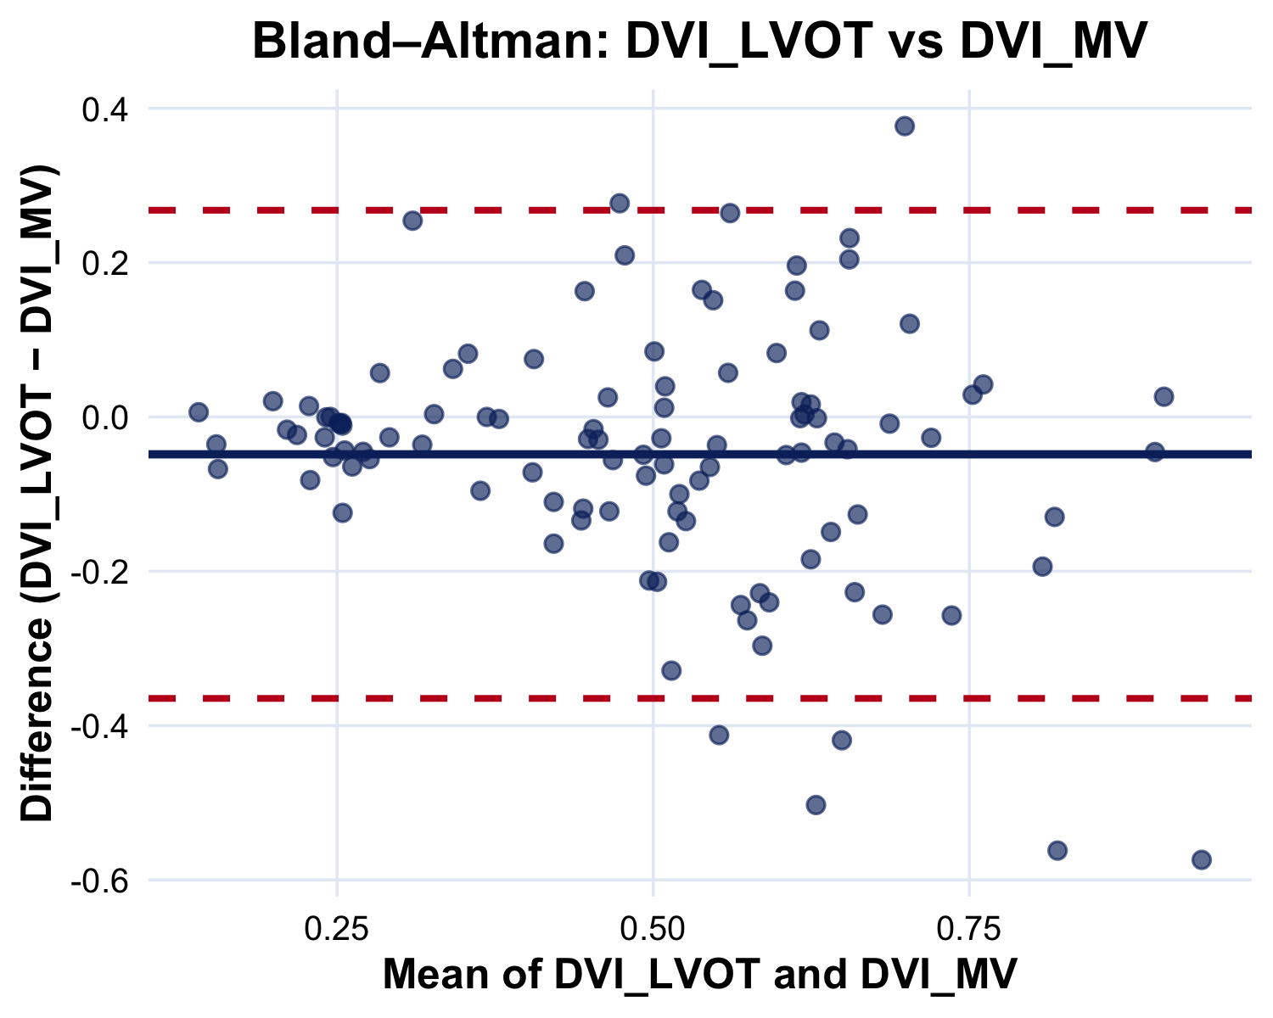
Bland–Altman analysis comparing DVI derived from LVOT and from the mitral valve showed a small negative mean bias of −0.05 (LVOT − MV), with 95% limits of agreement ranging from −0.36 to 0.27. This indicates that, on average, LVOT-based DVI values were slightly lower than MV-based values, but most paired measurements differed by less than about ±0.35 units across the observed range.

Figure 3. ROC curves for DVI_MV to identify severe aortic stenosis using two reference definitions (AVA < 1 cm² and DVI_LVOT < 0.25).
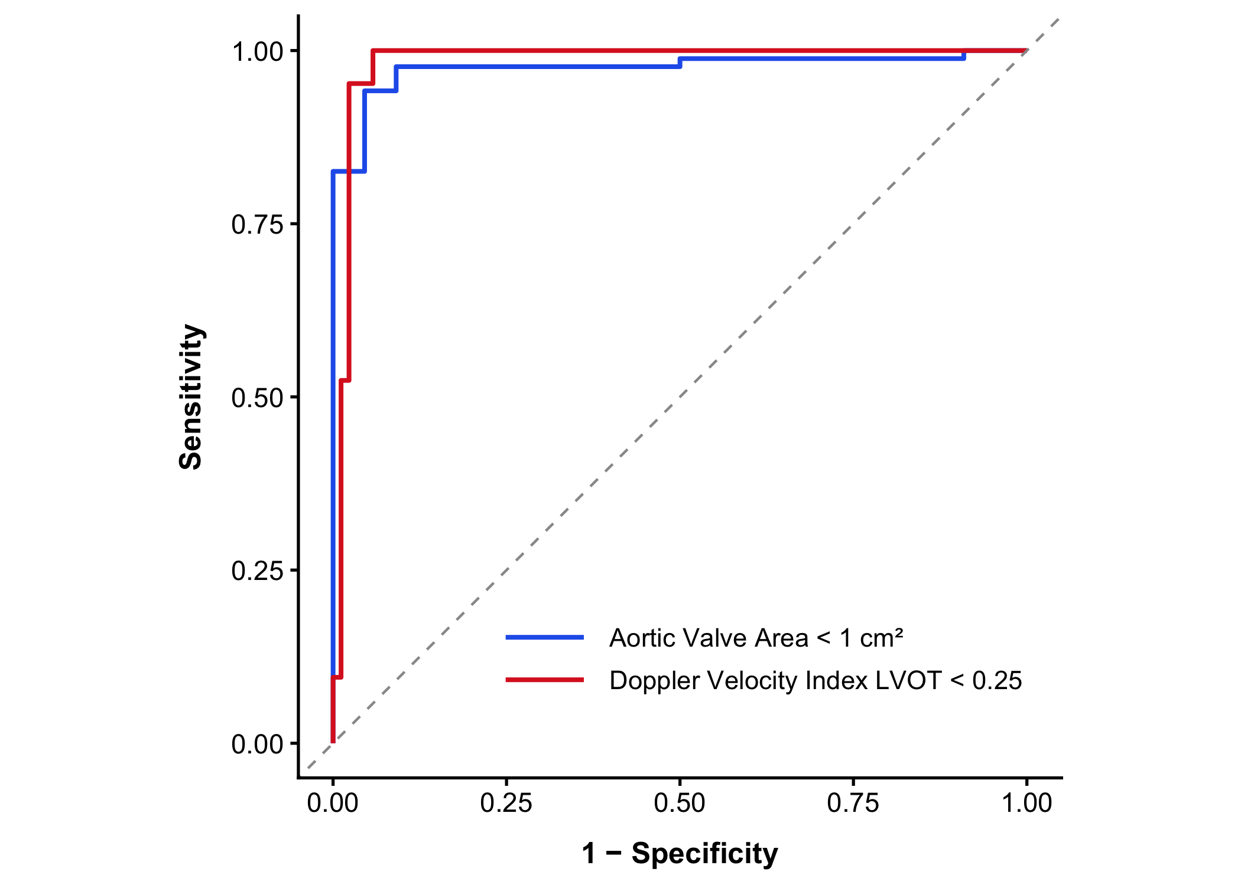
The diagnostic performance of the Doppler Velocity Index using the Mitral Valve (DVI-MV) in detecting severe aortic stenosis (AS) was evaluated against two outcome definitions using receiver operating characteristic (ROC) curve analysis. When severe AS was defined by an aortic valve area (AVA) < 1 cm², DVI-MV demonstrated excellent discriminative ability, with an optimal cut-off value of 0.321, yielding a sensitivity of 94.2%, specificity of 95.5%, positive predictive value (PPV) of 98.8%, and negative predictive value (NPV) of 80.8%. In this model, higher DVI-MV values were associated with the disease group, consistent with an expected positive relationship between mitral and aortic Doppler indices. When severe AS was alternatively defined by a LVOT Doppler Velocity Index (DVI-LVOT) < 0.25, DVI-MV retained the same optimal cut-off of 0.321, achieving a sensitivity of 100.0%, specificity of 94.3%, PPV of 80.8%, and NPV of 100.0%. Notably, in this model, lower DVI-MV values were associated with severe AS classification, reflecting that both indices — mitral and LVOT — decrease concordantly in the context of severe outflow obstruction. Both ROC curves demonstrated superior performance well above the diagonal reference line, indicating strong discriminative capacity under either outcome definition

Table 3. Diagnostic accuracy of DVI_MV for severe aortic stenosis under two reference definitions (Youden-optimal cut-off)
Outcome definition | Optimal cut-off | Sensitivity (%) | Specificity (%) | PPV (%) | NPV (%)
Severe AS by AVA < 1 cm² | 0.321 | 94.2 | 95.5 | 98.8 | 80.8
Severe AS by DVI_LVOT < 0.25 | 0.321 | 100.0 | 94.3 | 80.8 | 100.0

