Prevalence of Video Gaming Addiction Among Male Health Related Students and its Effect on Academic Achievement
Osama Ahmed Ibrahim

Statistical Analysis
All analyses were conducted in R (version: 4.5.1). Descriptive statistics were reported as frequencies and percentages for all categorical variables. The prevalence of Internet Gaming Disorder (IGD) was estimated using the IGD-20 instrument [CITATION], with a 95% Wilson confidence interval calculated to account for the binary outcome. Internal consistency of each IGD-20 subscale was assessed using Cronbach’s α, with values ≥ 0.70 considered acceptable.
Grade Point Average (GPA) was treated as an ordinal outcome with four levels (<2.5, 2.5–3.74, 3.75–4.49, 4.5–5.0) and analyzed using cumulative link models (CLM) with a logit link function, implemented via the ordinal package in R. Unadjusted odds ratios (ORs) were estimated through univariable CLM for each predictor. Two multivariable CLMs were subsequently constructed. Model selection was based on a likelihood ratio test (LRT) comparing nested models, alongside the Akaike Information Criterion (AIC) and Bayesian Information Criterion (BIC), with lower values indicating better fit. Results were considered statistically significant at a two-sided p-value < 0.05.

Participant Characteristics
A total of 485 university students were included in the final analysis after excluding incomplete responses. The majority were aged between 20 and 23 years (n = 293, 60.4%), single (n = 444, 91.5%), and living with their family (n = 455, 93.8%). Students were distributed across six health sciences colleges, with Applied Medical Sciences representing the largest proportion (n = 170, 35.1%). Fifty participants (10.3%) reported a history of psychiatric diagnosis, and 57 (11.8%) were current smokers (Table 1). With respect to academic performance, 6 (1.2%), 104 (21.4%), 227 (46.8%), and 148 (30.5%) students fell within the GPA categories of <2.5, 2.5–3.74, 3.75–4.49, and 4.5–5.0, respectively.

Table 1. Sociodemographic and behavioral characteristics of university students stratified by Grade Point Average (GPA) category
 |  | Grade Point Average (GPA)
Characteristic | Overall  N = 485¹ | <2.5  N = 6¹ | 2.5-3.74  N = 104¹ | 3.75-4.49  N = 227¹ | 4.5-5  N = 148¹
Age
18-20 | 77 (16%) | 1 (17%) | 10 (9.6%) | 34 (15%) | 32 (22%)
>20-23 | 293 (60%) | 2 (33%) | 59 (57%) | 142 (63%) | 90 (61%)
>23 | 115 (24%) | 3 (50%) | 35 (34%) | 51 (22%) | 26 (18%)
Social Status
Single | 444 (92%) | 5 (83%) | 94 (90%) | 207 (91%) | 138 (93%)
Married | 41 (8.5%) | 1 (17%) | 10 (9.6%) | 20 (8.8%) | 10 (6.8%)
Living with
Alone | 21 (4.3%) | 0 (0%) | 4 (3.8%) | 7 (3.1%) | 10 (6.8%)
Family | 455 (94%) | 6 (100%) | 97 (93%) | 218 (96%) | 134 (91%)
Friends | 9 (1.9%) | 0 (0%) | 3 (2.9%) | 2 (0.9%) | 4 (2.7%)
College
Nursing | 49 (10%) | 1 (17%) | 6 (5.8%) | 23 (10%) | 19 (13%)
Public Health and Tropical Meidicne | 67 (14%) | 2 (33%) | 26 (25%) | 31 (14%) | 8 (5.4%)
Pharmacy | 76 (16%) | 1 (17%) | 16 (15%) | 36 (16%) | 23 (16%)
Applied Medical Sciences | 170 (35%) | 1 (17%) | 32 (31%) | 88 (39%) | 49 (33%)
Dentistry | 30 (6.2%) | 1 (17%) | 6 (5.8%) | 14 (6.2%) | 9 (6.1%)
Medicine | 93 (19%) | 0 (0%) | 18 (17%) | 35 (15%) | 40 (27%)
Ever been Diagnosed with a mental illness | 56 (12%) | 0 (0%) | 12 (12%) | 25 (11%) | 19 (13%)
Smoking
Never Smoker | 394 (81%) | 4 (67%) | 72 (69%) | 190 (84%) | 128 (86%)
Previous Smoker | 34 (7.0%) | 2 (33%) | 11 (11%) | 13 (5.7%) | 8 (5.4%)
Current Smoker | 57 (12%) | 0 (0%) | 21 (20%) | 24 (11%) | 12 (8.1%)
Addiction | 50 (10%) | 0 (0%) | 15 (14%) | 18 (7.9%) | 17 (11%)
¹n (%). Percentages are column-based within each GPA category. The GPA <2.5 group contains only 6 participants; cell-level percentages should be interpreted with caution. GPA, Grade Point Average.

IGD-20 Subscale Analysis and Addiction Prevalence
Across the six IGD-20 subscales, Mood had the highest mean item score (3.04 ± 0.77), followed by Conflict (2.39 ± 0.81) and Salience (2.29 ± 1.04). All subscales demonstrated acceptable-to-good internal consistency, with Cronbach’s α ranging from 0.76 (Conflict) to 0.85 (Relapse) (Table 2). The overall prevalence of IGD was 10.3% (n = 50; 95% CI: 7.8–13.0%) (Table 3)

Table 2. Internal consistency and descriptive statistics of the Internet Gaming Disorder Scale–20 (IGD-20) subscales
Dimension | Mean ± SD | Chronbach's Alpha
Salience | 2.29 ± 1.04 | 0.78
Mood | 3.04 ± 0.77 | 0.81
Tolerance | 2.27 ± 1.07 | 0.78
Withdrawal | 2.06 ± 1.02 | 0.82
Conflict | 2.39 ± 0.81 | 0.76
Relapse | 2.23 ± 1.1 | 0.85

Table 3.Prevalence and 95% confidence interval of Internet Gaming Disorder (IGD) among university students
Characteristic | N = 485¹ | 95% CI
Addiction
No | 435 (90%) | 87%, 92%
Yes | 50 (10%) | 7.8%, 13%
¹n (%).
Abbreviation: CI = Confidence Interval. IGD classification is based on the IGD-20 total score threshold as per the original instrument scoring guidelines. CI, Confidence Interval.

Ordinal Logistic Regression
In univariable analysis, age, college, and smoking status showed statistically significant associations with GPA (Table 4). Both multivariable models converged successfully. Model 1 included five predictors (age, living arrangement, college, psychiatric diagnosis history, and smoking), while Model 2 retained three predictors (age, college, and smoking). A likelihood ratio test comparing the two nested models was non-significant (LRT = 3.12, df = 3, p = 0.374), indicating that the removal of living arrangement and psychiatric diagnosis history did not significantly worsen model fit. Model 2 was further favored by lower AIC (1044.8 vs. 1047.6) and BIC (1095.0 vs. 1110.4) values. Nagelkerke’s pseudo-R² was 0.106 and 0.113 for Models 2 and 1, respectively, reflecting modest but consistent explanatory power.

Table 4. Unadjusted and adjusted odds ratios from ordinal logistic regression models examining predictors of Grade Point Average (GPA)
 | Unadjusted |  |  | Model 1 |  |  | Model 2
Characteristic | OR | 95% CI | p-value | OR | 95% CI | p-value | OR | 95% CI | p-value
Age
18-20 | — | — |  | — | — |  | — | —
>20-23 | 0.64 | 0.39, 1.02 | 0.060 | 0.69 | 0.42, 1.12 | 0.14 | 0.71 | 0.43, 1.14 | 0.2
>23 | 0.37 | 0.21, 0.64 | <0.001 | 0.37 | 0.21, 0.67 | 0.001 | 0.37 | 0.21, 0.67 | <0.001
Social Status
Single | — | —
Married | 0.74 | 0.41, 1.35 | 0.3
Living With
Alone | — | — |  | — | —
Family | 0.53 | 0.22, 1.24 | 0.15 | 0.49 | 0.20, 1.14 | 0.10
Friends | 0.64 | 0.13, 3.14 | 0.6 | 0.64 | 0.13, 3.20 | 0.6
College
Nursing | — | — |  | — | — |  | — | —
Public Health and Tropical Meidicne | 0.24 | 0.12, 0.49 | <0.001 | 0.28 | 0.14, 0.57 | <0.001 | 0.29 | 0.14, 0.59 | <0.001
Pharmacy | 0.65 | 0.33, 1.28 | 0.2 | 0.74 | 0.37, 1.47 | 0.4 | 0.76 | 0.38, 1.51 | 0.4
Applied Medical Sciences | 0.68 | 0.37, 1.23 | 0.2 | 0.75 | 0.41, 1.38 | 0.4 | 0.75 | 0.41, 1.37 | 0.3
Dentistry | 0.62 | 0.26, 1.47 | 0.3 | 0.86 | 0.35, 2.13 | 0.7 | 0.92 | 0.38, 2.27 | 0.9
Medicine | 1.03 | 0.53, 1.99 | >0.9 | 1.39 | 0.70, 2.74 | 0.3 | 1.42 | 0.72, 2.81 | 0.3
Ever Been Diagnosed with a Mental Illness
No | — | — |  | — | —
Yes | 1.16 | 0.69, 1.96 | 0.6 | 1.12 | 0.65, 1.95 | 0.7
Smoking
Never Smoker | — | — |  | — | — |  | — | —
Previous Smoker | 0.45 | 0.23, 0.90 | 0.023 | 0.47 | 0.23, 0.95 | 0.034 | 0.50 | 0.25, 1.00 | 0.051
Current Smoker | 0.48 | 0.28, 0.81 | 0.006 | 0.63 | 0.36, 1.10 | 0.10 | 0.64 | 0.37, 1.10 | 0.11
Addiction Score | 1.0 | 0.98, 1.00 | 0.3
Addiction
No | — | —
Yes | 0.92 | 0.52, 1.62 | 0.8
Results are presented as odds ratios (OR) with 95% confidence intervals (CI). Model 1 (adjusted): age, living arrangement, college, history of mental illness diagnosis, and smoking status. Model 2 (adjusted, parsimonious): age, college, and smoking status. All models were fitted using cumulative link models (CLM) with logit link and flexible threshold. OR > 1 indicates higher odds of being in a higher GPA category. Reference categories: Age, 18–20; College, Nursing; Smoking, Never Smoker. CI, Confidence Interval; OR, Odds Ratio.

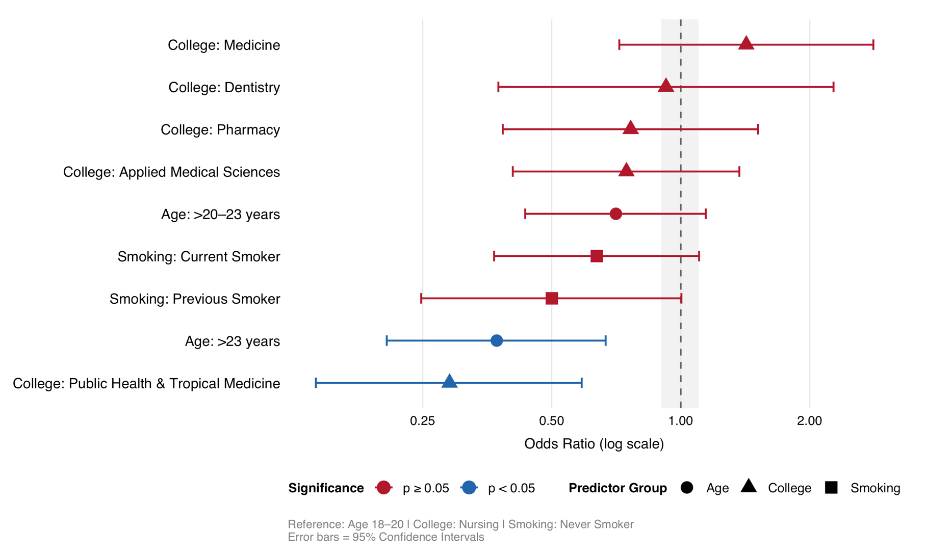
Figure 1. Adjusted Odds Ratios for Academic Performance (GPA) Among University Students
OR, Odds Ratio; CI, Confidence Interval. ORs were estimated using a cumulative link model (CLM) with logit link. Reference categories: Age, 18–20 years; College, Nursing; Smoking, Never Smoker. Blue points indicate statistically significant associations (p < 0.05); red points indicate non-significant associations. Error bars represent 95% CIs

