Total Hip Arthroplasty in Patients with Proximal Femoral Migration
Osama Ahmed Ibrahim
Statistical analysis: Statistical analyses were performed using R software. Continuous variables were expressed as mean ± standard deviation or median with interquartile range, depending on distribution. Categorical variables were presented as frequencies and percentages. Normality was assessed prior to analysis. Pre- and postoperative comparisons of paired continuous variables (limb length discrepancy and flexion deformity) were performed using the Wilcoxon signed-rank test. Repeated measures of Harris Hip Score across multiple time points were analyzed using one-way repeated-measures ANOVA, followed by post hoc pairwise comparisons with Bonferroni correction. Changes in categorical variables (pelvic obliquity) were assessed using McNemar’s test. A p-value < 0.05 was considered statistically significant.

Table 1. Baseline demographic and clinical characteristics of patients undergoing total hip arthroplasty
Characteristic | N = 24¹
Age | 42 ± (13)
Gender
Male | 15 (63%)
Female | 9 (38%)
Side
Right | 13 (54%)
Left | 11 (46%)
Complications | 1 (4.2%)
Acetabular reconstruction | 2 (8.3%)
¹Mean ± (SD); n (%)
Baseline characteristics:
A total of 24 patients undergoing total hip arthroplasty for proximal femoral migration were included in the study. The mean age was 42 ± 13 years, indicating a relatively young cohort. Males represented 63% of the study population, while females accounted for 37%. The right hip was more frequently affected (54%) compared to the left (46%). Postoperative complications were uncommon, occurring in 4.2% of patients, while 8.3% required acetabular reconstruction due to bone loss or migration.

Table 2. Comparison of limb length discrepancy and flexion deformity before and after total hip arthroplasty
Characteristic | Preoperative  N = 24¹ | 95% CI | Postoperative  N = 24¹ | 95% CI | p-value²
Limb Length Discrepancy | 2.75 (2.40, 3.25) | 2.6, 3.3 | 0.45 (-0.30, 0.70) | -0.15, 0.50 | <0.001
Flexion Deformity | 25 (15, 30) | 17, 28 | 5 (0, 5) | 2.6, 6.5 | <0.001
¹Median (Q1, Q3)
²Wilcoxon signed rank test with continuity correction
Abbreviation: CI = Confidence Interval
Limb length discrepancy and flexion deformity There was a statistically significant improvement in both limb length discrepancy and flexion deformity following surgery. Limb length discrepancy decreased from 2.75 (2.40–3.25) preoperatively to 0.45 (-0.30–0.70) postoperatively (p < 0.001). Similarly, flexion deformity improved significantly from 25° (15–30°) preoperatively to 5° (0–5°) postoperatively (p < 0.001), demonstrating effective correction of anatomical deformities after THA.

Table 3. Longitudinal changes in Harris Hip Score following total hip arthroplasty
Outcome | Preoperative  N = 24¹ | Post 6 weeks  N = 24¹ | Post 6 months  N = 24¹ | Post 1 year  N = 24¹ | p-value
HHS Score | 42 ± 6 | 77 ± 3 | 82 ± 3 | 88 ± 3 | <0.001
¹Mean ± SD
Functional outcomes (Harris Hip Score):
The Harris Hip Score showed a significant and sustained improvement over time (p < 0.001). The mean score increased from 42 ± 6 preoperatively to 77 ± 3 at 6 weeks, 82 ± 3 at 6 months, and 88 ± 3 at 1 year postoperatively. The greatest improvement was observed in the early postoperative period, followed by continued but smaller gains over time, indicating progressive functional recovery.
Pairwise comparisons of Harris Hip Score demonstrated statistically significant differences between all time points (adjusted p < 0.001 for all comparisons). The most substantial improvement occurred between the preoperative period and 6 weeks postoperatively, while continued significant gains were observed between 6 weeks and 6 months, as well as between 6 months and 1 year.

Table 4. Pairwise comparisons of Harris Hip Score across follow-up time points
Harris Hip Score Pairwise Comparison | Adjusted p-value
Preoperative vs Post 6 weeks | <0.001
Preoperative vs Post 6 months | <0.001
Preoperative vs Post 1 year | <0.001
Post 6 weeks vs Post 6 months | <0.001
Post 6 weeks vs Post 1 year | <0.001
Post 6 months vs Post 1 year | <0.001

Table 5. Changes in pelvic obliquity before and after total hip arthroplasty
Characteristic | Postoperative  N = 24¹ | Preoperative  N = 24¹ | p-value²
Pelvic Obliquity |  |  | 0.008
No | 23 (96%) | 14 (58%)
Yes | 1 (4.2%) | 10 (42%)
¹n (%)
²McNemar's Chi-squared test with continuity correction
Pelvic obliquity:
Pelvic obliquity improved significantly following surgery (p = 0.008). The proportion of patients without pelvic obliquity increased from 58% preoperatively to 96% postoperatively, while those with persistent pelvic obliquity decreased from 42% to 4.2%, indicating effective coronal plane realignment after THA.

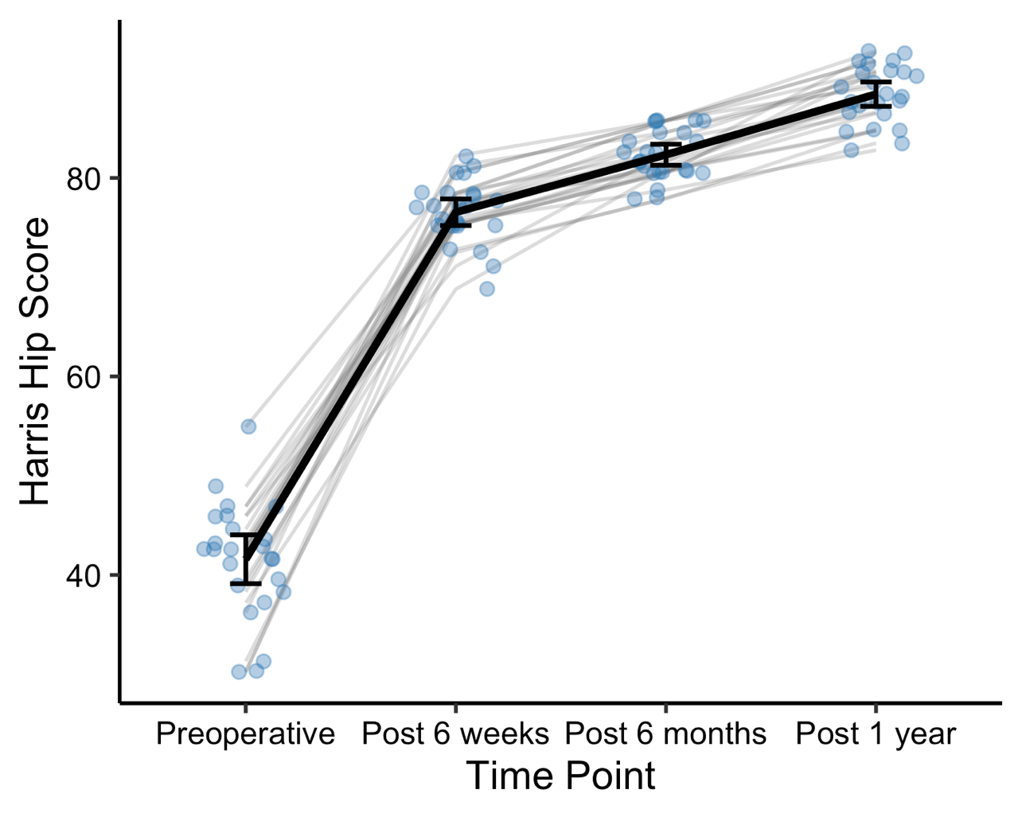
Figure 1. Longitudinal changes in Harris Hip Score following total hip arthroplasty
Individual patient trajectories are shown in gray. The black line represents the mean Harris Hip Score over time. Error bars indicate 95% confidence intervals.

