ISSP Block Efficacy Report
Osama Ahmed Ibrahim
R version 4.5.1 (2025-06-13) was used to conduct the analysis. Visual Inspection and Shapiro-Wilk test were performed to assess normality of data to determine the appropriate statistical tests. Data not normally distributed was presented by a median and interquartile range, and Mann-Whitney U test was used to compare between groups of data not normally distributed. Categorical data were presenetd with frequencies and an appropriate Chi-squared test or Fisher exact test was used for the comparison. Time to first pethidine administration was evaluated using Kaplan–Meier survival curves and compared between groups with the log‑rank test. P value <0.05 was considered statis- tically significant.

Results
44 patients were enrolled in the study. Table 1 represents different patients’ demographics.

Table 1
Characteristic | Control group  N = 22¹ | ISSP Block group  N = 22¹ | p-value²
Age | 54 (49, 58) | 54 (44, 61) | 0.9
Weight(Kg) | 88 (79, 98) | 82 (72, 90) | 0.026
Hight | 164.0 (162.0, 167.0) | 163.5 (159.0, 169.0) | 0.9
Sex |  |  | 0.8
Female | 8 (36%) | 7 (32%)
Male | 14 (64%) | 15 (68%)
¹Median (Q1, Q3); n (%)
²Wilcoxon rank sum test; Pearson's Chi-squared test
4 patients in the ISP group required postoperative rescue pethidine compared to 14 patients in control group (P = 0.002). The median (quartiles) of total postoperative rescue pethidine consumption was significantly lower in the ISP group [0 (0–0 mg)] compared to that of the control group [85 (0–100 mg)]; P < 0.003). (Table 2). The median (quartiles) of intraoperative fentanyl consumption in the ISP group [100 (100–100) μg] was significantly lower compared to that of the control group [100 (100–150 μg); P = 0.044].(Table 2) Risk ratio for the need of postoperative pethidine in ISSP group compared to control is 0.29(0.11 , 0.73) indicating the significant protective effect.

Table 2
Characteristic | Control group  N = 14¹ | ISSP Block group  N = 4¹ | p-value²
Needed of Pethidine Post Operative
1 | 14 (100%) | 4 (100%)
Time of Pethidine Post Operative (min) | 60 (30, 60) | 180 (75, 360) | 0.12
First Dose of Pethidine Post Operative (mg) | 30 (30, 40) | 30 (30, 35) | 0.8
Total of Pethidine Consumed Post Operative (mg) | 100 (90, 100) | 95 (75, 110) | 0.7
Intraoperative Fentanyl Consumption (microgram) | 100 (100, 100) | 100 (100, 100) | 0.4
¹n (%); Median (Q1, Q3)
²NA; Wilcoxon rank sum test
The ISSP Block group demonstrated lower median pain scores at multiple postoperative time points, with statistically significant differences at 1 hour (3.50 vs 4.00, p=0.025), 8 hours (3.00 vs 4.00, p=0.007), and 12 hours (4.00 vs 5.00, p=0.009) post-surgery. However, after applying Bonferroni correction for multiple comparisons, none of these differences reached statistical significance (all q-values >0.05), suggesting that while the ISSP block showed a trend toward reduced pain in the early-to-mid postoperative period, the evidence was insufficient to confirm a definitive analgesic benefit at individual time points.(Table 3)

Table 3
Characteristic | Control group  N = 22¹ | ISSP Block group  N = 22¹ | p-value² | q-value³
Pre opr VAS score | 4.50 (4.00, 6.00) | 5.00 (4.00, 6.00) | 0.7 | >0.9
30 min post opt VAS | 4.00 (3.00, 5.00) | 3.00 (2.00, 5.00) | 0.2 | >0.9
1 h post opt VAS | 4.00 (3.00, 6.00) | 3.50 (2.00, 4.00) | 0.025 | 0.3
2h post opt VAS | 4.00 (2.00, 4.00) | 3.50 (3.00, 6.00) | 0.7 | >0.9
4 h post opt VAS | 4.00 (3.00, 5.00) | 4.00 (3.00, 4.00) | 0.5 | >0.9
6h post opt VAS | 4.00 (3.00, 5.00) | 4.00 (2.00, 5.00) | 0.4 | >0.9
8h post opt VAS | 4.00 (3.00, 5.00) | 3.00 (2.00, 4.00) | 0.007 | 0.087
12h post opt VAS | 5.00 (4.00, 6.00) | 4.00 (2.00, 5.00) | 0.009 | 0.11
18h post opt VAS | 4.00 (3.00, 5.00) | 4.00 (2.00, 5.00) | 0.5 | >0.9
24h post opt VAS | 5.00 (4.00, 5.00) | 4.00 (2.00, 5.00) | 0.14 | >0.9
36h post opt VAS | 5.00 (4.00, 5.00) | 5.00 (3.00, 6.00) | >0.9 | >0.9
48h post opt VAS | 5.00 (4.00, 6.00) | 4.00 (4.00, 5.00) | 0.061 | 0.7
¹Median (Q1, Q3)
²Wilcoxon rank sum test
³Bonferroni correction for multiple testing
Fig.1 shows visual analogue scale of pain nbetween groups at different time points.

Visual Analogue Scale of Pain between Groups at Different Time Points
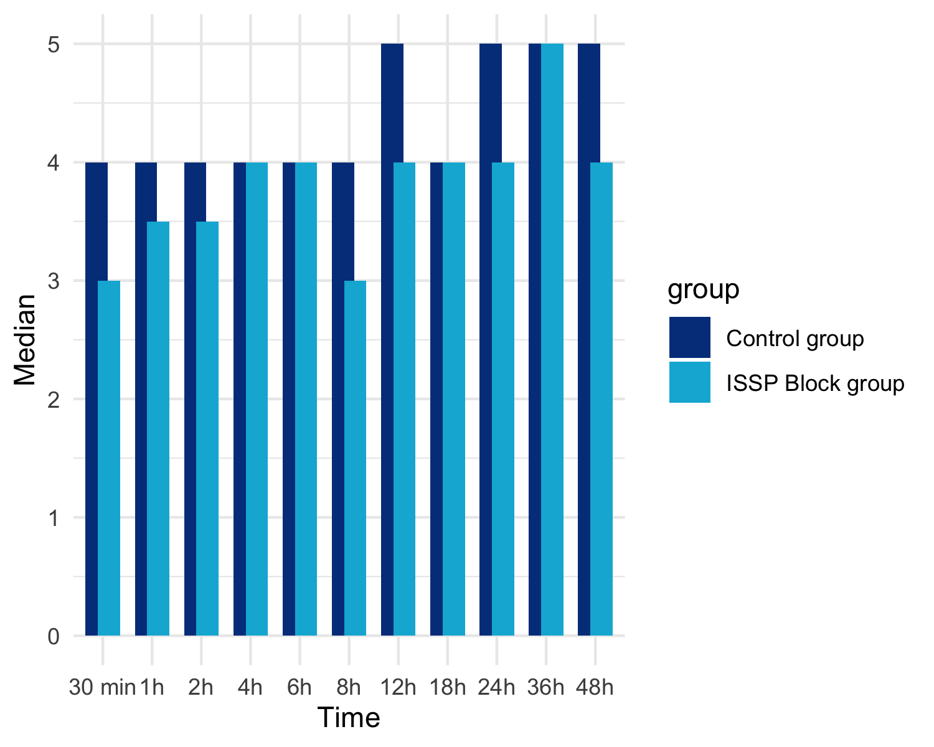
Fig. 2 shows the Kaplan–Meier curve for the time till first pethidine administration post operative. The median of time to first rescue pethidine administration was significantly longer in ISSP group (p = 0.0013).

Kaplan–Meier curve for the time till first pethidine administration post operative
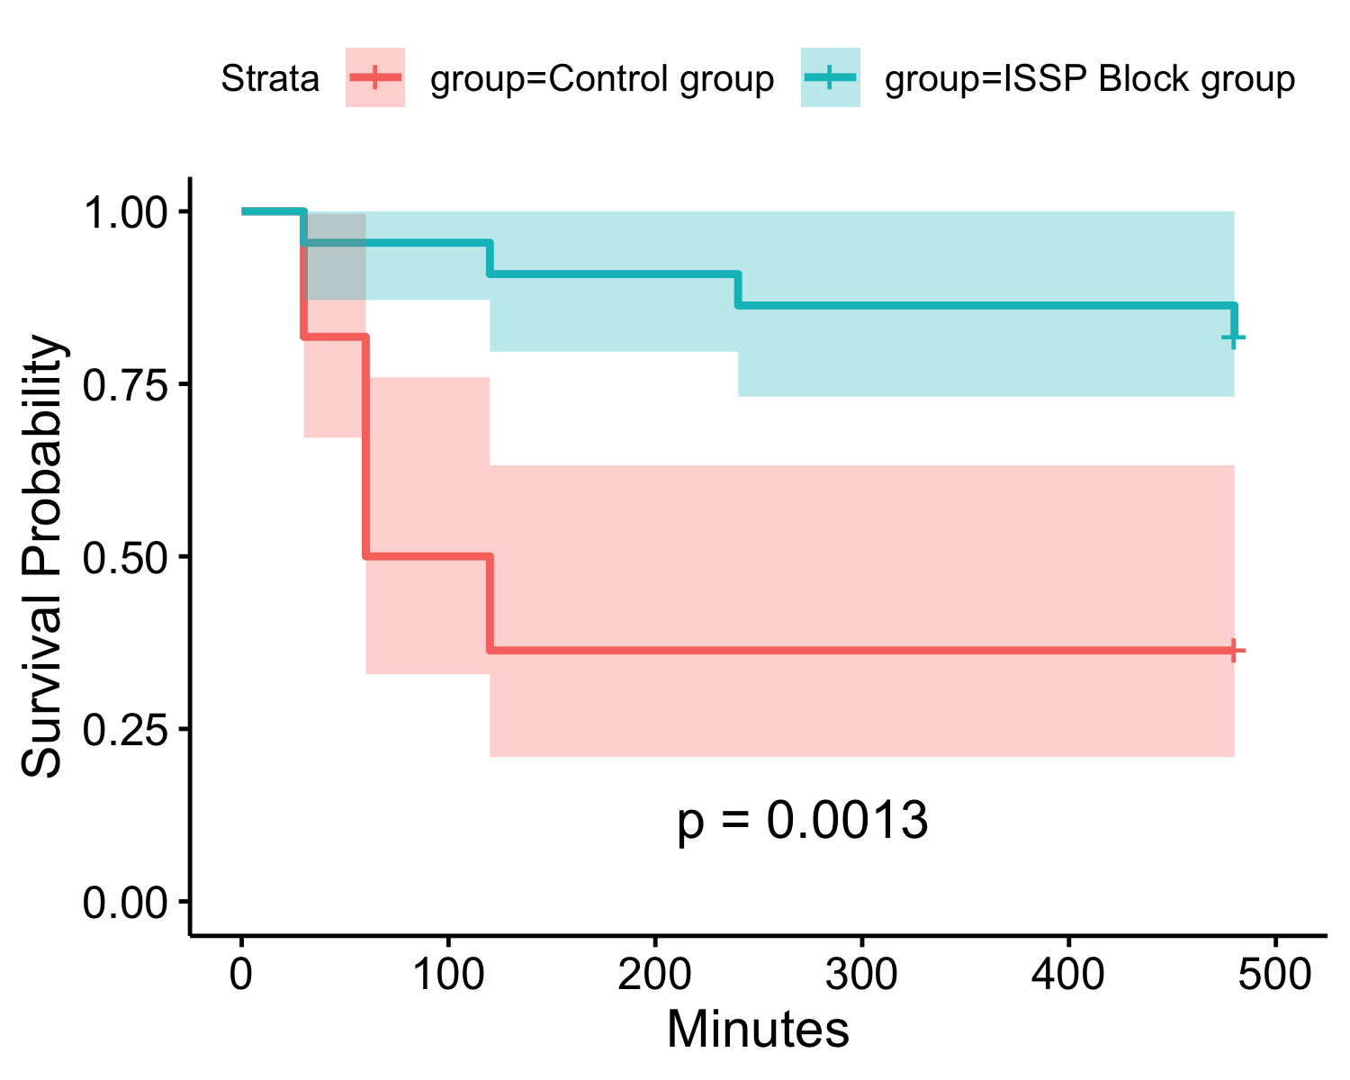
No significant difference in any of the adverse events or complications was detected in the studied groups.(Table 3)

Table 3
Characteristic | Control group  N = 22¹ | ISSP Block group  N = 22¹ | p-value²
Nausea | 1 (4.5%) | 1 (4.5%) | >0.9
Vomiting | 0 (0%) | 2 (9.1%) | 0.5
Pruritis | 0 (0%) | 1 (4.5%) | >0.9
Any ADRs | 1 (4.5%) | 4 (18%) | 0.3
¹n (%)
²Fisher's exact test
No significant difference in patient satisfaction between ISSP group and control group p(0.12).(Table 4)

Table 4
Characteristic | Control group  N = 22¹ | ISSP Block group  N = 22¹ | p-value²
patient satisification |  |  | 0.13
dissatisfied | 7 (32%) | 5 (23%)
fair | 12 (55%) | 8 (36%)
satisfied | 3 (14%) | 9 (41%)
¹n (%)
²Pearson's Chi-squared test

