Success of Medical Management of Tubal Ectopic Pregnancy with Methotrexate
Osama Ahmed Ibrahim

Statistical Analysis
Data was cleaned and coded using RStudio software version 2026.1.1.403 for analysis with R version 4.5.1 (2025-06-13). Descriptive statistics were reported as median (interquartile range, Q1–Q3) for continuous variables and as frequency (percentage) for categorical variables. Univariable logistic regression was performed to evaluate the association of each candidate predictor with methotrexate treatment outcome, reported as unadjusted odds ratios (OR) with 95% confidence intervals (CI). Two multivariable logistic regression models were subsequently constructed. Nested model comparison was performed using the likelihood ratio test via analysis of deviance (χ² test). Model calibration was assessed using the Hosmer–Lemeshow goodness-of-fit test, where a non-significant p-value (> 0.05) indicated adequate calibration. Model fit was further quantified using McFadden’s, Nagelkerke’s, and Cox–Snell pseudo-R² statistics. Discrimination was assessed by the area under the receiver operating characteristic curve (AUC) with 95% CI, and the two models were formally compared using DeLong’s test for correlated ROC curves. Multicollinearity was assessed using the variance inflation factor (VIF), with values < 5 considered acceptable. A clinical nomogram was constructed from the final model using the rms package to enable individual patient probability estimation. A two-tailed p-value < 0.05 was considered statistically significant.

Results

Study Population
A total of 121 women with tubal ectopic pregnancy who received methotrexate were included. The median age was 35 years (IQR: 30–39) and the median BMI was 28.5 kg/m² (IQR: 26.5–30.8). The median gestational age at treatment was 6.20 weeks (IQR: 5.50–7.00), and the median serum b-HCG level was 2,569 mIU/mL (IQR: 1,187–4,560). Free fluid was detected in 17 patients (14%). The median ectopic mass diameter was 2.60 cm (IQR: 1.70–3.50). Baseline characteristics are summarized in Table 1.

Table 1. Baseline characteristics of patients with tubal ectopic pregnancy managed with methotrexate
Characteristic¹ | N = 121²
Age | 35 (30, 39)
Weight | 74 (65, 82)
Height | 1.60 (1.56, 1.65)
BMI | 28.5 (26.5, 30.8)
Gravity | 3.00 (2.00, 4.00)
Parity | 2.00 (0.00, 3.00)
Abortion | 0.00 (0.00, 1.00)
Gestational Age (Weeks) | 6.20 (5.50, 7.00)
b-HCG (mIU/mL) | 2,569 (1,187, 4,560)
Free Fluid | 17 (14%)
Ectopic mass diameter (cm) | 2.60 (1.70, 3.50)
Outcome
Failure | 22 (18%)
Success | 99 (82%)
Number of Doses
One | 81 (67%)
Two | 29 (24%)
Multiple | 11 (9.1%)
¹Abbreviations: BMI = body mass index; b-HCG = beta human chorionic gonadotropin.
²Median (Q1, Q3); n (%)

Treatment Outcome
Methotrexate treatment was successful in 99 patients (82%), while treatment failed in 22 patients (18%). Among those who succeeded, 81 patients (67%) required a single dose, 29 (24%) required two doses, and 11 (9.1%) required multiple doses.
Univariable logistic regression identified several candidate predictors of methotrexate failure. On multivariable analysis, both models demonstrated adequate fit. The likelihood ratio test comparing Model 1 (BMI, gestational age, b-HCG, free fluid) to Model 2 (BMI, b-HCG, free fluid) showed no statistically significant difference in model deviance (χ² = −0.233, df = 1, p = 0.630), indicating that gestational age did not contribute meaningfully beyond the other predictors. The adjusted odds ratios for both models are presented in Table 2.

Table 2. Univariable and multivariable logistic regression analysis of predictors of methotrexate treatment failure.
 | Unadjusted |  |  | Model 1² |  |  | Model 2³
Characteristic | OR¹ | 95% CI | p-value | OR¹ | 95% CI | p-value | OR¹ | 95% CI | p-value
Age | 0.96 | 0.88, 1.04 | 0.3
BMI | 0.86 | 0.77, 0.94 | 0.003 | 0.80 | 0.70, 0.91 | 0.001 | 0.80 | 0.70, 0.91 | 0.001
Gravity | 0.91 | 0.73, 1.15 | 0.4
Parity | 0.88 | 0.66, 1.19 | 0.4
Abortion | 0.82 | 0.50, 1.43 | 0.5
Gestational Age (Weeks) | 0.69 | 0.45, 0.96 | 0.043 | 0.87 | 0.54, 1.58 | 0.6
b-HCG (mIU/mL) | 1.00 | 1.00, 1.00 | <0.001
Free Fluid⁴
No | — | — |  | — | — |  | — | —
Yes | 0.04 | 0.01, 0.14 | <0.001 | 0.04 | 0.01, 0.18 | <0.001 | 0.04 | 0.01, 0.16 | <0.001
Ectopic mass diameter (cm) | 1.02 | 0.80, 1.45 | 0.9
BHCG |  |  |  | 1.00 | 1.00, 1.00 | 0.007 | 1.00 | 1.00, 1.00 | 0.006
¹OR = odds ratio; CI = confidence interval. Exponentiated logistic regression coefficients.
²Model 1: BMI + gestational age + b-HCG + free fluid
³Model 2: BMI + b-HCG + free fluid
⁴Binary variable: Yes = free fluid present on ultrasound
Abbreviations: CI = Confidence Interval, OR = Odds Ratio

Model Performance
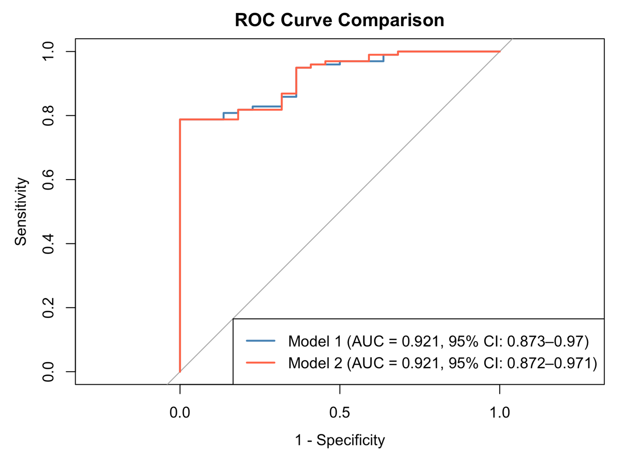
The Hosmer–Lemeshow test for Model 2 yielded a non-significant result (χ² = 11.40, df = 8, p = 0.180), indicating good calibration between observed and predicted outcomes. Pseudo-R² statistics for Model 2 were: McFadden = 0.407, Nagelkerke = 0.523, and Cox–Snell = 0.320, collectively indicating excellent model fit. Both Model 1 and Model 2 achieved identical discrimination, with an AUC of 0.921 (95% CI reported in Figure 2). DeLong’s test confirmed no significant difference in discriminative performance between the two models (Z = 0, p = 1.000). All VIF values for Model 1 were below 1.20 (BMI = 1.19, gestational age = 1.05, b-HCG = 1.09, free fluid = 1.17), confirming the absence of multicollinearity.

Figure 1. Receiver operating characteristic (ROC) curves for Model 1 and Model 2 predicting methotrexate treatment success.
The area under the curve (AUC) with 95% confidence interval is shown in the legend for each model. DeLong's test for correlated ROC curves: Z = 0, p = 1.000. Model 1: BMI + gestational age + b-HCG + free fluid (AUC = 0.921). Model 2: BMI + b-HCG + free fluid (AUC = 0.921).
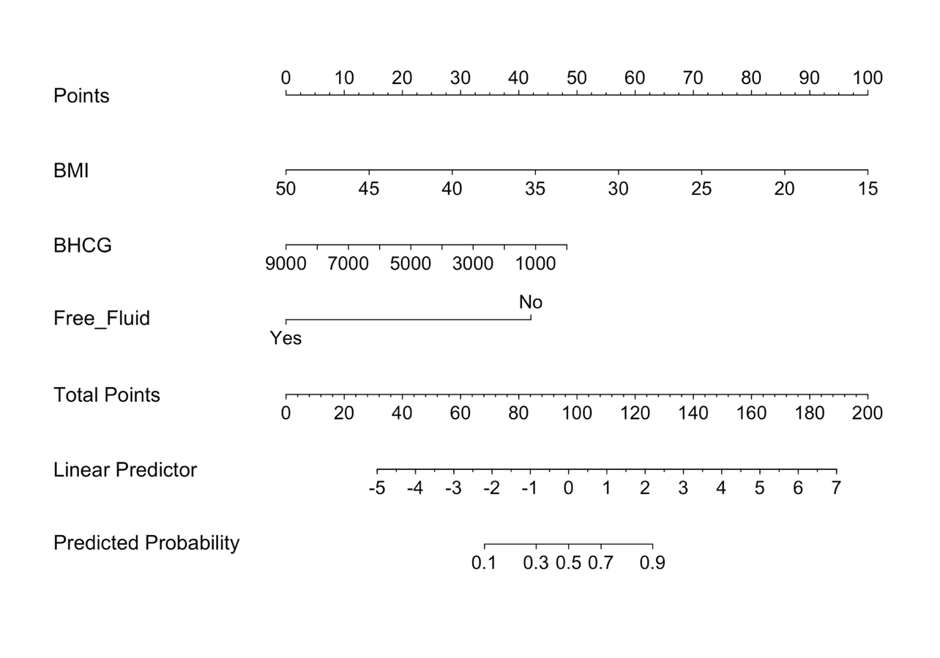

Figure 2. Nomogram for individualized prediction of methotrexate treatment success in tubal ectopic pregnancy.
Footnote: To use the nomogram, locate the patient's value on each predictor axis (BMI, b-HCG, free fluid), draw a vertical line upward to the Points axis, and sum the individual points to obtain the Total Points score. The Total Points value maps to the Predicted Probability of treatment success on the bottom axis. BMI = body mass index; b-HCG = beta human chorionic gonadotropin.

