Laser Therapy in Lumbar Disc Herniation Report
Osama Ahmed Ibrahim
R version 4.5.1 (2025-06-13) was used to conduct the analysis. Visual Inspection and Shapiro-Wilk test were performed to assess normality of data to determine the appropriate statistical tests. Data not normally distributed was presented by median and interquartile range. Mann-Whitney U test and Kruskal-Wallis test were used to compare between groups of data not normally distributed. Categorical data were presenetd with frequencies and an appropriate Chi-squared test or Fisher exact test was used for the comparison. Significant differences were determined by Bonferroni post hoc tests. P value <0.05 was considered statistically significant.

Results
60 patients were enrolled in the study. Table 1 represents different patients’ demographics.

Table 1: Demographics and Patients Characteristics
Characteristic | Overall  N = 60¹ | High Intensity  N = 20¹ | Low Intensity  N = 20¹ | Placebo  N = 20¹ | p-value²
Gender |  |  |  |  | >0.9
Female | 24 (40%) | 8 (40%) | 8 (40%) | 8 (40%)
Male | 36 (60%) | 12 (60%) | 12 (60%) | 12 (60%)
Age | 41 (32, 51) | 38 (31, 49) | 41 (33, 50) | 42 (31, 53) | 0.8
BMI | 26.0 (25.0, 29.0) | 26.5 (24.0, 31.5) | 26.0 (24.0, 27.5) | 28.5 (25.0, 30.0) | 0.2
Marital Status |  |  |  |  | >0.9
Married | 52 (87%) | 17 (85%) | 17 (85%) | 18 (90%)
Single | 8 (13%) | 3 (15%) | 3 (15%) | 2 (10%)
Roland Morris Disability Questionnaire | 15.0 (13.0, 16.0) | 15.0 (14.0, 16.5) | 14.5 (12.0, 16.0) | 14.5 (13.0, 16.5) | 0.8
Schober Test | 16 (15, 16) | 16 (15, 16) | 16 (15, 17) | 16 (15, 16) | 0.8
Oswestry Disability Index | 0.66 (0.56, 0.71) | 0.66 (0.60, 0.70) | 0.62 (0.53, 0.71) | 0.64 (0.56, 0.72) | 0.8
VAS Rest | 6.0 (6.0, 7.0) | 7.0 (6.0, 7.5) | 6.0 (5.0, 7.0) | 6.0 (5.5, 7.0) | 0.076
VAS Activity | 8 (7, 9) | 9 (8, 9) | 8 (7, 9) | 8 (7, 9) | 0.4
¹n (%); Median (Q1, Q3)
²Pearson's Chi-squared test; Kruskal-Wallis rank sum test; Fisher's exact test
All three groups demonstrated significant improvements from baseline to post-intervention across all outcome measures (p<0.001). All within-group comparisons remained significant after Bonferroni correction for multiple testing (q<0.01). (Table 2)

Table 2: Within-group changes in patient-reported outcomes and pain scores from baseline to post-intervention
 | High Intensity |  |  | Low Intensity |  |  | Placebo
Characteristic | Before  N = 20¹ | After  N = 20¹ | p-value² | Before  N = 20¹ | After  N = 20¹ | p-value² | Before  N = 20¹ | After  N = 20¹ | p-value²
RMDQ | 15.0 (14.0, 16.5) | 4.0 (3.0, 9.0) | <0.001 | 14.5 (12.0, 16.0) | 7.0 (3.5, 10.5) | <0.001 | 14.5 (13.0, 16.5) | 10.0 (5.0, 13.5) | <0.001
ST | 16.0 (15.0, 16.0) | 19.0 (17.5, 19.5) | 0.001 | 16.0 (15.0, 17.0) | 18.0 (16.5, 18.5) | <0.001 | 16.0 (15.0, 16.0) | 17.0 (16.0, 18.0) | 0.002
OSW | 0.66 (0.60, 0.70) | 0.15 (0.08, 0.51) | <0.001 | 0.62 (0.53, 0.71) | 0.38 (0.21, 0.55) | <0.001 | 0.64 (0.56, 0.72) | 0.53 (0.23, 0.64) | 0.001
VAS-Rest | 7.0 (6.0, 7.5) | 0.0 (0.0, 4.0) | <0.001 | 6.0 (5.0, 7.0) | 3.0 (0.0, 5.0) | 0.001 | 6.0 (5.5, 7.0) | 5.0 (1.5, 5.5) | 0.002
VAS-Activity | 8.5 (8.0, 9.0) | 1.0 (1.0, 6.0) | <0.001 | 8.0 (7.0, 9.0) | 3.5 (2.0, 5.5) | 0.001 | 8.0 (7.0, 9.0) | 5.5 (2.0, 8.0) | 0.002
¹Median (Q1, Q3)
²Wilcoxon signed rank test with Bonferroni correction for multiple testing
Between-group comparisons of change scores revealed significant differences across all outcome measures. The High Intensity group demonstrated significantly greater improvements compared to the other groups, with a median RMDQ reduction of -10.0 points, ST increase of 3.00, OSW decrease of -0.41, and VAS-Activity and VAS-Rest reductions of -7.00 and -6.00, respectively. Group differences were statistically significant for RMDQ, OSW, VAS-Activity, and VAS-Rest (p≤0.003), with most remaining significant after Bonferroni correction ( Table 3 )

Table 3: Between-group change scores and pairwise comparisons Kruskal–Wallis with Bonferroni-adjusted post hoc tests.
Characteristic | High Intensity  N = 20¹ | Low Intensity  N = 20¹ | Placebo  N = 20¹ | p-value² | High Intensity vs. Low Intensity | High Intensity vs. Placebo | Low Intensity vs. Placebo
RMDQ Change | -10.0 (-11.0, -6.5) | -8.0 (-9.0, -4.0) | -3.5 (-9.0, -2.0) | 0.003 | 0.032 | <0.001 | 0.4
ST Change | 3.00 (1.00, 4.00) | 2.00 (1.00, 2.00) | 1.00 (1.00, 2.00) | 0.090 | 0.14 | 0.033 | 0.7
OSW Change | -0.41 (-0.55, -0.17) | -0.28 (-0.39, -0.11) | -0.15 (-0.34, -0.07) | 0.011 | 0.045 | 0.003 | 0.7
VAS Activity Change | -7.00 (-8.00, -2.00) | -4.50 (-6.00, -1.00) | -1.00 (-5.50, -1.00) | 0.006 | 0.032 | 0.002 | 0.5
VAS Rest Change | -6.00 (-7.00, -2.50) | -3.00 (-5.00, -1.50) | -1.50 (-4.00, -1.00) | 0.013 | 0.061 | 0.004 | 0.4
¹Median (Q1, Q3)
²Kruskal-Wallis rank sum test with Bonferroni correction for multiple testing
Post hoc pairwise comparisons with Bonferroni correction revealed that the High Intensity group achieved significantly greater improvements than the Placebo group across all outcome measures (RMDQ: p.adj<0.001; OSW: p.adj=0.003; ST: p.adj=0.033; VAS-Activity: p.adj=0.002; VAS-Rest: p.adj=0.004). The High Intensity group also demonstrated significantly superior outcomes compared to the Low Intensity group for RMDQ (p.adj=0.032), OSW (p.adj=0.045), and VAS-Activity (p.adj=0.032), though differences in ST and VAS-Rest did not reach significance after correction (p.adj=0.138 and 0.061, respectively). In contrast, the Low Intensity group did not differ significantly from the Placebo group on any outcome measure after Bonferroni correction (all p.adj>0.42), suggesting that low-intensity intervention provided minimal additional benefit beyond placebo effects.
Figure 1 and 2 illustrates the median and IQR values of all outcome measures before and after intervention for the High Intensity, Low Intensity, and Placebo groups. All three groups showed improvements across disability scores. The visual representation highlights the dose-dependent relationship between intervention intensity and clinical outcomes, with greater improvements observed in functional capacity and pain reduction as intervention intensity increased.

Figure 1: Faceted median line plot (IQR error bars) of pre–post outcomes by treatment group
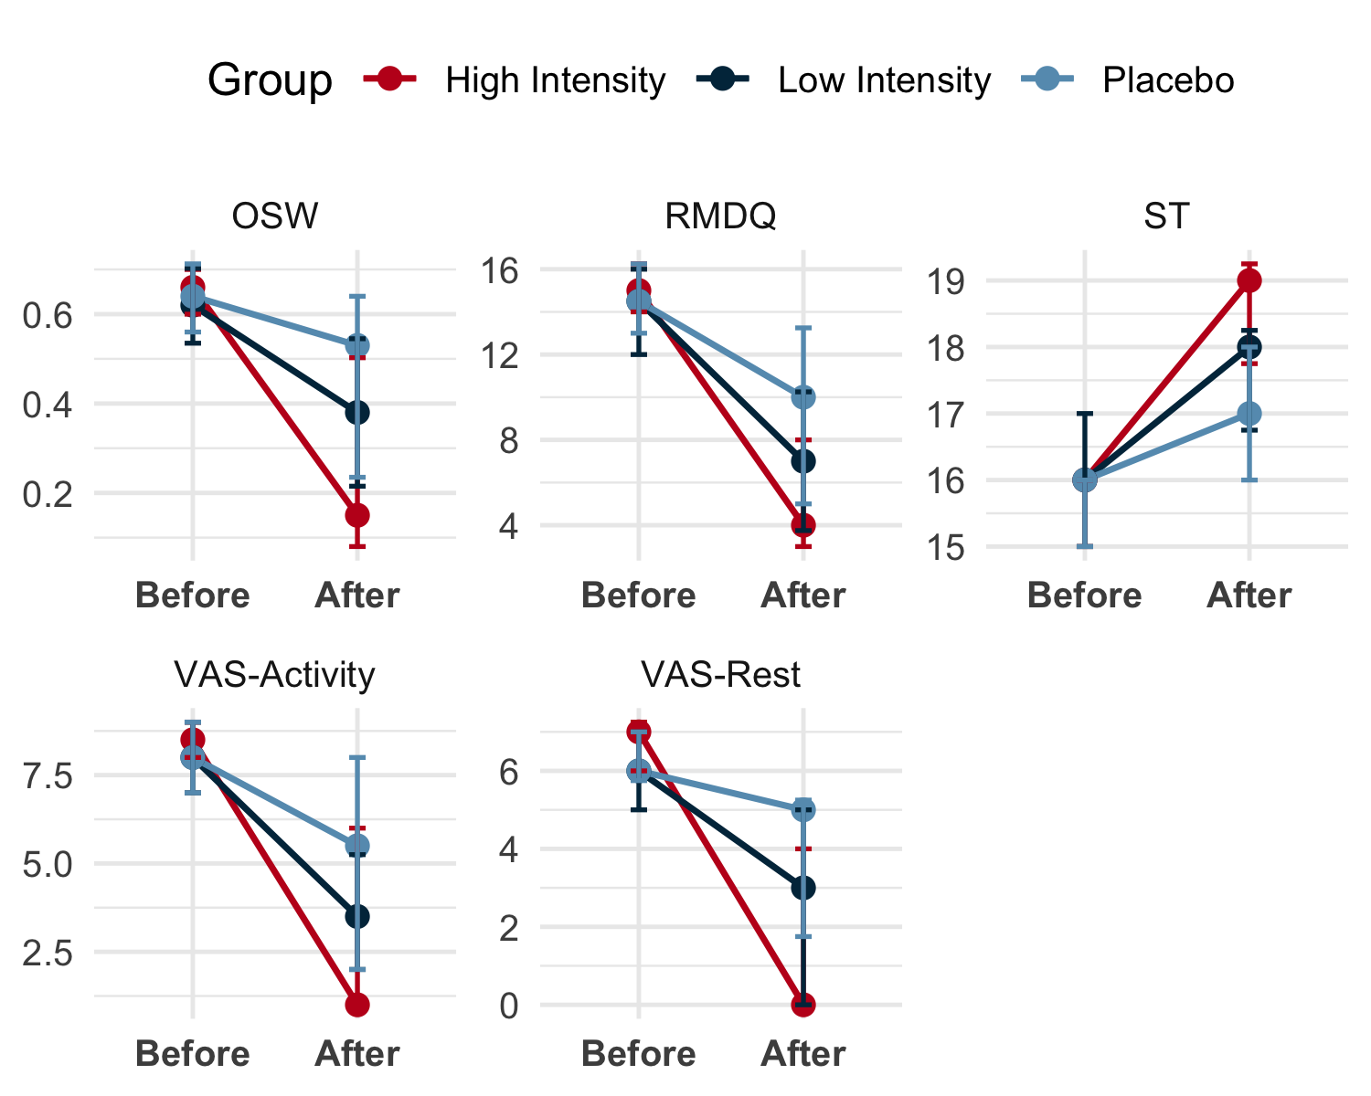

Figure 2: Comparison of Pre- and Post-Intervention Outcome Measures Across Treatment Groups
