Post Bariatric Surgery Depression Prevalence and Risk Factors
Osama Ahmed Abd El-Basset Ibrahim
R version 4.5.1 (2025-06-13) was used to conduct the analysis. Descriptive statistics, including medians, inter-quartile ranges, and frequencies, were calculated to summarize the characteristics of the study population. A p-value of less than 0.05 was considered statistically significant. Additionally, logistic regression analysis was done to examine the impact of various factors on the likelihood of experiencing depression.

Results
A total of 186 post-bariatric surgery patients were included in this study. The sample was predominantly female (66%) with a median age of 37 years (IQR: 29–44). The majority were married (61%) and held a bachelor’s degree (51%), while 30% had a high school education or less. The median preoperative BMI was 46 kg/m² (IQR: 41–53), and restrictive procedures accounted for the vast majority of surgeries (84%). Regarding comorbidities, hypertension was the most prevalent condition (18%), followed by diabetes and high cholesterol (12% each), with 10% of patients reporting post-surgical complications and only 4.8% having visited a psychiatrist prior to surgery.

Table 1: Sociodemographic profile of the study participants
Characteristic | N = 186¹
Age | 37 (29, 44)
Gender
Female | 123 (66%)
Male | 63 (34%)
Maraital Status
Single | 47 (25%)
Married | 113 (61%)
Divorced | 18 (9.7%)
Widow | 8 (4.3%)
BMI PreOp | 46 (41, 53)
Educational Level
High School Or Less | 55 (30%)
Diploma | 23 (12%)
Bachelor Degree | 95 (51%)
Masters Or PhD | 13 (7.0%)
Hypertension | 34 (18%)
Diabetes | 23 (12%)
Heart Disease | 9 (4.8%)
Asthma | 13 (7.0%)
High Cholesterol | 22 (12%)
Other Comorbidities | 13 (7.0%)
Surgery_Type
Malabsorptive or Mixed | 29 (16%)
Restrictive | 157 (84%)
Date since operation
< 1 year | 62 (33%)
1 - 2 years | 41 (22%)
> 2 - 3 years | 44 (24%)
> 3 years | 39 (21%)
Post Surgical Complications | 19 (10%)
Visiting Psychiatric Pre-Operation | 9 (4.8%)
¹Median (Q1, Q3); n (%)
Assessment of depressive sypmtoms using the PHQ-9 revealed a median total score of 5.0 (IQR: 2.0–9.0) across the sample. Fatigue and appetite disturbance were the most frequently endorsed symptoms, with 85% and 83% of patients reporting tiredness and appetite changes on at least several days, respectively. Sleep disturbance was also notable, with 22% of patients experiencing it nearly every day. In contrast, psychomotor symptoms and suicidal ideation were the least commonly reported, with 69% and 83% of patients denying psychomotor changes and thoughts of self-harm entirely, respectively — though 14% did endorse suicidal ideation at some frequency. Core depressive symptoms of anhedonia and depressed mood were reported on at least several days by 60% and 66% of patients, respectively.

Figure 1: Distributionn of depression severity postbariatric surgery
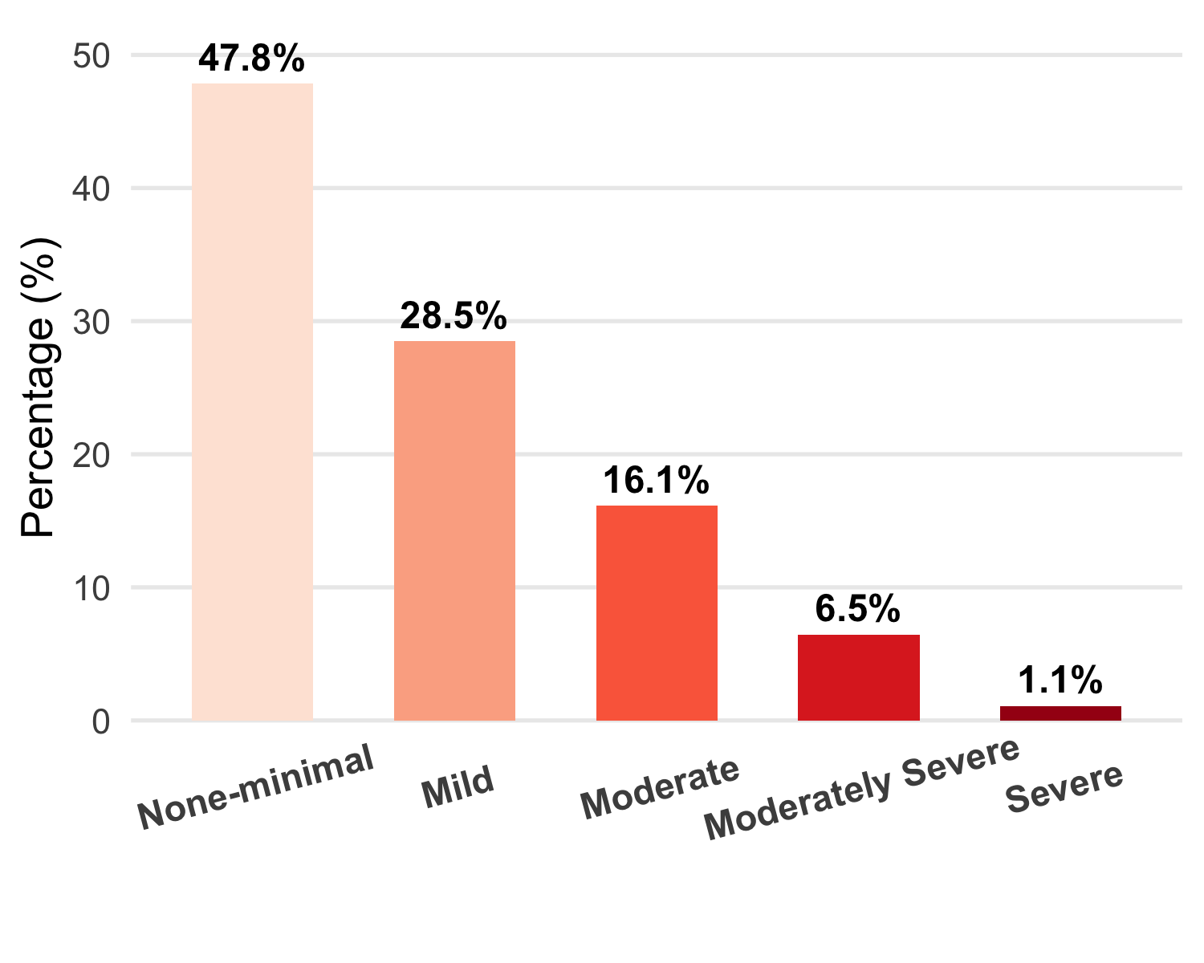

Table 2: Participants assessment of depression after bariatric surgery based on Patient Health Questionnaire-9 survey
Characteristic | N = 186¹
Little interest or pleasure in doing things
Not at all | 74 (40%)
Several days | 90 (48%)
More than half days | 9 (4.8%)
Nearly everyday | 13 (7.0%)
Feeling down, depressed, or hopeless
Not at all | 63 (34%)
Several days | 88 (47%)
More than half days | 12 (6.5%)
Nearly everyday | 23 (12%)
Trouble falling or staying asleep, or sleeping too much
Not at all | 66 (35%)
Several days | 68 (37%)
More than half days | 12 (6.5%)
Nearly everyday | 40 (22%)
Feeling tired or having little energy
Not at all | 27 (15%)
Several days | 106 (57%)
More than half days | 18 (9.7%)
Nearly everyday | 35 (19%)
Poor appetite or overeating
Not at all | 32 (17%)
Several days | 109 (59%)
More than half days | 17 (9.1%)
Nearly everyday | 28 (15%)
Feeling bad about yourself — or that you are a failure or have let yourself or your family down
Not at all | 115 (62%)
Several days | 49 (26%)
More than half days | 8 (4.3%)
Nearly everyday | 14 (7.5%)
Trouble concentrating on things, such as reading the newspaper or watching television
Not at all | 107 (58%)
Several days | 58 (31%)
More than half days | 9 (4.8%)
Nearly everyday | 12 (6.5%)
Moving or speaking so slowly that other people could have noticed? Or the opposite — being so fidgety or restless that you have been moving .around a lot more than usual
Not at all | 129 (69%)
Several days | 39 (21%)
More than half days | 7 (3.8%)
Nearly everyday | 11 (5.9%)
Thoughts that you would be better off dead or of hurting yourself in some way
Not at all | 155 (83%)
Several days | 21 (11%)
More than half days | 5 (2.7%)
Nearly everyday | 5 (2.7%)
Score of PHQ-9 | 5.0 (2.0, 9.0)
¹n (%); Median (Q1, Q3)
Unadjusted and adjusted logistic regression analyses were conducted to identify predictors of depression following bariatric surgery. No statistically significant predictor was identified in either the unadjusted or adjusted models, as all 95% confidence intervals crossed the null value of 1.0.

Table 3: Logistic regression analysis: Factors associated with development of depression after bariatric surgey
 | Unadjusted |  |  | Adjusted
Characteristic | OR | 95% CI | p-value | OR | 95% CI | p-value
Age | 1.01 | 0.98, 1.05 | 0.4 | 1.02 | 0.98, 1.07 | 0.3
Gender
Female | — | — |  | — | —
Male | 0.76 | 0.35, 1.59 | 0.5 | 1.18 | 0.47, 2.93 | 0.7
Maraital Status
Single | — | — |  | — | —
Married | 0.79 | 0.35, 1.85 | 0.6 | 0.57 | 0.19, 1.69 | 0.3
Divorced | 1.64 | 0.48, 5.33 | 0.4 | 0.94 | 0.21, 4.01 | >0.9
Widow | 1.09 | 0.15, 5.57 | >0.9 | 0.29 | 0.02, 2.52 | 0.3
Educational Level
High School Or Less | — | — |  | — | —
Diploma | 0.68 | 0.20, 2.04 | 0.5 | 0.66 | 0.17, 2.32 | 0.5
Bachelor Degree | 0.57 | 0.26, 1.25 | 0.2 | 0.42 | 0.17, 1.03 | 0.057
Masters Or PhD | 0.44 | 0.06, 1.90 | 0.3 | 0.26 | 0.03, 1.49 | 0.2
Hypertension | 1.11 | 0.44, 2.59 | 0.8 | 1.69 | 0.48, 5.75 | 0.4
Diabetes | 0.72 | 0.20, 2.05 | 0.6 | 0.39 | 0.08, 1.57 | 0.2
Heart Disease | 0.43 | 0.02, 2.43 | 0.4 | 0.25 | 0.01, 1.91 | 0.2
Asthma | 0.62 | 0.09, 2.45 | 0.6 | 0.51 | 0.07, 2.36 | 0.4
Other Comorbidities | 1.07 | 0.23, 3.69 | >0.9 | 1.03 | 0.19, 4.44 | >0.9
High Cholesterol | 0.52 | 0.12, 1.64 | 0.3 | 0.44 | 0.08, 1.96 | 0.3
BMI PreOp | 0.98 | 0.94, 1.02 | 0.3 | 0.98 | 0.93, 1.03 | 0.5
Type of Surgery
Malabsorptive or Mixed | — | —
Restrictive | 1.43 | 0.54, 4.48 | 0.5
Date since operation
< 1 year | — | — |  | — | —
1 - 2 years | 1.68 | 0.62, 4.54 | 0.3 | 2.88 | 0.91, 9.37 | 0.073
> 2 - 3 years | 1.73 | 0.66, 4.60 | 0.3 | 3.28 | 1.03, 11.0 | 0.047
> 3 years | 1.79 | 0.66, 4.87 | 0.2 | 2.55 | 0.82, 8.12 | 0.11
Post Surgical Complications
No | — | — |  | — | —
Yes | 1.74 | 0.58, 4.75 | 0.3 | 1.48 | 0.42, 4.75 | 0.5
Percentage of Weight Loss | 0.97 | 0.94, 1.00 | 0.042 | 0.95 | 0.91, 0.98 | 0.007
Surgery_Type
Malabsorptive or Mixed |  |  |  | — | —
Restrictive |  |  |  | 1.73 | 0.54, 6.59 | 0.4
Abbreviations: CI = Confidence Interval, OR = Odds Ratio

