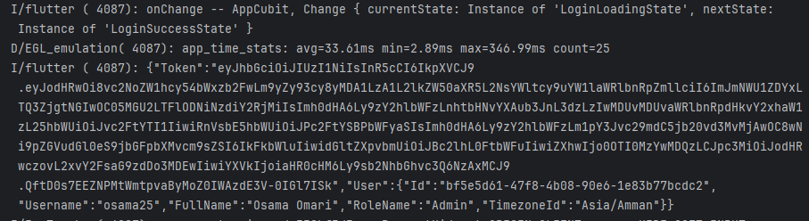
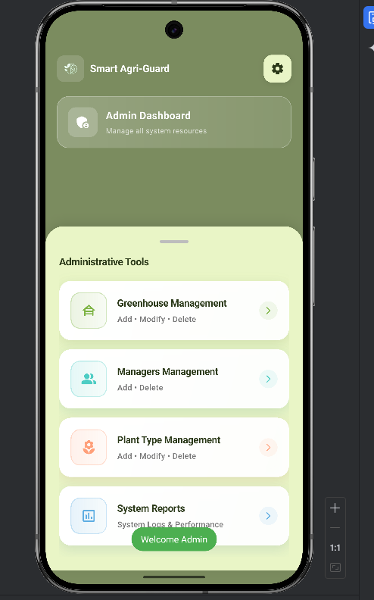
Successful Admin Authentication showing JWT issuance) and successful Dashboard navigation (Right)."

