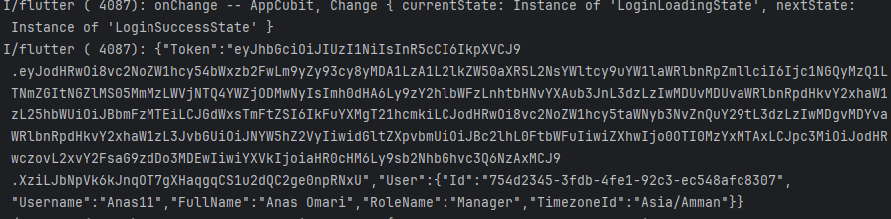
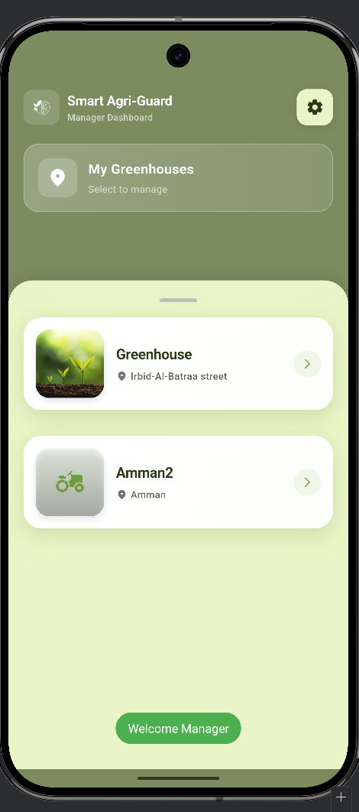
Successful Manager Authentication showing JWT issuance and successful Dashboard navigation.

