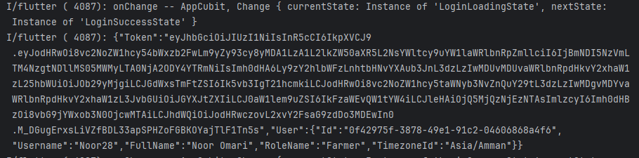
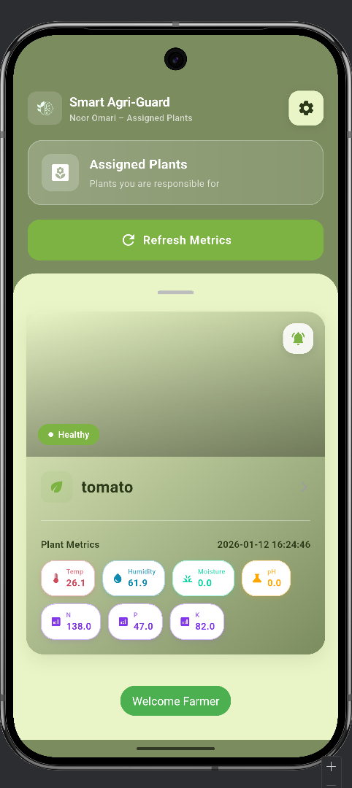
Successful Farmer Authentication showing JWT issuance and successful Dashboard navigation .

