# Digital forensics CTF Write-Ups

## Cat.jpg

Steps:

* Used strings command on image file to extract readable text.

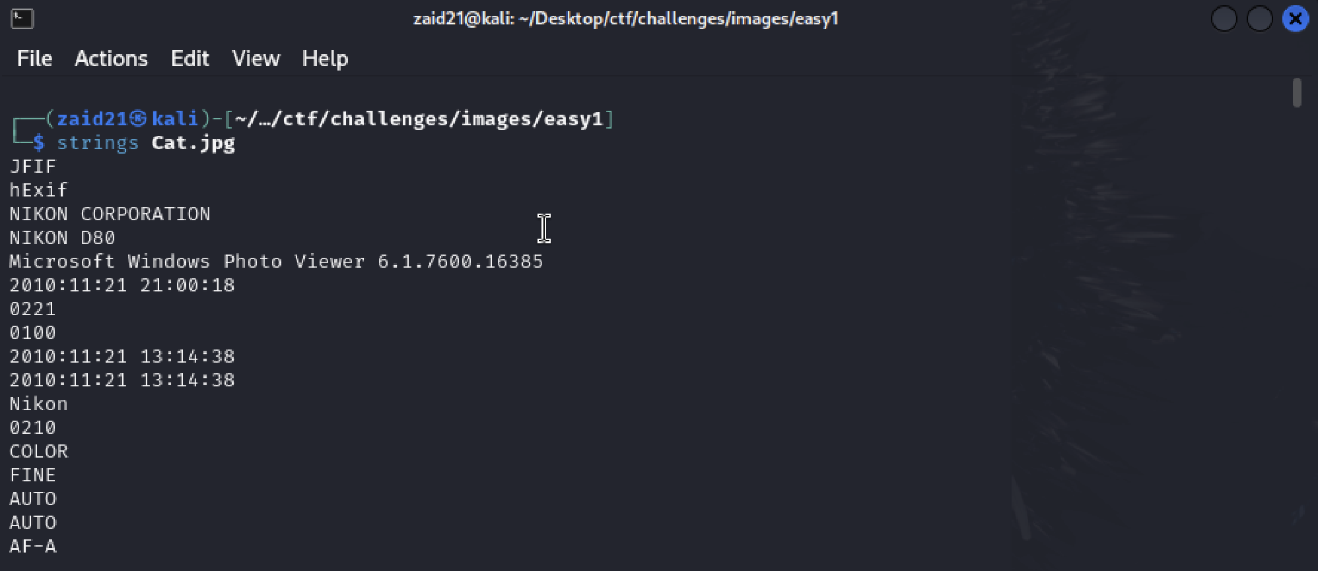

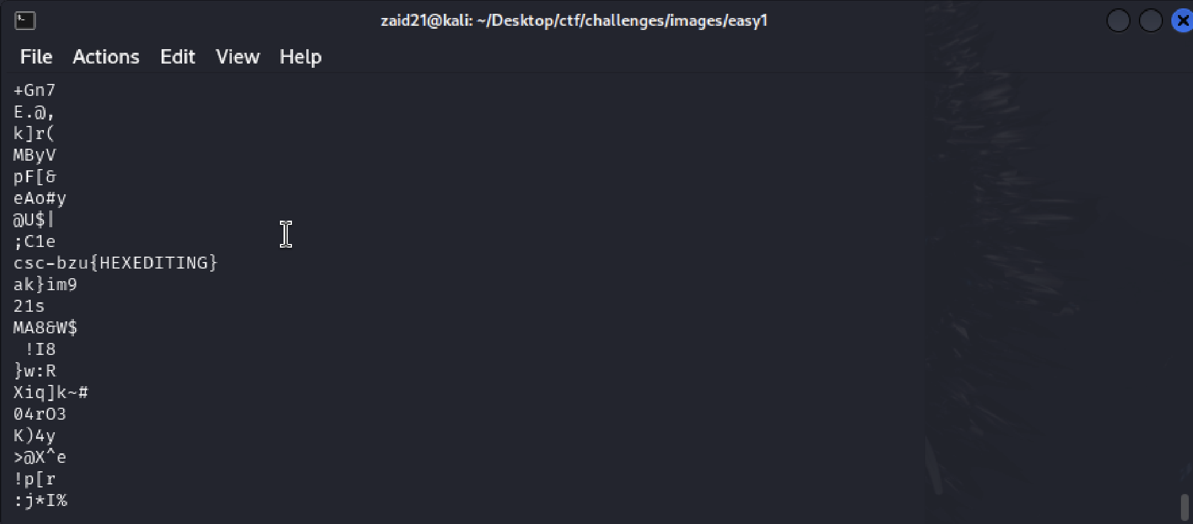

Flag: csc-bzu{HEXEDITING}

## Image.png

Steps:

* Use hexeditor or strings could work also to check embedded text

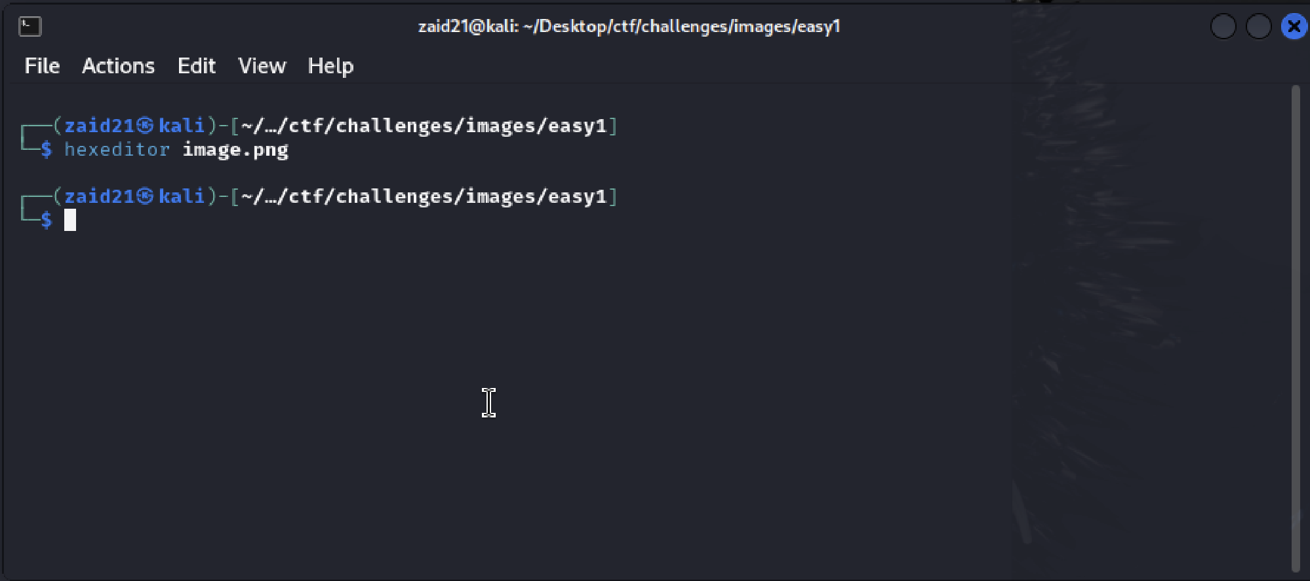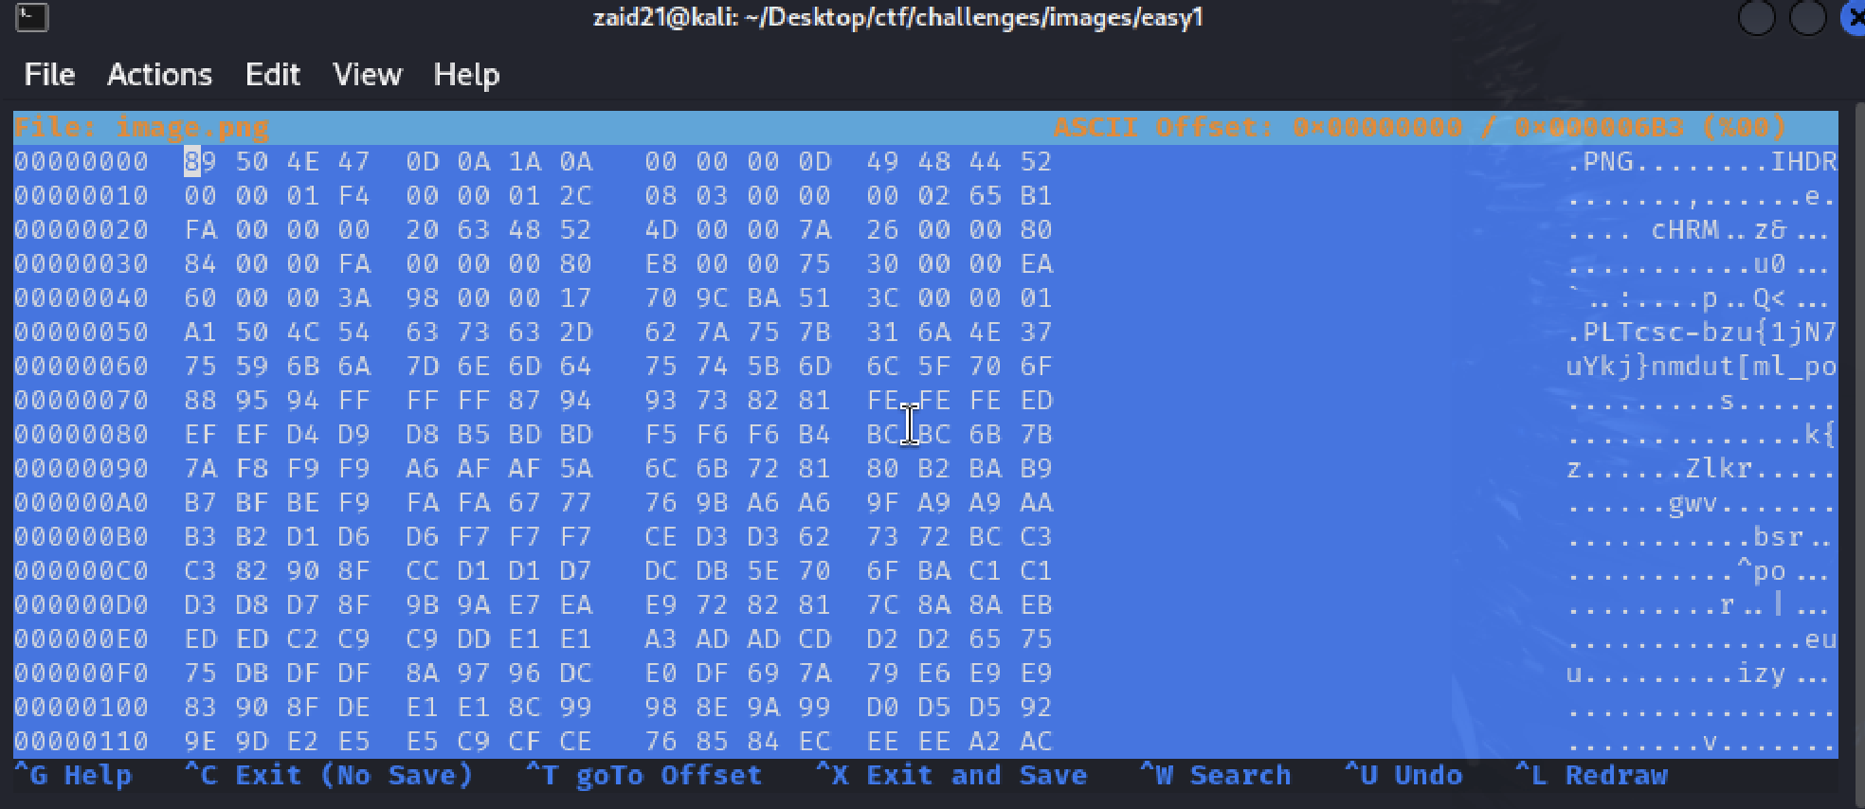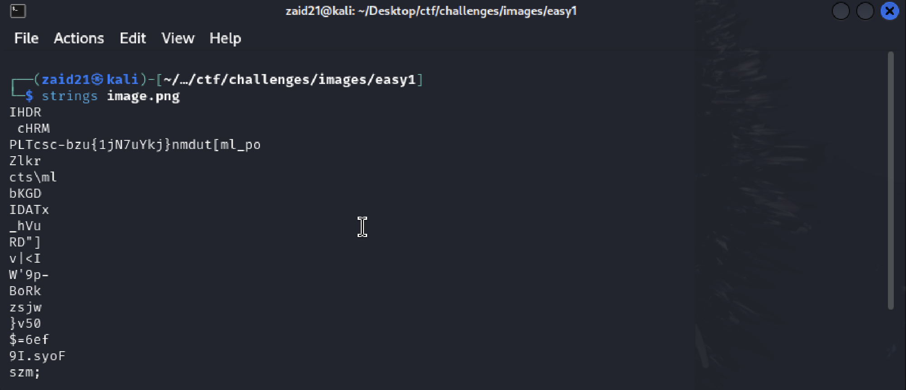

Flag: csc-bzu{1jN7uYkj}