# **Network Security CTF Write-Ups**

## **Not_easy_to_get.pcap**

Steps:

* Opened the pcap file and followed the tcp stream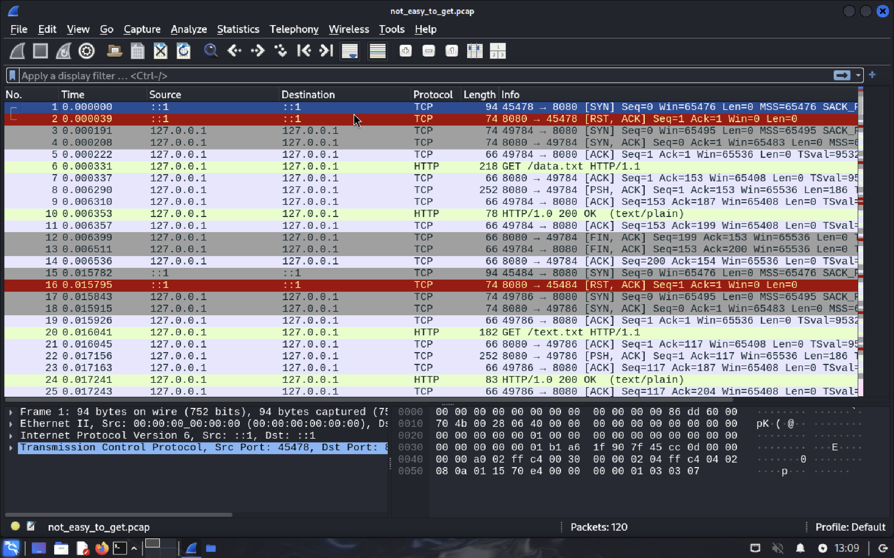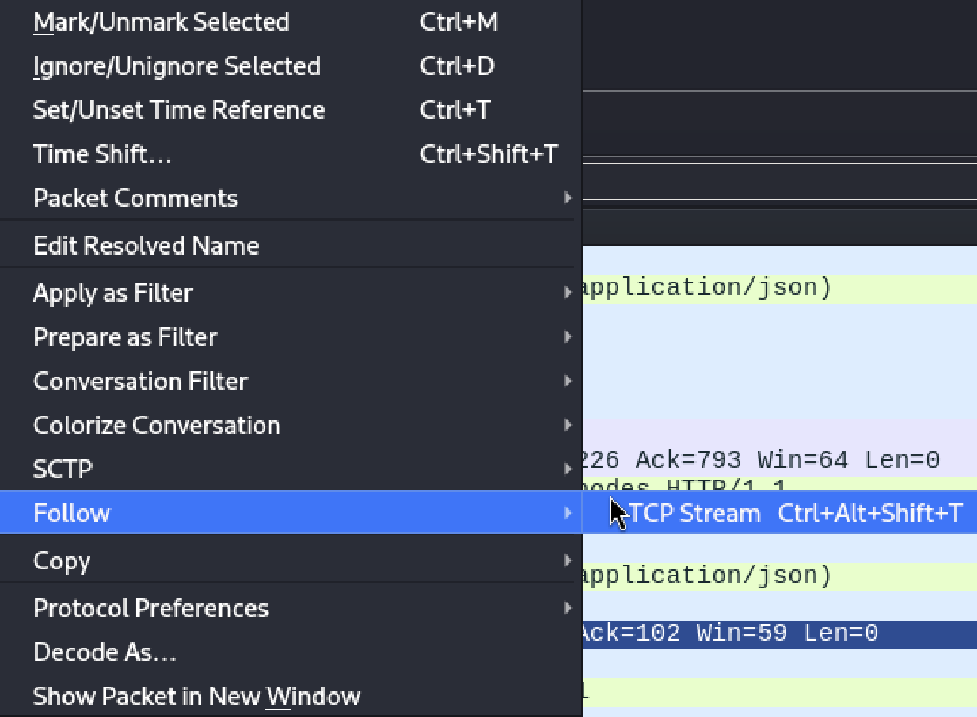
* found a suspicious packet text, copied it and checked it with cyberchef

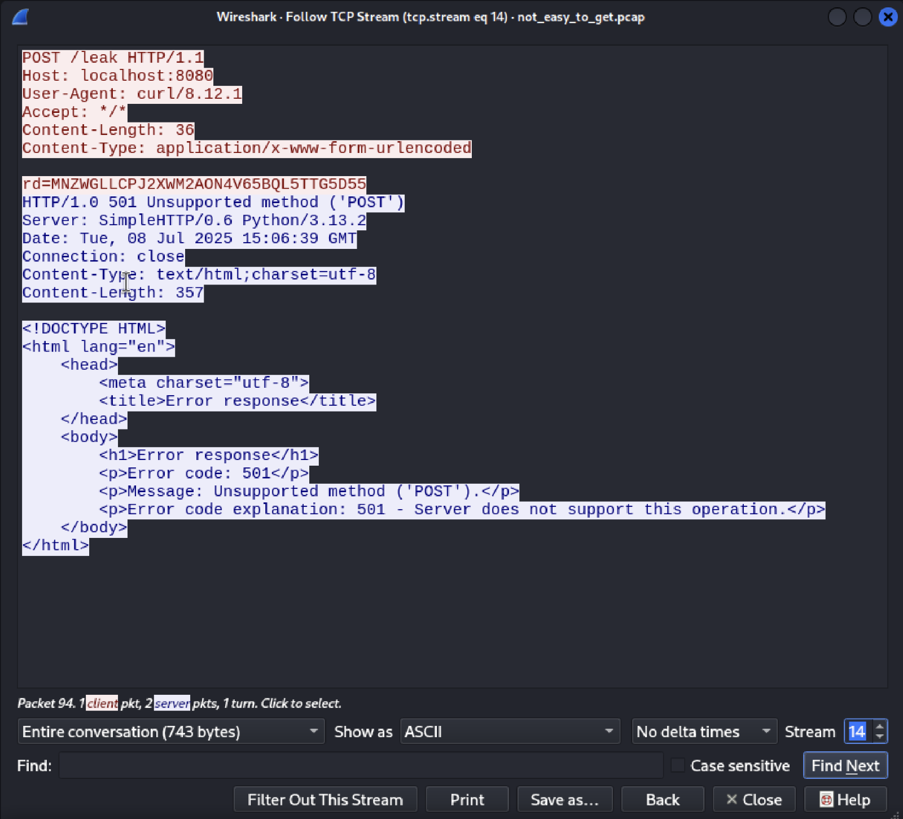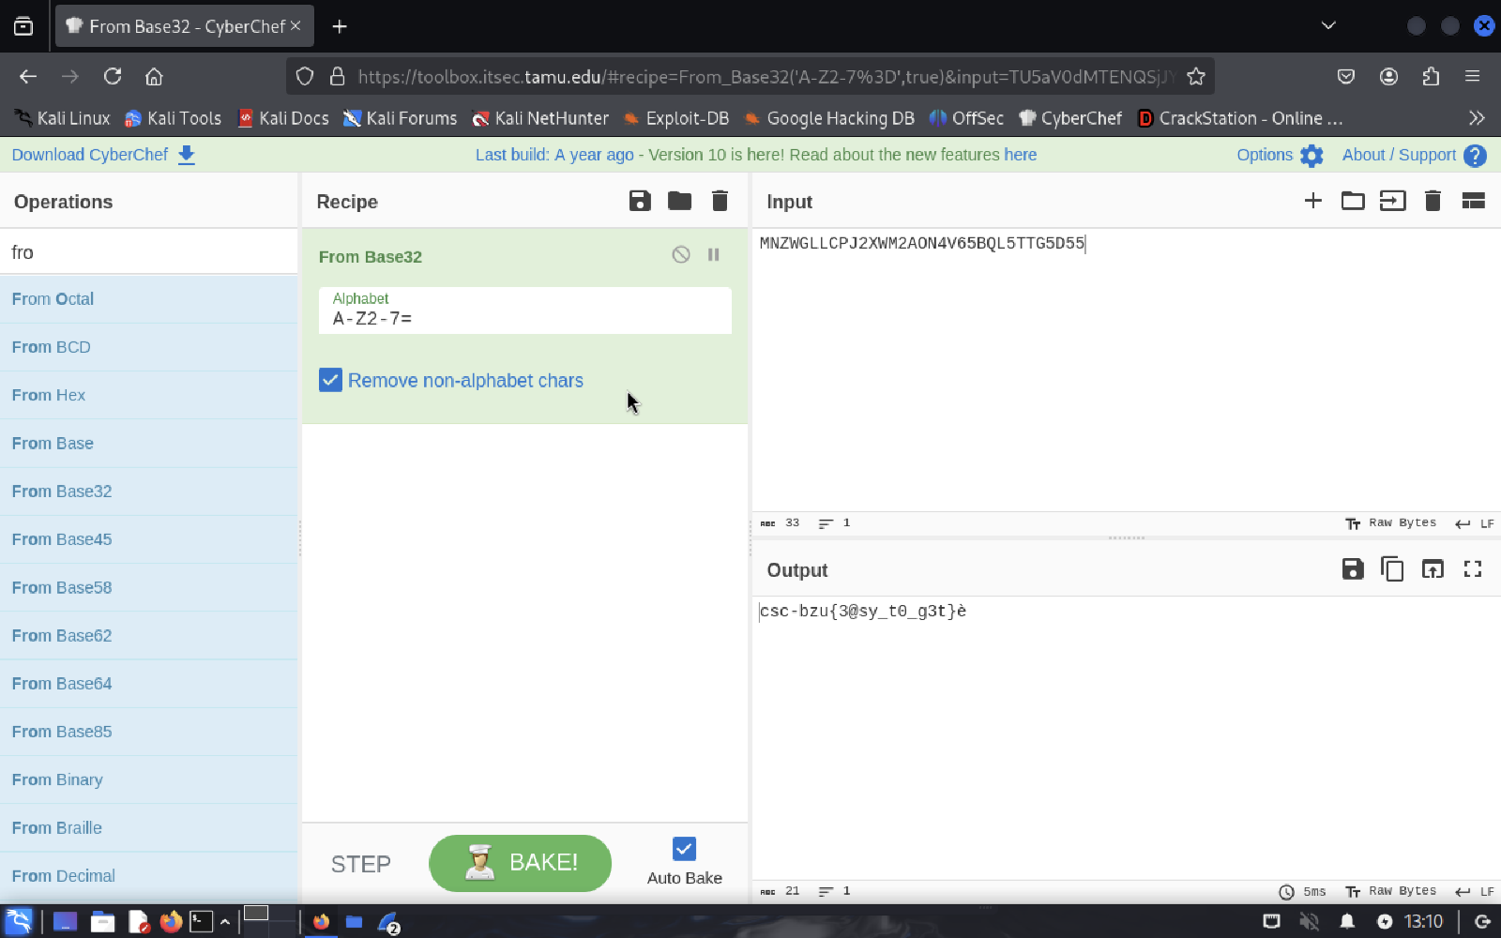

Flag: csc-bzu{3@sy_t0_g3t}

## **flag.pcap**

Steps:

* Same as before after checking the tcp stream we found a suspicious text in the packet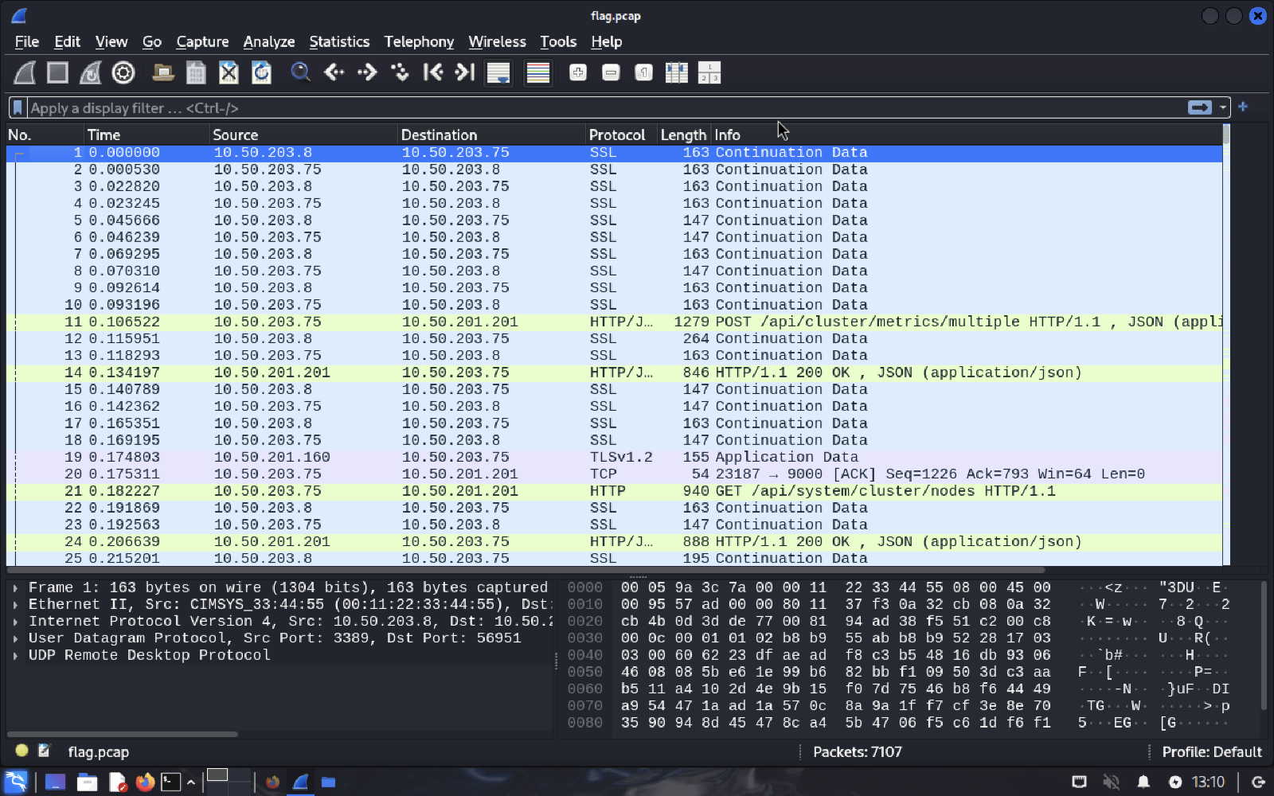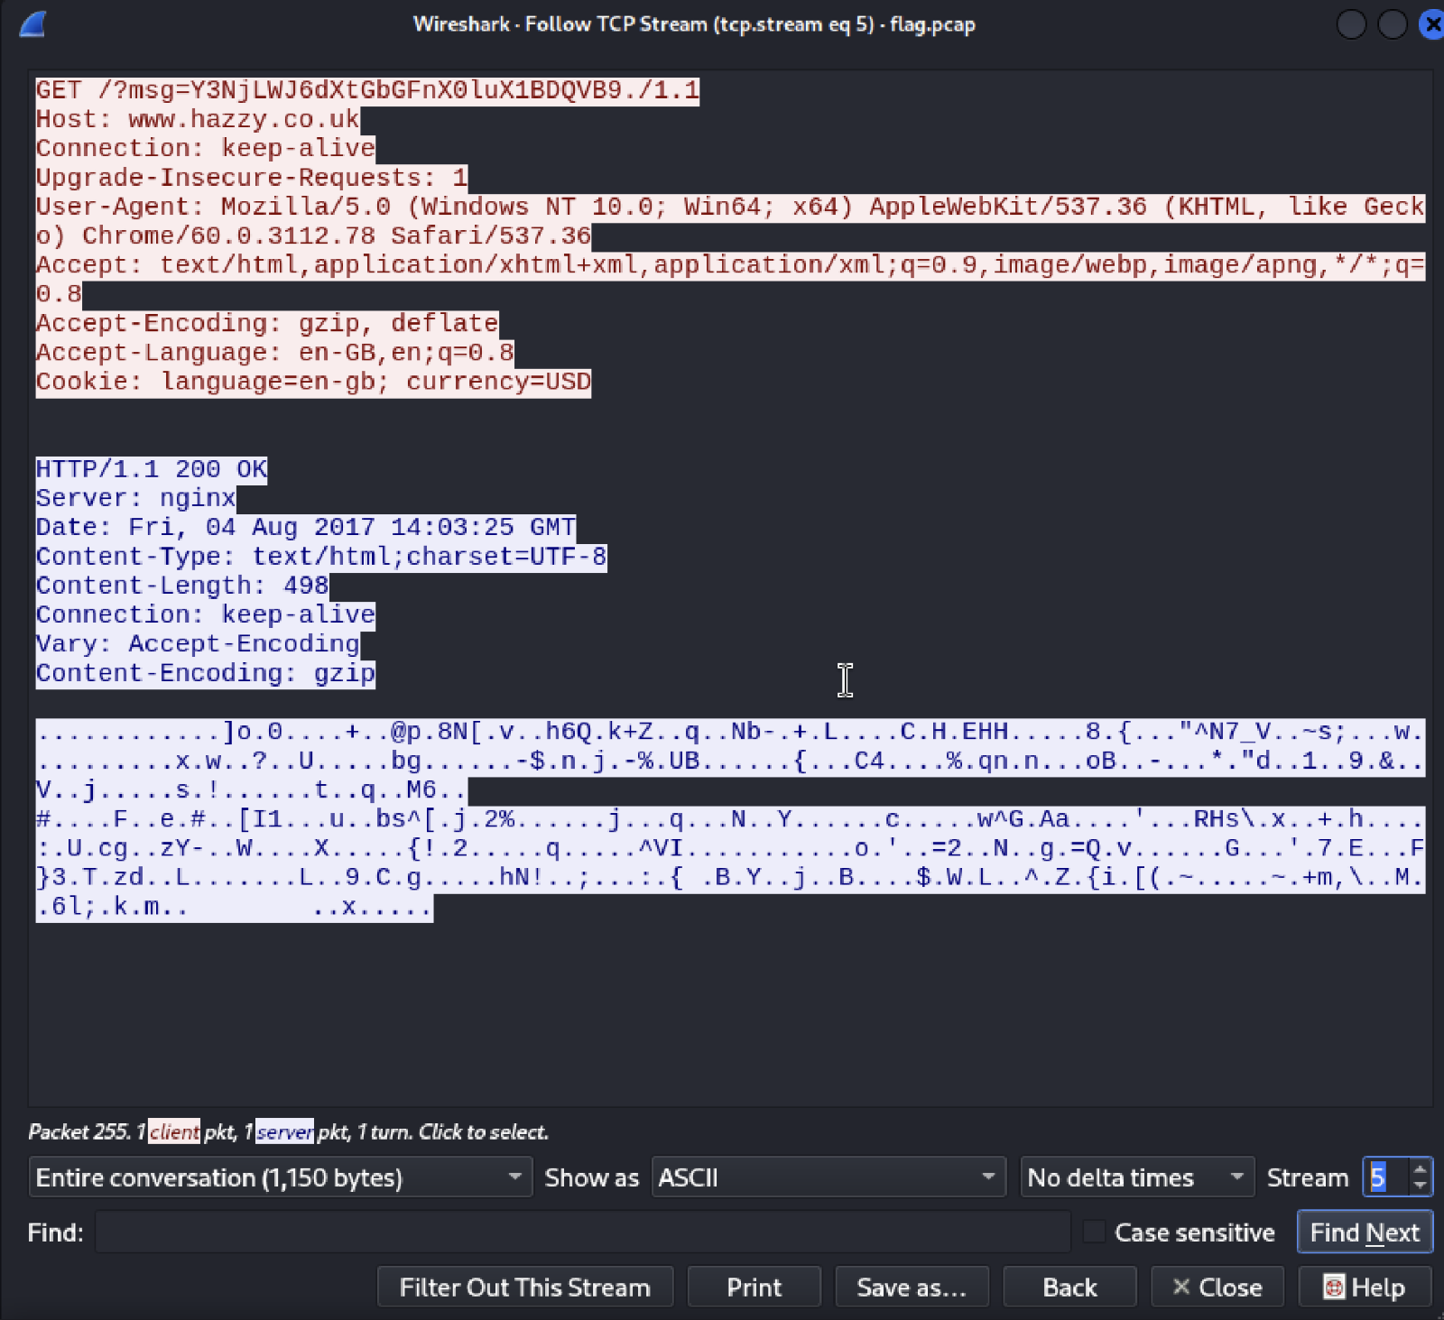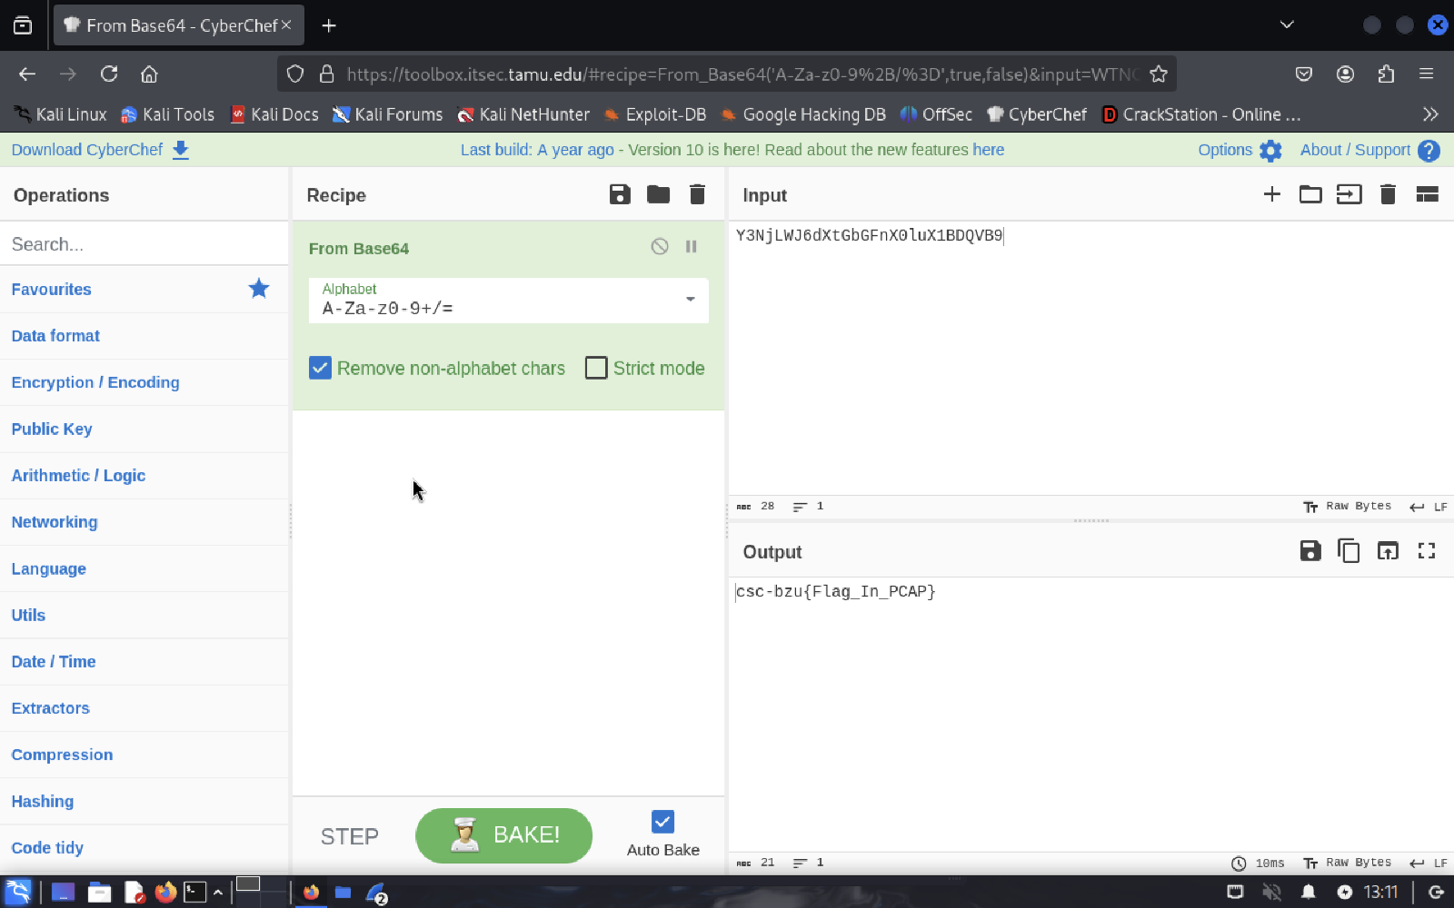

Flag: csc-bzu{Flag_In_PCAP}