## **CSC-BZU**

## **Digital Forensics Writeup**

**Challenge 1 :**

**( kid.png )**

**You can extract the metadata from a picture using:**

1) using strings tool:

2) using exiftool:

After you find the flag, you can decode the text using [**CyberChef**](https://gchq.github.io/CyberChef/):

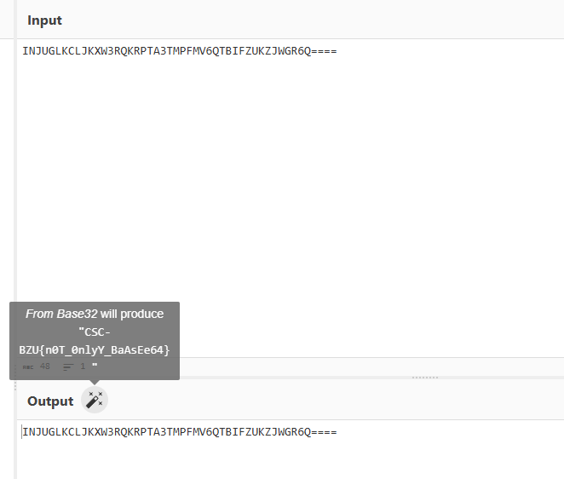

**Flag :** **CSC-BZU{n0T_0nlyY_BaAsEe64}**

**Challenge 2:**

**( cat.png )**

**Here the flag is very easy to catch:**

1) using **strings** tool:

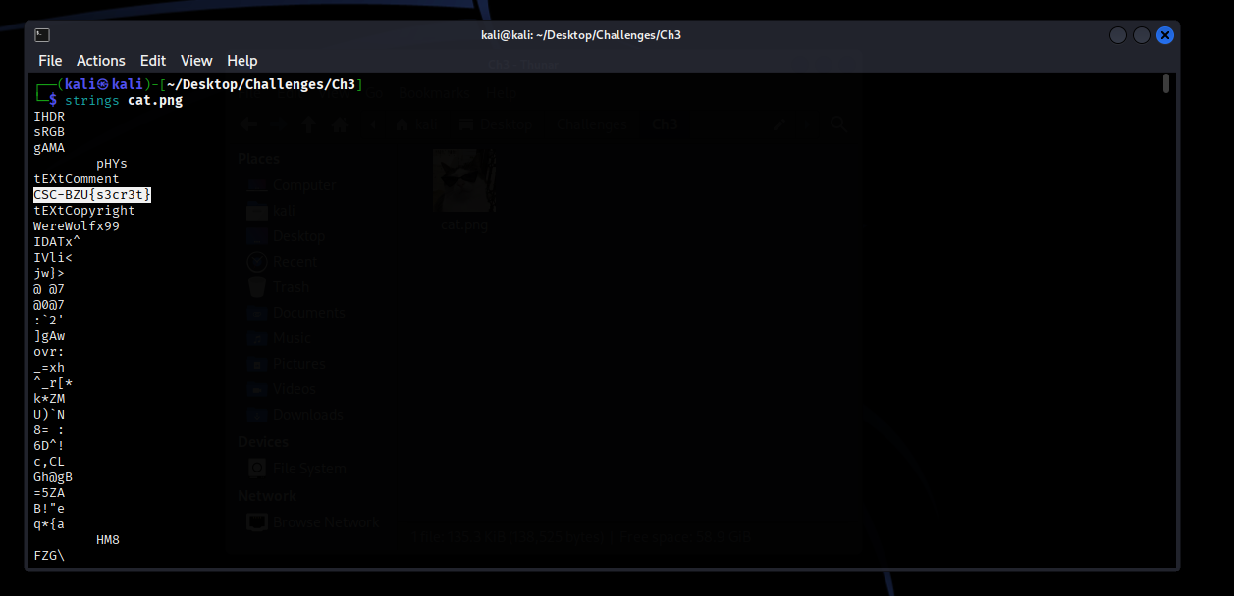

2) using **zsteg** tool:

**You also can use exiftool to extract the metadata 😊 .**

**Flag: CSC-BZU{s3cr3t}**