The Last Clue
  - System Analysis and Architecture
Digital Egypt Pioneers Initiative | Full Stack .NET
Analysis and design submission deadline: 6 November 2026
This design turns the agreed requirements into components, data boundaries, and workflows for implementation. The game supports 4-8 players, one criminal, three rounds, and no more than two accepted accusations per game.

Problem and Objectives
A fixed mystery becomes predictable after its solution is known. We will generate new fictional cases and use reviewed saved cases when generation is unavailable. The system must keep players synchronized, protect role information, and save each completed result once.
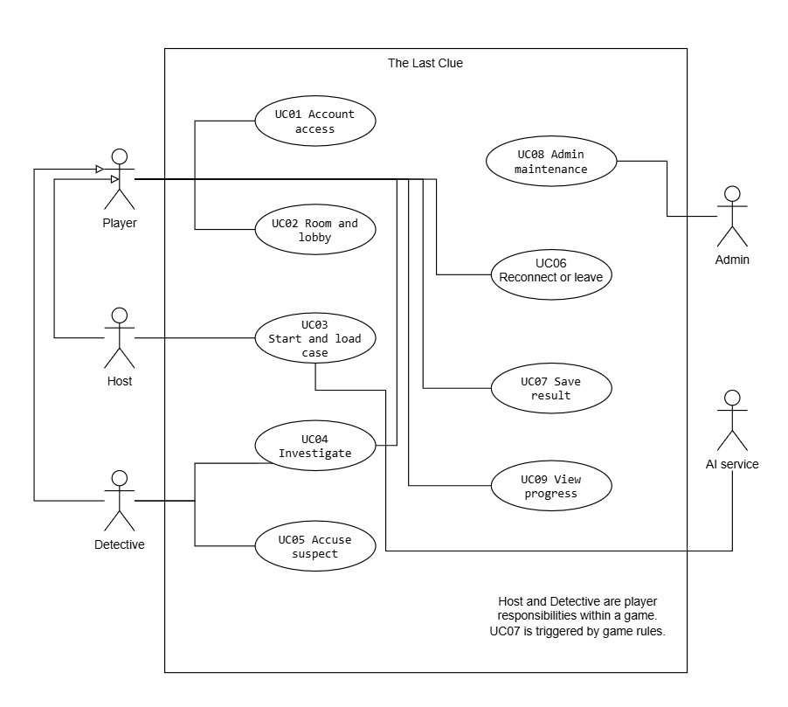
Figure 1. Main use cases and participating actors. The AI provider is an external system actor, not an account role.

Use Cases and Requirements Coverage
Use case | Interaction and alternative path | Requirements
UC01 Account access | Register or sign in; reject invalid details and blocked sign-in without exposing account existence. | FR01-FR02
UC02 Room and lobby | Create or join by code, mark ready, and transfer a departing host. Start requires all 4-8 members ready. | FR03-FR06
UC03 Start and load case | Lock startup settings; validate AI output or load a reviewed local case. Return to lobby if no valid case exists. | FR07-FR14
UC04 Investigate | One statement per suspect; two questions per detective each round; one answer per target question; release only authorized clues. | FR12, FR14-FR17, FR33
UC05 Accuse suspect | Accept a single detective choice or matching final votes from the pair. Catch ends play; two wrong arrests also end play. | FR18-FR21, FR26, FR33
UC06 Reconnect or leave | One 60-second grace per player with shared pause. Innocent departure continues; detective or criminal departure cancels. | FR22-FR25, FR34
UC07 Save result | Store outcome, cumulative score events, and achievements atomically; retries return the saved result. Cancellation awards nothing. | FR21, FR26-FR29
UC08 Admin maintenance | Manage users, public status, reviewed case versions, and future settings. Keep five complete active cases. | FR09-FR11, FR30-FR32
UC09 View progress | Show own profile, achievements and history, plus overall and weekly rankings. Keep active solutions private. | FR27-FR29

Detailed actor, precondition, main flow, alternative flow, and result descriptions remain in the Requirements Gathering user stories and use cases document. These use case IDs are unchanged.

Quality Requirements
NFR01-NFR07 guide authentication, authorization, safe input, secrets, and diagnostics. NFR08-NFR14 guide API timing, AI failover, valid output, live events, availability, transactions, and recovery. NFR15-NFR21 guide Arabic/English usability, accessibility, maintainability, deployment, coverage, and pilot testing. The acceptance measures stay aligned with KPIs K1-K7.

Architecture and Component Responsibilities
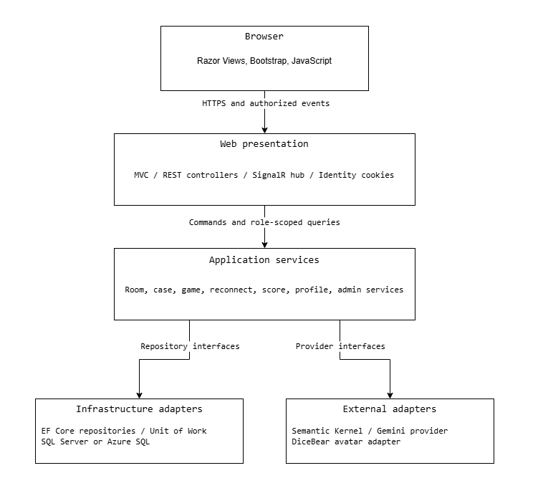
Figure 2. Runtime components and service interfaces. Infrastructure implements interfaces owned by the application layer.
Layer | Responsibility and dependency rule
Web | MVC views, REST endpoints, Identity integration, DTO mapping and SignalR transport. Controllers delegate game decisions to services.
Application and domain | Game rules, authorization policies, state transitions, score calculations, validation, and interfaces. No dependency on browser code or concrete provider clients.
Infrastructure | EF Core repositories, Unit of Work, SQL persistence, AI and avatar adapters. Repository calls do not decide winners or publish secret data.
Workers | Durable startup jobs, deadlines, reconnect grace expiry, and outbox dispatch. Workers call the same application services as requests.

Classes and Consistency Boundaries
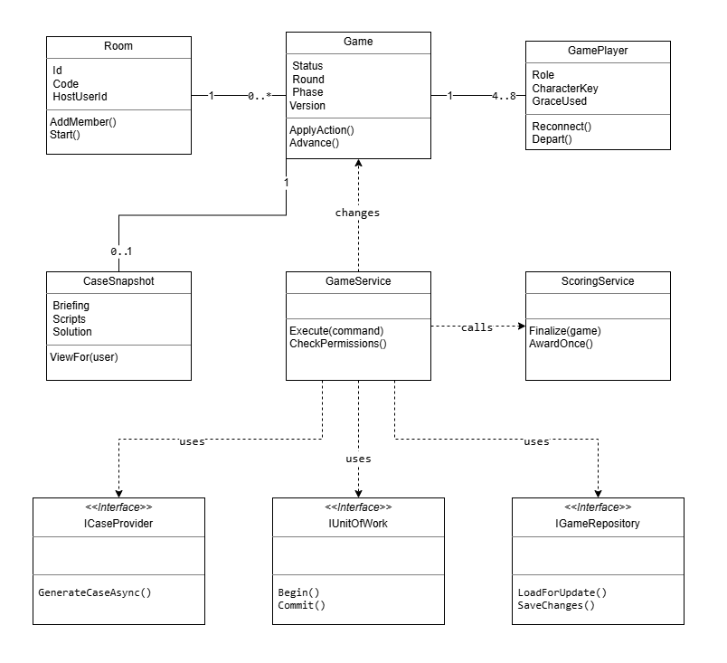
Figure 3. Selected classes and interfaces. Solid lines show associations; dashed arrows show service dependencies. The 4-8 player count applies after activation; a case snapshot is optional during startup.
Game is the consistency boundary for actions and phase transitions. A service loads the current game, checks the authenticated actor and server time, applies one legal change, and commits with a concurrency token. Provider calls run outside database transactions. Public APIs receive commands, never a client-selected role or score.
The first deployment runs one application instance. SQL holds authoritative state; memory may cache it but cannot replace it. SignalR groups are transport destinations only. Every connection and reconnect is authorized again, and safe DTOs are built separately for public, private, spectator, and admin views.

