The Last Clue
  - Database Design and Data Modeling
Digital Egypt Pioneers Initiative | Full Stack .NET
Analysis and design submission deadline: 6 November 2026
The database stores accounts, room membership, private game snapshots, player actions, and completed results. Historical games keep their own case and settings so later administration changes cannot rewrite a played game.

Core Relationships
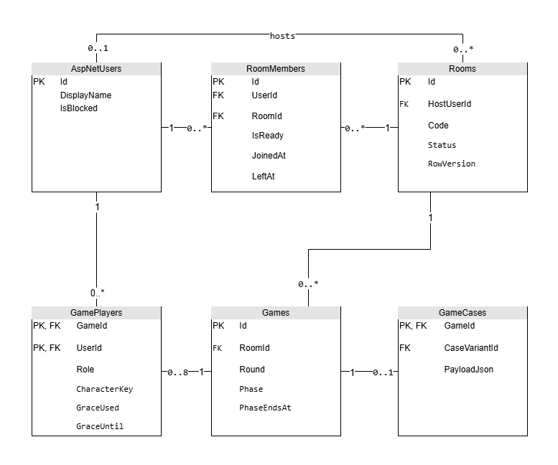
Figure 4. Core entities. PK denotes a primary key and FK a foreign key. A game can hold 0-8 player records while starting, but activation requires 4-8. A room can temporarily have no host.
One room has many historical games, but at most one Starting or Active game at a time. Each active game starts with 4-8 GamePlayers. ASP.NET Identity owns login, password hashes, and account roles; game roles are stored only in GamePlayers.

Normalization and Snapshots
Membership, actions, clues, and scores use separate tables to avoid repeated groups. The model follows third normal form for relational records. Immutable case and settings JSON are deliberate snapshots of versioned input, not editable copies of shared current settings.

Game Actions and Clue Relationships
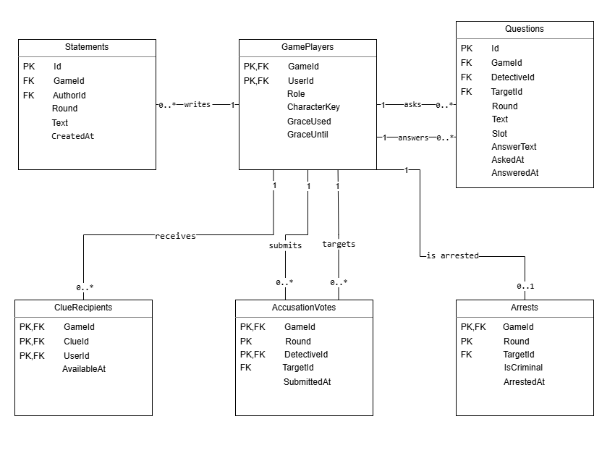
Figure 5. Action entities are scoped by GameId. All actor and target references must identify members of the same game.
Statements are unique per game, round, and author. Questions use a slot of 1 or 2 for each detective in a round, and hold at most one answer. Votes are immutable final choices per detective and round. An arrest is unique per game and round, and each target can be arrested only once in that game. Each GamePlayer therefore has zero or one arrest record. The service enforces no more than two arrests across the game.
GameClues define a round and audience. ClueRecipients records delivery eligibility for a specific GamePlayer. A released clue can be read again after reconnect without applying its release effects twice. A spectator receives public state, but no newly released private clues.

Case Versions and Progress Relationships
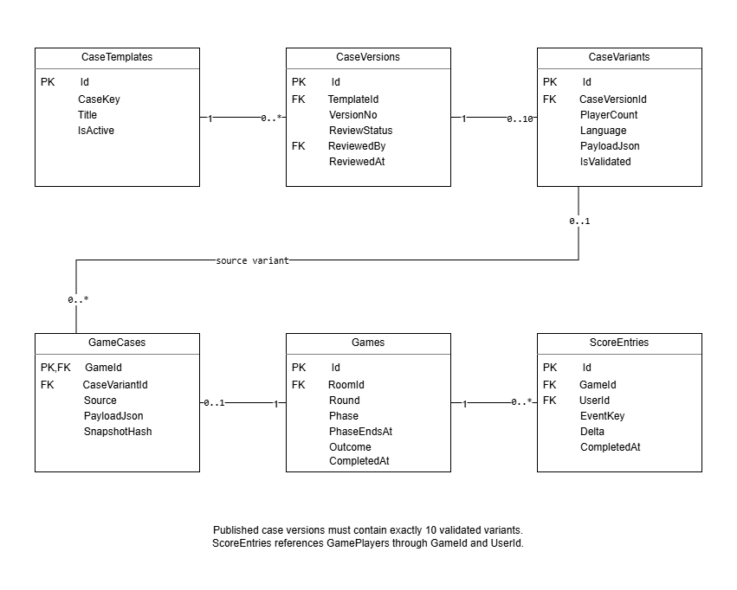
Figure 6. A draft version may contain 0-10 variants; publication requires exactly ten reviewed and validated variants. AI snapshots have no source variant. Scores refer to the composite GamePlayers key GameId and UserId.
Each of the five or more published case families has one current reviewed version covering 4, 5, 6, 7, and 8 players in English and Arabic. Historical versions remain available for references. A generated case has no CaseVariantId; a saved fallback case records its source variant. Both become an immutable GameCases snapshot.
Scores refer to GamePlayers. PlayerAchievements refers to its user, achievement definition, and awarding game. RankDefinitions stores named thresholds; the lowest rank covers negative totals. Neither ranks nor achievements are calculated from live unpublished game events.

Accounts Rooms and Runtime Schema
Physical SQL Server types are shown below. Composite primary keys containing Identity string IDs use NONCLUSTERED indexes; use surrogate clustered keys if later volume requires them. PK columns are NOT NULL. Other columns are NOT NULL unless marked nullable. All datetime2 values use UTC. Identity creates its standard supporting tables through migrations.
Entity | Columns and constraints
AspNetUsers | Identity string key Id nvarchar(450); Identity-managed account fields; DisplayName nvarchar(80); AvatarSeed nvarchar(80); IsBlocked bit; CreatedAt datetime2(3).  Standard Identity tables keep roles, claims, logins and tokens.
Rooms | Id uniqueidentifier PK; Code varchar(12); HostUserId nvarchar(450) nullable; Language char(2); Status varchar(16); CreatedAt datetime2(3); StateVersion bigint; RowVersion rowversion.  HostUserId -> AspNetUsers. Unique Code; Language en/ar; Status Lobby/Starting/Active/Closed.
RoomMembers | Id uniqueidentifier PK; RoomId uniqueidentifier; UserId nvarchar(450); JoinedAt datetime2(3); LeftAt datetime2(3) nullable; IsReady bit.  RoomId -> Rooms; UserId -> AspNetUsers. Unique room/user; filtered unique UserId where LeftAt IS NULL.
Games | Id uniqueidentifier PK; RoomId uniqueidentifier; Number int; Status varchar(16); IsRunning bit; Round tinyint; Phase varchar(20); PhaseEndsAt datetime2(3) nullable; PauseStartedAt datetime2(3) nullable; AccusationsUsed tinyint; SettingsVersionId uniqueidentifier; SettingsJson nvarchar(max); StateVersion bigint; CreatedAt datetime2(3); CompletedAt datetime2(3) nullable; Outcome varchar(24) nullable; CancellationReason nvarchar(200) nullable; RowVersion rowversion.  RoomId -> Rooms; SettingsVersionId -> SettingsVersions. Status Starting/Active/Completed/Cancelled. Unique room/number; filtered unique RoomId for unfinished games via IsRunning bit maintained in the transaction.
GamePlayers | GameId uniqueidentifier + UserId nvarchar(450) composite PK; Role varchar(12); CharacterKey varchar(40) nullable; PrivateScript nvarchar(max); IsActive bit; IsArrested bit; GraceUsed bit; GraceUntil datetime2(3) nullable; DepartedAt datetime2(3) nullable.  GameId -> Games; UserId -> AspNetUsers. Unique game/character for non-null CharacterKey. Detective/Criminal/Innocent roles.
SettingsVersions | Id uniqueidentifier PK; VersionNo int; ValuesJson nvarchar(max); PublishedAt datetime2(3); ChangedBy nvarchar(450).  ChangedBy -> AspNetUsers; unique VersionNo; valid JSON. Games retain a copy, including scoring, durations and rank/achievement definitions.
PlayerConnections | ConnectionId nvarchar(128) PK; GameId uniqueidentifier; UserId nvarchar(450); LastSeenAt datetime2(3); ClosedAt datetime2(3) nullable.  GameId/UserId -> GamePlayers. Presence is lost only when all live connections for the member are gone.

Cases Clues and Startup Schema
Physical SQL Server types are shown below. Composite primary keys containing Identity string IDs use NONCLUSTERED indexes; use surrogate clustered keys if later volume requires them. PK columns are NOT NULL. Other columns are NOT NULL unless marked nullable. All datetime2 values use UTC. Identity creates its standard supporting tables through migrations.
Entity | Columns and constraints
CaseTemplates | Id uniqueidentifier PK; CaseKey varchar(60); Title nvarchar(120); IsActive bit.  Unique CaseKey. Five active complete families are a transactional library invariant.
CaseVersions | Id uniqueidentifier PK; TemplateId uniqueidentifier; VersionNo int; ReviewStatus varchar(16); ReviewedBy nvarchar(450) nullable; ReviewedAt datetime2(3) nullable.  TemplateId -> CaseTemplates; ReviewedBy -> AspNetUsers. Unique template/version. Draft/Reviewed/Published/Retired.
CaseVariants | Id uniqueidentifier PK; CaseVersionId uniqueidentifier; PlayerCount tinyint; Language char(2); PayloadJson nvarchar(max); IsValidated bit.  CaseVersionId -> CaseVersions. Unique version/count/language; count 4-8; en/ar; valid JSON.
GameCases | GameId uniqueidentifier PK; CaseVariantId uniqueidentifier nullable; Source varchar(12); PayloadJson nvarchar(max); SnapshotHash char(64).  GameId -> Games; CaseVariantId -> CaseVariants. Source AI/Fallback; valid JSON. AI requires a null source variant; Fallback requires a source variant. Hidden solution never leaves authorized views.
GameClues | Id uniqueidentifier PK; GameId uniqueidentifier; ClueKey varchar(60); Round tinyint; Audience varchar(12); CharacterKey varchar(40) nullable; Body nvarchar(2000); ReleasedAt datetime2(3) nullable.  GameId -> Games. Unique game/clue key; round 1-3; Public/Detectives/Character. Unique GameId/Id supports composite recipient FK.
ClueRecipients | GameId uniqueidentifier + ClueId uniqueidentifier + UserId nvarchar(450) composite PK; AvailableAt datetime2(3).  GameId/ClueId -> GameClues; GameId/UserId -> GamePlayers. Recipient inclusion follows role and active status at release.
GenerationJobs | Id uniqueidentifier PK; GameId uniqueidentifier; RequestId uniqueidentifier; Status varchar(16); DeadlineAt datetime2(3); LeaseUntil datetime2(3) nullable; Attempts int; LastErrorCode varchar(40) nullable.  GameId -> Games, unique GameId and RequestId. Pending/Running/Succeeded/Failed; total AI deadline is durable.

Actions and Score Schema
Physical SQL Server types are shown below. Composite primary keys containing Identity string IDs use NONCLUSTERED indexes; use surrogate clustered keys if later volume requires them. PK columns are NOT NULL. Other columns are NOT NULL unless marked nullable. All datetime2 values use UTC. Identity creates its standard supporting tables through migrations.
Entity | Columns and constraints
Statements | Id uniqueidentifier PK; GameId uniqueidentifier; Round tinyint; AuthorId nvarchar(450); Text nvarchar(1000); CreatedAt datetime2(3).  GameId/AuthorId -> GamePlayers. Unique game/round/author; non-empty; round 1-3.
Questions | Id uniqueidentifier PK; GameId uniqueidentifier; Round tinyint; DetectiveId nvarchar(450); Slot tinyint; TargetId nvarchar(450); Text nvarchar(300); AnswerText nvarchar(1000) nullable; AskedAt datetime2(3); AnsweredAt datetime2(3) nullable.  Both game/detective and game/target -> GamePlayers. Unique game/round/detective/slot; slot 1-2. One target-owned answer.
AccusationVotes | GameId uniqueidentifier + Round tinyint + DetectiveId nvarchar(450) composite PK; TargetId nvarchar(450); SubmittedAt datetime2(3).  Both game/detective and game/target -> GamePlayers. Votes cannot be edited after acceptance.
Arrests | GameId uniqueidentifier + Round tinyint composite PK; TargetId nvarchar(450); IsCriminal bit; ArrestedAt datetime2(3).  GameId/TargetId -> GamePlayers. Unique game/target. Winner and budget rules checked under the game transaction.
PendingScoreEvents | Id uniqueidentifier PK; GameId uniqueidentifier; UserId nvarchar(450); EventKey varchar(80); Delta int.  GameId/UserId -> GamePlayers. Unique game/user/event key. Hidden until finalization; never counted by leaderboards.
ScoreEntries | Id uniqueidentifier PK; GameId uniqueidentifier; UserId nvarchar(450); EventKey varchar(80); Delta int; CompletedAt datetime2(3).  GameId/UserId -> GamePlayers. Unique game/user/event key. Copy pending events only for Completed games; never for cancellation.

Progress Audit and Delivery Schema
Physical SQL Server types are shown below. Composite primary keys containing Identity string IDs use NONCLUSTERED indexes; use surrogate clustered keys if later volume requires them. PK columns are NOT NULL. Other columns are NOT NULL unless marked nullable. All datetime2 values use UTC. Identity creates its standard supporting tables through migrations.
Entity | Columns and constraints
RankDefinitions | Id uniqueidentifier PK; Code varchar(40); Name nvarchar(80); MinPoints int; SettingsVersionId uniqueidentifier.  SettingsVersionId -> SettingsVersions. Unique version/code and version/threshold; ascending thresholds.
Achievement  Definitions | Id uniqueidentifier PK; Code varchar(40); Name nvarchar(80); CriteriaJson nvarchar(max); SettingsVersionId uniqueidentifier.  SettingsVersionId -> SettingsVersions. Unique version/code; valid JSON. Definitions use completed games only.
PlayerAchievements | UserId nvarchar(450) + AchievementCode varchar(40) composite PK; DefinitionId uniqueidentifier; GameId uniqueidentifier; AwardedAt datetime2(3).  UserId -> AspNetUsers; DefinitionId -> AchievementDefinitions; GameId/UserId -> GamePlayers. Stable code prevents duplicate awards across versions.
AdminAudit | Id uniqueidentifier PK; ActorId nvarchar(450); Action varchar(60); EntityType varchar(40); EntityId nvarchar(450); OccurredAt datetime2(3); SafeDetailsJson nvarchar(max).  ActorId -> AspNetUsers. Store changed metadata and references; no keys, private scripts or case solution.
ActionReceipts | Id uniqueidentifier PK; UserId nvarchar(450); GameId uniqueidentifier nullable; RequestId uniqueidentifier; PayloadHash char(64); ResponseJson nvarchar(max); CreatedAt datetime2(3).  UserId -> AspNetUsers; GameId -> Games. Unique user/request ID. Reuse with a different payload returns 409; recheck visibility on replay.
OutboxMessages | Id uniqueidentifier PK; RoomId uniqueidentifier nullable; GameId uniqueidentifier nullable; StateVersion bigint; Audience varchar(16); UserId nvarchar(450) nullable; EventType varchar(40); PayloadJson nvarchar(max); CreatedAt datetime2(3); DispatchedAt datetime2(3) nullable.  RoomId -> Rooms; GameId -> Games. Exactly one room or game target is required. Optional GameId/UserId -> GamePlayers for private game events. Room events use Rooms.StateVersion. Dispatch after commit and deduplicate by event ID; Public payloads contain no secrets.

Integrity Indexes and Transaction Rules
Rule | Database and service enforcement
Running game | Unique filtered index Games(RoomId) WHERE IsRunning = 1. IsRunning is true only for Starting/Active; false for Completed/Cancelled. A paused game remains Active.
Character and criminal counts | Unique non-null game/character index. The startup service validates exactly one criminal, 1 or 2 detectives and 4-8 participants before one atomic activation.
Case publication | Bootstrap the first five reviewed complete families in one transaction before enabling startup. Serialize later publication and retirement on the case library transaction. Require ten valid reviewed variants for each published version, one current published version per family through a filtered unique TemplateId index for Published status, and at least five active complete families.
Membership and quotas | Unique active RoomMembers(UserId) prevents parallel room membership. Composite FKs keep actors in the same game. Quotas and role checks are enforced by services inside the game transaction.
JSON and indexes | Use ISJSON checks for payloads and snapshots. Index Games(Status,PhaseEndsAt), GenerationJobs(Status,LeaseUntil), OutboxMessages(DispatchedAt,CreatedAt), and ScoreEntries(CompletedAt,UserId), including Delta.
Atomic results | Under one transaction: set Completed, copy pending score events, award progress, save an action receipt and outbox messages. Cancellation writes no ScoreEntries or achievements. Negative score deltas are allowed.
Concurrency | Use Rooms/Games rowversion and a serialized game write lock. Increment StateVersion once per committed transition. Retry safe conflicts by reloading and checking current phase; never rerun a provider call inside a retry.
Retention and removal | Do not cascade-delete historical games, snapshots or scores when accounts are blocked. No destructive admin delete endpoint is exposed. Logs exclude case content and credentials; database backups include private snapshots and require restricted access.

Games.CompletedAt is null until a Completed or Cancelled terminal outcome is stored; ScoreEntries.CompletedAt uses the completed game time. Weekly rankings aggregate only Completed games from Monday 00:00 UTC up to, but not including, the next Monday, then use stable user ID to break equal totals.

