The Last Clue
  - Data Flow and System Behavior
Digital Egypt Pioneers Initiative | Full Stack .NET
Analysis and design submission deadline: 6 November 2026
These diagrams describe startup, player actions, phase changes, reconnection, and result storage. The server owns the state machine; browser clocks and SignalR delivery do not decide which action is valid.
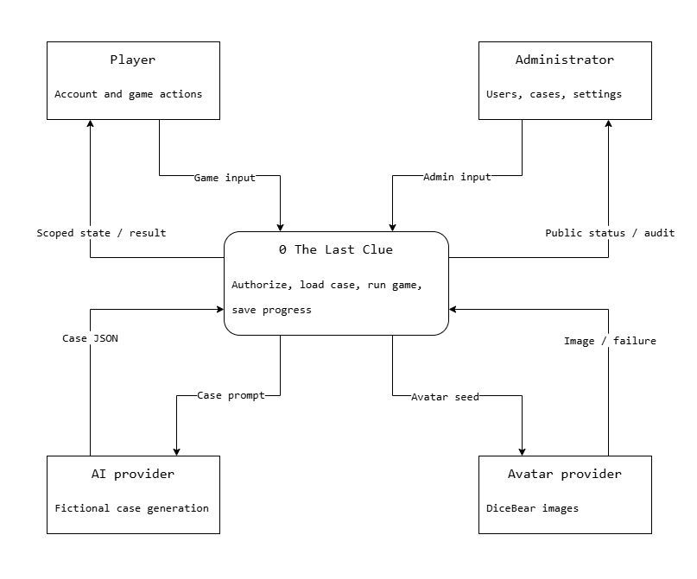
Figure 7. Context DFD. Players and admins submit requests; responses contain only the information their permissions allow.

External Data Boundaries
AI receives fictional case instructions, player count, and language. It does not receive account data or player messages. Avatar requests use a random non-personal seed. Failures from either provider are converted into local fallback behavior rather than exposed credentials or raw provider errors.

Detailed Data Flow
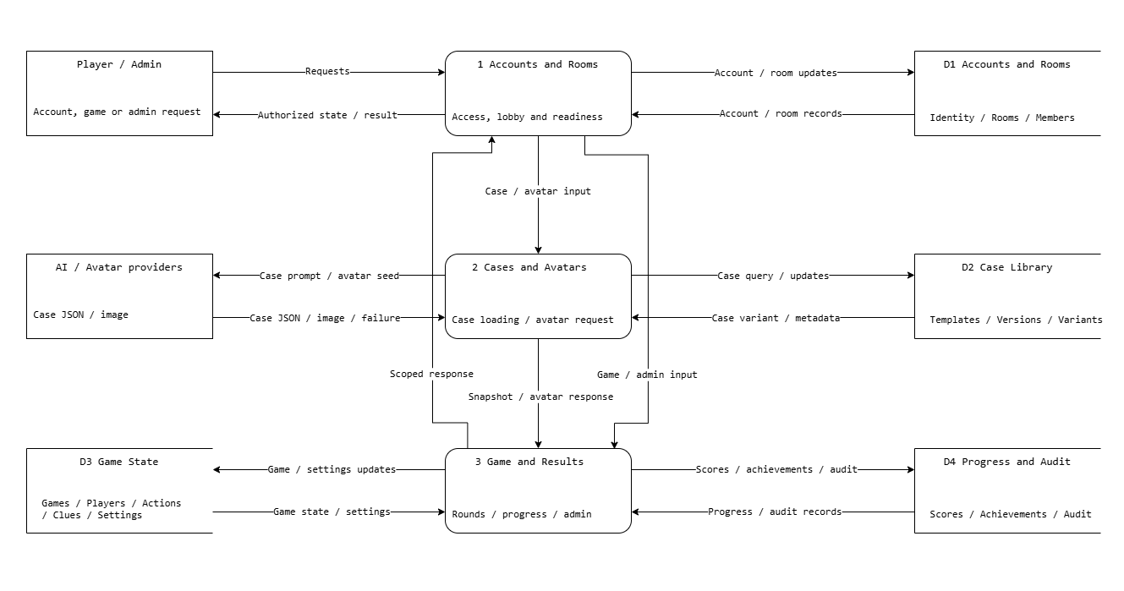
Figure 8. Level 1 DFD. Store groups summarize the physical tables in the database design document.
Accounts and room handling checks identity, membership, readiness and admin policy. Case loading validates provider output or reads a compatible reviewed variant. Game services write actions and deadlines to game state, while finalization writes scores, achievements and audit metadata. Public and private queries read these stores through authorized projections.
Every write records a durable outbox event in the same transaction. The dispatcher rechecks the audience before sending the appropriate DTO after commit, including current spectator and departure restrictions. Missing or duplicate events are repaired by an authenticated state reload; the server never trusts a client event to change stored results.

Case Startup Sequence
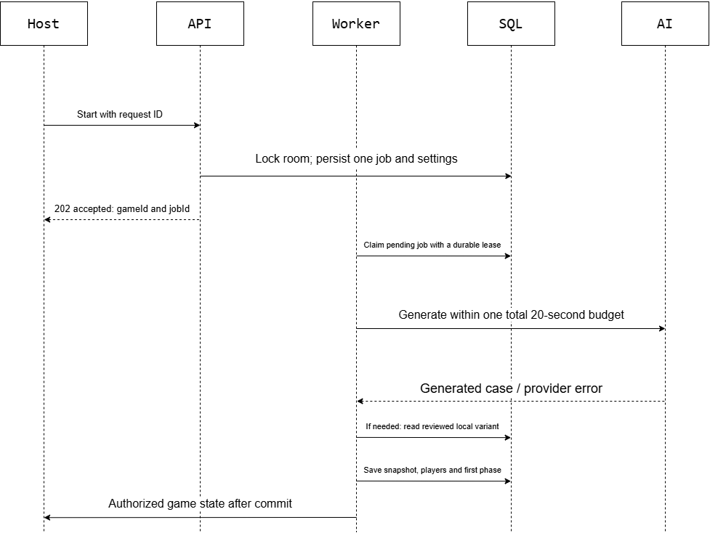
Figure 9. Startup sequence. The 202 response accepts the durable job; clients observe case loading through state updates.
The API persists Starting and a generation job before any external call. DeadlineAt is the accepted server time plus 20 seconds, so queue delay cannot extend the AI budget. The accepted request returns 202 without waiting for generation. The worker follows the sequence shown, sharing one 20-second budget across retries and provider switches. The final update is delivered after the snapshot and roles commit.
Before activation, recheck that the locked room still has all expected connected members. A departure or no eligible case cancels that startup job and returns the room to the lobby with readiness cleared. Ignore late provider responses for a finished job. No points are created.

Accusation and Finalization Sequence
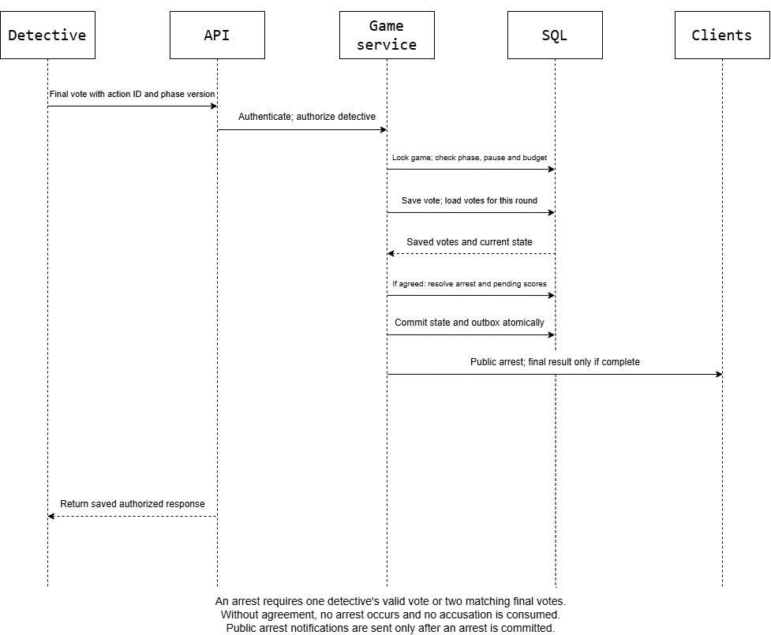
Figure 10. A valid vote is stored once; matching votes resolve one arrest. One detective does not need a second vote.
The transaction checks membership, detective role, current phase, pause state, deadline, current round and remaining budget. A final vote cannot be changed. Different or missing paired votes leave the phase open until its deadline without consuming an accusation.
One wrong arrest makes the innocent a spectator. Two wrong arrests end with criminal victory. A catch ends immediately with detective victory. Pending score events are cumulative but stay private until a completed result; cancellation discards their effect on progress. Replayed requests return the existing result.

Game Activity and Round Progression
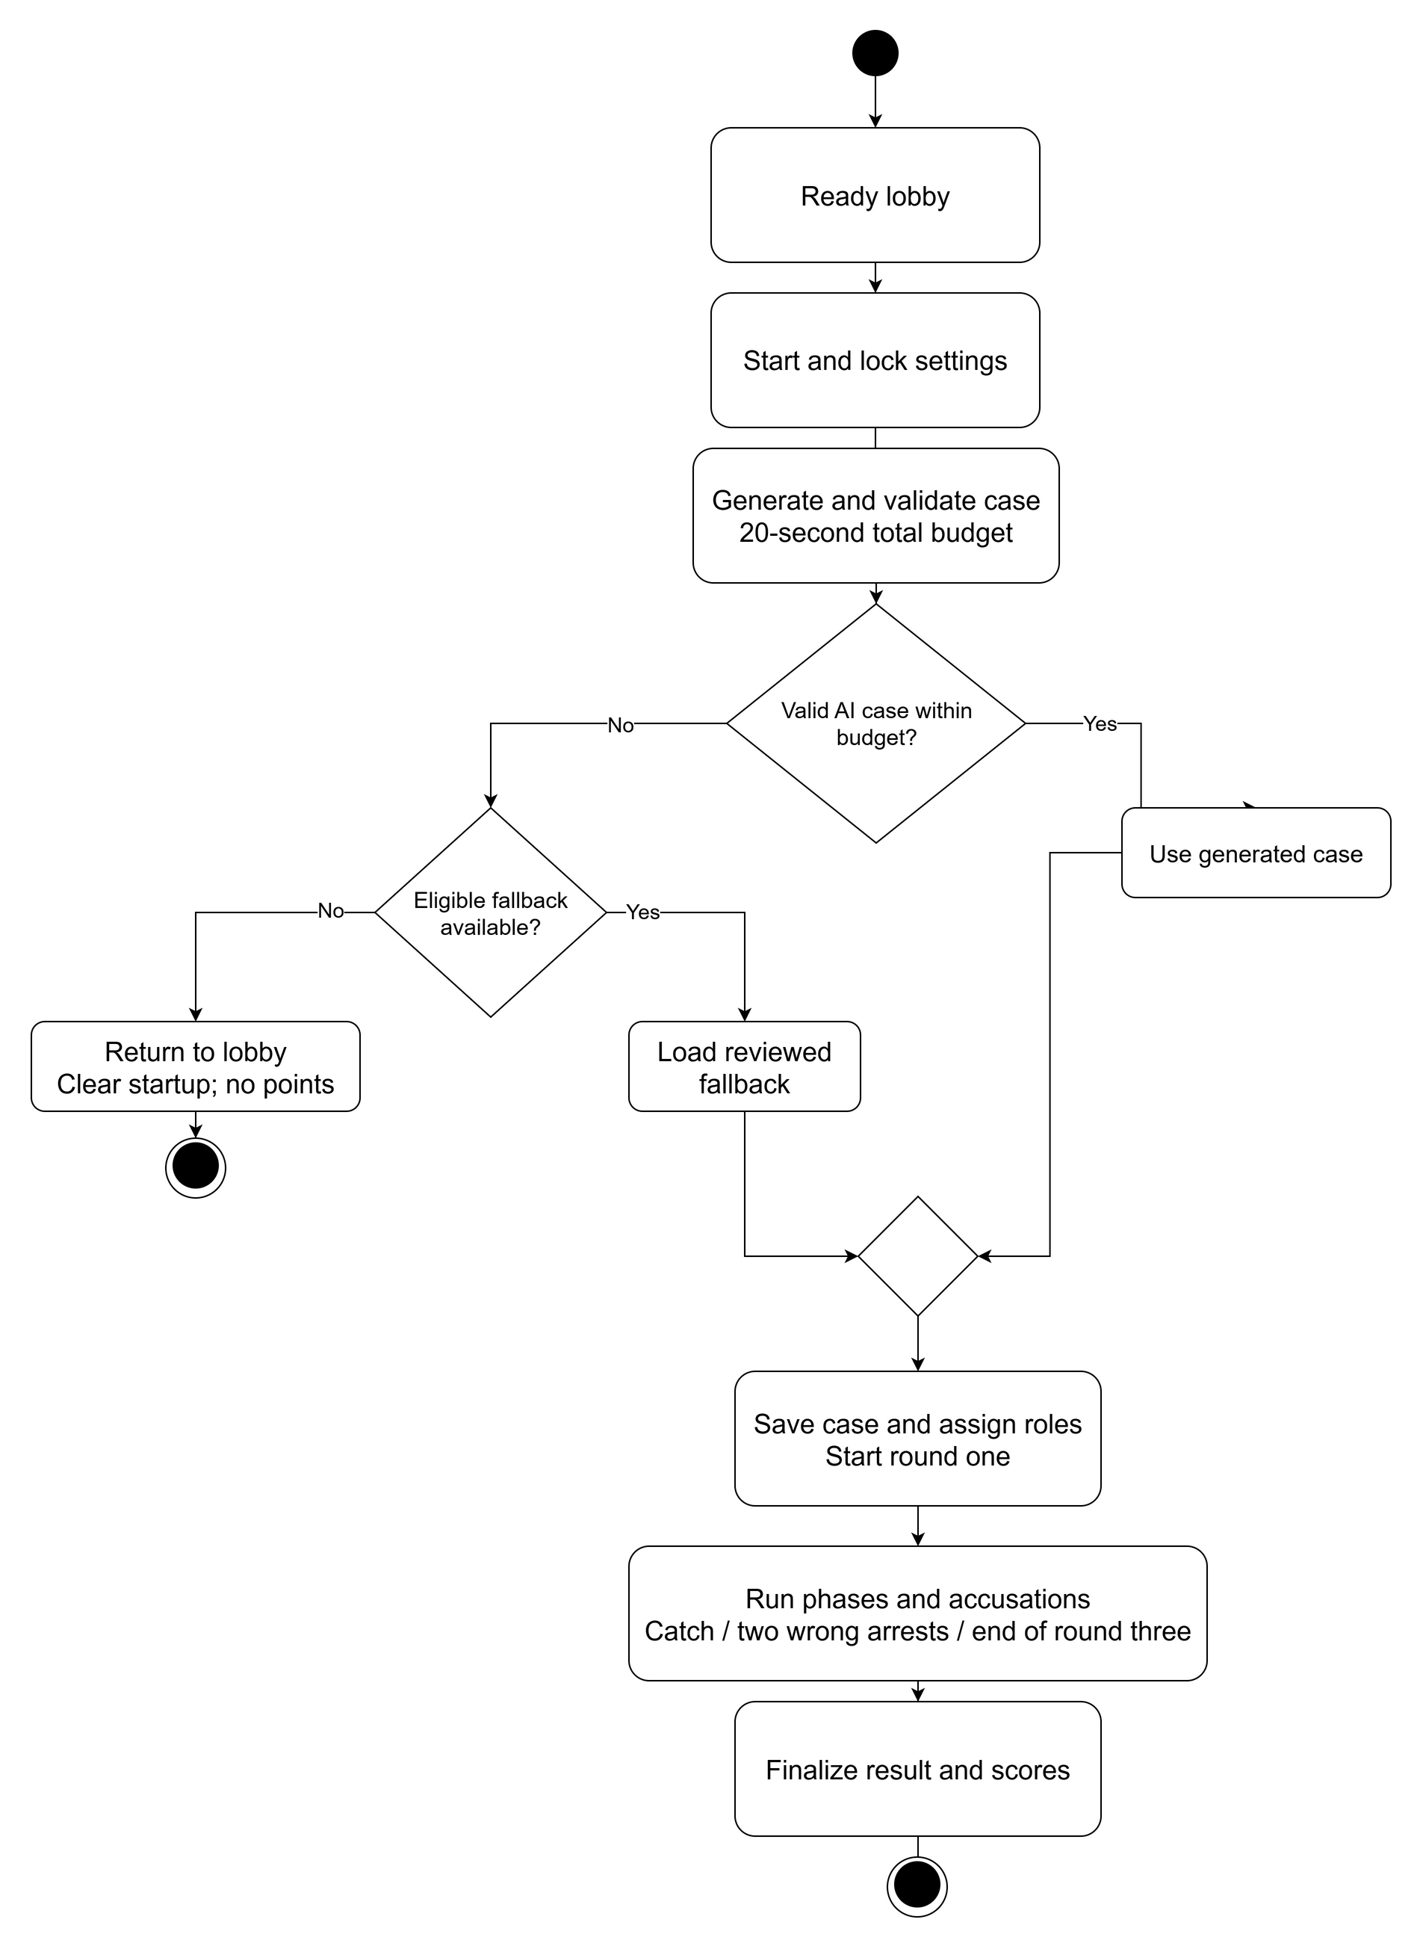
Figure 11. Startup and play activity. Invalid or late AI output uses a reviewed fallback. With no eligible fallback, startup ends in the lobby without points.

Round and Timer Rules
Initial phase defaults are 30 seconds for Briefing, 90 for Statements, 120 for Questioning, 30 for Clue Release, and 45 for Accusation. They are configurable before a game and frozen at startup. Each round follows Briefing, Statements, Questioning, Clue Release, and Accusation. At most one arrest can be resolved in the round. After a non-terminal arrest, move to the next round; after round three, finalize the criminal win if no catch occurred. Phase expiry makes unanswered questions final and rejects late submissions. A stale timer carries its expected state version and cannot advance a newer phase.

State and Reconnection Rules
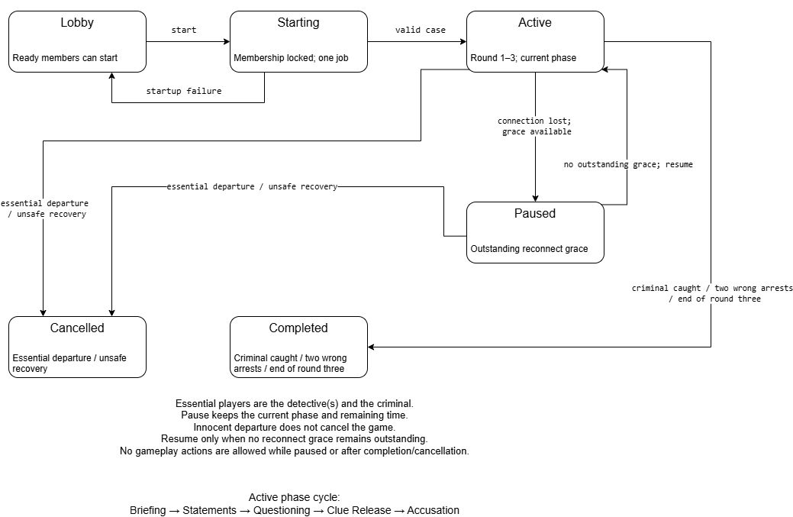
Figure 12. Lifecycle state view. Paused is a logical Active substate represented by PauseStartedAt and outstanding grace deadlines.
During shared pause, reject gameplay submissions and freeze the remaining phase duration. Each player has one 60-second grace per game. Only losing the last live connection starts grace, so closing one of several tabs does not disconnect the member. Reconnecting as the same account restores the same role and authorized state.
Resume after all outstanding grace periods resolve, adding the actual wall-clock pause interval once. A later loss, deliberate leave or expired grace marks departure. Innocent departure continues play; criminal or detective departure cancels without points or solution reveal. A spectator leaving has no additional effect on active play.
After restart, read persisted jobs, game state, presence and deadlines. Resume recoverable work under a lease and reject stale workers by state version. An expired phase advances at most once. If the stored state is incomplete or cannot be trusted, cancel without scores. Test restart and overlapping grace explicitly before release.

