The Last Clue
  - UI UX Design and Prototypes
Digital Egypt Pioneers Initiative | Full Stack .NET
Analysis and design submission deadline: 6 November 2026
The screens below define the layout, navigation and role restrictions for the first release. They are wireframes for implementation, with fictional values used to show screen content.
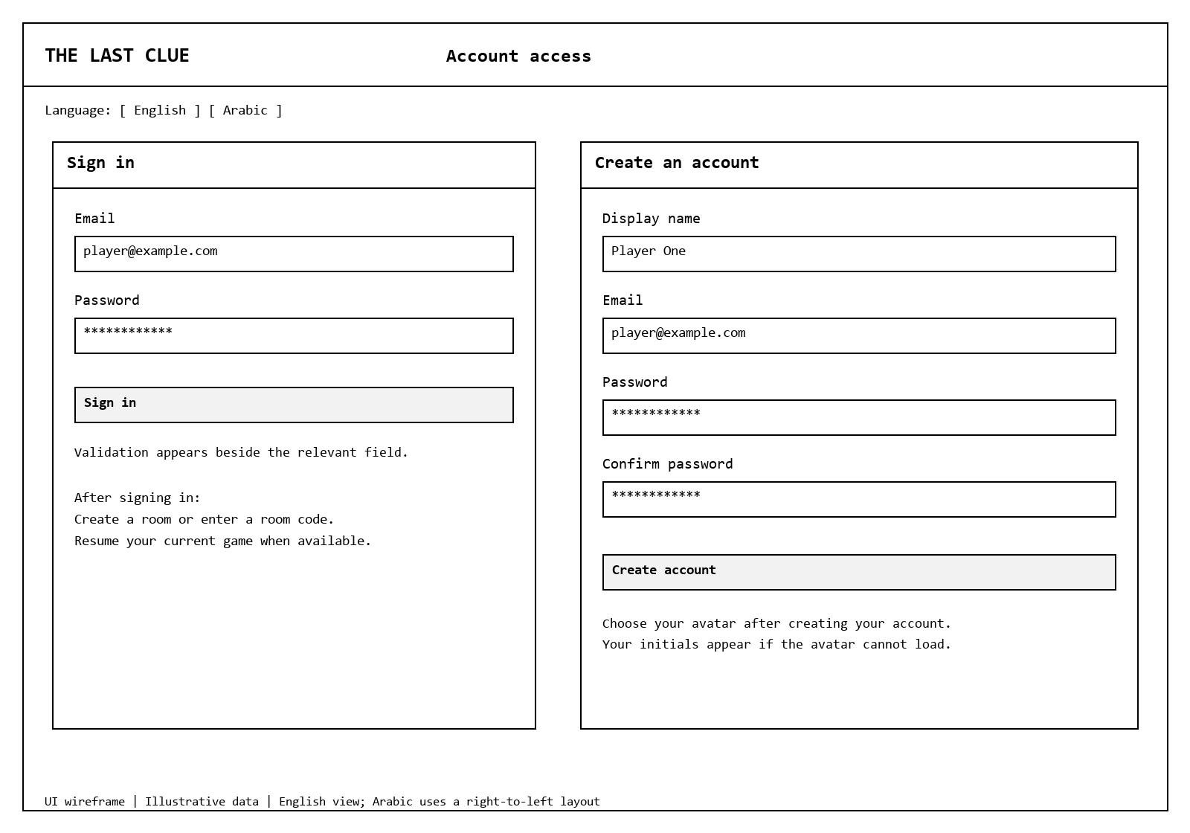
Figure 13. Sign-in and registration layouts. Room creation, joining and resuming become available after sign-in.

Account and Home Behavior
Use field labels, inline validation and a general sign-in error. After login, show Create Room and Join by Code. If the account already belongs to an unfinished game, show Resume rather than allowing a second membership. A failed avatar request shows local initials. Never include private case content in page source or hidden HTML.

Lobby and Case Loading
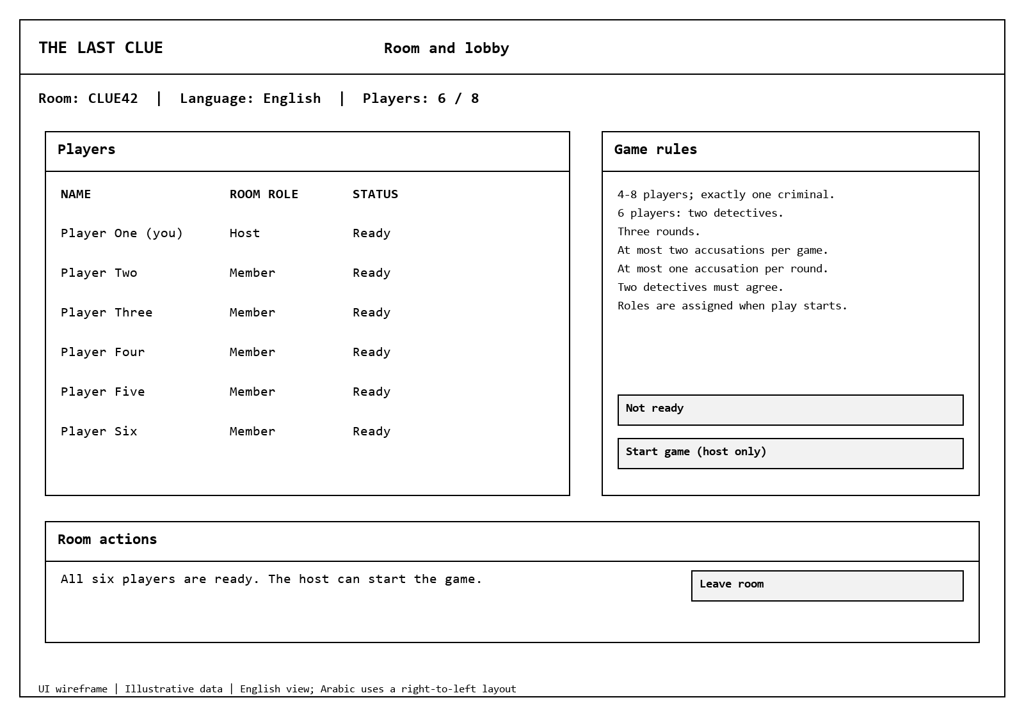
Figure 14. Lobby wireframe. Readiness, capacity and host controls are public; secret roles are assigned only after a valid case is saved.
Room creation chooses English or Arabic. The lobby displays the code, players, connection status and readiness. Room codes are generated with a cryptographically secure random generator and checked for uniqueness. Only the host sees an enabled Start control when all 4-8 members are ready. Membership changes clear readiness. A host leaving before play transfers hosting to the longest-present connected member.
After Start, show a loading message and disable repeated starts. A generated or stored case opens the same game screen. If startup fails, return to the lobby with a short retry message. Technical provider names, error traces and fallback internals do not need to appear in the player flow.

Game Board and Reconnection
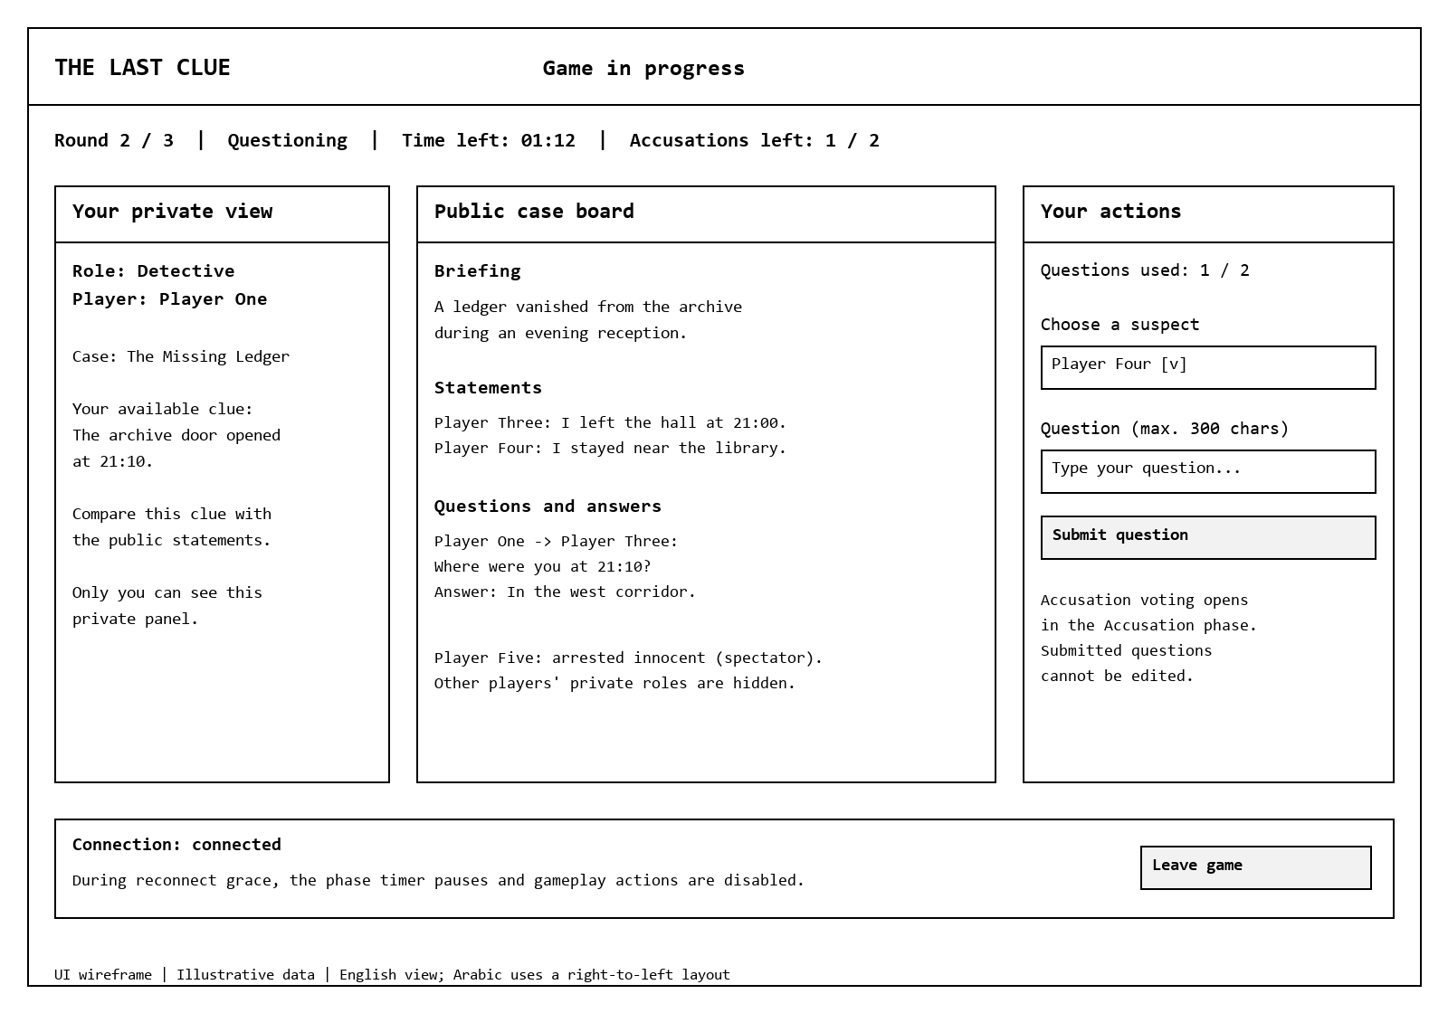
Figure 15. Game board wireframe. The private panel is different for each authorized player.
Player state | Visible controls and information
Detective | Own clues, public statements, questions and responses; up to two question submissions per round; final target choice during Accusation.
Active suspect | Own script, allowed clues, one statement per round and answers only to questions addressed to this character. Criminal truth stays in the criminal private view.
Spectator | Public board and revealed innocent status. No action inputs and no new private clues.
Paused or reconnecting | Clear reconnect banner and paused phase time. Disable gameplay actions while pause is active; retry state loading after reconnect.
All players | Round, phase, remaining time and accusations left. Confirmation before deliberate leave; explain that leaving affects the session without revealing another role.

Results and Player Progress
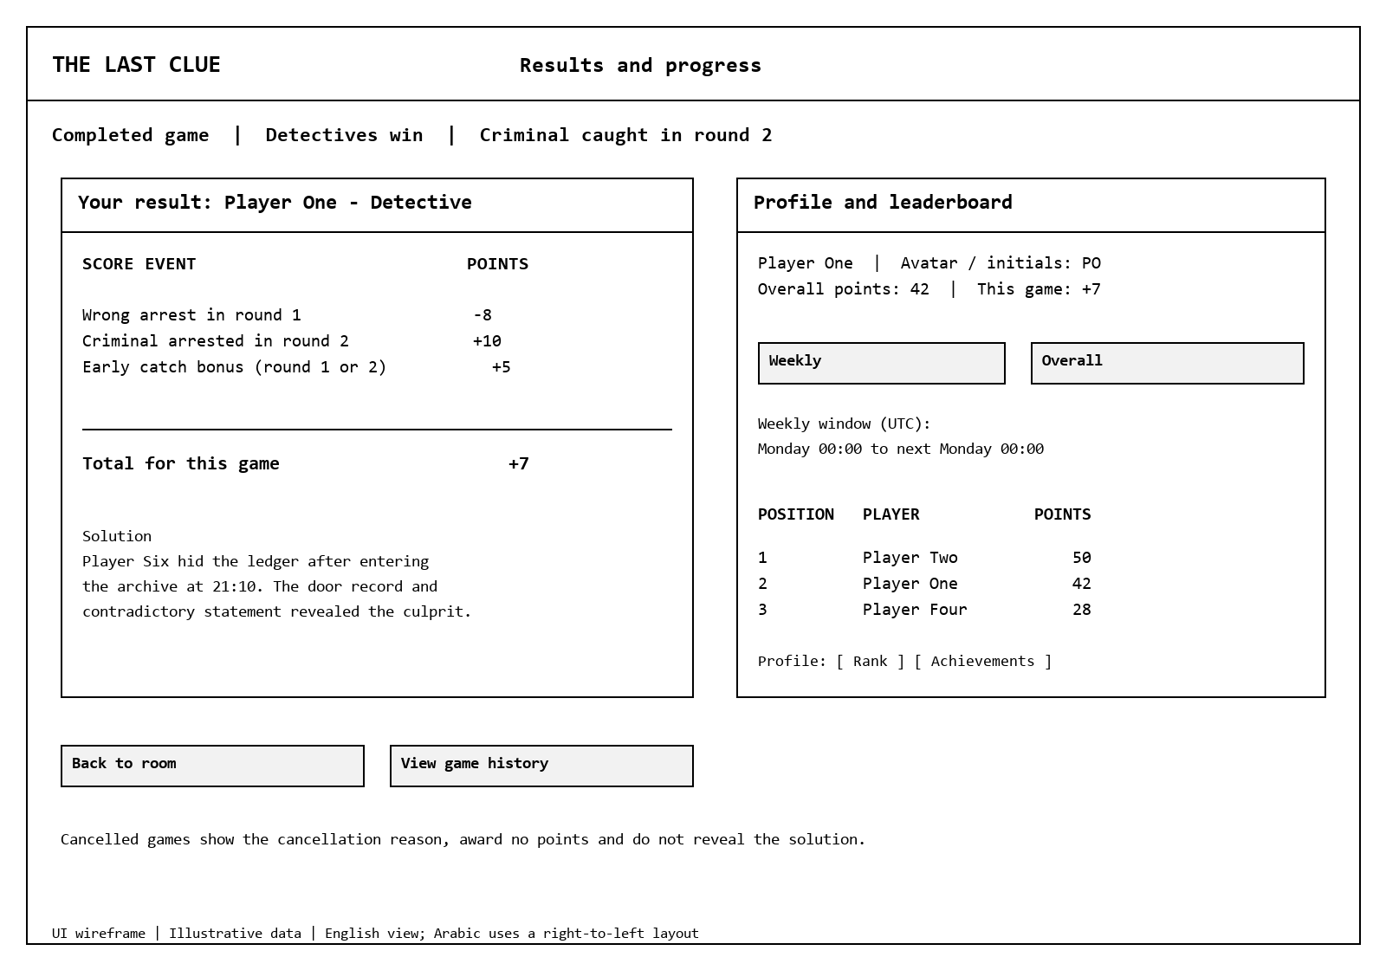
Figure 16. Example completed game. One wrong arrest followed by a round-two catch gives each detective -8 + 10 + 5 = 7 points. The solution is available only after completion.
The game screen and result use the same example: Player Five was wrongly arrested in round one, one accusation remains during round two, and Player Six is later caught. The account names, case titles and totals are illustrative.
Completed results show the final solution and each player's score breakdown. A cancelled game shows its reason and zero score effect without a solution. Profiles show own history, total points, rank and achievements. Weekly leaderboards label the UTC week, and empty history has a clear empty state.

Administration and Case Review
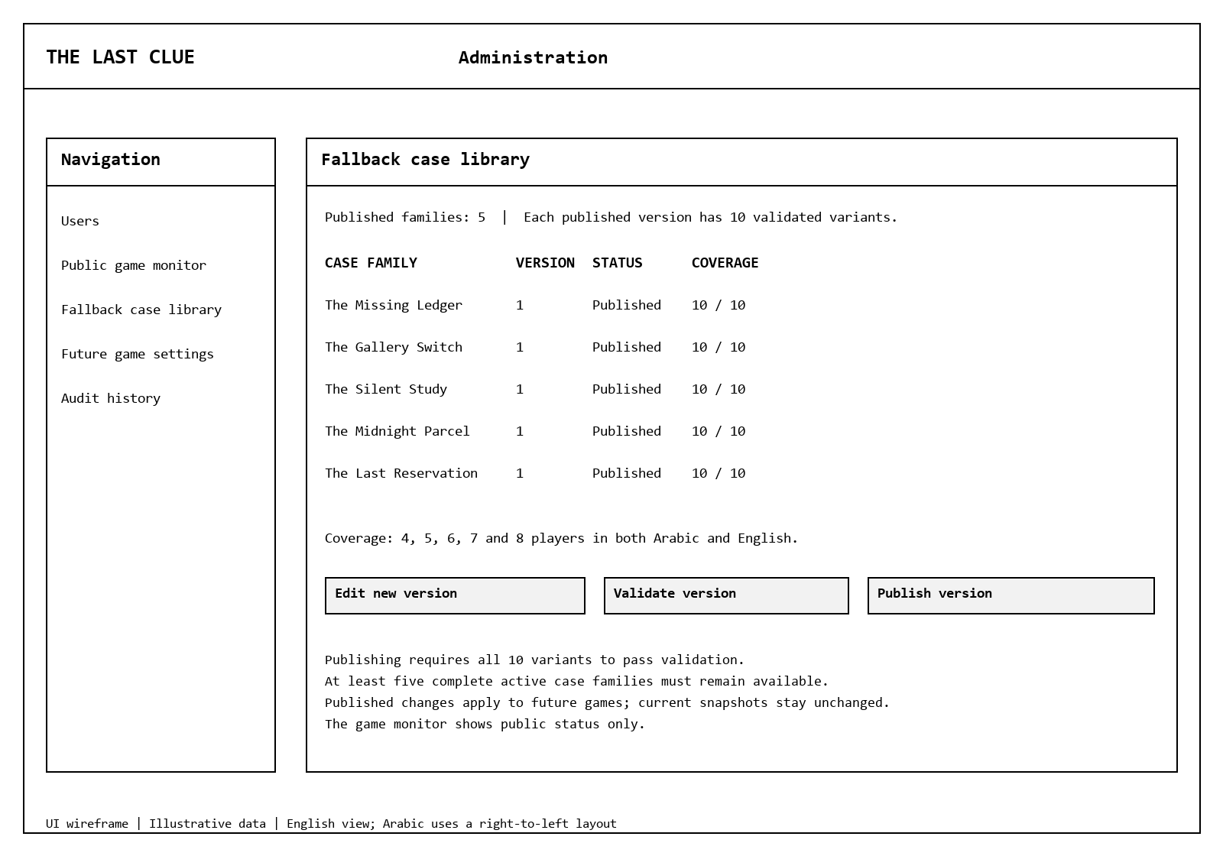
Figure 17. Case administration layout with sample rows. Published coverage means five player counts in both languages. Actual case content must be written, reviewed and validated before use.

Navigation and Visual Guidelines
Area | Design rule
Navigation | Account > Home > Lobby > Loading > Game > Result > Lobby or Home. Home also links to Profile and Leaderboards. Admin navigation is shown only to authorized accounts.
Layout | Use a fluid Bootstrap layout. At 360 px width, stack the private panel, public board and actions in that order. Keep core buttons visible and avoid horizontal page scrolling.
Typography | Use a readable system font stack with Arabic support; 16 px base body text and larger headings. Use logical CSS properties so spacing and alignment follow language direction.
Colors | Use a white or pale background, dark navy text (#17354B), blue primary controls (#25435E), and dark red errors (#A32626). Verify at least 4.5:1 text contrast. Add words or icons so status does not depend on color.
Accessibility | Provide keyboard access, visible focus, explicit labels and associated error descriptions. Announce phase and connection changes without moving keyboard focus away from an active input.
Feedback | Disable a submitted action until its response arrives. Show request outcome and remaining quota. On a conflict, reload current state and explain the expired phase or already-submitted action.
Arabic and English | Translate controls, phase names, errors and instructions. Apply RTL to Arabic screens while keeping codes and timestamps readable. Test long player names in both languages.
Privacy | Request a dedicated role-scoped view; do not fetch full hidden data and conceal it with CSS. Admin monitoring excludes active scripts, criminal identity and unrevealed clues.

Usability checks will cover login, joining, readiness, one complete round, accusation, reconnect, and result navigation in both languages. Record observations from the planned pilot and adjust unclear labels before the final demonstration.

