The Last Clue
  - Deployment and Integration Design
Digital Egypt Pioneers Initiative | Full Stack .NET
Analysis and design submission deadline: 6 November 2026
The first release uses one Azure App Service instance and Azure SQL. This keeps live sessions and timer workers manageable while preserving durable state in SQL for recovery.
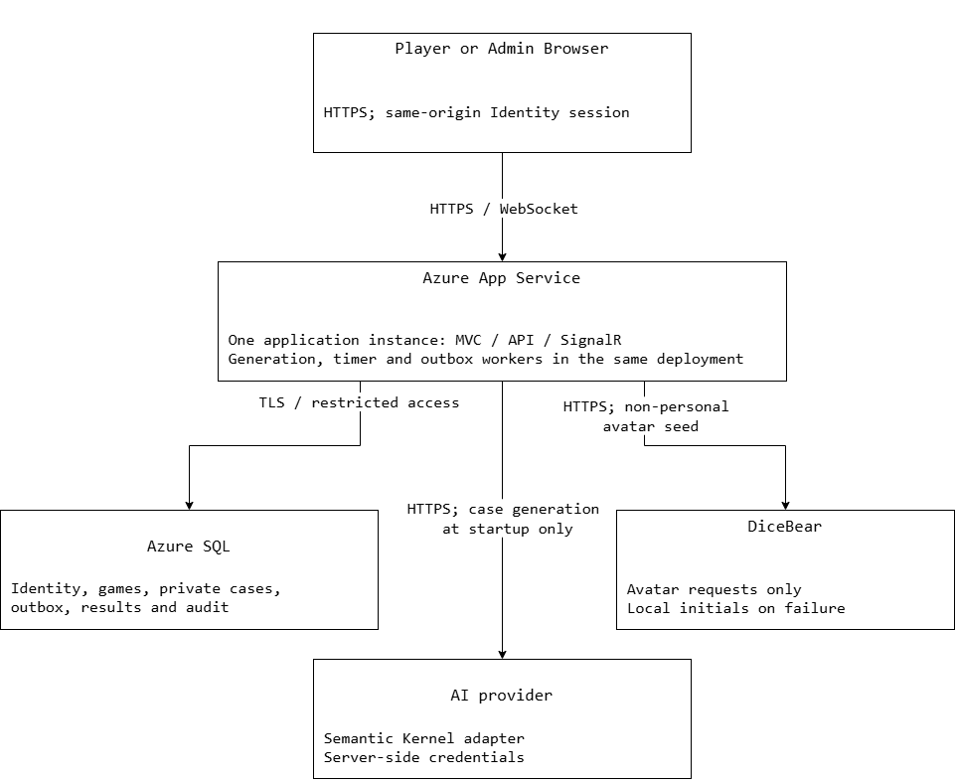
Figure 18. One App Service instance hosts MVC, API, SignalR and generation, timer and outbox workers. Provider calls use HTTPS; SQL connections use TLS and restricted access.

Hosting and Operational Boundaries
The application hosts MVC, REST endpoints, the SignalR hub and background workers. Enable WebSockets and keep the app running during scheduled testing. Configure the database connection, provider credentials and Identity data-protection key storage through protected deployment configuration. Do not commit environment secrets.
SQL is the source of truth for game state, job leases and results. The timer worker uses persisted deadlines and checks state versions before advancing. The outbox worker sends events only after database commit. Loss of a SignalR event is repaired by authorized state reload.

Technology Stack and Integration Contracts
Component | Selected approach and purpose
Web application | ASP.NET Core MVC and Web API, Razor Views, Bootstrap 5, JavaScript/jQuery. Same-origin authenticated UI and REST writes.
Live updates | SignalR at /hubs/game. Server-authorized room and game subscriptions; separate public and per-user payloads.
Data access | Entity Framework Core with SQL Server in development and Azure SQL in deployment. Repository and Unit of Work interfaces separate persistence from business rules.
Authentication | ASP.NET Identity with Player/Admin account roles, secure cookies and antiforgery validation for browser writes. Game-role authorization is checked separately.
AI generation | Semantic Kernel with a Gemini provider adapter behind ICaseProvider. A shared deadline covers provider changes and retries. No runtime AI call is needed after case loading.
Fallback cases | At least five reviewed local case families with ten variants each. Select randomly, avoid the room's last completed family when alternatives exist, and retain an immutable game snapshot.
Avatar service | DiceBear with a non-personal seed. Return local initials when unavailable; avatar loading cannot block joining or playing.
Testing and delivery | xUnit, WebApplicationFactory and Playwright for unit, integration and critical UI checks. GitHub Actions builds, tests and publishes the deployment artifact.
Version control | Pin the chosen SDK and package versions in project configuration and the dependency lock file when setting up the solution. Record the actual versions in the setup guide.

Provider Validation and Failure Handling
Validate generated JSON before activation: supported language, required fields, unique character keys, correct role counts, one criminal, a hidden timeline and solution, three rounds of clues, and valid references. Reject oversized or unsuitable content. Structural validation cannot prove a mystery is solvable; review sample generated cases and every stored fallback variant for logical consistency.

Deployment Strategy and Scaling
Step | Required action
Build and test | Restore pinned dependencies, compile, run service/repository tests and critical checks, then produce one versioned artifact. Publish pipeline results without secrets.
Database release | Back up the target database, review generated migrations, and apply them once in a controlled release step. Do not let multiple application startups race to migrate the database.
Configuration | Provide connection strings, provider keys, allowed origin, logging levels and protected Identity key storage. Validate required configuration before accepting game startups.
Activate release | Schedule a maintenance window without active games. Deploy the tested artifact, verify /health and /health/ready, then run account, lobby, SignalR and full AI-outage smoke checks.
Rollback | Keep the previous artifact. Roll back application code only while database changes remain compatible; use reviewed recovery steps for destructive migrations. Never overwrite game history with an old backup while accepting live writes.
Monitor | Record endpoint latency, generation/fallback timing, outbox lag, phase failures and cancellation counts. Use correlation IDs and public metadata; exclude hidden case content from logs.
Recover | On restart, reload unfinished jobs and games, reclaim only expired leases, and replay unsent outbox messages. Cancel an unsafe unrecoverable session without scores.
Scale later | Before adding app instances, provide a SignalR scale-out service/backplane, shared Identity keys and cross-instance presence coordination. Keep SQL leases and game serialization. Multi-instance operation is outside the first demonstration configuration.

The design target remains one room with up to eight players for KPI timing measurements. A successful rehearsal is evidence for the demonstration environment; it does not claim production-wide availability or unlimited concurrent room capacity.

