The Last Clue
  - System Analysis and Design
Digital Egypt Pioneers Initiative | Full Stack .NET
Analysis and design submission deadline: 6 November 2026
This document brings together the architecture, database model, behavior diagrams, screen wireframes, deployment design, API contracts, and test plan for The Last Clue. It is the implementation reference for the agreed requirements.

Contents
1. System Analysis and Architecture
2. Database Design and Data Modeling
3. Data Flow and System Behavior
4. UI UX Design and Prototypes
5. Deployment and Integration Design
6. API Contracts and Testing Plan
The rules remain: 4-8 players, one criminal, three rounds, two accepted accusations per game and one per round. Five reviewed fallback case families keep startup available when AI is down. Every design section uses the same requirements identifiers and server authorization boundary.

The Last Clue
  - System Analysis and Architecture
Digital Egypt Pioneers Initiative | Full Stack .NET
Analysis and design submission deadline: 6 November 2026
This design turns the agreed requirements into components, data boundaries, and workflows for implementation. The game supports 4-8 players, one criminal, three rounds, and no more than two accepted accusations per game.

Problem and Objectives
A fixed mystery becomes predictable after its solution is known. We will generate new fictional cases and use reviewed saved cases when generation is unavailable. The system must keep players synchronized, protect role information, and save each completed result once.
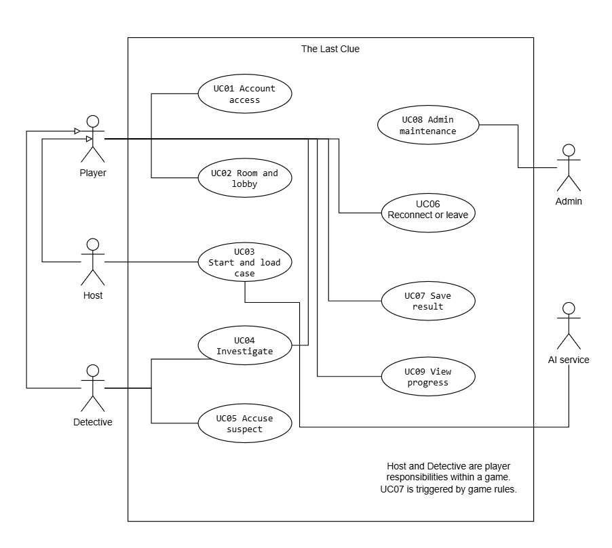
Figure 1. Main use cases and participating actors. The AI provider is an external system actor, not an account role.

Use Cases and Requirements Coverage
Use case | Interaction and alternative path | Requirements
UC01 Account access | Register or sign in; reject invalid details and blocked sign-in without exposing account existence. | FR01-FR02
UC02 Room and lobby | Create or join by code, mark ready, and transfer a departing host. Start requires all 4-8 members ready. | FR03-FR06
UC03 Start and load case | Lock startup settings; validate AI output or load a reviewed local case. Return to lobby if no valid case exists. | FR07-FR14
UC04 Investigate | One statement per suspect; two questions per detective each round; one answer per target question; release only authorized clues. | FR12, FR14-FR17, FR33
UC05 Accuse suspect | Accept a single detective choice or matching final votes from the pair. Catch ends play; two wrong arrests also end play. | FR18-FR21, FR26, FR33
UC06 Reconnect or leave | One 60-second grace per player with shared pause. Innocent departure continues; detective or criminal departure cancels. | FR22-FR25, FR34
UC07 Save result | Store outcome, cumulative score events, and achievements atomically; retries return the saved result. Cancellation awards nothing. | FR21, FR26-FR29
UC08 Admin maintenance | Manage users, public status, reviewed case versions, and future settings. Keep five complete active cases. | FR09-FR11, FR30-FR32
UC09 View progress | Show own profile, achievements and history, plus overall and weekly rankings. Keep active solutions private. | FR27-FR29

Detailed actor, precondition, main flow, alternative flow, and result descriptions remain in the Requirements Gathering user stories and use cases document. These use case IDs are unchanged.

Quality Requirements
NFR01-NFR07 guide authentication, authorization, safe input, secrets, and diagnostics. NFR08-NFR14 guide API timing, AI failover, valid output, live events, availability, transactions, and recovery. NFR15-NFR21 guide Arabic/English usability, accessibility, maintainability, deployment, coverage, and pilot testing. The acceptance measures stay aligned with KPIs K1-K7.

Architecture and Component Responsibilities
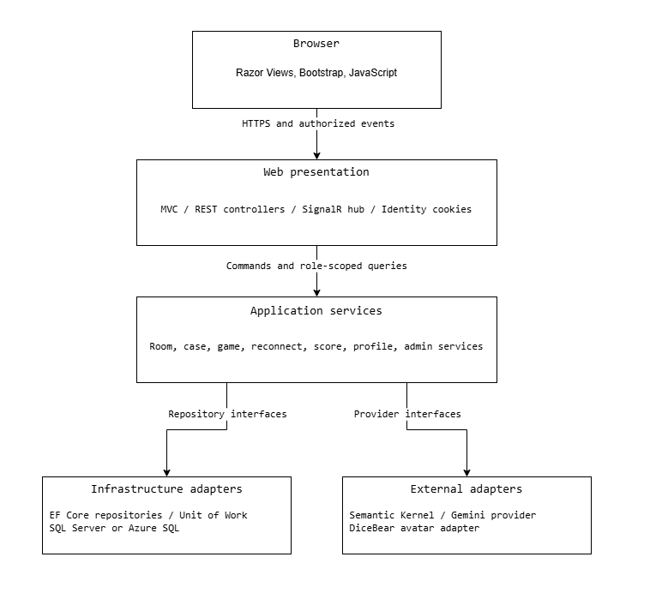
Figure 2. Runtime components and service interfaces. Infrastructure implements interfaces owned by the application layer.
Layer | Responsibility and dependency rule
Web | MVC views, REST endpoints, Identity integration, DTO mapping and SignalR transport. Controllers delegate game decisions to services.
Application and domain | Game rules, authorization policies, state transitions, score calculations, validation, and interfaces. No dependency on browser code or concrete provider clients.
Infrastructure | EF Core repositories, Unit of Work, SQL persistence, AI and avatar adapters. Repository calls do not decide winners or publish secret data.
Workers | Durable startup jobs, deadlines, reconnect grace expiry, and outbox dispatch. Workers call the same application services as requests.

Classes and Consistency Boundaries
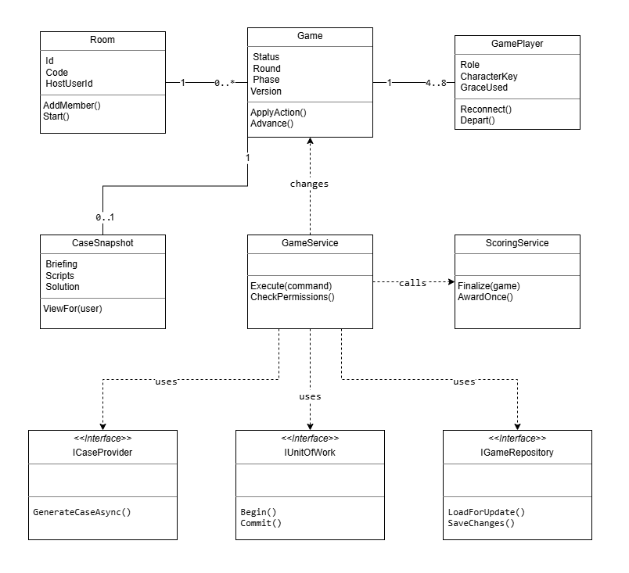
Figure 3. Selected classes and interfaces. Solid lines show associations; dashed arrows show service dependencies. The 4-8 player count applies after activation; a case snapshot is optional during startup.
Game is the consistency boundary for actions and phase transitions. A service loads the current game, checks the authenticated actor and server time, applies one legal change, and commits with a concurrency token. Provider calls run outside database transactions. Public APIs receive commands, never a client-selected role or score.
The first deployment runs one application instance. SQL holds authoritative state; memory may cache it but cannot replace it. SignalR groups are transport destinations only. Every connection and reconnect is authorized again, and safe DTOs are built separately for public, private, spectator, and admin views.

The Last Clue
  - Database Design and Data Modeling
Digital Egypt Pioneers Initiative | Full Stack .NET
Analysis and design submission deadline: 6 November 2026
The database stores accounts, room membership, private game snapshots, player actions, and completed results. Historical games keep their own case and settings so later administration changes cannot rewrite a played game.

Core Relationships
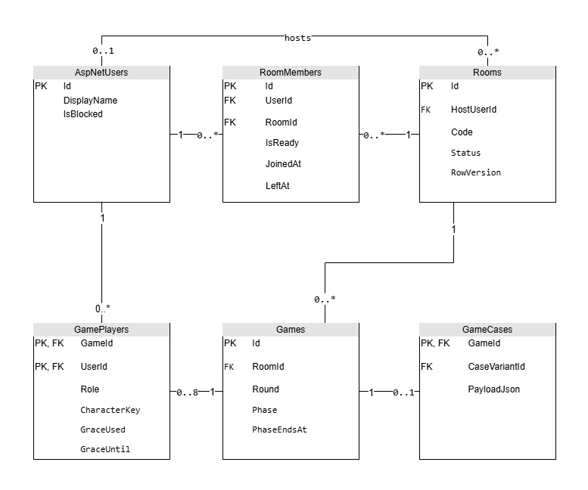
Figure 4. Core entities. PK denotes a primary key and FK a foreign key. A game can hold 0-8 player records while starting, but activation requires 4-8. A room can temporarily have no host.
One room has many historical games, but at most one Starting or Active game at a time. Each active game starts with 4-8 GamePlayers. ASP.NET Identity owns login, password hashes, and account roles; game roles are stored only in GamePlayers.

Normalization and Snapshots
Membership, actions, clues, and scores use separate tables to avoid repeated groups. The model follows third normal form for relational records. Immutable case and settings JSON are deliberate snapshots of versioned input, not editable copies of shared current settings.

Game Actions and Clue Relationships
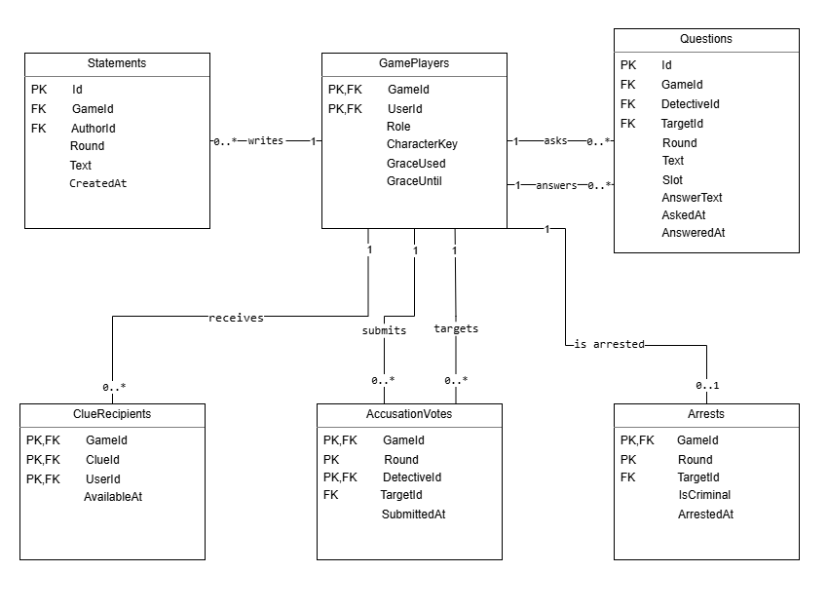
Figure 5. Action entities are scoped by GameId. All actor and target references must identify members of the same game.
Statements are unique per game, round, and author. Questions use a slot of 1 or 2 for each detective in a round, and hold at most one answer. Votes are immutable final choices per detective and round. An arrest is unique per game and round, and each target can be arrested only once in that game. Each GamePlayer therefore has zero or one arrest record. The service enforces no more than two arrests across the game.
GameClues define a round and audience. ClueRecipients records delivery eligibility for a specific GamePlayer. A released clue can be read again after reconnect without applying its release effects twice. A spectator receives public state, but no newly released private clues.

Case Versions and Progress Relationships
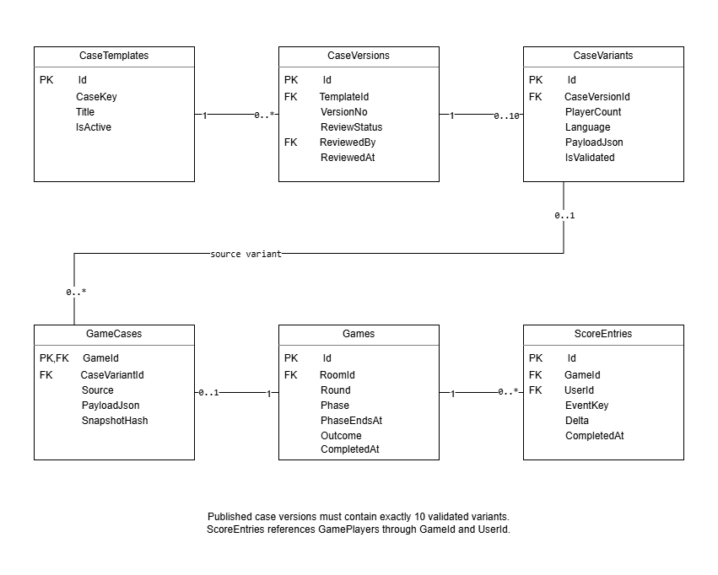
Figure 6. A draft version may contain 0-10 variants; publication requires exactly ten reviewed and validated variants. AI snapshots have no source variant. Scores refer to the composite GamePlayers key GameId and UserId.
Each of the five or more published case families has one current reviewed version covering 4, 5, 6, 7, and 8 players in English and Arabic. Historical versions remain available for references. A generated case has no CaseVariantId; a saved fallback case records its source variant. Both become an immutable GameCases snapshot.
Scores refer to GamePlayers. PlayerAchievements refers to its user, achievement definition, and awarding game. RankDefinitions stores named thresholds; the lowest rank covers negative totals. Neither ranks nor achievements are calculated from live unpublished game events.

Accounts Rooms and Runtime Schema
Physical SQL Server types are shown below. Composite primary keys containing Identity string IDs use NONCLUSTERED indexes; use surrogate clustered keys if later volume requires them. PK columns are NOT NULL. Other columns are NOT NULL unless marked nullable. All datetime2 values use UTC. Identity creates its standard supporting tables through migrations.
Entity | Columns and constraints
AspNetUsers | Identity string key Id nvarchar(450); Identity-managed account fields; DisplayName nvarchar(80); AvatarSeed nvarchar(80); IsBlocked bit; CreatedAt datetime2(3).  Standard Identity tables keep roles, claims, logins and tokens.
Rooms | Id uniqueidentifier PK; Code varchar(12); HostUserId nvarchar(450) nullable; Language char(2); Status varchar(16); CreatedAt datetime2(3); StateVersion bigint; RowVersion rowversion.  HostUserId -> AspNetUsers. Unique Code; Language en/ar; Status Lobby/Starting/Active/Closed.
RoomMembers | Id uniqueidentifier PK; RoomId uniqueidentifier; UserId nvarchar(450); JoinedAt datetime2(3); LeftAt datetime2(3) nullable; IsReady bit.  RoomId -> Rooms; UserId -> AspNetUsers. Unique room/user; filtered unique UserId where LeftAt IS NULL.
Games | Id uniqueidentifier PK; RoomId uniqueidentifier; Number int; Status varchar(16); IsRunning bit; Round tinyint; Phase varchar(20); PhaseEndsAt datetime2(3) nullable; PauseStartedAt datetime2(3) nullable; AccusationsUsed tinyint; SettingsVersionId uniqueidentifier; SettingsJson nvarchar(max); StateVersion bigint; CreatedAt datetime2(3); CompletedAt datetime2(3) nullable; Outcome varchar(24) nullable; CancellationReason nvarchar(200) nullable; RowVersion rowversion.  RoomId -> Rooms; SettingsVersionId -> SettingsVersions. Status Starting/Active/Completed/Cancelled. Unique room/number; filtered unique RoomId for unfinished games via IsRunning bit maintained in the transaction.
GamePlayers | GameId uniqueidentifier + UserId nvarchar(450) composite PK; Role varchar(12); CharacterKey varchar(40) nullable; PrivateScript nvarchar(max); IsActive bit; IsArrested bit; GraceUsed bit; GraceUntil datetime2(3) nullable; DepartedAt datetime2(3) nullable.  GameId -> Games; UserId -> AspNetUsers. Unique game/character for non-null CharacterKey. Detective/Criminal/Innocent roles.
SettingsVersions | Id uniqueidentifier PK; VersionNo int; ValuesJson nvarchar(max); PublishedAt datetime2(3); ChangedBy nvarchar(450).  ChangedBy -> AspNetUsers; unique VersionNo; valid JSON. Games retain a copy, including scoring, durations and rank/achievement definitions.
PlayerConnections | ConnectionId nvarchar(128) PK; GameId uniqueidentifier; UserId nvarchar(450); LastSeenAt datetime2(3); ClosedAt datetime2(3) nullable.  GameId/UserId -> GamePlayers. Presence is lost only when all live connections for the member are gone.

Cases Clues and Startup Schema
Physical SQL Server types are shown below. Composite primary keys containing Identity string IDs use NONCLUSTERED indexes; use surrogate clustered keys if later volume requires them. PK columns are NOT NULL. Other columns are NOT NULL unless marked nullable. All datetime2 values use UTC. Identity creates its standard supporting tables through migrations.
Entity | Columns and constraints
CaseTemplates | Id uniqueidentifier PK; CaseKey varchar(60); Title nvarchar(120); IsActive bit.  Unique CaseKey. Five active complete families are a transactional library invariant.
CaseVersions | Id uniqueidentifier PK; TemplateId uniqueidentifier; VersionNo int; ReviewStatus varchar(16); ReviewedBy nvarchar(450) nullable; ReviewedAt datetime2(3) nullable.  TemplateId -> CaseTemplates; ReviewedBy -> AspNetUsers. Unique template/version. Draft/Reviewed/Published/Retired.
CaseVariants | Id uniqueidentifier PK; CaseVersionId uniqueidentifier; PlayerCount tinyint; Language char(2); PayloadJson nvarchar(max); IsValidated bit.  CaseVersionId -> CaseVersions. Unique version/count/language; count 4-8; en/ar; valid JSON.
GameCases | GameId uniqueidentifier PK; CaseVariantId uniqueidentifier nullable; Source varchar(12); PayloadJson nvarchar(max); SnapshotHash char(64).  GameId -> Games; CaseVariantId -> CaseVariants. Source AI/Fallback; valid JSON. AI requires a null source variant; Fallback requires a source variant. Hidden solution never leaves authorized views.
GameClues | Id uniqueidentifier PK; GameId uniqueidentifier; ClueKey varchar(60); Round tinyint; Audience varchar(12); CharacterKey varchar(40) nullable; Body nvarchar(2000); ReleasedAt datetime2(3) nullable.  GameId -> Games. Unique game/clue key; round 1-3; Public/Detectives/Character. Unique GameId/Id supports composite recipient FK.
ClueRecipients | GameId uniqueidentifier + ClueId uniqueidentifier + UserId nvarchar(450) composite PK; AvailableAt datetime2(3).  GameId/ClueId -> GameClues; GameId/UserId -> GamePlayers. Recipient inclusion follows role and active status at release.
GenerationJobs | Id uniqueidentifier PK; GameId uniqueidentifier; RequestId uniqueidentifier; Status varchar(16); DeadlineAt datetime2(3); LeaseUntil datetime2(3) nullable; Attempts int; LastErrorCode varchar(40) nullable.  GameId -> Games, unique GameId and RequestId. Pending/Running/Succeeded/Failed; total AI deadline is durable.

Actions and Score Schema
Physical SQL Server types are shown below. Composite primary keys containing Identity string IDs use NONCLUSTERED indexes; use surrogate clustered keys if later volume requires them. PK columns are NOT NULL. Other columns are NOT NULL unless marked nullable. All datetime2 values use UTC. Identity creates its standard supporting tables through migrations.
Entity | Columns and constraints
Statements | Id uniqueidentifier PK; GameId uniqueidentifier; Round tinyint; AuthorId nvarchar(450); Text nvarchar(1000); CreatedAt datetime2(3).  GameId/AuthorId -> GamePlayers. Unique game/round/author; non-empty; round 1-3.
Questions | Id uniqueidentifier PK; GameId uniqueidentifier; Round tinyint; DetectiveId nvarchar(450); Slot tinyint; TargetId nvarchar(450); Text nvarchar(300); AnswerText nvarchar(1000) nullable; AskedAt datetime2(3); AnsweredAt datetime2(3) nullable.  Both game/detective and game/target -> GamePlayers. Unique game/round/detective/slot; slot 1-2. One target-owned answer.
AccusationVotes | GameId uniqueidentifier + Round tinyint + DetectiveId nvarchar(450) composite PK; TargetId nvarchar(450); SubmittedAt datetime2(3).  Both game/detective and game/target -> GamePlayers. Votes cannot be edited after acceptance.
Arrests | GameId uniqueidentifier + Round tinyint composite PK; TargetId nvarchar(450); IsCriminal bit; ArrestedAt datetime2(3).  GameId/TargetId -> GamePlayers. Unique game/target. Winner and budget rules checked under the game transaction.
PendingScoreEvents | Id uniqueidentifier PK; GameId uniqueidentifier; UserId nvarchar(450); EventKey varchar(80); Delta int.  GameId/UserId -> GamePlayers. Unique game/user/event key. Hidden until finalization; never counted by leaderboards.
ScoreEntries | Id uniqueidentifier PK; GameId uniqueidentifier; UserId nvarchar(450); EventKey varchar(80); Delta int; CompletedAt datetime2(3).  GameId/UserId -> GamePlayers. Unique game/user/event key. Copy pending events only for Completed games; never for cancellation.

Progress Audit and Delivery Schema
Physical SQL Server types are shown below. Composite primary keys containing Identity string IDs use NONCLUSTERED indexes; use surrogate clustered keys if later volume requires them. PK columns are NOT NULL. Other columns are NOT NULL unless marked nullable. All datetime2 values use UTC. Identity creates its standard supporting tables through migrations.
Entity | Columns and constraints
RankDefinitions | Id uniqueidentifier PK; Code varchar(40); Name nvarchar(80); MinPoints int; SettingsVersionId uniqueidentifier.  SettingsVersionId -> SettingsVersions. Unique version/code and version/threshold; ascending thresholds.
Achievement  Definitions | Id uniqueidentifier PK; Code varchar(40); Name nvarchar(80); CriteriaJson nvarchar(max); SettingsVersionId uniqueidentifier.  SettingsVersionId -> SettingsVersions. Unique version/code; valid JSON. Definitions use completed games only.
PlayerAchievements | UserId nvarchar(450) + AchievementCode varchar(40) composite PK; DefinitionId uniqueidentifier; GameId uniqueidentifier; AwardedAt datetime2(3).  UserId -> AspNetUsers; DefinitionId -> AchievementDefinitions; GameId/UserId -> GamePlayers. Stable code prevents duplicate awards across versions.
AdminAudit | Id uniqueidentifier PK; ActorId nvarchar(450); Action varchar(60); EntityType varchar(40); EntityId nvarchar(450); OccurredAt datetime2(3); SafeDetailsJson nvarchar(max).  ActorId -> AspNetUsers. Store changed metadata and references; no keys, private scripts or case solution.
ActionReceipts | Id uniqueidentifier PK; UserId nvarchar(450); GameId uniqueidentifier nullable; RequestId uniqueidentifier; PayloadHash char(64); ResponseJson nvarchar(max); CreatedAt datetime2(3).  UserId -> AspNetUsers; GameId -> Games. Unique user/request ID. Reuse with a different payload returns 409; recheck visibility on replay.
OutboxMessages | Id uniqueidentifier PK; RoomId uniqueidentifier nullable; GameId uniqueidentifier nullable; StateVersion bigint; Audience varchar(16); UserId nvarchar(450) nullable; EventType varchar(40); PayloadJson nvarchar(max); CreatedAt datetime2(3); DispatchedAt datetime2(3) nullable.  RoomId -> Rooms; GameId -> Games. Exactly one room or game target is required. Optional GameId/UserId -> GamePlayers for private game events. Room events use Rooms.StateVersion. Dispatch after commit and deduplicate by event ID; Public payloads contain no secrets.

Integrity Indexes and Transaction Rules
Rule | Database and service enforcement
Running game | Unique filtered index Games(RoomId) WHERE IsRunning = 1. IsRunning is true only for Starting/Active; false for Completed/Cancelled. A paused game remains Active.
Character and criminal counts | Unique non-null game/character index. The startup service validates exactly one criminal, 1 or 2 detectives and 4-8 participants before one atomic activation.
Case publication | Bootstrap the first five reviewed complete families in one transaction before enabling startup. Serialize later publication and retirement on the case library transaction. Require ten valid reviewed variants for each published version, one current published version per family through a filtered unique TemplateId index for Published status, and at least five active complete families.
Membership and quotas | Unique active RoomMembers(UserId) prevents parallel room membership. Composite FKs keep actors in the same game. Quotas and role checks are enforced by services inside the game transaction.
JSON and indexes | Use ISJSON checks for payloads and snapshots. Index Games(Status,PhaseEndsAt), GenerationJobs(Status,LeaseUntil), OutboxMessages(DispatchedAt,CreatedAt), and ScoreEntries(CompletedAt,UserId), including Delta.
Atomic results | Under one transaction: set Completed, copy pending score events, award progress, save an action receipt and outbox messages. Cancellation writes no ScoreEntries or achievements. Negative score deltas are allowed.
Concurrency | Use Rooms/Games rowversion and a serialized game write lock. Increment StateVersion once per committed transition. Retry safe conflicts by reloading and checking current phase; never rerun a provider call inside a retry.
Retention and removal | Do not cascade-delete historical games, snapshots or scores when accounts are blocked. No destructive admin delete endpoint is exposed. Logs exclude case content and credentials; database backups include private snapshots and require restricted access.

Games.CompletedAt is null until a Completed or Cancelled terminal outcome is stored; ScoreEntries.CompletedAt uses the completed game time. Weekly rankings aggregate only Completed games from Monday 00:00 UTC up to, but not including, the next Monday, then use stable user ID to break equal totals.

The Last Clue
  - Data Flow and System Behavior
Digital Egypt Pioneers Initiative | Full Stack .NET
Analysis and design submission deadline: 6 November 2026
These diagrams describe startup, player actions, phase changes, reconnection, and result storage. The server owns the state machine; browser clocks and SignalR delivery do not decide which action is valid.
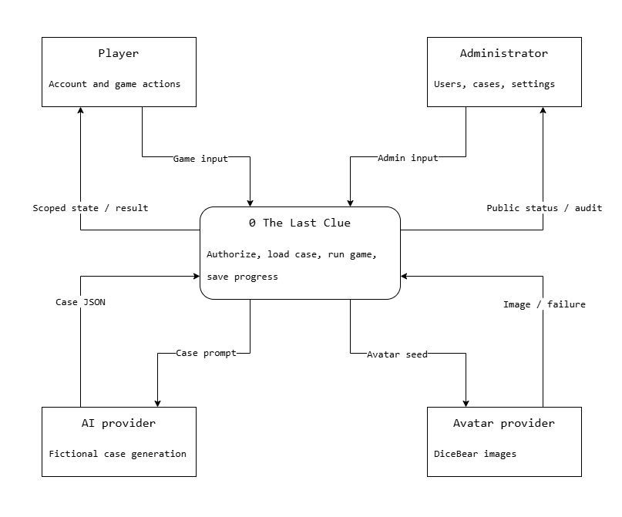
Figure 7. Context DFD. Players and admins submit requests; responses contain only the information their permissions allow.

External Data Boundaries
AI receives fictional case instructions, player count, and language. It does not receive account data or player messages. Avatar requests use a random non-personal seed. Failures from either provider are converted into local fallback behavior rather than exposed credentials or raw provider errors.

Detailed Data Flow
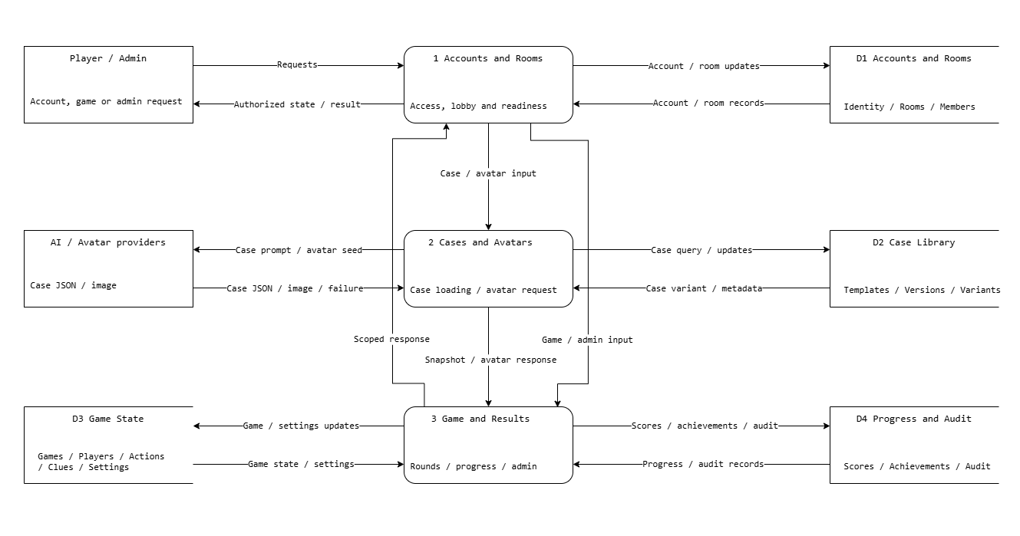
Figure 8. Level 1 DFD. Store groups summarize the physical tables in the database design document.
Accounts and room handling checks identity, membership, readiness and admin policy. Case loading validates provider output or reads a compatible reviewed variant. Game services write actions and deadlines to game state, while finalization writes scores, achievements and audit metadata. Public and private queries read these stores through authorized projections.
Every write records a durable outbox event in the same transaction. The dispatcher rechecks the audience before sending the appropriate DTO after commit, including current spectator and departure restrictions. Missing or duplicate events are repaired by an authenticated state reload; the server never trusts a client event to change stored results.

Case Startup Sequence
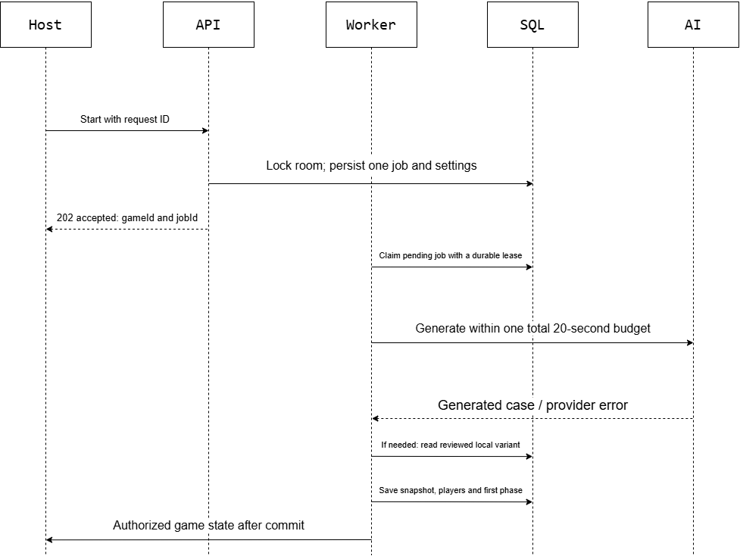
Figure 9. Startup sequence. The 202 response accepts the durable job; clients observe case loading through state updates.
The API persists Starting and a generation job before any external call. DeadlineAt is the accepted server time plus 20 seconds, so queue delay cannot extend the AI budget. The accepted request returns 202 without waiting for generation. The worker follows the sequence shown, sharing one 20-second budget across retries and provider switches. The final update is delivered after the snapshot and roles commit.
Before activation, recheck that the locked room still has all expected connected members. A departure or no eligible case cancels that startup job and returns the room to the lobby with readiness cleared. Ignore late provider responses for a finished job. No points are created.

Accusation and Finalization Sequence
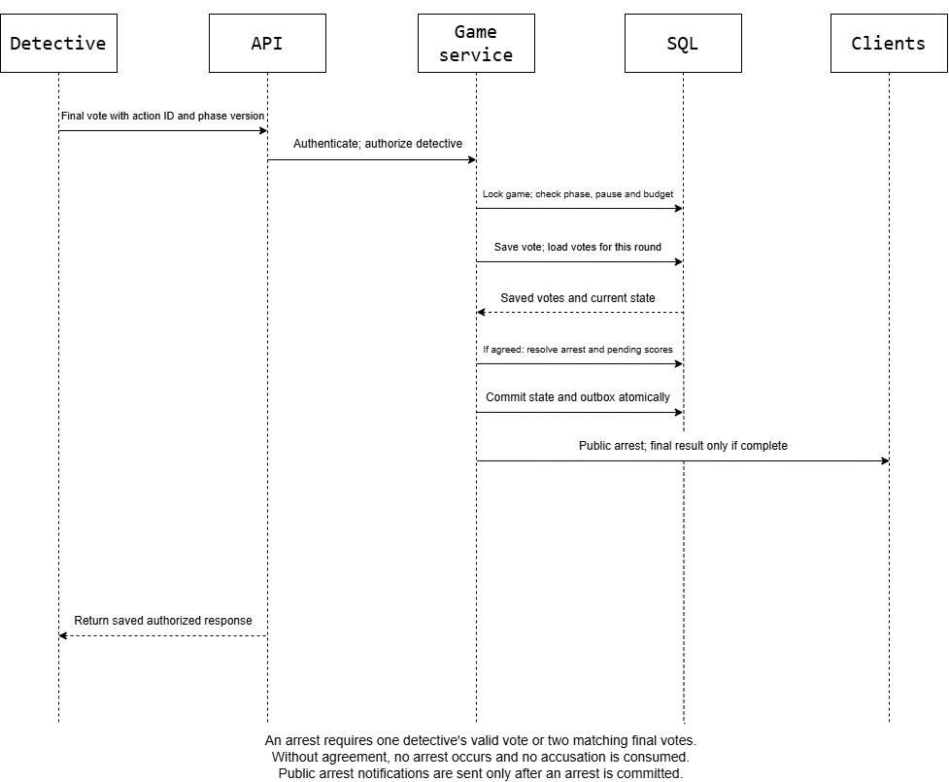
Figure 10. A valid vote is stored once; matching votes resolve one arrest. One detective does not need a second vote.
The transaction checks membership, detective role, current phase, pause state, deadline, current round and remaining budget. A final vote cannot be changed. Different or missing paired votes leave the phase open until its deadline without consuming an accusation.
One wrong arrest makes the innocent a spectator. Two wrong arrests end with criminal victory. A catch ends immediately with detective victory. Pending score events are cumulative but stay private until a completed result; cancellation discards their effect on progress. Replayed requests return the existing result.

Game Activity and Round Progression
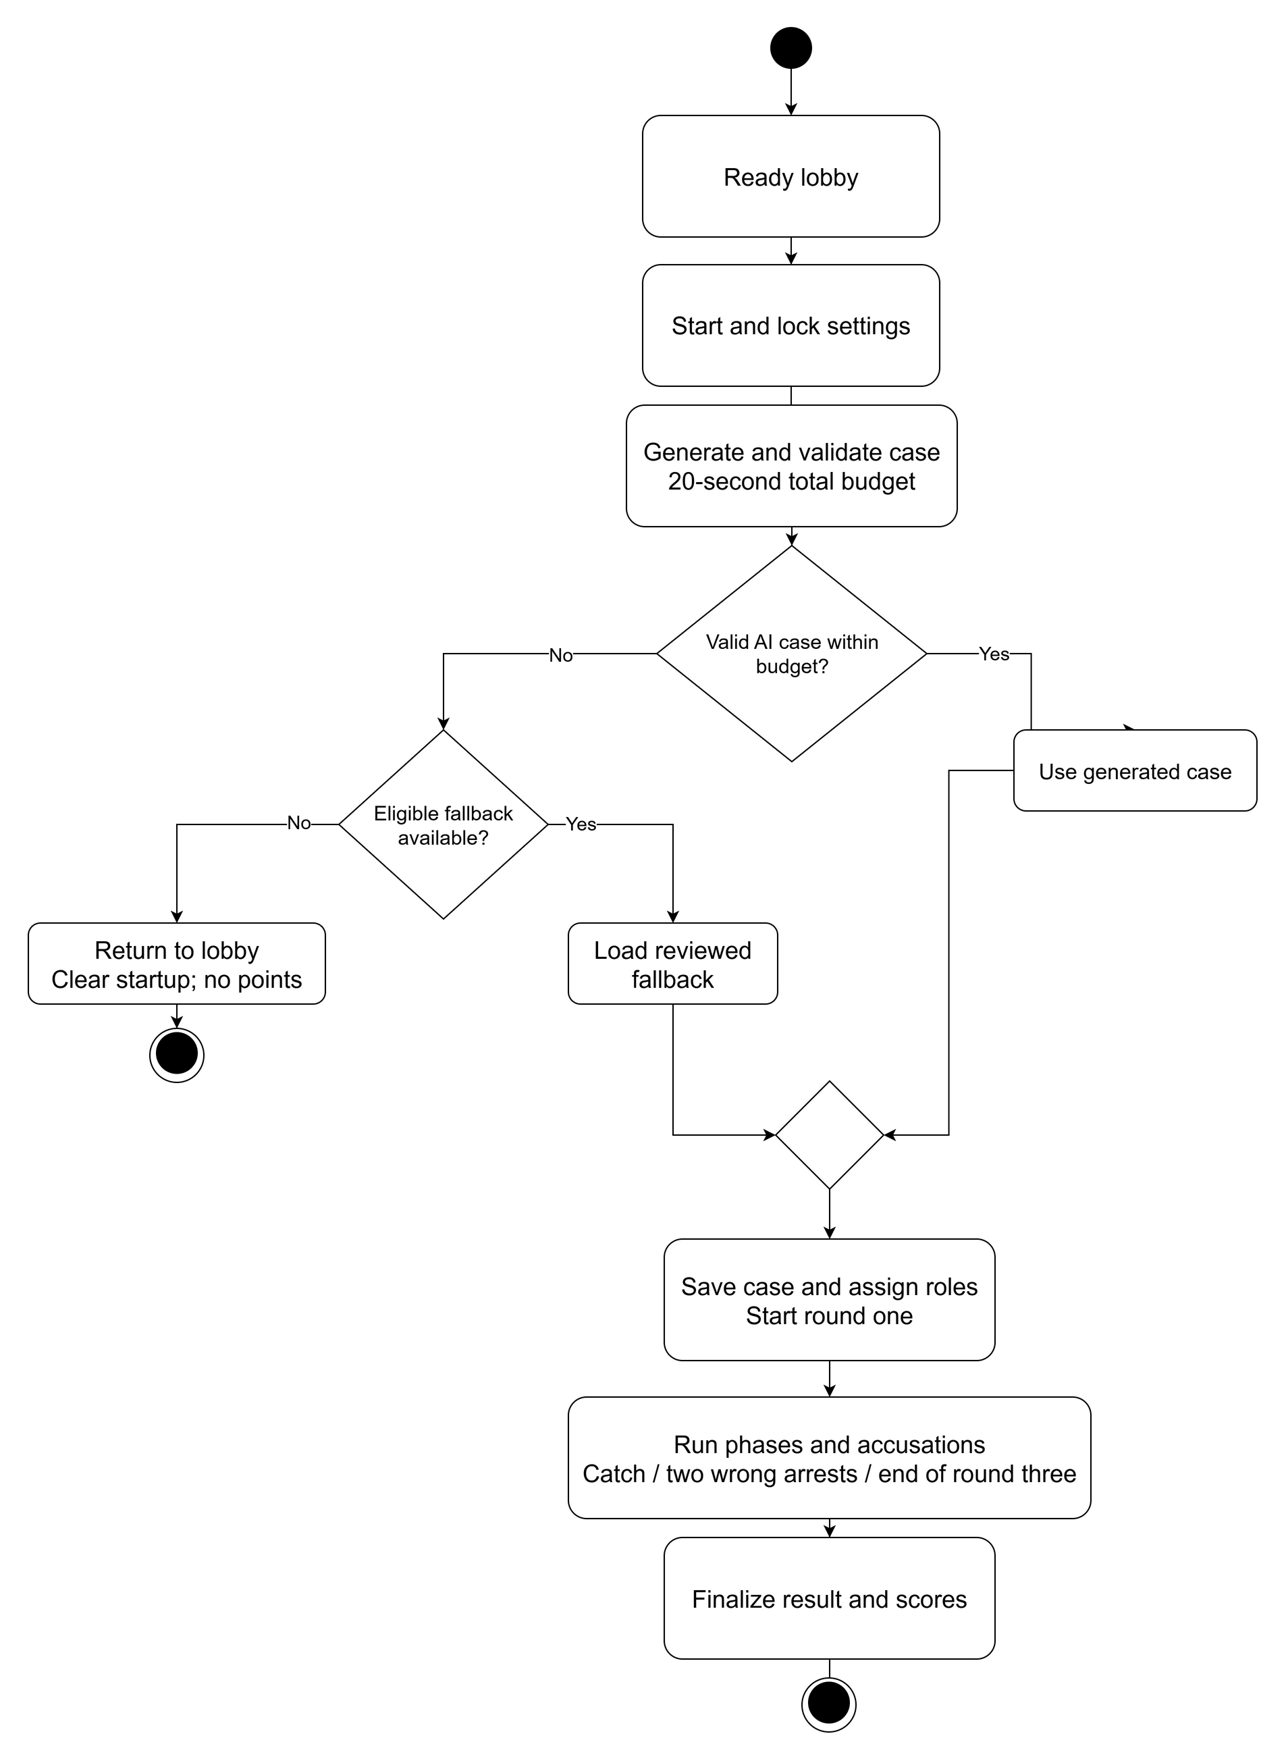
Figure 11. Startup and play activity. Invalid or late AI output uses a reviewed fallback. With no eligible fallback, startup ends in the lobby without points.

Round and Timer Rules
Initial phase defaults are 30 seconds for Briefing, 90 for Statements, 120 for Questioning, 30 for Clue Release, and 45 for Accusation. They are configurable before a game and frozen at startup. Each round follows Briefing, Statements, Questioning, Clue Release, and Accusation. At most one arrest can be resolved in the round. After a non-terminal arrest, move to the next round; after round three, finalize the criminal win if no catch occurred. Phase expiry makes unanswered questions final and rejects late submissions. A stale timer carries its expected state version and cannot advance a newer phase.

State and Reconnection Rules
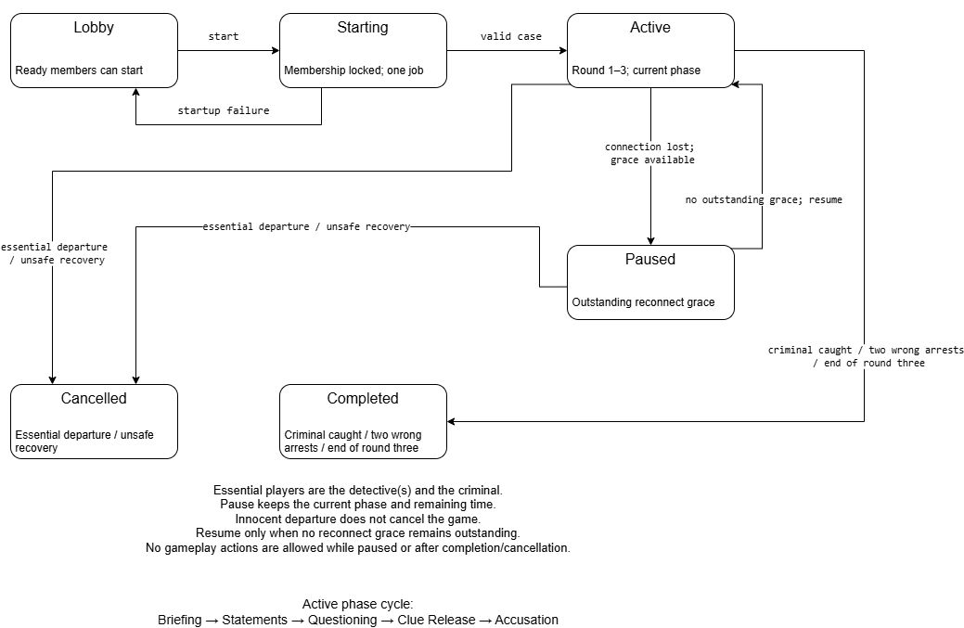
Figure 12. Lifecycle state view. Paused is a logical Active substate represented by PauseStartedAt and outstanding grace deadlines.
During shared pause, reject gameplay submissions and freeze the remaining phase duration. Each player has one 60-second grace per game. Only losing the last live connection starts grace, so closing one of several tabs does not disconnect the member. Reconnecting as the same account restores the same role and authorized state.
Resume after all outstanding grace periods resolve, adding the actual wall-clock pause interval once. A later loss, deliberate leave or expired grace marks departure. Innocent departure continues play; criminal or detective departure cancels without points or solution reveal. A spectator leaving has no additional effect on active play.
After restart, read persisted jobs, game state, presence and deadlines. Resume recoverable work under a lease and reject stale workers by state version. An expired phase advances at most once. If the stored state is incomplete or cannot be trusted, cancel without scores. Test restart and overlapping grace explicitly before release.

The Last Clue
  - UI UX Design and Prototypes
Digital Egypt Pioneers Initiative | Full Stack .NET
Analysis and design submission deadline: 6 November 2026
The screens below define the layout, navigation and role restrictions for the first release. They are wireframes for implementation, with fictional values used to show screen content.
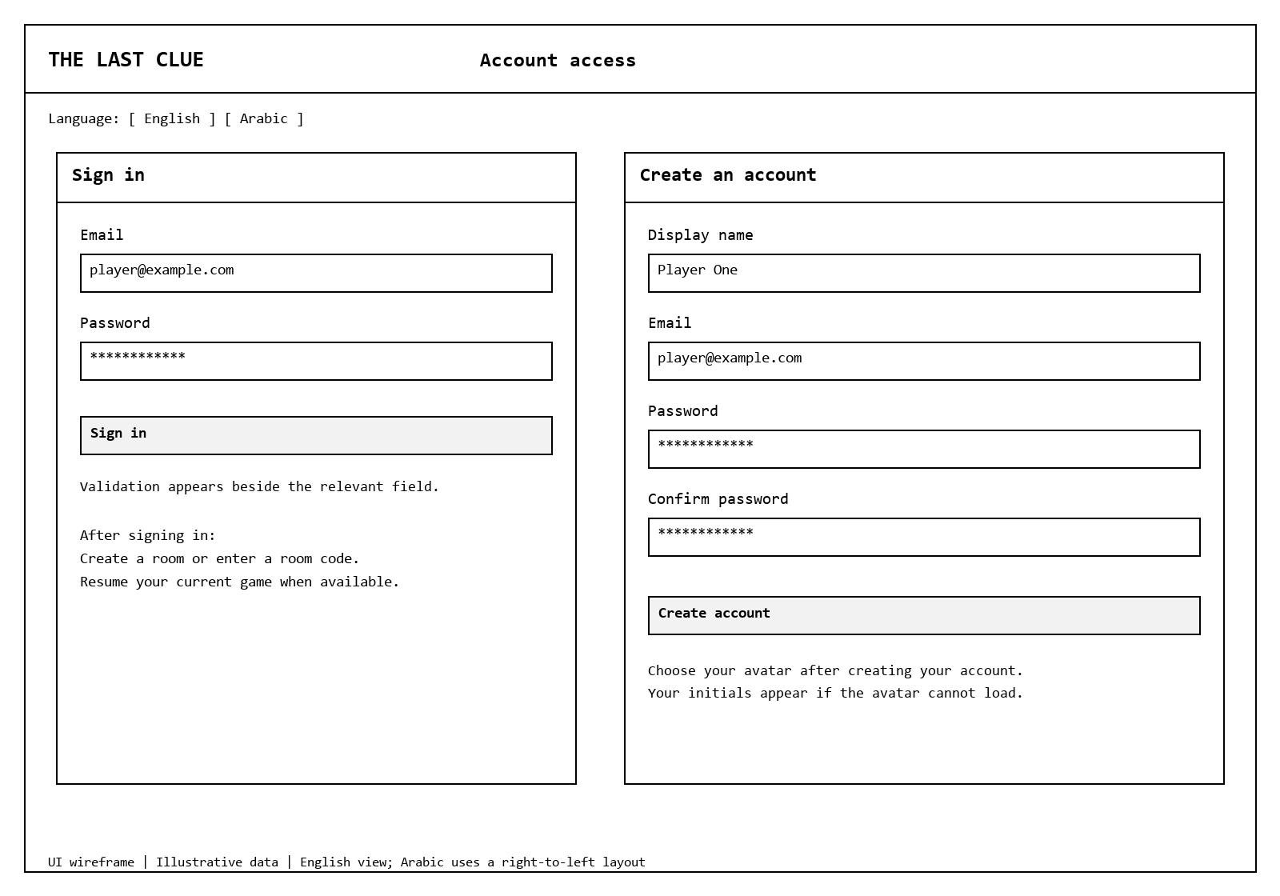
Figure 13. Sign-in and registration layouts. Room creation, joining and resuming become available after sign-in.

Account and Home Behavior
Use field labels, inline validation and a general sign-in error. After login, show Create Room and Join by Code. If the account already belongs to an unfinished game, show Resume rather than allowing a second membership. A failed avatar request shows local initials. Never include private case content in page source or hidden HTML.

Lobby and Case Loading
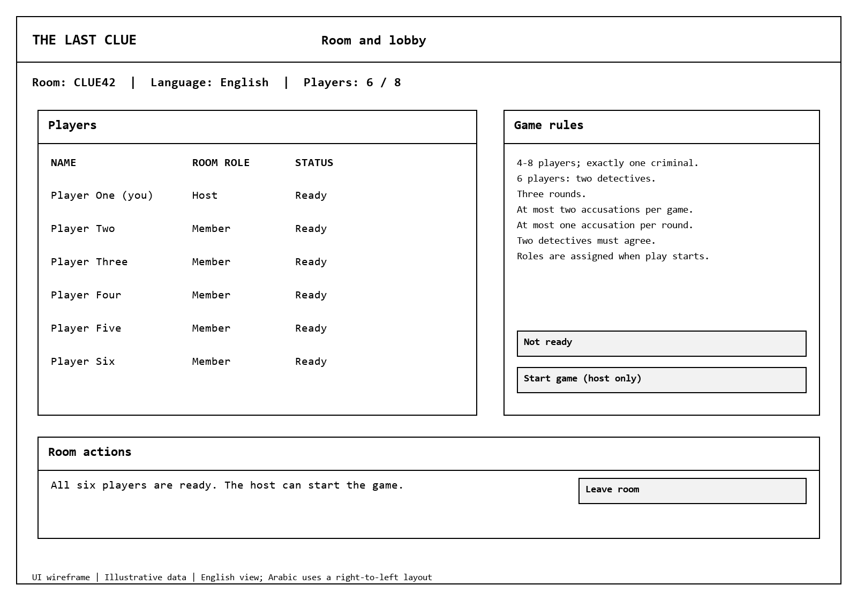
Figure 14. Lobby wireframe. Readiness, capacity and host controls are public; secret roles are assigned only after a valid case is saved.
Room creation chooses English or Arabic. The lobby displays the code, players, connection status and readiness. Room codes are generated with a cryptographically secure random generator and checked for uniqueness. Only the host sees an enabled Start control when all 4-8 members are ready. Membership changes clear readiness. A host leaving before play transfers hosting to the longest-present connected member.
After Start, show a loading message and disable repeated starts. A generated or stored case opens the same game screen. If startup fails, return to the lobby with a short retry message. Technical provider names, error traces and fallback internals do not need to appear in the player flow.

Game Board and Reconnection
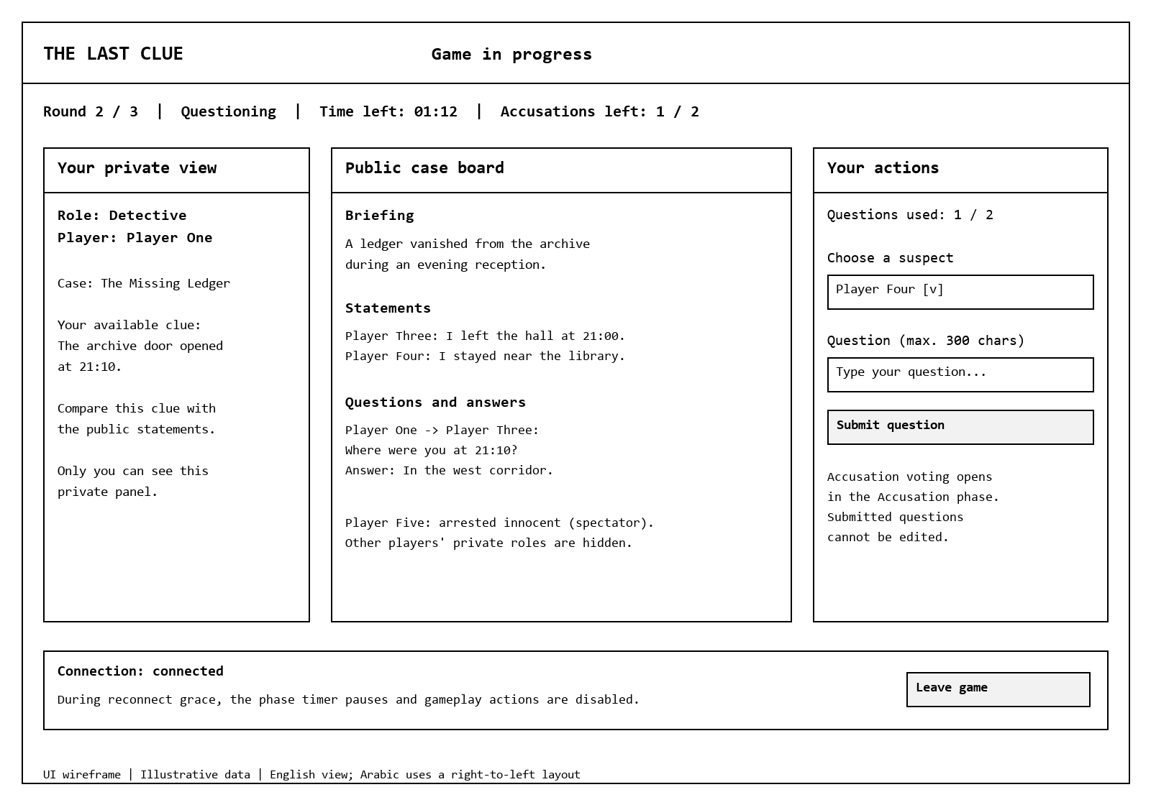
Figure 15. Game board wireframe. The private panel is different for each authorized player.
Player state | Visible controls and information
Detective | Own clues, public statements, questions and responses; up to two question submissions per round; final target choice during Accusation.
Active suspect | Own script, allowed clues, one statement per round and answers only to questions addressed to this character. Criminal truth stays in the criminal private view.
Spectator | Public board and revealed innocent status. No action inputs and no new private clues.
Paused or reconnecting | Clear reconnect banner and paused phase time. Disable gameplay actions while pause is active; retry state loading after reconnect.
All players | Round, phase, remaining time and accusations left. Confirmation before deliberate leave; explain that leaving affects the session without revealing another role.

Results and Player Progress
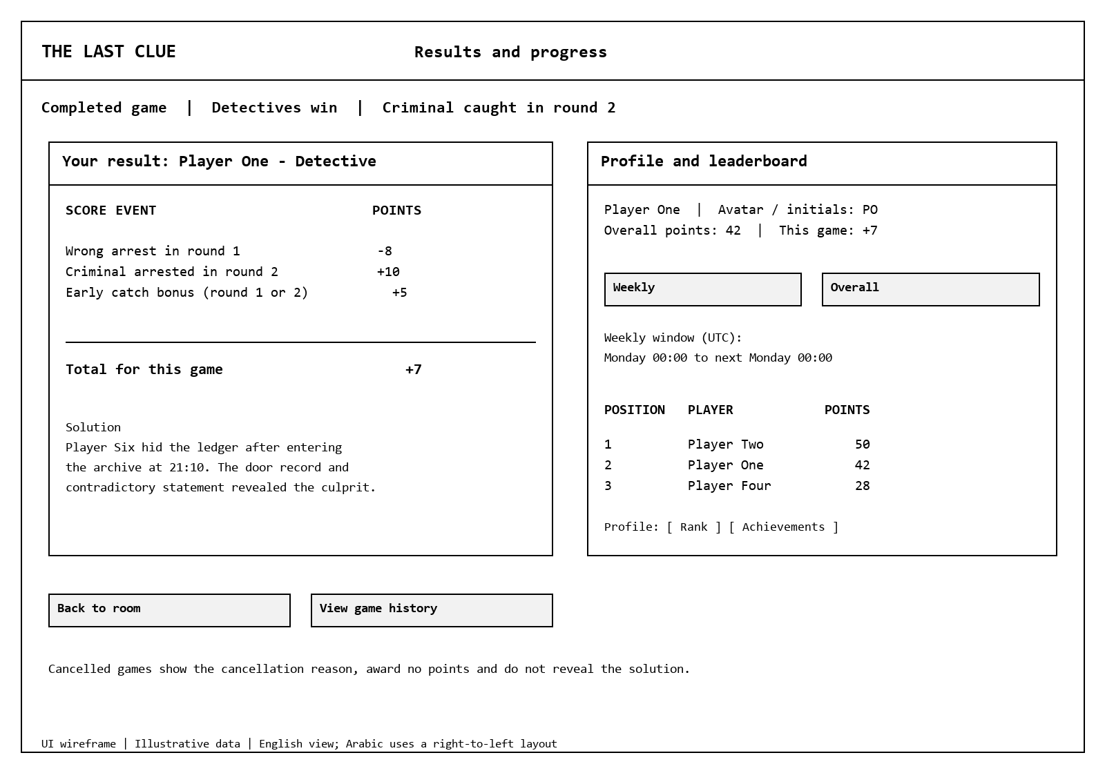
Figure 16. Example completed game. One wrong arrest followed by a round-two catch gives each detective -8 + 10 + 5 = 7 points. The solution is available only after completion.
The game screen and result use the same example: Player Five was wrongly arrested in round one, one accusation remains during round two, and Player Six is later caught. The account names, case titles and totals are illustrative.
Completed results show the final solution and each player's score breakdown. A cancelled game shows its reason and zero score effect without a solution. Profiles show own history, total points, rank and achievements. Weekly leaderboards label the UTC week, and empty history has a clear empty state.

Administration and Case Review
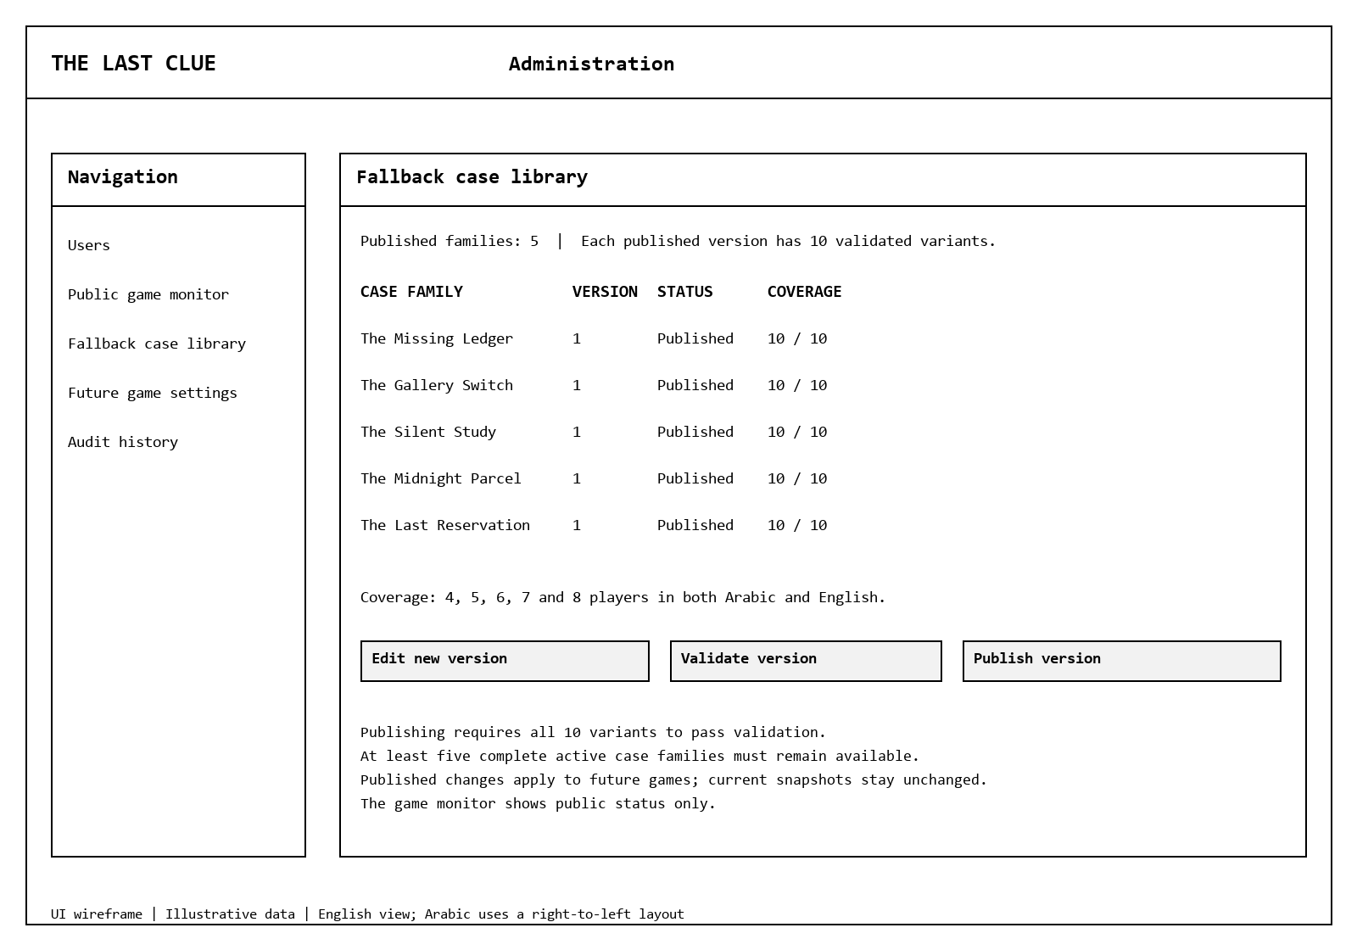
Figure 17. Case administration layout with sample rows. Published coverage means five player counts in both languages. Actual case content must be written, reviewed and validated before use.

Navigation and Visual Guidelines
Area | Design rule
Navigation | Account > Home > Lobby > Loading > Game > Result > Lobby or Home. Home also links to Profile and Leaderboards. Admin navigation is shown only to authorized accounts.
Layout | Use a fluid Bootstrap layout. At 360 px width, stack the private panel, public board and actions in that order. Keep core buttons visible and avoid horizontal page scrolling.
Typography | Use a readable system font stack with Arabic support; 16 px base body text and larger headings. Use logical CSS properties so spacing and alignment follow language direction.
Colors | Use a white or pale background, dark navy text (#17354B), blue primary controls (#25435E), and dark red errors (#A32626). Verify at least 4.5:1 text contrast. Add words or icons so status does not depend on color.
Accessibility | Provide keyboard access, visible focus, explicit labels and associated error descriptions. Announce phase and connection changes without moving keyboard focus away from an active input.
Feedback | Disable a submitted action until its response arrives. Show request outcome and remaining quota. On a conflict, reload current state and explain the expired phase or already-submitted action.
Arabic and English | Translate controls, phase names, errors and instructions. Apply RTL to Arabic screens while keeping codes and timestamps readable. Test long player names in both languages.
Privacy | Request a dedicated role-scoped view; do not fetch full hidden data and conceal it with CSS. Admin monitoring excludes active scripts, criminal identity and unrevealed clues.

Usability checks will cover login, joining, readiness, one complete round, accusation, reconnect, and result navigation in both languages. Record observations from the planned pilot and adjust unclear labels before the final demonstration.

The Last Clue
  - Deployment and Integration Design
Digital Egypt Pioneers Initiative | Full Stack .NET
Analysis and design submission deadline: 6 November 2026
The first release uses one Azure App Service instance and Azure SQL. This keeps live sessions and timer workers manageable while preserving durable state in SQL for recovery.
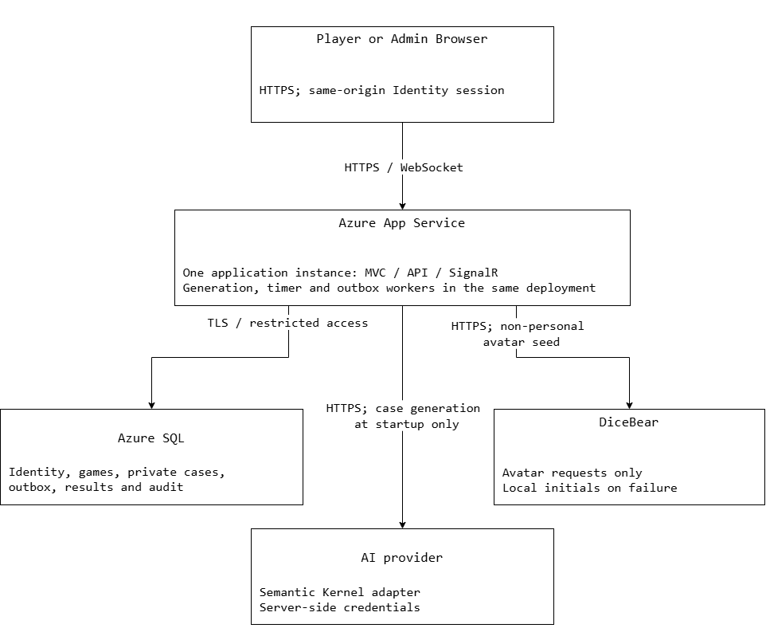
Figure 18. One App Service instance hosts MVC, API, SignalR and generation, timer and outbox workers. Provider calls use HTTPS; SQL connections use TLS and restricted access.

Hosting and Operational Boundaries
The application hosts MVC, REST endpoints, the SignalR hub and background workers. Enable WebSockets and keep the app running during scheduled testing. Configure the database connection, provider credentials and Identity data-protection key storage through protected deployment configuration. Do not commit environment secrets.
SQL is the source of truth for game state, job leases and results. The timer worker uses persisted deadlines and checks state versions before advancing. The outbox worker sends events only after database commit. Loss of a SignalR event is repaired by authorized state reload.

Technology Stack and Integration Contracts
Component | Selected approach and purpose
Web application | ASP.NET Core MVC and Web API, Razor Views, Bootstrap 5, JavaScript/jQuery. Same-origin authenticated UI and REST writes.
Live updates | SignalR at /hubs/game. Server-authorized room and game subscriptions; separate public and per-user payloads.
Data access | Entity Framework Core with SQL Server in development and Azure SQL in deployment. Repository and Unit of Work interfaces separate persistence from business rules.
Authentication | ASP.NET Identity with Player/Admin account roles, secure cookies and antiforgery validation for browser writes. Game-role authorization is checked separately.
AI generation | Semantic Kernel with a Gemini provider adapter behind ICaseProvider. A shared deadline covers provider changes and retries. No runtime AI call is needed after case loading.
Fallback cases | At least five reviewed local case families with ten variants each. Select randomly, avoid the room's last completed family when alternatives exist, and retain an immutable game snapshot.
Avatar service | DiceBear with a non-personal seed. Return local initials when unavailable; avatar loading cannot block joining or playing.
Testing and delivery | xUnit, WebApplicationFactory and Playwright for unit, integration and critical UI checks. GitHub Actions builds, tests and publishes the deployment artifact.
Version control | Pin the chosen SDK and package versions in project configuration and the dependency lock file when setting up the solution. Record the actual versions in the setup guide.

Provider Validation and Failure Handling
Validate generated JSON before activation: supported language, required fields, unique character keys, correct role counts, one criminal, a hidden timeline and solution, three rounds of clues, and valid references. Reject oversized or unsuitable content. Structural validation cannot prove a mystery is solvable; review sample generated cases and every stored fallback variant for logical consistency.

Deployment Strategy and Scaling
Step | Required action
Build and test | Restore pinned dependencies, compile, run service/repository tests and critical checks, then produce one versioned artifact. Publish pipeline results without secrets.
Database release | Back up the target database, review generated migrations, and apply them once in a controlled release step. Do not let multiple application startups race to migrate the database.
Configuration | Provide connection strings, provider keys, allowed origin, logging levels and protected Identity key storage. Validate required configuration before accepting game startups.
Activate release | Schedule a maintenance window without active games. Deploy the tested artifact, verify /health and /health/ready, then run account, lobby, SignalR and full AI-outage smoke checks.
Rollback | Keep the previous artifact. Roll back application code only while database changes remain compatible; use reviewed recovery steps for destructive migrations. Never overwrite game history with an old backup while accepting live writes.
Monitor | Record endpoint latency, generation/fallback timing, outbox lag, phase failures and cancellation counts. Use correlation IDs and public metadata; exclude hidden case content from logs.
Recover | On restart, reload unfinished jobs and games, reclaim only expired leases, and replay unsent outbox messages. Cancel an unsafe unrecoverable session without scores.
Scale later | Before adding app instances, provide a SignalR scale-out service/backplane, shared Identity keys and cross-instance presence coordination. Keep SQL leases and game serialization. Multi-instance operation is outside the first demonstration configuration.

The design target remains one room with up to eight players for KPI timing measurements. A successful rehearsal is evidence for the demonstration environment; it does not claim production-wide availability or unlimited concurrent room capacity.

The Last Clue
  - API Contracts and Testing Plan
Digital Egypt Pioneers Initiative | Full Stack .NET
Analysis and design submission deadline: 6 November 2026
These contracts define the REST endpoints, authorized live events, and acceptance checks for implementation. The REST base path is /api/v1 and the SignalR path is /hubs/game. Operational probes use the root paths /health and /health/ready.

Request and Authorization Rules
Use same-origin Identity cookies. Browser writes include the antiforgery token. Game and startup commands also include an Idempotency-Key UUID; store the authenticated user, payload hash and saved receipt. Round actions supply round, phase and expectedStateVersion. Deliberate leave is permitted in any non-terminal phase, including pause. The server rechecks permissions, deadlines, pause state and quotas inside the transaction.
Return 400 for invalid input, 401 for unauthenticated API access, 403 for a forbidden action, 404 for resources that should not be disclosed, 409 for stale state or an incompatible replay, and 429 for configured rate limits. API failures return JSON rather than an HTML sign-in redirect. Log a correlation ID without sensitive request content.
Method and path | Actor and request | Success response
POST /auth/register | Public; email, password, displayName | 201 account created; field errors on failure
POST /auth/login | Public; email, password | 200 signed in; generic invalid-credentials error
POST /auth/logout | Signed-in account; antiforgery token | 204; revoke the current browser session
GET /profiles/me | Player | 200 own progress, avatar/initials and achievements
GET /profiles/me/history | Player; pagination | 200 own completed-game summaries
GET /leaderboards?period=weekly | Player; period weekly or overall | 200 totals, deterministic ties and UTC week bounds
POST /rooms | Player; language en/ar | 201 roomId, code, members and host
POST /rooms/join | Player; code | 200 joined lobby; reject existing membership/full room
GET /rooms/{roomId} | Room member | 200 public lobby view and readiness
PUT /rooms/{roomId}/ready | Room member; isReady | 200 updated readiness
POST /rooms/{roomId}/leave | Room member | 200 lobby state or closed-room confirmation
POST /rooms/{roomId}/start | Host; idempotency key | 202 gameId, jobId and status Starting

Game and Administration Endpoints
Method and path | Actor and request | Success response
GET /games/{gameId}/state | Game member | 200 role-scoped snapshot, server time and version
POST /games/{gameId}/statements | Active suspect; text, round, phase, expectedStateVersion | 201 saved statement; max 1,000 characters
POST /games/{gameId}/questions | Detective; targetUserId, text and phase fields | 201 question; max 300 characters; slot 1 or 2
POST /games/{gameId}/questions/{id}/answer | Named active target; text and phase fields | 200 saved answer; max 1,000 characters
POST /games/{gameId}/votes | Detective; targetUserId and phase fields | 200 vote recorded; arrest only when agreement holds
POST /games/{gameId}/leave | Game member; deliberate leave | 200 departure or cancellation; no host-only powers
GET /games/{gameId}/result | Game member | 200 terminal result; completed solution or cancellation reason
GET /admin/users | Admin; pagination | 200 user management list
PUT /admin/users/{userId}/block | Admin; isBlocked | 200 future login/entry restriction; audit record
GET /admin/games | Admin; pagination/status | 200 public game status only
GET /admin/cases | Admin; pagination | 200 case family/version review metadata
POST /admin/cases/bootstrap | Admin; five complete reviewed families in an empty library | 201 first five families activated together
POST /admin/cases/{caseId}/versions | Admin; draft variants | 201 unpublished case version
POST /admin/case-versions/{id}/validate | Admin | 200 structure and coverage validation report
POST /admin/case-versions/{id}/review | Admin; reviewed variant checklist | 200 human review recorded
POST /admin/case-versions/{id}/publish | Admin | 200 published; reject incomplete or unreviewed variants
POST /admin/case-versions/{id}/retire | Admin | 200 retired only if at least five complete families remain
PUT /admin/settings | Admin; scoring, durations and progression definitions | 200 new version for future games; audit record
GET /admin/audit | Admin; pagination | 200 safe change metadata
GET /health and /health/ready | Operational probes | Liveness; readiness checks SQL and required local case coverage, including the initial batch of five complete reviewed families

Case editing and review endpoints contain hidden content and are admin-only. They do not expose active game assignments or active case snapshots. Human review is a separate step from JSON validation. There is no public endpoint for a full active case or a client-controlled finalization command.

Payloads and SignalR Events

Example public state response
A detective response may contain: gameId, status, round: 2, phase: "Questioning", stateVersion: 18, serverUtc, phaseEndsAt, isPaused, accusationsRemaining: 1, publicPlayers, statements, questions, publicClues, and myPrivateView. myPrivateView contains only that user's script and authorized clues. publicPlayers never contains hidden criminal flags. These values illustrate field names rather than a live result.

Example action and error
A vote body contains targetUserId, round: 2, phase: "Accusation", and expectedStateVersion: 18. The authenticated account is the voter; no voterId, role, isCriminal or score is accepted from the browser. A conflict response contains code: "PHASE_CHANGED", a short message, correlationId and currentStateVersion so the client can reload state.
Event | Audience and payload
LobbyUpdated | Current room members; roomId, host, readiness, connected members and version.
GameStarted / PhaseChanged | Game members; gameId, round, phase, deadline, pause state and version. No private scripts.
PublicActionAdded | Game members; accepted statement, question, answer or revealed arrest.
PrivateViewChanged | Only the intended authenticated user; authorized clues and own private view. Never a room-wide broadcast.
ConnectionStatusChanged | Game members; connected/reconnecting/inactive state and shared pause. Uniform behavior for all hidden roles.
GameCompleted | Game members; terminal outcome and a signal to request the authorized result.
GameCancelled | Game members; safe reason and zero score effect. No solution payload.

Every event includes eventId, gameId or roomId, stateVersion and serverUtc. Events may be delivered more than once or arrive after a newer event. Deduplicate event IDs; on any version gap or reconnect, reload authorized state. Hub subscription methods accept a room/game identifier, then verify membership before joining groups. Clients cannot choose another user's private group.

Functional and Security Test Plan
Test | Scenario and expected result | Coverage
T01 | For each room size 4-8, startup assigns the required detectives, exactly one criminal and the remaining innocents. | FR03-FR14
T02 | Force total AI outage and invalid JSON. All five saved families start in all ten size/language variants; missing data returns safely to lobby. | FR08-FR11; NFR09-NFR10
T03 | Request another room, another private view, a spectator action or active solution through REST and SignalR; reject without leaking secrets. | FR02, FR12, FR17; NFR01-NFR07
T04 | Submit duplicate statements, third questions, repeated answers, late votes and concurrent start requests. Enforce each quota once. | FR07, FR15-FR19, FR33
T05 | Pair detectives choose different targets, then time expires: no arrest and no budget consumed. Matching votes resolve once; final votes cannot be edited. | FR18-FR20
T06 | Two wrong arrests finish with criminal victory; catching the criminal ends immediately; round three without catch also ends. | FR20-FR21
T07 | First loss pauses for any role; one tab closing leaves other connections alive. Overlapping grace adds shared pause once; repeat loss follows departure rules. | FR22-FR25, FR34
T08 | Cancel after a pending wrong-arrest event: persist cancellation, reveal no solution, and write no score or achievement. | FR23, FR26-FR29
T09 | Race finalization and restart workers: exactly one outcome, one score entry per event/player and no duplicate achievement. | FR26, FR33-FR34; NFR13-NFR14
T10 | Publish invalid/unreviewed cases or retire below five families: reject. Changing settings and templates cannot change an active game. | FR30-FR32
T11 | Weekly ranking uses completed-game UTC time within the displayed half-open Monday interval; stable user ID breaks equal totals. | FR27-FR29
T12 | Complete critical flows on desktop and 360 px mobile, in Arabic and English, using keyboard navigation and clear reconnect feedback. | NFR15-NFR17

Service tests use fake providers and clocks. Repository integration tests use SQL Server-compatible storage so rowversion, filtered indexes and transactions are exercised. UI checks use Playwright against a test deployment. Do not replace these checks with coverage percentage alone.

Measurement and Release Acceptance
Check | Measurement and evidence
K1 / NFR08 | Warm API P95 below 500 ms. At least 100 authenticated samples per selected room, state and profile endpoint in one room of up to eight players. Record environment and exclusions.
K2 / NFR09 | One total AI budget of 20 seconds. Initiate local fallback by expiry; load it within 2 seconds with a healthy database. Report AI wait and local load separately.
K3 / NFR10 | At least 95% valid generated case jobs after allowed retries, over at least 40 jobs covering room sizes and both languages. Fallback is not AI success.
K4 / NFR11 | Event P95 below 1 second over at least 100 events in an eight-player game, with synchronized timestamps or measured clock offsets.
K5 / NFR12 | During a 60-minute rehearsal, run 360 probe cycles ten seconds apart. Both /health and an authenticated game-state read must pass. At least 99% of cycles succeed.
K6 / NFR20 | At least 70% Services line coverage. Retain reports, included assemblies and exclusions. All secrecy, concurrency and winner tests must pass.
K7 / NFR21 | At least 20 distinct testers and 10 completed games before the final presentation; include normal generation and total AI outage. Keep non-sensitive feedback and counts.

Score Acceptance Examples
Using the initial scoring values: a round-two catch after one wrong arrest gives each detective -8 + 10 + 5 = 7 points. Two wrong arrests followed by criminal victory give each detective -8 - 8 - 5 = -21 and the criminal 10 + 10 + 15 = 35. These are cumulative event totals, not separate leaderboard updates during play. Cancellation gives no score effect, even if pending events exist.

Evidence Before Handover
Retain build logs, unit/integration/UI results, coverage reports, timing samples, fallback coverage records and pilot feedback. A teammate must be able to deploy from the setup guide with their own configuration. Check login, complete gameplay, restart recovery and full AI outage on the deployed application. These are planned checks; implementation and measured results will be delivered in their later phases.

