The Last Clue
  - Project Plan
Digital Egypt Pioneers Initiative (DEPI) | Full Stack .NET
Phase 1 deadline: 16 October 2026 | Team size: 4 members
We will build the game in sprints, with tests and documentation developed alongside each feature. A complete version will be deployed before user acceptance testing on 1-4 December.

Delivery Plan

Delivery Priorities
We will start with accounts, rooms, roles, case loading, timed rounds, questions, accusations, and results. We will then complete player progression, leaderboards, and the admin dashboard. Voice, video, native mobile apps, payments, bots, and the AI judge are outside this release.

Resource Allocation
T1 will handle data and permissions, T2 the game rules, T3 the interface and live updates, and T4 testing and deployment. T2 and T4 will share AI provider integration, while T3 connects avatar loading to the interface. All four members will write and review fallback case content. GitHub holds the code, documents, tasks and automated checks.

Project Milestones
Milestone | Deadline | Deliverable
Planning and management | 16 Oct 2026 | Proposal, project plan, roles, risk plan, and KPIs.
Literature review and requirements | 16 Oct 2026 | Lecturer feedback and grading criteria; stakeholders, stories, use cases, and requirements. Separate workstreams.
Analysis and design | 6 Nov 2026 | Architecture, database design, required diagrams, and UI prototypes.
Implementation | 30 Nov 2026 | Source code, README, working deployment, and API documentation.
Final testing and presentation | 4 Dec 2026 | Test reports, manuals, technical documentation, presentation, and infographic.

Schedule and Work Packages
The schedule runs from 4 October to 4 December 2026. Sprint dates follow our original project plan. Submission deadlines follow the DEPI schedule.
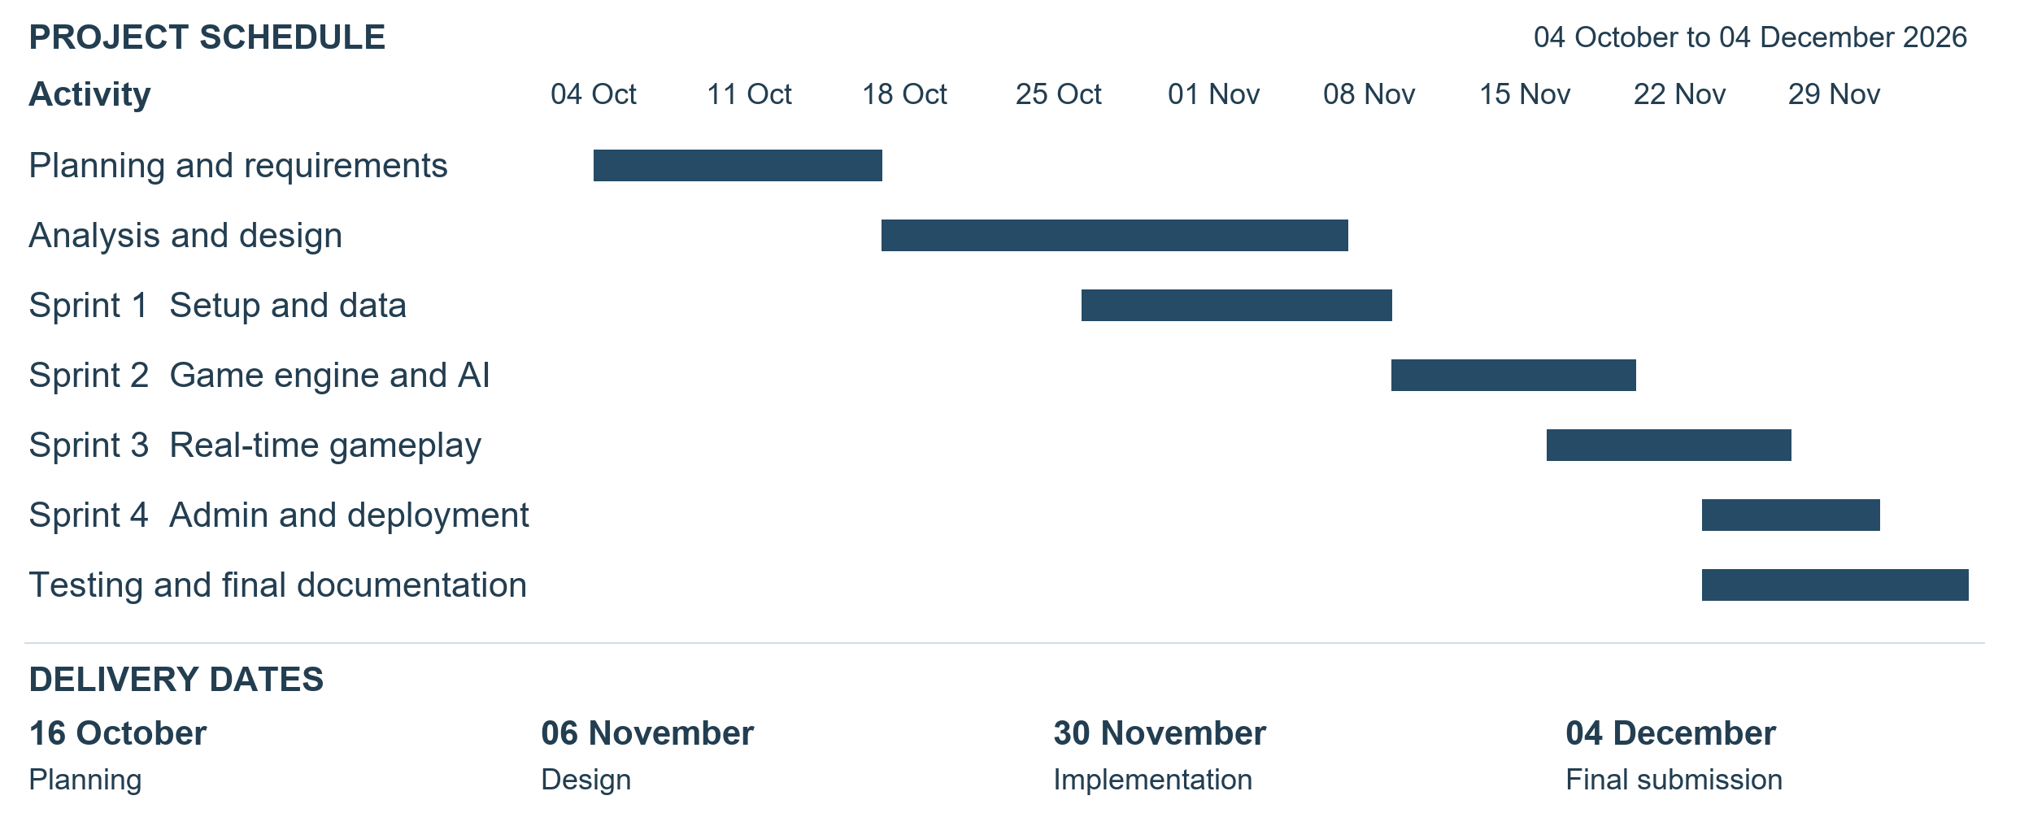
Target period | Work package and output | Lead
4-16 Oct | Prepare the proposal, project plan, roles, risks, KPIs, feedback, and requirements backlog. | T1 + all
17 Oct-6 Nov | Complete architecture, ERD and schemas, required diagrams, wireframes, and interface contracts. | T1, T2, T3
26 Oct-8 Nov | Sprint 1: create the solution, database, migrations, Identity, repositories, and Unit of Work; deploy a basic health endpoint with T4. | T1
9-19 Nov | Sprint 2: implement game rules, roles, phases, accusations, scoring, AI generation, validation, fallback cases, and business tests. | T2 + T2 + T4
16-26 Nov | Sprint 3: connect SignalR to the lobby and game interface; integrate complete sessions and reconnection. | T3 + T2
23-30 Nov | Sprint 4: complete administration and progression views, deploy the application, verify configuration, and freeze features. | T1, T3, T4
23 Nov-4 Dec | 23-30 Nov: system and integration testing. 1-4 Dec: user acceptance, reports, manuals, presentation, infographic, pilot review, and rehearsal. | T4 + all

We will write unit and integration tests during each sprint and update the related documentation. The final testing period is for checking the complete game, fixing remaining issues, and preparing the handover.

Dependencies
Login, permissions, and shared data formats must be ready before we connect protected game actions. The game engine and case format must work before we test a full live session. The deployed game must be ready for user acceptance testing on 1 December.

