🩺
AI Fetal Ultrasound Analyzer
Project Report
EfficientNet-B2 + Gemini 2.5 Flash

97.15%  Test Accuracy | 5,265  Total Samples | 4 Classes  AC / BPD / FL / NO | 2 Engines  EfficientNet+Gemini

1. Problem Statement
During pregnancy, doctors use ultrasound scans to monitor baby growth. These scans capture critical body parts — head, abdomen, and thigh bone — that require years of medical training to interpret accurately. Non-experts find it very difficult to understand what they are looking at.

Our Goal
Build an AI tool that automatically identifies which body part is shown in an ultrasound image and provides useful information about the baby's position.

2. Classification Labels
The AI classifies each ultrasound image into one of four categories based on the anatomical plane visible:

Label | Full Name | Body Part | Clinical Purpose
AC | Abdominal Circumference | Tummy (Abdomen) | The scan is showing the baby's belly area. Doctors use this view to estimate weight and growth.
BPD | Biparietal Diameter | Head | The scan is showing the baby's head. Doctors use this view to check brain development and age.
FL | Femur Length | Thigh Bone (Femur) | The scan is showing the baby's thigh bone. Doctors use this view to check bone growth and age.
NO_PLANE | No Standard Plane | Unknown | The image is unclear or does not show a standard measurement view.

3. Dataset Overview
The model was trained and evaluated on a labelled fetal ultrasound dataset of 5,265 images, distributed across four classes as shown below.

AC_PLANE  1,386 images  26.3% of dataset | NO_PLANE  1,318 images  25.0% of dataset | FL_PLANE  1,281 images  24.3% of dataset | BPD_PLANE  1,280 images  24.3% of dataset

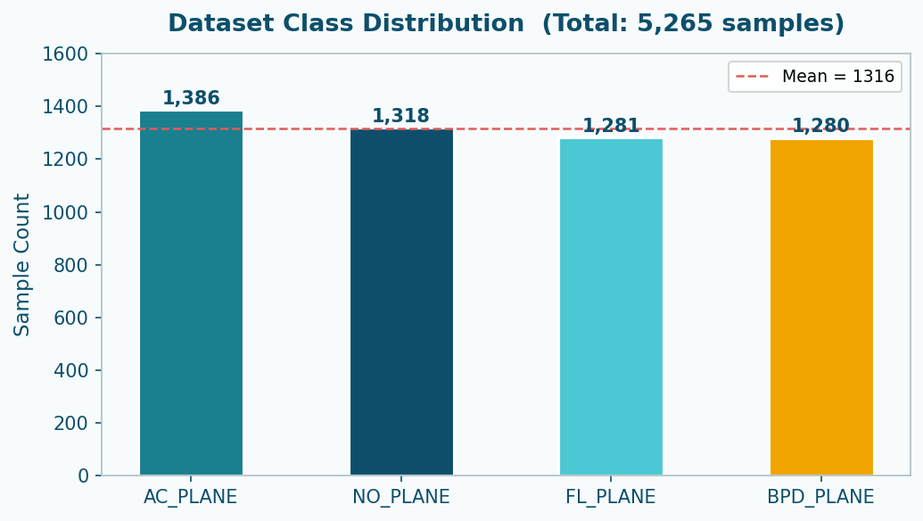
The dataset is well-balanced across all four classes, ensuring no significant class imbalance bias during training.

4. Solution Architecture
The system combines two AI engines to deliver a complete and reliable analysis of fetal ultrasound images.

🔬 EfficientNet-B2  Deep learning model trained on ultrasound images. Identifies the body part and returns a confidence score. | 🤖 Gemini 2.5 Flash (LLM)  Google's multimodal AI. Determines baby position and draws a bounding box on the image.

4.1 Without LLM — EfficientNet Only
Upload Image → EfficientNet-B2 → Outputs
Biological Plane | Body Part Name | Confidence Score

✅ Available Outputs  • Biological Plane  • Detected Body Part  • Confidence Score (e.g., 98.50%) | ❌ Not Available  • Baby position / orientation  • Bounding box on image

4.2 With LLM — Full System (5 Outputs)
Upload Image
↙ ↘
EfficientNet-B2 + Gemini 2.5 Flash
↘ ↙
Final Dashboard — All 5 Outputs

✅ Full Output Suite
• Biological Plane • Detected Body Part • Confidence Score • Baby Orientation • Bounding Box on Image

5. Model Accuracy & Performance

5.1 Model Details

Detail | Value
Model Name | EfficientNet-B2
Framework | TensorFlow / Keras
Total Classes | 4 (AC_PLANE, BPD_PLANE, FL_PLANE, NO_PLANE)
Input Size | 224 × 224 pixels
Total Samples | 5,265 labelled images

5.2 Training & Testing Results

Metric | Accuracy | Loss
Training (Final Epoch) | 93.96% | 0.4975
Validation (Final Epoch) | 94.73% | 0.4771
Testing | 97.15% | 0.4433

5.3 Test Accuracy Summary
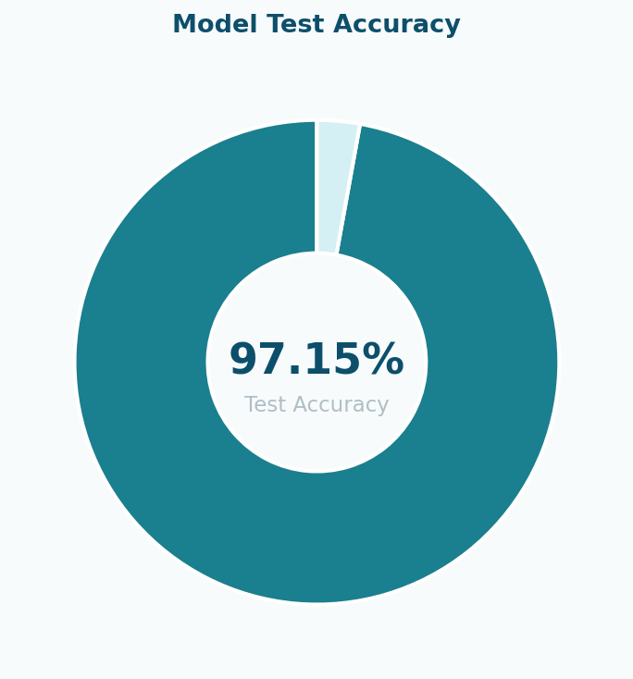

6. Classification Report

6.1 Per-Class Metrics
Detailed Precision, Recall, and F1-Score for each category, evaluated on 527 test samples.

Class | Precision | Recall | F1-Score | Support
AC_PLANE | 0.96 | 0.99 | 0.98 | 139
BPD_PLANE | 0.98 | 1.00 | 0.99 | 128
FL_PLANE | 0.97 | 0.98 | 0.98 | 128
NO_PLANE | 0.98 | 0.91 | 0.94 | 132
Overall Accuracy | — | — | 0.97 | 527
Macro Avg | 0.97 | 0.97 | 0.97 | 527
Weighted Avg | 0.97 | 0.97 | 0.97 | 527

6.2 Per-Class Metric Comparison Chart
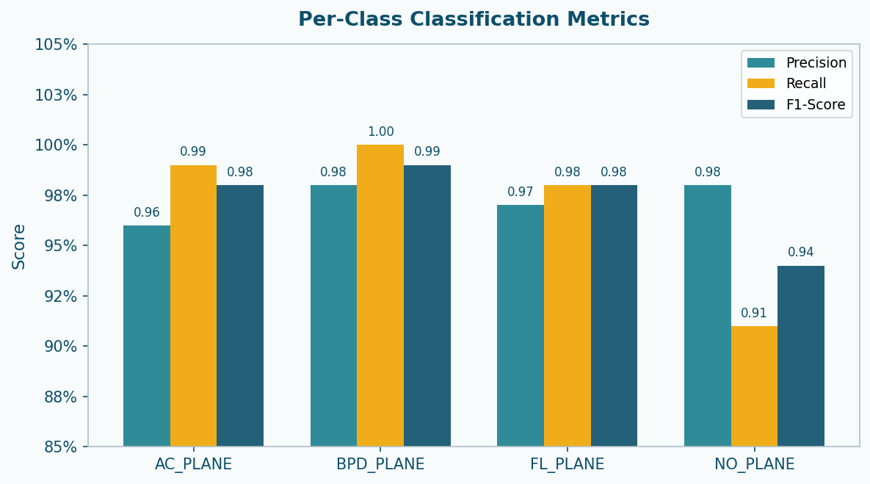

7. Confusion Matrix
The confusion matrix below visualises the model's predictions versus the true labels on the test set. The strong diagonal demonstrates high classification accuracy across all four planes.

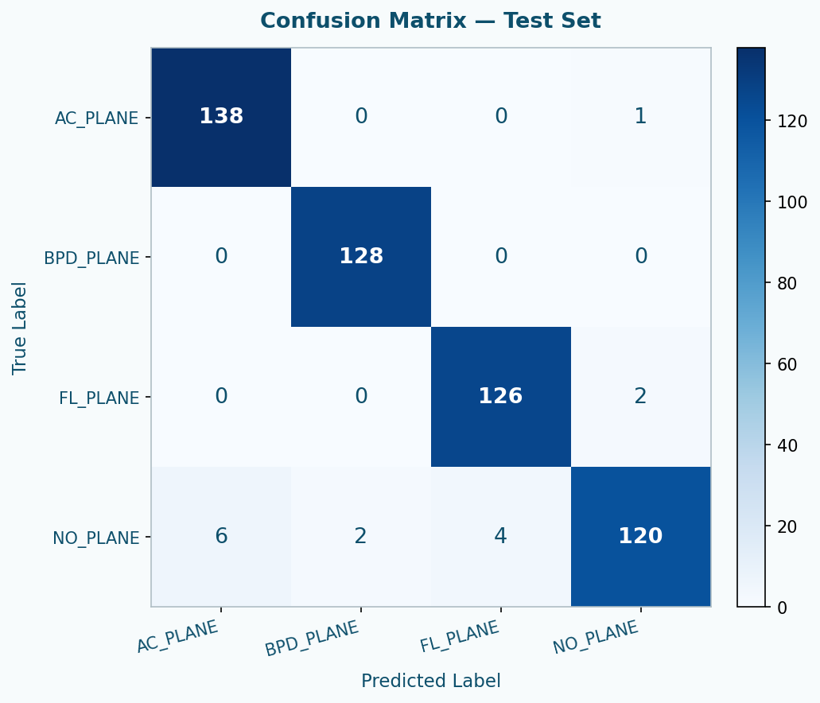

End of Report
This document was generated from AI Fetal Ultrasound Analyzer project data. Model: EfficientNet-B2 | LLM: Gemini 2.5 Flash | Dataset: 5,265 images | Test Accuracy: 97.15%

