**Mastering Embedded System Online Diploma**

[**www.learn-in-depth.com**](http://www.learn-in-depth.com)

**First Term (Final Project1)**

**Report for “High_Pressure_Detection” project**

**Name: Osama Khallaf Samir Moktar**

**Mail:** [**osamakhallaf0285@gmail.com**](mailto:osamakhallaf0285@gmail.com)

**Githup repo:** [**https://github.com/Osama485/Embedded_System_Online_Diploma.git**](https://github.com/Osama485/Embedded_System_Online_Diploma.git)

**My profile:** [**https://www.learn-in-depth-store.com/certificate/osamakhallaf0285%40gmail.com**](https://www.learn-in-depth-store.com/certificate/osamakhallaf0285%40gmail.com)

***Case Study***

**The system should be in a plain cabin, if the pressure in the cabin is higher we will put a sensor -to sense the high pressure- and connected with an Alarm to tell the crew in the cabin that there is a high pressure to be safe**

**The Sensor should make Alarm if the pressure is greater than 20 bar.**

**Then the Alarm -The led- will turn on 60s and the Alarm still turn on if the pressure is greater than 20bar to tell the crew or the Pilot that there are a danger on the plain.**

***Requirements Diagram***

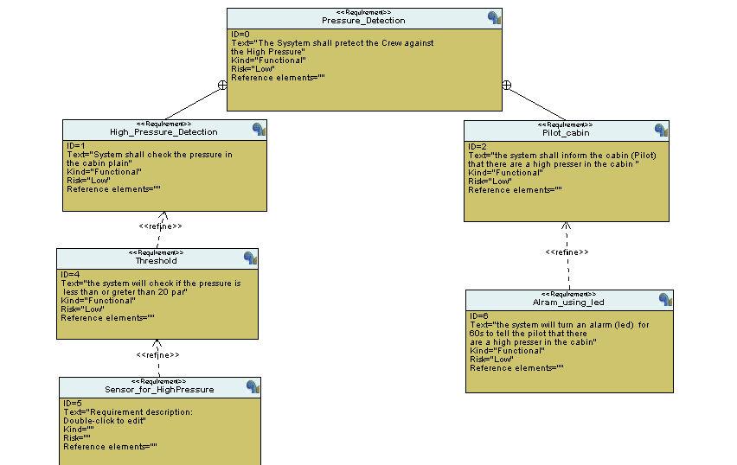

***System Analysis***

1. ***Usecase Diagram***

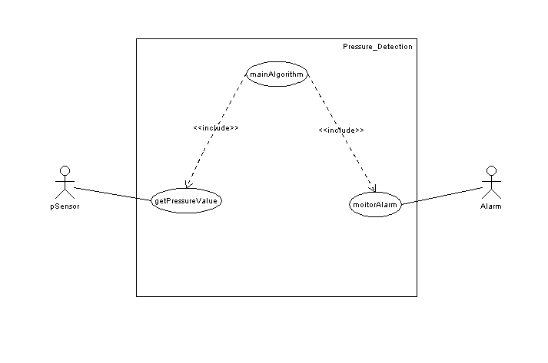

1. ***Activity Diagram***

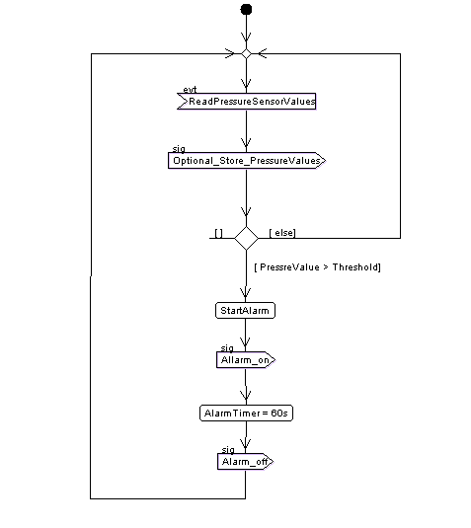

1. ***Sequence Diagram***

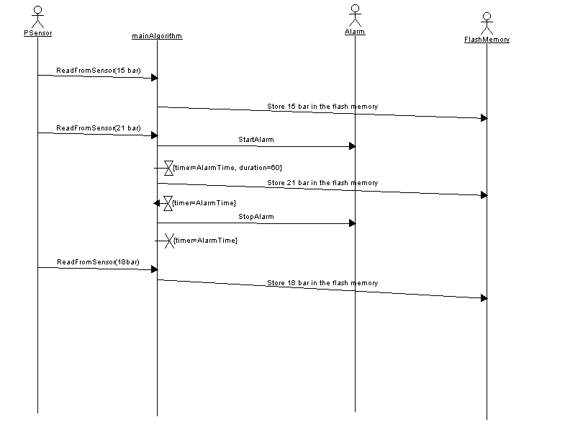

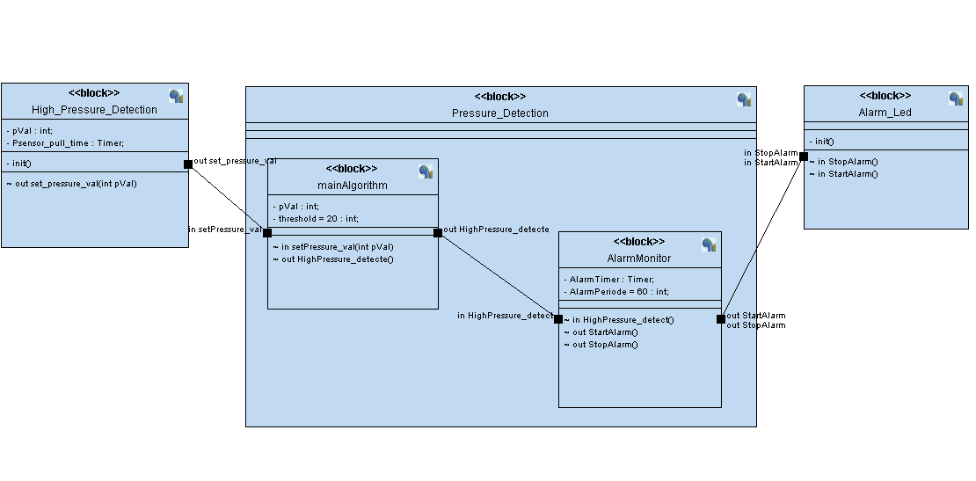***System Design Diagram***

***State Machine of Design Diagram***

1. ***High_Pressure_Detection***

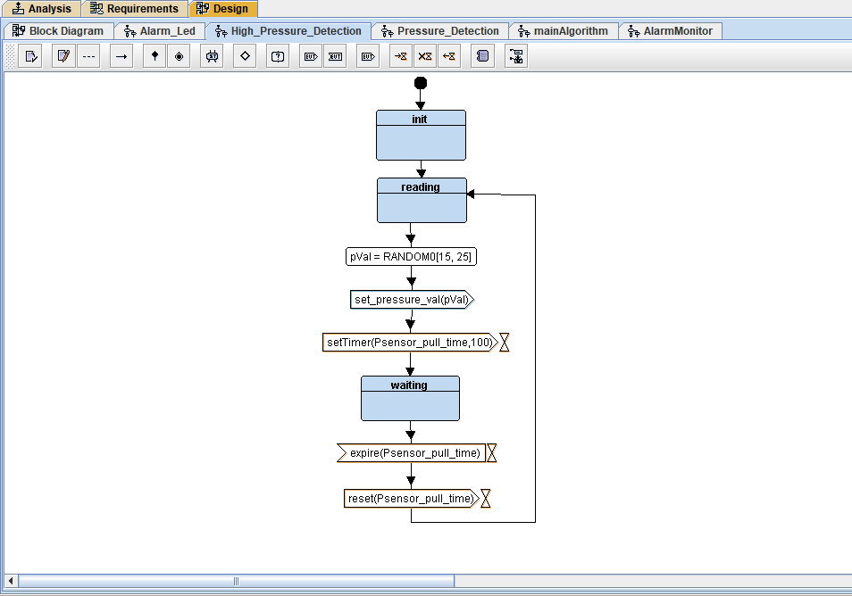

1. ***Main_Algorithm***

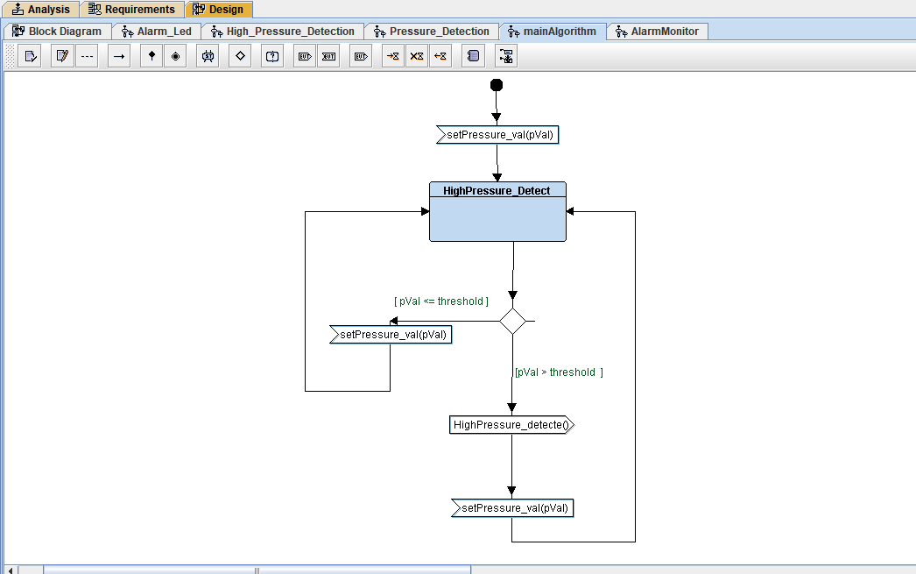

1. ***Alarm_Monitor***

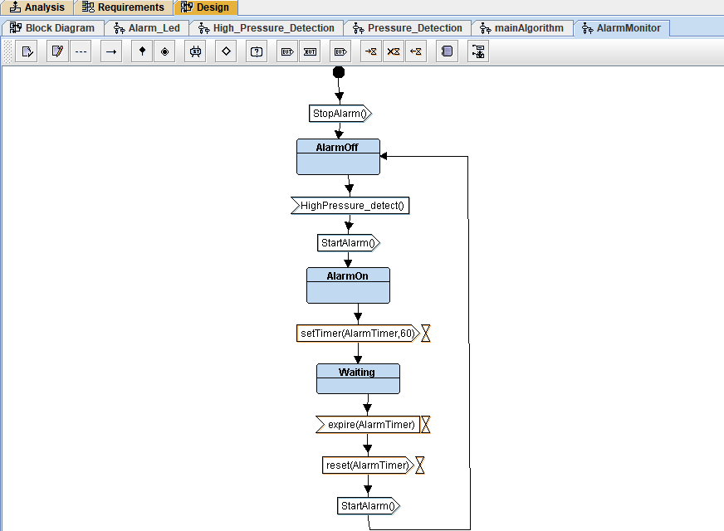

1. ***Alarm_Acuator(led)***

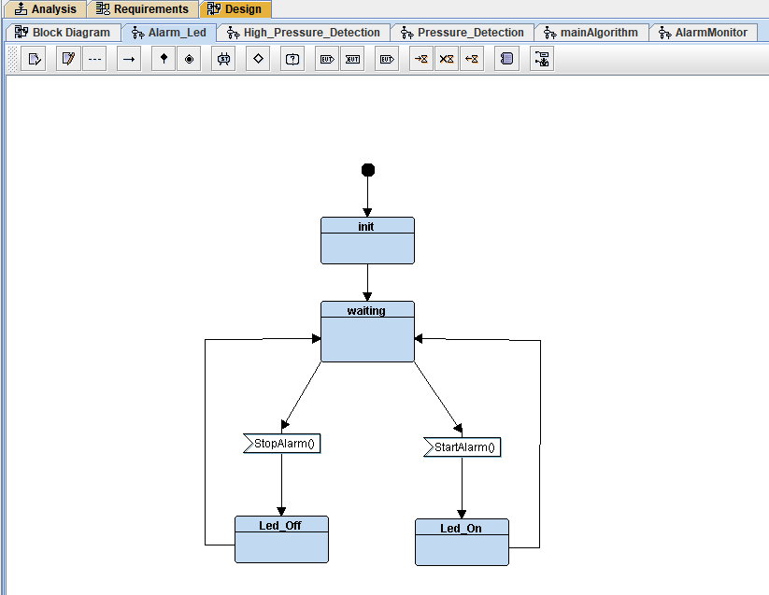

*Files*

1. State.h

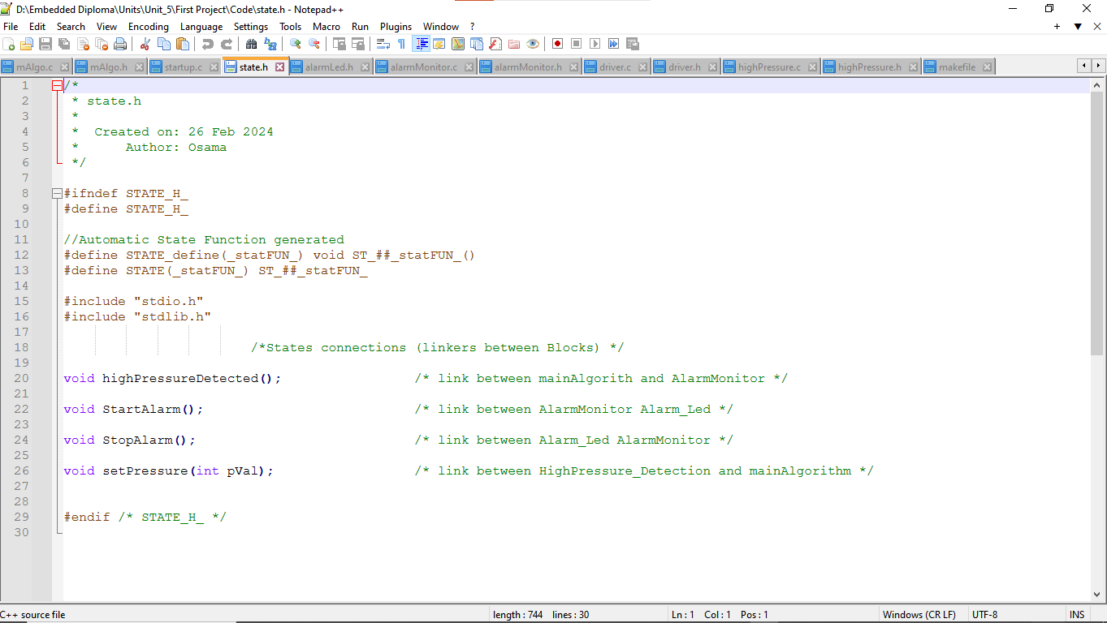

1. Main.c

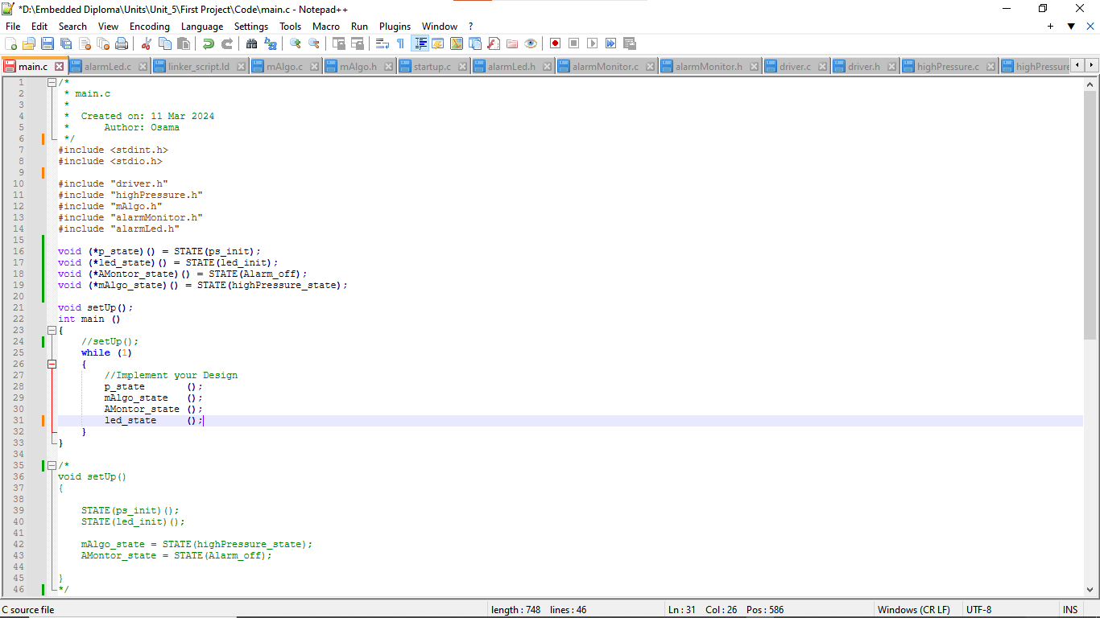

1. Driver.h

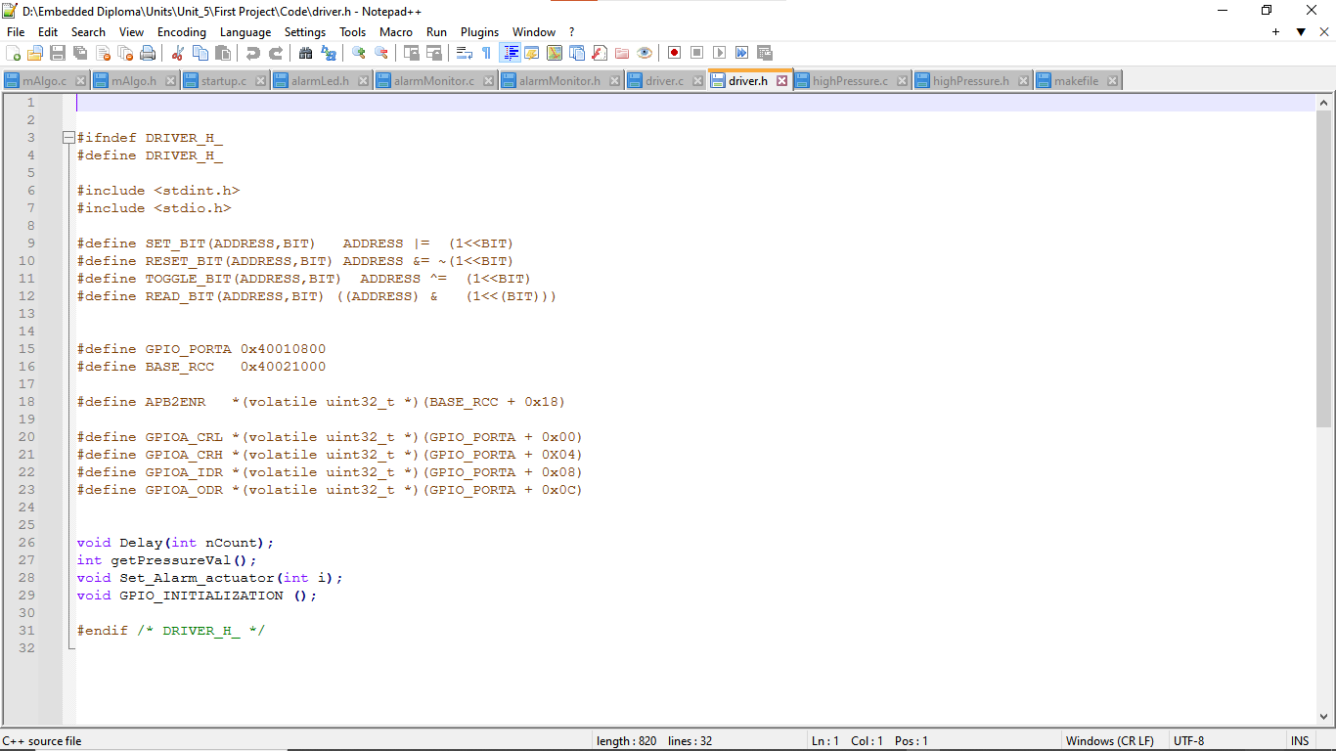

1. Driver.c

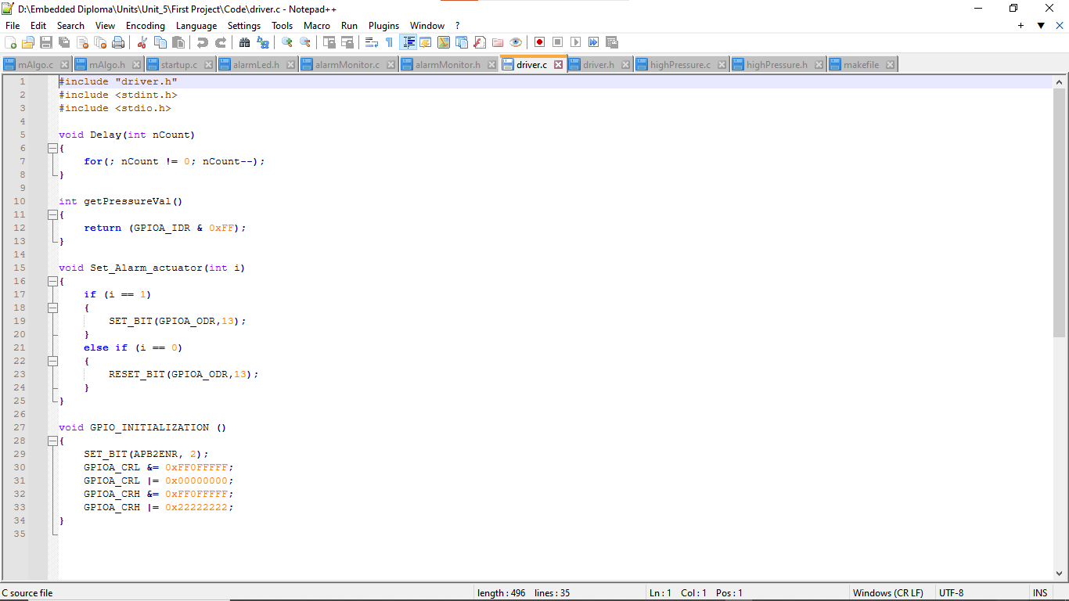

1. mainAlgorith.h

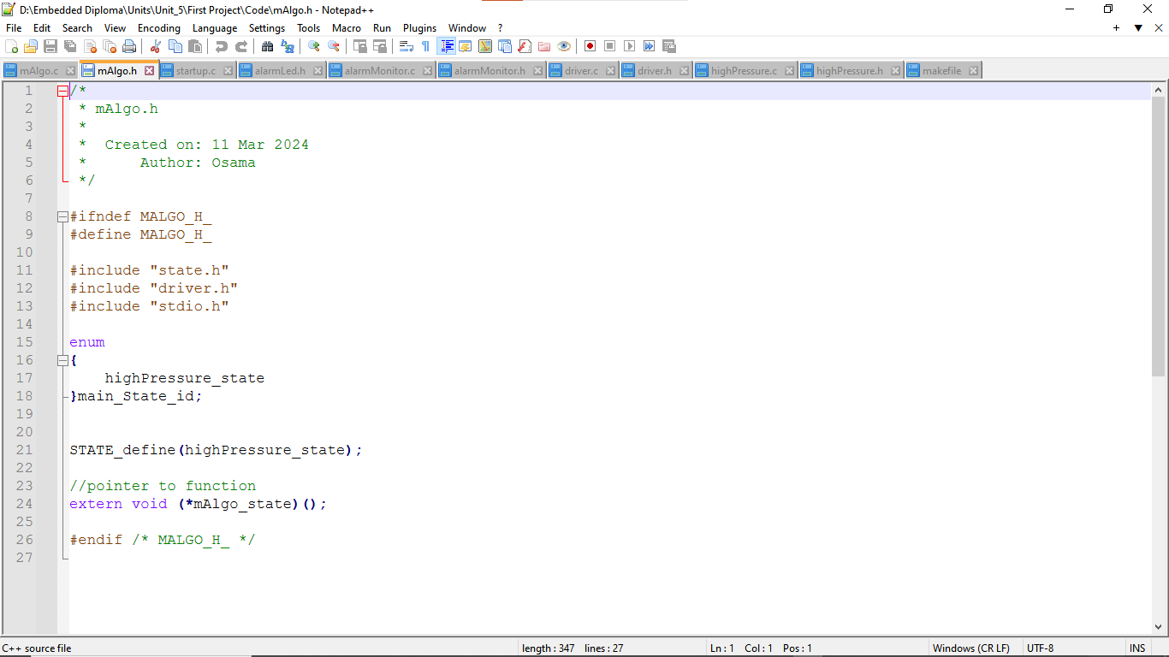

1. mainAlgoritm.c

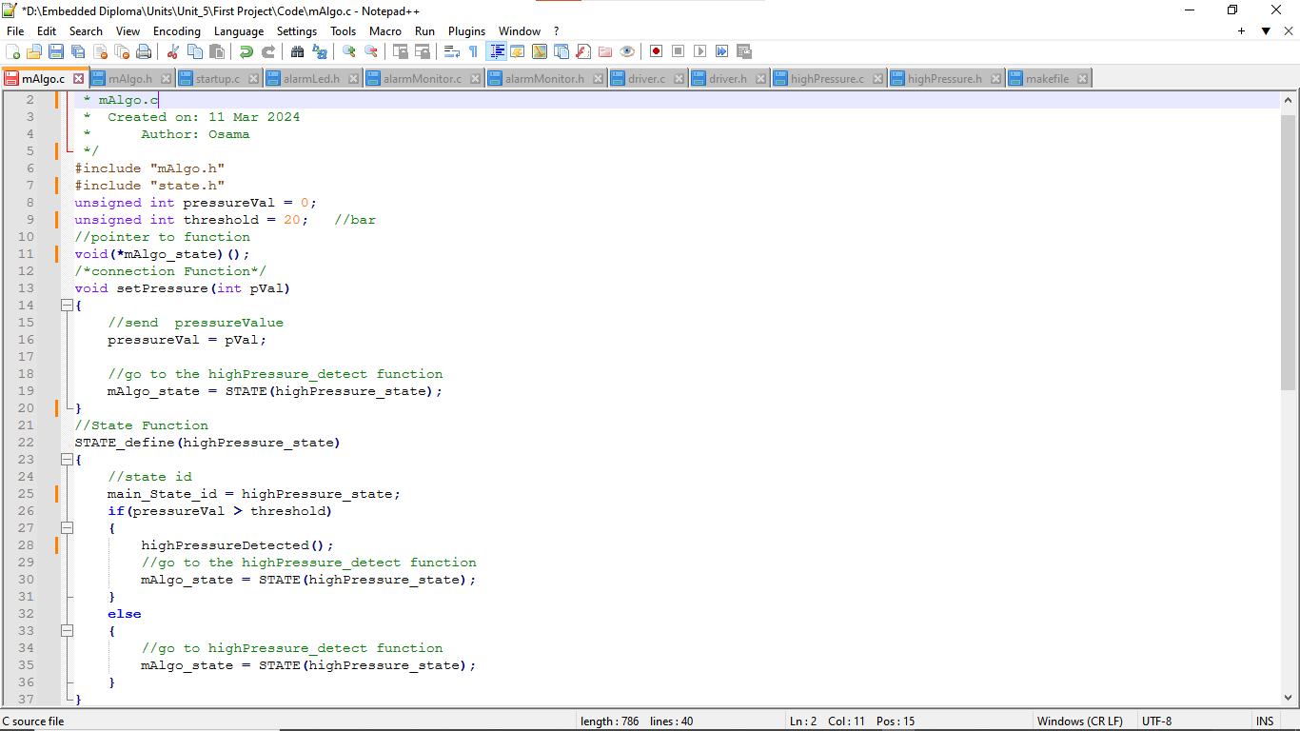

1. highpressre_detction.h

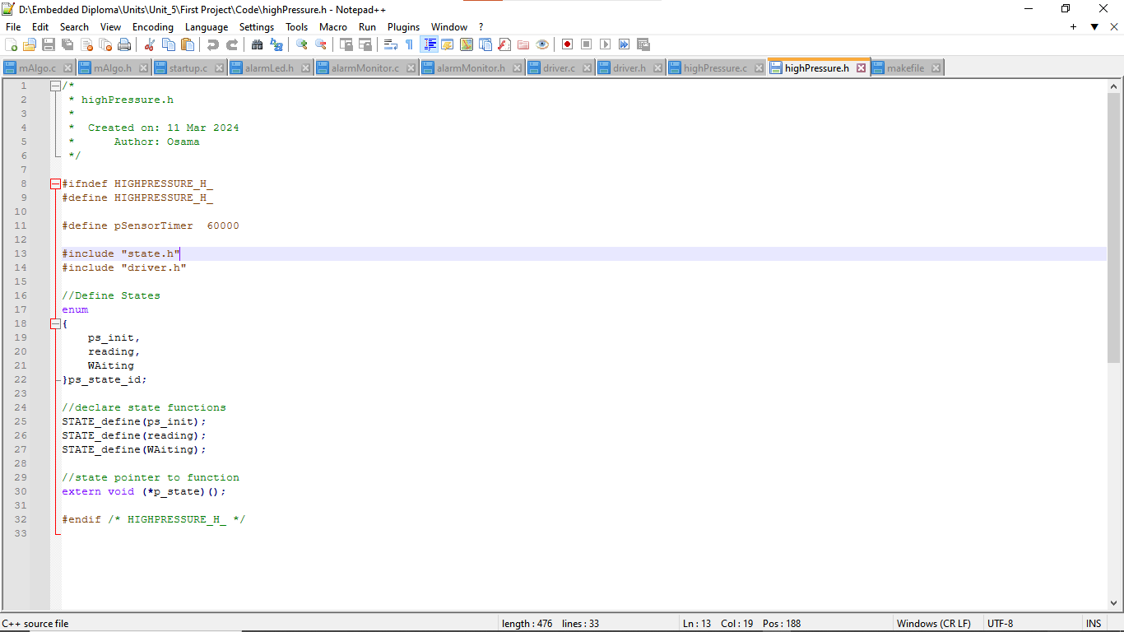

1. highpressre_detction.c

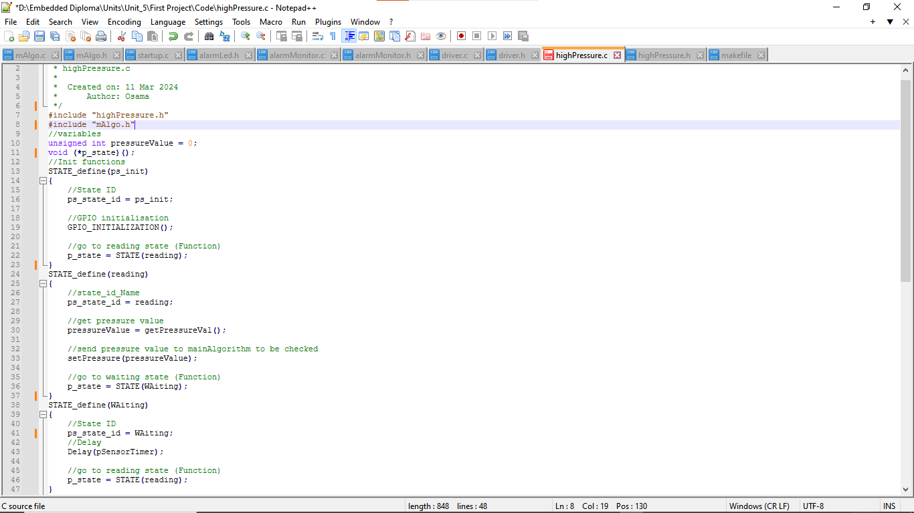

1. MonitorAlarm.h

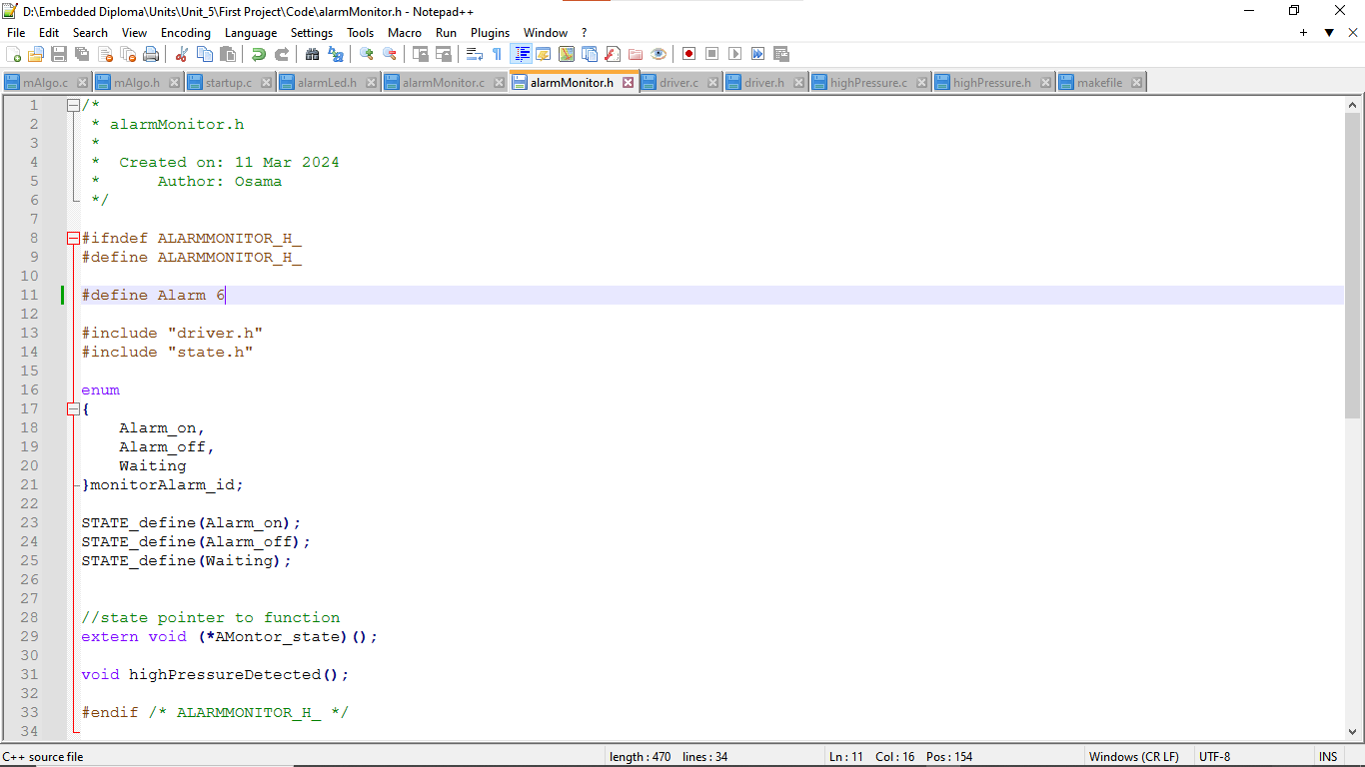

1. MonitorAlarm.c

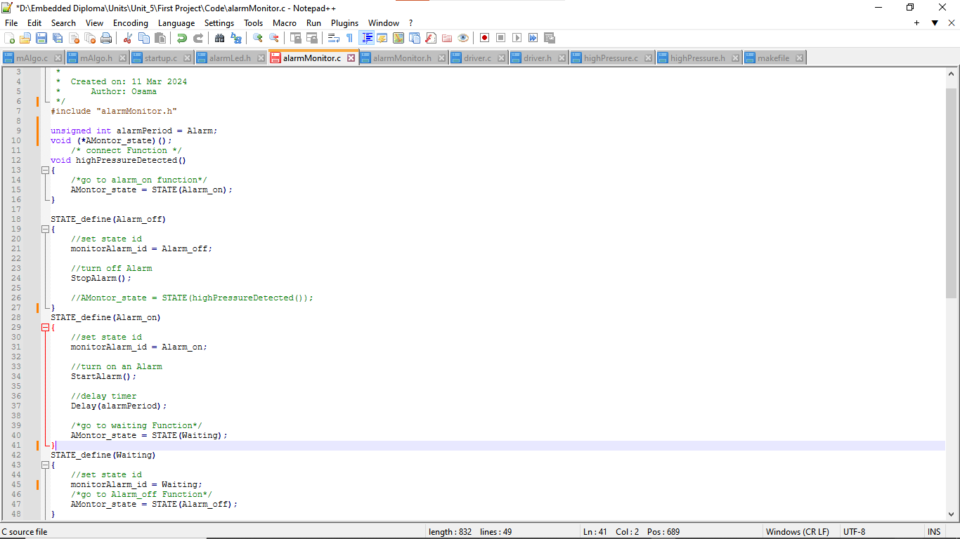

1. AlarmLed.h

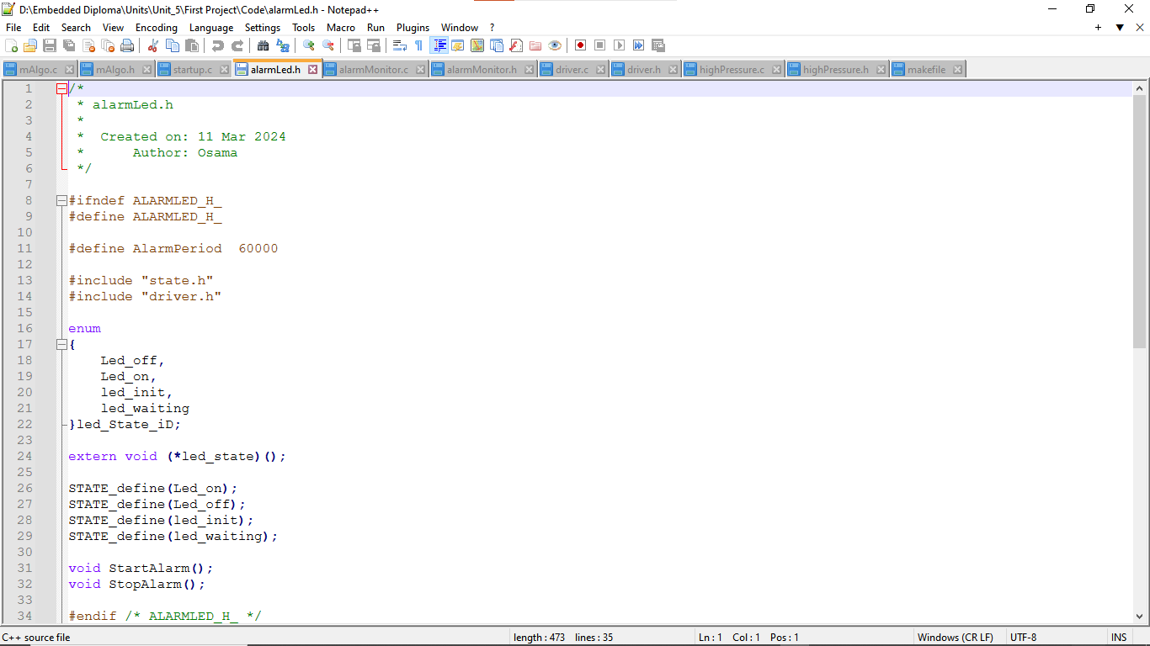

1. AlarmLed.c

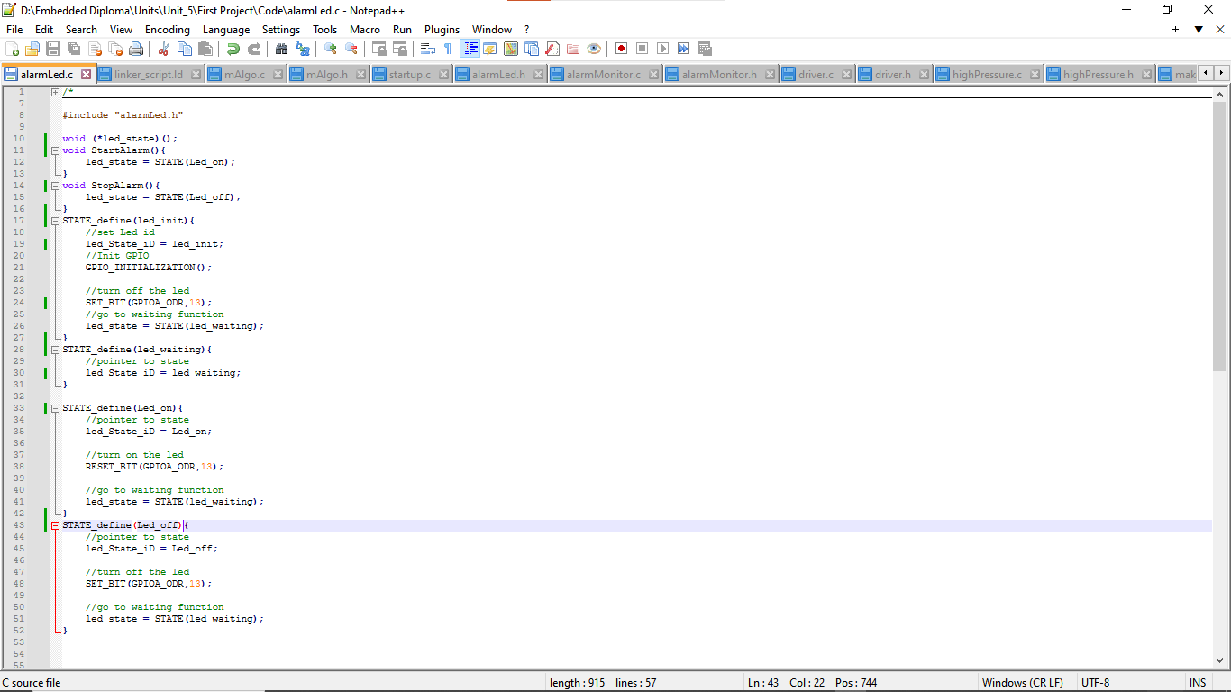

1. Startup.c

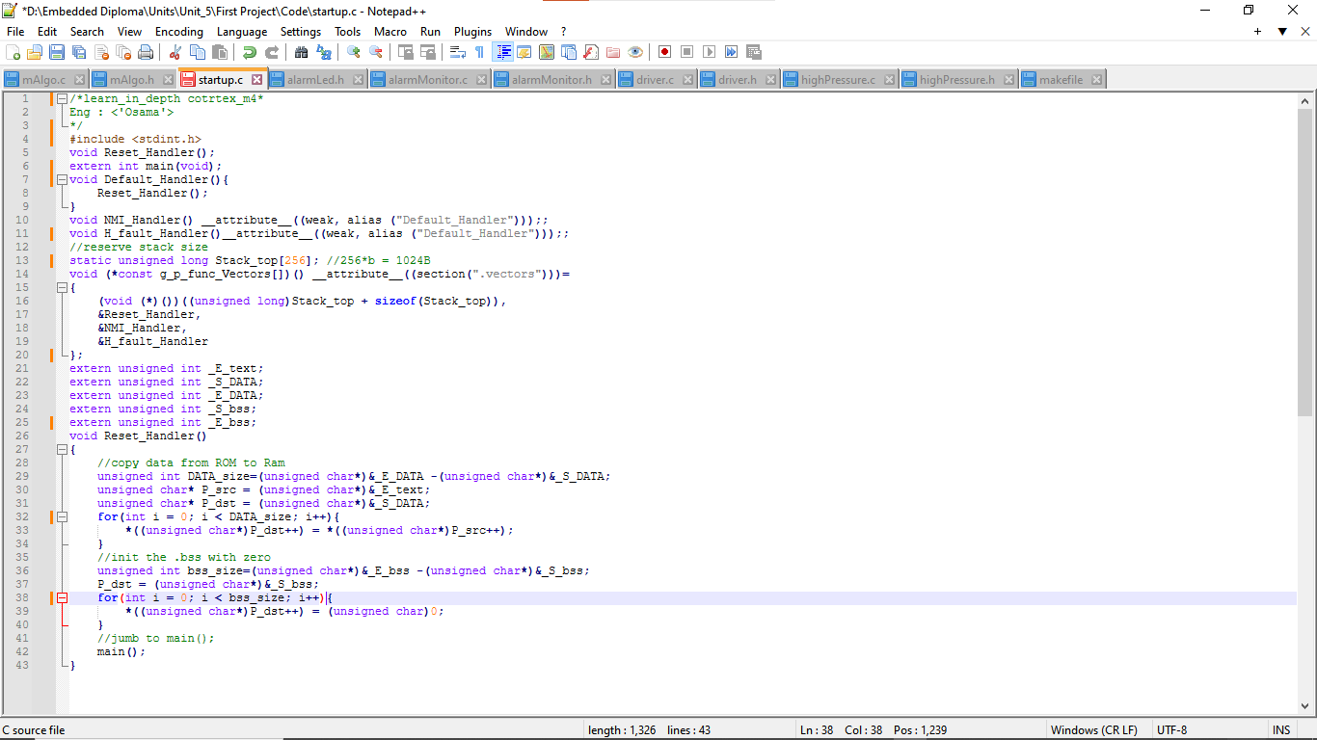

1. Linker_script.ld

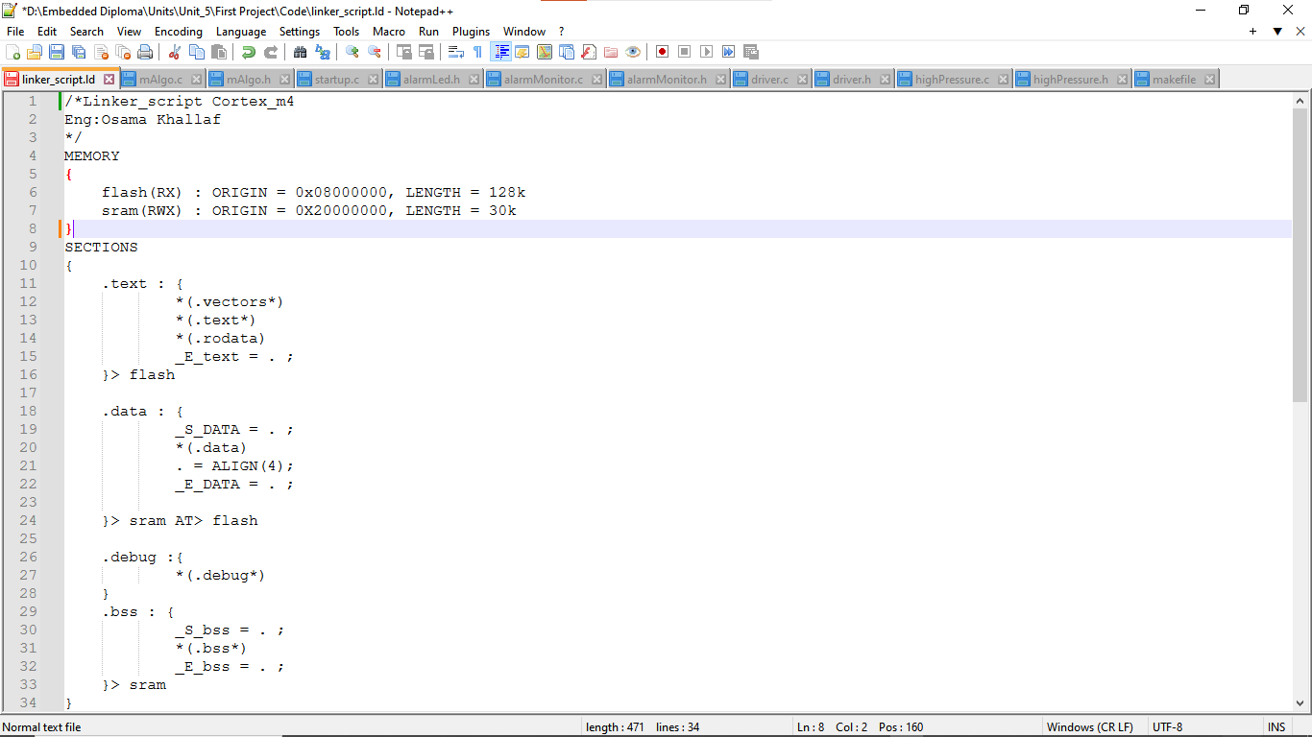

1. Makefile

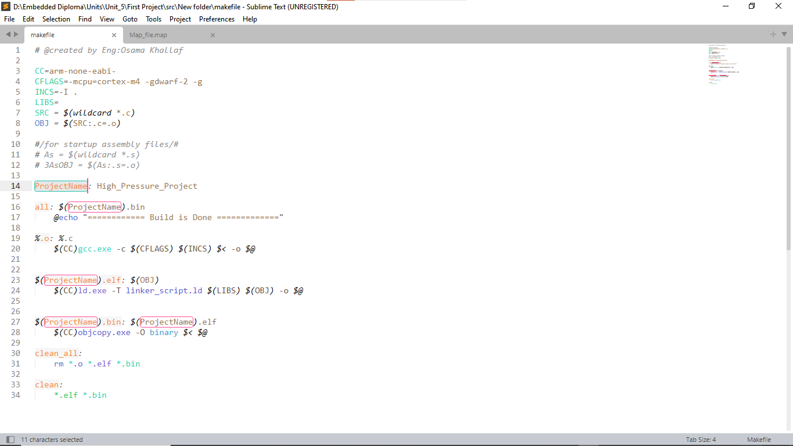

1. mapFile

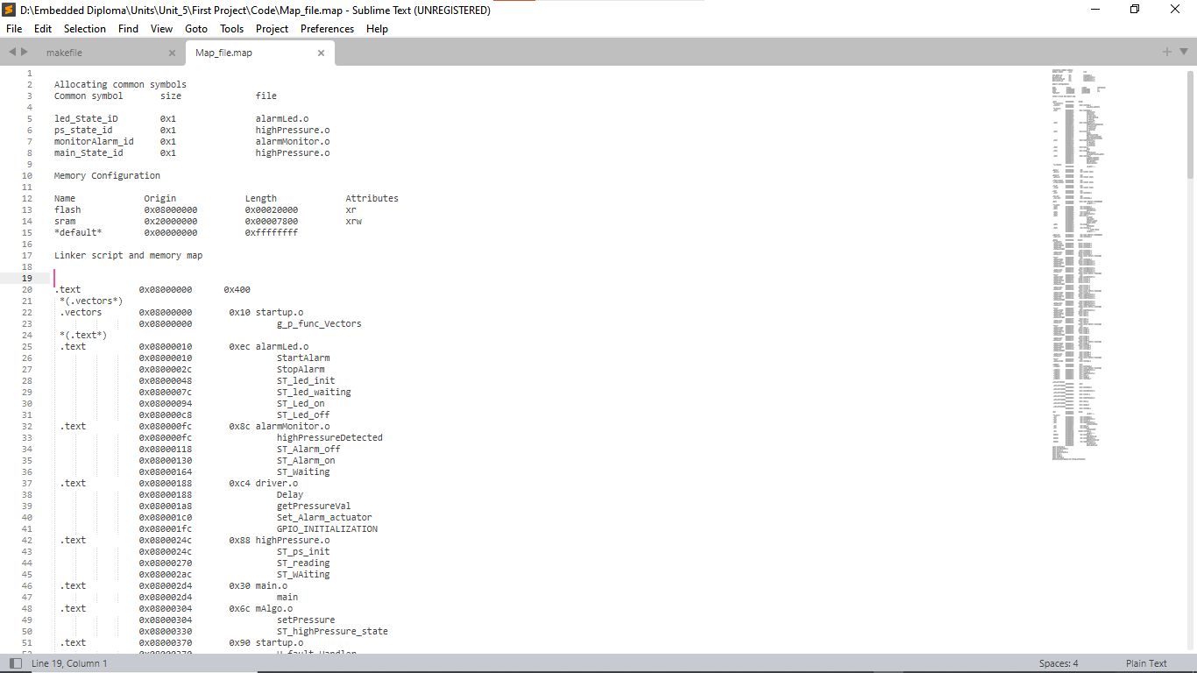

1. symbolTable

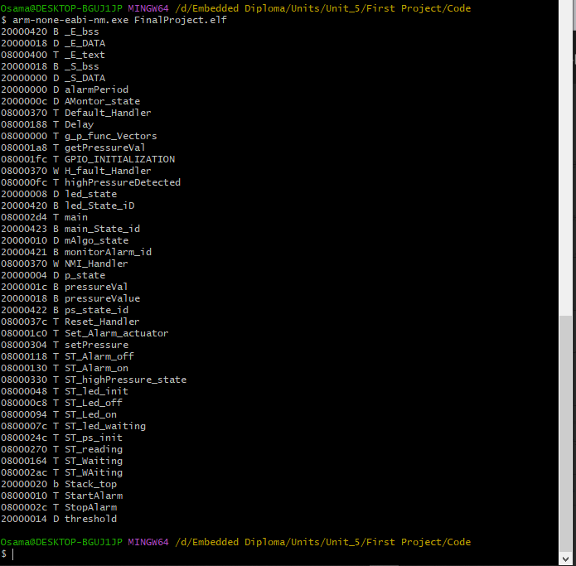

1. simulation before burn the bin file

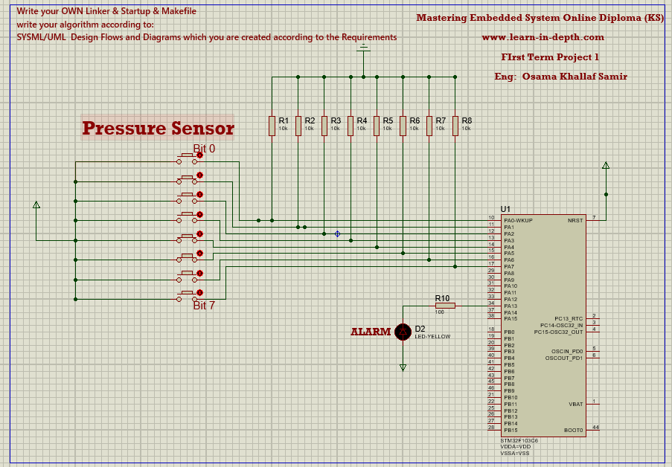

1. simulation after burn the bin file

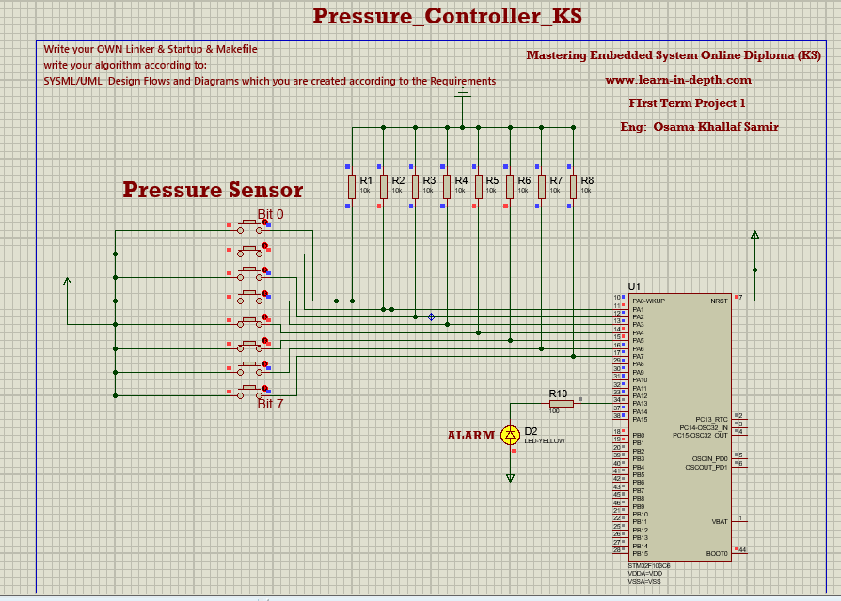

1. interactive simulation1

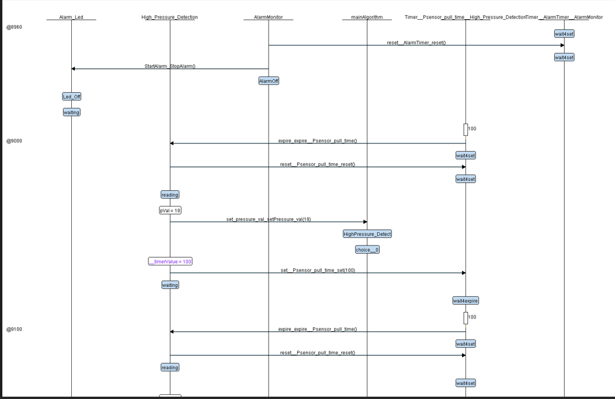

1. interactive simulation2

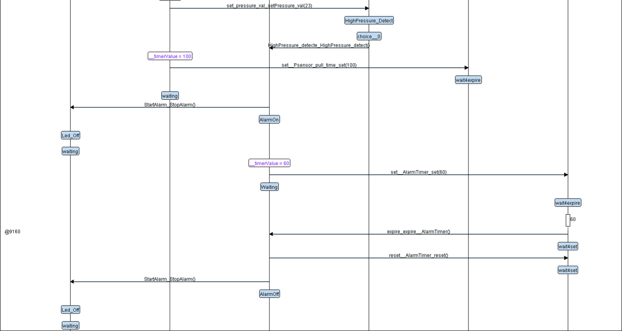

1. interactive simulation3

