
CSE334s - Database Systems

Gym Management System
Team 2

BN | ID | Name
103 | 2300354 | Karen Nasser Abd El-Malek
145 | 2300075 | Ibrahim Alaa Ibrahim
17 | 2300178 | Habiba Mohamed Abd El-Mohsen
177 | 2300509 | Marina George Boshra
33 | 2300360 | Lobna Ahmed Abd El Hamid
51 | 2301016 | Zeina Wael Mahmoud
99 | 2300337 | Osama Ahmed Mahmoud

Contents
Project Theme 2
Forms and Their Functionalities 2
Member Management 3
Trainer Management 4
Class Schedule Management 5
Membership Management 6
Branch Management 7
UI Flow 8

Project Theme
This project implements a relational database system for managing a multi-branch gym organization. The system is built on SQL Server and covers all core operational aspects of a modern gym: member registration and tracking, trainer and class management, membership plans, workout planning, equipment maintenance, and branch administration.
The goal is to provide a structured, consistent, and efficient way to store and retrieve gym data across multiple branches, ensuring data integrity through foreign key constraints, check constraints, and normalized table design.

Forms and Their Functionalities
The application provides a dashboard with five management forms. Each form connects directly to the database and allows users to perform full CRUD operations (Create, Read, Update, Delete).

Member Management
This form is the primary interface for managing gym members. It displays two data grids: one showing all member records and one showing member phone numbers.
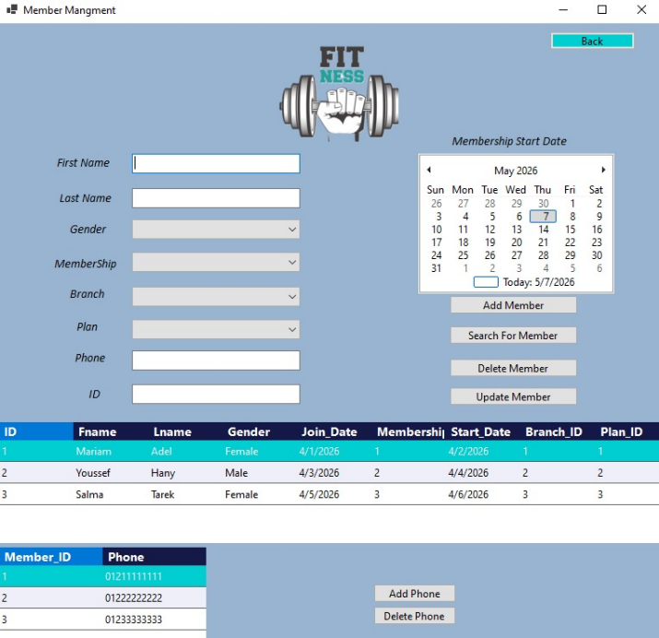
Functionalities:
- Add a new member by filling in First Name, Last Name, Gender, Membership, Branch, Plan, Phone, and selecting a Membership Start Date from the calendar picker.
- Search for a member.
- Update an existing member's information after selecting them from the grid.
- Delete a member record from the system.
- Add Phone or Delete Phone to manage multiple phone numbers per member independently.
Member Management Accesses: Member, Member_Phone, Membership, Workout_Plan, Branch_Manager
The form reads Membership, Workout_Plan, and Branch_Manager to populate the dropdowns so the user picks valid foreign key values. It writes directly to Member and Member_Phone. This scope makes sense because a member is the central entity that connects to almost everything — their branch, their plan, and their membership tier all need to be validated at the point of entry.
Procedures:
1. Constructor Procedure
- public Member()

2. Data Loading Procedures
- LoadMemberData()  - LoadPhoneData(int memberId = -1) | - LoadBranchOptions()  - LoadPlanOptions()
- LoadMembershipOptions() | - SetupGenderComboBox()
- ClearFields()

3. Event Procedures
- Add_Member_Click | - btnNoPlan_Click
- Delete_Member_Click | - comboBox1_SelectedIndexChanged
- Search_Click | - dataGridView1_CellClick
- Add_Phone_Click | - Back_Click

Trainer Management
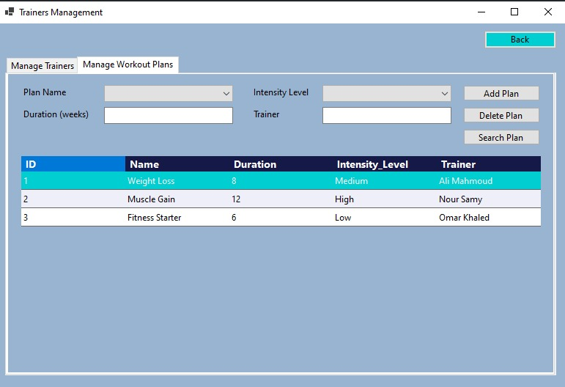
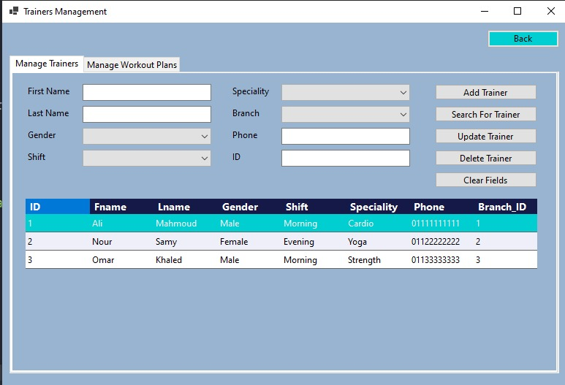
This form has two tabs: Manage Trainers and Manage Workout Plans, keeping trainer and plan management in one place.

Manage Trainers tab:
- Add, update, delete, and search trainers.
- Fields include First Name, Last Name, Gender, Shift, Specialty, Phone, and Branch.
- Dropdown menus enforce valid values for Gender, Shift, Specialty, and Branch.
- Search for a trainer.
Manage Workout Plans tab:
- Add and delete workout plans.
- Fields include Plan Name (dropdown), Duration in weeks, Intensity Level (dropdown), and assigned Trainer.
- Displays all plans in a grid showing ID, Name, Duration, Intensity Level, and the full trainer’s name.
- Search for a Workout Plans.
Trainer Management Accesses: Trainer, Workout_Plan, Branch_Manager
Trainer management reads Branch_Manager for the branch dropdown and writes to both Trainer and Workout_Plan. These two are kept together in one form because a workout plan can't exist without a trainer — it's a direct 1:M dependency, so it made sense to manage them in the same place rather than a separate form.
Procedures:
1. Constructor Procedures
- public Trainers()

2. Data Loading Procedures
- LoadTrainerData()  - LoadWorkoutPlanData() | - ClearPlanFields()  - ClearFields()
- LoadBranchOptions(string gender = "")

3. Event Procedures
- Add_Trainer_Click | - DataGridView1_CellClick
- Delete_Trainer_Click | - Add_Plan_Click
- Update_Trainer_Click | - Delete_Plan_Click
- Search_Click | - Search_Plan_Click
- Back_Click

Class Schedule Management
This form manages gym classes and their schedules. It displays two grids side by side: one for classes and one for class schedules.
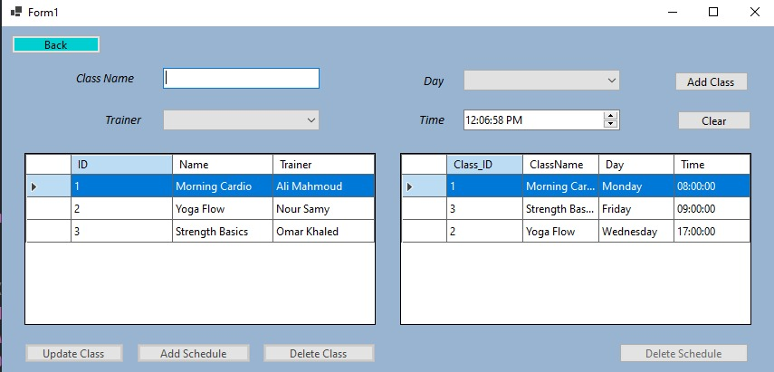
Functionalities:
- Add a new class by entering a Class Name and selecting a Trainer.
- Update an existing class name.
- Delete a class from the system.
- Add a Schedule to a class by selecting the Day (dropdown with all 7 days) and Time.
- Delete Schedule entries from the schedule grid independently.
Class Schedule Management Accesses: Class, Class_Schedule, Trainer
The form reads Trainer to populate the trainer dropdown when adding a class and writes to Class and Class_Schedule. These two tables are tightly coupled, a schedule entry is meaningless without the class it belongs to, so managing them together on one screen is the best choice.

Procedures:
1. Constructor Procedures
- ClassScheduler()

2. Data Loading Procedures
- LoadClassData()  - LoadScheduleData() | - LoadTrainerComboBox()  - LoadDayComboBox()

3. Event Procedures
- btnAddClass.Click | - dgvSchedules.CellClick
- btnDeleteClass.Click | - dgvClasses.CellClick
- btnUpdateClass.Click | - btnClear.Click

Membership Management
This is a straightforward form for managing membership tiers offered by the gym.

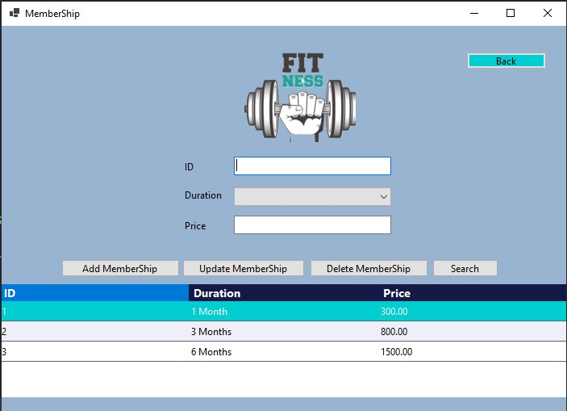
Functionalities:
- Add a new membership plan by specifying an ID, Duration (dropdown: 1 Month, 3 Months, 6 Months), and Price.
- Update an existing membership plan’s detail.
- Delete a membership tier from the system.
- Search for a specific membership.
- All current membership tiers are displayed in a grid with ID, Duration, and Price.
Membership Management Accesses: Membership only
This is the most isolated form by design. Membership tiers are reference data, they don't depend on any other table, and other tables (like Member) just reference them.

Procedures:
1. Constructor Procedure
- public Membership()

2. Data Loading Procedures
- LoadMembershipData()  - SetupDurationComboBox() | - StyleDataGridView()  - ApplyStyle(DataGridView dgv)
- ClearFields()

3. Event Procedures
- Add_MemberShip_Click | - Search_Click
- Update_MemberShip_Click | - Back_Click
- Delete_MemberShip_Click | - dataGridView1_CellClick

Branch Management
This is the most comprehensive form, managing branches, their equipment, and the classes each branch offers.
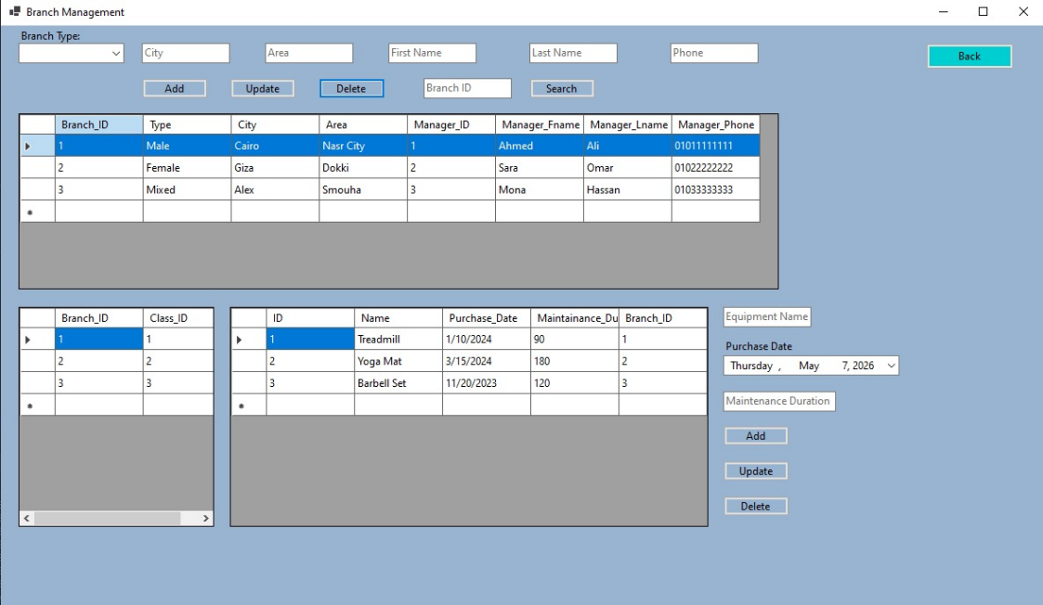
Functionalities:
- Add, update, delete, and search branches using the top section of the form.
- Fields include Branch Type (Male / Female / Mixed), City, Area, Manager First Name, Last Name, and Phone.
- The Offers grid at the bottom-left shows which classes each branch offers (Branch_ID, Class_ID).
- Search for a Branch by ID.
- The Equipment grid shows all equipment assigned to branches (ID, Name, Purchase Date, Maintenance Duration, Branch_ID).
- Add, update, and delete equipment records directly from this form using the panel on the right side.
Branch Management Accesses: Branch_Manager, Equipment, Offers, Class
This is the broadest form. It writes to Branch_Manager and Equipment, and reads Offers and Class to display which classes each branch provides. The reason this form is the widest in scope is that a branch is the physical container for everything - equipment lives in a branch, classes are offered by a branch. It made sense to give branch managers a full operational view of their branch from one screen.
Procedures:
1. Constructor Procedure
- public Branch(DashBord dash)

2. Data Loading Procedures
- LoadBranchData()  - LoadOffers(int branchId = -1) | - LoadEquipment(int branchId = -1(  - SearchBranchById(int id)

3. Event Procedures
- btnAdd_Click | - btnUpdateEquipment_Click
- btnDelete_Click | - btnDeleteEquipment_Click
- btnSearch_Click | - dgvEquipment_CellClick
- dgvBranch_CellClick | - btnBack_Click
- btnAddEquipment_Click

UI Flow
