Maham-مهام

**Project brief:**

**Maham** is a web platform to help people find workers-freelancers to do certain jobs for them. the customers can search for workers based on categories and then send them requests.

The customer will see the (last seen,rating and the number of finished tasks) for the worker before they send the request

The worker can then accept the request or deny it ,if the request is accepted then the customer can see the worker schedule and contact the worker.

When the task is done the customer will receive a notification to rate the worker.

**Use Case Diagram:**

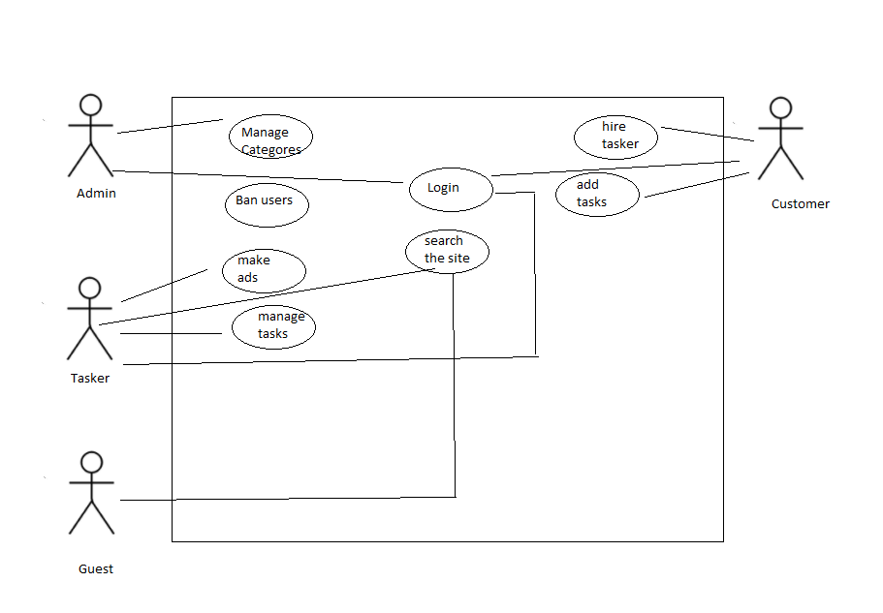

The website and the system will have four users types:

1. The guest user is anyone who visits the website to browse it, will have access to view the **Landing**, **Services**, **About us**, and Can view taskers ads but won't be able to send requests.
2. The customer is the normal user when they sign up an account, this type of user is allowed to send requests to the tasker.
3. The tasker, this type of user can make ads and assign them to a specific category for customers to see it.
4. The admin, this type of user can manage the categories and ban users.

**Project Requirements:**

**All the pages will have:**

1. Navbar
2. Footer

(All the pages should be fully responsive and with a good SEO)

--------------------------------------------------------------------------------------------------------

**The general user contains 4 pages which are:**

**Landing Page:**

Should have a neat structure, well organized, and consider the UX/UI for the page. It will contain:

1. Search input, to search for a specific thing task.
2. Popular projects in your area a grid view to the most common categories
3. About us sections and why choose us.

**About Us:**

It will have specific details about the Maham objective, who is the targeted audience.

**Contact Us:**

Will have a form to fill the user information and their message.

-------------------------------------------------------------------------------------------------------

**Services Pages:**

It will show all available categories

**Advertisements Page:**

Will display the Taskers advertisements for a specific category

**Single Advertisements Page:**

Will display a specific advertisements along with user comments and the tasker informations and the contact button

**Tasker Schedule Page:**

Will display the tasker schedule and allow the customer to insert their tasks on the tasker schedule and it will allow them to contact each other

**Profile page:**

profile page, it will contain :

1. Changeable photo, email, name, and phone number.
2. tasker info ex: finished tasks rating.

**ManageTasks:**

This page is only for taskers to manage their tasks ex: change the task status or delete it.

**Dashboard:**

1. Manage Users
2. Manage Categories

**Database Schema:**

The main database is Mongo Db (non-relational)

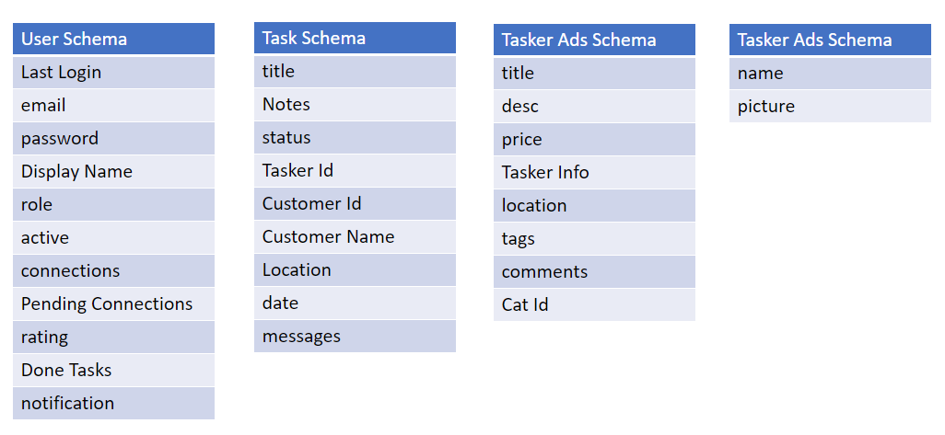

* **Technologies: MERN Stack**





