# Department of Computing

**Osama Akhlaq(213452)**

**CS-213: Advanced Programming**

**Class: BSCS 7AB**

# Lab 4: Introduction to Node.js

**Date: 26rd September, 2019**

**Time: 10:00-01:00pm & 02:00-05:00pm**

# Instructor: Dr. Sidra Sultana

**Lab Engineer: Ms. Ayesha Asif**

# 

# Lab 4: Introduction to Node.js

**Introduction**

This lab is about the installation and introduction to node.js environment. Node.js is an open source server environment. It runs on various platforms (Windows, Linux, Unix, Mac OS X, etc.). Node.js uses JavaScript on the server.

**Node.js uses asynchronous programming!**

A common task for a web server can be to open a file on the server and return the content to the client.

**Objectives**

This lab will get you familiar with the node.js environment.

**Tools/Software Requirement**

Node.js, Notepad

**Description**

**Helping Material**

Slides of Lecture 4 & 5

<https://www.w3schools.com/nodejs/nodejs_get_started.asp>

**Lab Tasks**

**Task 1:** Download Node.js from the official Node.js web site: [https://nodejs.org](https://nodejs.org/).

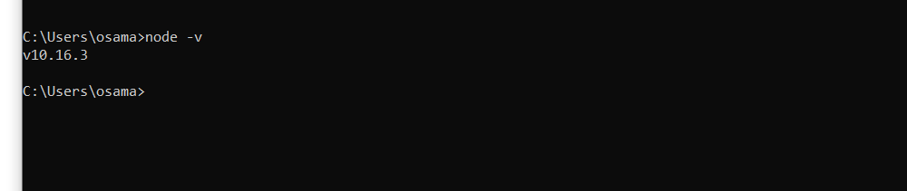

**Task 2:** Once you have downloaded and installed Node.js on your computer, let's try to display "Hello World" in a web browser.

Hint:

Create a Node.js file named "myfirst.js", and add the code.

Save the file on your computer: C:\Users\Your Name\myfirst.js

The file you have just created must be initiated by Node.js before any action can take place.

Start your node.js command line interface, write node myfirst.js and hit enter

**Solution:-**

console.log('Hello WOrld!');

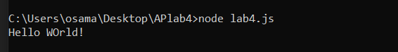

**Task 3:** Create a module that returns the current date and time. Save the code in a file called "myfirstmodule.js".

**DateModule.js**

exports.myDateTime = function () {

return Date();

};

**Lab4.js**

var http = require('http');

var dt = require('./DateModule.js');

http.createServer(function (req, res) {

res.writeHead(200, {'Content-Type': 'text/html'});

res.write("The date and time are currently: " + dt.myDateTime());

res.end();

console.log("The date and time are currently: " + dt.myDateTime());

}).listen(8080);

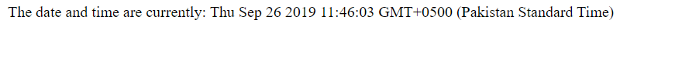

**Task 4:** Use the module "myfirstmodule" of date and time in a Node.js file.

**DateModule.js**

exports.myDateTime = function () {

return Date();

};

**Lab4.js**

var http = require('http');

var dt = require('./DateModule.js');

http.createServer(function (req, res) {

res.writeHead(200, {'Content-Type': 'text/html'});

res.write("The date and time are currently: " + dt.myDateTime());

res.end();

console.log("The date and time are currently: " + dt.myDateTime());

}).listen(8080);



**Node.js as a Web Server**

**Task 5:** The HTTP module can create an HTTP server that listens to server ports and gives a response back to the client. Use the createServer() method to create an HTTP server.

**Solution:-**

var http = require('http');

http.createServer(function (req, res) {

res.writeHead(200, {'Content-Type': 'text/plain'});

res.write('Hello World!');

res.end();

}).listen(8080);

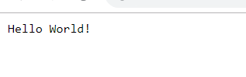

**Task 6:** Add an HTTP Header

Hint: If the response from the HTTP server is supposed to be displayed as HTML, you should include an HTTP header with the correct content type like:

**res.writeHead(200, {'Content-Type': 'text/html'});**

The first argument of the res.writeHead() method is the status code, 200 means that all is OK, the second argument is an object containing the response headers.

**Solution:-**

var http = require('http');

http.createServer(function (req, res) {

res.writeHead(200, {'Content-Type': 'text/html'});

res.write("Hello i am created");

res.end();

}).listen(8080);

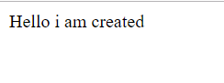

**Node.js as a File Server**

The Node.js file system module allows you to work with the file system on your computer. To include the File System module, use the require() method:

var fs = require('fs');

Common use for the File System module:

* Read files
* Create files
* Update files
* Delete files
* Rename files

**Task 7:** Create a Node.js file that reads the HTML file, and return the content.

**Solution:-**

var http = require('http');

var fs = require('fs');

http.createServer(function (req, res) {

fs.readFile('Parho.html', function(err, data) {

res.writeHead(200, {'Content-Type': 'text/html'});

res.write(data);

res.end();

});

}).listen(8080);

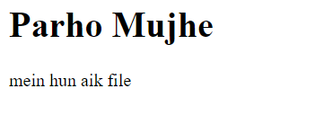

**Task 8:** Create a new file using

* appendFile() method
* open() method
* writeFile() method

**Append:-**

var fs = require('fs');

fs.appendFile('mynewfile1.txt', 'Hello content!', function (err) {

if (err) throw err;

console.log('Ban gae file');

});





**Open:-**

var fs = require('fs');

fs.open('mynewfile2.txt', 'w', function (err, file) {

if (err) throw err;

console.log('Dosri bi ban gar');

});





writeFile():-

var fs = require('fs');

fs.writeFile('mynewfile3.txt', 'This is my text', function (err) {

if (err) throw err;

console.log('Teesri bi ban gae');

});





**Task 9:** Append "This is my text." to the end of the file "mynewfile1.txt".

**Solution:-**

var fs = require('fs');

fs.appendFile('mynewfile1.txt', ' aPPEND KR DI', function (err) {

if (err) throw err;

console.log('Updated!');

});

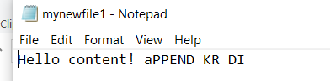

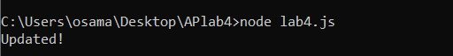

**Task 10:** Replace the content of the file "mynewfile3.txt".

**Solution:-**

var fs = require('fs');

fs.writeFile('mynewfile3.txt', 'Replaced text', function (err) {

if (err) throw err;

console.log('Replace kr di hai!');

});



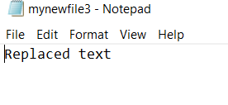

**Task11:** Delete "mynewfile2.txt".

**Solution:-**

var fs = require('fs');

fs.unlink('mynewfile2.txt', function (err) {

if (err) throw err;

console.log('File deleted!');

});



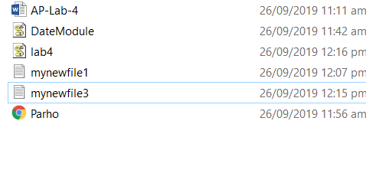

**Task 12:** Rename "mynewfile1.txt" to "myrenamedfile.txt".

**Solution:-**

var fs = require('fs');

fs.rename('mynewfile1.txt', 'myrenamedfile.txt', function(err) {

if ( err ) console.log('ERROR: ' + err);

});



  
  
  