**Department of Computing**

**Osama AKhlaq(213452)**

**CS-213: Advanced Programming**

**Class: BSCS 7AB**

**Lab 08: React JS**

**Date: 07 November, 2019**

**Time: 10:00-01:00pm & 02:00-05:00pm**

**Instructor: Dr. Sidra Sultana**

**Lab Engineer: Ms. Ayesha Asif**

**Lab 08: ReactJS States**

**Lab Tasks**

1. **You have to practice the states codes covered in class lecture**

**App.js:-**

import React, { Component } from 'react';

class App extends Component {

render() {

return (

<div className="App">

<h1>Hello World!</h1>

</div>

);

}

}

export default App;

**index.js:-**

import React from 'react';

import ReactDOM from 'react-dom';

class Car extends React.Component {

constructor(props) {

super(props);

this.state = {

brand: "Ford",

model: "Mustang",

color: "red",

year: 1964

};

}

render() {

return (

<div>

<h1>My {this.state.brand}</h1>

<p>

It is a {this.state.color}

{this.state.model}

from {this.state.year}.

</p>

</div>

);

}

}

ReactDOM.render(<Car />, document.getElementById('root'));

Index.html:-

<!DOCTYPE html>

<html lang="en">

<head>

<meta charset="utf-8" />

<meta name="viewport" content="width=device-width, initial-scale=1" />

<title>React App</title>

</head>

<body>

<div id="root"></div>

</body>

</html>



**App.js:-**

import React, { Component } from 'react';

class App extends Component {

render() {

return (

<div className="App">

<h1>Hello World!</h1>

</div>

);

}

}

export default App;

**index.js:-**

import React from 'react';

import ReactDOM from 'react-dom';

class Car extends React.Component {

constructor(props) {

super(props);

this.state = {

brand: "Ford",

model: "Mustang",

color: "red",

year: 1964

};

}

changeColor = () => {

this.setState({color: "blue"});

}

render() {

return (

<div>

<h1>My {this.state.brand}</h1>

<p>

It is a {this.state.color}

{this.state.model}

from {this.state.year}.

</p>

<button

type="button"

onClick={this.changeColor}

>Change color</button>

</div>

);

}

}

ReactDOM.render(<Car />, document.getElementById('root'));

**Index.html:-**

<!DOCTYPE html>

<html lang="en">

<head>

<meta charset="utf-8" />

<meta name="viewport"

content="width=device-width, initial-scale=1" />

<title>React App</title>

</head>

<body>

<div id="root"></div>

</body>

</html>

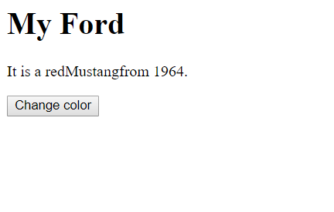

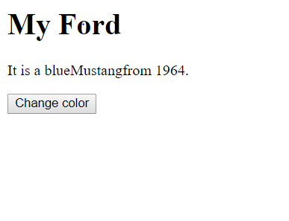

**App.js:-**

import React, { Component } from 'react';

class App extends Component {

render() {

return (

<div className="App">

<h1>Hello World!</h1>

</div>

);

}

}

export default App;

**Index.js:-**

import React, { Component } from 'react';

import ReactDOM from 'react-dom';

class Message extends Component{

state={

message: 'welcome visitor'

}

changeMessage = ()=>{

this.setState({

message: 'Thank you for subscribing'

});

}

render(){

return(

<div>

<h1>{this.state.message}</h1>

<button onClick={()=>this.changeMessage()}>Subsribe</button>

</div>

)

}

}

ReactDOM.render(<Message />, document.getElementById('root'));

**Index.html:-**

<!DOCTYPE html>

<html lang="en">

<head>

<meta charset="utf-8" />

<meta name="viewport"

content="width=device-width, initial-scale=1" />

<title>React App</title>

</head>

<body>

<div id="root"></div>

</body>

</html>

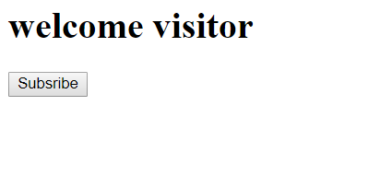



**App.js:-**

import React, { Component } from 'react';

class App extends Component {

render() {

return (

<div className="App">

<h1>Hello World!</h1>

</div>

);

}

}

export default App;

Index.js:-

import React, { Component } from 'react';

import ReactDOM from 'react-dom';

class Counter extends Component {

constructor(props){

super(props)

this.state={ count:0 } }

Increment = ()=>{

this.setState({

count: this.state.count + 1

})

}

render(){

return (

<div>

<h1>counter - {this.state.count}</h1>

<button onClick={()=>this.Increment()}>Increment</button>

</div>

)

}

}

ReactDOM.render(<Counter />, document.getElementById('root'));

**Index.html:-**

<!DOCTYPE html>

<html lang="en">

<head>

<meta charset="utf-8" />

<meta name="viewport"

content="width=device-width, initial-scale=1" />

<title>React App</title>

</head>

<body>

<div id="root"></div>

</body>

</html>

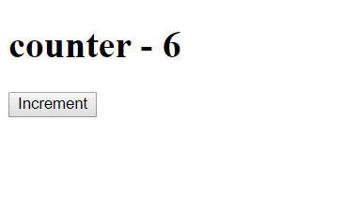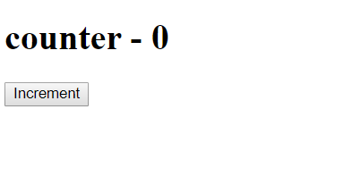

1. Create a timer application which asks the user for minutes. The user then click Start button and starts the timer count down. Preview @ <https://7zyz2y4p5j.csb.app/>

**Code:**

**Index.js:-**

import React from "react";

import ReactDOM from "react-dom";

import "./style.css";

class TimerInput extends React.Component {

render() {

return (

<div style={{marginLeft:100}}>

<h3>Input your desired time</h3>

<input type="number" value={this.props.value} onChange={this.props.handleChange} required />

</div>

);

}

}

class Timer extends React.Component {

render() {

return (

<div>

<h1 style={{ fontSize: 100, marginLeft:100 }}>{this.props.value}:{this.props.seconds}</h1>

</div>

);

}

}

class StartButton extends React.Component {

render() {

return (

<div style={{ marginLeft: 130 }}>

<button className="btn btn-lg btn-success" disabled={!this.props.value} onClick={this.props.startCountDown}>Start</button>

</div>

);

}

}

class App extends React.Component {

constructor(props) {

super(props);

this.state = {

seconds: '00',

value: '',

isClicked : false

}

/* this.secondsRemaining;

this.intervalHandle; */

this.handleChange = this.handleChange.bind(this);

this.startCountDown = this.startCountDown.bind(this);

this.tick = this.tick.bind(this);

}

handleChange(event) {

this.setState({

value: event.target.value

})

}

tick() {

var min = Math.floor(this.secondsRemaining / 60);

var sec = this.secondsRemaining - (min * 60);

this.setState({

value: min,

seconds: sec,

})

if (sec < 10) {

this.setState({

seconds: "0" + this.state.seconds,

})

}

if (min < 10) {

this.setState({

value: "0" + min,

})

}

if (min === 0 & sec === 0) {

clearInterval(this.intervalHandle);

}

this.secondsRemaining--

}

startCountDown() {

this.intervalHandle = setInterval(this.tick, 1000);

let time = this.state.value;

this.secondsRemaining = time * 60;

this.setState({

isClicked : true

})

}

render() {

const clicked = this.state.isClicked;

if(clicked){

return (

<div>

<div className="row">

<div className="col-md-4"></div>

<div className="col-md-4">

<Timer value={this.state.value} seconds={this.state.seconds} />

</div>

</div>

</div>

);

}else{

return (

<div>

<div className="row">

<div className="col-md-4"></div>

<div className="col-md-4">

<TimerInput value={this.state.value} handleChange={this.handleChange} />

<Timer value={this.state.value} seconds={this.state.seconds} />

<StartButton startCountDown={this.startCountDown} value={this.state.value} />

</div>

</div>

</div>

);

}

}

}

const rootElement = document.getElementById("root");

ReactDOM.render(<App />, rootElement);

**Index.html:**

<!DOCTYPE html>

<html lang="en">

<head>

<meta charset="utf-8">

<meta name="viewport" content="width=device-width, initial-scale=1, shrink-to-fit=no">

<meta name="theme-color" content="#000000">

<link rel="manifest" href="%PUBLIC_URL%/manifest.json">

<link rel="shortcut icon" href="%PUBLIC_URL%/favicon.ico">

<title>React App</title>

</head>

<body>

<noscript>

You need to enable JavaScript to run this app.

</noscript>

<div id="root"></div>

</body>

</html>

**Style.css:**

.App {

font-family: sans-serif;

text-align: center;

}

