Report

**Laith Thani Al-Alawi**

**Osama Al-Rawahi**

**Ahmed Al-Abri**

Report content

The overview of the structure of website: 3

description about each page: 3

The type of CSS styles and Bootstrap layout: 7

summarize the project tasks and the contribution for each team member: 8

Hyperlink to website in the web-hosting site and GitHub project 8

# The overview of the structure of website:

1. **Website Structure**: The structure of the website has been completely revamped to enhance user-friendliness and intuitiveness. The navigation system has been simplified, making it easier for users to find what they’re looking for. The website is now organized in a way that guides users seamlessly through the content, improving their overall browsing experience.
2. **Website Design**: The design of the website has been significantly enhanced to increase its visual appeal. The overall shape and layout of the site have been updated to a more modern and engaging design. The color scheme and typography have been carefully chosen to align with the brand identity, creating a consistent and visually pleasing aesthetic across the entire site.
3. **Background**: The background of the website has been changed to a design that not only provides a visually pleasing experience but also complements the content of the website and enhances readability. This ensures that the text is easy to read and the images and other elements stand out, improving the overall user experience.
4. **Additional Effects**: To make the website more interactive and dynamic, new effects have been added. These include transitions that smoothly guide users from one section to another, animations that add a sense of liveliness to the site, and hover effects that provide immediate visual feedback when users interact with the site. These effects enrich the user experience by making the site more engaging and enjoyable to navigate.
5. **Content Organization**: The content on the website is organized in a logical and intuitive manner. Important information is prominently displayed, and related content is grouped together. This makes it easy for users to find the information they’re looking for and understand the flow of the site.
6. **Responsive Design**: The website is designed to be responsive, meaning it automatically adjusts to fit different screen sizes. Whether users are accessing the site from a desktop computer, a laptop, a tablet, or a smartphone, they will have an optimal viewing experience.
7. **Accessibility**: The website is designed with accessibility in mind, ensuring that it can be easily used by people with various abilities and disabilities. This includes features like alt text for images, high contrast text, and keyboard-friendly navigation.

All these changes aim to provide a better user experience and make the website more effective in serving its purpose. The website is now not only visually appealing but also functional, accessible, and user-friendly. It effectively represents the brand and serves as a valuable resource for its users.

# description about each page:

About us page:

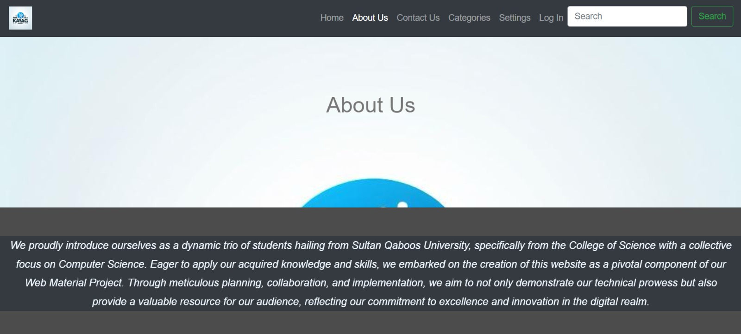

webpage with a logo picture background, and gray container color, so that’s gives a beautiful consistency of colors and comfortable for the user eyes. It features a navigation bar at the top with various options including Home, About Us, Contact Us, Categories, Settings, Login, and a search icon. The main content of the page is under the “About Us” section, which includes an image of two red pushpins on the left side of the text. The text introduces the creators of the website as three students from Sultan Qaboos University, College of Science, majoring in Computer Science.

Login page: 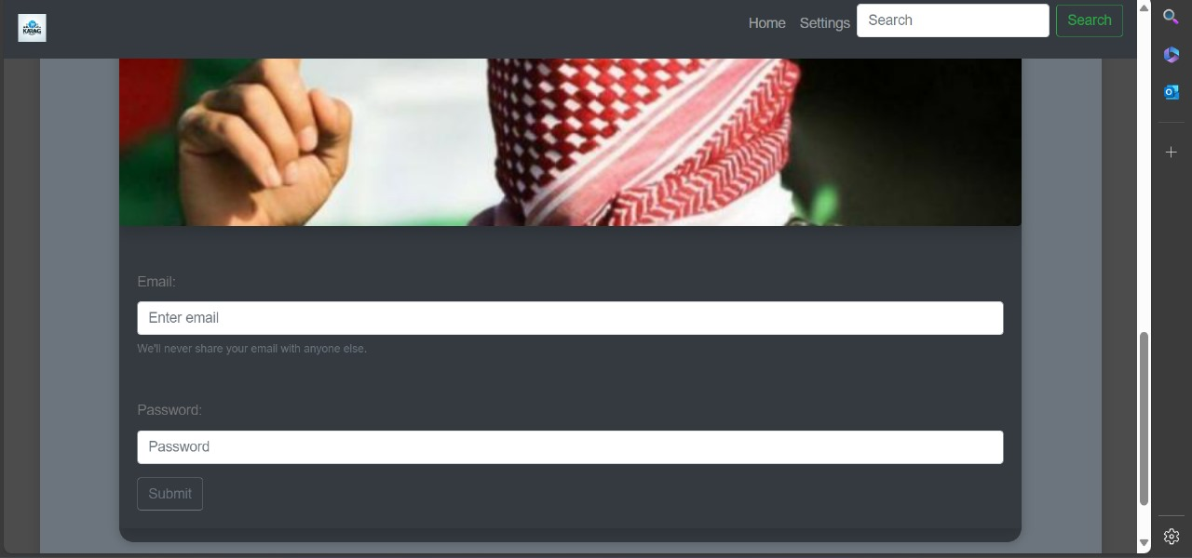

a simple and essential layout for users to access their accounts. The page has fields for entering an email and password, a “Submit” button, and a user profile picture. Additionally, the top bar of the page contains options like Home, Settings, and Search. This design highlights the user-friendly nature of the website.

Categories page:

section of a webpage titled “Categories”. Where the page categories includes 5 categories and each category contains 3 categories, which are new and exclusive items, cheap & used items and best selling items, for example here transport is associated with a description: “New & Exclusive”, “Cheap & Used”, and “Best-selling”, and same for other categories like Electronic Devices, Electrical Appliances, etc. The page offers users various transport options categorized and others categorized by their condition and exclusivity, providing viewers with diverse choices tailored to their needs and preferences.

Home page:

Home webpage with a navigation bar at the top and two sections titled “Hot Items” and “For You”. The “Hot Items” section displays three images: a tank, another of a red sports car, and a third of a small aircraft. The “For You” section displays an image of tools hanging on a wall and another of a yacht. This webpage appears to the user to be an e-commerce platform showcasing a variety of high-value and unique products for sale that attract everyone enter the website.

Settings page:

a user-friendly settings page. It features options to change the language, with “Arabic” currently selected. There’s also a toggle to turn notifications on or off. Additionally, it includes an option to enable dark mode, which is currently activated as indicated by the highlighted “dark mode” option. This settings page is straightforward and designed for simplicity and clarity, making it easy for users to navigate and adjust according to their preferences.

Add new item page:

“Add New Product” page on a website. This user interface allows users to input information about a new product they wish to add to a database or listing. It features fields for entering the product’s name, price, and description, and also provides an option to upload an image of the product. The layout is clean with a logo picture background, gray container color, and header displaying the title, also page includes a dropdown containing the 5 categories to enable the user to choose which category his product belongs, a “Submit” button for finalizing the addition of the new item. This design highlights its simplicity and user-friendly nature for efficient data entry.

Contact us page:

Contact Us” page on a website. It showcases profiles of three individuals, each represented with an illustrative avatar and accompanied by their contact information, including names, phone numbers, email addresses, and locations. This layout provides direct and visually appealing contact information for users seeking to get in touch with the individuals listed.

# The type of CSS styles and Bootstrap layout:

About Us page:

On the "About Us" page, Bootstrap was applied to manage containers, colors, buttons and nav bar designs. With CSS, we added background effects and borders to present information about us attractively.

Login page:

For the login page, Bootstrap was used to create navigation bars and various button styles and input for email and password. With CSS, we customized margins, padding, and font styles to ensure ease of use.

Categories page:

For the categories page, we used Bootstrap to organize elements into groups and design buttons, nav bar , container and cards. To enhance the design, we used CSS to specify colors, borders, and transformations.

Home page:

We utilized Bootstrap for designing list groups, navigation bars, button groups, images, and background colors. CSS was employed to add background effects such as linear gradients, margins, and font styles to enhance the user experience.

Settings page:

On the settings page, we implemented Bootstrap for buttons, container designs, and nav bar. Using CSS, we customized padding, margins, and font styles to facilitate navigation and usage.

Add new item page:

Bootstrap was used to create forms, buttons, nav bar, dropdown, and input on the "Add New Items" page. To improve interactivity, we used CSS to adjust borders, margins, and background effects.

Contact Us page:

On the "Contact Us" page, we applied Bootstrap styles for buttons, containers, nav bar, cards, and headers. To improve visual appeal, we used CSS to define background colors, borders, and transformations.

# summarize the project tasks and the contribution of each team member:

|  |  |
| --- | --- |
| Name | Taskes |
| Osama | -Home  -Account  -Add item |
| Ahmed | -About us  -Settings |
| Laith | -Categories  -Contact us  -Report |

# Hyperlink to website in the web-hosting site and GitHub project

<https://osamaalrawahi.github.io/Karag/>