

English Premier League

## Description

The English Premier League (EPL) is one of the most popular and competitive football leagues in the world. The 2018/2019 season promises to be another exciting year for fans, players, and businesses alike. With 10 teams competing for the coveted title, each match brings a new level of intensity and drama.

As business intelligence analysts, it is important to understand that by analyzing data on player performance and market trends, companies can make informed decisions about how to profit from this lucrative industry. It is a great opportunity to analyze data and uncover insights that can help drive success for companies operating in this dynamic industry.

## Entity Relationship Diagram ( ERD )

* We have a dataset for the English Premier League containing 5 Entities:
  + **Player** : (full_name, age , ID , position)
  + **Teams** : (Team_name, Sponsor , Sponsor_value)
  + **Manger**: (Manger_name , Manger_age, Manger_Assistant, MGRPointRate )
  + **Stadium : (** stadium_name, average_attendance_overall , county , price_ticket , stadium_website )
  + **Performance**: ( Minutes, Assists, Clean Sheets, Concended_Goals, Yellow_Cards , Red_Cards , Pass_Accuracy, Shot_Accuracy , Chances_Created, Conversion_Rate, Clearances, Intraceptions , Blocks Tackles_Made, Aerial Duels, Forward_Passes, Annual Salary, Goals , saves_rate)
* **Rules for Drawing ERD :**
  + The team must have a list of players, and each player has a name, Age, and Position.
  + Each player must be in a team and have a captain --among its players.
  + Each player’s performance includes Minutes, Assists, Clean Sheets, Conceded Goals, Yellow Cards, Red Cards, Pass Accuracy, Shot Accuracy, Chances Created, Conversion Rate, Clearances, Interceptions, Blocks, Tackles Made, Aerial Duels, Forward Passes, Annual Salary, Goals and saves rate.
  + Each team has a unique name and sponsor and sponsor value.
  + Each team must have a manager with a unique name, age, Assistant, and Point Rate, who must manage one team.
  + Each team must have a stadium that has a unique name, average attendance, county, price ticket, and website, one stadium for each team.

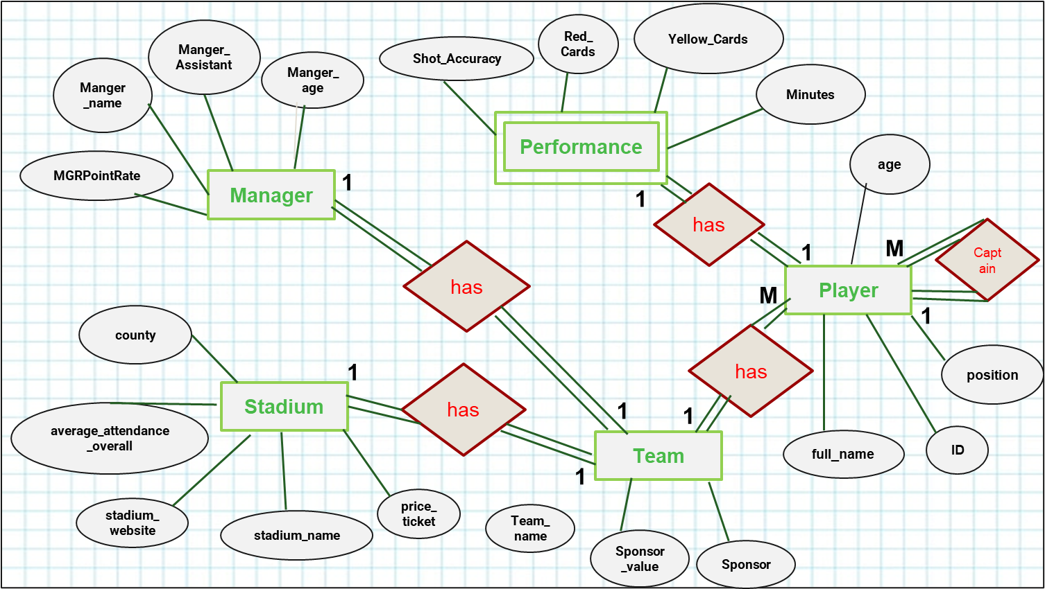

## Mapping Rules

## 

## 

## 

## 

## 

## 

## 

## Requirements (Business Needs)

**Evaluating salaries based on performance :**

1. Monthly financial plan for salary payments for each team.

**The query:** Create a stored procedure that shows club outcomes on salaries monthly.

1. Finding the relationship between scoring goals and salary (Positive relationship)

**The query:** Create a view that will display the player’s full name, Goals, Annual Salary,and team name for the highest goal total.

1. Finding players who meet annually more than 10,000,000 and scored less than 10 goals (Useless extra cost) .

**The query:** create a stored procedure or a function that compares salary to 10000000 and goals to 10 if less display the message: ‘Find a better player or less expensive’.

1. Find players who earn less than 10,000,000 annually and score more than 10 goals (they have a great chance to move to another team with a higher salary commensurate with their performance).

**The query:** create a stored procedure or a function that compares salary to 10000000 and goals to 10 if more display the message: ‘Player_have_chance’.

1. Display the Player ID , Full Name who earns more than 1000000 Monthly.
2. Upgrade the salary of a player who scored more than 10 goals by 20 % of its last value.

**Captain's performance:**

1. Evaluation of the captain's level as a team leader and scoring the highest total goals for the team.

**The query:** Display Captain's full name, and team name for the highest goal total.

**Team manager performance:**

1. Finding the manager's plan, if it was an offensive or defensive plan, based on the highest total goals for each team (As the offensive plan helps the team to score goals)

**The query:**

* If the team achieved the highest total goals, write a manager with an offensive plan.

* If he achieves the least total goals, write a manager with a defensive plan.

1. Finding the manager and assistant for the team that achieved the highest league goals.

**The query:** Create a view that displays the name of the manager , assistant and team name with the highest total goals.

1. Create inline function that takes player id and returns team name with his manager full name
2. Finding a sponsor for each team with the highest total goals scored.

**The query:** Create a view that displays the team sponsor, team name, total goals and total salary for the top 3 goal-scoring teams.

**Evaluate the level of the player :**

1. Evaluate aggressive player behavior based on **red cards**

**The query:** Function that displays the player with most red card and highest salary for every team*

And display message ‘aggressive player’

1. Select the highest two conversion rates in Each team for players. (**Conversion rates** in football refer to the successful conversion of scoring chances into goals.
2. Team needs a playmaker (a playmaker is typically a midfielder who controls the flow of the game and is responsible for creating scoring chances for their teammates.)

**The query:** Create a stored procedure without parameters to show the maximum chances created, maximum forward passes, maximum pass accuracy. 👍

1. Team needs the best players in aerial duels (aerial duels refer to the situations where two players from opposing teams contest for the ball in the air)

**The query:** Create a view that selects a player from under-30s with most aerial duels

1. **The MVP organization** that selects only the starting XI players from London County selects the best players as winners.

* create a view that displays the Goalkeeper with the highest save percentage.
* create a view that displays Center back with the highest aerial duels and minimum blocks = 20
* create a view that displays Center back with the highest forward passes and minimum pass accuracy = 90
* create a view that displays Left back & Right Back with the highest assists.
* create a view that displays Defensive midfielder with the highest tackles made and minimum interceptions = 45
* create a view that displays Central midfielder with the highest forward pass and minimum chances created 30.
* create a view that displays Playmaker with the highest chances created and minimum assist = 5
* create a view that displays Left winger & Right winger with the highest assists and minimum goals = 12
* create a view that displays Center forward with the highest goals and minimum conversion rate = 20

## Team Project :

* Hesham Mohamed Hosny
* Shrouk Osama Mohammed
* Shaimaa Shawky Al-Nady
* Mariam Moheb Fahmy
* Osama Ayman Mostafa

## Data sources

* Transfermarkt: <https://www.transfermarkt.com/premier-league/startseite/wettbewerb/GB1>
* NFL Team Contracts & Payrolls EPL Team Contracts & Payrolls :

<https://www.spotrac.com/epl/>

* Squawka:

<https://www.squawka.com/en/bet/football-tips/premier-league/>

page break