

**SWE 445**

**Phase #2**

**Software Design**

**Group #4**

**(a) User Interface Design:**

* Screen Images - Screenshots showing (high fidelity prototype) complete interface from the user’s perspective **for 3 mitigating use cases and 3 those use cases which have relation with the mitigating use cases**

**1st Mitigating Use case: Check User Input**

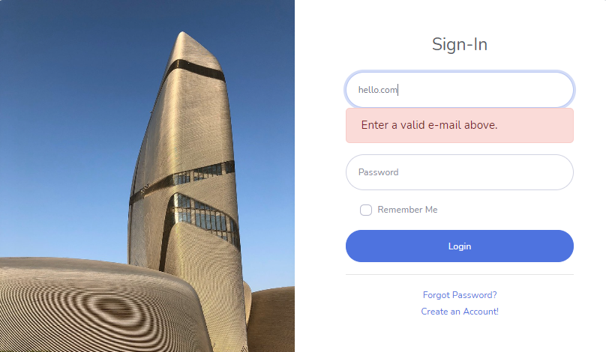

**Related Use case for 1st mitigating: Sign-up & Sign-in**

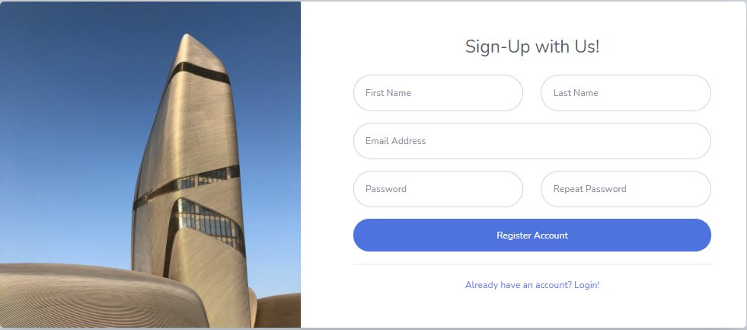

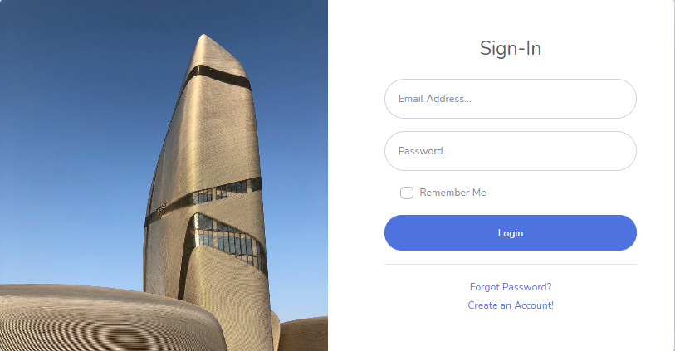

**2nd Mitigating Use case: Multi-Factor Authentication**

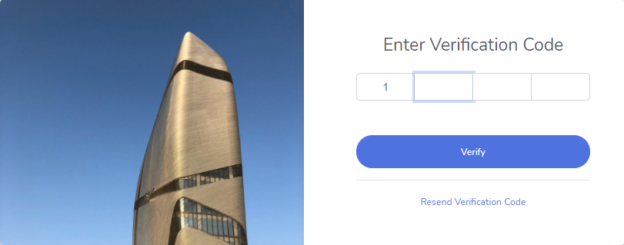

**Related Use case for 2nd mitigating: Checkout**

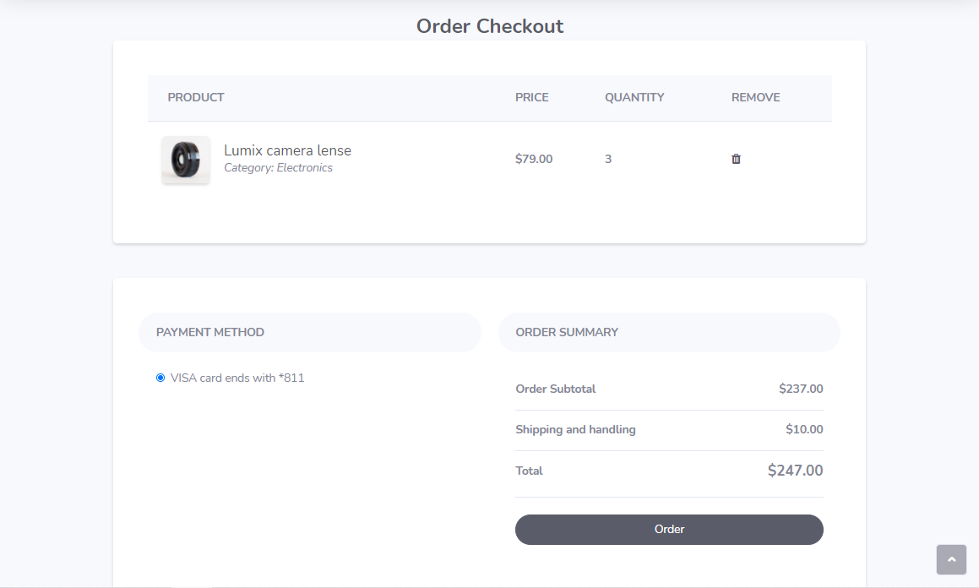

**3rd Mitigating Use case: Hash Card Details**

**Note: This use case is implemented in the backend, the user does not see the hashed details, so there is no user interface to be provided.**

**Related Use case for 3rd mitigating: Add Payment Method**

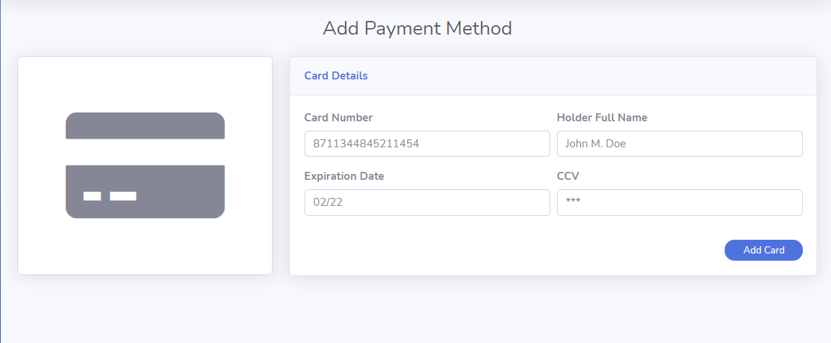

**(b) Database design**

* **Conceptual**

|  |  |  |  |  |
| --- | --- | --- | --- | --- |
| **Customer** | **Items** | **Order** | **Card** | **Auth Code** |
| C_ID *(PK)*  Name  Phone  Email  Password | I_ID *(PK)*  Name  Price | O_ID *(PK)*  Payment Method  Total  Date & Time  C_ID *(FK)*  I_ID *(FK)* | Card number*(PK)*  Expiration _date  Secret_number  Holder_name  C_ID *(FK)* | A_ID(PK)  Code  TTL  C_ID *(FK)*  I_ID *(FK)* |

* **Diagrams**
  + **Logical Design**

**Link:** https://lucid.app/lucidchart/invitations/accept/b8695637-08f7-4b5a-93da-efc60bd71d65?viewport_loc=239%2C-150%2C2151%2C941%2C0_0

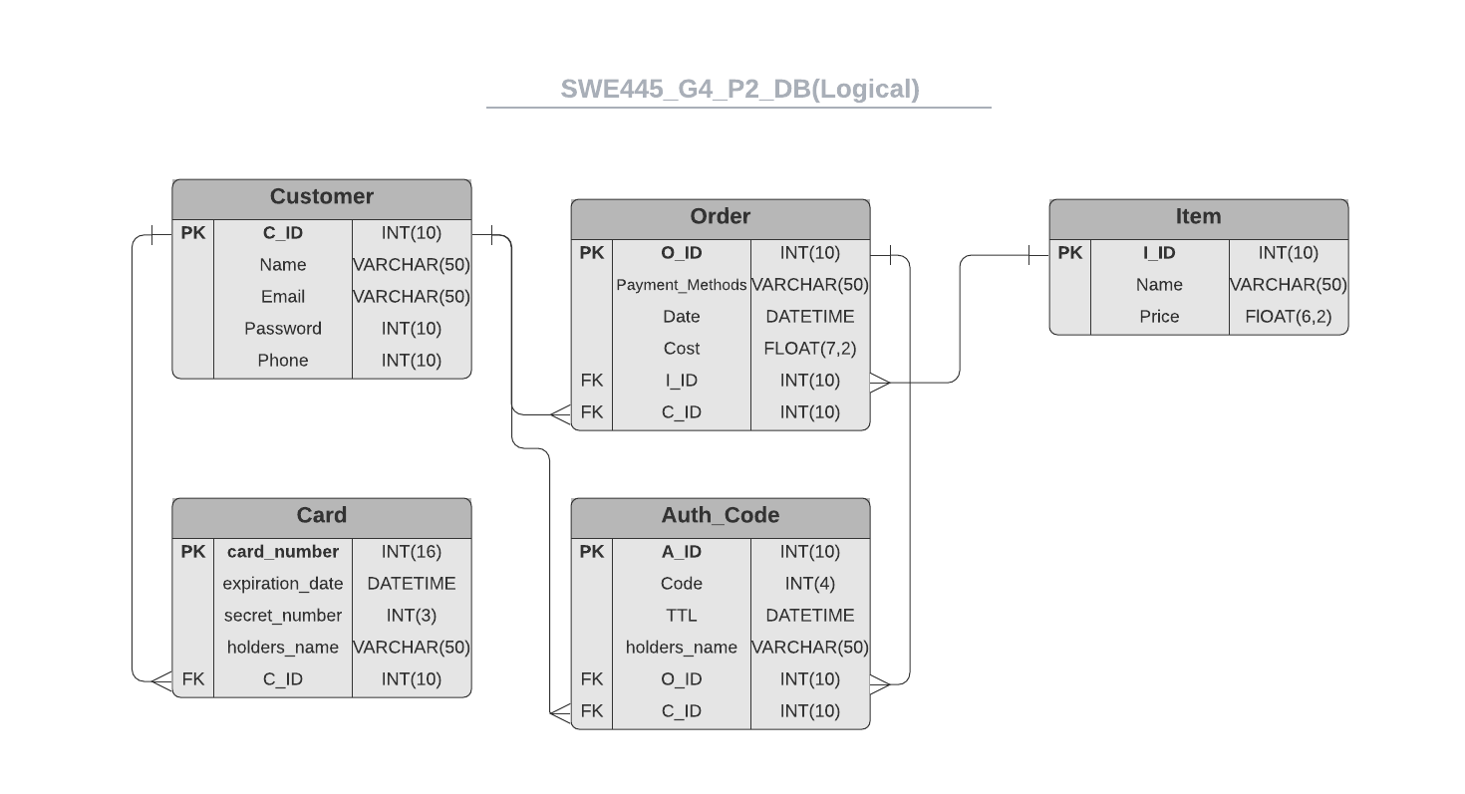

* + **Entity Relation Diagram**

**Link:** <https://lucid.app/lucidchart/invitations/accept/61b088c3-c1a6-4295-a798-1ec68cddc8c1?viewport_loc=-69%2C13%2C1707%2C823%2C0_0>

