An-Najah National University
Network Administration

Report
Introduction to Linux
Command Line Interface (CLI)
Prepared by: | Osama Esam Masri
Submitted to: | Dr. Jehad Hammamrah
Date: | October 2026

1. Introduction
Linux and other UNIX-like operating systems are the backbone of modern servers, network equipment, embedded devices and cloud infrastructure. Although graphical desktops exist, almost all administration work is carried out through the command line interface (CLI), which is faster, scriptable, always available and works over remote connections. This report summarises the content of Lecture 3 (Introduction to Linux / CLI) of the Network Administration course, and explains each command covered in the lecture together with its options and an example of its output.
Note: the terminal figures in this report are example outputs prepared for illustration. They use a sample user (student@linux) and sample files so that the behaviour of every command is clear.

2. X Windows, Consoles and Terminals

2.1 X Windows
X Windows is an architecture-independent system for building graphical user interfaces on UNIX-like systems. It talks to the display and to any type of input device, and it was designed from the start to work over network connections, which makes it possible to run remote applications and keep several concurrent sessions. Typical features include virtual screens, X-terminal windows, scroll bars and cut, copy and paste.
A window manager is a configurable program that controls how windows look and behave, while a desktop environment is a fully integrated set of tools in which a window manager runs and which can save and restore the state of running applications when the user logs out.

2.2 Why use the command line?
- It is always available, even when the GUI is not installed or not working.
- It works naturally over remote sessions.
- It is more efficient and more powerful for repetitive or complex tasks.
- It gives a better understanding of what the system is actually doing.

2.3 Terminals, console and shell
Originally a terminal was a piece of hardware used to interact with a computer, connected through serial lines, modems or the network (telnet). The console is the monitor, keyboard and mouse attached to the machine itself, where boot and error messages are displayed. Today a terminal is usually a program that provides a text window.
The shell is a command-line interpreter that provides the CLI. Users interact with it by entering commands, writing scripts made of one or more commands, and through system start-up scripts. The basic UNIX philosophy is: 10% of the work solves 90% of the problems, smaller is better, portability, and solve problems at the right level.

3. Command Anatomy and Help

3.1 Command anatomy
Every command follows the form command [-switches] [arg1] [arg2] ... where the command is the name of the program, the switches modify its behaviour (Windows normally uses / instead of -), and the arguments are the objects the command works on. In Figure 1, ls is used first alone, then with -l (long format), then with -la (long format including hidden files), and finally with a directory as an argument.
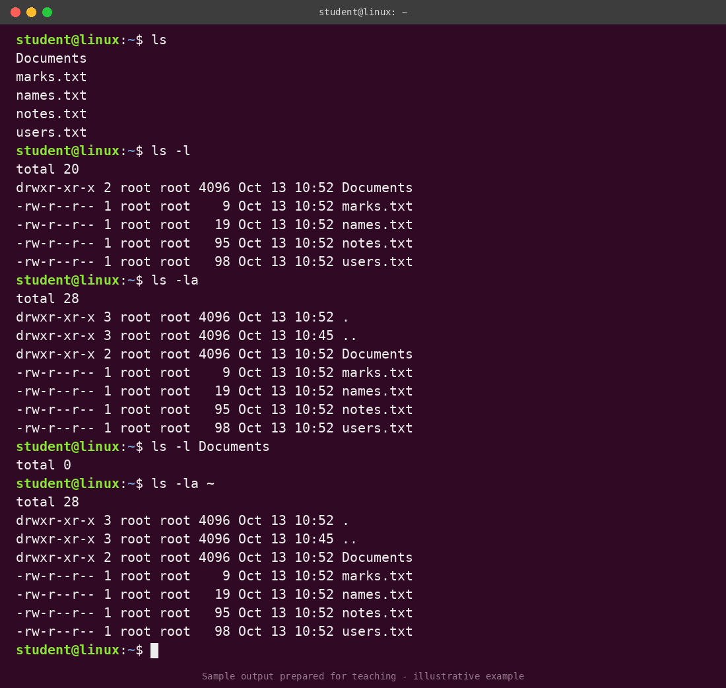
Figure 1: ls with different switches and arguments

3.2 The man command
man displays the manual page of a command. man command shows the page of that command, man n intro shows the content of section n, man -k string searches the short descriptions (the same as apropos), and man -K string searches the full text of all manual pages.
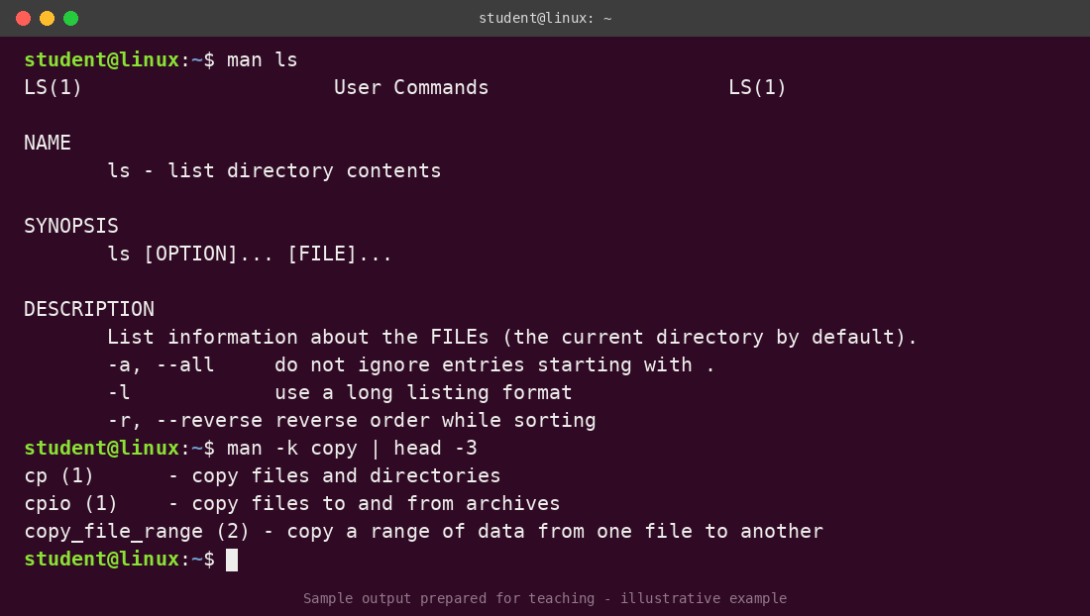
Figure 2: man ls and man -k copy

4. Account-Related Commands
login starts a session, passwd changes the account password, and logout (or exit) closes the session. whoami and echo $USER show the current user name and echo $HOME shows the home directory.
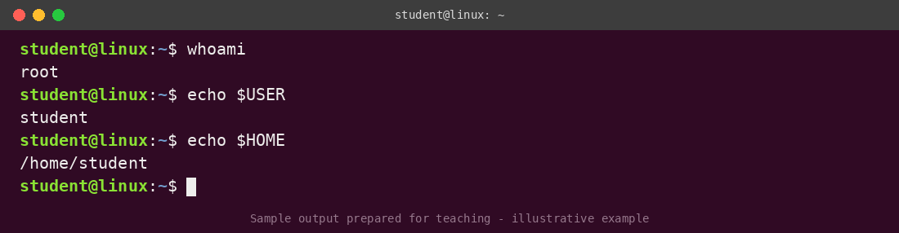
Figure 3: Displaying the current user and home directory
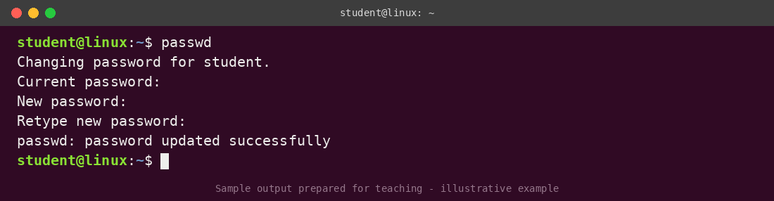
Figure 4: Changing the password with passwd

5. File and Directory Commands

5.1 Directory commands
- pwd prints the current working directory.
- ls [-la] lists the contents of a directory; -l gives details and -a includes hidden files.
- mkdir dir1 creates a directory.
- cd dir1 changes the current directory.
- rmdir dir1 removes an empty directory.
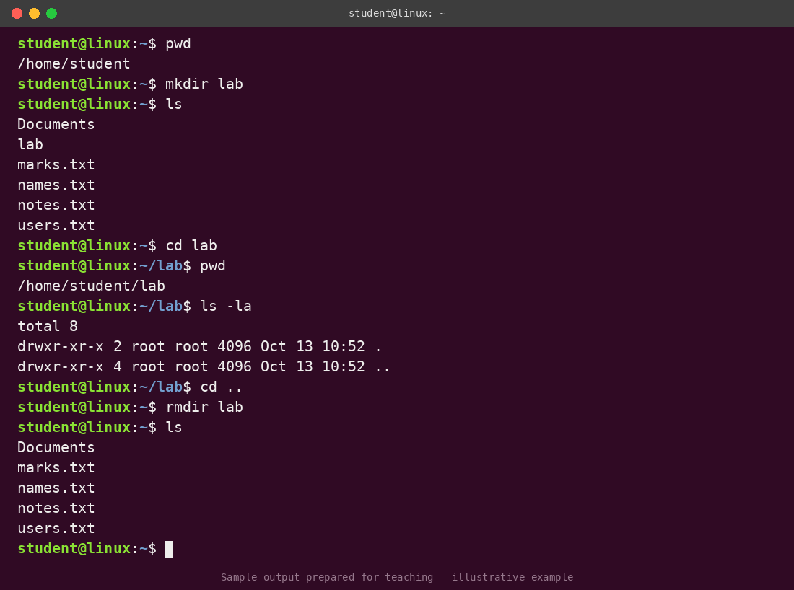
Figure 5: pwd, mkdir, cd, ls and rmdir

5.2 Copying, moving and renaming
cp file1 file2 copies a file, and cp file1 dir1 copies it into a directory. cp -r dir1 dir2 copies a whole directory with its content. mv file1 file2 renames a file when both are in the same directory, and mv file1 dir1 moves it into a directory.
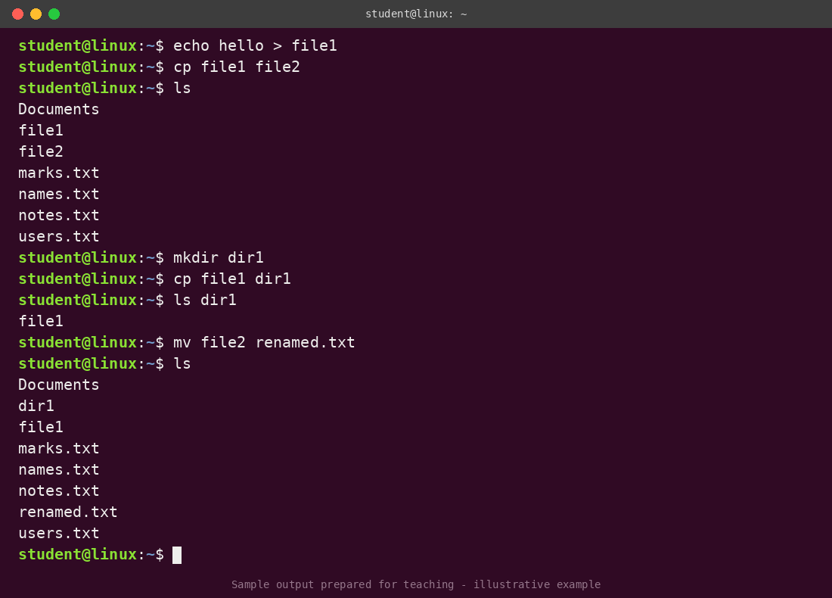
Figure 6: cp and mv on files
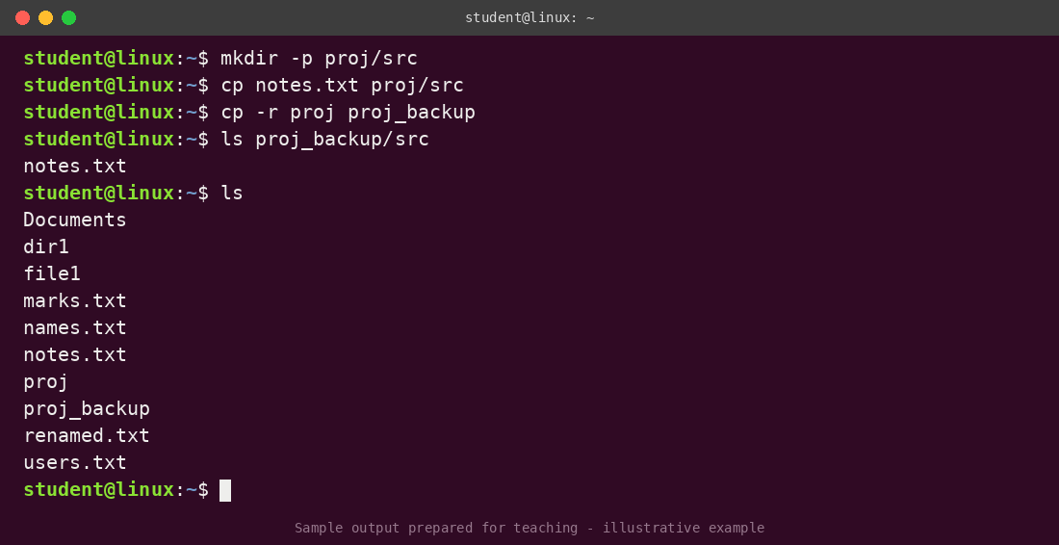
Figure 7: Copying a directory with cp -r

5.3 Viewing files
cat file displays the whole file on the screen. more file displays it one screen at a time. less is a more powerful replacement for more that also allows scrolling backwards (press q to quit).
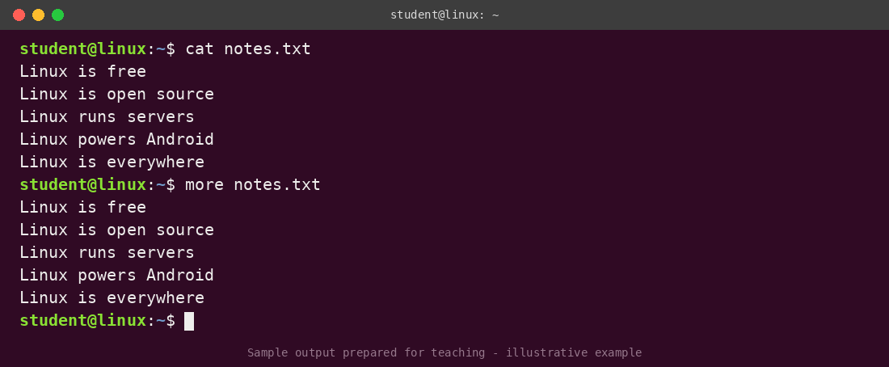
Figure 8: cat and more
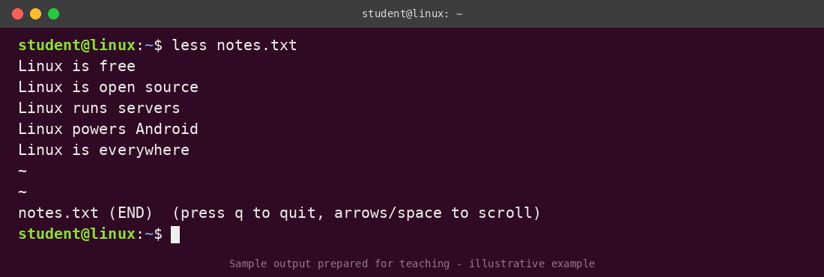
Figure 9: less

5.4 Removing files and directories
rm file1 file2 removes a list of files, rmdir dir1 removes dir1 only if it is empty, and rm -r dir1 removes a directory and everything inside it. rm -r is very dangerous because deleted files cannot be recovered, so it must be used with care.
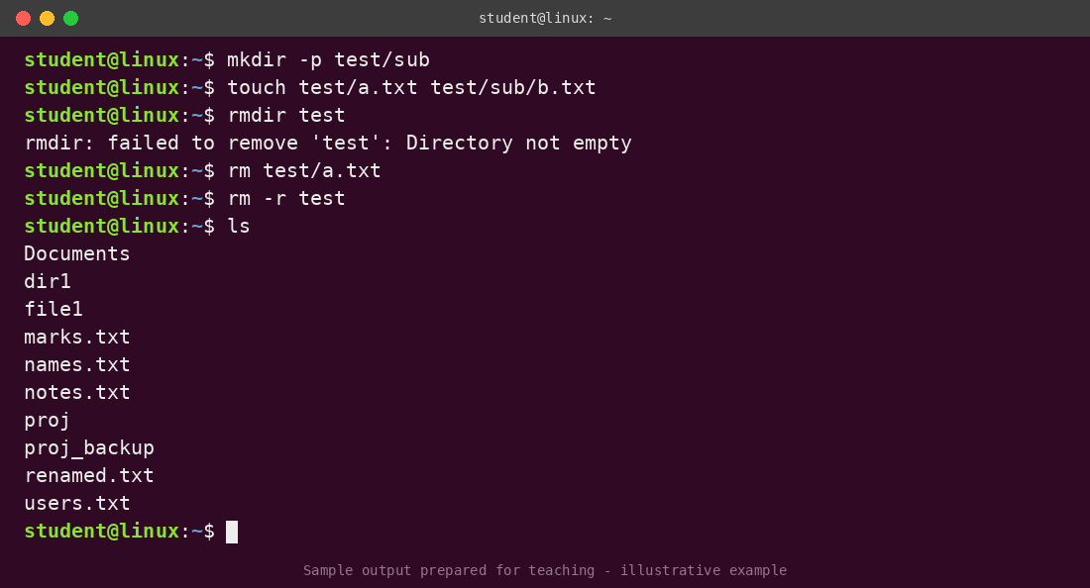
Figure 10: rmdir fails on a non-empty directory while rm -r succeeds

6. The Linux Filesystem

6.1 Hierarchy
The filesystem is a single tree that starts at the root directory /. Important directories include /bin and /sbin (essential programs), /usr (user programs and libraries), /etc (configuration files), /dev (devices), /home (user home directories), /var (variable data such as logs and spool), /tmp (temporary files), /lib (libraries), /boot (boot files) and /root (the home of the root user).
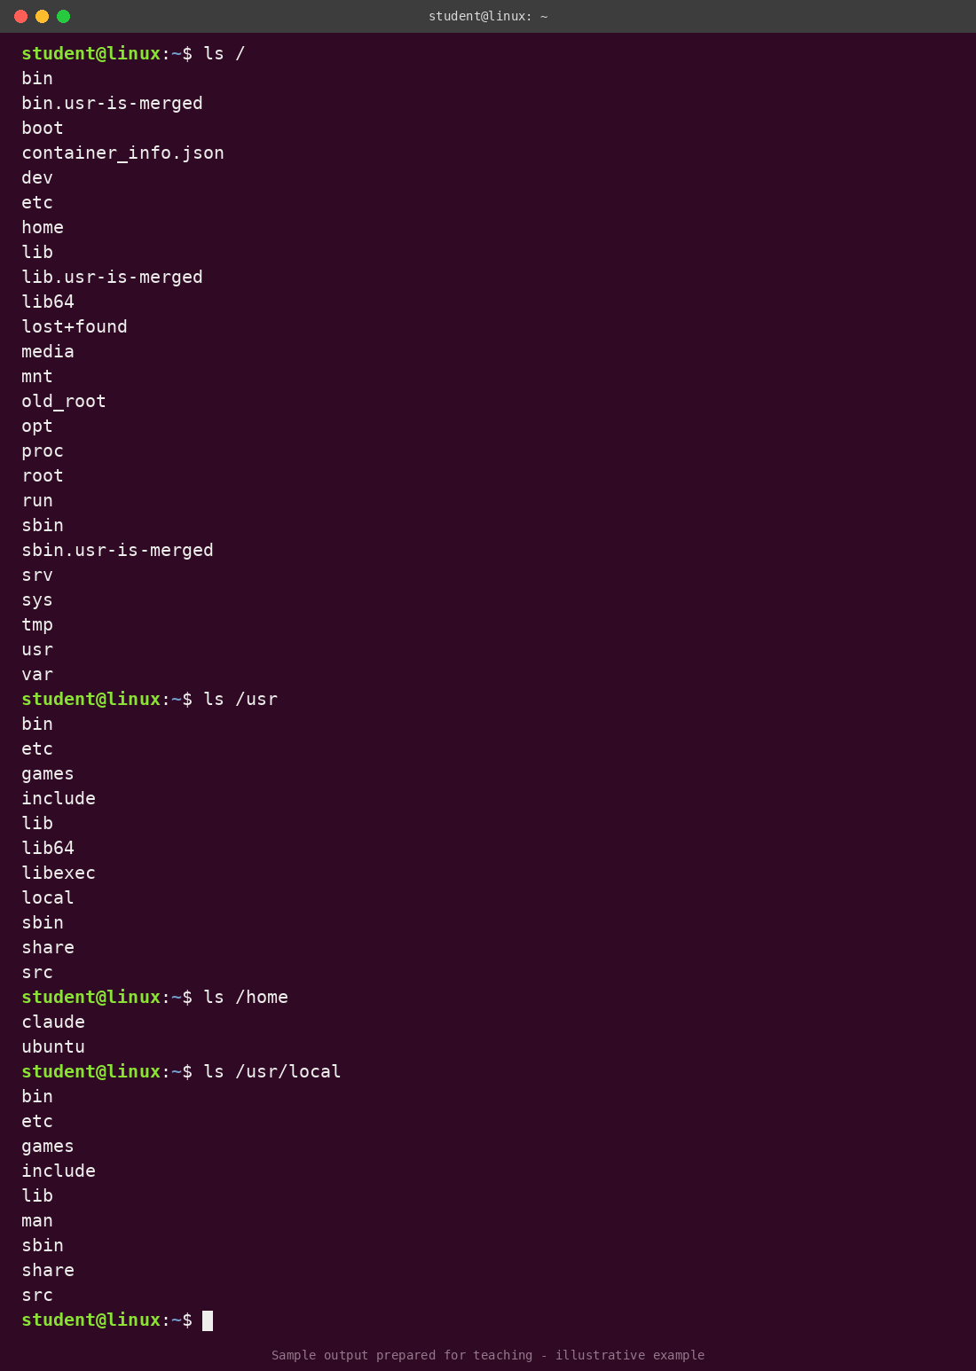
Figure 11: Listing the top-level directories

6.2 bin versus sbin
bin directories hold user programs while sbin directories hold system administration programs. /bin and /sbin are needed at boot time, whereas /usr/bin and /usr/sbin become available when the system is fully operating.
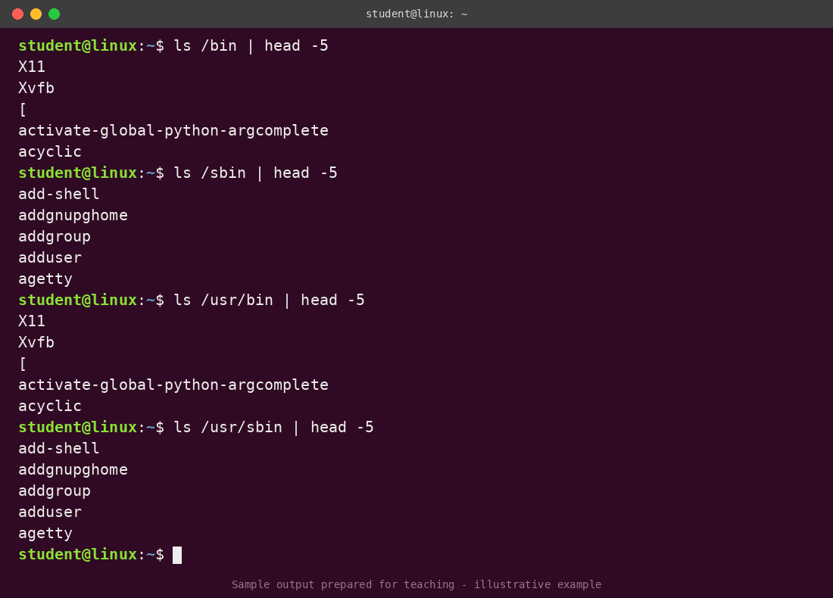
Figure 12: Contents of bin and sbin directories

6.3 Comparison with Windows
/usr corresponds to %SystemRoot% (C:\Windows), /bin and /usr/bin to System32, /dev to System32\Drivers, /etc to System32\Config and the Windows Registry, /tmp to C:\Temp, and /var/spool to System32\Spool.

6.4 Absolute and relative paths
An absolute path starts from the root directory, for example /usr/local/bin. A relative path starts from the current location: . is the current directory, .. is the parent directory and ~ is the home directory. For example, ~/.. is /home.
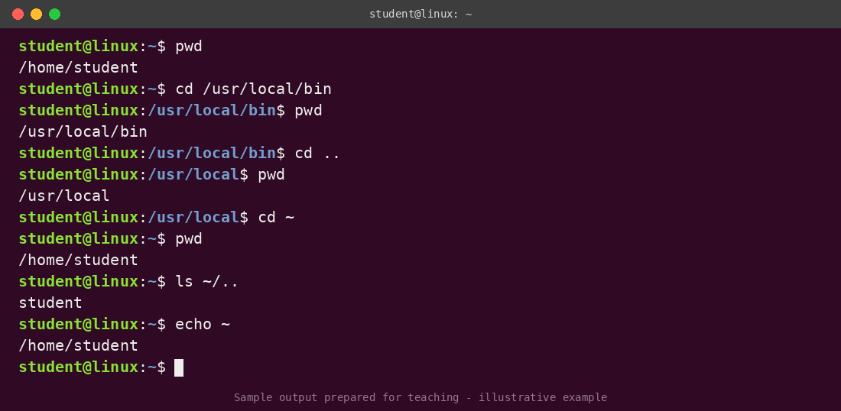
Figure 13: Navigating with absolute and relative paths

7. Filter Commands
Filters read text, transform it, and write the result, which makes them very powerful when combined with pipes (|).

7.1 head, tail and wc
head -n file shows the first n lines and tail -n file shows the last n lines. wc counts lines, words and characters; the options -l, -w and -c select only one of them.
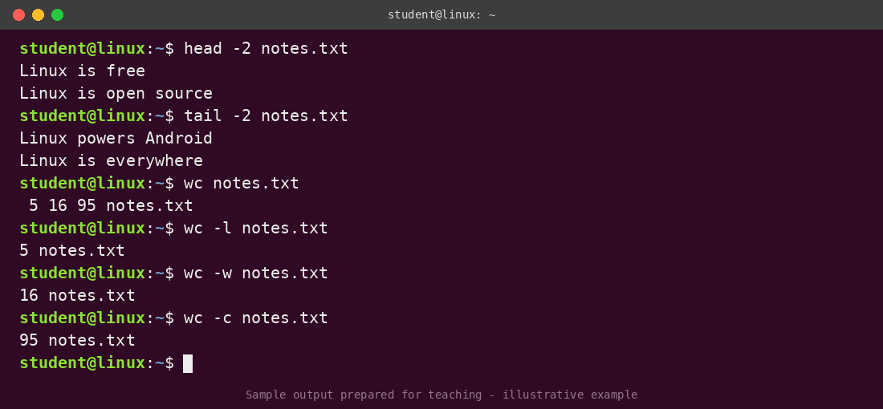
Figure 14: head, tail and wc

7.2 sort
sort file sorts alphabetically and sort -r sorts in reverse order. The command sort -t: -n -k 3 file sorts by the third field (-k 3), numerically (-n), where fields are separated by a colon (-t:).
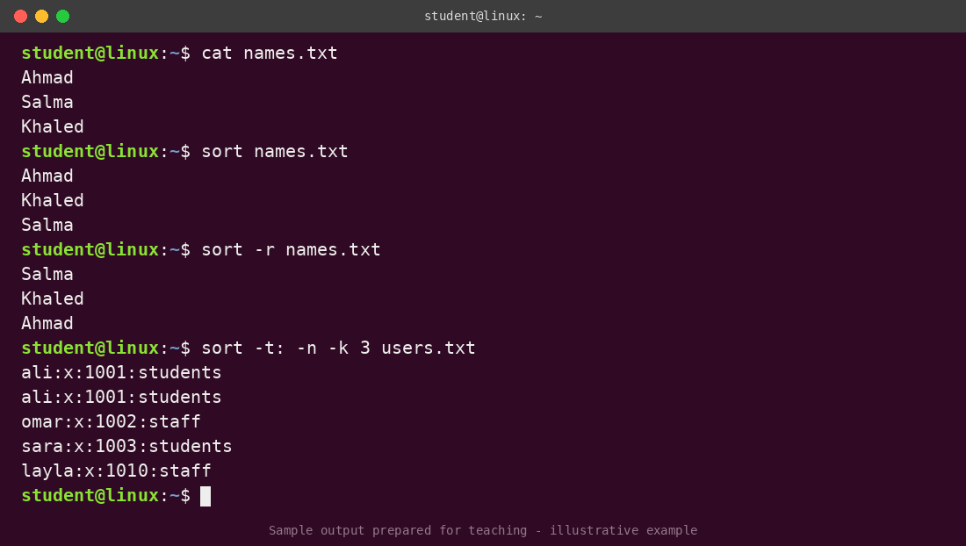
Figure 15: Sorting files

7.3 uniq, cut and grep
uniq removes duplicate adjacent lines (so it is normally used after sort). cut -f# -d% file extracts field number # using % as the delimiter; awk is a more advanced replacement. grep search-string file prints the lines that contain the string, and -i makes the search case-insensitive.
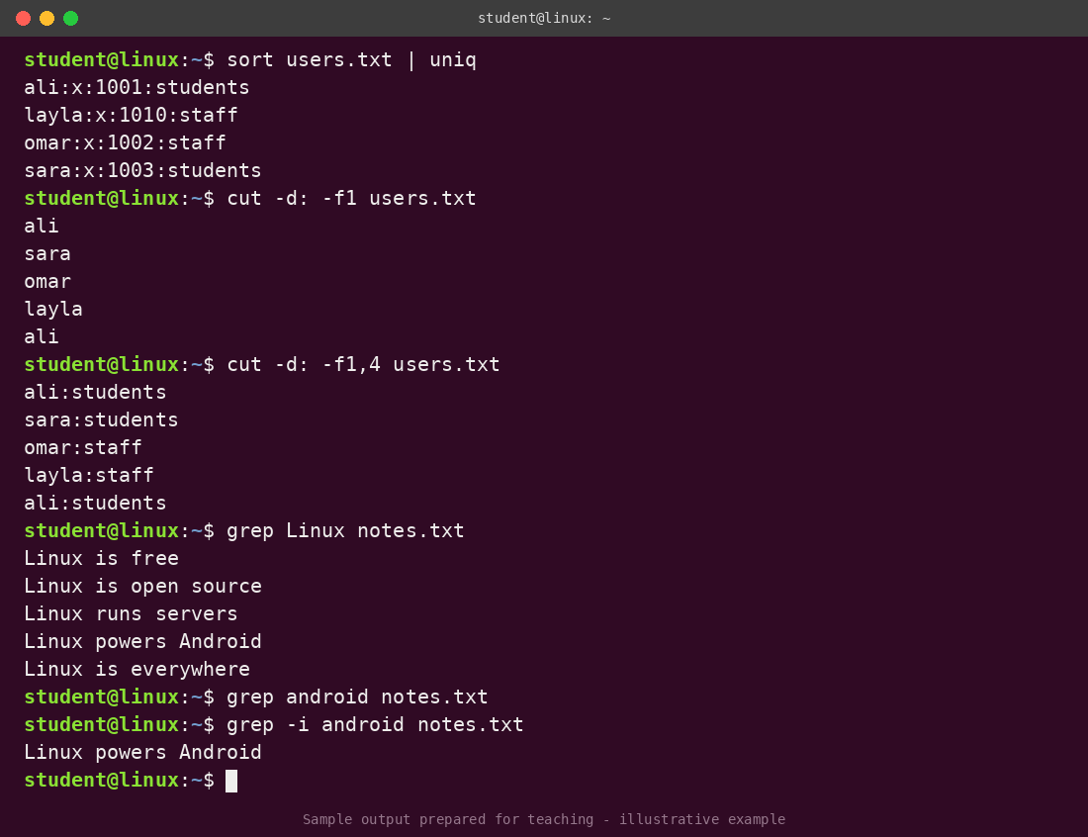
Figure 16: uniq, cut and grep

7.4 paste and tr
paste file1 file2 merges two files line by line. tr c1 c2 < file replaces every occurrence of the character c1 with c2.
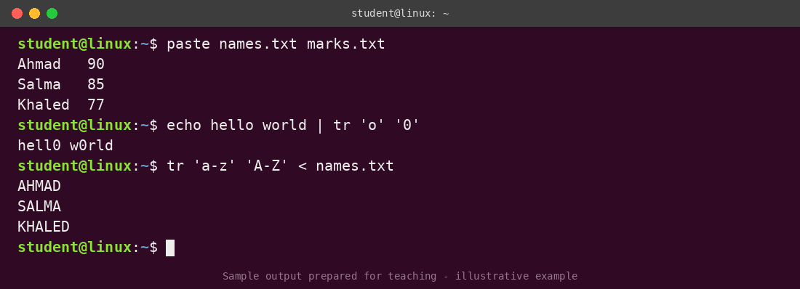
Figure 17: paste and tr

8. Miscellaneous Commands
date shows (or sets) the system date and time and accepts a format string, cal displays a calendar, and echo prints strings and shell variables.
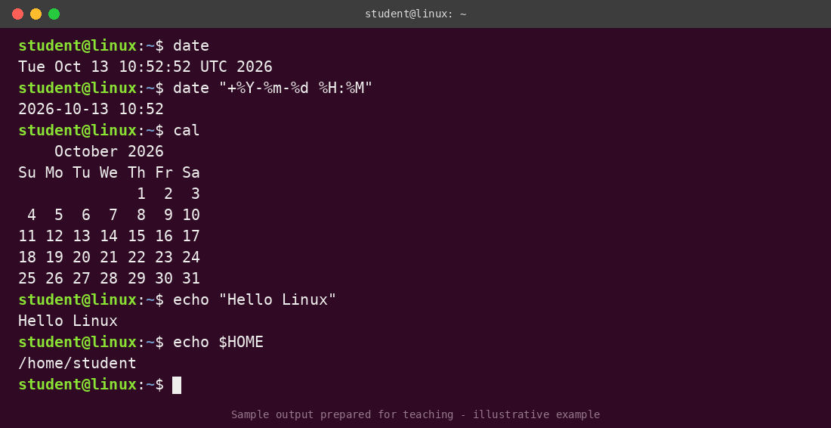
Figure 18: date, cal and echo

9. The vi Editor
vi is a very powerful visual editor that is available on almost every UNIX system, which is why it is important to know. It has three modes: command mode (the default, used for navigation and editing commands), insert mode (for typing text; press i to enter and Esc to leave), and ex mode (colon commands such as :w to save, :q to quit, :wq to save and quit, and :q! to quit without saving). It can be frustrating at first, so keeping a cheat sheet at hand is recommended.
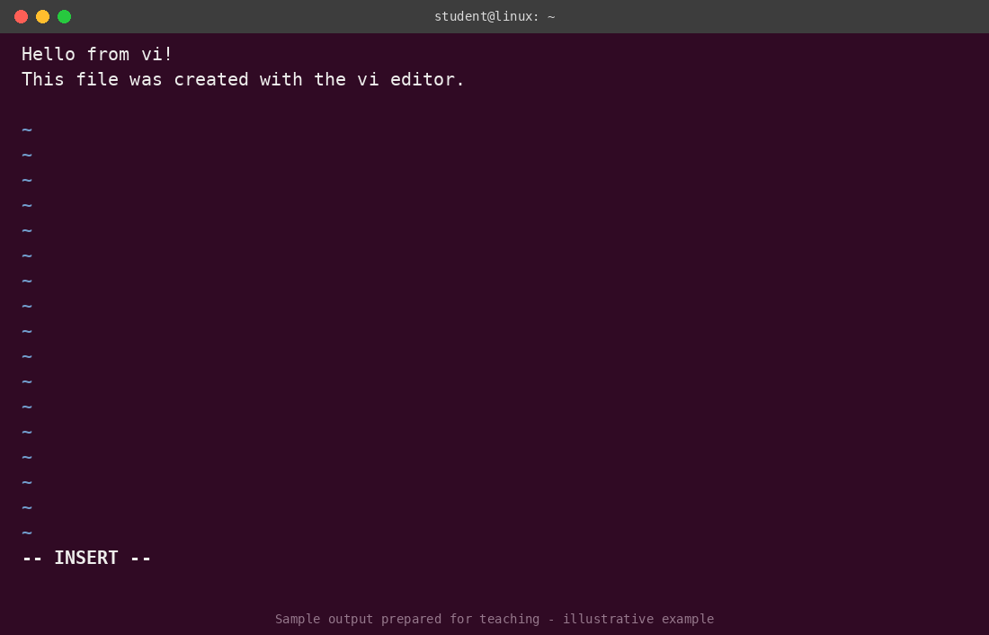
Figure 19: vi in insert mode
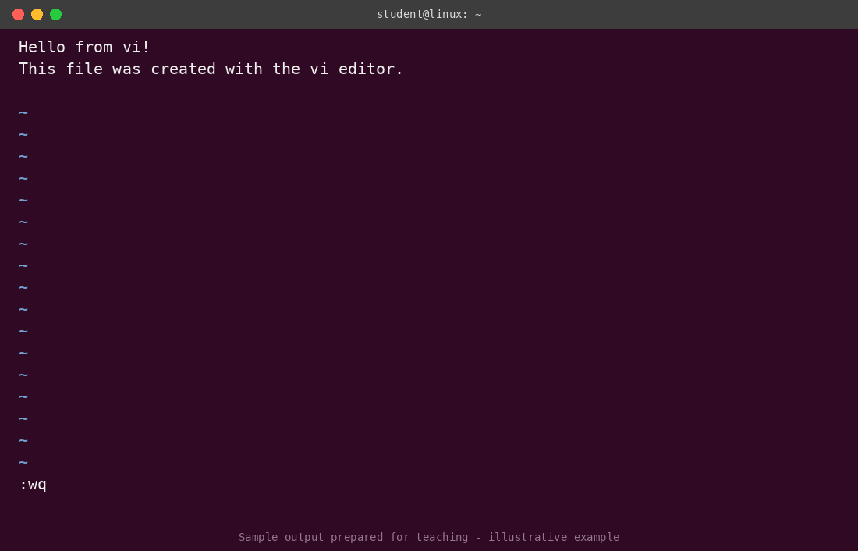
Figure 20: Saving and quitting vi with :wq

10. Conclusion
This report covered the basics of working with the Linux command line: how the shell and terminal work, the structure of a command, getting help with man, managing files and directories, understanding the filesystem hierarchy and paths, processing text with filter commands, and editing files with vi. These tools are the foundation for network and system administration, and the best way to master them is regular practice in a real terminal.

References
- Lecture 3: Command Line Interface (CLI), Network Administration (10686341), based on material by Scott Orr and the Trustees of Indiana University.
- Mark Burgess, Principles of Network and System Administration.

