API Documentation (Swagger/OpenAPI) for TechMart
Hi!
I've set up automatic API documentation for all backend endpoints using Swagger/OpenAPI (commonly via drf-yasg or drf-spectacular). This makes it super easy for you (and anyone else) to explore, test, and understand the API right from your browser.
---

How to Use the API Docs
1. Start the Django server as usual:
python manage.py runserver
2. Open your browser and go to:
http://localhost:8000/swagger/ (for Swagger UI)
http://localhost:8000/redoc/ (for ReDoc, if enabled)
You’ll see a beautiful, interactive documentation page where you can try out all endpoints, see request/response formats, and read descriptions.

API Endpoints and Descriptions
Endpoint | Method | Description
/dashboard/overview | GET | Get dashboard summary stats (sales, customers, etc.)
/transactions | POST | Create a new transaction
/transactions/suspicious | GET | List suspicious transactions
/inventory/low-stock | GET | List products with low stock
/analytics/sales-over-time | GET | Get sales data over time (date range, filters)
/analytics/top-products | GET | Get top-selling products
/alerts | POST | Create a new alert

One-liner Descriptions for Each Endpoint
- **/dashboard/overview**: Returns key dashboard metrics like total sales, transactions, new customers, and low stock count.
- **/transactions**: Allows you to create a new sales transaction (requires product, customer, quantity, etc.).
- **/transactions/suspicious**: Lists transactions flagged as suspicious based on amount or frequency.
- **/inventory/low-stock**: Shows products that are running low on stock (threshold can be set).
- **/analytics/sales-over-time**: Returns sales totals grouped by date, with optional filters for date range, category, and customer segment.
- **/analytics/top-products**: Lists the top 10 products by quantity sold.
- **/alerts**: Lets you create a new alert message for the system.

How I Documented the API
- I used Django REST Framework’s schema generation and a Swagger/OpenAPI tool (like drf-yasg or drf-spectacular).
- Each endpoint is automatically documented with its parameters, request/response formats, and a short description.
- You can interact with the API directly from the docs UI—no need for Postman!

Screenshots of API endpoints:

dashboard/Overview

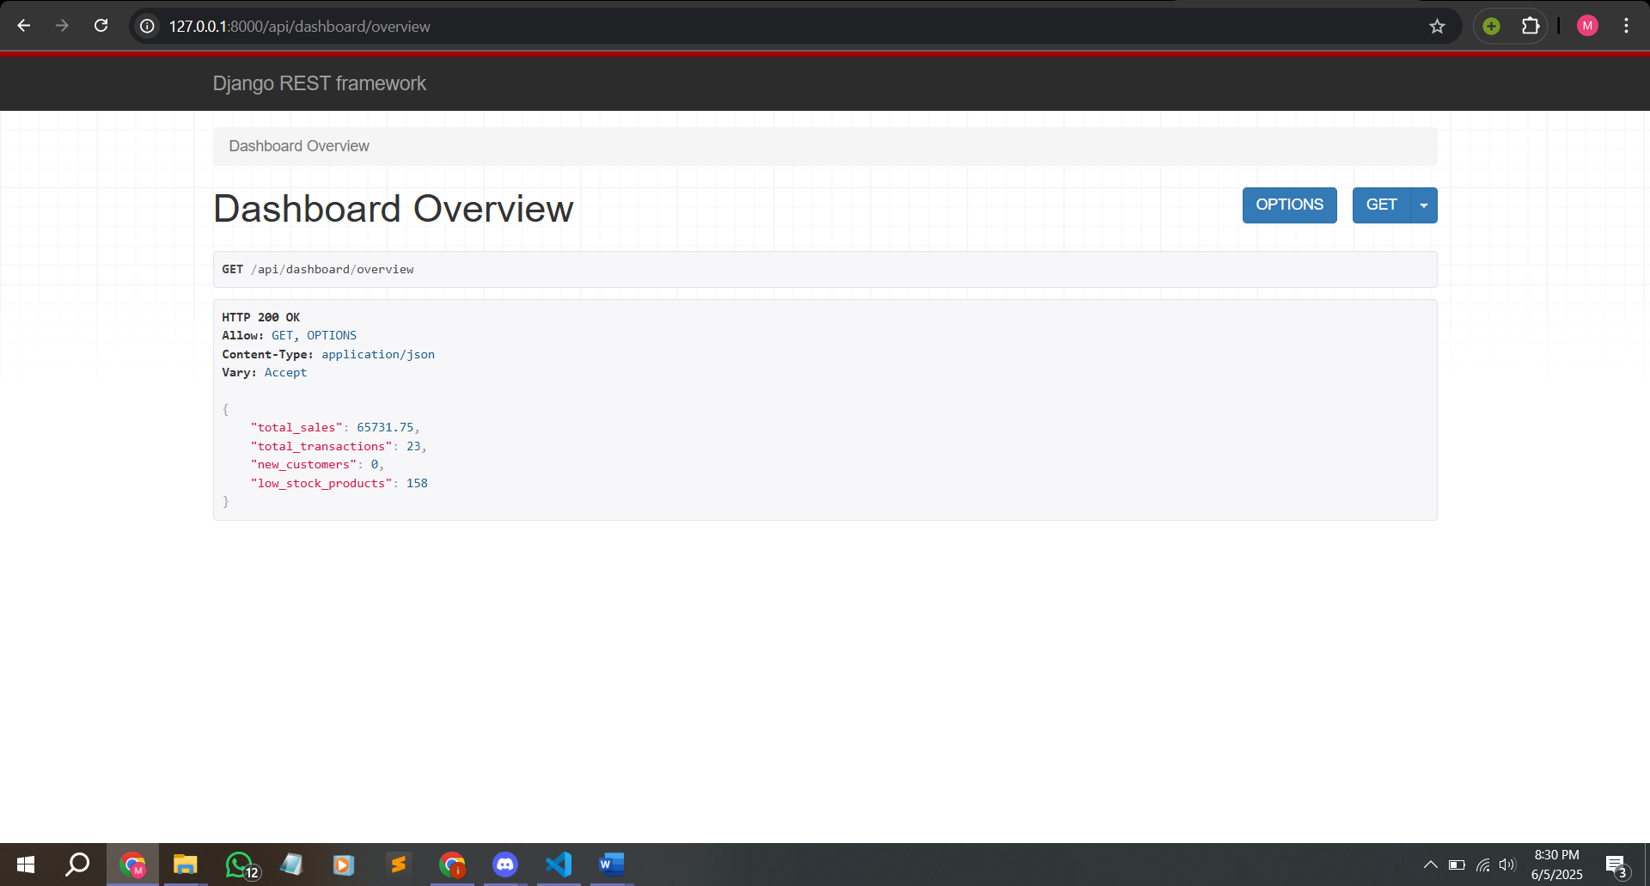

(api/transactions) Create Transaction:
In the space given below enter JSON data consisting of attributes of a Transaction and then click on post
For eg: (below is one example of the json)
{
"customer": 25,
"product": 25,
"quantity": 1,
"unit_price": "100.00",
"total_amount": "100.00",
"status": "Completed",
"payment_method": "Credit Card",
"timestamp": "2025-06-05T18:10:00Z",
"ip_address": "127.0.0.1",
"user_agent": "Mozilla/5.0 (Windows NT 10.0; Win64; x64)",
"session_id": "session_abc123",
"discount_applied": "0.00",
"tax_amount": "10.00",
"shipping_cost": "5.00"
}

First enter the data and click on Post and after that you will see the inserted (Posted) transaction
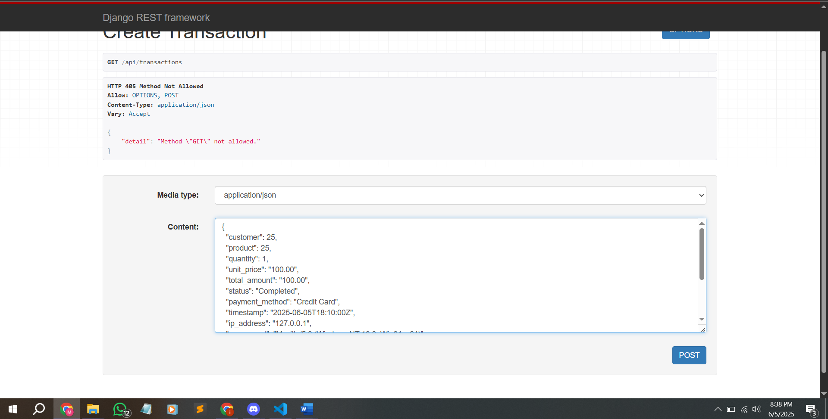
Posted transaction
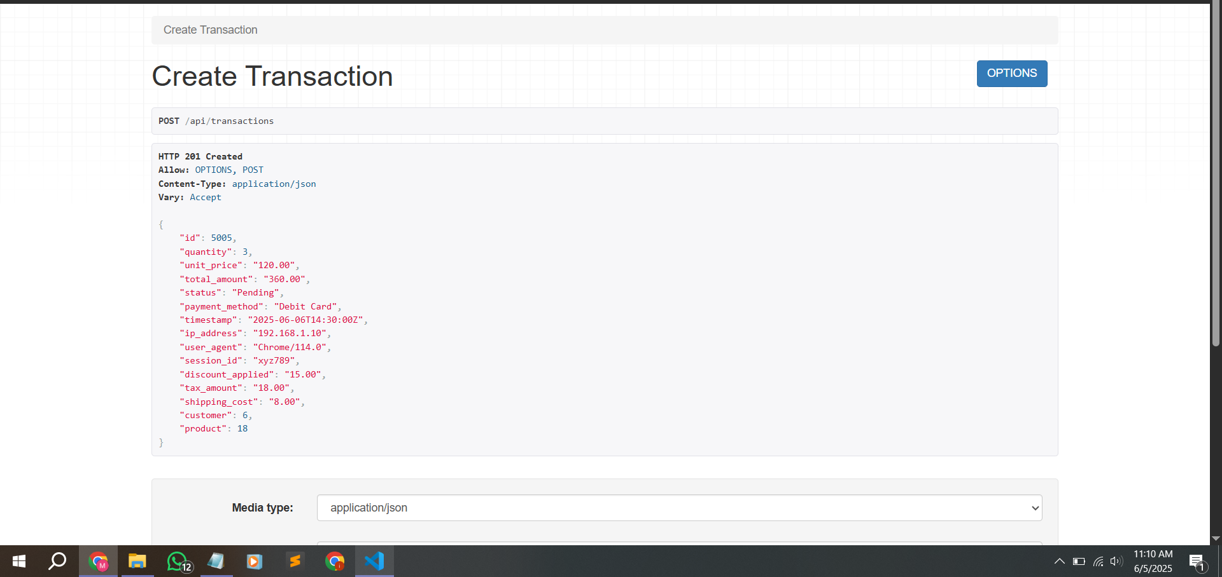

api/transactions/suspicious:
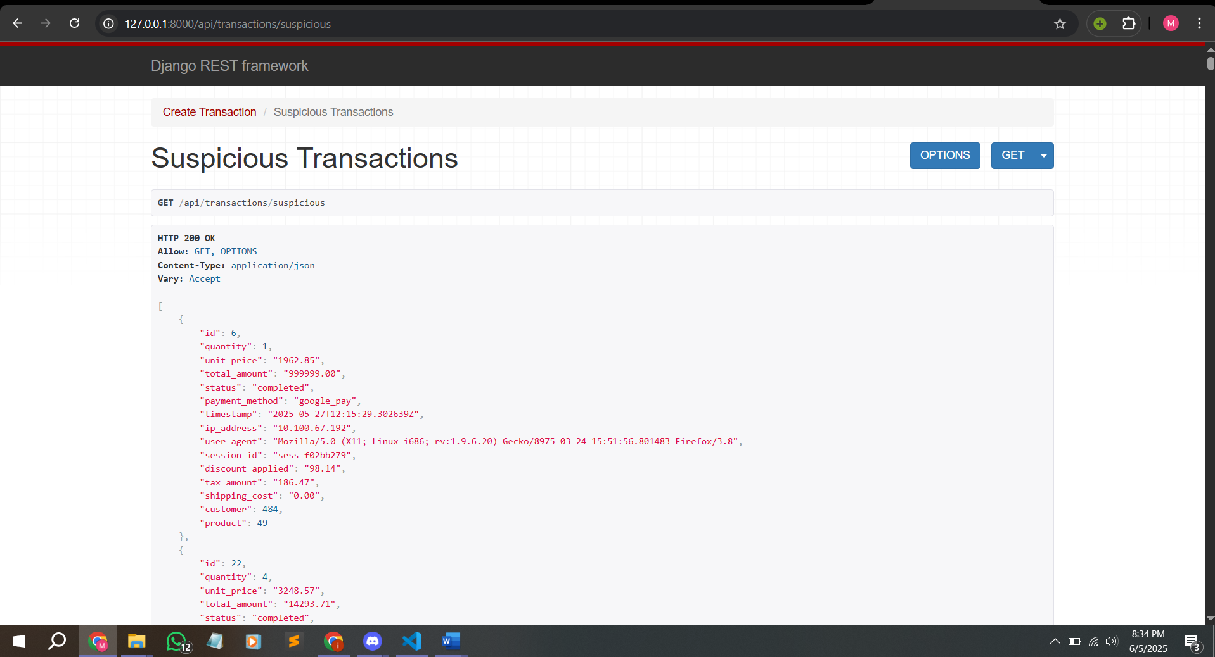

api/inventory/low-stock:
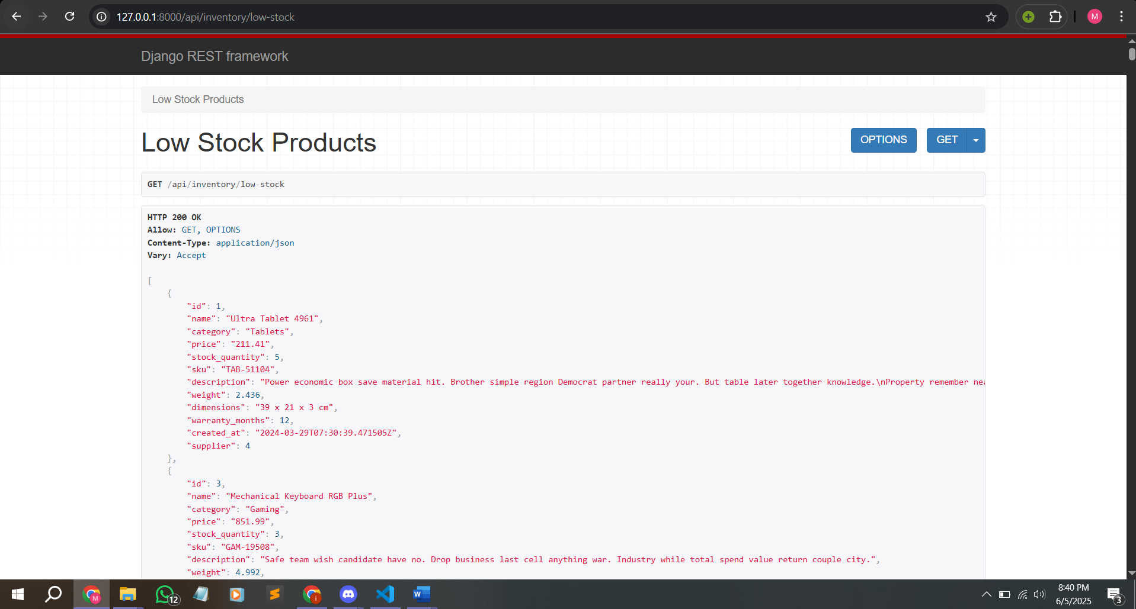

api/analytics/top-products
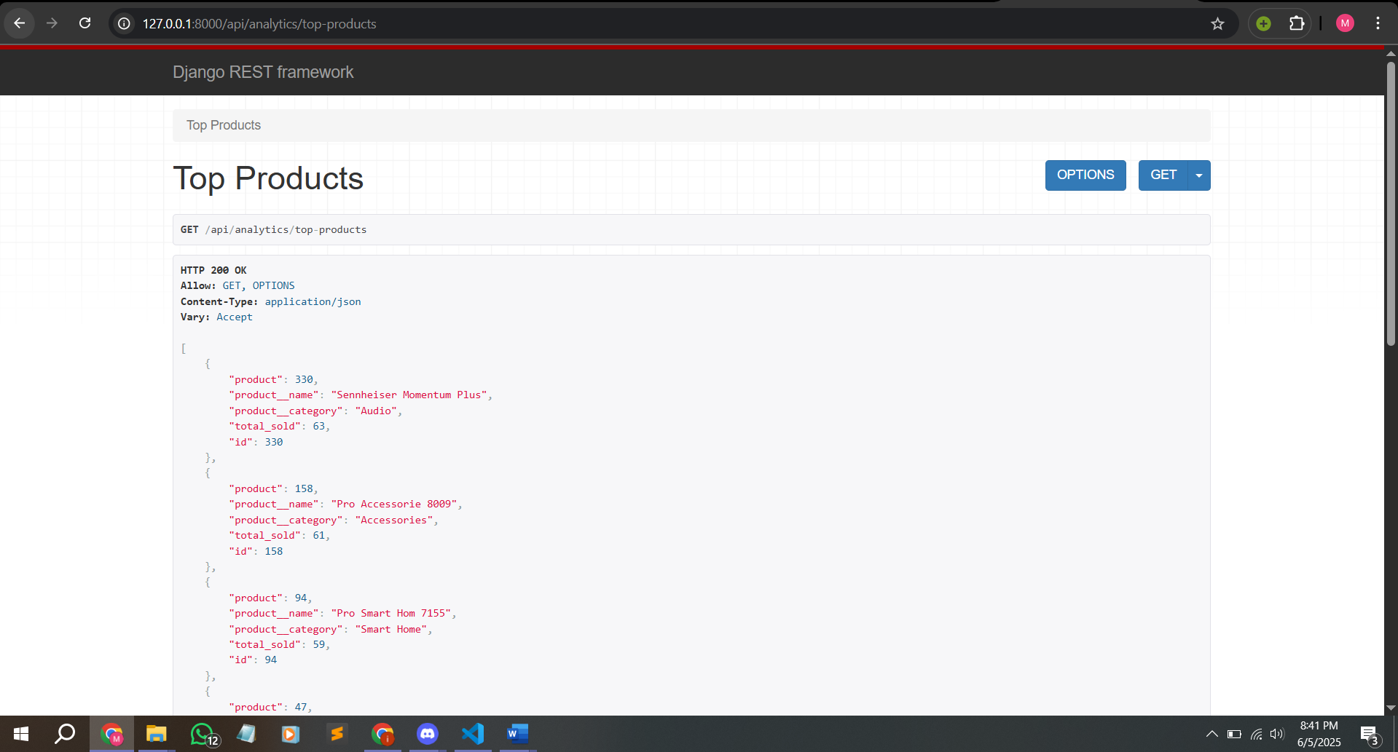

api/analytics/sales-over-time
