PORTFOLIO / USER GUIDE

Osama Farouk — Portfolio Website Documentation & User Guide
  - Content, navigation, design and delivery
A practical guide for recruiters, clients, collaborators and future maintainers. It explains how to explore the portfolio, understand its published records and maintain its content and delivery workflow.
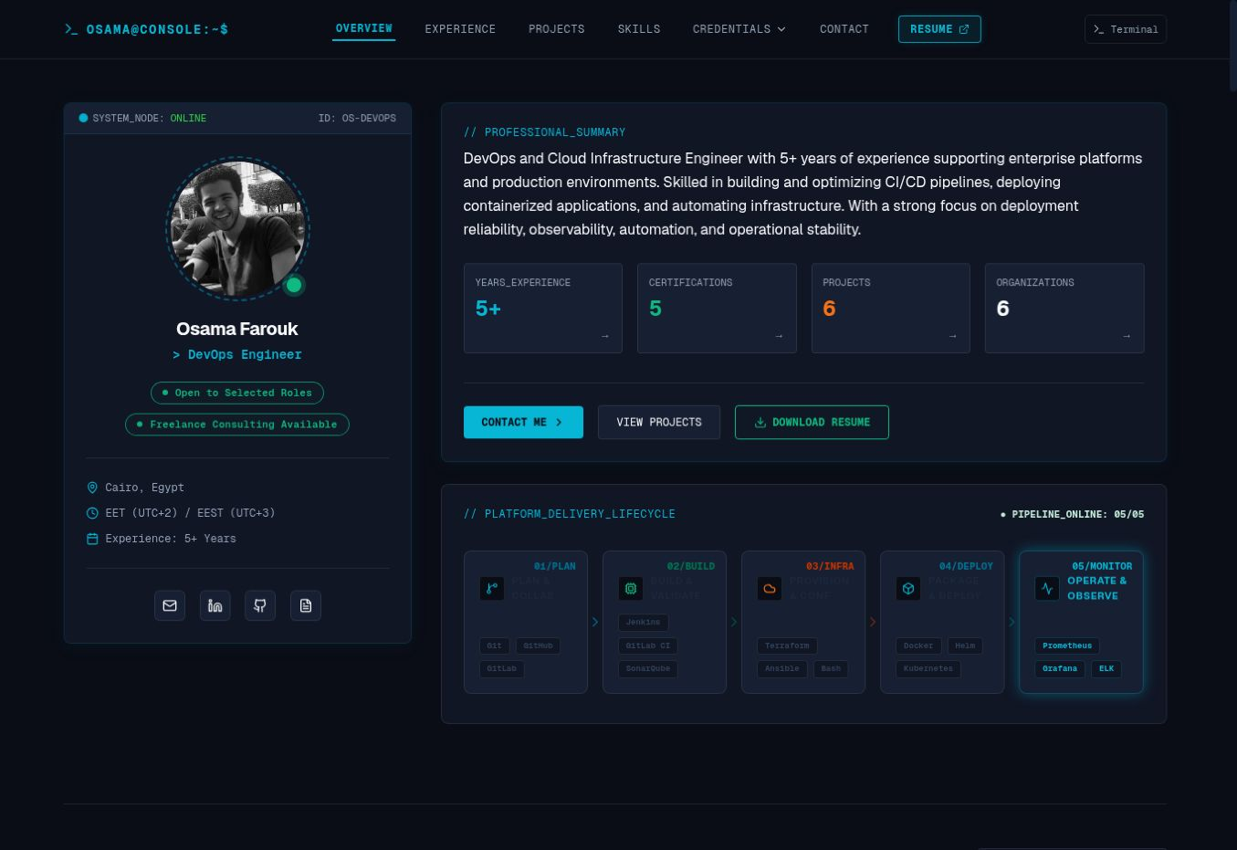
Live desktop overview, captured 16 September 2026. The interface combines a professional profile with a terminal-inspired presentation.
Document information | Value
Owner | Osama Farouk
Website | https://osamafarouk.com/
Prepared | 16 September 2026
Document version | 1.0
Website label observed | v1.3.11-STABLE / V1.3.11

Open the live portfolio

Contents and reading guide
1 Portfolio overview / 3
2 Website structure and navigation / 4
3 Professional experience / 5
4 Projects and case studies / 6
5 Exploring a project / 7
6 Skills and certifications / 8
7 Education and course inventory / 9
8 Browsing courses / 10
9 Using the interactive terminal / 11
10 Resume and contact / 12
11 Visual design and responsive use / 13
12 Reusable maintenance templates / 14
13 Hosting delivery and recovery / 15
14 Maintenance and troubleshooting / 16
15 References and confirmation register / 17
16 Glossary / 18

How to use this guide
Recruiters can begin with experience, projects and credentials. Clients can review the case studies and contact options. Maintainers should also read the reusable templates, delivery workflow and maintenance checklist.

Evidence and scope
The public homepage, all six project pages, courses page and HTML resume were inspected on 16 September 2026. Screenshots show the live desktop interface. The supplied two-page resume was read separately. The owner’s deployment statement is reproduced in Section 13.
Published experience, skills and project outcomes are described as portfolio content, not independently audited results. No repository, deployment dashboard or configuration files were supplied. Mobile rendering, external credential validity and contact-message delivery remain unverified. No message was submitted and no deployment was changed.

1 Portfolio overview
The portfolio presents Osama Farouk as a DevOps and cloud infrastructure engineer based in Cairo, Egypt, with more than five years of published experience. Its central themes are reliable application delivery, infrastructure automation, containers, observability and operational stability. [1]

Professional identity
The opening profile includes a portrait, location, local time-zone information and availability labels for selected roles and freelance consulting. The role line changes between professional identities; DevOps Engineer, Cloud Infrastructure Engineer and Site Reliability Engineer were observed.
The professional story connects infrastructure and telecom operations with enterprise application support and DevOps delivery. Four specialization blocks cover CI/CD and release engineering, Kubernetes and containers, infrastructure automation, and observability and operations.

Who the website serves
Audience | What to review | Useful next action
Recruiters | Current role, work history, skills and credentials | Open the resume and contact Osama.
Clients | Relevant professional case studies and service focus | Use the consulting inquiry option.
Collaborators | Lab projects, technical stack and learning record | Open GitHub or choose project collaboration.
Maintainers | Page structure, content patterns and release process | Use Sections 12–15 before publishing changes.

How the story is organized
The homepage moves from a concise professional introduction to evidence: experience, projects, skills, certifications and education. An interactive terminal offers an alternative way to explore records. Contact details and a message form close the page.
A five-stage platform delivery graphic illustrates planning, building, infrastructure provisioning, deployment and monitoring. The technologies displayed there describe Osama’s professional toolkit. They do not establish which tools build or operate this portfolio website.

Published snapshot
At review time, the homepage showed seven timeline entries, six projects, 25 skills, five certification entries and 23 professional courses. Its overview also displayed six organizations. These are interface counts, not independently recalculated measures of career history.

2 Website structure and navigation
The homepage is a long, section-based page. Links containing a # move to a section; project, course and resume routes open supporting pages. [1–4]
Location | Verified destination | Purpose
Overview | /#home | Profile, summary and delivery lifecycle; followed by About Operator.
Experience | /#experience | Expandable career and training records.
Projects | /#projects | Searchable project inventory and case-study links.
Skills | /#skills | Grouped skills, levels and years.
Certifications | /#certifications | Five credential cards and verification links.
Education | /#education | Degree, award and five course previews.
Terminal | /#terminal | Command-based portfolio exploration.
Contact | /#contact | Email, phone, profiles and inquiry form.
Professional courses | /courses | All 23 courses, filters and certificate viewer.
Resume | /resume | HTML resume with section controls and print action.
Resume PDF | /resume/Osama_Farouk_DevOps_Resume.pdf | Linked downloadable resume asset.
Project details | /projects/<project-slug> | Six case-study pages listed in Section 4.

Desktop navigation
The top bar provides Overview, Experience, Projects, Skills, Credentials, Contact, Resume and a separate Terminal link. Credentials opens Certifications, Professional Courses and Education & Award. The console brand returns to the overview. The top bar remains visible in the captured scrolled views.
Project details include BACK_TO_PROJECTS. The course page includes BACK_TO_EDUCATION. The resume includes RETURN_TO_CONSOLE. A Back to top button appears on scrolled pages. The homepage’s summary counters also link to relevant sections.

Mobile navigation
Use the same section destinations and supporting-page links on a phone. If the compact navigation is not visible, scroll to the section or use a direct link from this guide. The mobile menu, breakpoints, card arrangement and touch interactions could not be inspected in this session; they require device verification before mobile-specific steps are treated as confirmed.

3 Professional experience
The experience timeline separates role identity from supporting detail. Each compact header shows a logo, job title, employment or training type, employer and project, dates, and location. The current role also carries a CURRENT marker. [1, 3]
Published role and organization | Period | Content focus
DevOps Engineer  ZainTECH | Bahrain Airport Services | Jul 2026–Present | AWS infrastructure, delivery automation, observability and cross-team support.
DevOps Engineer  ProgressSoft | Boubyan Bank | May 2025–Jul 2026 | GitLab CI/CD, Kubernetes and Helm releases for PayHub ACH and DMS.
DevOps Engineer  Qeema | STC | Jun 2024–Jun 2025 | Jenkins delivery, Kubernetes, infrastructure/API monitoring and documentation.
System Administration & DevOps Trainee  Information Technology Institute | Nov 2023–Mar 2024 | System administration, cloud, automation and a multibranch delivery project.
AWS Cloud Computing Trainee  ALX Africa | May 2023–Feb 2024 | AWS architecture, availability, scaling, networking and managed data services.
Shift Leader / Incident Manager  Huawei | MTN South Africa | Mar–Jun 2023 | Shift coordination, incident response, SLA follow-up and team training.
Front Office Engineer  Huawei | MTN South Africa | Aug 2021–Feb 2023 | Network monitoring, first-line triage, escalation and service restoration.

Reading an experience entry
1. Choose EXPERIENCE in the top navigation or scroll to Professional Experience.
2. Select a role header to reveal its detail. The ZainTECH entry was expanded in the desktop review.
3. Read the summary first, then Core Responsibilities, Key Contributions and Deployment Stack.
4. Compare the role with a related project or use the resume for a consolidated view.
The detailed records distinguish routine responsibilities from contributions. Technology tags provide context; they should be read alongside the description rather than used as proof of proficiency by themselves.

Content consistency note
The supplied resume lists ProgressSoft as “May 2025–Present” and does not include ZainTECH. The live HTML resume and homepage include ZainTECH and close the ProgressSoft period in July 2026. The supplied file also uses Giza, Sheikh Zayed rather than the website’s Cairo label. Confirm the intended location and update the resume source before replacing its downloadable asset. [1, 3, 5]

4 Projects and case studies
Projects & Labs contains two professional records, three personal labs and one ALX training project. Cards show a category, year, title, short summary, technology tags, role and INSPECT_CASE action. Professional preview cards are marked SANITIZED. [1, 4]

AWS ECS Fargate Container Deployment
Personal lab · 2026 | Open case study
Container image delivery through ECR to ECS/Fargate, with load balancing and AWS networking. The case describes resolving an ECS service-linked IAM role dependency.

PayHub CI/CD & Kubernetes Release Operations
Professional · 2025 | Open case study
GitLab CI/CD and Helm releases for ACH/DMS across local and bank UAT environments, including image, configuration, policy and startup troubleshooting.

Kubernetes Observability Platform
Personal lab · 2026 | Open case study
Prometheus metrics and Loki logs in Grafana; Helm-based setup and ingestion tuning. Alert implementation and testing claims contain conditional wording.

End-to-End GitLab CI/CD with Kubernetes and Helm
Personal lab · 2025 | Open case study
Java packaging, versioned Docker images, Docker Hub and Helm delivery to Minikube; runner access and duplicate Ingress issues are discussed.

STC Enterprise Application Deployment & Observability
Professional · 2024 | Open case study
Jenkins delivery to local Kubernetes plus Prometheus/Grafana monitoring, Slack notifications and team documentation.

Highly Available AWS Web Architecture
ALX training · 2023 | Open case study
Multi-AZ design with ALB, EC2 Auto Scaling, S3 and DynamoDB; gateway endpoints provide private data-service access.
These summaries report the published case studies. No performance measurements or project environments were independently tested. All inspected detail pages display SOURCE: CONFIDENTIAL; no project repository link was exposed there.

5 Exploring a project
1. Open PROJECTS. Search by a title, technology or category. Searching “Fargate” returned one of six records during review.
2. Use the visible filters: All Projects, Professional, Personal Labs, Training Projects, AWS / Cloud, Kubernetes, CI/CD or Observability. Clear the search and select All Projects to broaden results.
3. Select a project card or INSPECT_CASE. Read its type, period, role and organization before assessing the technical work.
4. Use BACK_TO_PROJECTS to return to the inventory.
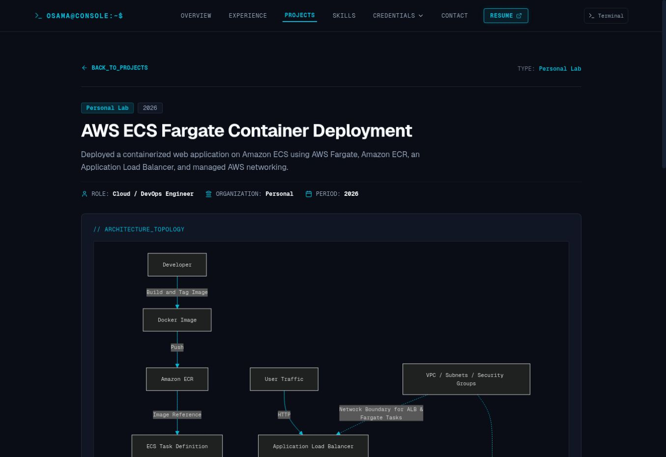
Figure 1. A project detail page. The top area identifies the lab and owner’s role; ARCHITECTURE_TOPOLOGY introduces the delivery relationships. Screenshot shows the upper portion of the page.

Case-study reading order
Each reviewed detail page includes an architecture area, Problem Statement & Context, Solution & Delivery Approach, Engineering Challenges & Resolution, Key Outcomes, Responsibilities and Technology Stack. Start with the problem and solution, then use the diagram and challenges to understand implementation decisions.
The Fargate case explicitly says the lab resources were removed after testing to avoid charges. A portfolio project record or terminal “Deployed Node” label should therefore not be interpreted as a currently running public service.

6 Skills and certifications
Skills & Technologies groups 25 published skills into six areas. Each skill shows a self-described level and duration. The legend describes Intermediate as practical experience and Advanced as extensive hands-on experience. Durations are profile claims, not audited time records. [1]
Group | Published skills
Cloud & Virtualization | AWS; Microsoft Azure; VMware vSphere
Containers & Orchestration | Kubernetes; Docker; Helm
Infrastructure as Code & Scripting | Terraform; Ansible; Bash / Shell Scripting; Python
CI/CD, Version Control & Code Quality | GitLab CI/CD; Jenkins; Git; SonarQube
Monitoring & Observability | Prometheus; Grafana; Loki; Elastic Stack (ELK); Alertmanager
Systems, Networking & Operations | Linux / Red Hat; Windows Server; Nginx; Routing & Switching; Network Security; Incident & SLA Management

Certification records
Certification | Issuer | Linked evidence
AWS Certified Cloud Practitioner | AWS | Credly badge
AWS Certified Solutions Architect – Associate | AWS | Credly badge
Certified Kubernetes Administrator | Linux Foundation | Credly badge
Red Hat Certified System Administrator | Red Hat | Credly badge
HCIA – Datacom | Huawei | Google Drive certificate

Viewing credentials
1. Open Credentials → Certifications, or select a credential abbreviation beside a related skill.
2. Read the certification title and issuer. Select the badge image or VERIFY CREDENTIAL to open its external evidence.
3. On the destination, check the holder, issuing organization, issue date and any expiry or status shown. Return to the portfolio when finished.
The presence and destinations of these links were inspected. External credential status, holder details and current validity were not independently verified. Course-completion certificates are listed separately and should not be described as professional certifications automatically.

7 Education and course inventory
Education & Training lists a Bachelor’s Degree in Communication Engineering from Delta University for Science and Technology, Faculty of Engineering, 2015–2020, in Dakahlia, Egypt. The IoT-based 3D printer graduation project is described as Excellent / A+. [1]
The honors block lists first place in Electronics and Embedded Systems at JAC-ECC in 2019. Five course previews lead to the complete 23-course directory. The following inventory preserves the directory’s provider and year distinctions. [2]
Year | Course or course group | Provider | Count
2025 | Certified Kubernetes Administrator course | KodeKloud | 1
2024 | Elasticsearch 8, Kibana, Logstash and Beats | Udemy | 1
2024 | vSphere: Install, Configure, Manage; Operate, Scale and Secure | VMware IT Academy | 2
2024 | Red Hat System Administration I and II | Red Hat Academy | 2
2023 | IP Network Sales; Transmission & Access Sales; Intelligent Collaboration; Digital Power; Storage | Huawei | 5
2023 | Database Fundamentals | Mahara-Tech | 1
2023 | Git/GitHub; Python | Codecademy | 2
2021 | Flutter and Dart Development | Udemy | 1
2021 | HCIA - 5G | Huawei | 1
2020 | JavaScript; Java; SQL | Codecademy | 3
2020 | Python | University of Michigan - USA | 1
2018 | Android Development; Network+ | New Horizons | 2
2017 | Java | Syscoms ITI - UAE | 1

Information hierarchy
The degree establishes the academic foundation. The award provides a specific engineering achievement. Course previews keep the homepage concise, while the directory supports more detailed review. Repeated subjects such as Python or Java remain separate records where providers or years differ.
The profile also records GDG Delta community participation from 2023 to the present, Arabic as native, and English at professional working proficiency. These appear in the personal story and HTML resume. [1, 3]

8 Browsing courses
1. Choose Credentials → Professional Courses, or VIEW ALL 23 COURSES under Education & Training. A homepage course link targets its corresponding course record.
2. Enter a title, provider or topic in search. Use Provider, Year and Topic / Stack to narrow the directory. The displayed count helps show the current result set.
3. Select VIEW CERTIFICATE or the certificate preview to enlarge it. Use OPEN ORIGINAL HIGH-RES when you need the original image.
4. Close the viewer with its close button, Escape, or a click outside. Select RESET FILTERS to return to the full directory.
5. Where VERIFY COMPLETION is available, open it to inspect the external completion record. Use BACK_TO_EDUCATION to return to the homepage.
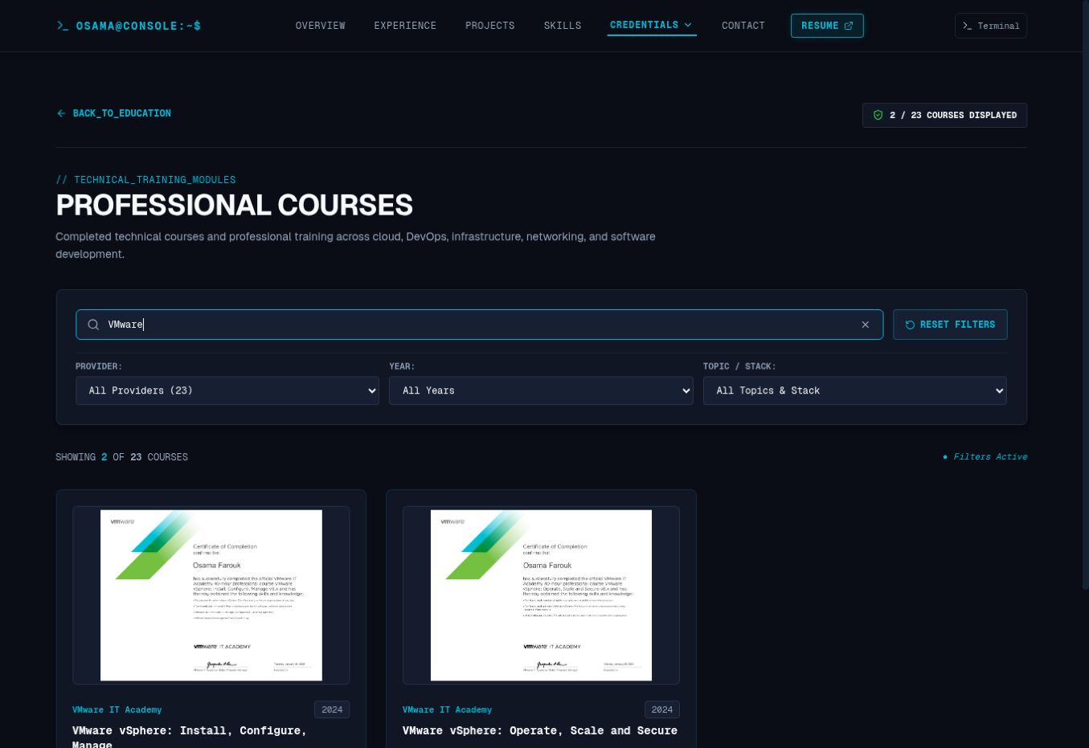
Figure 2. Searching for VMware returns two of 23 courses. Search sits above provider, year and topic filters; the result count appears above the certificate cards.

What was checked
The VMware search returned both vSphere courses. The CKA course certificate viewer opened and exposed its close control and original-image link. External verification actions vary by course; not every card includes one.

9 Using the interactive terminal
The terminal is an alternative interface for exploring portfolio records. Its shell, cluster and health wording is part of the presentation. The public interface does not establish that visitors receive a real server shell or that status labels come from live infrastructure monitoring. [1]
1. Select Terminal in the top bar or scroll to Interactive System Terminal.
2. Enter help and select EXECUTE. The terminal lists commands and their descriptions.
3. Enter help projects or help courses for command-specific usage.
4. Follow the displayed output. For a project-open request, review the summary and answer the Y/N prompt to continue or cancel.
Command | Purpose shown by help
overview / whoami | Professional summary or operator identity
experience | Browse career records
projects | Browse project records and case studies
skills | Inspect technologies and certifications
certifications / courses | Browse credentials or completed training
education / contact / resume | View academic, contact or resume information
status / help / clear | Display status, show instructions or clear output
ls / tree; cd <dir>; cat <file> | Explore the virtual directory and record interface

Verified project example
help projects
projects list
projects search Fargate
projects show 1
projects open 1
The help output advertises list, search, show and open, with an ID or number for selection. In this review, projects open 1 displayed the Fargate summary and asked “Open this project? [Y/N]”. The prompt was observed; confirmation navigation was not exercised. Record numbers can change as the inventory changes.
A Clear Output button is also available. Use the normal navigation if you prefer to browse without commands. The terminal’s console version was v1.3.11-STABLE at review time.

10 Resume and contact

Viewing or downloading the resume
1. Select RESUME in the top navigation to open /resume.
2. Use Full Resume, Experience, Technical Stack, Education & Certs, or Courses & Awards to choose the available resume view. These controls were present; every view was not exercised.
3. Select PRINT_RECORD for the print action, or DOWNLOAD_PDF for the linked PDF file. Your browser may display a PDF viewer or offer to save the file.
4. Use RETURN_TO_CONSOLE to return to the main site.
The homepage’s View Resume icon and DOWNLOAD RESUME action point directly to the PDF asset, while the navigation RESUME link opens the HTML page. The HTML resume includes the current ZainTECH entry. The supplied resume file differs, so the live downloadable asset should be compared with the approved source before updating it. [1, 3, 5]

Contact channels
Channel | Published destination
Email | osama.faroukk97@gmail.com
Phone | +20 100 074 8445
LinkedIn | https://linkedin.com/in/osamafaroukk
GitHub | https://github.com/OsamaFarouk
Location | Cairo, Egypt

Email Osama | LinkedIn | GitHub

Using the contact form
1. Open CONTACT and enter Name, Return Email and Message Body; these are marked required.
2. Choose an Inquiry Type. Options include General Inquiry, Job Opportunity, DevOps / Cloud Consulting, Project Collaboration, Professional Networking and Other. Subject is optional.
3. Select TRANSMIT MESSAGE and read the feedback before assuming the inquiry was delivered. If delivery fails, use the published email address.
Copy controls sit beside the email and phone number. The page says the form uses an HTTPS endpoint without opening an external email application. The endpoint implementation, message delivery, spam protection, retention and other security controls were not inspected; the form was not submitted.

11 Visual design and responsive use
The interface uses a dark operations-console identity: a near-black background, navy panels, cyan accents, green availability markers and occasional orange emphasis. Sans-serif text supports longer reading, while monospace labels, prompts and metadata reinforce the terminal theme. [1, 2, 4]
Observed design element | Evidence and role
Base color | Computed body background: #0A0D16.
Primary text | Computed body foreground: #F8FAFC.
Cyan accent | Computed section-label color: #06B6D4.
Typography | Computed font stacks name Geist for body/headings and Geist Mono for navigation and console labels, with fallback fonts.
Panels and cards | Dark raised surfaces, subtle borders, rounded corners and consistent interior spacing separate records.
Icons and imagery | Portrait, employer logos, technology marks, badges and small action icons support recognition; the icon library is unconfirmed.
Hierarchy | Large human-readable headings sit below small console-style labels; chips group category, status and technology metadata.
Layout | Desktop overview uses a profile column and wider summary area. Course results use a multi-column card layout.

Spacing and interaction patterns
Wide outer margins and section gaps separate dense technical content. Repeated cards and rows make projects, courses and experience easier to compare. The selected navigation item uses cyan emphasis. Experience headers reveal supporting detail; certificate previews open an overlay. Exact spacing tokens and component definitions require source access.

Responsive behavior and accessibility
The desktop layout and interactions were observed. No mobile viewport was available, so this guide does not assert a specific menu pattern, breakpoint, mobile font size or default collapsed state. The mobile release check should confirm readable wrapping, touch targets, overlay controls, terminal input visibility and diagram scrolling.
Preserve existing website text sizes when maintaining layout unless Osama explicitly approves typography changes. Prefer wrapping, spacing and content prioritization when resolving small-screen crowding. Keyboard focus, contrast, screen-reader behavior and reduced-motion support should be tested; this review is not an accessibility certification.

Document design
This guide translates the console identity into light A4 pages: black headings, restrained teal links, pale table accents and monospace command examples. Website screenshots retain their original dark appearance. Document formatting is separate from the website’s typography.

12 Reusable maintenance templates
The following templates are suggested authoring checklists derived from visible patterns. They are not a verified database schema or repository file format. “Required” means required for a complete future content entry in this guide’s maintenance process.
Record | Required content fields | Conditional fields
Experience | Role; organization; employment/training type; start/end period; location; short summary; responsibilities; contributions; technology stack. | Logo; client/project label; current-role flag; evidence for any quantified claim.
Project preview | Unique route slug; title; category; year/period; short summary; role; technology tags. | Organization; training provider; sanitized label; approved external source link.
Project case study | Preview fields; problem/context; solution; challenges and resolution; outcomes; responsibilities; architecture description. | Architecture diagram; evidence attachments; confidentiality notice; repository link if publishable.
Certification | Title; issuer; badge image and alternative text; verification destination. | Credential code; issue and expiry dates; current verification status. Issue years are visible in the HTML resume.
Course | Unique anchor; title; provider; year; certificate image and alternative text; completion status. | External verification URL; topic/stack tags for filtering; original high-resolution image.

Suggested writing pattern
For an experience summary, state the environment, your role and the purpose of the work in one short paragraph. Keep responsibility bullets about recurring work and contribution bullets about specific results. Include a number only when supporting evidence exists.
For a case study, explain the problem, the implementation and one meaningful challenge. Describe the result in plain language and make its scope explicit: professional environment, personal lab or training project. Keep internal hostnames, secrets and customer-sensitive information out of public content.

Editorial checks before publication
Keep employer names, dates and titles aligned across the homepage, HTML resume and PDF. Use consistent category spelling and stable route IDs. Add descriptive image text, verify destination links, and remove drafting qualifiers such as “if tested” only after confirming the underlying claim. Review the resulting card and detail page together.

13 Hosting delivery and recovery
Owner-provided implementation statement:
“The portfolio is deployed on Vercel. I created a CI/CD workflow connected to the project’s GitHub repository for automatic deployment and rollback.”
This statement confirms the owner’s intended delivery setup. It does not identify the automation service, branch rules, build commands, tests or rollback trigger. No repository or Vercel project configuration was available to verify those details. [6]
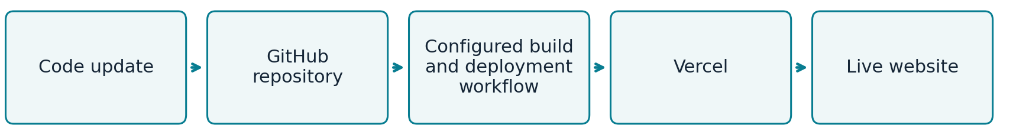
Figure 3. Owner-described delivery flow. The configured workflow is intentionally unnamed because its implementation has not been supplied.

Delivery in plain language
A maintainer updates the code or content and records the change in GitHub. The configured workflow prepares a deployable website build and sends it through Vercel. The published result is then available at the portfolio domain. The exact event that starts this process and the checks it runs still require confirmation.
CI/CD means a repeatable process for integrating changes and delivering software. Automatic deployment can reduce manual publishing work, but it does not by itself prove that automated tests, approval gates or automatic failure recovery are configured. Vercel supports Git-connected deployment as a platform capability. [7]

Rollback and recovery
Rollback restores a previous working release when a newer release causes a problem. The actual mechanism for this portfolio has not been verified. Do not treat GitHub Actions, an automatic trigger, a Git revert or Vercel Instant Rollback as the confirmed implementation.
Vercel documents Instant Rollback as a platform option that redirects production domains to an eligible previous deployment. That is reference information, not this portfolio’s verified runbook. Its documentation also notes configuration caveats and changes to automatic domain assignment after rollback. Consult it only after identifying the project’s real recovery method. [8]

Recovery information to record
Identify the Vercel project, production branch, workflow, known-good deployment and responsible operator. Confirm the rollback action, target release, configuration handling and how deployments resume. After recovery, check key pages, links, the resume and contact behavior; record the cause and restored release.
Observed status: the public pages were reachable and displayed V1.3.11. Deployment IDs, commit hashes, release timestamps, build logs and recovery history were unavailable. The displayed version is not a verified release history.

14 Maintenance and troubleshooting

Routine content care
After a role change, update dates, status, descriptions and the resume together. After a certification or course update, check its title, issuer/provider, date, image and verification link. After adding a project, review the category, search results, case-study route and confidentiality wording. Check contact details and professional-profile links regularly.

Review after every update
• Desktop: inspect the overview, navigation, experience expansion, project search, case pages, course viewer, terminal and contact layout.
• Mobile: test a real phone or a verified mobile viewport; check wrapping, horizontal overflow, navigation access, tap targets and the on-screen keyboard.
• Content: compare all resume representations; verify dates, titles, counts, credential links and image alternative text.
• Delivery: confirm the intended release is live using actual deployment evidence, then check the public domain and key supporting routes.
• Recovery: retain a known-good release reference and verify the documented rollback path before it is needed.

Troubleshooting reference
Symptom | First checks and next action
Broken link or missing page | Record the exact URL. Open the source page and inspect its link. Confirm the target exists and correct the content or route through the normal update process.
No project or course results | Clear search text and reset filters. If expected records remain missing, review their category/tag values and whether the newest content was published.
Missing image or certificate | Check the file path and filename case. Open the original asset if linked. Confirm it was included in the deployed release.
Terminal command fails | Run help or help <command>. Use only supported syntax. If navigation is blocked, use the ordinary page links and record the command/output.
Contact inquiry not delivered | Read the visible response. Check the return email and required fields. Use direct email as a fallback; the maintainer should inspect the actual endpoint and delivery logs.
Build or deployment failure | Inspect the configured workflow and Vercel logs. Identify the failing stage and compare the change with the last working release. Do not guess build commands.
Published release breaks a key task | Assess impact, identify the known-good release and use the verified recovery procedure. If the mechanism is unknown, confirm it with the project owner before acting.

Suggested release note fields: document/site version, date, change summary, commit, deployment ID, checks completed, known issues and recovery reference. This is a proposed maintenance record, not an existing release log.

15 References and confirmation register
Sources reviewed on 16 September 2026. Website content was read directly in the browser; screenshots are original captures from the same review.
[1] Live portfolio homepage
[2] Professional courses
[3] HTML resume
[4] Six project detail pages. Direct links are provided in Section 4. All six were read; the Fargate architecture was also inspected visually.
[5] Owner-supplied Osama_Farouk_DevOps_Resume.pdf, two pages. Read as supporting material; it was not assumed to match the live downloadable asset.
[6] Owner’s implementation statement supplied with this documentation request.
[7] Vercel documentation: Deploying Git Repositories
[8] Vercel documentation: Instant Rollback

Details requiring confirmation
Area | Missing evidence or action
Website implementation | Repository URL, application framework, dependency versions, source layout, content model and design-token definitions.
Deployment | Vercel project identity, production branch, configured workflow, build/output settings, tests, approvals and environment configuration.
Rollback | Actual tool, steps, trigger, permissions, eligible release, configuration handling and resumption of normal deployment.
Release history | Commit hashes, deployment IDs, release dates and previous recovery events.
Resume alignment | Compare the live PDF with the supplied file; align employer status, dates and location with the approved current record.
Observability case study | Confirm alert-rule implementation, notification routing and testing; conditional wording remains on the published page.
Mobile and accessibility | Verify compact navigation, responsive breakpoints, touch behavior, focus, contrast and screen-reader support.
Credentials and contact | Check current external credential status and link access; confirm form delivery and the actual security and privacy controls.

The guide is complete for the inspected public content. Operational details above remain explicitly unconfirmed so future maintainers can add evidence without confusing assumptions with implemented behavior.

16 Glossary
Term | Plain-language meaning
DevOps | Practices that connect software development and operations to make delivery and maintenance more reliable.
CI/CD | Continuous integration and continuous delivery/deployment: repeatable steps for preparing and releasing software changes.
Repository | A version-controlled collection of source files and their change history.
Commit | A recorded set of changes in a Git repository.
Build | The process that prepares source files for deployment.
Deployment | A published instance or release of an application or website.
Rollback | Restoring a previous working release after a problem.
Vercel | The hosting and deployment platform identified by the owner for this portfolio.
GitHub | The service identified by the owner as hosting the project repository.
Container | A packaged application and the dependencies it needs to run.
Kubernetes and Helm | Kubernetes manages containerized workloads; Helm packages and configures Kubernetes applications.
Infrastructure as Code | Describing infrastructure in versioned configuration files so it can be created and changed consistently.
Observability | Using signals such as metrics and logs to understand system behavior and investigate problems.
UAT | User acceptance testing: an environment or stage used to check that a system meets business needs.
SLA | Service-level agreement: an agreed service target or commitment.
Multi-AZ | Use of more than one AWS Availability Zone to reduce dependence on one location.
HTTPS | An encrypted connection between a browser and a server; it does not alone verify every application security control.
Responsive design | A layout that adapts to different screen sizes.
Anchor and route | An anchor identifies a location within a page; a route identifies a page or resource address.
Sanitized case study | A public account with sensitive internal information removed or generalized.

Keeping this guide current
Revise this document when navigation, page content or delivery behavior changes. Increment the document version independently from the website version, refresh affected screenshots and recheck the confirmation register. Keep the editable source and final PDF aligned.

