SpingBoot-MySQL-HelmChart Document

This project demonstrates a simple BookService SpringBoot MySQL application and its deployment on a kubernetes cluster with the help oh Helm chart.

The project consist of 2 charts :

1)Helm chart for BookService application

2)Helm chart for MySQL with persistence storage

Pre-Requesites To Run The Project :

Kubernetes Client Version : v1.15.3

Kubernetes Server Version : v1.15.12

Helm Chart Client Version : v2.14.3

Helm Chart Server Version : v2.14.3

Docker Version : 19.03.5

openjdk version "1.8.0_272"

OpenJDK Runtime Environment (build 1.8.0_272-8u272-b10-0ubuntu1~16.04-b10)

OpenJDK 64-Bit Server VM (build 25.272-b10, mixed mode)

Apache Maven 3.3.9

Steps To Run The Project :

To compile the java application, create docker image and deploy the application in kubernetes cluster with the help of helm chart simply run below command

bash start.sh

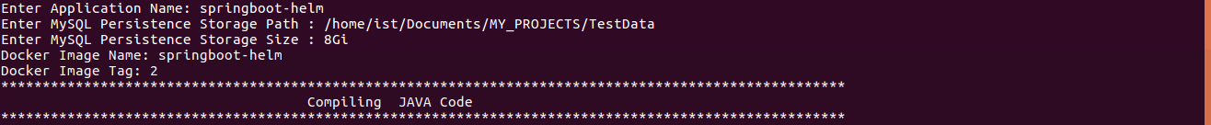

Enter the Inputs asked in scripts as shown in below image and wait for the application to be deployed.Once the helm chart is successfuly deployed on kubernetes cluster you will receive an URL as show in below image.

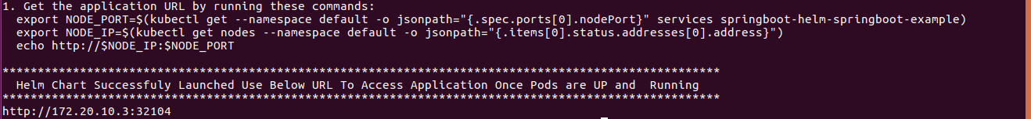



Copy the URL and and run it in your desired browser. Once URL is opened in the browser you will see below image which shows application is UP and running from GUI interface you can add a book information, list all books, view book information, edit book information and delete the book information. All the operation are persistent and are stored using MySQL, You can check the data is persisted in MySQL from command line.

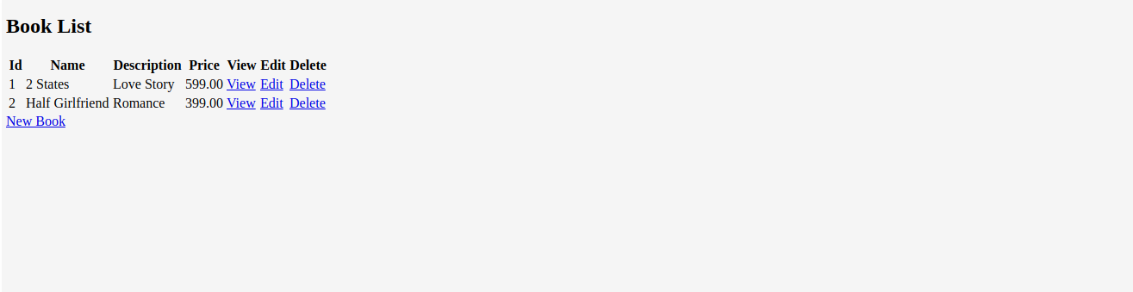



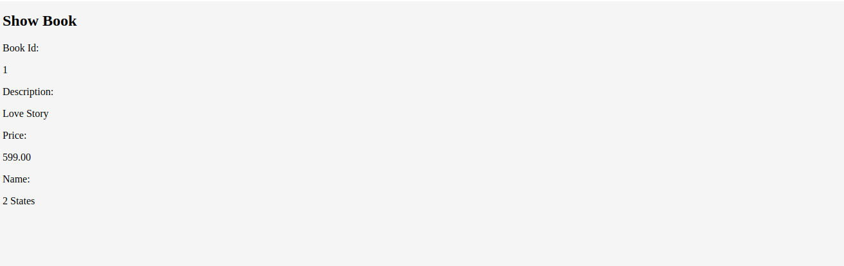



Steps To Uninstall The Project :

To uninstall the simply run the below command followed by aplication name given during installation this will delete the application from kubernetes cluster.

bash uninstall.sh <APP_NAME>

bash uninstall.sh springboot-helm