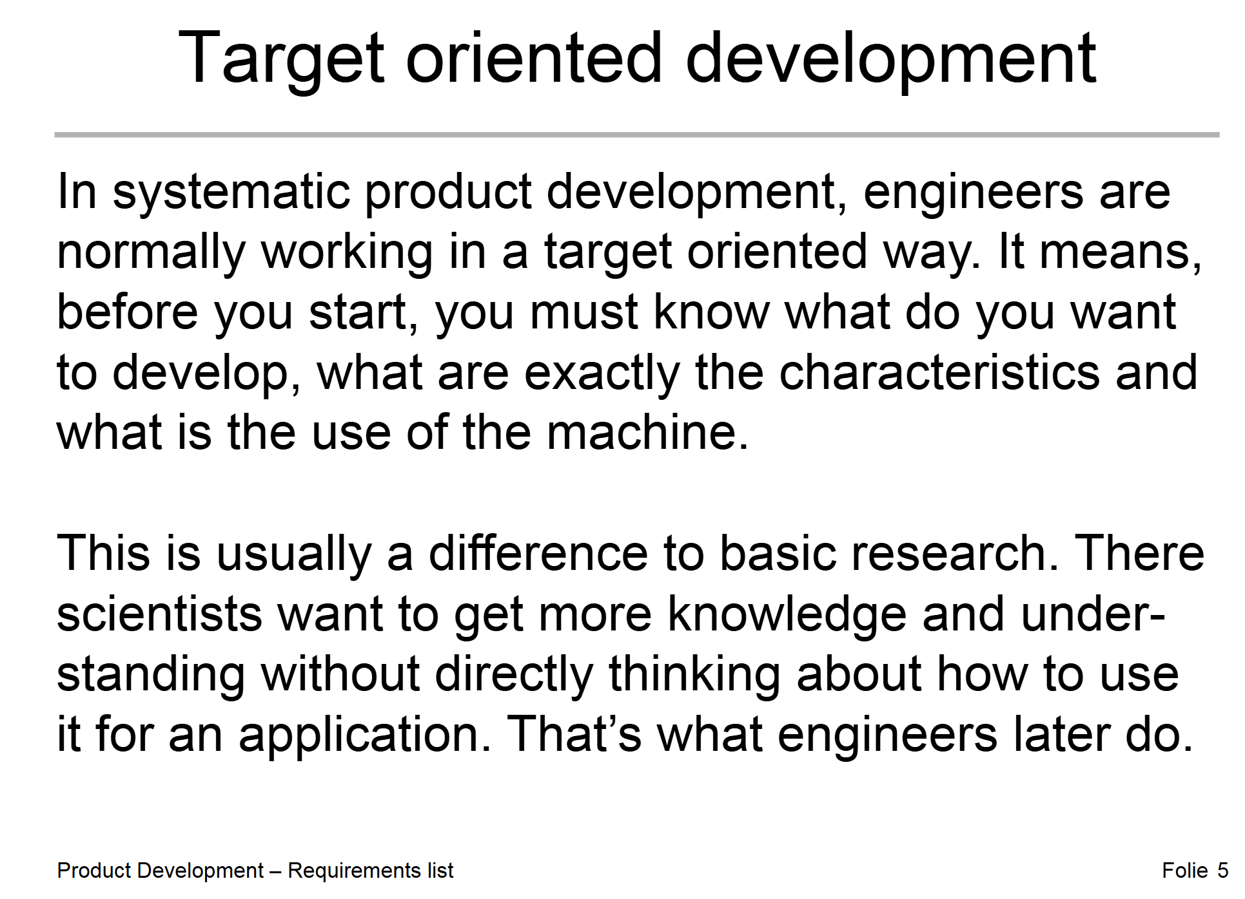
From RL (Lecture):
- The design team has to develop a robot, that can remove invasive plants. This is to be used in professional agriculture and forestry or from environmental protection agencies in order to protect the environment.
- The machine must be designed to recognize, locate and remove (or rendering harmless) invasive plants autonomously. The focus is on invasive neophytes and poisonous plants with good recognizability as: perennial lupine, giant hog weed, common ragwort.
- The invasive plants must be removed effectively, so that in the best case they disappear permanently. The area around, especially other plants, should not be damaged.
- Reaching or leaving the place of use the device should cause as little soil com paction as possible and should also be usable on slightly damp soils.
- The device should be able to be used in open areas with vegetation (meadows and pastures), which may also be overgrown with trees or bushes. It should be possible to overcome bumps, ditches, hills, stones or other obstacles that may occur in such terrain.
- When selecting the drive energy, it must be ensured that the machine can be operated independently for an appropriate period of time.
- A high level of safety must be ensured. Unauthorized access to the work area by other persons must also be taken into account.
- It is important to ensure, that there are sufficient cost advantages compared to conventional work. Please decide as a group how high acceptable production costs may be.
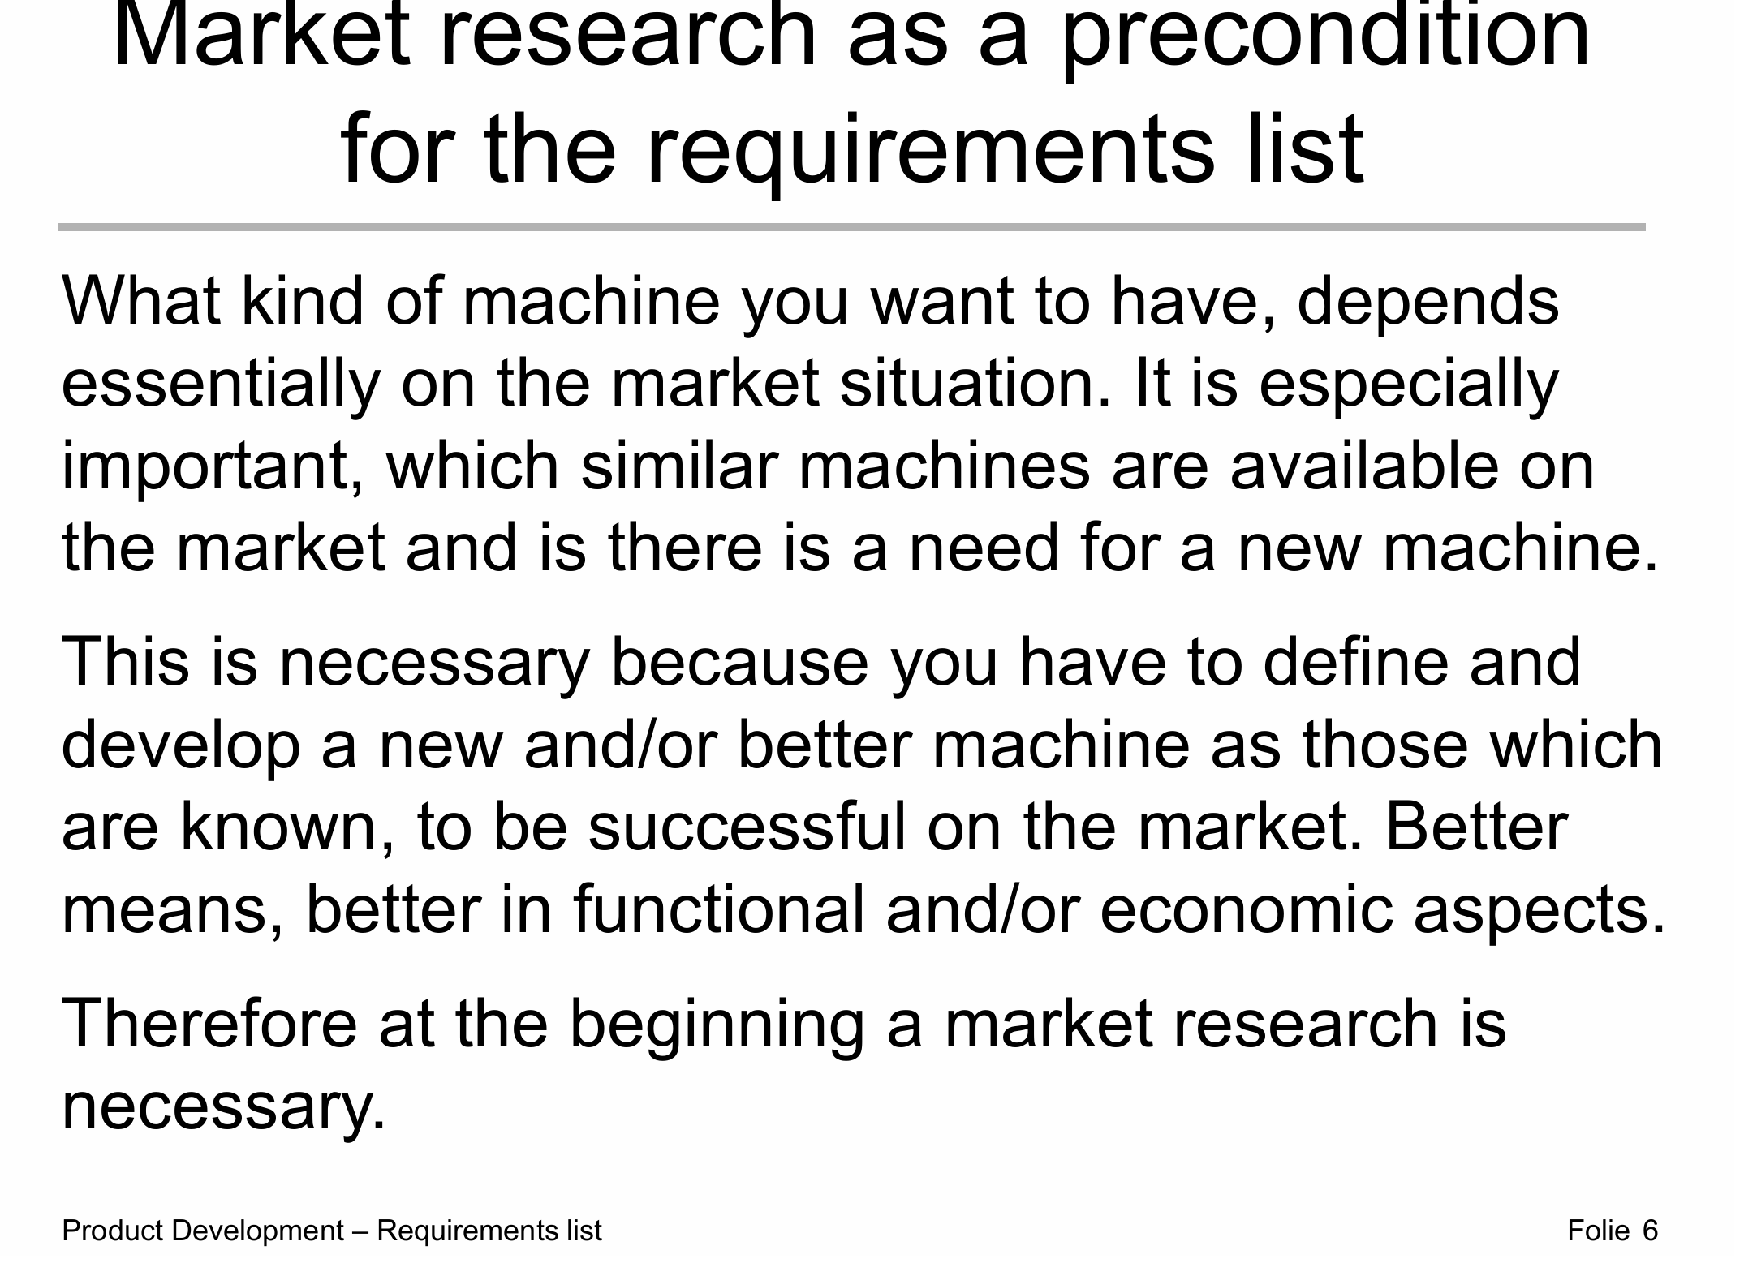
Neophyten-Radar mit Drohnen und KI in der Schweiz: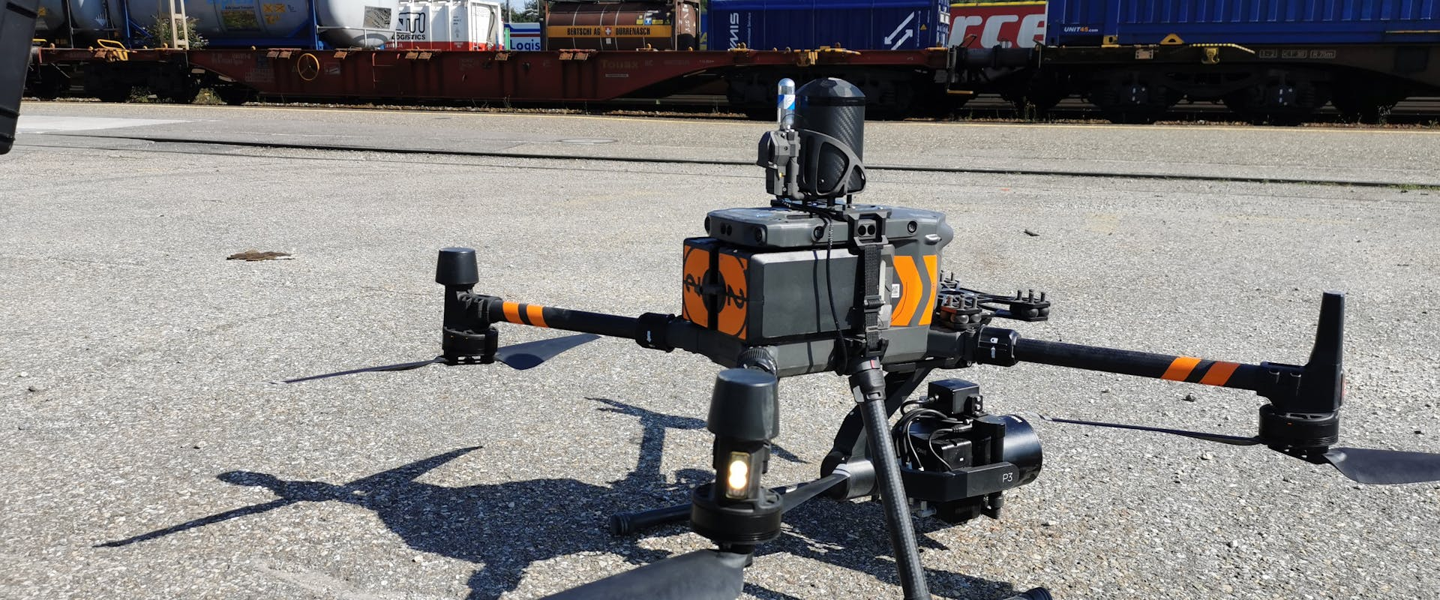Mit Drohnen und KI invasive Pflanzen aufspüren
Hydrilla Hunter – Roboterboot zur Bekämpfung von Wasserpflanzen:
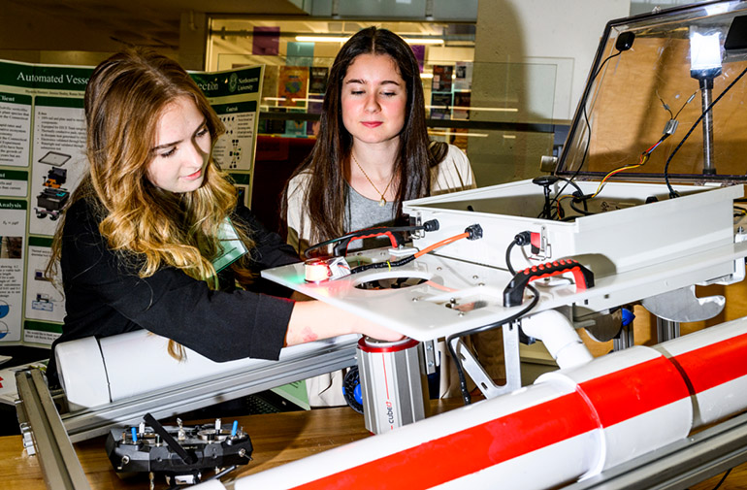Northeastern students develop robotic boat to attack invasive plants - The Robot Report
Automatisierte Erfassung invasiver Neophyten an Autobahnen:
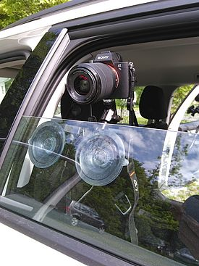
Automatisierte Erfassung invasiver Neophyten an Autobahnen
Roboter zur Bekämpfung invasiver Arten auf österreichischen Almen:
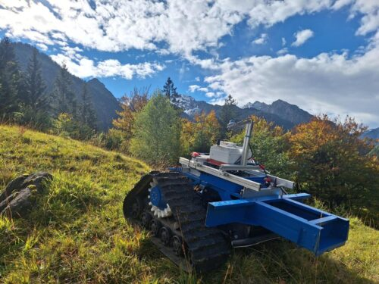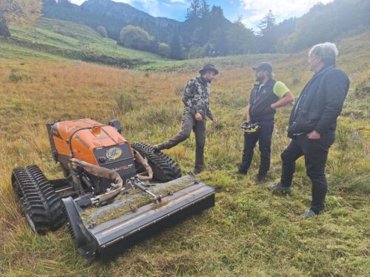
Per Roboter gegen invasive Arten auf Österreichs Almen – BMIMI INFOTHEK
Clearbot – Autonome elektrische Roboterboote:
Clearbot - autonomous electric robotic boats

Laserweeder:
Carbon Robotics: First & Only Commercial LaserWeeder™

Farmwise:
FarmWise - Wikipedia

Seadling remover:
https://techxplore.com/news/2024-06-weeding-robot-autonomously-seedlings.html?utm_source=chatgpt.com

Tertill Gartenroboter

Greenfield Robotics' Unkrautroboter:
Could robot weedkillers replace the need for pesticides? | Farming | The Guardian

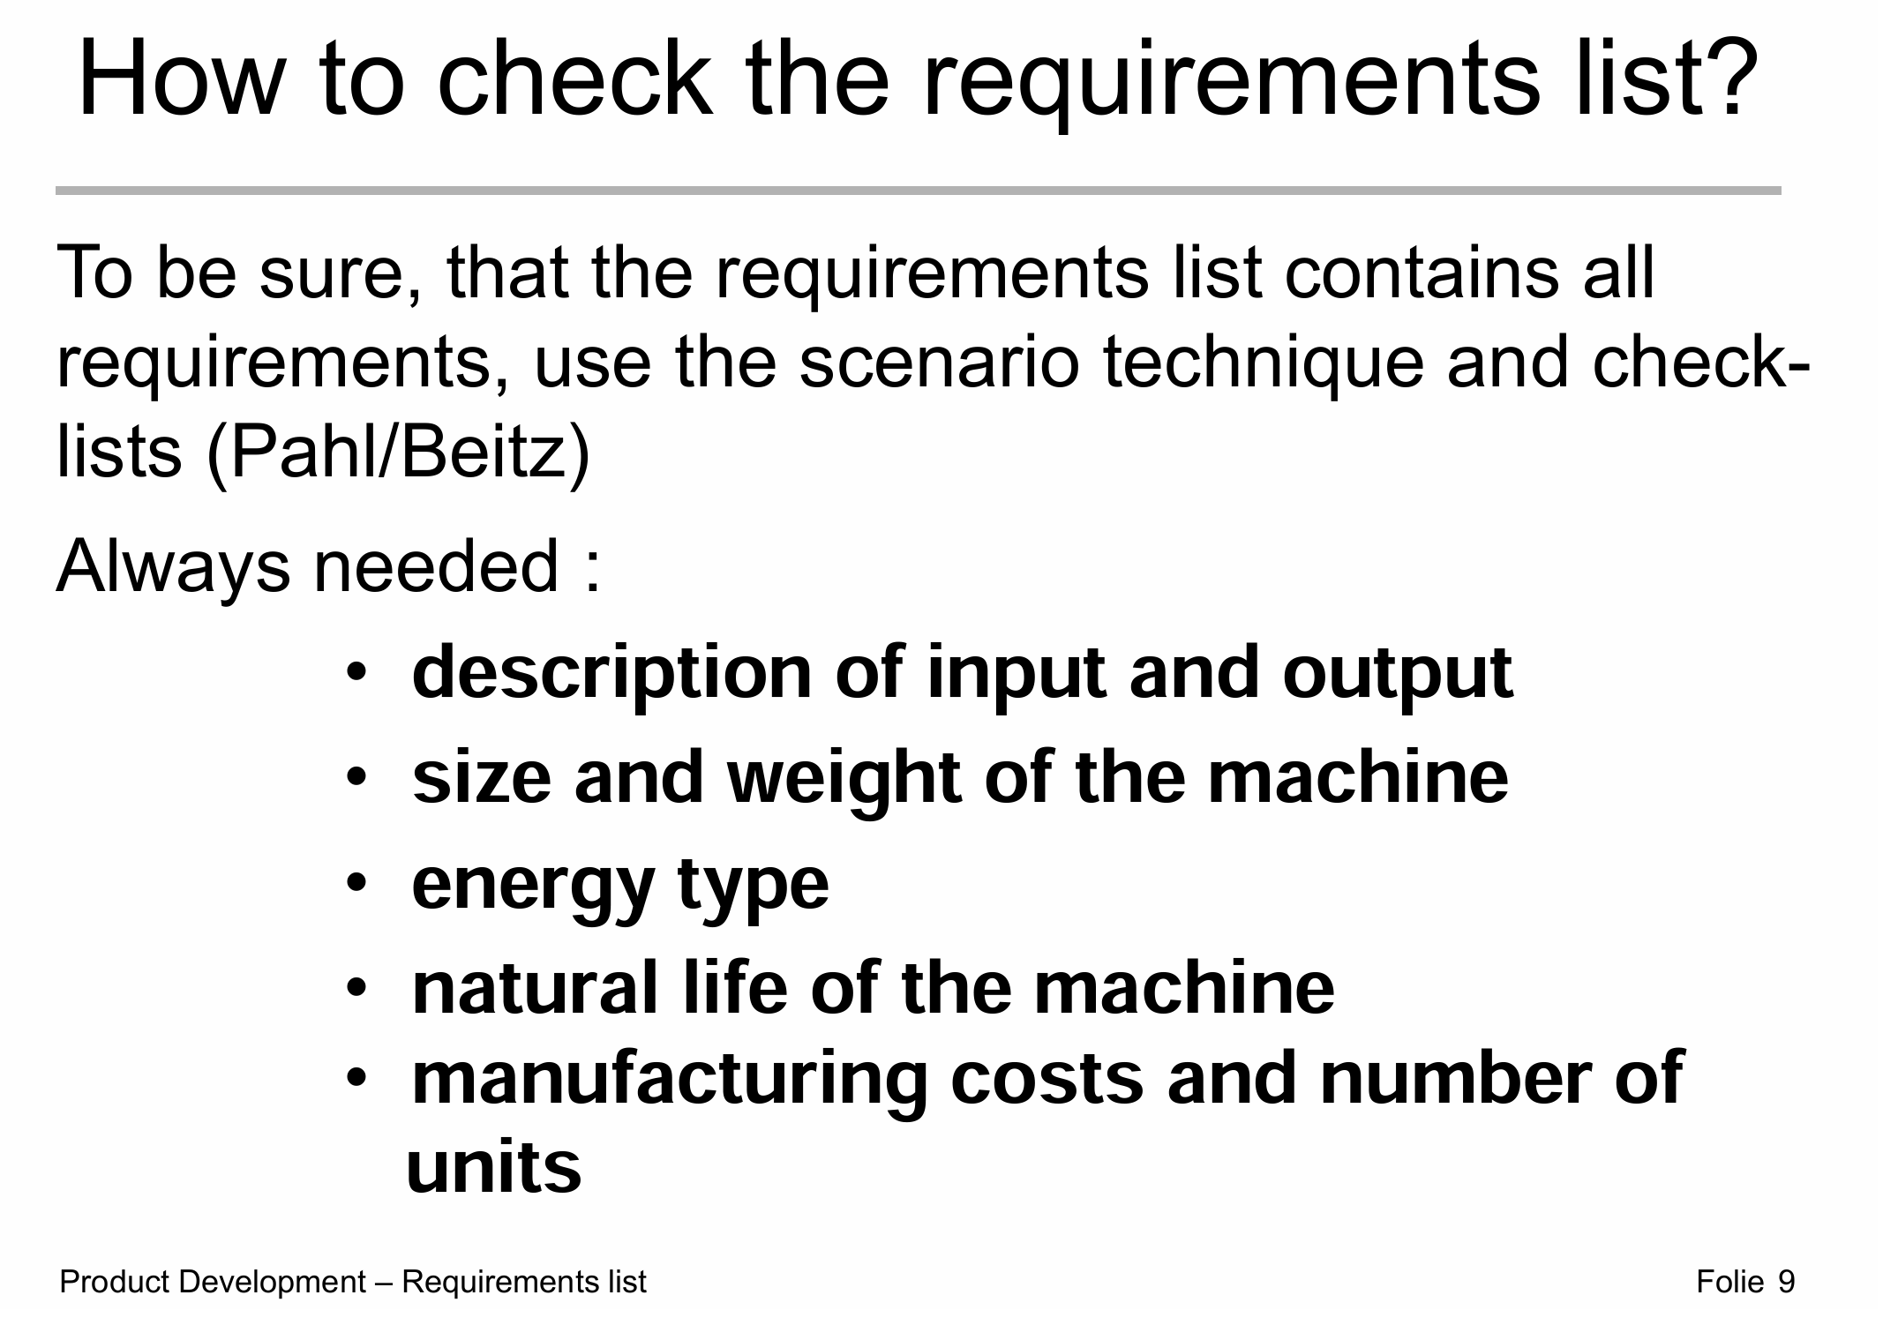
Mr Maier always said Reqirements should be able to be ticked. That means “Product needs to be safe” is not a reqirement. “sharp blades need to be covered, so a Finger cant touch it (e.g. with a mash with a hole size <1,5 cm). I would recommend using the “requirements” the Profs gave us and creating actual requirements + adding ours:
- The design team has to develop a robot, that can remove invasive plants. This is to be used in professional agriculture and forestry or from environmental protection agencies in order to protect the environment.
  - The robot should cut off and transport away the plants
  - The robot should spray the plants with weed remover, so they die
  - A List of Invasive Plants would be good to be attached or at least referenced
  - Robot is not for private use
- The machine must be designed to recognize, locate and remove (or rendering harmless) invasive plants autonomously. The focus is on invasive neophytes and poisonous plants with good recognizability as: perennial lupine, giant hog weed, common ragwort.
  - Same as above
- The invasive plants must be removed effectively, so that in the best case they disappear permanently. The area around, especially other plants, should not be damaged.
  - Plants around the invasive plant should not be damaged
- Reaching or leaving the place of use the device should cause as little soil com paction as possible and should also be usable on slightly damp soils.
  - Robot is only allowed to remove up to XXXXqm of soil
- The device should be able to be used in open areas with vegetation (meadows and pastures), which may also be overgrown with trees or bushes. It should be possible to overcome bumps, ditches, hills, stones or other obstacles that may occur in such terrain.
  - Robot should be able to get over stones of XXXXcm
  - Robot should be able to be water resistant lie IPXXX
  - Robot should not have any wires or loops sticking out <XXXcm
  - Robot should get over ditches of <XXXcm
  - Robot should be able to achieve an inclibe of <XXXcm
  - Robot should be able to drive through gras/bushes <XXXcm

- When selecting the drive energy, it must be ensured that the machine can be operated independently for an appropriate period of time.
  - Battery should last <XXXXh
- A high level of safety must be ensured. Unauthorized access to the work area by other persons must also be taken into account.
  - Robot must be able to detect persons within a radius of <XXXm
- It is important to ensure, that there are sufficient cost advantages compared to conventional work. Please decide as a group how high acceptable production costs may be.
  - The Robot should not cost more than XXXX€

- The Robot should be withing the dimension of:
- The Robot should not be heavier than:
- The Robot should be able to cut??? Plants up to <XXXcm
- The robot should be able to detect …… plants
- The robot should be able to navigate by it self
- The software …. Should be used

Doku:

Eigenschaften von den Pflanzen
Wie kann man pflanzen töten schneiden, Chemie, verbrennen

Osamah macht Market reseach liste inlatex

3.3 Area is missing like 1 qm
4. maybe different Headline Maybe just Terrain Compatibility
5.1 Instead of Autonomous operation Cordless operation
10.1 is that enough?

In 3.1 In 1.X What width of the ditch/hole should it overcome ?
Any german safety certification required ? TÜV, CE, GS, Gutachten von z.B. Intertek
Some more of my notes:
- The robot should cut off and transport away the plants
- The robot should spray the plants with weed remover, so they die
- Robot is only allowed to remove up to XXXXqm of soil or XXXX Kg
- Robot should be able to get over stones of XXXXcm
- Robot should be able to be water resistant lie IPXXX
- Robot should not have any wires or loops sticking out <XXXcm
- Robot should get over ditches of <XXXcm
- Robot should be able to drive through gras/bushes <XXXcm
- Robot must be able to detect persons within a radius of <XXXm
- The Robot should not cost more than XXXX€
- The Robot should be within the dimension of:
- The Robot should not be heavier than:
- The Robot should be able to cut??? Plants up to <XXXcm
- The robot should be able to navigate by it self
- The software …. Should be used
Bitte mach eine kleine recherche auf basis meines textes, hinterlege diese mit quellen, schreibe diese etwas professioneller und fasse die punkte strukturierter zusammen:
Ich muss für eie UNI aufgabe eine Recherche über Robotter machen, welche invasive pflanzen entfernt. Ich habe bereits eine Internetrecherche gemacht und auch eine Patentrecherche. Heute wwar ich auf einer messe und ich bin auf die firma XAG australia gestoßen und hatte mit diesen intensive gespräche. Ich habe mich hauptsächlich über die drohnenversion mit sprühausatz mit ihnen unterhalten. Genauer der XAG P150. Ich habe dazu auch einige flyer und informationen erhalten. Des weiteren habe ich mich über den mährobotter ROBO MOWER T-90 von NetEvoTech mit Ihnen unterhalten. Von diesem haben Sie mir aber in unserem fall abgeraten, da die erfahrung gezeigt hat, dass die zugänglichkeit nur sehr eingeschränkt möglich ist. Des weiteren haben Sie mir eine Lademöglichkeit der Drohnen von enovance aufgezeigt. Des weiteren haben die experten mir die software PIX4Dfields gezeigt, welche sie benutzen um die drohnen zu steuern. Sie würden erst eine Drohne mit einer Kamera losschicken, welche die zu untersuchende fläche engmaschig abfliegt. Danach wird der benutzer bilddaten erhalten, in welchen er dann die zu entfernenden, bzw schützende pflanzen, wie auch hindernisse einzeichnet. Dies geschiet über die App. Je mehr und je genauer der benutzer dies tut, desto genauer kann die software die daten verarbeiten und daraus lernen, d.h. ähnliche pflanzen automatisch erkennen. Wurden die bereiche eingezeichnet, startet eine weitere drohne, welche chemikalien auf die pflanzen verssprüht. Dies kann großflächig mit einer feinen düse passieren oder sehr geziehlt mit einer düse, die nur in einem strhl die chemikalien versprüht. Dadurch ist eine operation von wenigen qcm möglich. Die experten haben mir auch zu dieser variante geraten, weil es beim abmähen zu einem samen verteilen kommen kann. Des weitern wachsen die pflanzen sehr schnell nach und ein entfernen der wurzeln ist nur sehr schwer möglich. In der Erfahrung hat sich gerzeigt, dass die zugänglichkeit der fahrenden robottter nur sehr selten gegeben ist. Eine Kombination wäre jedoch möglich. Ein system mit zwei drohnen und software kostet ca 50.000 AUD$

During a recent trade fair visit to XAG Australia, supported by further online research, the XAG P150 agricultural drone was identified as a promising solution for the removal of invasive plant species. The drone features a payload capacity of up to 70 kg and uses the RevoSpray 4 system to apply herbicides either across wide areas or with pinpoint accuracy. The spraying system delivers fine droplets via adjustable centrifugal nozzles, enabling effective coverage on both sides of plant leaves.
The process is managed using PIX4Dfields, a mapping and control software. First, a drone equipped with a high-resolution camera captures detailed images of the area. In the software, the user manually marks invasive species, protected plants, and obstacles. These inputs train the software to recognize similar vegetation patterns using machine learning. The generated prescription map is then uploaded to the spraying drone, which treats only the marked zones with high precision.
Compared to ground-based mowers like the ROBO MOWER T-90 by NetEvoTech, spraying drones offer several advantages. Mechanical mowing can lead to seed dispersion and is limited in difficult or uneven terrain. Experts advised against the use of mowers in this context and recommended drone application to avoid further spread and ensure better reach. The system is also compatible with drone charging stations from Enovance, which can quickly recharge batteries for continuous operation. The total cost for a two-drone system including software is approximately AUD 50,000.
Sources:
XAG P150 Product Page: https://www.xa.com/en/p150
PIX4Dfields Software Overview: https://www.pix4d.com/product/pix4dfields
RevoSpray 4 Spraying System: https://www.xa.com/en/revospray
ROBO MOWER T-90 Specs (NetEvoTech): https://www.netevotech.com/robo-mower-t90
Enovance Drone Charging: https://enovance.com.au/

