Name: Usama Jamil
Roll no: 22F-3248
Course: Web Programming
Assignment: 01
Instructor: Mam Iqra

Screenshots:


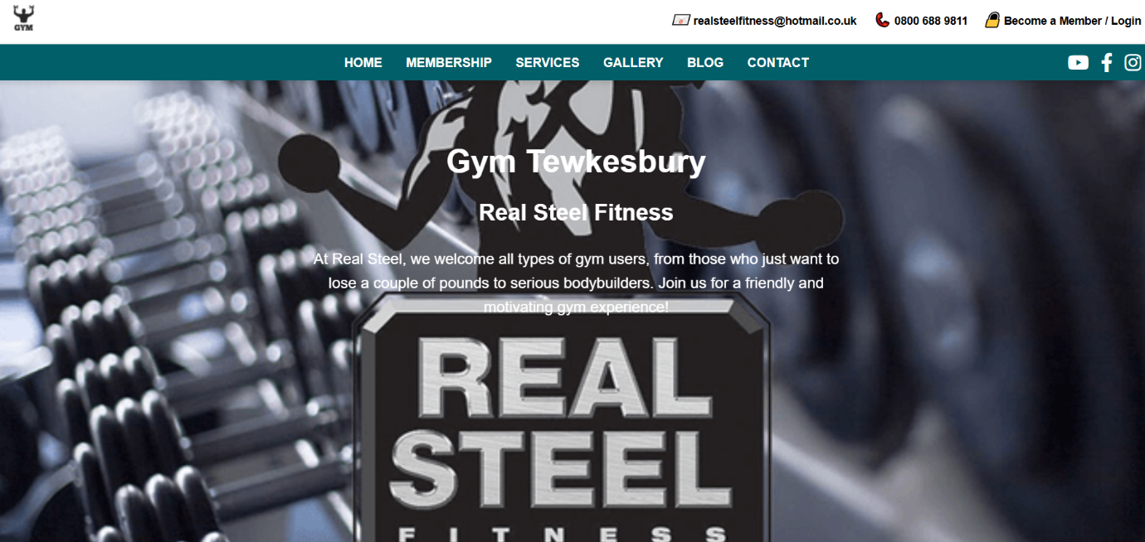
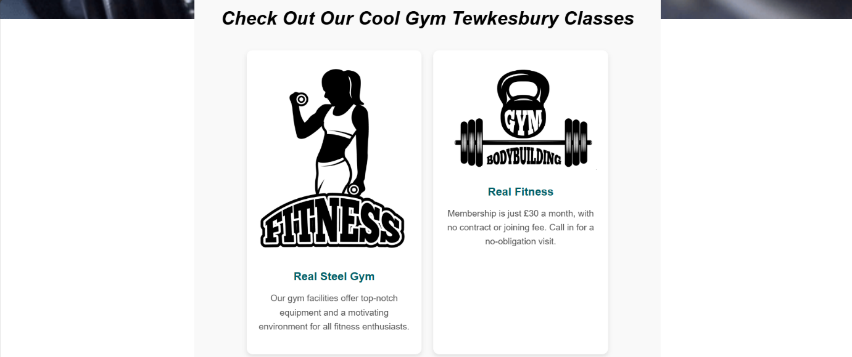


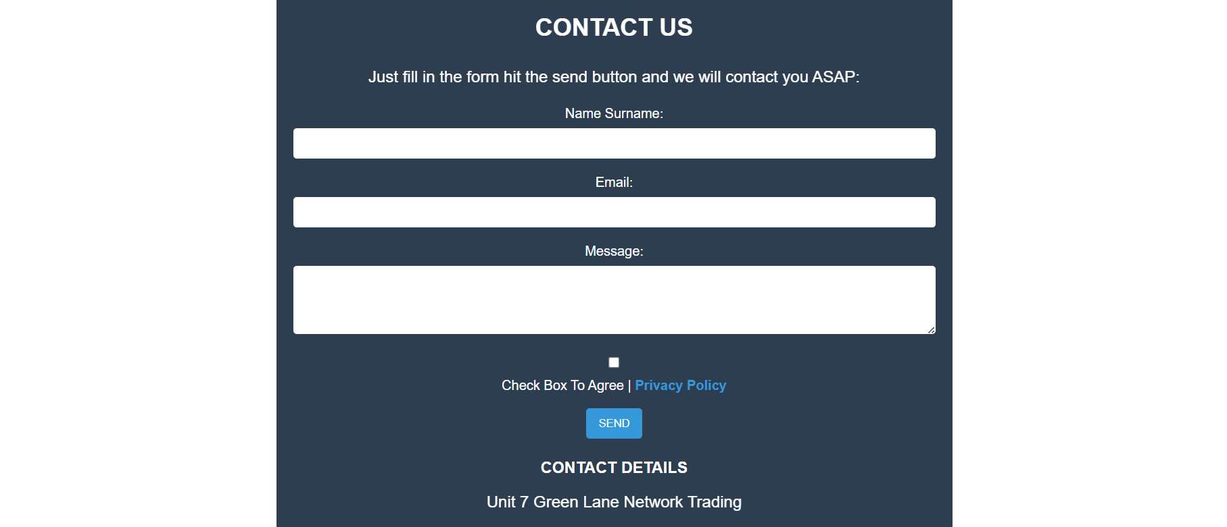

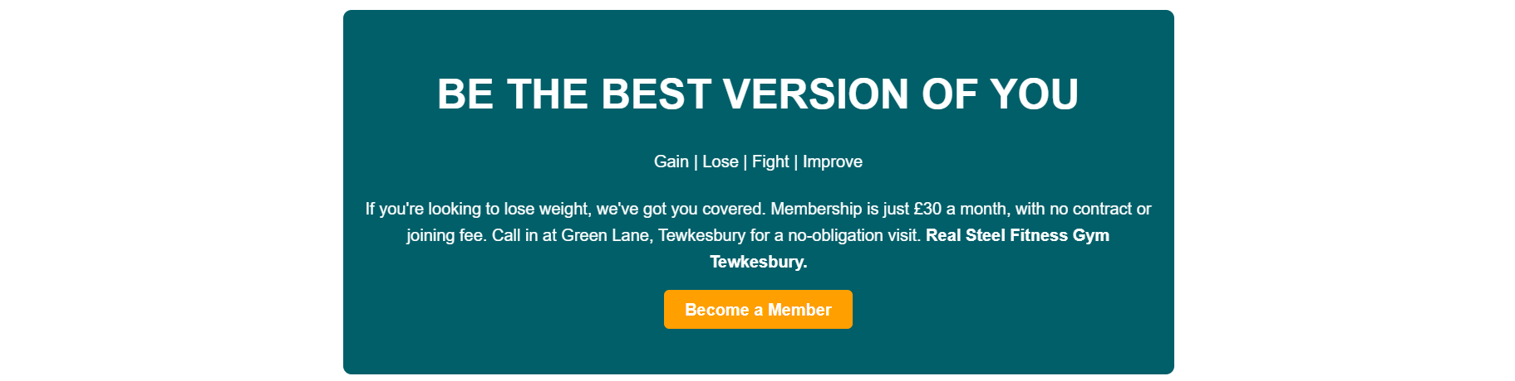



Codes:
Landing page:
Index.html

<!-- Header -->
<!DOCTYPE html>
<html lang="en">
<head>
<link rel="stylesheet" href="https://cdnjs.cloudflare.com/ajax/libs/font-awesome/6.0.0-beta3/css/all.min.css">

<title>Gym Website</title>
<link rel="stylesheet" href="style.css">
</head>
<body>
<!-- Header -->
<header>
<div class="top-bar">
<div class="logo">
<img src="logo.png" alt="Gym Logo">
</div>
<div class="contact-info">
<div>
<i class="email-icon">📧</i>
<a href="mailto:realsteelfitness@hotmail.co.uk">realsteelfitness@hotmail.co.uk</a>
</div>
<div>
<i class="phone-icon">📞</i>
<a href="tel:08006889811">0800 688 9811</a>
</div>
<div>
<i class="lock-icon">🔒</i>
<a href="signin.html">Become a Member / Login</a>
</div>
</div>
</div>
</header>

<!-- Navigation -->
<nav>
<a href="#">Home</a>
<a href="#">Membership</a>
<a href="#">Services</a>
<a href="#">Gallery</a>
<a href="#">Blog</a>
<a href="#">Contact</a>
</nav>
<div class="social-media">
<a href="https://www.youtube.com" target="_blank"><i class="fab fa-youtube"></i></a>
<a href="https://www.facebook.com" target="_blank"><i class="fab fa-facebook-f"></i></a>
<a href="https://www.instagram.com" target="_blank"><i class="fab fa-instagram"></i></a>
</div>
<!-- Hero Section -->
<section class="hero">
<h1>Gym Tewkesbury</h1>
<h2>Real Steel Fitness</h2>
<p>At Real Steel, we welcome all types of gym users, from those who just want to lose a couple of pounds to serious bodybuilders. Join us for a friendly and motivating gym experience!</p>
</section>

<!-- Gym Classes Section -->
<section class="classes-section">
<h2 class="h2">Check Out Our Cool Gym Tewkesbury Classes</h2>
<div class="classes-container">
<div class="class-card">
<img src="fit.png" alt="Fitness">
<h3>Real Steel Gym</h3>
<p>Our gym facilities offer top-notch equipment and a motivating environment for all fitness enthusiasts.</p>
</div>
<div class="class-card">
<img src="Gym.png" alt="Bodybuilding">
<h3>Real Fitness</h3>
<p>Membership is just £30 a month, with no contract or joining fee. Call in for a no-obligation visit.</p>
</div>
<div class="class-card">
<img src="gymboy.png" alt="Beginners Welcome">
<h3>Beginners Welcome</h3>
<p>Our staff is experienced and ready to help you start your fitness journey with personalized advice and support.</p>
</div>
</div>
</section>

<!-- New Section: Be the Best Version of You -->
<section class="best-version">
<h2>Be the Best Version of You</h2>
<p>Gain | Lose | Fight | Improve</p>
<p>If you're looking to lose weight, we've got you covered. Membership is just £30 a month, with no contract or joining fee. Call in at Green Lane, Tewkesbury for a no-obligation visit. <strong>Real Steel Fitness Gym Tewkesbury.</strong></p>
<a href="signin.html">Become a Member</a>
</section>

<section>
<img class="boyimg" src="boy.jpg" alt="Gym History">
<h1>Tewkesbury Gym</h1>
<h2>No Pain No Gain!</h2>
<p>
At Real Steel, we welcome all types of gym users, from those who just want to lose a couple pounds, to serious bodybuilders. Our friendly inclusive gym has all the tools you need to reach your goals!
</p>
<p>
<a href="boy.jpg" target="_blank">Learn a bit of History | Wikipedia about Gyms</a>
</p>
<a href="contact.html">CONTACT US FOR MORE INFO</a>
</section>

<section class="contact-us">
<h2>CONTACT US</h2>
<p>Just fill in the form hit the send button and we will contact you ASAP:</p>

<form action="submit-form.php" method="POST">
<label for="name">Name Surname:</label>
<input type="text" id="name" name="name" required>

<label for="email">Email:</label>
<input type="email" id="email" name="email" required>

<label for="message">Message:</label>
<textarea id="message" name="message" rows="4" required></textarea>

<div class="agreement">
<input type="checkbox" id="agreement" name="agreement" required>
<label for="agreement">Check Box To Agree | <a href="#">Privacy Policy</a></label>
</div>

<button type="submit">SEND</button>
</form>

<div class="contact-details">
<h3>CONTACT DETAILS</h3>
<p>Unit 7 Green Lane Network Trading</p>
<p>Estate Tewkesbury</p>
<p>GL20 8HD</p>
<p>0800 688 3811</p>
<p><a href="mailto:realsteelfitness@gmail.com">realsteelfitness@gmail.com</a></p>
</div>
</section>
<!-- Footer -->
<footer>
<div class="footer-container">
<div class="footer-section company-info">
<h3>Our Company</h3>
<p>Real Steel Fitness</p>
<p>Unit 7 Green Lane Network Trading</p>
<p>Estate Tewkesbury</p>
<p><a href="mailto:realsteelfitness@gmail.com">realsteelfitness@gmail.com</a></p>
<p>0800 688 3811</p>
</div>
<div class="footer-section links">
<h3>More Links</h3>
<p><a href="#">Privacy Policy</a></p>
<p><a href="#">Membership</a></p>
<p><a href="#">Blog - Latest news</a></p>
</div>
<div class="footer-section hours">
<h3>Opening Hours</h3>
<p>Mon - Fri: 5:30 am – 9:30 pm</p>
<p>Sat: 5:30 am – 9:30 pm</p>
<p>Sun: 8:00 am – 5:00 pm</p>
</div>
<div class="footer-section map">
<h3>Find us on the Map</h3>
<p><img src="map.jfif" alt="Map location" /></p>
</div>
</div>
</footer>
</body>
</html>

Sign in/sign out.html:
<!DOCTYPE html>
<html lang="en">
<head>
<meta charset="UTF-8">
<meta name="viewport" content="width=device-width, initial-scale=1.0">
<title>Sign In</title>
<link rel="stylesheet" href="styles.css"> <!-- Link to your external CSS file -->
</head>
<style>
body {
font-family: Arial, sans-serif;

margin: 0;
padding: 0;
background-image: url('back.png');
background-size: cover;
}

.container {
width: 100%;
max-width: 400px; /* Set a max width for the form */
margin: 100px auto; /* Center the form vertically and horizontally */
padding: 20px;
background: white;
border-radius: 10px; /* Rounded corners */
box-shadow: 0 2px 10px rgba(0, 0, 0, 0.1); /* Subtle shadow */
}

h1 {
text-align: center;
color: #333;
margin-bottom: 20px;
}

.input-group {
margin-bottom: 15px;
}

label {
display: block;
margin-bottom: 5px;
color: #555;
}

input[type="text"],
input[type="password"] {
width: 100%; /* Full width of the input */
padding: 10px;
border: 1px solid #ccc; /* Gray border */
border-radius: 5px; /* Rounded corners for inputs */
font-size: 16px; /* Font size */
}

button {
width: 100%; /* Full width of the button */
padding: 10px;
background-color: #005f69; /* Button background color */
color: white; /* Button text color */
border: none; /* Remove border */
border-radius: 5px; /* Rounded corners */
font-size: 16px; /* Font size */
cursor: pointer; /* Pointer cursor on hover */
}

button:hover {
background-color: #004a54; /* Darker shade on hover */
}

.signup-link {
text-align: center; /* Center the sign-up link */
margin-top: 15px;
}

.signup-link a {
color: #005f69; /* Link color */
text-decoration: none; /* Remove underline */
}

.signup-link a:hover {
text-decoration: underline; /* Underline on hover */
}

/* Responsive Styles */
@media (max-width: 480px) {
.container {
margin: 50px 20px; /* Adjust margin for smaller screens */
padding: 15px; /* Adjust padding */
}
}
</style>
<body>
<div class="container">
<h1>Sign In</h1>
<form action="" method="POST">
<div class="input-group">
<label for="username">Username</label>
<input type="text" id="username" name="username" required>
</div>
<div class="input-group">
<label for="password">Password</label>
<input type="password" id="password" name="password" required>
</div>
<button type="submit">Sign In</button>
<p class="signup-link">Don't have an account? <a href="index.html">Sign Up</a></p>
</form>
</div>
</body>
</html>

Styles.css:

* {
margin: 0;
padding: 0;
box-sizing: border-box;
}

body {
font-family: Arial, sans-serif;
line-height: 1.6;
background-image: url('back.png'); /* Path to your background image */
background-repeat: no-repeat; /* Prevents the image from repeating */
background-size: cover; /* Ensures the image covers the entire background */
background-position: center; /* Centers the image */
height: 100vh; /* Ensures the body takes full viewport height */
margin: 0; /* Remove default margin */
}
/* Header Section */
header {
background: #fff;
padding: 10px 20px;
border-bottom: 1px solid #ccc;
}

.top-bar {
display: flex;
justify-content: space-between;
align-items: center;
}

.top-bar .logo img {
max-height: 50px;
}

.top-bar .contact-info {
display: flex;
align-items: center;
}

.top-bar .contact-info div {
margin-left: 20px;
text-align: center;
}

.contact-info i {
font-size: 18px;
}

.top-bar a {
text-decoration: none;
color: #000;
font-size: 14px;
}

.top-bar a:hover {
text-decoration: underline;
}

/* Navigation Bar */
nav {
background: #005f69;
color: #fff;
display: flex;
justify-content: center;
padding: 10px 0;
box-shadow: 0px 4px 6px rgba(0, 0, 0, 0.1);
}

nav a {
color: #fff;
text-decoration: none;
font-size: 16px;
margin: 0 15px;
text-transform: uppercase;
}

nav a:hover {
text-decoration: underline;
}

.social-media {
position: absolute; /* Position it on the right */
top: 65px; /* Adjust as necessary */
right: 20px; /* Adjust for spacing from the right */
display: flex; /* Flexbox for alignment */
gap: 15px; /* Space between icons */
}

.social-media a {
color: white; /* Change to your preferred color */
font-size: 24px; /* Size of the icons */
text-decoration: none; /* Remove underline */
}

.social-media a:hover {
color: #ff9f00; /* Change color on hover */
}
/* Hero Section */
.hero {
text-align: center; /* Center the text */
padding: 50px; /* Add padding */
background:none; /* Background color */
position: relative; /* For absolute positioning of animations */
}

h1, h2, p {

transform: translateY(20px); /* Move text down */
animation-duration: 1s; /* Set animation duration */
animation-fill-mode: forwards; /* Keep the end state of animation */
}

h1 {
animation-name: fadeInUp; /* Animation for h1 */
animation-delay: 0.5s; /* Delay for h1 */
}

h2 {
animation-name: fadeInUp; /* Animation for h2 */
animation-delay: 1s; /* Delay for h2 */
}

p {
animation-name: fadeInUp; /* Animation for p */
animation-delay: 1.5s; /* Delay for paragraph */
}

/* Keyframes for the fadeInUp animation */
@keyframes fadeInUp {
to {
opacity: 1; /* Fully visible */
transform: translateY(0); /* Move to original position */
}
}
/* Gym Classes Section */
.classes-section {
padding: 50px 20px;
text-align: center;
background: #f9f9f9;
margin-top: 220px;
}

.classes-section h2 {
font-size: 2rem;
margin-bottom: 30px;
font-style: italic;
color: black;
}

.classes-container {
display: flex;
flex-wrap: wrap;
justify-content: center;
gap: 20px;
}

.class-card {
background: #fff;
box-shadow: 0 4px 8px rgba(0, 0, 0, 0.1);
border-radius: 10px;
overflow: hidden;
text-align: center;
width: 300px;
padding: 20px;
}

.class-card img {
max-width: 100%;
height: auto;
}

.class-card h3 {
font-size: 1.2rem;
margin: 15px 0 10px;
color: #005f69;
}

.class-card p {
font-size: 0.95rem;
color: #555;
margin-top: 10px;
}

/* New Section CSS */
.best-version {
background: #005f69;
color: white;
text-align: center;
padding: 50px 20px;
}

.best-version h2 {
font-size: 2.5rem;
margin-bottom: 20px;
text-transform: uppercase;
}

.best-version p {
font-size: 1rem;
max-width: 800px;
margin: 0 auto;
margin-bottom: 20px;
}

.best-version a {
background: #ff9f00;
color: white;
padding: 10px 20px;
text-decoration: none;
border-radius: 5px;
font-weight: bold;
}

.best-version a:hover {
background: #cc7a00;
}

.contact-us {
background-color: #2c3e50; /* Dark background */
color: white; /* White text */
padding: 20px; /* Padding around the section */
max-width: 800px; /* Maximum width */
margin: 20px auto; /* Center the section */
border-radius: 8px; /* Rounded corners */
}

h2, h3 {
margin-bottom: 15px; /* Space below headings */
}

label {
display: block; /* Make labels block-level for spacing */
margin-bottom: 5px; /* Space below labels */
}

input[type="text"],
input[type="email"],
textarea {
width: 100%; /* Full width */
padding: 10px; /* Padding inside inputs */
margin-bottom: 15px; /* Space below inputs */
border: none; /* Remove border */
border-radius: 4px; /* Rounded corners */
}

textarea {
resize: vertical; /* Allow vertical resizing only */
}

.agreement {
margin-bottom: 15px; /* Space below agreement section */
}

button {
background-color: #3498db; /* Button color */
color: white; /* Button text color */
padding: 10px 15px; /* Padding inside button */
border: none; /* Remove border */
border-radius: 4px; /* Rounded corners */
cursor: pointer; /* Pointer on hover */
}

button:hover {
background-color: #2980b9; /* Darker shade on hover */
}

.contact-details {
margin-top: 20px; /* Space above contact details */
}

footer {
background-color: #000000; /* Dark background */
color: white; /* White text */
padding: 20px; /* Padding around the footer */
}

.footer-container {
display: flex; /* Use Flexbox for layout */
justify-content: space-between; /* Space out sections */
flex-wrap: wrap; /* Allow wrapping on smaller screens */
}

.footer-section {
flex: 1; /* Each section takes equal space */
margin: 10px; /* Space between sections */
}

h3 {
margin-bottom: 10px; /* Space below headings */
}

p {
margin: 5px 0; /* Space between paragraphs */
}

a {
color: #3498db; /* Link color */
text-decoration: none; /* No underline */
}

a:hover {
text-decoration: underline; /* Underline on hover */
}
section {
background-color: #2c3e50; /* Dark background */
color: white; /* White text */
padding: 20px; /* Padding around the section */
border-radius: 8px; /* Rounded corners */
max-width: 800px; /* Maximum width */
margin: 20px auto; /* Center the section */
text-align: center; /* Center text */
}

h1 {
font-size: 2.5em; /* Large font size for the main heading */
margin-bottom: 10px; /* Space below the heading */
}

h2 {
font-size: 1.8em; /* Slightly smaller for the subheading */
margin-bottom: 20px; /* Space below the subheading */
}

p {
font-size: 1.2em; /* Standard font size for paragraphs */
margin-bottom: 15px; /* Space below paragraphs */
}

a {
color: #3498db; /* Link color */
text-decoration: none; /* No underline */
font-weight: bold; /* Bold text for links */
}

a:hover {
text-decoration: underline; /* Underline on hover */
}

.boyimg {
flex: 1; /* Take up half the space */
background-image: url('your-image.jpg'); /* Replace with your image */
background-size: cover; /* Change to 'contain' if you want to see the whole image */
background-position: center; /* Center the image */
height: 100%; /* Full height of the container */
max-height: 600px; /* Limit to viewport height */
}

