**Menoufia University**

**Faculty of Electronic Engineering**

**Department of Computer science & Engineering**

**Graduation Project**

**Making Attendance Using Face Identification**

**Supervisor**

**Dr Mohamed Azzam**

**July - 2023**

**Menoufia University**

**Faculty of Electronic Engineering**

**Department of Computer science & Engineering**

**Making Attendance Using Face Identification**

**By**

1. **Ahmed Sanad Ibrahim**
2. **Osama Ayman EL-Sayed Omera**
3. **Omar Mohamed Ibrahim Selim**

**Supervisor Head of Department Dean**

**Dr Mohamed Azzam Prof Gamal Attia Prof Ayman El-Sayed**

*ACKNOWLEDGMENTS*

**We would like to express our gratitude to Prof. Dr. Mohamed Azzam** **great engagement and guidance. We owe many thanks to him** **his great effort in directing the program systems, Control and** **Robotics during our graduation year.** **We also like to extent our thanks to all teaching staff members in** **our departments, and also like to extent our thanks to everyone** **supported and helped us all the way during this project been** **implemented. We really appreciate and grateful for what they have** **done. It was their kindness that given us opportunity to successfully** **completing the project.**

**Table of Contents**

**Abstract 8**

**List of Figures 9**

**List of Tables 10**

**1**. **Chapter1: Introduction ………………..……………………………. 11-16**

* 1. **Project Objective 12**
  2. **Background 12,13**
  3. **Problem Statement 14**
  4. **Aim and Objective 15**
  5. **Flow Chart 15**
  6. **Scope of The Project 16**

**2**. **Chapter2: Literature Review**........................................................... **17-23**

* 1. **Student Attendance System 18**
  2. **Digital Image Processing 20**

2.2.1 Image Representation in a Digital Computer 20

2.2.2 Steps in Digital Image Processing 21

* 1. **Definition of Terms and History 20**

2.3.1 45

**2.3.3 Node-MCU Code 46**

2.3.3.1 Code Explanations 46

2.3.3.2 WI-FI Connecting 48

**2.4 Summarized to connect your ESP board to Wi-Fi 52**

3. **Chapter3: CLOUD, IOT & Blynk**..............................................................**54**

* 1. **Introduction 54**
  2. **Cloud 55**
     1. Cloud Computing Definition 55
     2. Cloud Computing Basics 55
     3. Cloud Computing Benefits 56
     4. How the cloud connects business processes 57
     5. **Types of cloud computing 57**
        1. Public cloud 57
        2. Private cloud 58
        3. Hybrid cloud 58
     6. **Cloud computing services 58**
        1. SaaS 58
        2. PaaS 59
        3. IaaS 59
     7. Cloud computing challenges 59
  3. **IOT 60**
     1. What is internet of things? 60
     2. Why IOT is important? 61
     3. The technologies that make IoT possible 63
     4. Examples of IoT applications 63
     5. Risks and challenges in IoT 64
     6. How should businesses approach IoT 64
  4. **Blynk IOT Platform 66**
     1. IOT Platform 66
     2. **Work With Blynk 67**
        1. Introduction 67
        2. **Components of the Blynk IoT Platform 68**
           1. Blynk Console 68
           2. Blynk App 69
           3. Blynk Edgent and Blynk Library 70
        3. **Getting Started 71**
           1. What is a Device Template? 71
           2. Device Template Elements 72
           3. Code Overview 73
           4. Wi-Fi Provisioning 77
           5. Set Up Datastreams 78
           6. Send Data From Hardware To Blynk 79
           7. Events 80
           8. Notifications(Alerts) 81
  5. **Google Assistant (IFTTT) 83**

4. **Chapter4: Machine Learning**.........................................................................**89**

**4.1 INTRODUCTION 89**

**4.2 Why Machine learning? 90**

* 1. **Machine learning Process 90**
     1. Data collection 90
     2. Data preparation 90
     3. Model selection 90
     4. Model training 91
     5. Model evaluation 91
     6. Hyperparameter tuning. 91
     7. Model testing 91
     8. Deployment 91
  2. **Machine Learning Types 92**
     1. Supervised Learning 92
     2. Unsupervised Learning 94
     3. Reinforcement Learning 94
  3. **Machine Learning Models 94**
  4. **Machine Learning in Intellifarm 97**
     1. Data 97
     2. Preprocessing and Analysis on Data 98
     3. Building The Model 100

5. **Chapter5: INTELIFARM**.................................................................................**103**

* 1. **Introduction 103**
  2. **Block Diagram and Flow Chart 103**
     1. Block diagram 103
     2. Flow chart 104
  3. **Connecting sensors to the NodeMCU 106**
     1. Connecting the MQ35 Sensor 106
     2. Connecting the DHT11 Sensor 108
     3. Connecting the Soil Moisture Sensor 110
     4. Connecting the Soil Temp Sensor 111
     5. Connecting the Rain Sensor 113
     6. Connecting the Pump 114
     7. Connecting the Buzzer 116
     8. LM7805 9v to 5v converter 117
     9. PC817C 4 Pin DIP Photocoupler 119
  4. **Prepare Blynk IOT platform. 120**
  5. **Add Google Assistant 129**
  6. **Use the APIs 132**
  7. **Use Google Assistant 133**
  8. **Project Code 134**
  9. **Future work 139**
     1. **Attach model ML to the cloud. 139**
        1. Steps of Attaching a machine learning model to the cloud139
        2. Benefits of Attaching machine learning model to the cloud141
     2. **Add Soil NPK sensor.   141**
        1. Specifications 142
        2. Pinout MAX485 TTL to RS-485 Module 143
        3. Circuit Diagram 144
        4. The output Soil NPK values 145
        5. NPK sensors benefits for farmers and growers 145

1. Fawaz, A. (2019). A smart classroom of wireless sensor networks for students time attendance system. In *IEEE integrated STEM education conference (ISEC)*.
2. Helmi, R., Yusuf, S., & Jamal, A. (2019). Face recognition automatic class attendance system (FRACAS). In *IEEE international conference on automatic control and intelligent systems (I2CACIS 2019)*, Selangor, Malaysia, June 29, 2019.
3. Xing, Y. (2019). A class attendance system based on SL4A. In *IEEE 4th international conference on cloud computing and big data analytics*.
4. Mijić, D., Durutović, J., Bjelica, O., & Ljubojević, M. (2019). An improved version of student attendance management system based on RFID. In *18th international symposium INFOTEH*-*JAHORINA*, March 20–22, 2019.
5. Li, J., Gu, J., Huang, Z., & Wen, J. (2019). Application research of improved YOLO V3 algorithm in PCB electronic component detection. *Applied Sciences,9,* 3750.

**For Introduction**

**Abstract**

Nowadays, Artificial Neural networks can be trained over several billion images and can be used to detect and recognize faces with relative ease and flexibility in an instant.

Attendance monitoring of students in a classroom is a process that has been followed in the traditional manner of raising the names of every candidate and verifying their presence. Nowadays faculty members use roll numbers of the individual candidate to verify the presence of a candidate in a class. But students are not genuine in this process. More number of proxy entries is made while reporting. This has to be monitored properly and also proxy entries need to be taken out. To solve this problem, a new methodology is proposed using a traditional biometric mechanism with fast processing.

A fingerprint attendance system is used by many organizations for verifying their presence for a day. Maintenance of Attendance is the key aspect in most of the organizations in today's world. Biometric is a well-known authenticated technology for identifying a person for a day in the organization. Other technologies exist in the market which helps in identifying the person. Some of the technologies are RFID, NFC, and FACE Recognition. But, all the above technologies have their own disadvantages in terms of efficiency and duplication. To overcome this problem, a refined biometric technology is proposed which uniquely identifies the person and performs fast processing. A small handy device is used to mark the attendance without the involvement of faculty members. This concept is used in the implementation of this real time attendance cum surveillance system that can be prototyped and set into action.

The user-friendly graphical user interface provides flexibility and ease in running these powerful face recognition algorithms powered by deep-learning.

We have achieved a maximum recognition accuracy of 74 percent while running the real time surveillance algorithm. This work was done as a solution to the absence of a robust and user friendly face recognition attendance system.

**LIST OF FIGURES:**

Figure 1.1 Project outline 10

Figure 1.2 shows Block diagram of proposed system 12

Figure 2.1 : A diagram showing the steps in digital image processing 20

Figure 2.2 Haar Feature 15

Figure 2.3 Integral of Image 15

Figure 2.4 LBP Operation 17

Figure 2.5 The LBP operation Radius charge 18

Figure 2.6 Extracting the Histogram 19

Figure 3.1 Model Implement 22

Figure 3.2 Installing OpenCV 24

Figure 3.3 Jetson Nano Board 25

Figure 3.4The first step to configure your NVIDIA Jetson Nano for computer vision and deep learning is to download the Jetpack SD card image 28

***List of Tables***

Table 2.1: Advantages & Disadvantages of Different Biometric System 19

Table 2.2: Advantages & Disadvantages of Face Detection Methods 22

**Chapter 1**

Introduction

* 1. **Project Objective**

Attendance is prime important for both the teacher and student of an educational organization. So it is very important to keep record of the attendance. The problem arises when we think about the traditional process of taking attendance in class room.

Calling name or roll number of the student for attendance is not only a problem of time consumption but also it needs energy. So an automatic attendance system can solve all above problems.

There are some automatic attendances making system which are currently used by much institution. One of such system is biometric technique and RFID system. Although it is automatic and a step ahead of traditional method it fails to meet the time constraint. The student has to wait in queue for giving attendance, which is time taking.

This project introduces an involuntary attendance marking system, devoid of any kind of interference with the normal teaching procedure. The system can be also implemented during exam sessions or in other teaching activities where attendance is highly essential. This system eliminates classical student identification such as calling name of the student, or checking respective identification cards of the student, which can not only interfere with the ongoing teaching process, but also can be stressful for students during examination sessions. In addition, the students have to register in the database to be recognized. The enrolment can be done on the spot through the userfriendly interface.

* 1. ***Background***

Face recognition is crucial in daily life in order to identify family, friends or someone we are familiar with. We might not perceive that several steps have actually taken in order to identify human faces. Human intelligence allows us to receive information and interpret the information in the recognition process. We receive information through the image projected into our eyes, by specifically retina in the form of light. Light is a form of electromagnetic waves which are radiated from a source onto an object and projected to human vision. Robinson-Riegler, G., & Robinson-Riegler, B. (2008) mentioned that after visual processing done by the human visual system, we actually classify shape, size, contour and the texture of the object in order to analyze the information. The analyzed information will be compared to other representations of objects or face that exist in our memory to recognize. In fact, it is a hard challenge to build an automated system to have the same capability as a human to recognize faces. However, we need large memory to recognize different faces, for example, in the Universities, there are a lot of students with different race and gender, it is impossible to remember every face of the individual without making mistakes. In order to overcome human limitations, computers with almost limitless memory, high processing speed and power are used in face recognition systems.

The human face is a unique representation of individual identity. Thus, face recognition is defined as a biometric method in which identification of an individual is performed by comparing real-time capture image with stored images in the database of that person (Margaret Rouse, 2012).

Nowadays, face recognition system is prevalent due to its simplicity and awesome performance. For instance, airport protection systems and FBI use face recognition for criminal investigations by tracking suspects, missing children and drug activities (Robert Silk, 2017). Apart from that, Facebook which is a popular social networking website implement face recognition to allow the users to tag their friends in the photo for entertainment purposes (Sidney Fussell, 2018). Furthermore, Intel Company allows the users to use face recognition to get access to their online account (Reichert, C., 2017). Apple allows the users to unlock their mobile phone, iPhone X by using face recognition (deAgonia, M., 2017).

The work on face recognition began in 1960. Woody Bledsoe, Helen Chan Wolf and Charles Bisson had introduced a system which required the administrator to locate eyes, ears, nose and mouth from images. The distance and ratios between the located features and the common reference points are then calculated and compared. The studies are further enhanced by Goldstein, Harmon, and Lesk in 1970 by using other features such as hair colour and lip thickness to automate the recognition. In 1988, Kirby and Sirovich first suggested principle component analysis (PCA) to solve face recognition problem. Many studies on face recognition were then conducted continuously until today (Ashley DuVal, 2012).

* 1. ***Problem Statement***

Traditional student attendance marking technique is often facing a lot of trouble. The face recognition student attendance system emphasizes its simplicity by eliminating classical student attendance marking technique such as 5 calling student names or checking respective identification cards. There are not only disturbing the teaching process but also causes distraction for students during exam sessions. Apart from calling names, attendance sheet is passed around the classroom during the lecture sessions. The lecture class especially the class with a large number of students might find it difficult to have the attendance sheet being passed around the class. Thus, face recognition attendance system is proposed in order to replace the manual signing of the presence of students which are burdensome and causes students get distracted in order to sign for their attendance. Furthermore, the face recognition based automated student attendance system able to overcome the problem of fraudulent approach and lecturers does not have to count the number of students several times to ensure the presence of the students.

The paper proposed by Zhao, W et al. (2003) has listed the difficulties of facial identification. One of the difficulties of facial identification is the identification between known and unknown images. In addition, paper proposed by Pooja G.R et al. (2010) found out that the training process for face recognition student attendance system is slow and time-consuming. In addition, the paper proposed by Priyanka Wagh et al. (2015) mentioned that different lighting and head poses are often the problems that could degrade the performance of face recognition based student attendance system.

Hence, there is a need to develop a real time operating student attendance system which means the identification process must be done within defined time constraints to prevent omission. The extracted features from facial images which represent the identity of the students have to be consistent towards a change in background, illumination, pose and expression. High accuracy and fast computation time will be the evaluation points of the performance.

* 1. ***Aim and Objectives***

The objective of this project is to develop face recognition attendance system. Expected achievements in order to fulfill the objectives are:

● To detect the face segment from the video frame and capture photos.

● To extract the useful features from the face detected.

● To classify the features in order to recognize the face detected.

● To record the attendance of the identified student in database.

* 1. ***Flow Chart***

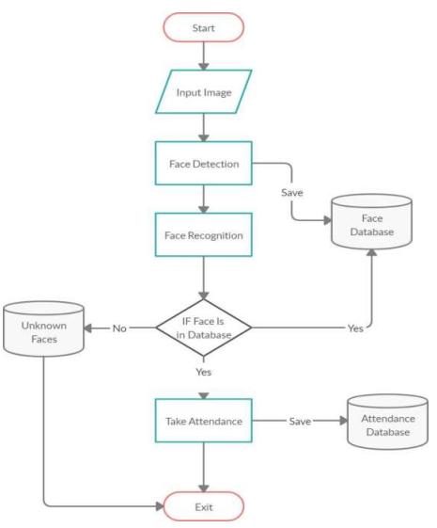

* 1. Project Outline
  2. ***Scope of the Project***

We are setting up to design a system comprising of two modules. The first module (face detector) is a camera component, which is basically a camera that captures student faces and stores them in a file using computer vision face detection algorithms and face extraction techniques.

The second module is a desktop GUI that does face recognition of the captured images (faces) in the file, marks the students register and then stores the results in a database for future analysis to enable them to make attendance of specific class.

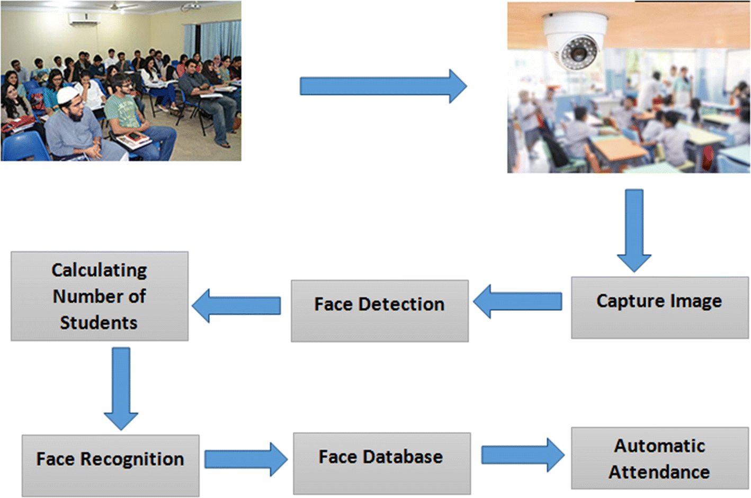

1.2 shows Block diagram of proposed system.

**Chapter 2**

Literature Review

* 1. **Student Attendance System**

Arun Katara et al. (2017) mentioned disadvantages of RFID (Radio Frequency Identification) card system, fingerprint system and iris recognition system.

RFID card system is implemented due to its simplicity. However, the user tends to help their friends to check in as long as they have their friend’s ID card. The fingerprint system is indeed effective but not efficient because it takes time for the verification process so the user has to line up and perform the verification one by one. However for face recognition, the human face is always exposed and contain less information compared to iris.

Iris recognition system which contains more detail might invade the privacy of the user. Voice recognition is available, but it is less accurate compared to other methods. Hence, face recognition system is suggested to be implemented in the student attendance system.

|  |  |  |
| --- | --- | --- |
| **System Type** | **Advantage** | **Disadvantages** |
| RFID card system | Simple | Fraudulent usage |
| Fingerprint system | Accurate | Time-consuming |
| Voice recognition system | Simple | Less accurate to others |
| Iris recognition system | Accurate | Privacy Invasion |

Table 2.1: Advantages & Disadvantages of Different Biometric System

* 1. **Digital Image Processing**

Digital Image Processing is the processing of images which are digital in nature by a digital computer. Digital image processing techniques are motivated by three major applications mainly:

● Improvement of pictorial information for human perception 11

● Image processing for autonomous machine application

● Efficient storage and transmission.

* + 1. **Image Representation in a Digital Computer:**

An image is a 2-Dimensional light intensity function

𝐟 (𝐱,𝐲) = 𝐫 (𝐱,𝐲) × 𝐢 (𝐱,𝐲) -(2.0)

Where, r (x, y) is the reflectivity of the surface of the corresponding image point. i(x,y) Represents the intensity of the incident light. A digital image f(x, y) is discretized both in spatial co-ordinates by grids and in brightness by quantization. Effectively, the image can be represented as a matrix whose row, column indices specify a point in the image and the element value identifies gray level value at that point. These elements are referred to as pixels or pels.

Typically following image processing applications, the image size which is used is 𝟐𝟓𝟔 × 𝟐𝟓𝟔, elements, 𝟔𝟒𝟎 × 𝟒𝟖𝟎 pels or 𝟏𝟎𝟐𝟒 × 𝟏𝟎𝟐𝟒 pixels. Quantization of these matrix pixels is done at 8 bits for black and white images and 24 bits for colored images (because of the three color planes Red, Green and Blue each at 8 bits).

* + 1. **Steps in Digital Image Processing:**

Digital image processing involves the following basic tasks:

* Image Acquisition - An imaging sensor and the capability to digitize the signal produced by the sensor.

* Preprocessing – Enhances the image quality, filtering, contrast enhancement etc.

* Segmentation – Partitions an input image into constituent parts of objects.

* Description/feature Selection – extracts the description of image objects suitable for further computer processing.

* Recognition and Interpretation – Assigning a label to the object based on the information provided by its descriptor.

Interpretation assigns meaning to a set of labelled objects.

* Knowledge Base – This helps for efficient processing as well as inter module cooperation.

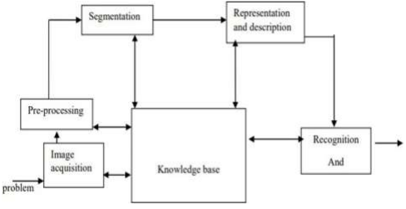

Figure 2.1: A diagram showing the steps in digital image processing.

* 1. **Definition of Terms and History**
     1. **Face Detection**

Face detection is the process of identifying and locating all the present faces

in a single image or video regardless of their position, scale, orientation, age and expression. Furthermore, the detection should be irrespective of extraneous illumination conditions and the image and video content [5].

* + 1. **Face Recognition**

Face Recognition is a visual pattern recognition problem, where the face, represented as a three dimensional object that is subject to varying illumination, pose and other factors, needs to be identified based on acquired images[6]. Face Recognition is therefore simply the task of identifying an already detected face as a known or unknown face and in more advanced cases telling exactly whose face it is[7].

* + 1. **Difference Between Face Detection and Face Recognition**

Face detection answers the question, Where is the face? It identifies an object as a “face” and locates it in the input image.

Face Recognition on the other hand answers the question who is this? Or whose face is it? It decides if the detected face is someone. It can therefore be seen that face detections output (the detected face) is the input to the face recognizer and the face Recognition’s output is the final decision i.e. face known or face unknown.

**Face Detection:**

A face Detector has to tell whether an image of arbitrary size contains a human face and if so, where it is.

Face detection can be performed based on several cues: skin color (for faces in color images and videos, motion (for faces in videos), facial/head shape, facial appearance or a combination of these parameters.

Most face detection algorithms are appearance based without using other cues. An input image is scanned at all possible locations and scales by a sub window.

Face detection is posed as classifying the pattern in the sub window either as a face or a non-face. The face/nonface classifier is learned from face and non-face training examples using statistical learning methods[9 ].

Most modern algorithms are based on the Viola Jones object detection framework, which is based on Haar Cascades

|  |  |  |
| --- | --- | --- |
| **Face Detection Method** | **Advantages** | **Disadvantages** |
| Viola Jones Algorithm | 1. High detection Speed.  2. High Accuracy. | 1. Long Training Time. 2.Limited Head Pose. 3.Not able to detect dark faces. |
| Local Binary Pattern Histogram | 1.Simple computation. 2.High tolerance against the monotonic illumination changes. | 1.Only used for binary and grey images.  2.Overall performance is inaccurate compared to Viola-Jones Algorithm. |
| Ada Boost Algorithm | Need not to have any prior knowledge about face structure. | The result highly depends on the training data and affected by weak classifiers |
| SMQT Features and SNOW Classifier Method | 1. Capable to deal with lighting problem in object detection.  2. Efficient in computation. | The region contain very similar to grey value regions will be misidentified as face. |
| Neural-Network | High accuracy only if large size of image were trained. | 1. Detection process is slow and computation is complex.  2. Overall performance is weaker than Viola-Jones algorithm |

Table 2.2: Advantages & Disadvantages of Face Detection Methods

Viola-Jones algorithm which was introduced by P. Viola, M. J. Jones (2001) is the most popular algorithm to localize the face segment from static images or video frame.

Basically the concept of Viola-Jones algorithm consists of four parts. The first part is known as Haar feature, second part is where integral image is created, followed by implementation of Adaboost on the third part and lastly cascading process.

**REFERENCES**

**1. Gadekar, Dipak, SanyuktaGhorpade, VishakhaShelar, and Ajay Paithane. "IoT BASED ATTENDANCE MONITORING**

**SYSTEM USING FACE AND FINGERPRINT." (2018).**

**2. Pasumarti, Priya, and P. Purna Sekhar. "Classroom Attendance Using Face Detection and Raspberry-Pi." International**

**Research Journal of Engineering and Technology (IRJET) 5, no. 03 (2018): 167-171.**

**3. Bhattacharya, Shubhobrata, Gowtham Sandeep Nainala, Prosenjit Das, and AurobindaRoutray. "Smart Attendance**

**Monitoring System (SAMS): A Face Recognition Based Attendance System for Classroom Environment." In 2018 IEEE**

**18th International Conference on Advanced Learning Technologies (ICALT), pp. 358-360. IEEE, 2018**

**4. Soniya, V., R. Swetha Sri, K. SwethaTitty, R. Ramakrishnan, and S. Sivakumar. "Attendance automation using face**

**recognition biometric authentication." In Power and Embedded Drive Control (ICPEDC), 2017 International**

**Conference on, pp. 122-127. IEEE, 2017.**

**5. Uma, K., S. Srilatha, D. Kushal, A. R. Pallavi, and V. Nanda Kumar. "Biometric Attendance Prediction using Face**

**Recognition Method." Indian Journal of Science and Technology 10, no. 17 (2017).**

**6. Kumar, P. Prudhvi Kiran Ravi. "Image Processing Based Student Attendance System using Raspberry PI." International**

**Journal Of Engineering And Computer Science 6, no. 4 (2017).**

**7. Katara, Arun, Mr Sudesh V. Kolhe, Mr Amar P. Zilpe, Mr Nikhil D. Bhele, and Mr Chetan J. Bele. "Attendance System**

**Using Face Recognition and Class Monitoring System." International Journal on Recent and Innovation Trends in**

**Computing and Communication 5, no. 2 (2017): 273-276.**

**8. Chandramohan, J., R. Nagarajan, T. Dineshkumar, G. Kannan, and R. Prakash. "Attendance Monitoring System of**

**Students Based on Biometric and GPS Tracking System." International Journal of Advanced engineering, Management**

**and Science 3, no. 3 (2017).**

**9. AnusayaTantak,ArchanaSudrik,Archanakale,Rutuja Mehere,Prof.Ms.S.S.Pophale.”Face recognition for E-attendance for**

**student and staff(IOSR-JCE)PP 89-94,(mar-apr 2017).**

**10. Varadharajan, E., R. Dharani, S. Jeevitha, B. Kavinmathi, and S. Hemalatha. "Automatic attendance management system**

**using face detection." In Green Engineering and Technologies (IC-GET), 2016 Online International Conference on, pp.**

**1-3. IEEE, 2016**

**LITERATURE REVIEW**

The students fingerprints area unit scanned by a code. the students impress the fingerprint against the scanner the system compares the new fingerprint patterns and it will be connecting to the various points for the fingerprint to the database. A match is recorded as knock[1].

The finger print module then we are taking the sample of there are four finger print and they are detected along the images when the user that should keep finger on the module and it will be scanning and compared is already stored in the memory the person whose finger print is matched their will be marking present and not matching the SMS send to his parents [8],[25].

When the Student images are stored the database. the raspberry pi camera module is placing the student entering in the class room. the USB camera module is capture the student image. the system will automatically update the student presence in the class to the students database and sends message to guardians of absentees and also to head of department[2],[3],[5].

The laptop of web camera is captured the image. Each student faces are stored to the database. The image of the students for further process. then detected face images are compared with the image of students database. And the recognition process. If the image is matched with the database. The student is marked as present. The student attendance report will send to student on mail account[9],[10]

The face recognition is captured the students image. The students entering in the classroom or everybody already occupies in the classroom. The students attendance automatically recognized.[11].

The student data base is collected and store to the pi. The camera will be connected to the raspberry pi module camera will be placed in front of the class. It captures the image of the student. Who are present in the class is used for face detection. Then the detected face is compared with the stored data of every student. Then recognized and mark the attendance[6].

The camera will now capture your image. If the image detected matches to the sample image for the database. The attendance marked as present on the LCD. if the camera fails the fingerprint scanner will be activated and the attendance will be marked present[1].

The system that can be automatically capture students attendance by flashing their student card at the RFID reader to entering the class room. The student ID is instantly capture by the reader after that the data is sent to the online server for recording.

The system help to automatically compute the percentage of attendance of each individual student. The GUI of user list function for adding and removing the students personal details[4],[20],[24].

The student to mark his attendance. After recognizing the faces of the students. The face information of students are updated in to an MySQL database. The data of present student are then sent to server computer and stored the authorized person can see it[7].

Biometric method is used for the eyeball detection. This method eyeball sensor is used. Also senses the iris. The individual of eyeball is stored in the database. The image of eyeball in database. the attendance are marked. This setup is practically not possible[10].

The students faces are pre stored in the databases. camera capture the student face and compared to the database image. If it is matched the student attendance register with time. The absentees faces will be send to the authorized mail id.[14].

Which obtain the faces images capture by camera. When face recognize operation is started and find out the nearest matched images from SD card. After completion of your time amount a file generated with student details like roll number, date, time, present or absent. someone will absent the message send to the parent mobile numbers using GSM. This system provides accurate attendance information of the students in easy and efficient[16].