Project Report

Advanced Calculator

Programming Fundamentals

CS112

18/9/2018

**Problem Statements:-**

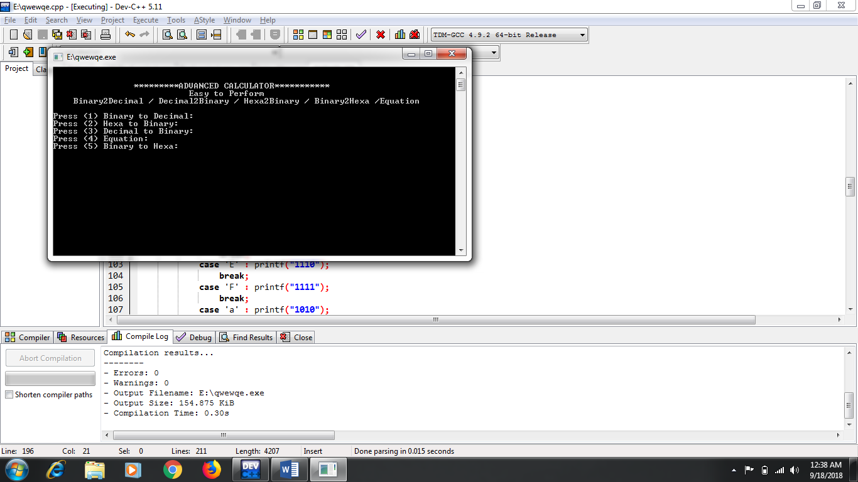

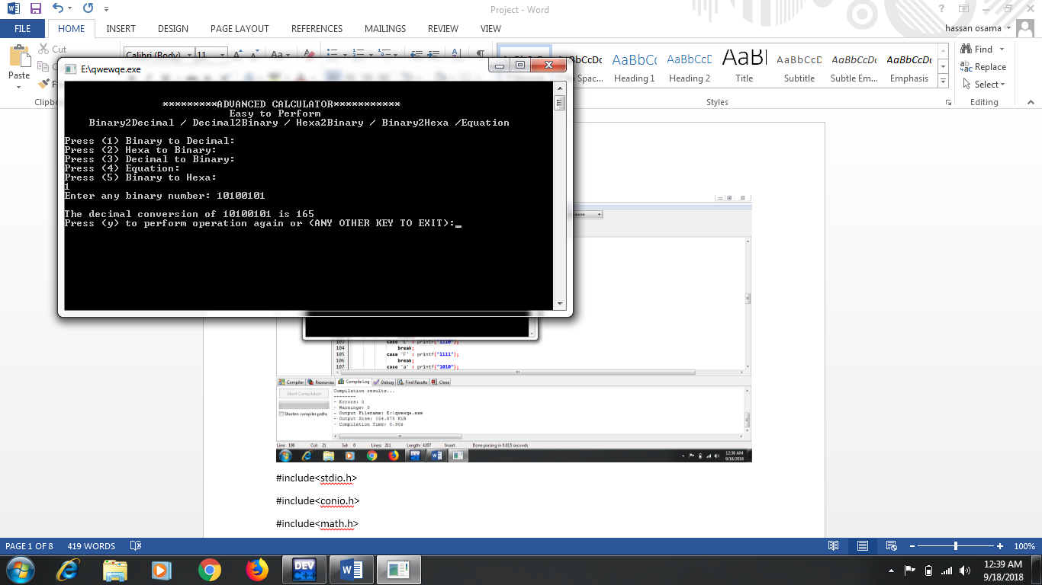

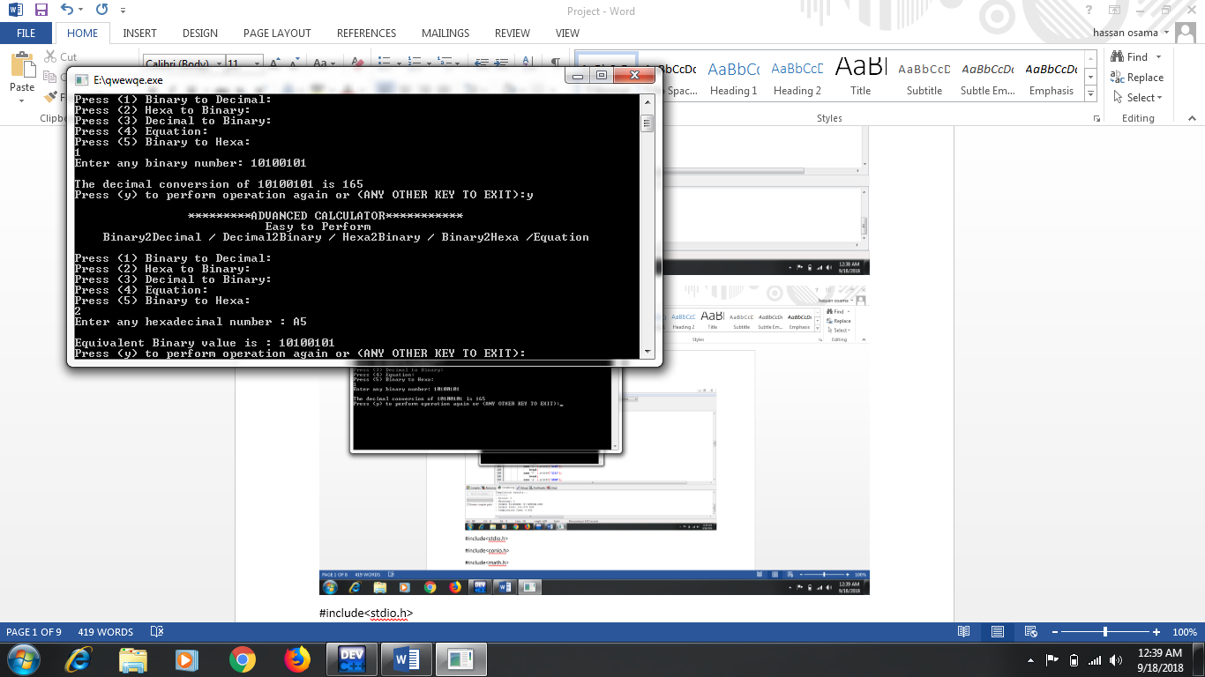

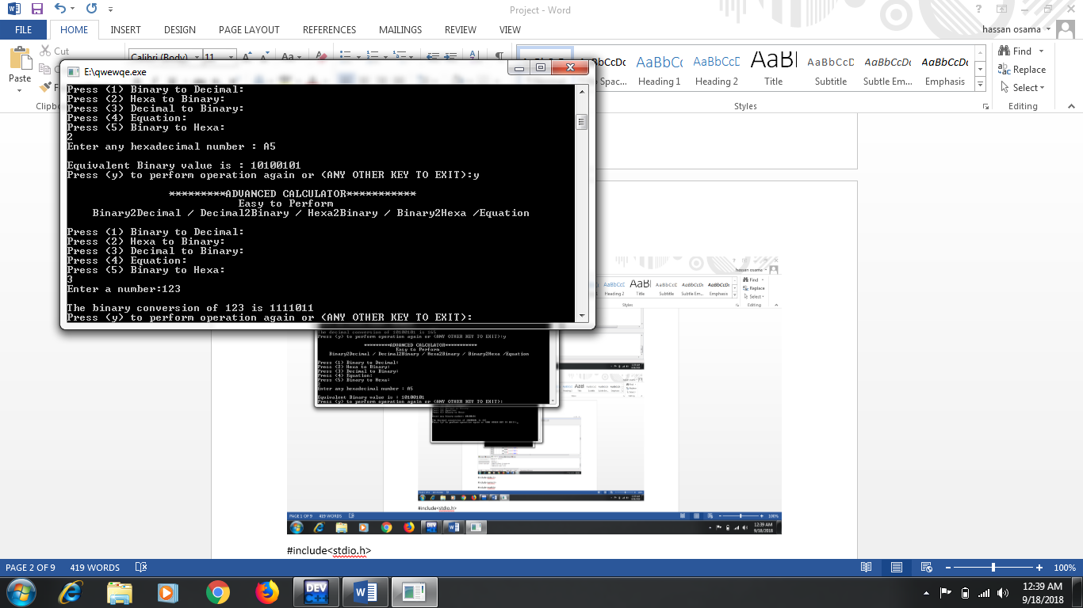

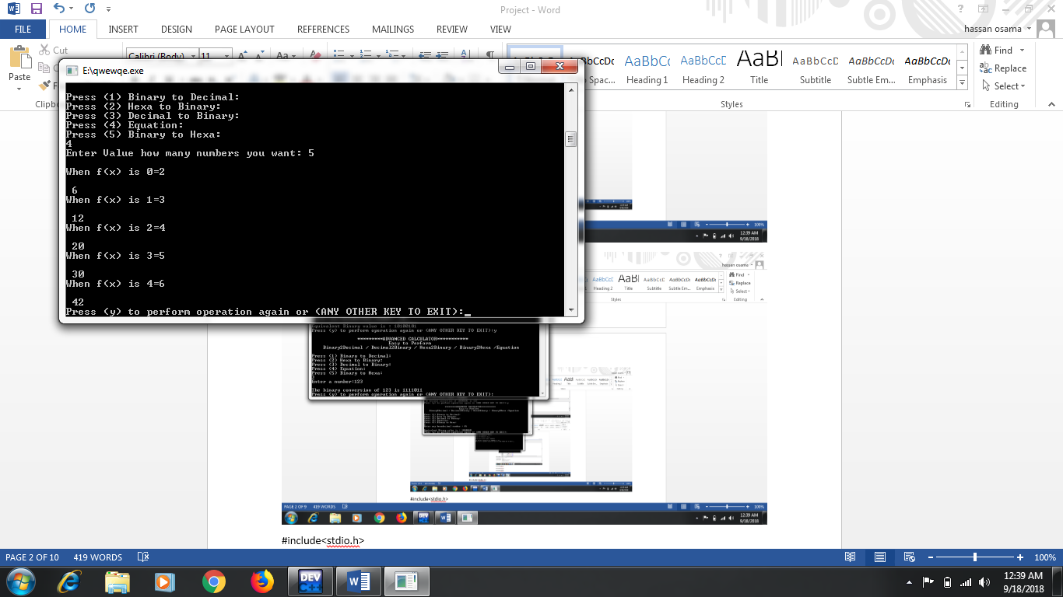

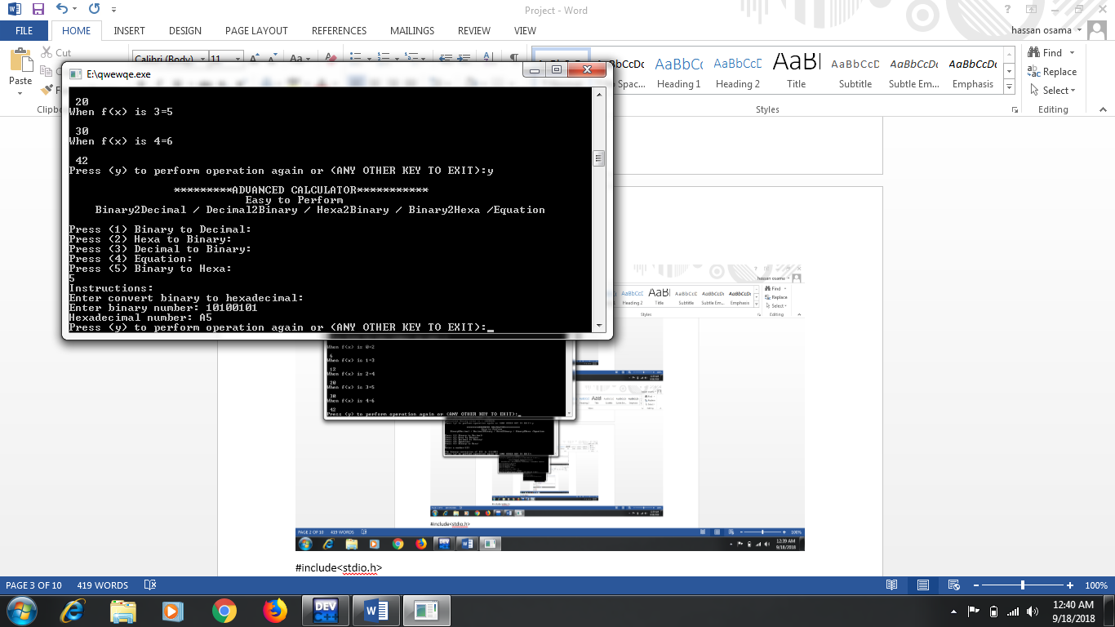

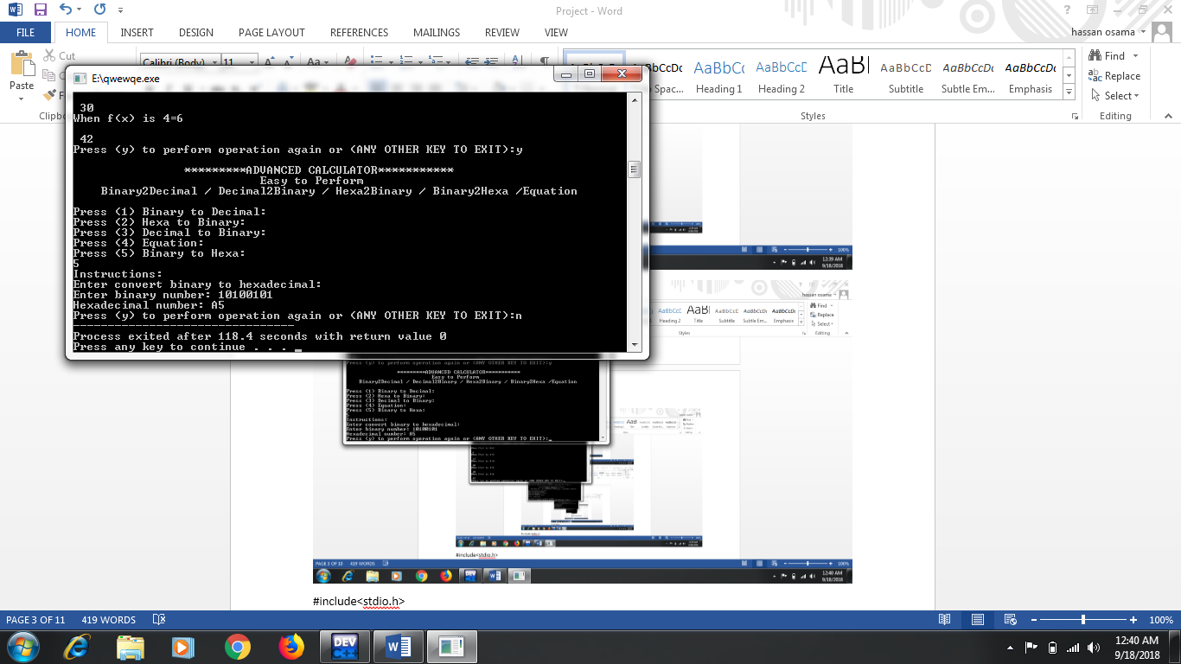

**ANALYSIS**

**PROBLEM DEFINITION:**

These days our generation is moving towards advance technology that’s why we

have designed this advance calculator, because it takes a lot of time for a person to

do a paper work for complex calculations when he has to solve a tricky problem which

will consume his quality time, this advance calculator will solve his problem in many

way, saves a lot of time and serve as a good problem solving application.

**SOLUTION TO THE PROBLEM:**

A Fully featured scientific calculator with proper operator proceedings is implemented

Including functions of proper calculation of hexadecimal and binary conversions function

of equations which will ease the problem very precisely.

The calculator is written in c language and you are welcome to view the source code of

this calculator.

This program also uses math.h library function to perform specific which it wants to

perform while solving the problem.

**BASIC CALCULATIONS:**

**BINARY TO DECIMAL CONVERSION:**

This function will give the decimal value when the system ask you to enter the binary

value,in this function we have used the loops with proper operator proceedings

regarding calculations.

**DECIMAL TO BINARY CONVERSION:**

This program also include a function of decimal to binary, we have used loops in this

function because to covert the number we must use to loop to reduce the value

therefore to convert it.

**HEXADECIMAL CONVERSION:**

There are two functions regarding this statement one will convert the binary number to

decimal and other functions will operates vice versa, in this case we have used the loop

structure and cases as well to indicate that the hexadecimal values from 10 onwards are

indicated by A to F till 15.

**EQUATION:**

This function is the most advanced function of this calculator, this function also used a

loop in order to find a value of x when function of x is given the scope is set to n

numbers which will be asked to the user, and he sets the scope to his wish and function

calculates the function of x till that value.

2) **FlowChart**

Start

Perform any Calculation

Binary to Decimal

Hexa to Binary

Yes

Perfrom Again Y/N

Decimal to Binary

Equation

No

Binary to Hexa

END

**Binary to Decimal:**

Start

Binary Numbers

a=n%10;

x=(a)*(pow(2,i))+x;

n=n/10;

Answer

Start

**Hexa to Binary:**

Start

Hexadecimal Number

Switch hex[i]

Condition True Case Perform

Answer

Start

**Decimal to Binary**

Start

Decimal number

If Condition

Decimal>0

Decimal == 0

for(i=1;n!=1;++i)

{

d=n%2;

a[i]=d;

n=n/2;

}

for(j=i-1;j>0;--j)

printf("%d",a[j]);

Answer

End

**Algorithm:**

**Main Function:**

Start

Declare a.

Read a.

Switch a

Case 1 perform Binary to Decimal

Case 2 perform Hexa to Binary

Case 3 perform Decimal to binary

Case 4 perform Equation

Case 5 perform Binary to Hexadecimal.

While Y to perform calculation again

Stop.

**Binary to Decimal**

Start

Declare i,x,a,n

Read n

For i=0 to user input is not equal to 0(zero)

Store user input modulus with 10 in a

A multiply with power into (2,i) and add with x.

To delete user input last value divide with 10.

Endfor

Write x

Stop.

**Hexadecimal to Binary**

Start

Declare I,bin in array list of 100 and hexdec in array list 100

Read hexdec

While i will increment

Switch

Case 0 write 0000

Case 1 write 0001

Case 2 write 0010

Case 3 write 0011

Case 4 write 0100

Case 5 write 0101

Case 6 write 0110

Case 7 write 0111

Case 8 write 1000

Case 9 write 1001

Case A or a write 1010

Case B or b write 1011

Case C or c write 1100

Case D or d write 1101

Case E or e write 1110

Case F or f write 1111

Default will write Invalid Hexadecimal digit

Increment i.

**Decimal to Binary**

Declare d,n,I,j,a in 50 array list

Read n

If n==0

Write The binary convertion of 0 is 0

Else n>0

for I start from 1 and user input n is not equal to 1 and than increment

user input modulus with 2 and store in d

a in array of I to store d

user input divide by 2 and store in user input

endfor

for I subtract with 1 and store in j condition j less than 0 and decrement in j

Write a in array of j

Stop

**CODE**

#include<stdio.h>

#include<conio.h>

#include<math.h>

#include<string.h>

int bin2dec();

int hex2bin();

int dec2bin();

int eq();

int bin2hex();

main()

{

char ag;

do

{

int a;

printf("\n\n\t\t*********ADVANCED CALCULATOR***********");

printf("\n\t\t\t Easy to Perform \n Binary2Decimal / Decimal2Binary / Hexa2Binary / Binary2Hexa /Equation");

printf("\n\nPress (1) Binary to Decimal: \nPress (2) Hexa to Binary:\nPress (3) Decimal to Binary:\nPress (4) Equation:\nPress (5) Binary to Hexa:\t\n");

scanf("%d",&a);

if(a>0&&a<6)

{

switch(a)

{

case 1:

bin2dec();

break;

case 2:

hex2bin();

break;

case 3:

dec2bin();

break;

case 4:

eq();

break;

case 5:

bin2hex();

break;

}

}

else{

printf("\nInvalid Input");

}

printf("\nPress (y) to perform operation again or (ANY OTHER KEY TO EXIT):");

ag=getche();

}

while(ag=='y');

}

int bin2dec()

{

long int i,n,x=0,a;

printf("Enter any binary number: ");

scanf("%ld",&n);

printf("\nThe decimal conversion of %ld is ",n);

for(i=0;n!=0;++i)

{

a=n%10;

x=(a)*(pow(2,i))+x;

n=n/10;

}

printf("%ld",x);

}

int hex2bin()

{long int i=0;

char binnum[100], hexdec[100];

printf("Enter any hexadecimal number : ");

scanf("%s",hexdec);

printf("\nEquivalent Binary value is : ");

while(hexdec[i])

{

switch(hexdec[i])

{

case '0' : printf("0000");

break;

case '1' : printf("0001");

break;

case '2' : printf("0010");

break;

case '3' : printf("0011");

break;

case '4' : printf("0100");

break;

case '5' : printf("0101");

break;

case '6' : printf("0110");

break;

case '7' : printf("0111");

break;

case '8' : printf("1000");

break;

case '9' : printf("1001");

break;

case 'A' : printf("1010");

break;

case 'B' : printf("1011");

break;

case 'C' : printf("1100");

break;

case 'D' : printf("1101");

break;

case 'E' : printf("1110");

break;

case 'F' : printf("1111");

break;

case 'a' : printf("1010");

break;

case 'b' : printf("1011");

break;

case 'c' : printf("1100");

break;

case 'd' : printf("1101");

break;

case 'e' : printf("1110");

break;

case 'f' : printf("1111");

break;

default : printf("\nInvalid hexadecimal digit %c",hexdec[i]);

}

i++;

}

}

int dec2bin()

{

int d,n,i,j,a[50];

printf("Enter a number:");

scanf("%d",&n);

if(n==0)

printf("\nThe binary conversion of 0 is 0");

else

{

printf("\nThe binary conversion of %d is 1",n);

for(i=1;n!=1;++i)

{

d=n%2;

a[i]=d;

n=n/2;

}

for(j=i-1;j>0;--j)

printf("%d",a[j]);

}

}

int eq()

{

int i,ans,x,n;

printf("Enter Value how many numbers you want: ");

scanf("%d",&n);

for(i=0;i<n;i++)

{

printf("\nWhen f(x) is %d=",i);

scanf("\n%d",&x);

ans = x*x + x;

printf("\n %d",ans);

}

}

int bin2hex()

{

char hex[20],c;

int n;

printf("Instructions:\n");

printf("Enter convert binary to hexadecimal:\n");

printf("Enter binary number: ");

scanf("%d",&n);

{

int i=0,decimal=0, rem;

while (n!=0)

{

decimal += (n%10)*pow(2,i);

n/=10;

++i;

}

i=0;

while (decimal!=0)

{

rem=decimal%16;

switch(rem)

{

case 10:

hex[i]='A';

break;

case 11:

hex[i]='B';

break;

case 12:

hex[i]='C';

break;

case 13:

hex[i]='D';

break;

case 14:

hex[i]='E';

break;

case 15:

hex[i]='F';

break;

default:

hex[i]=rem+'0';

break;

}

++i;

decimal/=16;

}

hex[i]='\0';

strrev(hex);

printf("Hexadecimal number: %s",hex);

}

}