Section C: Clustering Analysis
Airbnb NYC 2019 Dataset | K-Means Clustering
Member C Contribution

2.3 Clustering Approach
K-Means clustering was applied to identify distinct market segments within the NYC Airbnb dataset. Eight features were selected for clustering: log-transformed price, minimum nights, number of reviews, reviews per month, availability over 365 days, host listing count, neighbourhood group, and room type. The two categorical variables — neighbourhood group and room type — were label-encoded into numeric values to ensure compatibility with the algorithm. All features were then standardised using StandardScaler, transforming them to zero mean and unit variance, which prevents features with larger numeric ranges from dominating the distance calculations. The optimal number of clusters was determined by combining the Elbow Method, which plots within-cluster inertia against K, and the Silhouette Score, which measures cluster cohesion and separation. The elbow curve showed a visible bend at K=4, and the silhouette analysis confirmed K=4 as a strong choice (score: 0.262), balancing interpretability and statistical validity. Each cluster was subsequently profiled by computing mean values of key variables and examining distributions of room type and borough.
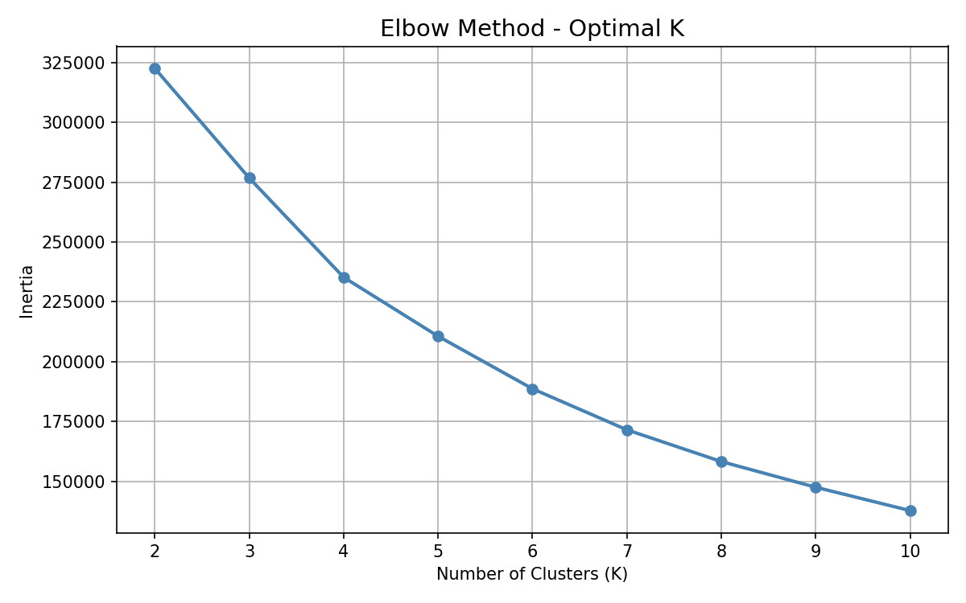
Figure 1: Elbow Method — Inertia vs Number of Clusters (K). The curve bends at K=4 indicating the optimal cluster count.
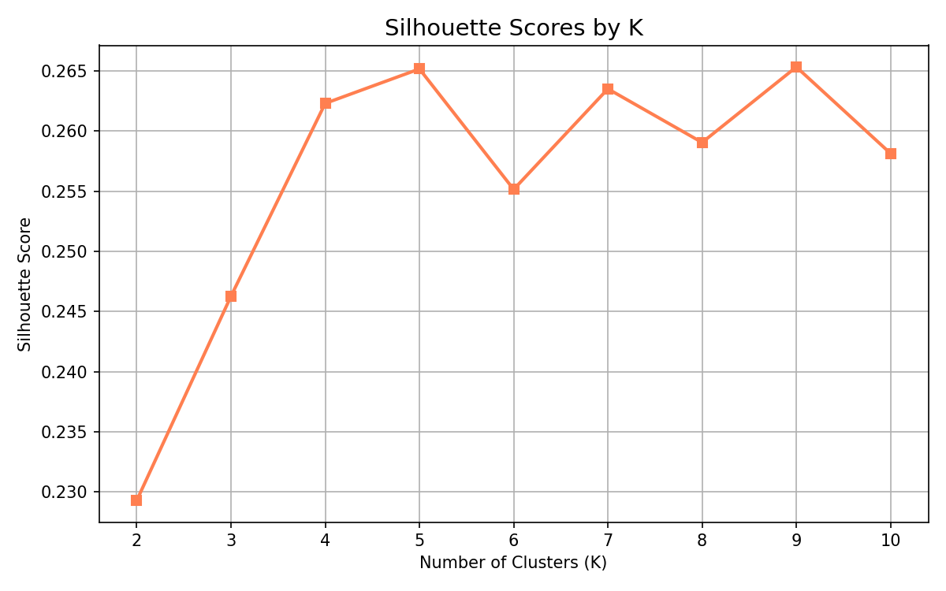
Figure 2: Silhouette Scores by K. K=4 achieves a score of 0.262, confirming it as the optimal number of clusters.

3.2 Clustering Results
K-Means clustering with K=4 successfully identified four distinct listing segments in the NYC Airbnb market, each with a clear and interpretable profile. Cluster 0 represents Mid-Range Mixed Listings, averaging $121 per night with a balanced split between entire homes (51%) and private rooms (48%), spread across Brooklyn (41%) and Manhattan (38%). Cluster 1 captures High-Value Entire Homes, with an average price of $203 and 98% entire home/apartment listings concentrated in Manhattan (54%), reflecting premium urban accommodation. Cluster 2 defines the Budget Private Room segment, with the lowest average price of $76 and 94% private rooms, predominantly located in Brooklyn (47%), indicating affordable short-stay options in outer boroughs. Cluster 3 identifies Long-Stay Luxury Apartments, commanding the highest average price of $273 with 98% entire homes almost exclusively in Manhattan (99%), and a notably high minimum stay of 30 nights on average, suggesting monthly corporate or executive rentals. Availability also varied meaningfully, with Cluster 3 listings available 282 days per year compared to just 99 days for Cluster 1, indicating very different hosting strategies across segments.
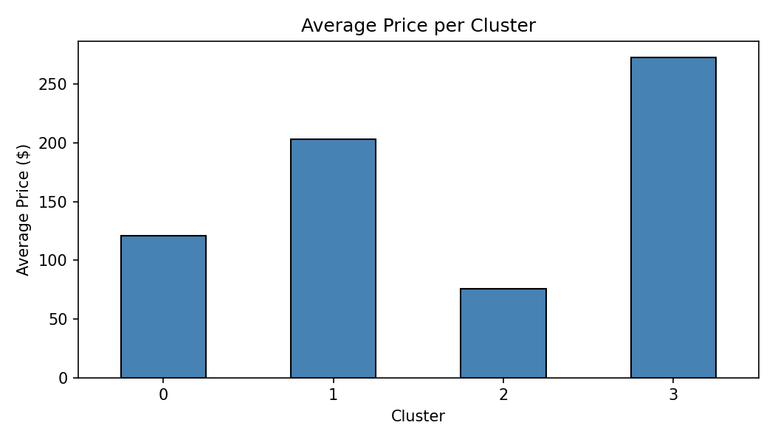
Figure 3: Average Price per Cluster. Cluster 3 (Long-Stay Luxury) commands the highest price at $273, while Cluster 2 (Budget) averages $76.
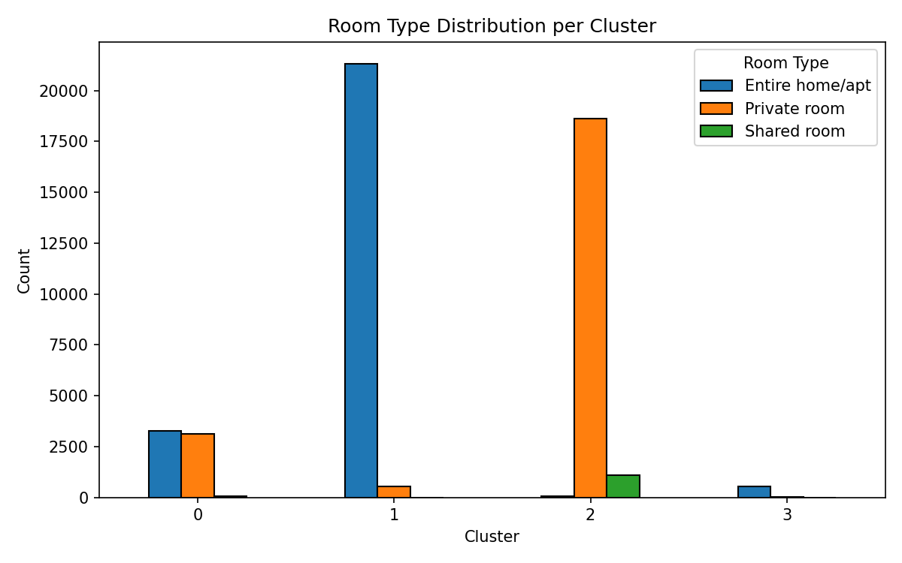
Figure 4: Room Type Distribution per Cluster. Clusters 1 and 3 are almost entirely entire homes, while Cluster 2 is dominated by private rooms.
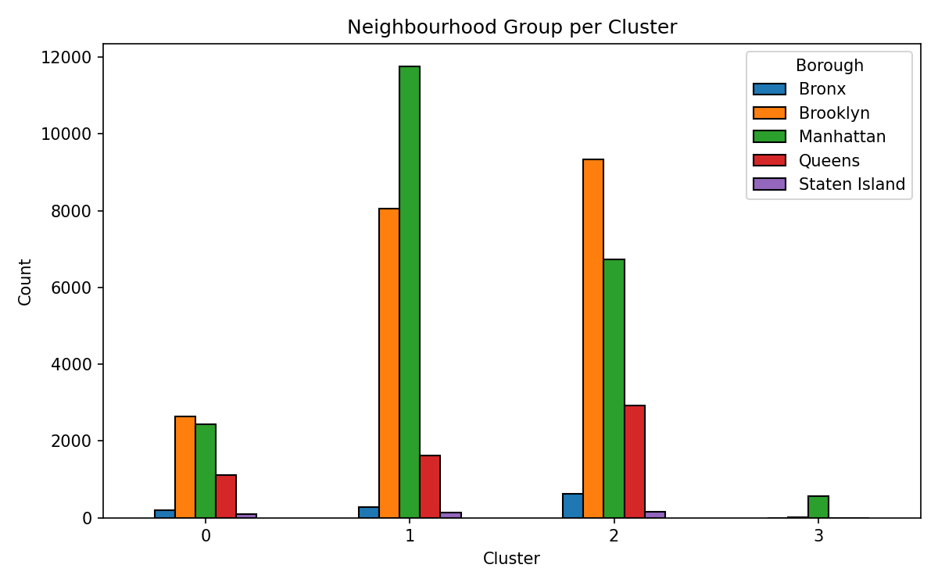
Figure 5: Neighbourhood Group Distribution per Cluster. Cluster 3 is almost entirely Manhattan, while Clusters 0 and 2 are spread across Brooklyn and outer boroughs.
Table 1: Cluster Profile Summary
Cluster | Label | Avg Price | Dominant Room Type | Main Borough
0 | Mid-Range Mixed | $121 | Entire/Private (50/50) | Brooklyn 41%
1 | High-Value Entire Homes | $203 | Entire home (98%) | Manhattan 54%
2 | Budget Private Rooms | $76 | Private room (94%) | Brooklyn 47%
3 | Long-Stay Luxury Apts | $273 | Entire home (98%) | Manhattan 99%
Note: Copy Section 2.3 and Section 3.2 text into the main group report document. All figures and the summary table can also be copied across directly.

