Dublin Business School
Programming for Data Analysis
CA Two: Predicting Term Deposit Subscription in a Bank Telemarketing Campaign
Module Code: B9DA108
Programme: MSc in Data Analytics
Student: Osamuyimen Osunde
Student ID: 20093878

1. Introduction
When a bank runs an outbound telemarketing campaign to sell term deposits, it typically has to work through a large volume of calls to land a comparatively small number of subscriptions. Being able to flag, ahead of time, which customers are more likely to say yes would let the bank prioritise its call lists more sensibly, cut down on wasted effort, and get more out of each campaign. This project works with a real telemarketing dataset from a Portuguese bank to explore what separates subscribers from non-subscribers, and to build models that predict whether a given customer will take out a term deposit.
The data used here is the bank-additional dataset from the UCI Machine Learning Repository, originally compiled by Moro, Cortez and Rita (2014). It holds 4,119 records — a 10% sample drawn from the larger bank-additional-full file — across 21 variables. These cover basic customer details (age, job, marital status, education), specifics of the current call (contact type, month, day of week, number of attempts), the result of any earlier campaign, and five economy-wide indicators recorded at the time of contact (employment variation rate, consumer price index, consumer confidence index, the 3-month Euribor rate, and number of employees). The outcome variable, y, records whether the customer went on to subscribe.
This analysis works towards four goals: cleaning and preparing the data, including building a couple of new features; exploring it visually to see what factors line up with subscription, with a particular eye on contact timing; training and comparing two tree-based classifiers — a Decision Tree and a Random Forest; and picking apart which features each model leans on most, with a view to what that implies for how the bank might run its campaigns.

2. Data Description
The data comes from the UCI Machine Learning Repository's Bank Marketing collection, specifically the bank-additional.csv file (Moro, Cortez and Rita, 2014) — not from Kaggle. It is a semicolon-separated file of 4,119 rows and 21 columns, and there are no missing values encoded as nulls anywhere in it. Broadly, the variables split into four groups:
- Client details: age, job (12 categories), marital status, education (8 levels), and whether the client currently has credit in default, a housing loan, or a personal loan.
- Details of the current contact: how the client was reached (cellular or telephone), the month and day of week of the last contact, and how many times they were contacted this campaign (campaign).
- Details of any earlier campaign: days since the last contact from a previous campaign (pdays), how many contacts happened before this campaign (previous), and how that earlier campaign turned out (poutcome).
- Macroeconomic context: employment variation rate, consumer price index, consumer confidence index, the 3-month Euribor rate, and number of employees — indicators of the wider Portuguese economy at the time.
The target is heavily skewed: 3,668 records (89.1%) are “no” and only 451 (10.9%) are “yes”. That imbalance shaped a number of decisions made throughout the rest of the analysis.

2.1 Feature Engineering
Two features were built to make better use of the raw data, both for exploring it and for modelling:
- was_contacted_before — pdays uses 999 as a placeholder for “never contacted before”, mixed in with genuine day counts for the 160 clients who had been reached previously. Pulling this out as a separate binary flag lets a model use the simple fact of prior contact (true for 160 of the 4,119 clients) without letting that placeholder value distort any calculation performed on pdays itself.
- age_group — age was bucketed into six bands (18-25, 26-35, 36-45, 46-55, 56-65, 66+), partly to make age-related patterns easier to read off a chart, and partly to give the models a coarser, ordinal view of age alongside the raw continuous value.

3. Method of Data Analysis

3.1 Data Cleaning
A check for fully duplicated rows turned up none (0 of 4,119). A handful of categorical columns — job, marital, education, default, housing, loan — use the literal string “unknown” as a stand-in for a missing value rather than an actual NaN. Rather than drop these rows or try to impute a value, “unknown” was kept as its own valid category throughout: customers who decline to disclose something (this is especially common for default, where 19.5% of entries are “unknown”) may well differ in meaningful ways from those who do disclose.

3.2 Encoding Categorical Variables
y was converted from “no”/“yes” strings into 0/1 for classification. The eleven nominal categorical variables — job, marital, education, default, housing, loan, contact, month, day_of_week, poutcome, and the engineered was_contacted_before — have no natural order, so they were one-hot encoded via pandas.get_dummies with drop_first=True, which avoids adding a redundant, perfectly collinear column for each variable. age_group, by contrast, is ordinal, so it was encoded separately as an integer from 0 to 5 that preserves the ordering — a one-hot encoding would have thrown away the fact that, say, ‘56-65’ is older than ‘26-35’. Once this was done, the dataset grew from 23 columns to 55.

3.3 Handling Target Leakage
The UCI documentation flags duration — how long the last call ran, in seconds — as a source of leakage: a 0-second call is always a “no”, and the duration itself is only known after the call has ended, so it cannot realistically be used to predict subscription before the call is made. It was dropped before modelling for this reason, so that the classifiers reflect what is genuinely knowable in advance rather than benefiting from hindsight.

3.4 Feature Scaling
Neither standardisation nor normalisation was applied to any feature. Decision Trees and Random Forests split on thresholds within individual features and are unaffected by monotonic transformations of the input, so — unlike distance-based or gradient-based methods — they gain nothing from scaled inputs.

3.5 Train/Test Split and Class Imbalance
The data was split 75/25 into a training set (3,089 rows) and a test set (1,030 rows), stratifying on y so that both sets keep the original 89.1%/10.9% balance. To deal with the imbalance during training, both models were configured with class_weight=“balanced”, which weights the minority (“yes”) class inversely to its frequency rather than resampling the underlying rows.

3.6 Models
Two tree-based classifiers were built, as required for this project:
- Decision Tree Classifier — a single tree capped at a maximum depth of 6, to keep it from overfitting; used here as a readable baseline.
- Random Forest Classifier — an ensemble of 300 trees (max depth 10) that averages across many decorrelated trees to bring down variance and generally generalise better than any one tree on its own.
Both were trained on the same training set and scored on the same held-out test set, using accuracy, precision, recall, F1-score, and ROC-AUC, since accuracy alone does not tell you much on a dataset this imbalanced.

4. Results

4.1 Exploratory Data Analysis
As already noted, the target is strongly skewed — just 10.9% of contacted clients ended up subscribing.
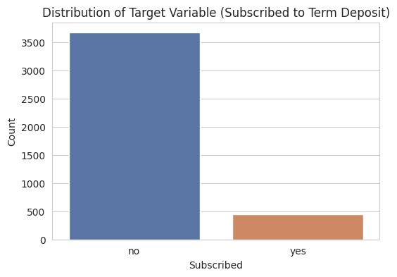
Figure 1. Distribution of the target variable y.
Boxplots of the main numeric variables show a long right tail for both call duration and number of campaign contacts, which fits with a small number of unusually long calls or repeatedly contacted clients rather than pointing to any data entry errors that would need fixing.
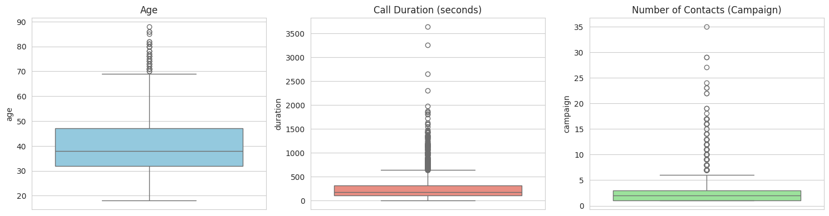
Figure 2. Boxplots of age, call duration, and number of campaign contacts.
Histograms of the numeric predictors show age skewing toward younger and middle-aged clients, while the macroeconomic indicators — emp.var.rate, euribor3m, nr.employed — cluster around a handful of discrete values rather than varying continuously, which fits with these being tied to a quarterly reporting cycle rather than changing from day to day.
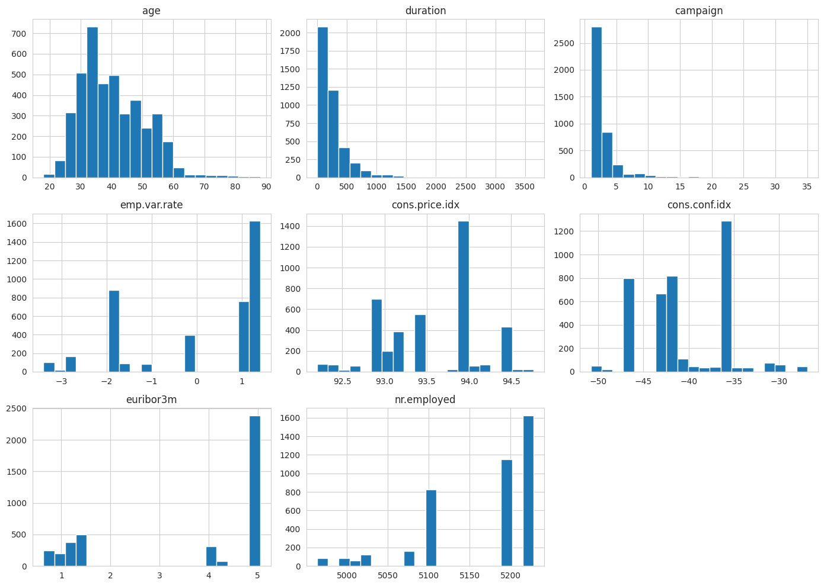
Figure 3. Distributions of key numeric features.
Subscription rates differ noticeably by job, marital status, education, and prior-contact status: retired clients, students, and anyone contacted during an earlier campaign show a visibly higher share of “yes” outcomes than the overall average.
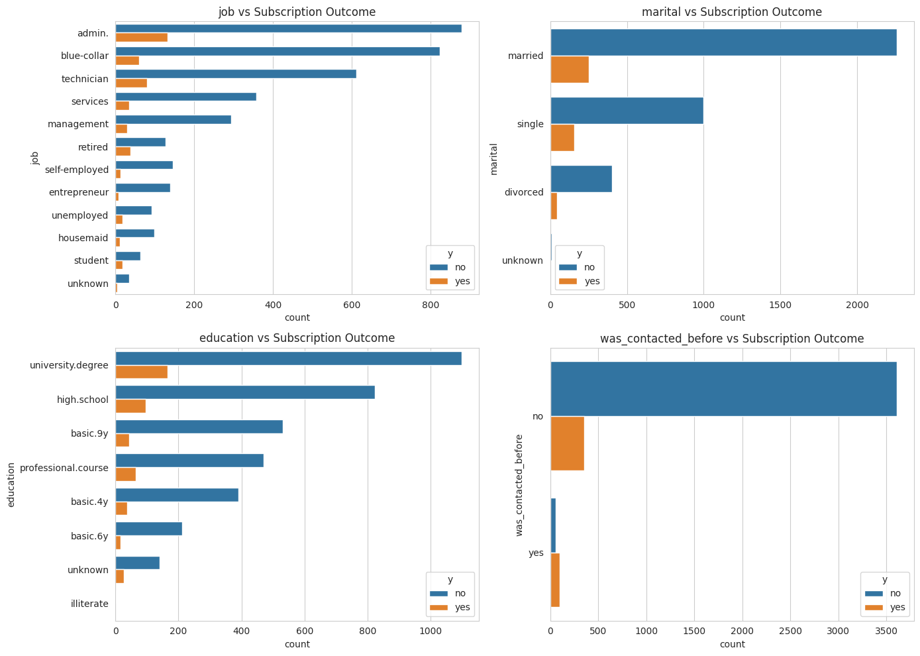
Figure 4. Categorical features vs. subscription outcome.
Older clients also tend to subscribe more often than those in the middle of the working-age range, with the 66+ group standing out in particular.
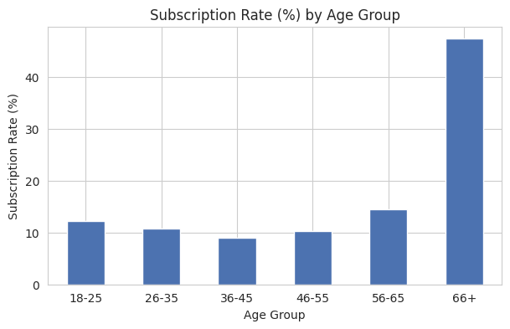
Figure 5. Subscription rate (%) by age group.
The correlation heatmap shows emp.var.rate, cons.price.idx, euribor3m, and nr.employed all moving closely together, which is unsurprising given they all track the same underlying economic cycle. Multicollinearity of this kind is not a problem for tree-based models, but it is worth keeping in mind when reading the feature importances discussed later.
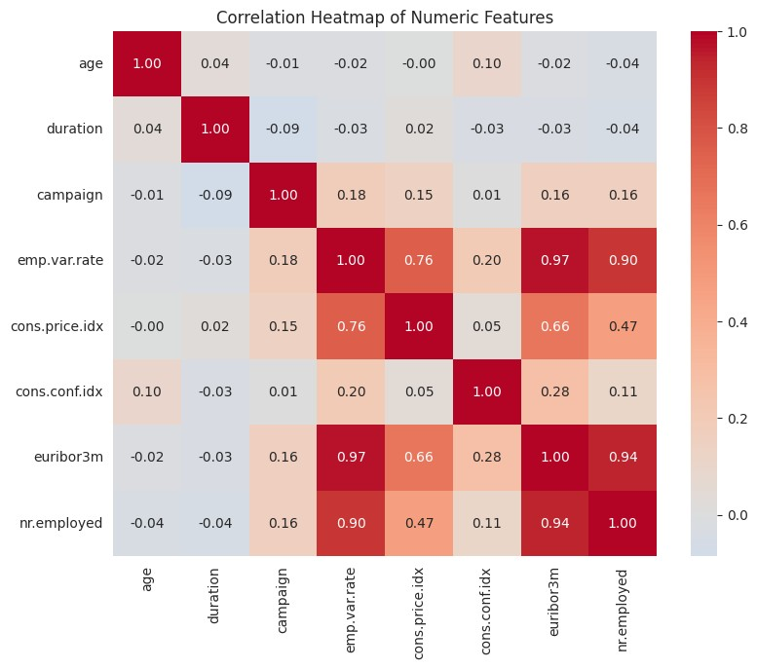
Figure 6. Correlation heatmap of numeric features.

4.2 Contact Timing: Month and Day of Week
Most calls were made in May, June, July, and August, but those months were not where the bank had its best luck. Looking at subscription rate rather than raw call counts, March, September, October, and December stand out with rates of 36-58%, well above the 6-13% seen in the busier summer months, despite far fewer calls being made in those months.
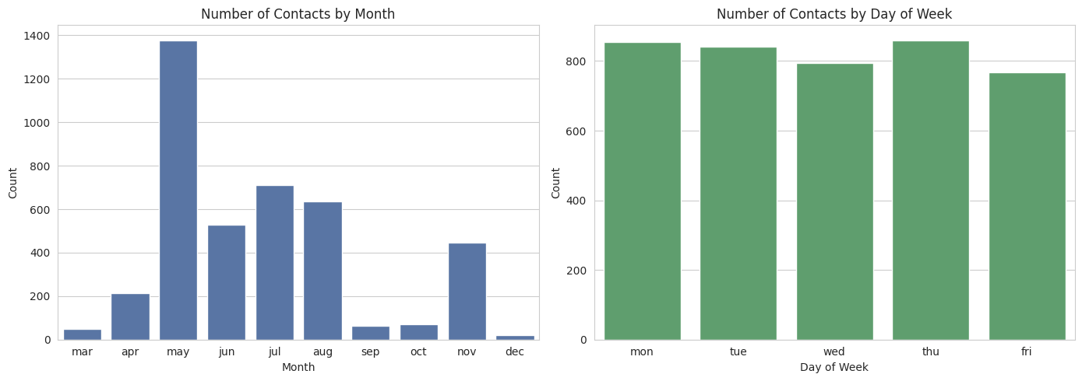
Figure 7. Number of contacts by month and by day of week.
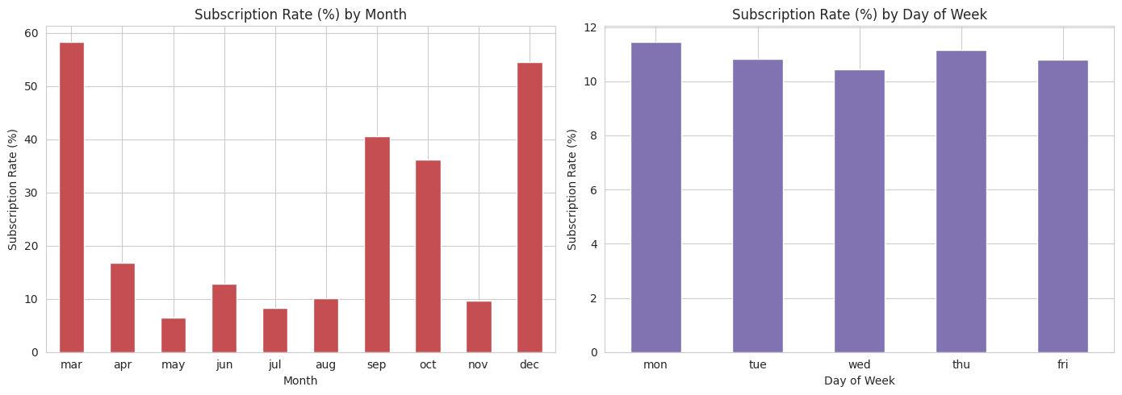
Figure 8. Subscription rate (%) by month and by day of week.
Day of week, in contrast, barely moves the needle — subscription rates sit in a tight 10.4-11.5% band across all five weekdays. Taken together, this suggests the bank's smaller, off-season campaigns were considerably more effective than its high-volume summer push, while which weekday a client was called on made almost no difference.

4.3 Model Performance
Both models were scored on the same 1,030-row held-out test set. The Random Forest came out ahead on accuracy, precision, F1-score, and ROC-AUC, while the Decision Tree edged it slightly on recall:
Table 1. Test-set performance of the Decision Tree and Random Forest classifiers.
Model | Accuracy | Precision | Recall | F1-score | ROC-AUC
Decision Tree | 0.844 | 0.344 | 0.469 | 0.397 | 0.711
Random Forest | 0.888 | 0.489 | 0.381 | 0.428 | 0.776

Looking at the confusion matrices, both models are cautious about predicting “yes”, which follows from the class imbalance: the Random Forest correctly picks out 43 of the 113 real subscribers in the test set (recall 0.38) while keeping false positives to just 45, whereas the Decision Tree catches more true subscribers (53, recall 0.47) but at the cost of considerably more false positives (101).
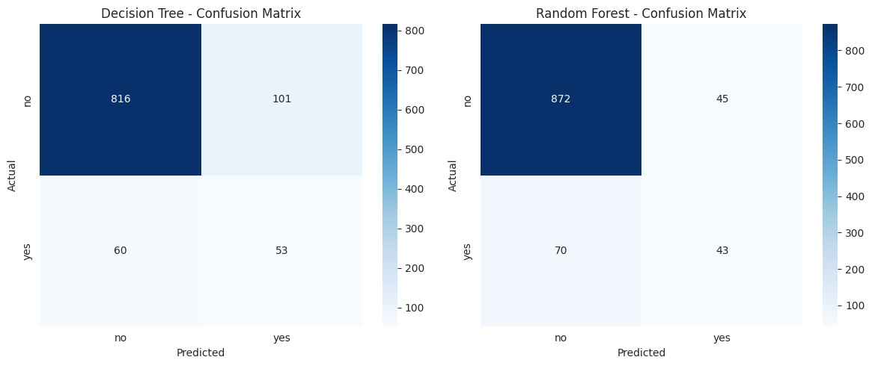
Figure 9. Confusion matrices for the Decision Tree and Random Forest models.
The ROC curves tell the same story — the Random Forest's curve sits consistently above the Decision Tree's, giving it the higher AUC (0.776 vs. 0.711).
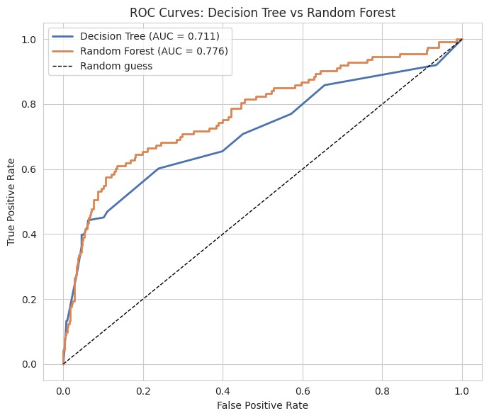
Figure 10. ROC curves comparing the two models (Random Forest AUC = 0.776 vs. Decision Tree AUC = 0.711).

4.4 Feature Importance
Looking at what each model actually relies on, macroeconomic conditions come out well ahead of any individual customer trait for the Random Forest:
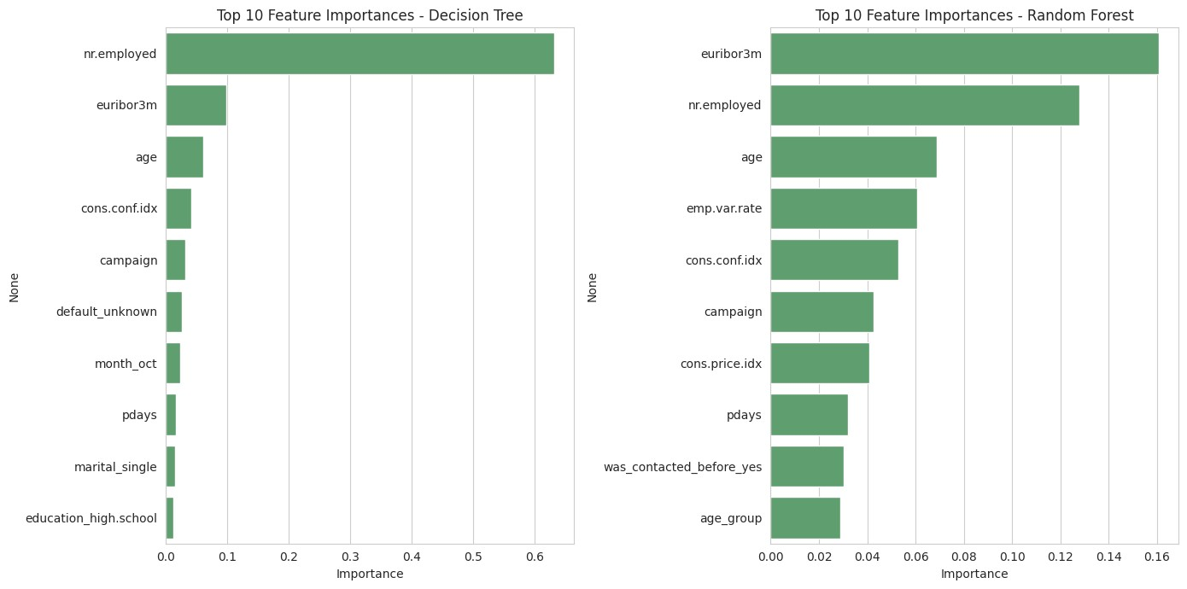
Figure 11. Top 10 feature importances for the Decision Tree and Random Forest models.
Table 2. Top 10 feature importances for the Random Forest model.
Rank | Feature | Importance
1 | euribor3m (3-month Euribor rate) | 0.161
2 | nr.employed (number employed, economy-wide) | 0.128
3 | age | 0.069
4 | emp.var.rate (employment variation rate) | 0.061
5 | cons.conf.idx (consumer confidence index) | 0.053
6 | campaign (number of contacts this campaign) | 0.043
7 | cons.price.idx (consumer price index) | 0.041
8 | pdays (days since last contact) | 0.032
9 | was_contacted_before_yes | 0.030
10 | age_group | 0.029

euribor3m and nr.employed are the two clear leaders, together making up close to 29% of total importance — more than any single customer characteristic manages on its own. Age, employment variation rate, and consumer confidence come next, with month and prior-contact-related features also making the top ten, which lines up with the seasonal pattern seen earlier in the EDA.

5. Discussion
Both the exploratory work and the models point to the same conclusion: whether someone subscribes to a term deposit has less to do with who they are and more to do with when they are called — specifically, the broader economic backdrop at that moment. The fact that euribor3m and nr.employed dominate the Random Forest's feature importances fits neatly with the month-by-month subscription pattern seen earlier: periods with different economic readings coincided with very different subscription rates, regardless of which individual customer picked up the phone.
The Random Forest's edge over the single Decision Tree (88.8% vs. 84.4% accuracy, 0.776 vs. 0.711 ROC-AUC) is broadly what one would expect — averaging across many decorrelated trees tends to smooth out the variance that comes from any one tree's particular split choices. The Decision Tree's better recall but weaker precision reflects the fact that a single tree tends to draw broader, blunter decision boundaries: it picks up more genuine subscribers, but at the cost of also flagging many more people who were never going to subscribe.
The biggest limitation here is simply how imbalanced the target is (89%/11%): even with class weighting, recall for the “yes” class stays modest for both models (0.38-0.47), so a fair share of real subscribers still slip through. In practice, this precision/recall trade-off would need to be tuned deliberately — for example by shifting the classification threshold — depending on whether the bank cares more about not wasting calls or about reaching as many subscribers as possible. Dropping duration to avoid leakage is a second limitation: it is a strong predictor, so leaving it out makes the models more realistic for actual pre-call use, but it also caps the accuracy achievable relative to a model that includes it. Finally, this is one bank's data from one period in Portugal, so the specific patterns found here — particularly which months performed best — might not carry over directly to a different bank, country, or time period without further checking.

6. Conclusion
This project set out to establish what drives term deposit subscription in a bank telemarketing dataset and to build classifiers capable of predicting it. After cleaning the data, building two new features (was_contacted_before and age_group), encoding the categorical variables appropriately, and dropping the leaky duration column, two tree-based models were trained and compared. The Random Forest came out on top, reaching 88.8% accuracy and a ROC-AUC of 0.776, against the Decision Tree's 84.4% accuracy and 0.711 ROC-AUC — though the Decision Tree's better recall illustrates the usual trade-off between a single tree and an ensemble.
The main finding is that contact timing and the wider economic backdrop — rather than individual customer demographics — are what drives subscription most strongly, with euribor3m and nr.employed the two most important features for the Random Forest, and a clear seasonal swing in subscription rate by month against almost none by day of week. For the bank, this points to a practical takeaway: paying attention to when a campaign runs and what the economic conditions look like at the time may matter as much as, or more than, targeting particular kinds of customers.
This project was a useful exercise in handling a dataset with disguised missing values and a sentinel placeholder, choosing sensible encodings for ordinal versus nominal variables, spotting and correcting for target leakage, and judging classifiers properly on an imbalanced target using precision, recall, F1, and ROC-AUC rather than accuracy alone. The trickiest parts were working out the duration leakage issue and deciding how to handle the pdays sentinel without simply discarding the information it carried — both were resolved through targeted feature engineering rather than dropping the columns outright. A logical next step, outside the scope of this assignment, would be to try threshold tuning or an alternative resampling approach such as SMOTE, to see whether recall on the minority class can be pushed further.

References
Moro, S., Cortez, P. and Rita, P. (2014) 'A data-driven approach to predict the success of bank telemarketing', Decision Support Systems, 62, pp. 22-31.
Moro, S., Rita, P. and Cortez, P. (2014) Bank Marketing [dataset]. UCI Machine Learning Repository. Available at: https://archive.ics.uci.edu/dataset/222/bank+marketing (Accessed: 17 July 2026).
Pedregosa, F. et al. (2011) 'Scikit-learn: Machine Learning in Python', Journal of Machine Learning Research, 12, pp. 2825-2830.

