Create a bank account in usd with wise



CONTENTS
1 Create a wise account 2
2 Get your us account details 10
3 Adding your local bank info to get paid 15
4 Send money from wise 23

Create a wise account
Creating a Wise account allows ZTERS workers to receive payments in US dollars easily and legally. Wise provides a USD account with local banking details, enabling fast, low-fee international transfers and simple conversion to your local currency when needed.
- Go to https://wise.com/
- Select Sign Up in the upper right part of the window.
- Enter your email address and click Next. You could also sign up using your Google, Facebook, or Apple account.
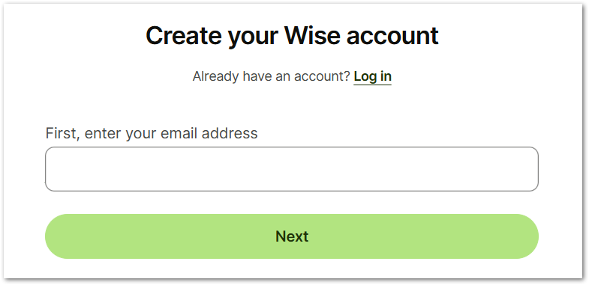
- Check your email and confirm the email address. Once it’s confirmed, you will be redirected to continue opening your wise account.
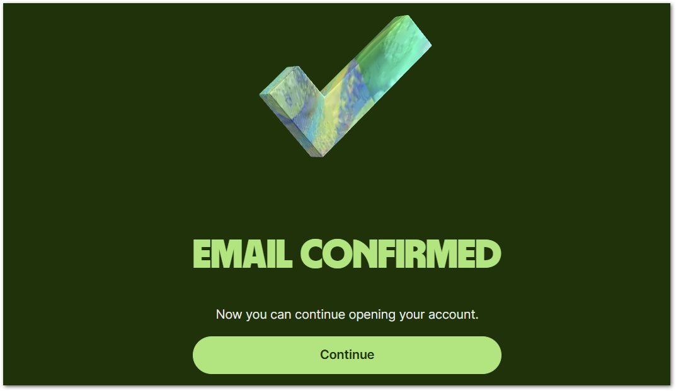
- In the account type option, select Personal Account, as you will use this one to receive payments in USD with ZTERS.
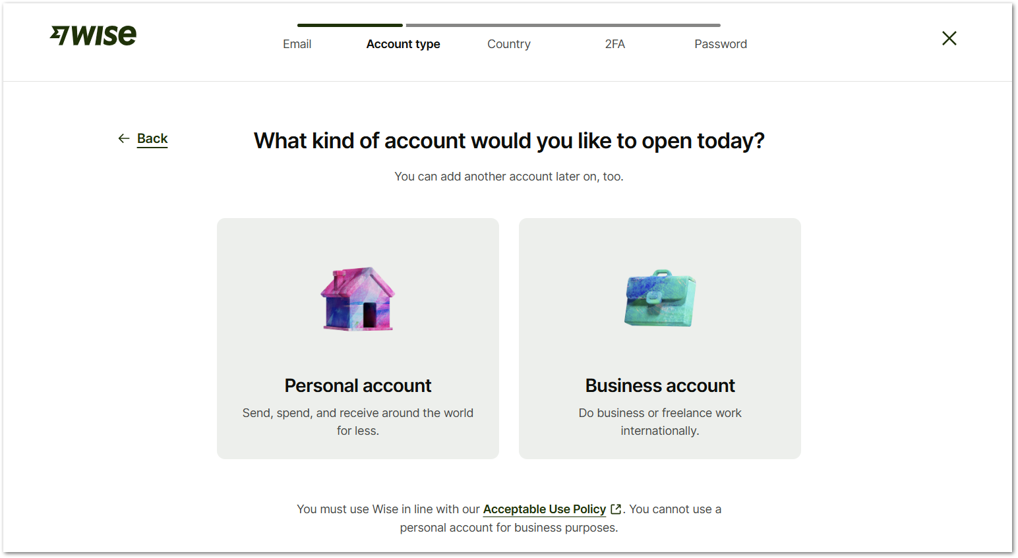
- Select your country of residence from the Country dropdown menu and click Continue. You will be prompted to the banking options that you’re allowed to do for your specific country:
- Send money abroad
- Receive money
- Hold and convert money
- Spend abroad with a card (optional for some countries).
- Earn and return (optional for some countries).
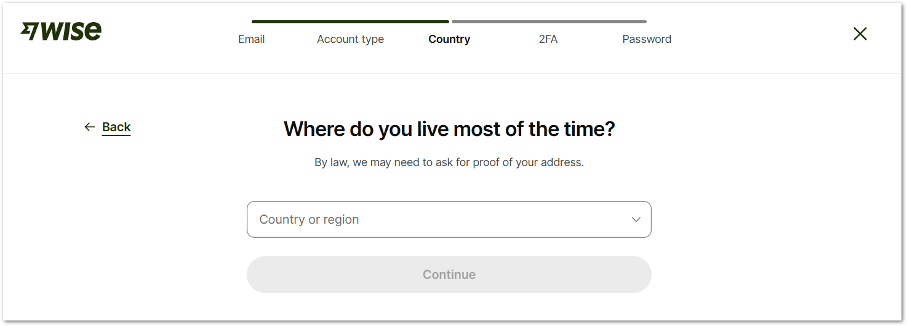
- Enter your phone number and click Send verification code, to verify it. The prefix number depends on the country you selected in the previous step.
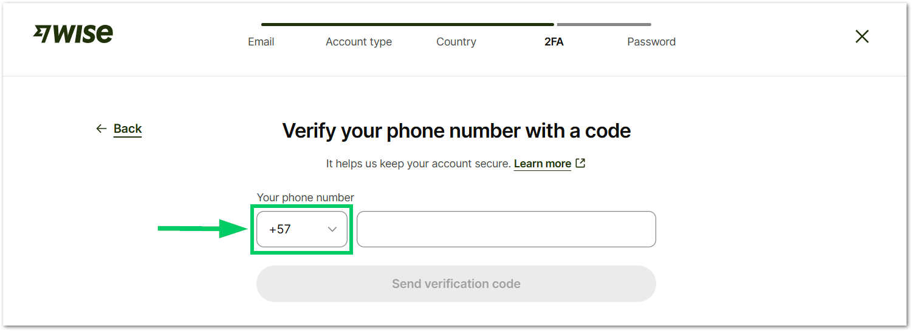
- You will receive a text message with a 6-digit WISE code. Enter the code and select Done.
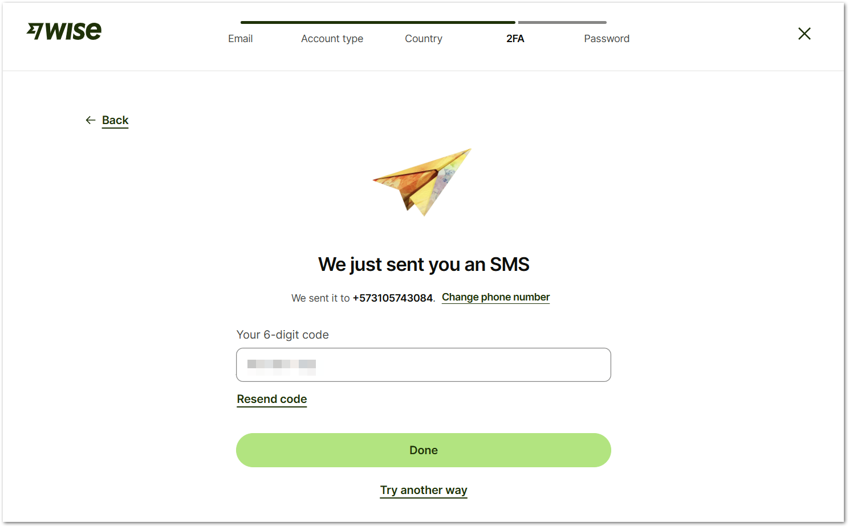
- Create a password for your account and select Continue. Follow the rules:
- Contains a letter
- Contains a number
- Has 9 or more characters
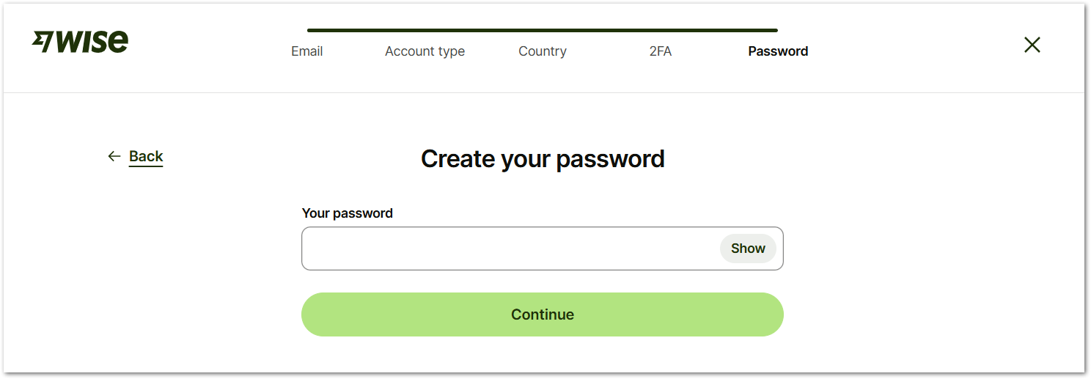

- In the next screen, enter more personal details for your account and select Save and continue.
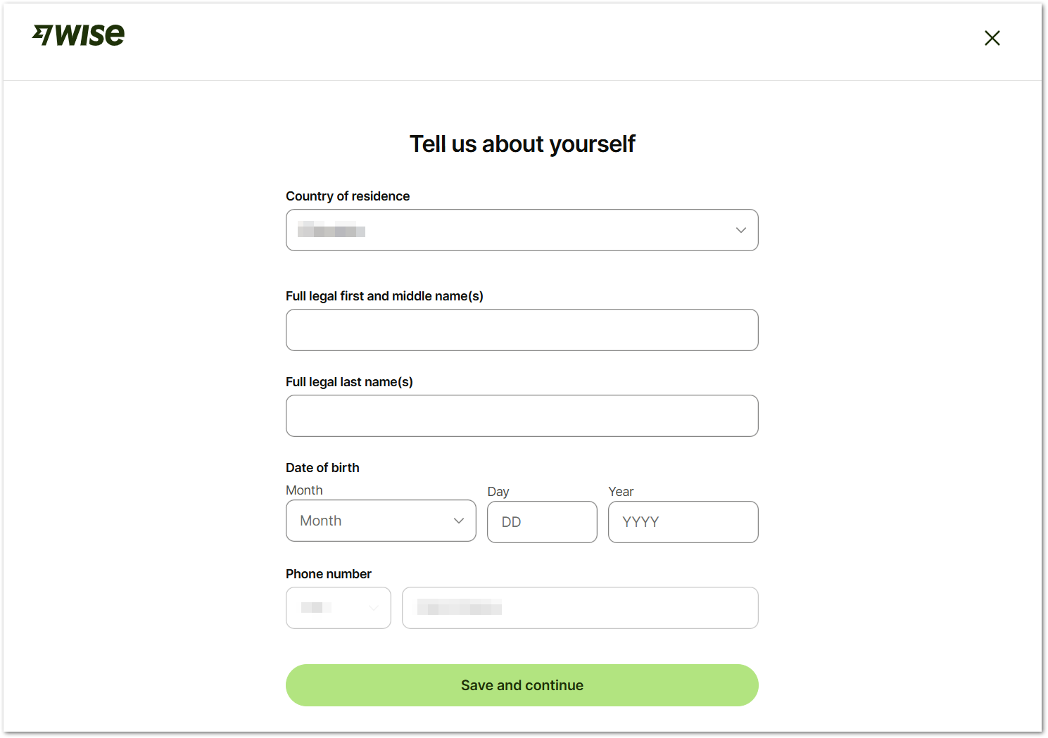

- Enter your address or post code to finish setting up your account.
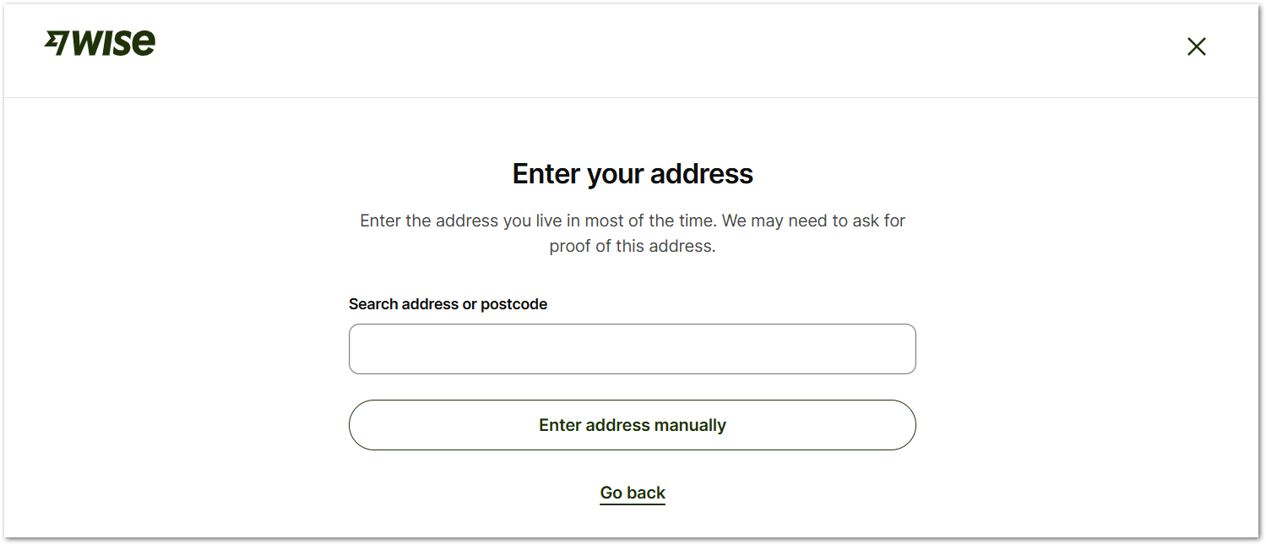
You will be prompted to select an address and confirm the information about it. Select Confirm and continue when you complete the information.
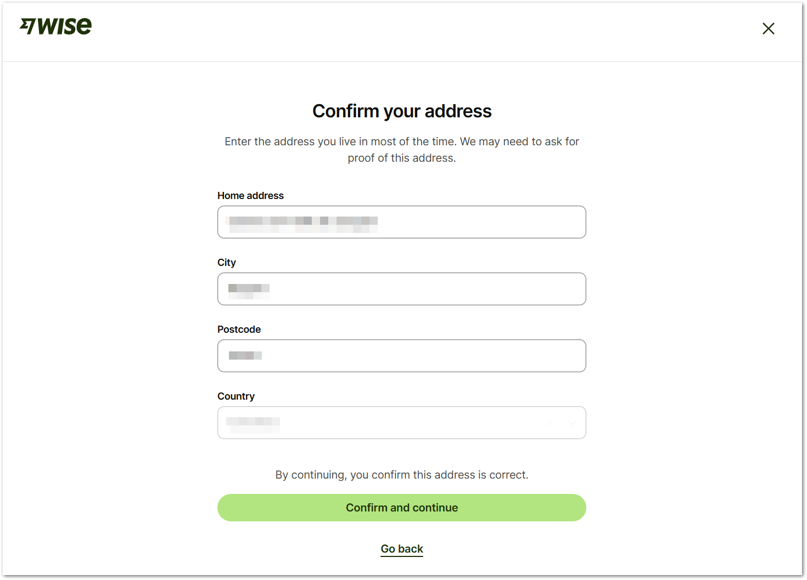

- You have finished setting up your WISE account. Now, you can take a look around first.
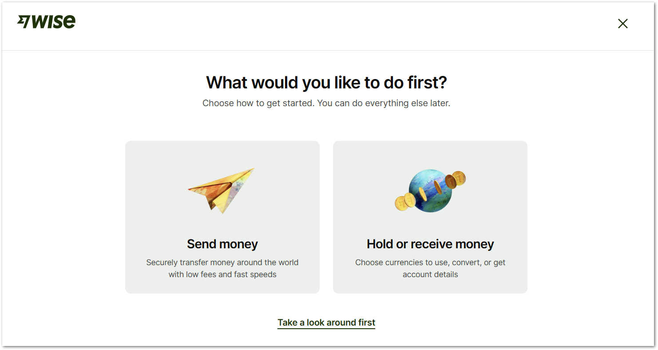
- To start receiving money in USD, select the button Add a currency to your account.
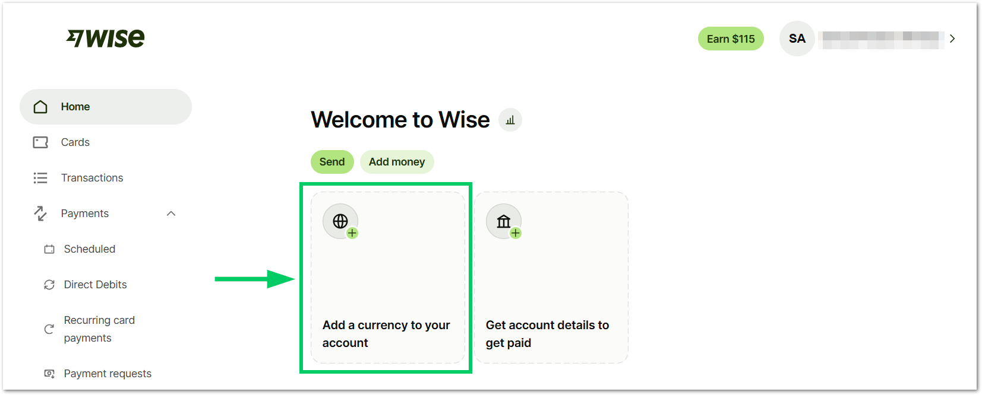
With this option you will be able to:
- Hold and convert 40+ currencies.
- Receive money from abroad

- Select US dollar from the dropdown menu and click Confirm. By selecting this option, ZTERS will be able to pay you in USD.
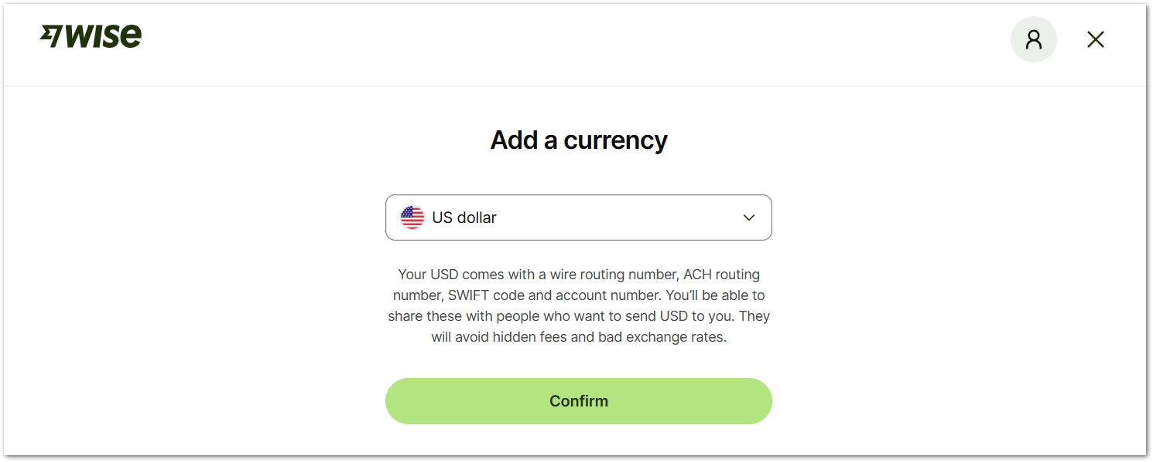
- Confirm the currency. After this, you will see the balance in your account.
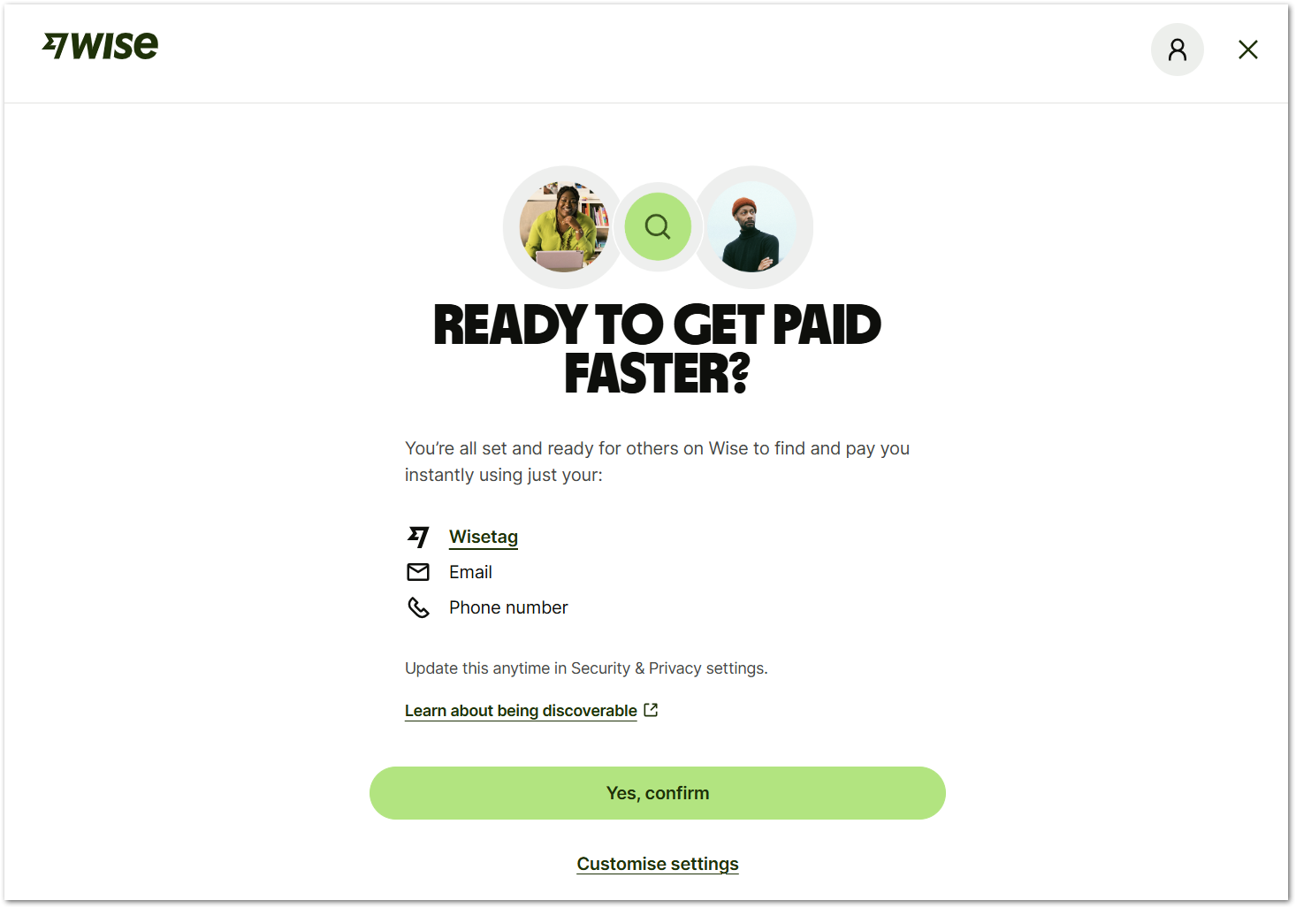
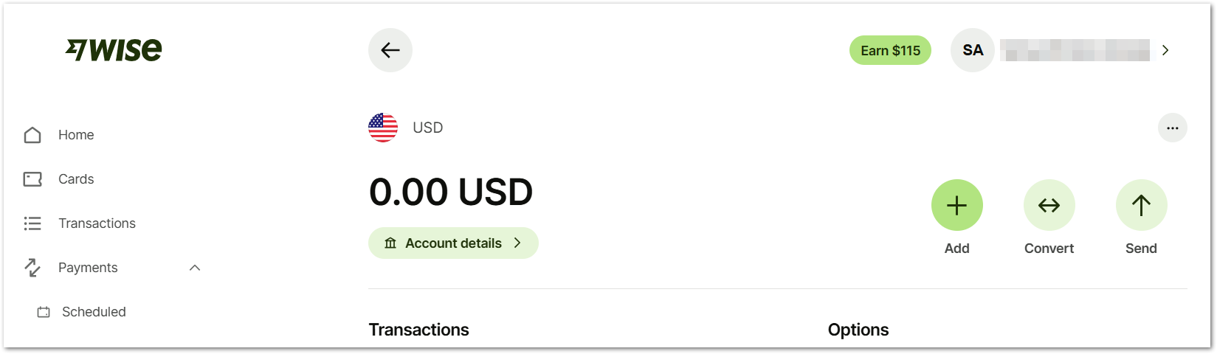

Tip: If your ZTERS account has already been set up, you will see ZTERS, Inc in the organizations list.

Warning: Un-linking and re-linking a project “disassociate” the tasks from the integration. So, if you unlink and relink a project you will end up with two copies of all those tasks, according to the official website.

Get your us account details
Once your Wise account is set up, you can generate your USD account details directly from the platform. These details (bank name, routing number, and account number) can be shared with ZTERS to receive payments just like a local US bank transfer, with full transparency and low fees.
- In your WISE home page, select Account details.
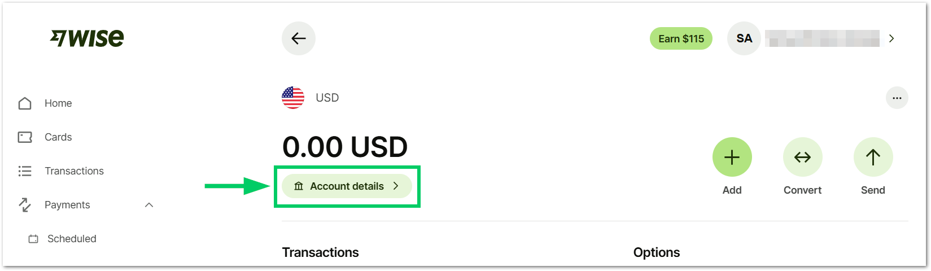
- To get your account details, you will need to add 20 USD to your WISE account. As mentioned, you can get this money back later, this step is only for verification purposes. Select Continue.
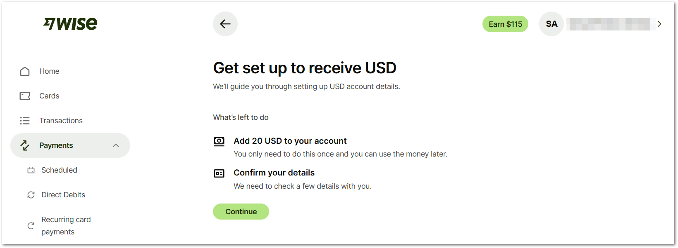
- You can select the way to add 20 dollars into your account. The following fees may change depending on the country where you are located:
Method | Fee | Transaction Time
Debit card | 0.25 USD | Seconds
Credit card | 1.31 USD | Seconds
Connected bank account (ACH) | 0.03 USD | Depending on the bank
Wire transfer | 6.11 USD | 1 day
International wire | 6.11 USD | 7 days

Tip: Both the Debit card and Credit card methods are recommended if you’re outside of the USA.

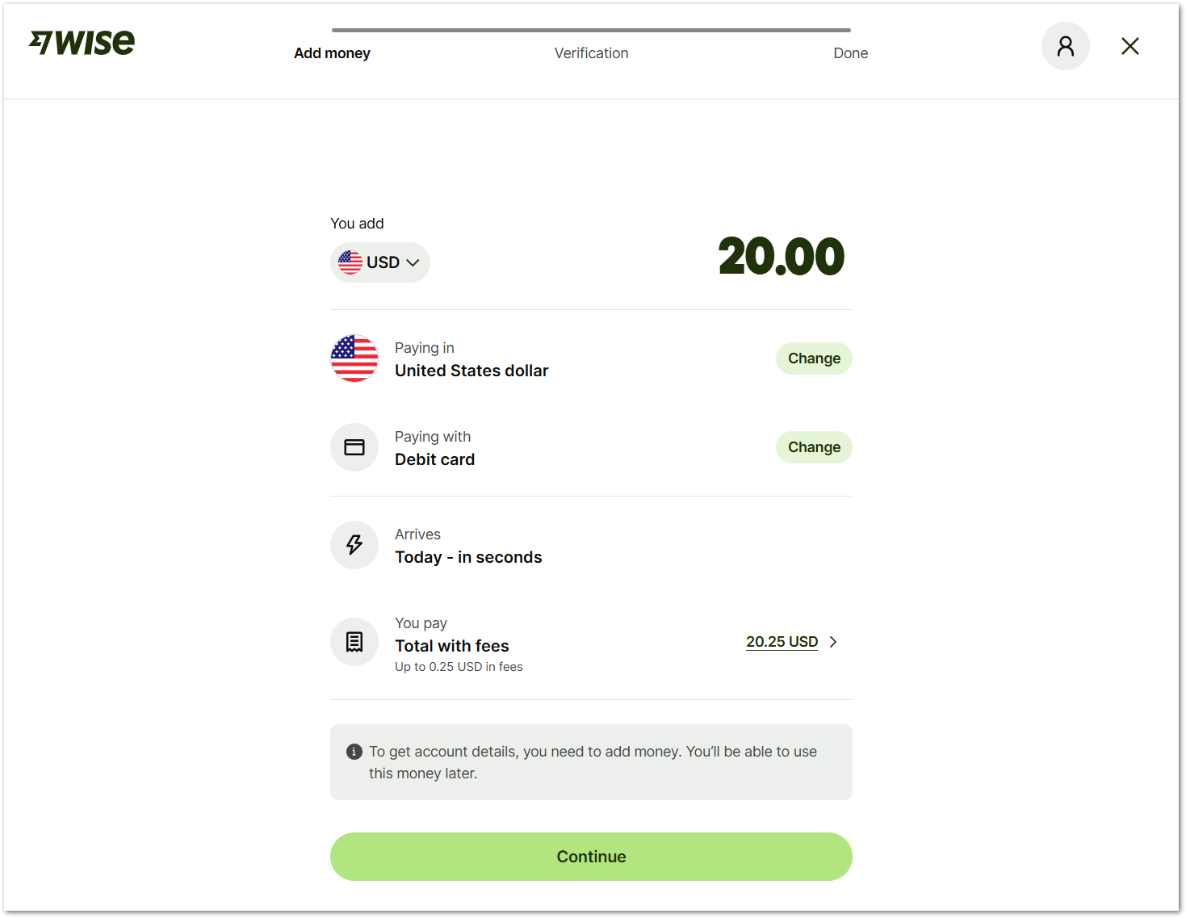

- Select your payment method and click Continue.
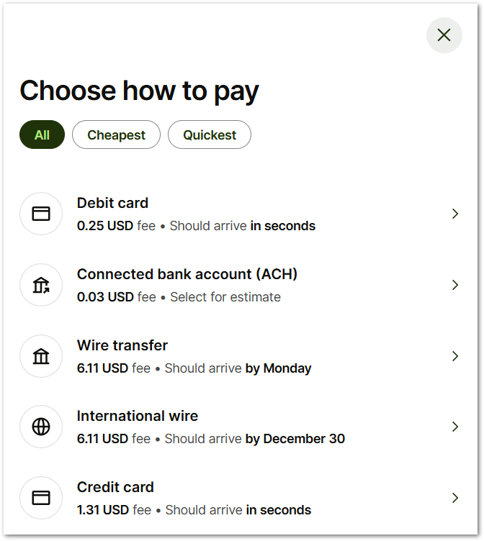
- Add your payment method details and select Pay.
- Confirm your SSN if you’re a US citizen. Otherwise, select the second option to verify your information for a non-US citizen. In the next window, select Continue to confirm that you’re not a US citizen.
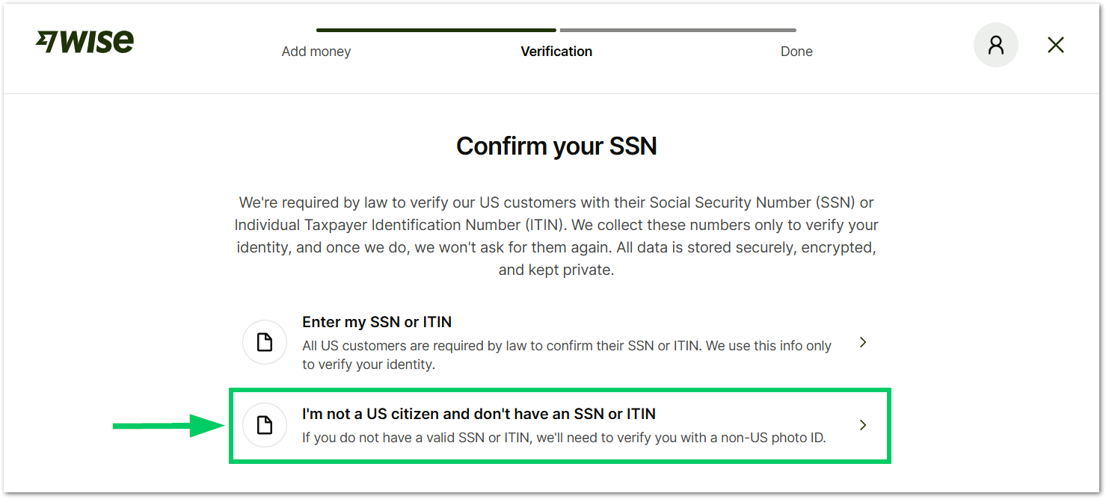
- Now, the system will ask you to switch to your phone by scanning a QR code to take a picture of your ID document and your face. This step appears only if you were completing the form from a computer.
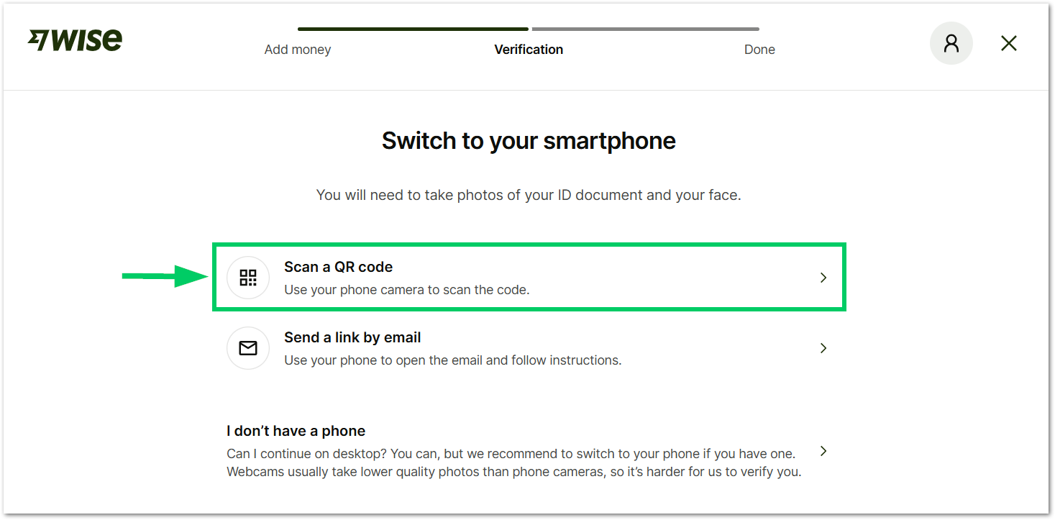
- From your phone, follow the instructions to take a picture of your ID document. The system will ask about the issuing country and document type; the following are allowed:
- Passport
- Driver’s license
- National ID
- Refugee identity document
- Agree to the WISE biometric data processing notice for your account setup and start capturing photos of your document and face.
- Finally, the system will ask you to upload a document to verify your address. The documents accepted include:
- A utility bill (gas, electric, or landline phone).
- A bank or credit card statement.
- A council tax bill.
- A vehicle registration or tax document.
- A photo driving license with your address and expiry date.
- A rental agreement — it must display the address, along with your name and your landlord's name, and include both signatures, as well as the start and end dates of the tenancy.
- Other documents issued by a government or financial institution (N26, Monzo, Bunq, Monese).

Tip: Make sure you have the address verification document already uploaded in your phone, so the process can be completed faster.

- After you upload the address verification documents, WISE will send you a notification for your account verification process. This process can take a few minutes only if the PDF can be read easily with all your information, otherwise, it will take up to 5 business days.
- Once your account is verified, check your account detail information here:
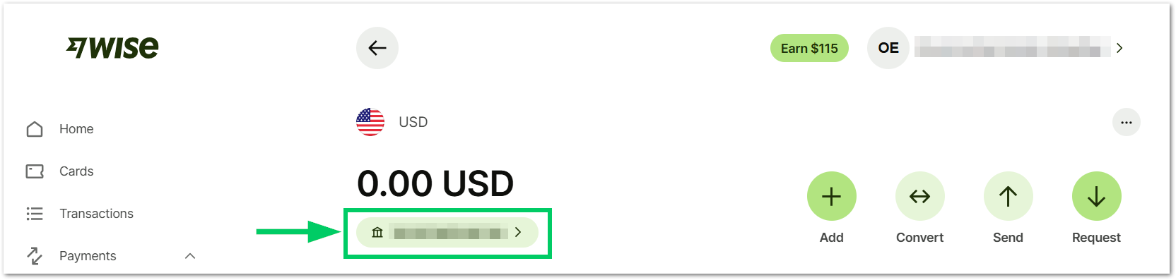
Your Wise US Inc account details include:
- Name
- Account number
- Account type
- Routing number (for wire and ACH)
- Swift/BIC
- Address
Feel free to share this information with the appropriate people at ZTERS to get paid in US dollars. Afterwards, you can send the money to your local bank.

Adding your local bank info to get paid
To send money from Wise to your local bank, you first need to add your bank account details in the Wise platform. Once saved, you can transfer funds securely, choose the amount and currency, and track the transfer until it reaches your bank account.
- In the WISE home page, select the Send icon.
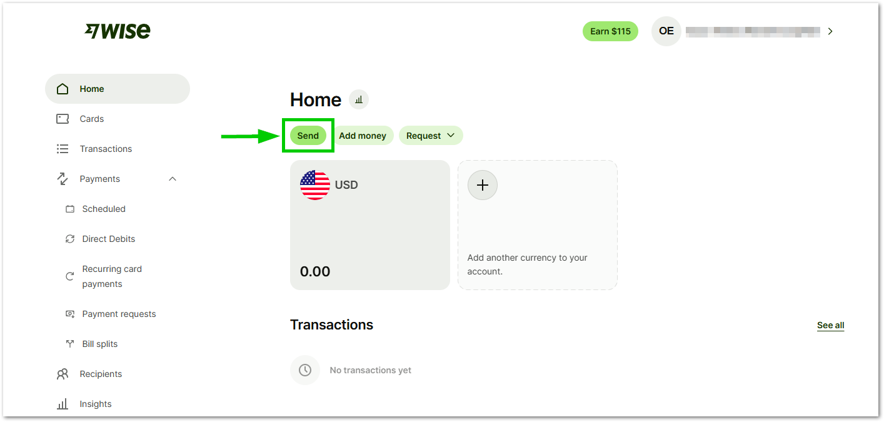
- Select the country where you want to send money.
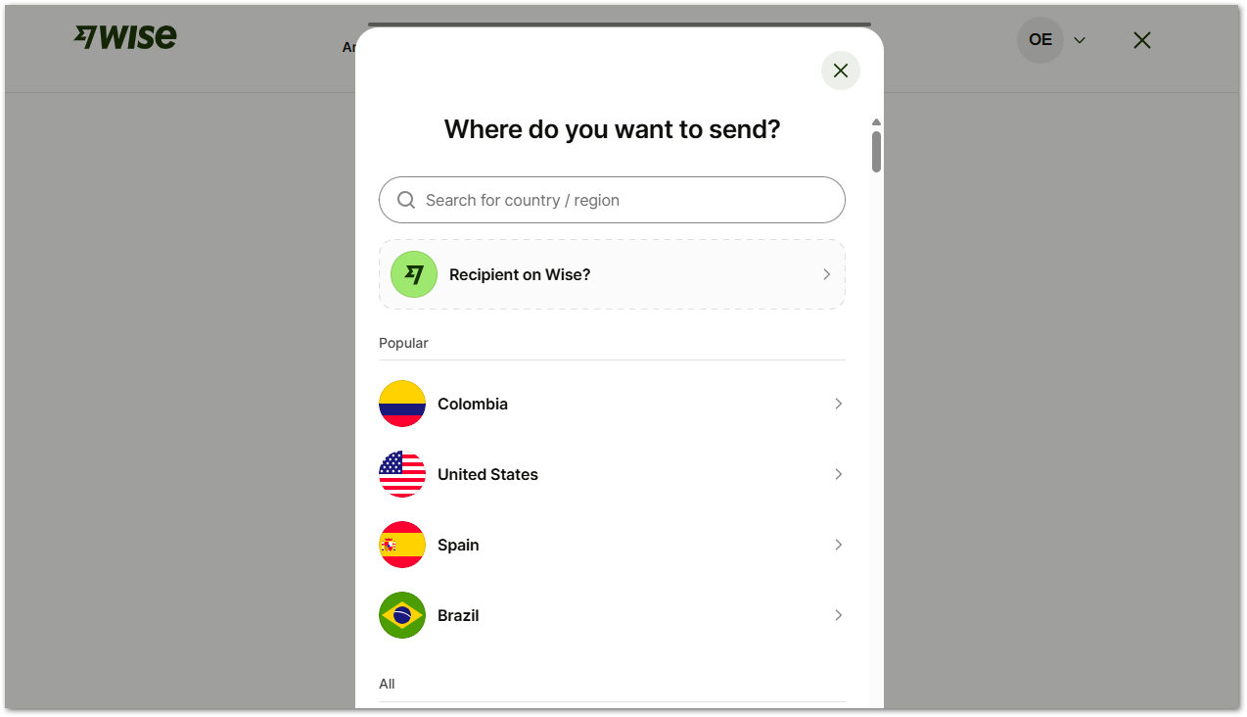
- Wise will show you exactly how much money you will get, based on the money you send through the system.
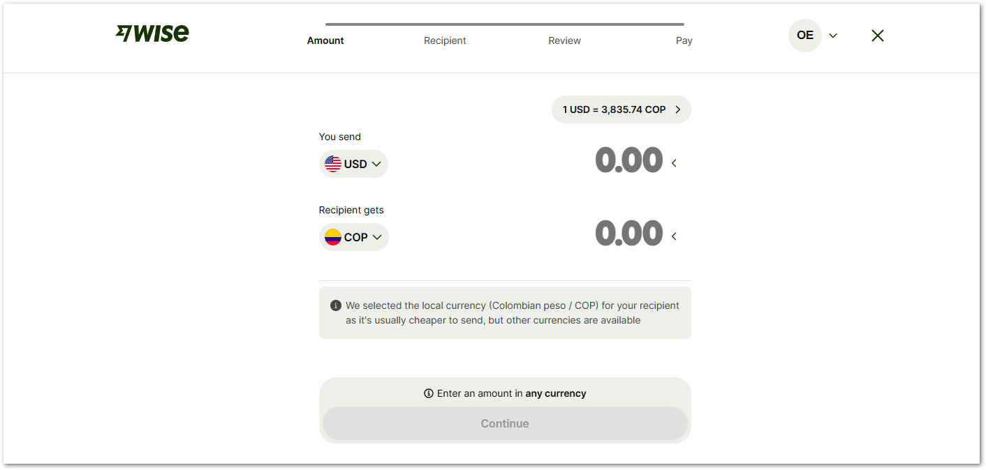
Each country will have their own policies and fees when it comes to sending money to a specific currency. As an example, if you want to send 1.000 USD to India, you will receive 90.252,56 Indian Rupee. The total fees go up to 7.33 USD per transfer.
*Other Fees may apply depending on your bank
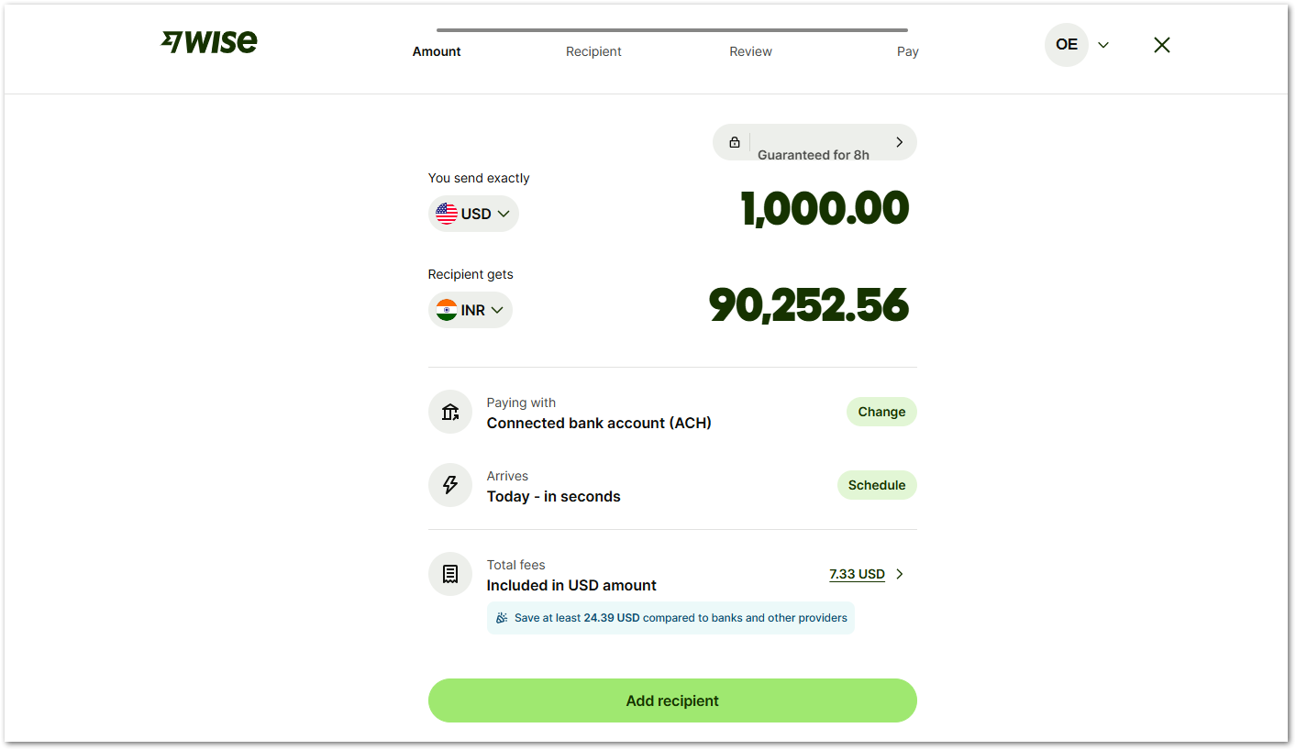
- For Mexico, if you send 1.000 USD, you will receive 17.810,52 Mexican Pesos. The total fees go up to 8.29 USD per transfer.
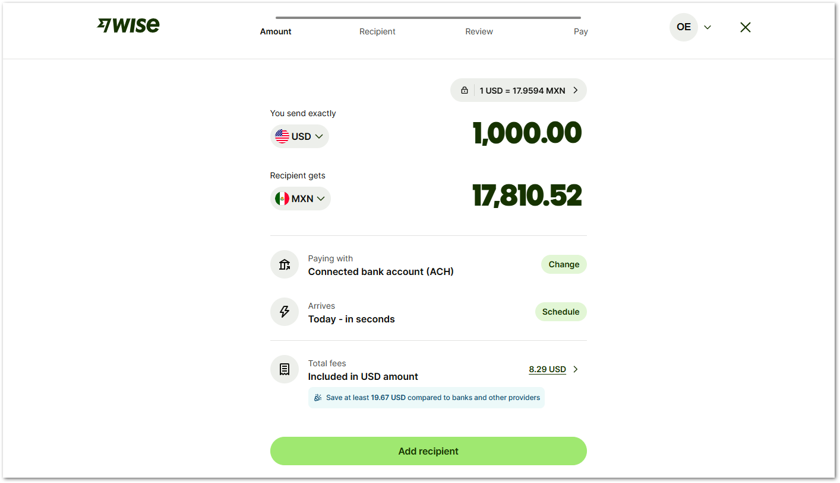

- Select Add recipient to complete the account’s information where the money will go.
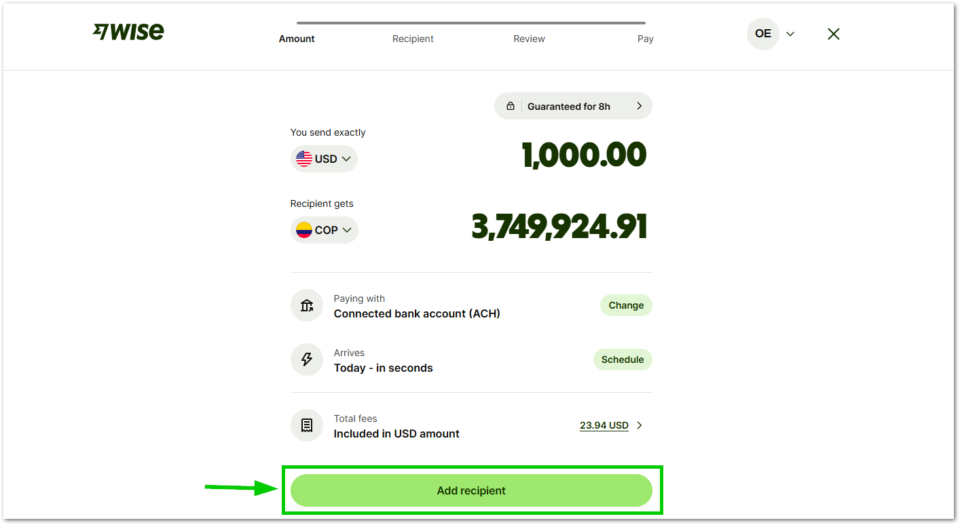
- Select Bank Details to add the bank account details.
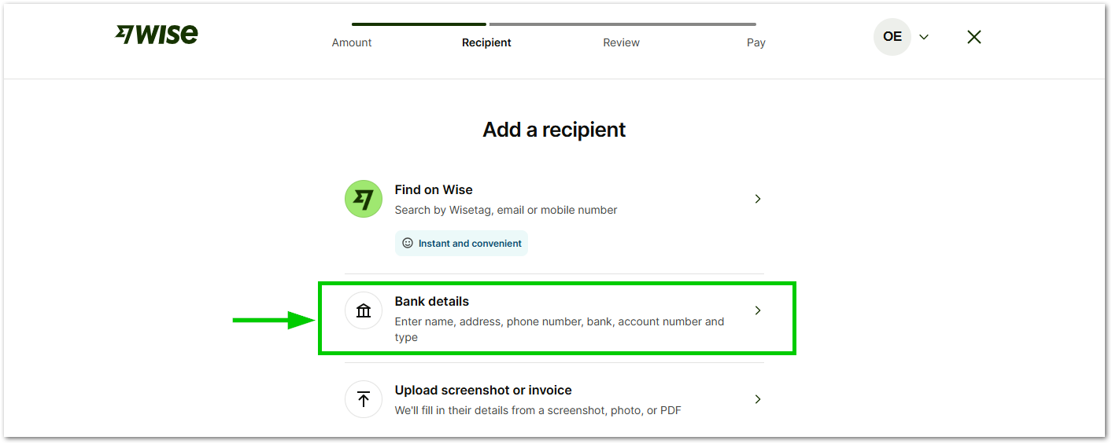
- Select Myself if you’re the person receiving the money.
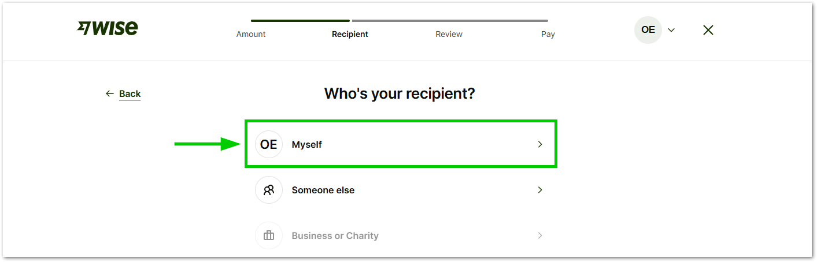
- Complete the missing information
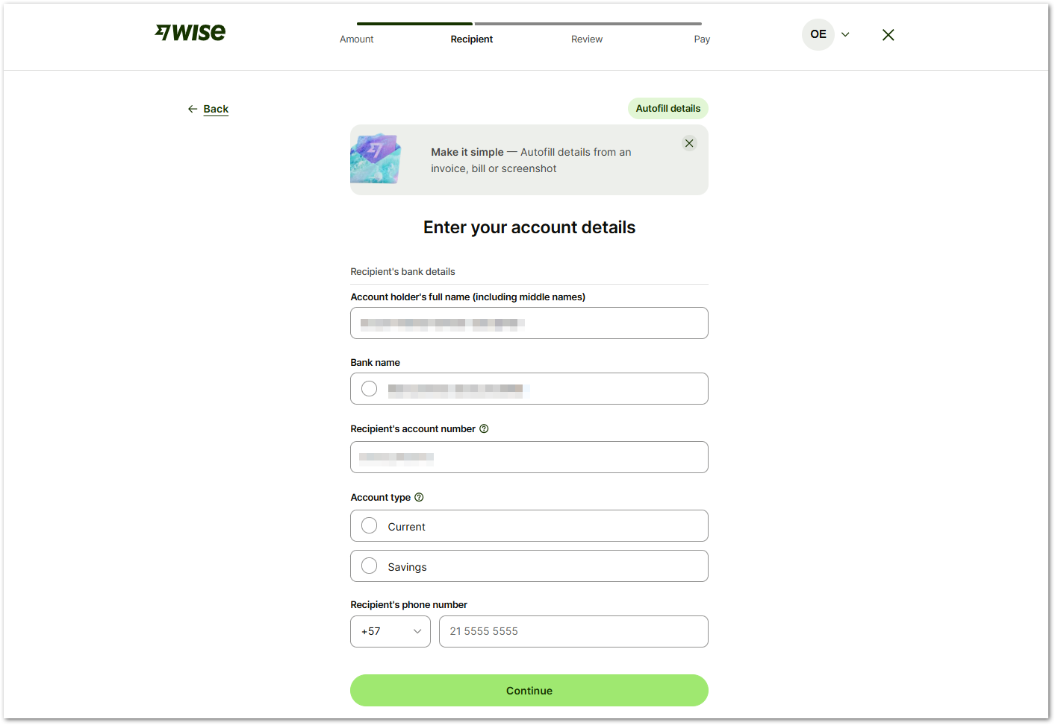
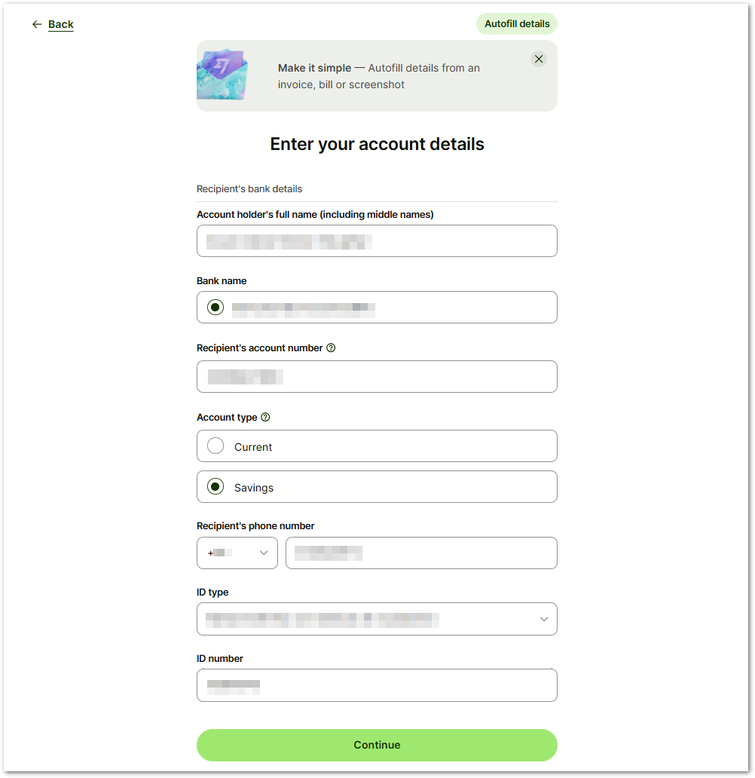
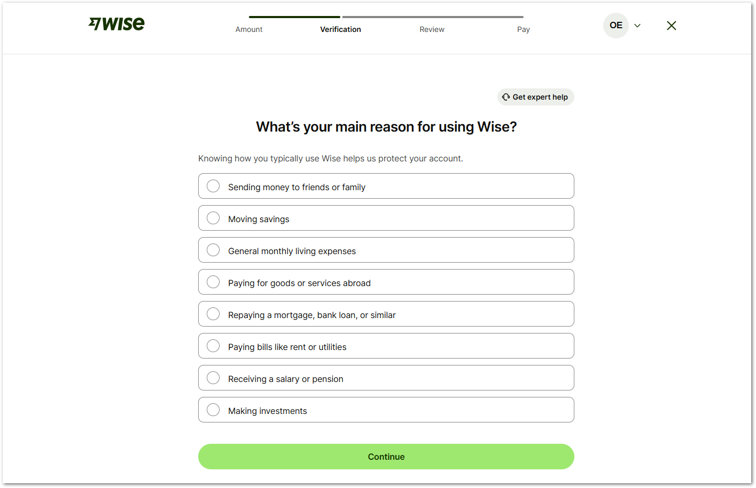
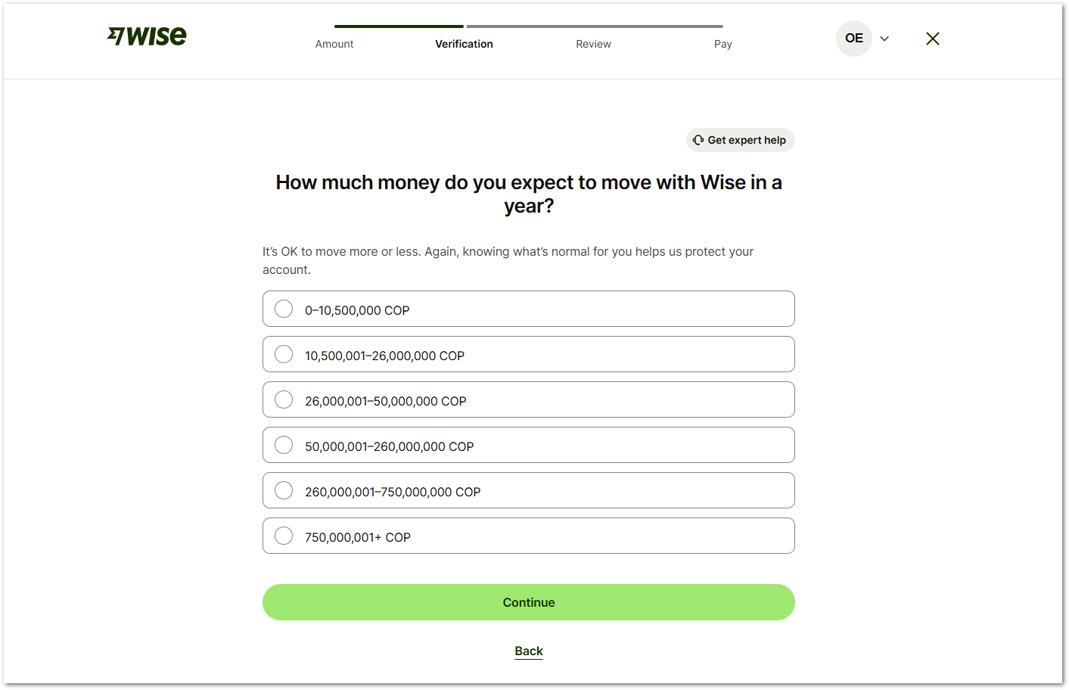
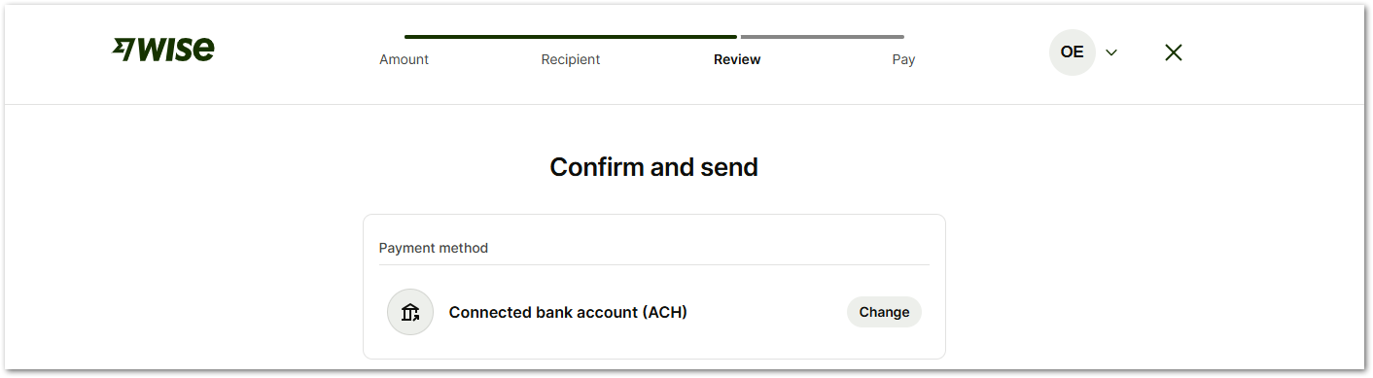
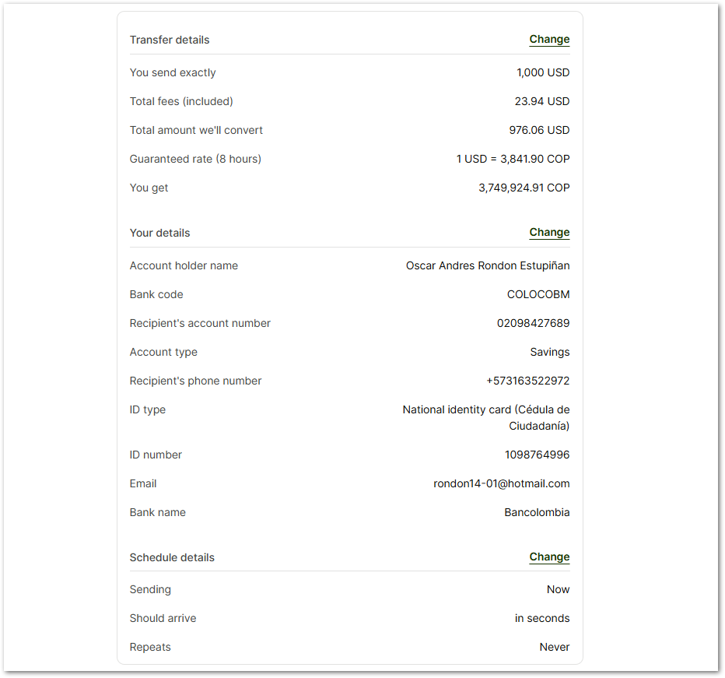
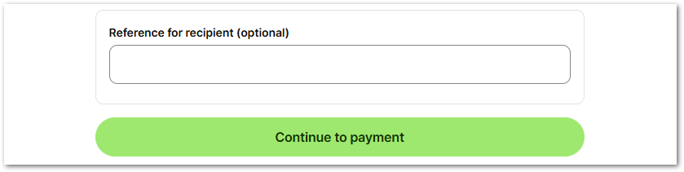
- Complete the missing information
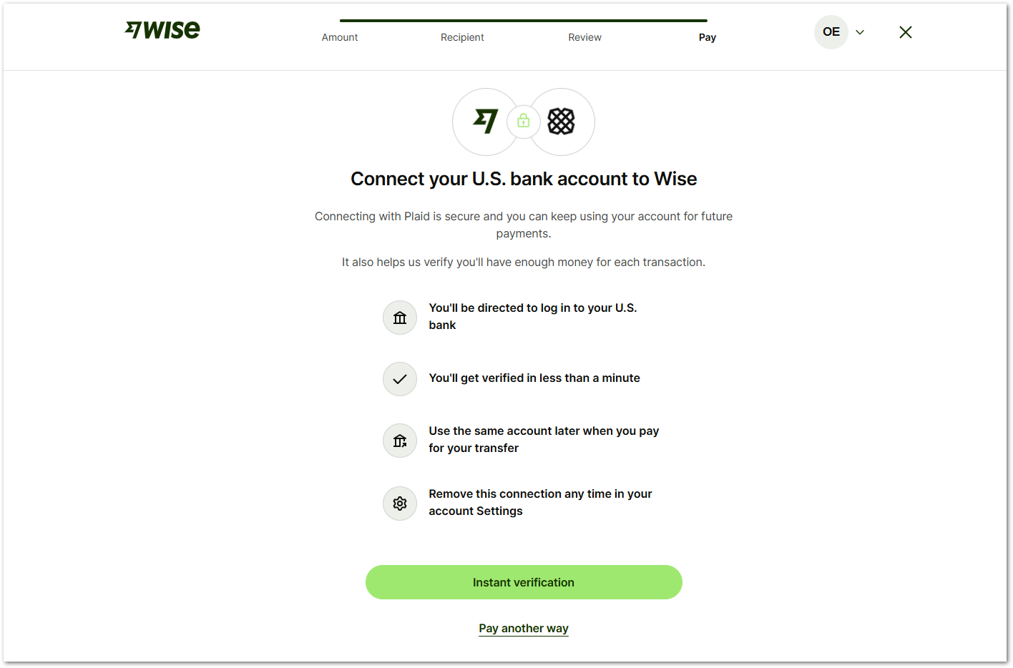
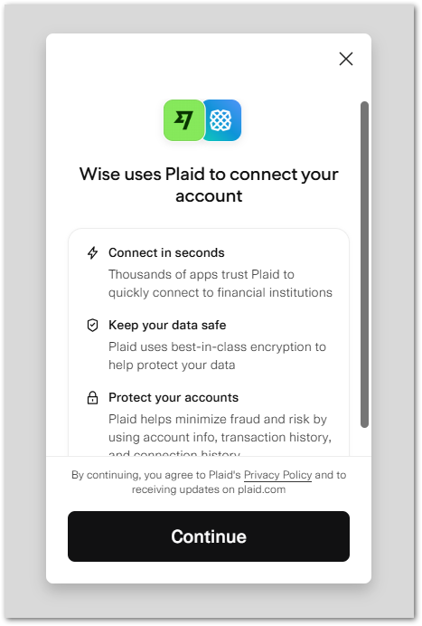

Send money from wise
After receiving funds in your Wise account, you can easily send money to your local bank in your home country. Wise handles the currency conversion at real exchange rates and transfers the money quickly, with clear fees and no hidden charges.
- In your WISE home page, you should have a payment from your company.
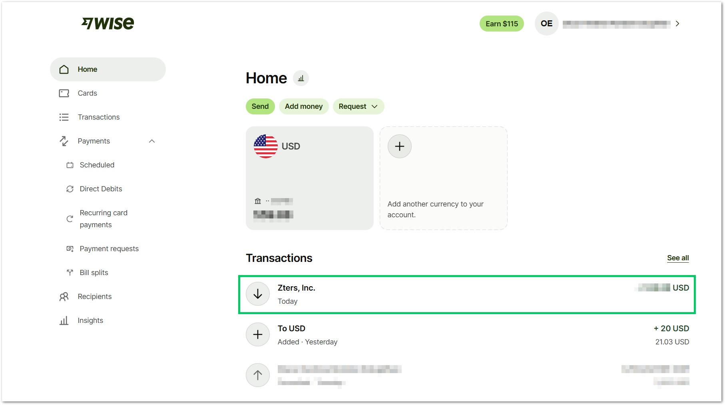
- Select your USD account > Send.
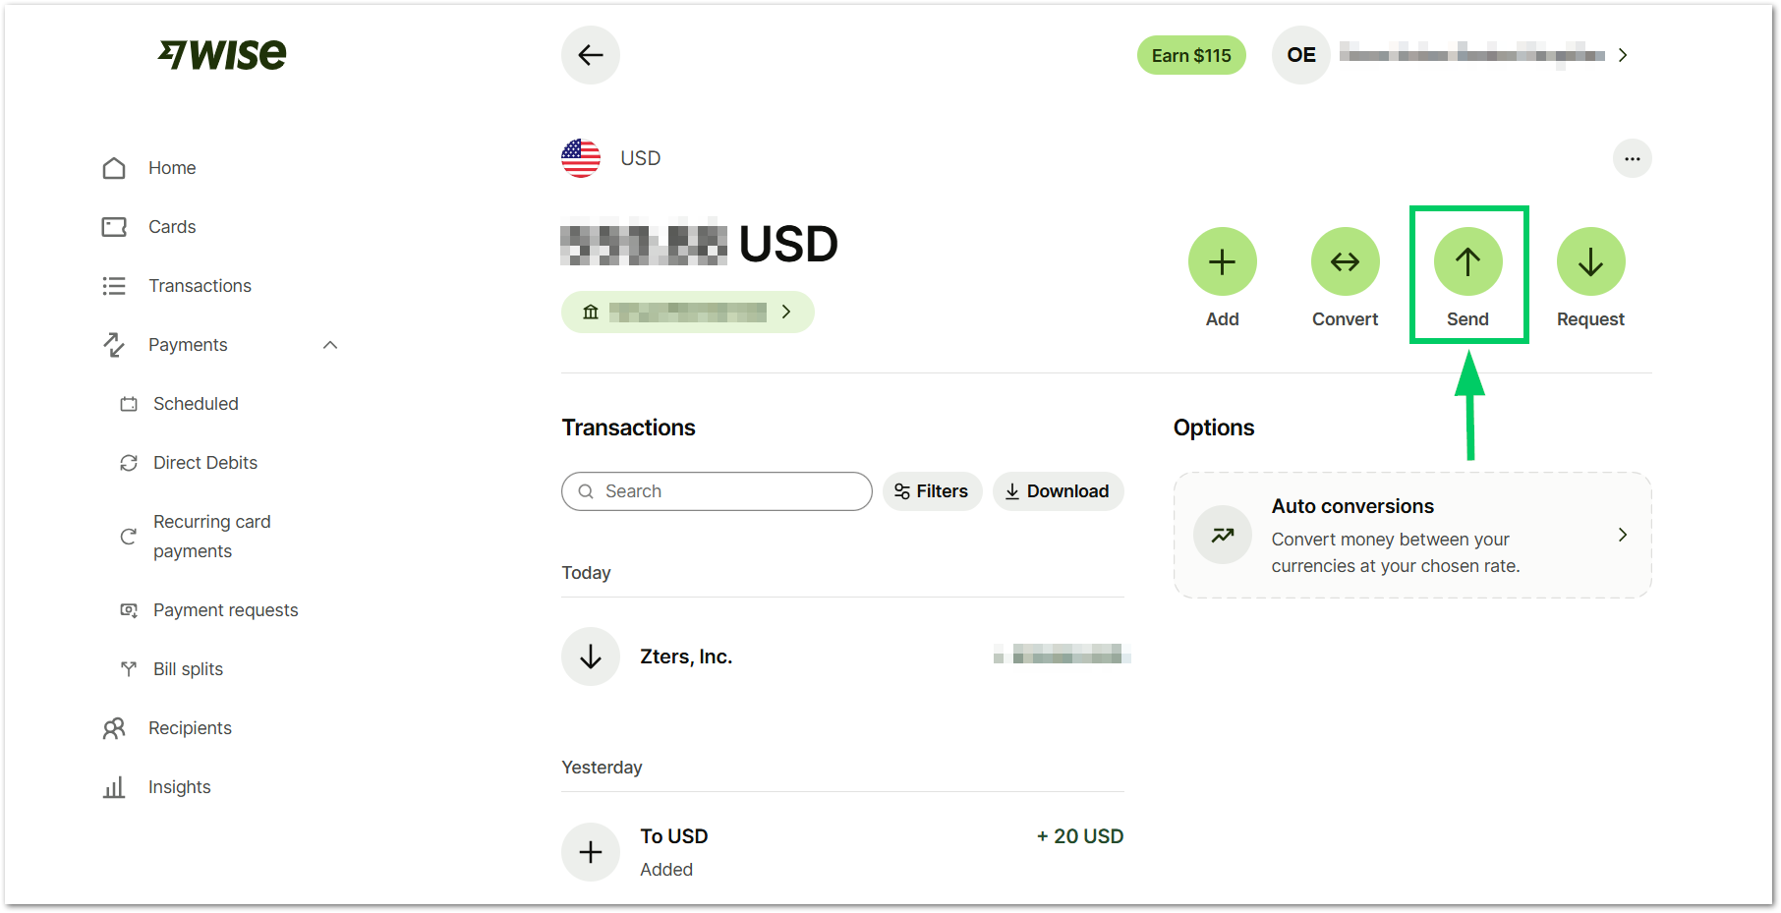
- Select the country where you will send or use the search bar to find it.
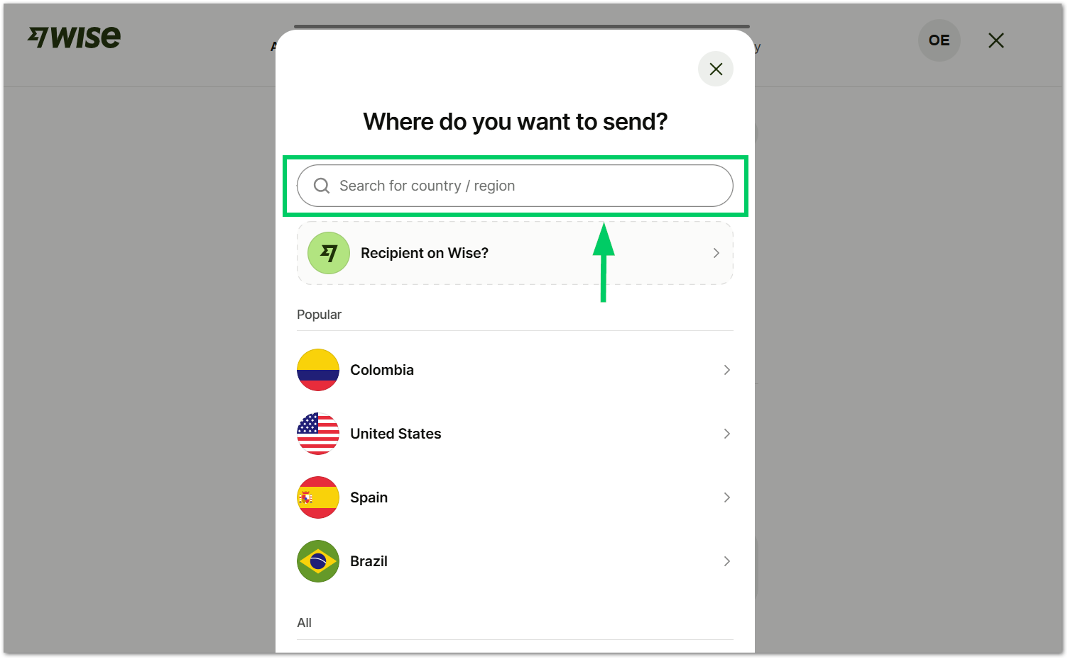

- You will see the exchange rate for the country that you selected. Select the Amount available option to send all your money.
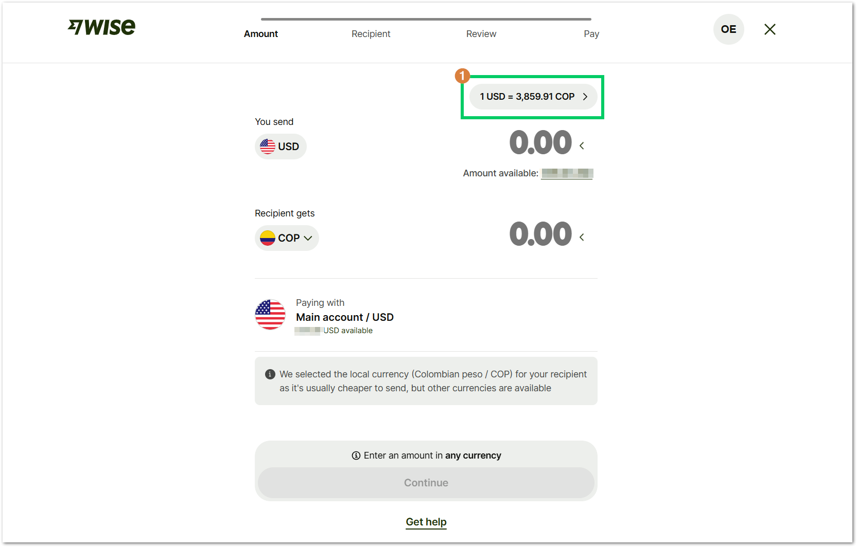

- Below, you will see the fees applicable to the country where you send the money. In the Rate is guaranteed option, you can check the rate that WISE locked for your transaction.
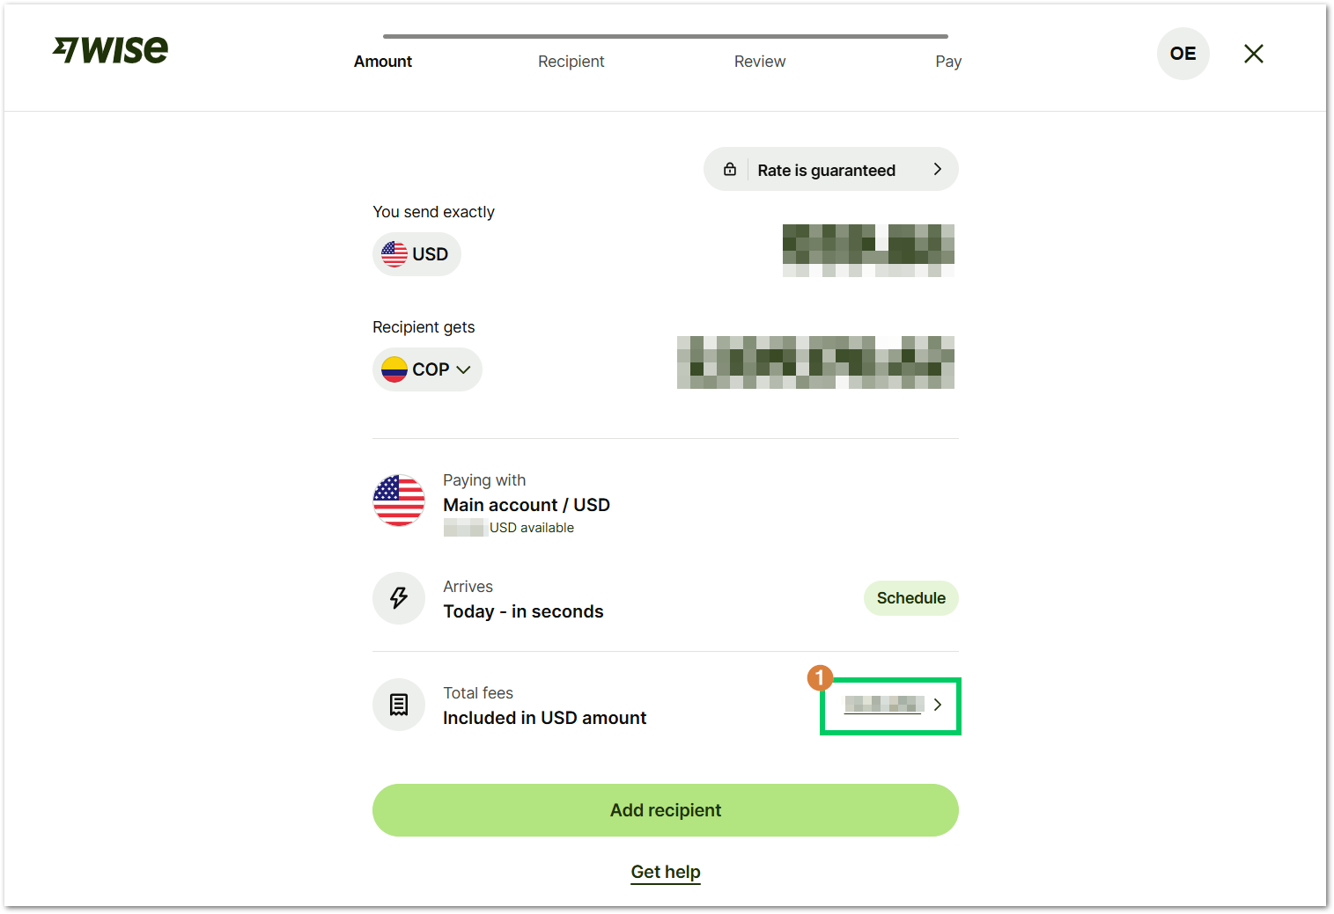
You can also schedule your transfer is they’re recurrent by selecting the Schedule button.
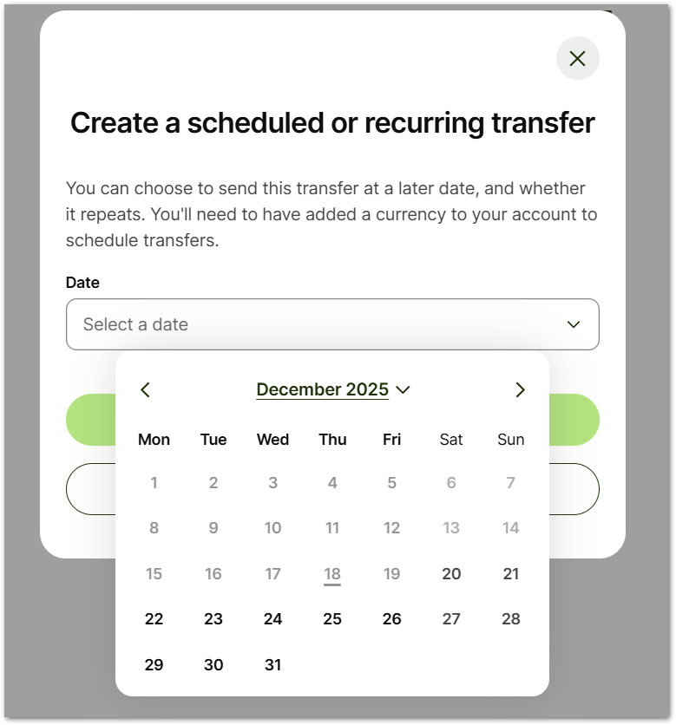

- Select Add recipient to select the account where you will send the money.
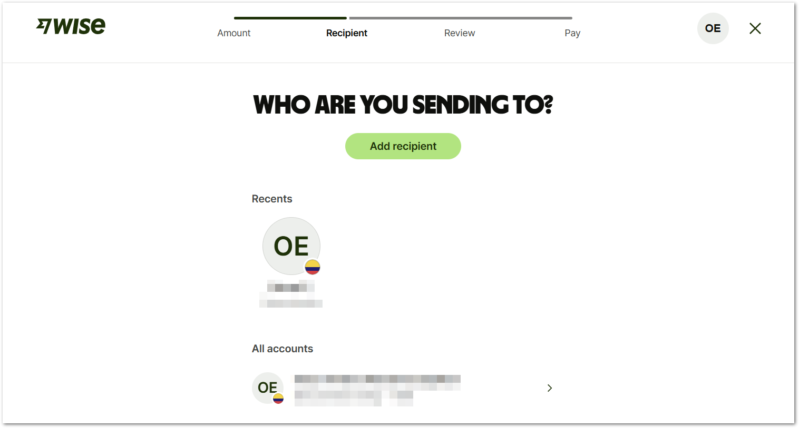

- Select Add recipient to select the account where you will send the money.
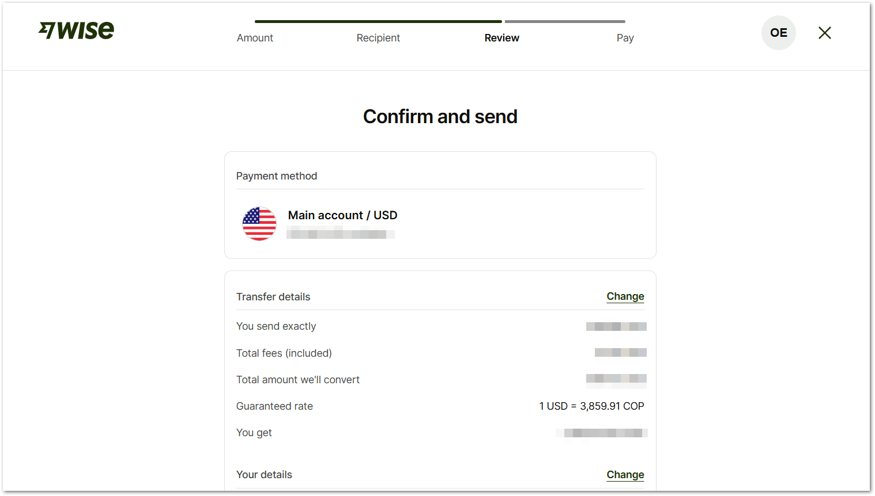
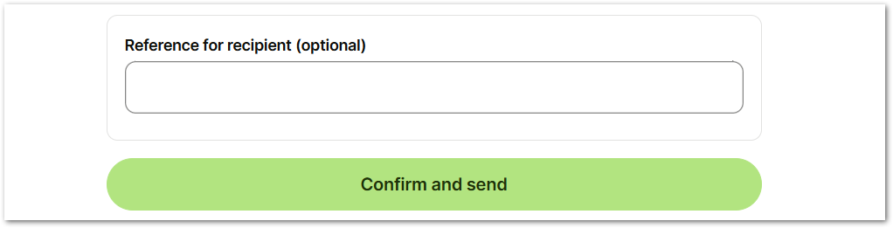
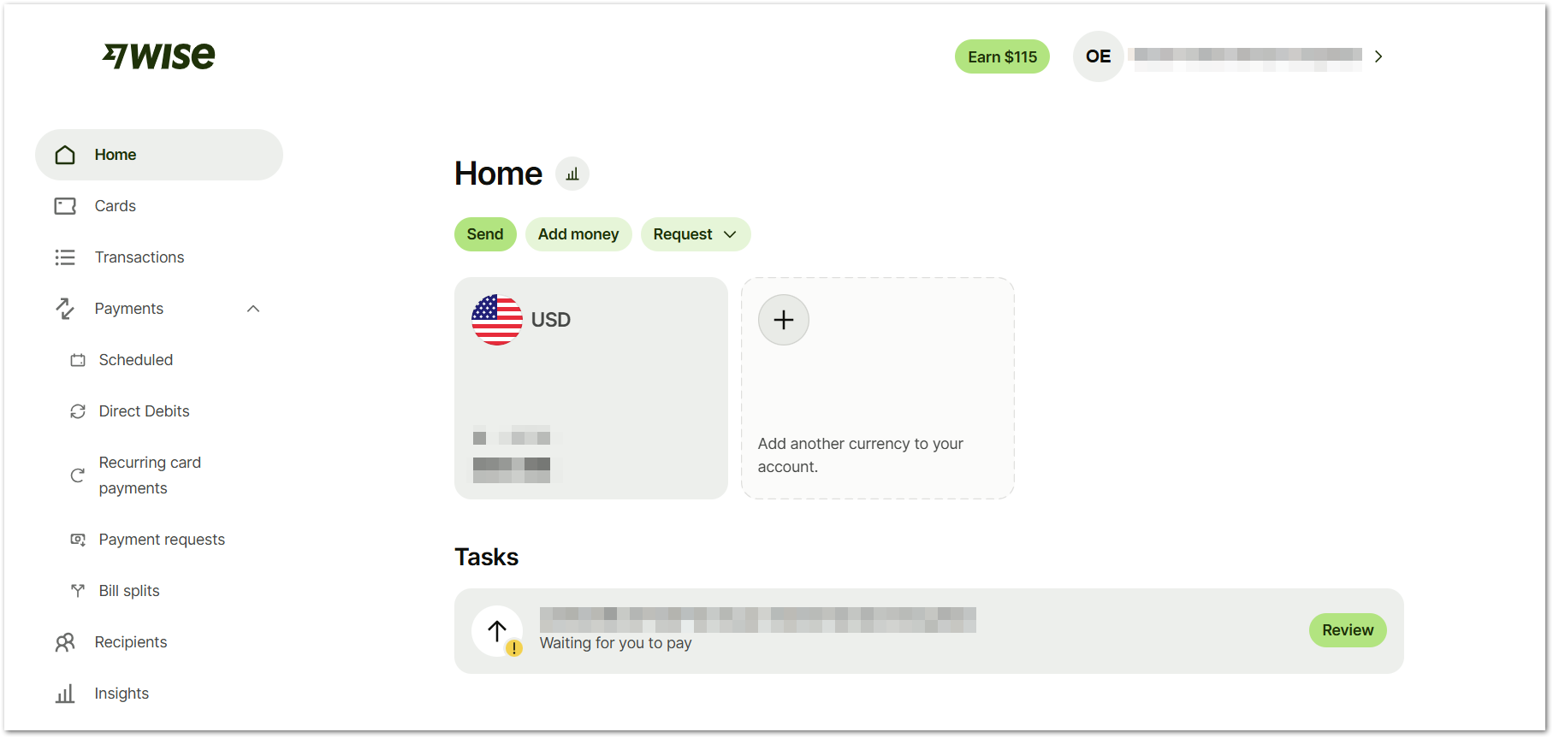
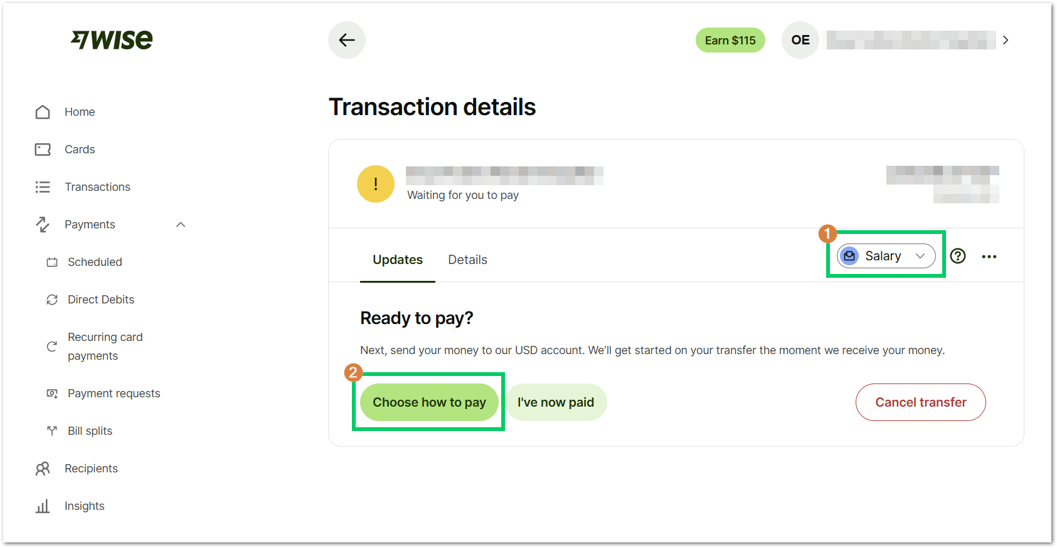
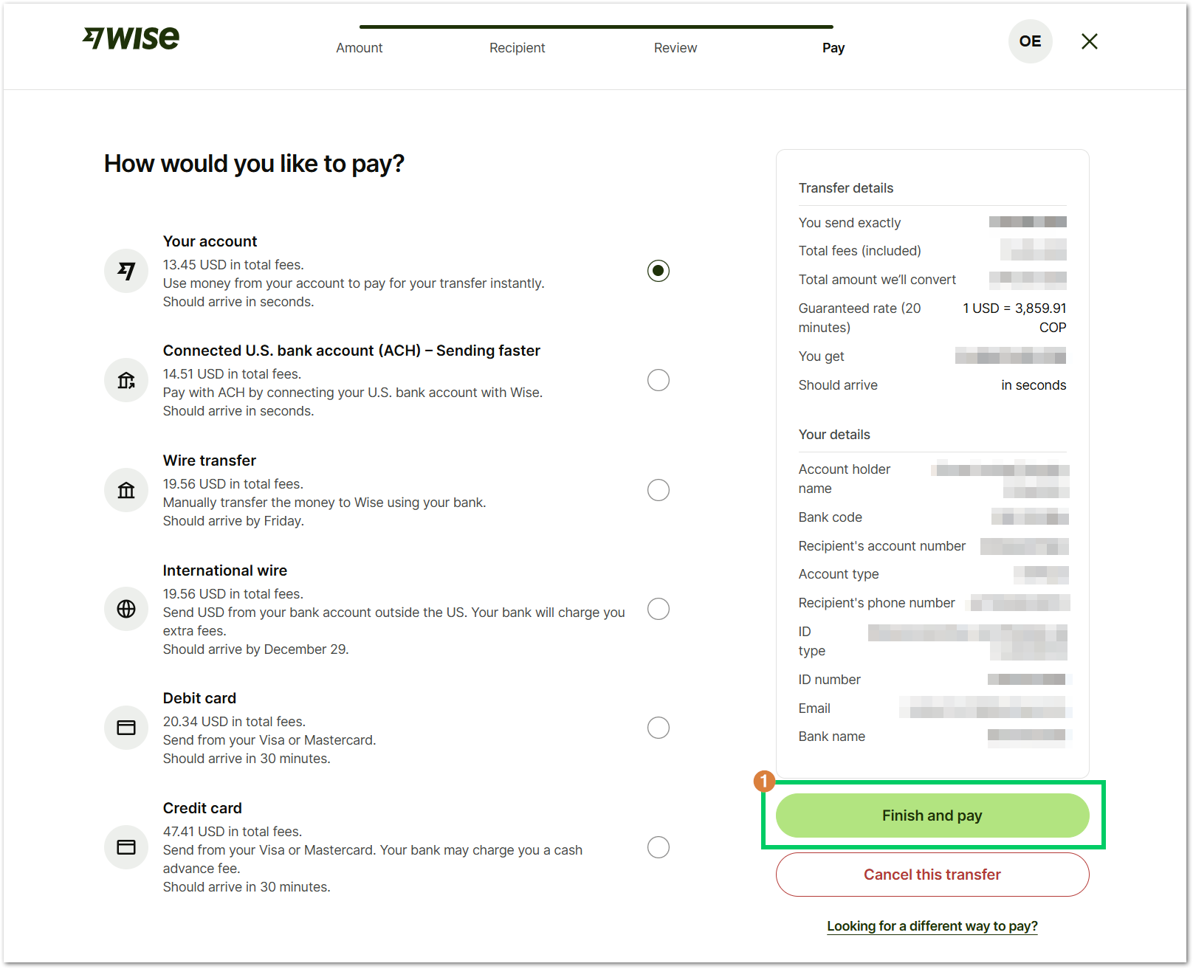

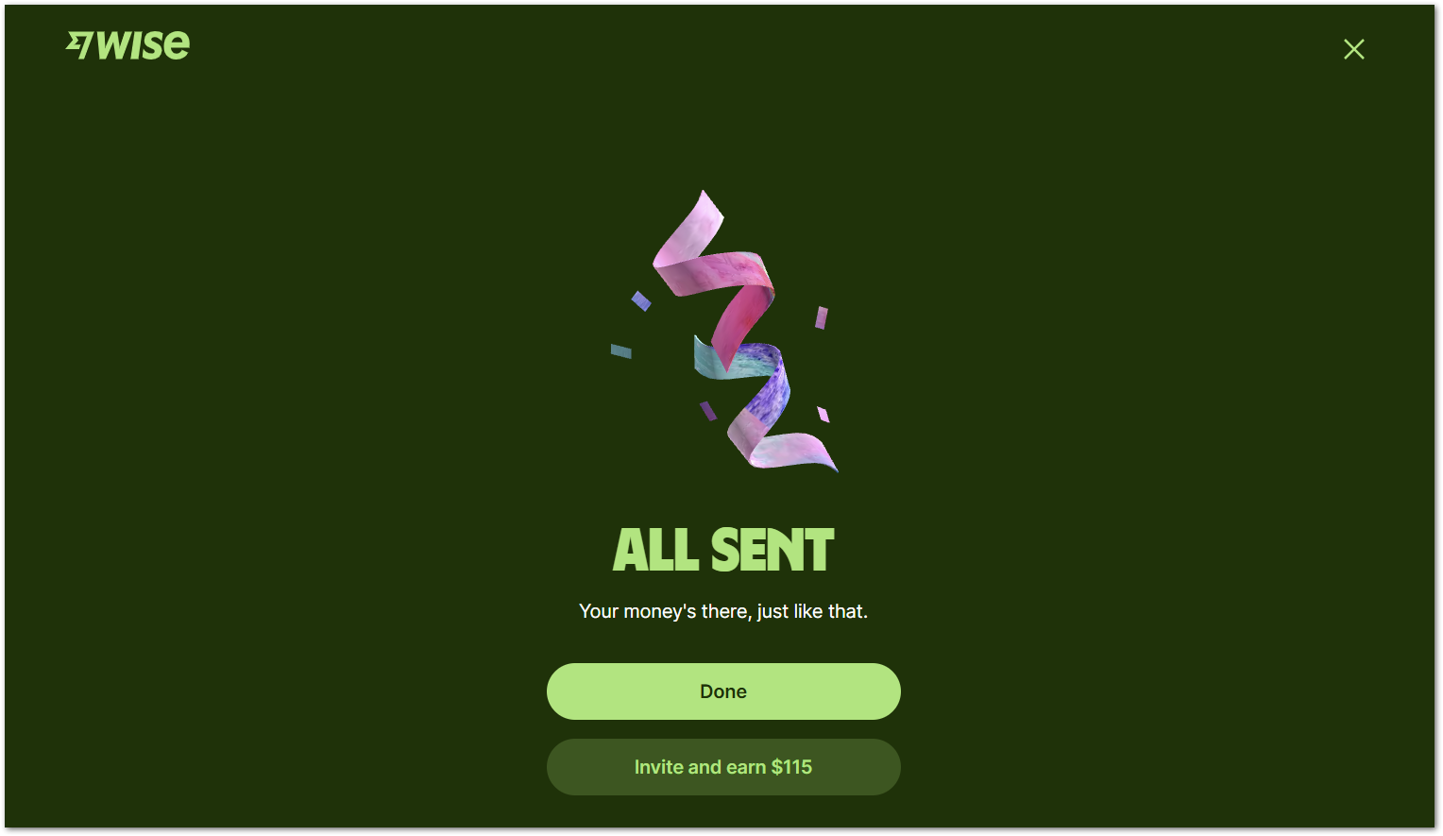

--- END OF THE DOCUMENT ---

