<CUBE> USER GUIDE (ugu)



Document ID | DEV-CUBE-UGU-001-v1.0
Product | CUBE
Environment | DEV
Confidentiality Level | Internal / Restricted

CONTENTS
1 DOCUMENT INFORMATION 5
1.1 Validation 5
1.2 Document Distribution 5
1.3 Version Control 5
2 PREFACE 6
2.1 About this document 6
2.2 Related documents 6
2.3 Who should read this document 6
2.4 Terminology 6
2.5 Conventions Used 7
3 cube OVERVIEW 8
3.1 Description 8
3.2 User Interface 8
3.2.1 Login Page 9
3.3 Dashboard 10
4 Customerz section 11
4.1 Customers 11
4.2 Customer Contacts 11
4.3 Sites 12
4.4 Reviews 12
4.5 CC Transactions 12
4.6 Credit Limit Requests 12
4.7 Accounting Inquiries 12
4.8 Billing Preferences 12
5 Salez section 13
5.1 Products 13
5.2 Service Tickets 13
5.3 Line Items 13
5.4 Invoices 13
5.5 AP Hub 13
5.6 Pricing History 13
5.7 Z Sight Monitors 14
5.8 Assets 14
6 Operationz section 15
6.1 Service Providers 15
6.2 Service Provider Contacts 16
6.3 Fulfillment Tickets 16
6.4 VM Tickets 16
6.5 Pricing Zones 17
6.6 Pricings 17
6.7 Hauler Quotes 17
6.8 VM Activities 17
6.9 Price Increases 17
6.10 Out of Stock 17
6.11 Zip Codes 17
6.12 Vendor Ratings 17
6.13 Hauler Business Hours 18
7 Administratorz section 19
7.1 Products 19
7.2 Product Codes 19
7.3 Ticket Codes 19
7.4 States 19
7.5 Notes 19
7.6 Vendor Link 19
7.7 Tasks 20
7.8 Lead Sources 20
7.9 Lead Parent 20
7.10 Answered Phone Calls 20
8 Userz section 21
8.1 Users 21
8.2 Roles 21
8.3 Permissions 21
8.4 Groups 22
9 Zeepz Section 23
9.1 Leads 23
9.2 Employees 23
9.3 Bonus Points 23
9.4 Badges 23
10 Reportz section 24
10.1 Static Reports 24
10.2 Custom Reports 24
10.3 AI Reports 25
10.4 Power BI Reports 25
11 Overall System Functionalities 26
11.1 Bulk Actions 26
11.2 Export and Print Options 26
12 Settings 28
12.1 Header Controls 28
12.1.1 Profile 28
12.1.2 Inbox 28
12.1.3 Settings 28
13 User Roles 29
14 WORKING PROCEDURES 31
14.1 Account Manager Working Procedures 31
14.1.1 Create and Manage a Customer Record 31
14.1.2 Manage Service Sites 32
14.2 Customer Success Specialist Working Procedures 34
14.3 Admin Working Procedures 34
15 APPROVAL SIGNATURES 35

DOCUMENT INFORMATION

Validation
Name |  | Role | Date (dd/mm/aa)
Issued by | Oscar Rondon | Technical Writer | 26/03/2026
Verified by | Justin Tuttle | Systems Operations Manager | 26/03/2026
Approved by | Anthony Bures | Digital Development Manager | 26/03/2026

Document Distribution
Normal | Role
Oscar Rondon | Technical Writer
Anthony Bures | Digital Development Manager
Justin Tuttle | Systems Operations Manager

Version Control
Version | Date | Author | Description of changes
1.0 | 26/03/2026 | Oscar Rondon | 1st version of the CUBE User Guide document – First Draft

PREFACE

About this document
This document provides the User Guide (UGU) for the CUBE platform, describing the main features, user interface components, roles, and operational workflows available within the system.
The purpose of this guide is to help users understand how to navigate the application and perform common operational tasks within CUBE. It includes descriptions of the user interface, explanations of system modules, and step-by-step working procedures for typical activities performed in the platform.
This document is intended to support onboarding, training, and daily operational use of the CUBE system.

Related documents
All documents or elements used for reference are presented in the following table:
Title | Reference | Author | Version
SOP | HUB SOP | Oscar Rondon | 1.0

Who should read this document
This document is intended for users who interact with the CUBE platform as part of their operational responsibilities. These users may include:
- Account Managers, responsible for managing customer records, service sites, and supporting service-related workflows.
- Customer Success Specialists, responsible for managing leads and supporting internal engagement features such as bonus points and badges.
- Cube Administrators, responsible for managing user access, roles, permissions, and system configuration.
- ZTERS team members, who require an understanding of the CUBE platform for operational, coordination, or support purposes.
This guide is also useful for new team members, support personnel, and stakeholders who need a clear understanding of the platform’s functionality, structure, and core workflows.

Terminology
Term Used | Description
CUBE | The internal web application used to manage customers, service locations, operational resources, and reporting tools within the ZTERS platform.
Customer | An individual or organization receiving services managed through the CUBE system.
Site | A physical location associated with a customer where services are delivered or maintained.
Service Provider | A vendor or partner responsible for delivering services associated with customer sites.
User Role | A predefined set of permissions that determines what actions a user can perform within the system.
Bonus Points | An internal recognition system used to reward team members for achievements or contributions.
Badge | A recognition element assigned to users based on achievements or participation within the platform.
Report | A system-generated view or dataset used to analyze operational or business information within the platform.
Bulk Actions | System functionality that allows users to perform actions on multiple records simultaneously within data tables.
Data Export | A functionality that allows users to extract system data (e.g., CSV format) for external use, reporting, or analysis.
CWS | The CWS (Commercial Waste Services) is a functional group within ZTERS responsible for managing waste service operations, including monitoring tools and asset-related functionalities.
VM | The Vendor Management is a functional group responsible for managing vendor-related configurations such as pricing and service provider data.
Leads | A functional group or role focused on managing sales leads and pipeline activities within the platform.

Conventions Used
The following structures are used as recommendations.
Info: Supplementary Information

Tip: A recommendation or useful advice

Warning: A warning or important notice

Note: A notice.

cube OVERVIEW

Description
The CUBE platform is a web-based application designed to support the management of customers, service locations, operational resources, and internal activities within the ZTERS ecosystem. It provides a centralized interface where users can access and manage data required for daily operations.
The system enables users to manage customer records, configure service sites, coordinate with service providers, control user access and permissions, and generate analytical reports. It also includes features that support internal engagement through recognition elements such as bonus points and badges, as well as system-wide functionalities for managing and interacting with data.
CUBE organizes its functionality into several main sections accessible through the left navigation panel:
- Customerz: Manage customer records, contacts, service sites, and financial information.
- Salez: Manage products, service tickets, line items, and invoicing activities.
- Operationz: Manage service providers, fulfillment processes, vendor coordination, and pricing configurations.
- Userz: Manage user accounts, roles, permissions, and groups.
- Administratorz: Configure system settings, codes, and workflow-related definitions.
- Zeepz: Manage leads, employees, and internal recognition elements such as bonus points and badges.
- Reportz: Access reporting tools, including standard, custom, AI-driven, and Power BI reports.
These sections enable users to perform daily operational tasks efficiently while maintaining proper access control, data consistency, and visibility across the platform.

User Interface
Screenshots, descriptions, and other important information about the application’s interface and functionalities.

Login Page
The Login Page is the entry point to the CUBE platform. Users must authenticate with their credentials before accessing the system.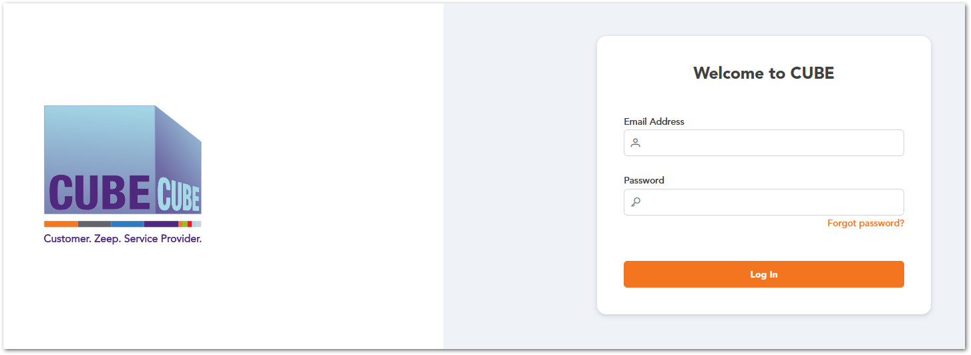

Forgot Password
The Forgot Password option allows users to recover access to their CUBE account if they are unable to log in due to a forgotten password. When this option is selected, the system prompts the user to enter the email address associated with their account. After submitting the request, the system sends a password recovery email containing instructions to reset the password.
Password Recovery Process
- On the Login Page, click Forgot Password.
- Enter the email address associated with your CUBE account.
- Click Send Recovery Mail.
- Check your email inbox for the password recovery message.
- Follow the instructions provided in the email to reset your password.
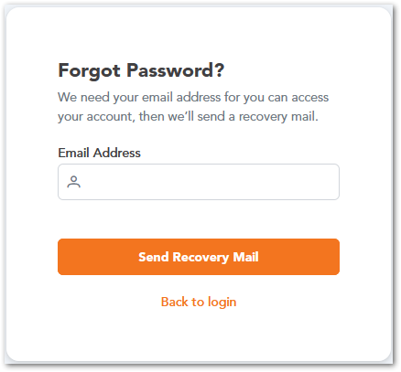
After completing the password reset process, the user can return to the Login Page and access the CUBE platform using the newly created password.

Dashboard
The Dashboard is the main landing page displayed after a user successfully logs into the CUBE platform. It provides an overview of system activity and quick access to frequently used features.
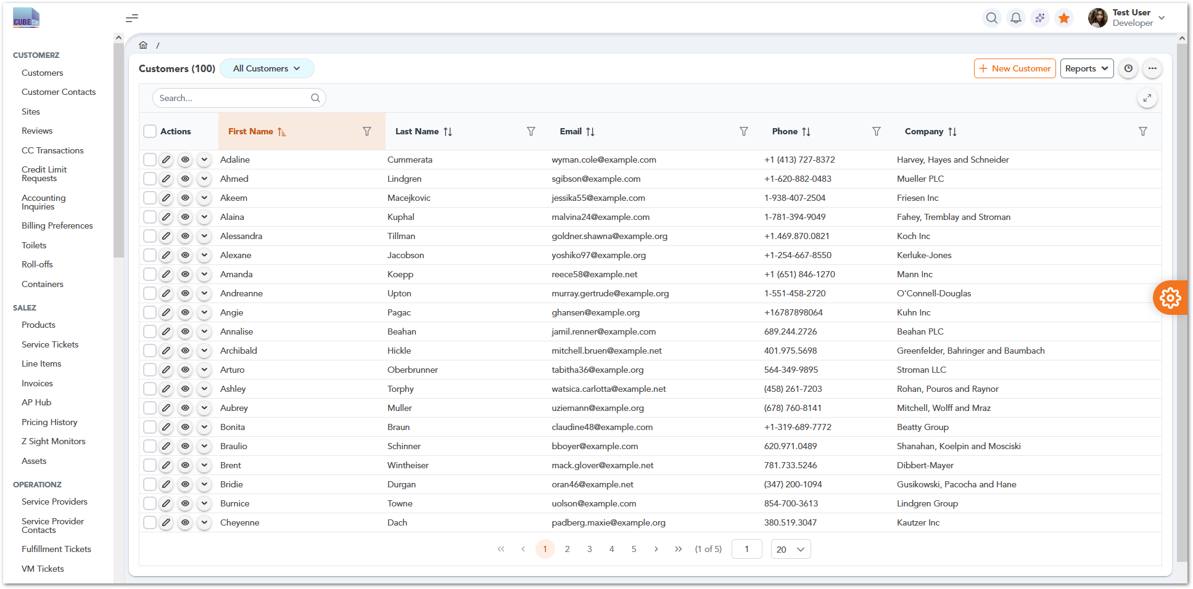
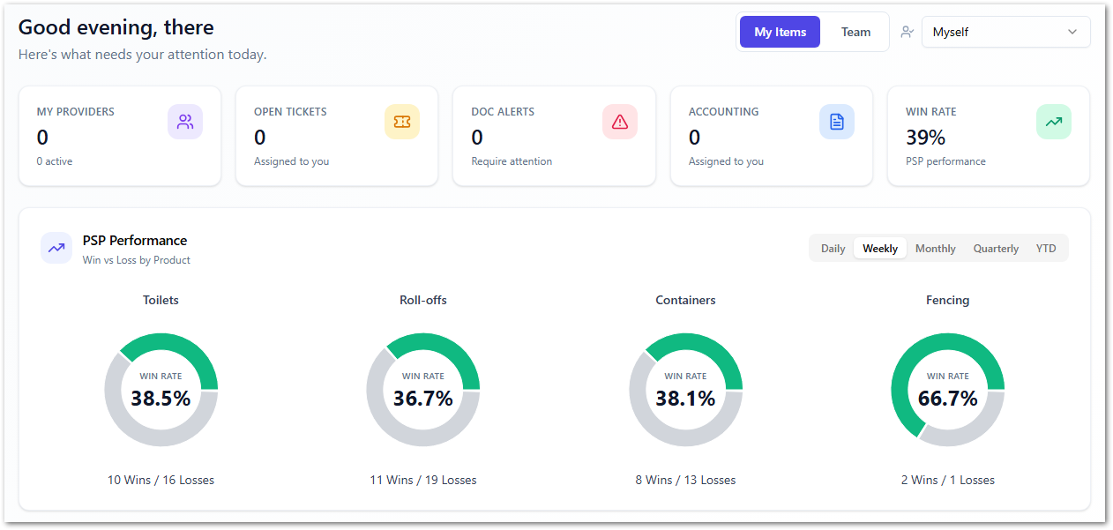

Customerz section
The Customerz section centralizes all customer-related information and operations within the CUBE platform. It allows users to manage customer profiles, contacts, service locations, and financial configurations such as billing preferences and transactions. This section serves as the foundation for linking customers to services, sites, and operational activities. It ensures accurate customer data management across the system.

Customers
This module displays a list of all customer records with key details such as name, contact information, and company. Users can search, filter, and manage records, as well as create new customers. This is the main entry point for customer management.
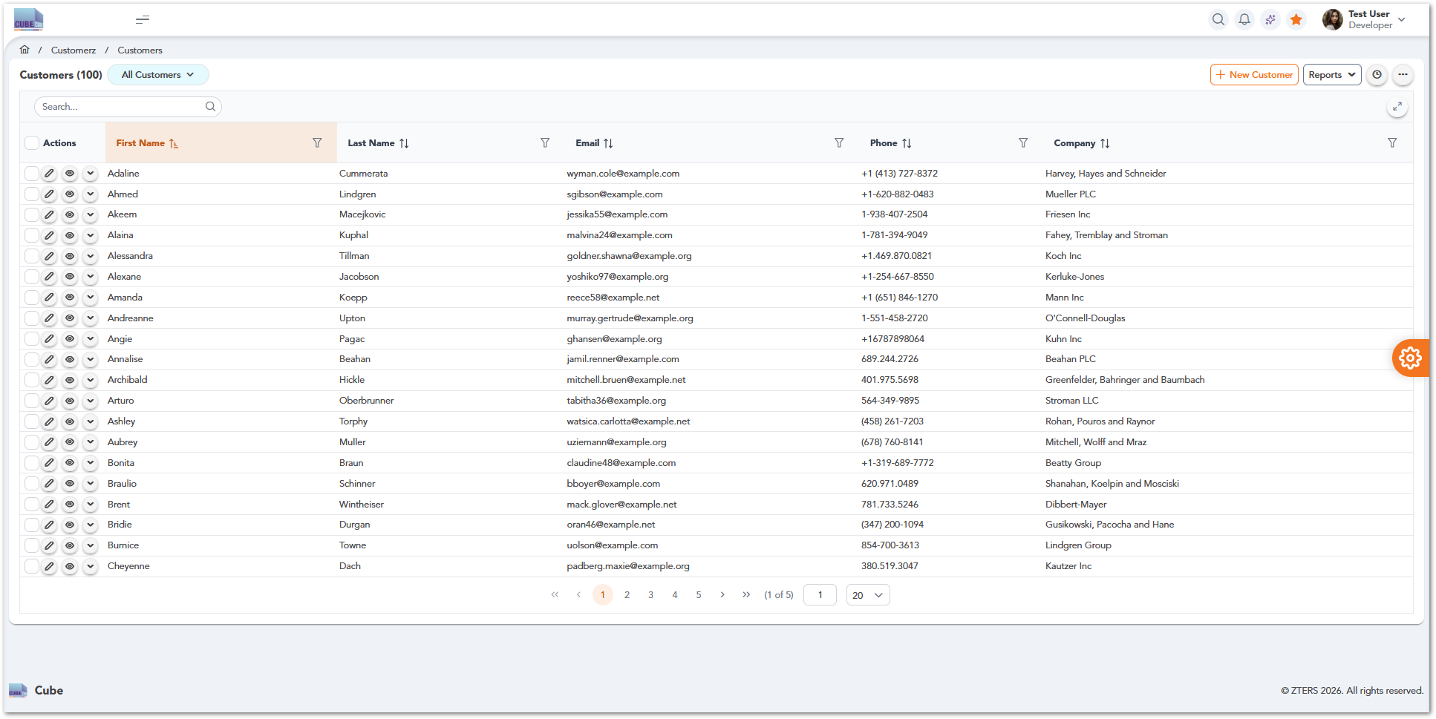

Customer Contacts
This module manages individual contacts associated with each customer account. This section is expected to store contact details such as names, roles, emails, and phone numbers, enabling effective communication and coordination with customer stakeholders. Contacts are typically linked to specific customer records.

Sites
This module manages service locations associated with customers. This section allows users to organize and track where services are delivered. It ensures operations are tied to the correct physical location.

Reviews
This module provides access to customer feedback and service evaluations. This section helps monitor service quality and identify improvement areas. It supports visibility in customer satisfaction.

CC Transactions
This module tracks credit card transactions linked to customer accounts. This includes payment activity and transaction status. It supports financial tracking and transparency.

Credit Limit Requests
This module manages requests related to customer credit limits. Users can review, approve, or update credit capacity. It supports financial control and risk management.

Accounting Inquiries
This module handles billing-related questions and financial issues from customers. This section supports tracking and resolving accounting concerns. It improves coordination between teams.

Billing Preferences
This module defines how customers are billed, including invoicing methods and payment preferences. This ensures billing aligns with customer agreements. It supports flexible financial operations.

Salez section
The Salez section focuses on managing the commercial and transactional aspects of the platform. It includes tools for handling products, service tickets, line items, and invoicing processes. Users can track pricing, manage assets, and monitor financial interactions related to sales. This section supports the full lifecycle of service transactions from creation to billing.

Products
This module manages the catalog of products and services available in the system. It allows users to define product details, pricing, and availability. It serves as the foundation for sales and service transactions.

Toilets
Manage portable toilet services, including standard units, specialty options, and servicing schedules.

Roll-offs
Handle temporary dumpster rentals for waste removal, typically used for construction and cleanup projects.

Containers
Manage storage container rentals for on-site storage needs, including delivery, pickup, and duration.

Fencing
Configure temporary fencing solutions for job sites, events, or restricted areas.

Front Loads
Manage scheduled waste collection services using front-load dumpsters for ongoing commercial use.

Equipment Rentals
Handle rentals of additional equipment such as machinery or support tools required for job sites.

Perm Roll-off
Manage permanent roll-off dumpster services for long-term or recurring waste management needs.

Grease Trap
Handle grease trap cleaning and maintenance services, typically for restaurants and commercial kitchens.

Other Services
Capture and manage miscellaneous services that do not fall under standard product categories.

Service Tickets
This module manages service tickets representing customer requests or operational tasks. It allows users to track the lifecycle of a service from creation to completion. It is central to managing service execution.

Line Items
This module manages individual items within service tickets, including quantities, pricing, and service details. It provides a detailed breakdown of services and charges. It ensures accuracy in billing and configuration.

Invoices
This module manages customer invoices, including creation, tracking, and status updates. It allows users to monitor billing and payment activity. It supports the financial lifecycle of transactions.

AP Hub
This module manages accounts payable processes, including vendor payments and financial reconciliation. It supports tracking outgoing payments. It ensures financial operations are properly recorded.

Pricing History
This module provides access to historical pricing data for products and services. It allows users to track changes over time. It supports auditing and pricing analysis.

Z Sight Monitors
This module provides visibility into operational and sales metrics through monitoring tools. It allows users to track system performance and activity. It supports data-driven decision-making.

Assets
This module manages assets associated with services, customers, or operations. It allows users to track asset details and assignments. It supports inventory and operational management.

Operationz section
The Operationz section manages the execution and coordination of services within the platform. It includes tools for handling service providers, fulfillment processes, vendor interactions, and pricing configurations. Users can track operational activities, manage service availability, and ensure proper service delivery. This section is critical for aligning internal operations with external providers.

Service Providers
This module manages vendors responsible for delivering services. It allows users to store provider details and maintain operational relationships. It supports coordination between internal teams and external partners.
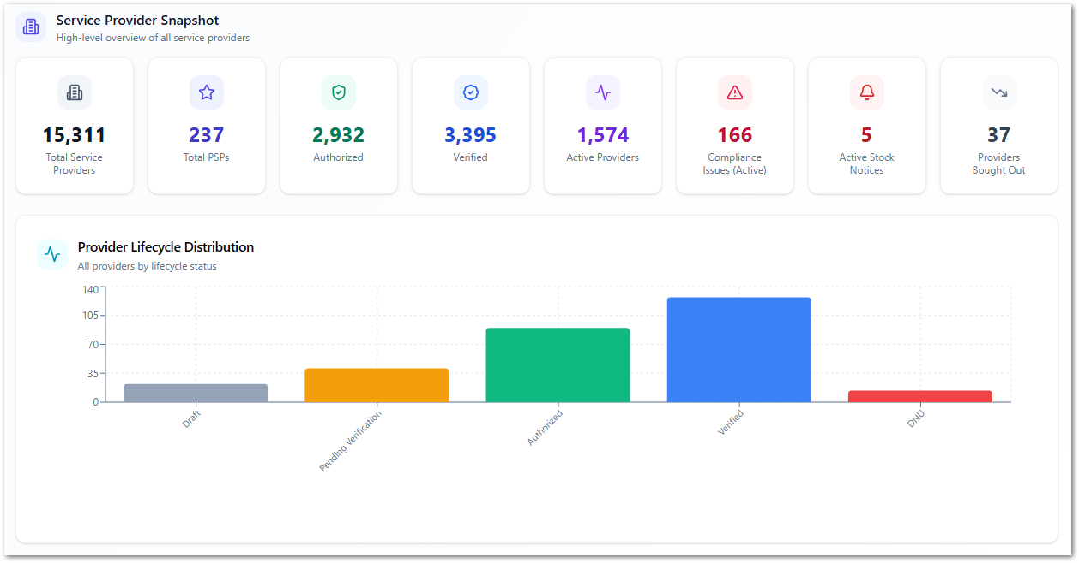
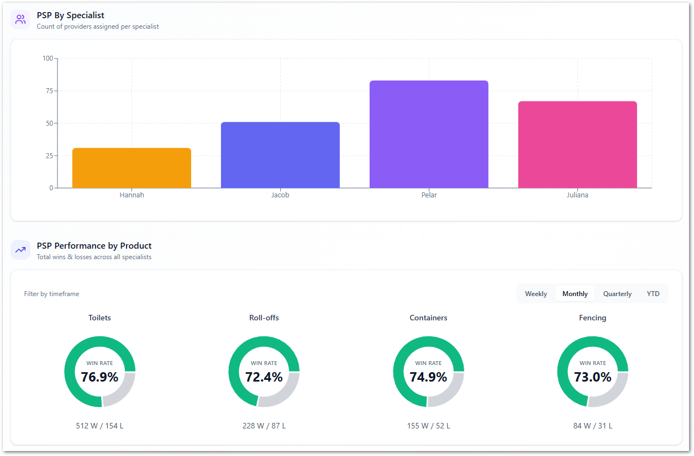

Service Provider Contacts
This module manages contact information for service providers and their representatives. It ensures proper communication channels are maintained. Contacts are linked to specific providers.

Fulfillment Tickets
This module manages tickets related to service fulfillment and execution. It allows users to track delivery, scheduling, and completion of services. It ensures customer requests are properly executed.

VM Tickets
This module manages vendor management tickets used for coordination with service providers. It supports tracking communication and resolving operational issues. It helps align vendor-related workflows.

Pricing Zones
This module defines geographic or operational zones used for pricing calculations. It allows users to organize areas based on service coverage. It supports location-based pricing strategies.

Pricings
This module manages pricing structures, rates, and rules for services and products. It allows users to configure how pricing is applied. It supports flexible and accurate pricing management.

Hauler Quotes
This module manages quotes submitted by service providers for service requests. It allows users to review and compare vendor pricing. It supports decision-making in service procurement.

VM Activities
This module tracks activities related to vendor management operations. It provides visibility into interactions and updates with service providers. It supports monitoring of vendor workflows.

Price Increases
This module manages updates and adjustments to pricing. It allows users to track and apply approved price changes. It supports financial control and transparency.

Out of Stock
This module tracks products or services that are currently unavailable. It provides visibility into stock limitations. It supports operational planning and service availability.

Zip Codes
This module manages geographic areas where services are available. It allows users to associate locations with providers and pricing. It supports accurate service coverage configuration.

Vendor Ratings
This module tracks and evaluates service provider performance. It allows users to review ratings and feedback. It supports quality control and vendor assessment.

Hauler Business Hours
This module manages the availability schedules of service providers. It allows users to define working hours and service windows. It supports scheduling and operational planning.

Administratorz section
The Administratorz section provides system configuration and control capabilities. It allows users to define codes, states, and system rules that govern workflows and data structure. This area supports internal administration, task management, and system customization. It ensures consistency and standardization across the platform.
Note: The Administratorz section is restricted by role-based access and only visible to admin users.

Products
This module manages the zters products and services. It ensures consistency across the system. It supports structured data management.

Product Codes
This module manages standardized codes used to identify products and services. It ensures consistency across the system. It supports structured data management.

Ticket Codes
This module defines codes used to classify and categorize tickets. It helps organize service requests and workflows. It supports better tracking and reporting.

States
This module manages system states used in workflows, such as statuses or process stages. It ensures consistency in process tracking. It supports workflow standardization.

Notes
This module manages internal notes associated with system records. It allows users to add contextual information or comments. It supports collaboration and traceability.

Vendor Link
This module manages relationships between service providers and system entities. It ensures proper linkage across modules. It supports data consistency and integration.

Tasks
This module manages internal tasks assigned to users. It allows tracking of activities and responsibilities. It supports operational coordination.

Lead Sources
This module manages the origin of leads, such as campaigns or referrals. It helps track how leads are generated. It supports sales analysis and reporting.

Lead Parent
This module manages hierarchical relationships between leads or accounts. It allows linking related entities. It supports better organization of sales data.

Answered Phone Calls
This module tracks and logs phone call interactions. It provides visibility into communication activities. It supports customer interaction tracking.

Userz section
The Userz section is responsible for managing user access and system security. It includes tools for creating users, defining roles, assigning permissions, and organizing groups. This section ensures that users have appropriate access based on their responsibilities. It supports role-based access control and system governance.

Users
This module manages user accounts with access to the platform. It allows creating, editing, and maintaining user information. It supports overall user administration.
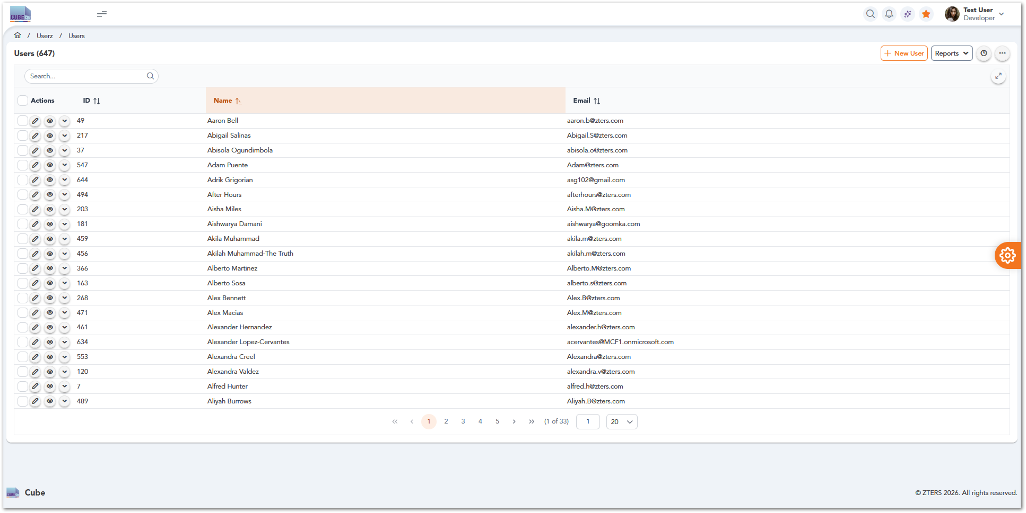

Roles
This module defines roles that determine user responsibilities and access levels. It allows grouping permissions based on job functions. It supports role-based access control.

Permissions
This module manages detailed access rights assigned to roles. It allows controlling what users can view or modify. It ensures system security and proper access control.

Groups
This module organizes users into groups for easier management. It allows assigning roles and permissions at a group level. It simplifies user administration.

Zeepz Section
The Zeepz section focuses on internal engagement and sales pipeline management. It includes tools for managing leads, employees, and recognition programs such as bonus points and badges. Users can track team participation and process reward redemptions. This section supports both operational engagement and sales-related activities.

Leads
This module manages potential customers and sales opportunities. It allows users to track lead information and progression. It supports pipeline management and conversion tracking.

Employees
This module manages internal employee records and related information. It allows users to maintain employee data within the system. It supports internal administration and tracking.

Bonus Points
This module manages the internal rewards system used to recognize employee contributions. It allows tracking and assigning points. It supports engagement and recognition initiatives.

Badges
This module manages recognition badges awarded to users. It allows creating and assigning badges based on achievements. It supports gamification and employee engagement.

Reportz section
The Reportz section provides access to data analysis and reporting tools within the platform. It includes predefined, custom, and AI-generated reports, as well as integrations with Power BI dashboards. Users can analyze operational and financial data to support decision-making. This section enables visibility into system performance and business insights.

Static Reports
This module provides access to predefined reports with standard system metrics. It allows users to view consistent and ready-to-use data. It supports routine monitoring and analysis.
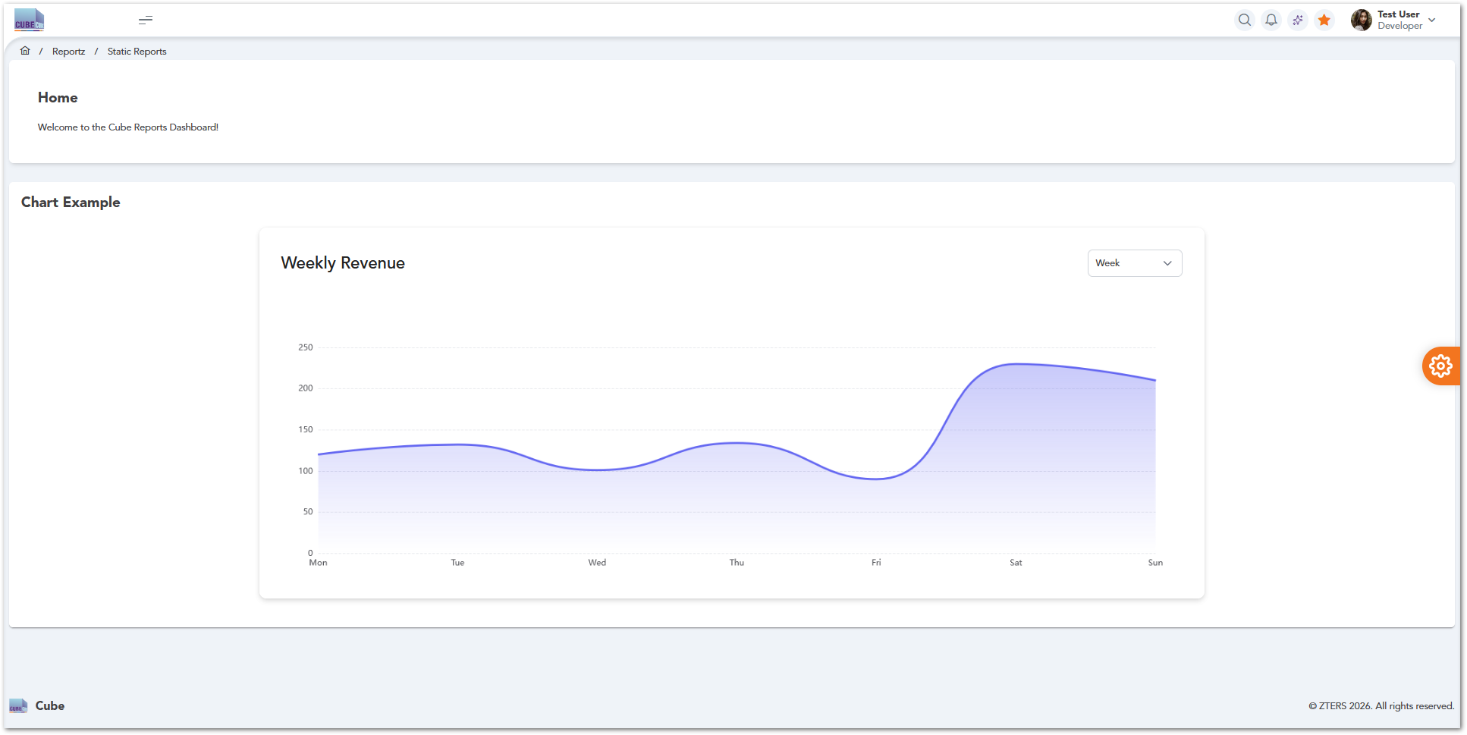

Custom Reports
This module allows users to create reports based on selected data fields and filters. It provides flexibility to generate tailored insights. It supports specific business and operational needs.
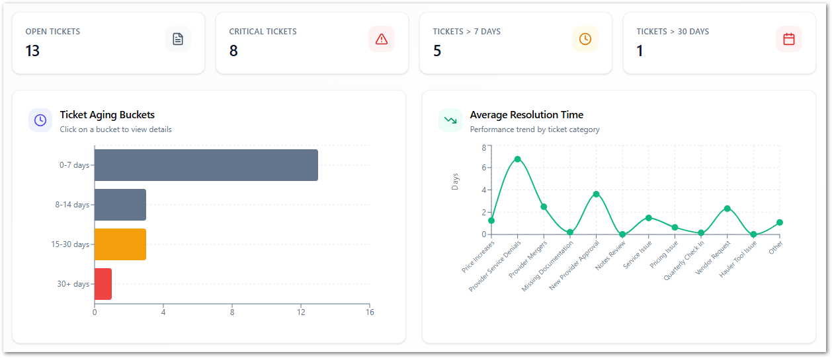

AI Reports
This module generates insights using AI-based analysis of system data. It helps identify trends, patterns, and potential predictions. It supports advanced decision-making.

Power BI Reports
This module provides access to reports integrated with Microsoft Power BI dashboards. It enables advanced data visualization and analytics. It supports business intelligence reporting.

Overall System Functionalities
This section describes common functionalities available across multiple modules within the CUBE platform, such as data filtering, bulk actions, export options, and table interactions. These features provide users with efficient ways to manage and analyze data regardless of the module being used.

Bulk Actions
Users can select multiple service provider records and apply actions to them simultaneously. Steps to Perform Bulk Actions:
- Navigate to Operationz → Service Providers.
- Locate the list of service providers displayed in the table.
- Use the checkboxes in the Actions column to select one or more records.
- To select all records on the page, use the checkbox located in the table header.
- Once records are selected, available bulk actions can be applied (depending on system configuration).
- Confirm the action if prompted.
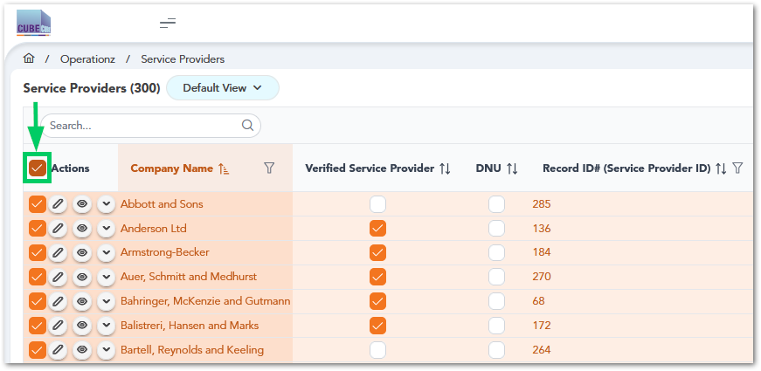

Export and Print Options
Users can export or print service provider data using the options available in the interface:
- Navigate to Operationz → Service Providers.
- Click the three-dot menu (⋯) located in the upper-right corner of the table.
- Select one of the following options:
- View Summary
- Export CSV
- Print
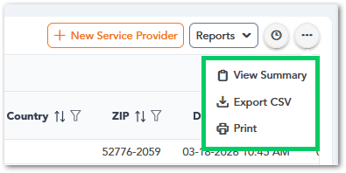

Settings

Header Controls
The Top Navigation Bar is located at the upper-right section of the CUBE interface and provides quick access to commonly used system functions and user-related options. These controls allow users to perform actions such as searching within the system, viewing notifications, accessing system utilities, and managing their user profile.
Icon / Element | Name | Description
 | Search | Allows users to quickly search within the application.
 | Notifications | Displays system alerts, updates, or important notifications.
 | Quick Actions | Provides access to additional system tools or quick actions.
 | Favorites | Allows users to bookmark or access frequently used items.
 | User Profile | Displays the logged-in user information and provides access to account-related options such as profile settings or logout.

Profile
Description of the user profile

Inbox
Description of user inbox

Settings
Description of settings section

User Roles
Role assignation for the application users. It could be presented in a table as follows:
Section | Module | AM | CSS | CWS | VM | Cube Leads | Cube Admin
Customerz | Customers | 
Customerz | Customer Contacts
Customerz | Sites
Customerz | Reviews
Customerz | CC Transactions
Customerz | Credit Limit Requests
Customerz | Accounting Inquiries
Customerz | Billing Preferences
Salez | Products
Salez | Service Tickets
Salez | Line Items
Salez | Invoices
Salez | AP Hub
Salez | Pricing History
Salez | Z Sight Monitors
Salez | Assets
Operationz | Service Providers
Operationz | Service Provider Contacts
Operationz | Fulfillment Tickets
Operationz | WM Tickets
Operationz | Pricing Zones
Operationz | Pricings
Operationz | Hauler Quotes
Operationz | VM Activities
Operationz | Price Increases
Operationz | Out of Stock
Operationz | Zip Codes
Operationz | Vendor Ratings
Operationz | Hauler Business Hours
Zeepz | Leads
Zeepz | Employees
Zeepz | Bonus Points
Zeepz | Badges
Administratorz | Products
Administratorz | Product Codes
Administratorz | Ticket Codes
Administratorz | States
Administratorz | (Combined) Notes
Administratorz | Vendor Link
Administratorz | Tasks
Administratorz | Lead Sources
Administratorz | Lead Parent
Administratorz | Answered Phone Calls
Userz | Users
Userz | Roles
Userz | Permissions
Userz | Groups
Reportz | Static Reports
Reportz | Custom Reports
Reportz | AI Reports
Reportz | Power BI Reports

Note: This section is mandatory for all applications with role-based access.

WORKING PROCEDURES
Workflows (including diagrams if applicable) for different options within the application.

Account Manager Working Procedures

Create and Manage a Customer Record

Purpose
This procedure describes how an Account Manager creates, searches, and manages customer records within the CUBE platform. Customer records store key information required for service delivery, billing, and operational activities.

Roles and Responsibilities
Role | Responsibility
Account Manager | Creates and manages customer records
Cube Admin | Maintains system configuration and user access if required

Preconditions
- The user must be logged into the CUBE platform.
- The user must have an Account Manager or Cube Admin role.
- The user must have access to Customerz → Customers.
- Required customer information must be available (name, contact details, company).

Process Diagram
Warning: Pending Diagram

Procedure Steps
Create a New Customer
- Navigate to Customerz → Customers.
- Click the New Customer button.
- Enter the required customer information (e.g., name, email, phone, company).
- Review the entered information.
- Click Save to create the record.
- Verify the customer appears in the customer list.
Search and Filter Customers
- Use the Search bar to locate specific customer records.
- Use column filters to refine results (e.g., name, email, company).
- Sort columns as needed to organize the data.
Manage Existing Customers
- Locate the customer in the table.
- Use the Actions column to:
- View details
- Edit the record
- Perform additional actions (if available)
- Save any updates made to the customer record.

System Behavior
Action | System Behavior
User opens Customers module | The system retrieves and displays a list of customer records.
User performs search/filter | The system dynamically updates the table based on criteria.
User creates a customer | The system validates input and stores the record in the database.
User updates a record | The system saves changes and refreshes the table view.

Results
- A new customer record is created and stored in the system.
- Customer information is available for linking to sites, services, and billing.
- Updated records are reflected immediately in the customer list.

Exceptions / Error Handling
Please refer to the troubleshooting section in BookStack.

Manage Service Sites

Purpose
This procedure describes how an Account Manager creates, searches, and manages service site records within the CUBE platform. Service sites represent physical locations where services are delivered.

Roles and Responsibilities
Role | Responsibility
Account Manager | Creates and manages service site records associated with customers
Cube Admin | Maintains system configuration and access permissions if necessary

Preconditions
- The user must be logged into the CUBE platform.
- The user must have an Account Manager or Cube Admin role.
- A customer record must already exist.
- The user must have access to Customerz → Sites.
- Required site information must be available (site name, location, associated customer).

Process Diagram
Warning: Pending Diagram

Procedure Steps
Create a New Site
- Navigate to Customerz → Sites.
- Click the New Site button.
- Enter required site information (site name, location, associated customer).
- Review the entered data.
- Click Save to create the site record.
- Verify the site appears in the list.
Search and Filter Sites
- Use the Search bar to locate specific site records.
- Apply filters based on location, customer, or other available fields.
- Sort columns to organize site information.
Manage Existing Sites
- Locate the site in the table.
- Use the Actions column to:
- View details
- Edit site information
- Perform additional actions (if available)
- Save updates to the site record.

System Behavior
Action | System Behavior
User opens Sites module | The system retrieves and displays site records.
User searches or filters | The system updates the table dynamically.
User creates a site | The system validates data and stores the record.
User updates a site | The system saves changes and refreshes the list.

Results
- A new service site is created and linked to a customer.
- Site records are available for service assignment and operations.
- Updates are reflected immediately in the system.

Exceptions / Erro Handling
Please refer to the troubleshooting section in BookStack.

Customer Success Specialist Working Procedures

Admin Working Procedures

APPROVAL SIGNATURES
Digital signature blocks below are formatted for DocuSign / Adobe Sign.
Name | Role | Digital Signature Block | Date (dd/mm/aa)
Anthony Bures | Digital Development Manager |  | 26/03/2026

--- END OF THE DOCUMENT ---

