<CUBE> USER GUIDE (ugu)



Document ID | DEV-CUBE-UGU-001-v1.0
Product | CUBE
Environment | DEV
Confidentiality Level | Internal / Restricted

CONTENTS
1 DOCUMENT INFORMATION 4
1.1 Validation 4
1.2 Document Distribution 4
1.3 Version Control 4
2 PREFACE 5
2.1 About this document 5
2.2 Related documents 5
2.3 Who should read this document 5
2.4 Terminology 5
2.5 Conventions Used 6
3 USER GUIDE 7
3.1 Overview 7
3.2 User Interface 7
3.2.1 Login Page 7
3.2.2 Dashboard 8
3.2.3 Sales Management 9
3.2.4 Users Management 9
3.2.5 Bonus Points 9
3.2.6 Reports 10
3.2.7 Interface Settings Panel 10
3.2.8 Header Controls 11
3.2.9 Profile 11
3.2.10 Inbox 11
3.2.11 Settings 11
3.3 User Roles 11
4 WORKING PROCEDURES 13
4.1 Account Manager Working Procedures 13
4.1.1 Create and Manage a Customer Record 13
4.1.2 Register and Manager a Service Site 14
4.1.3 Process Bonus Points Redemption Request 16
4.2 Customer Success Specialist Working Procedures 18
4.3 Admin Working Procedures 18
5 APPROVAL SIGNATURES 19

DOCUMENT INFORMATION

Validation
Name |  | Role | Date (dd/mm/aa)
Issued by | Oscar Rondon | Technical Writer | 16/03/2026
Verified by
Approved by | Anthony Bures | Digital Development Manager | 16/03/2026

Document Distribution
Normal | Role
Oscar Rondon | Technical Writer
Anthony Bures | Digital Development Manager

Version Control
Version | Date | Author | Description of changes
1.0 | 18/03/2026 | Oscar Rondon | First version of the CUBE UGU document

PREFACE

About this document
This document provides the User Guide (UGU) for the CUBE platform, describing the main features, user interface components, roles, and operational workflows available within the system.
The purpose of this guide is to help users understand how to navigate the application and perform common operational tasks within CUBE. It includes descriptions of the user interface, explanations of system modules, and step-by-step working procedures for typical activities performed in the platform.
This document is intended to support onboarding, training, and daily operational use of the CUBE system.

Related documents
All documents or elements used for reference are presented in the following table:
Title | Reference | Author | Version
SOP | HUB SOP | Oscar Rondon | 1.0

Who should read this document
This document is intended for users who interact with the CUBE platform as part of their operational responsibilities. These users may include:
- Account Managers, responsible for managing customer information and service locations.
- Customer Success Specialists, responsible for managing internal engagement features such as bonus points and redemption requests.
- Cube Administrators, responsible for managing user access, roles, and system configuration.
- ZTERS team members who require an understanding of the CUBE platform for operational or support purposes.
This guide may also be useful for new team members, support personnel, and stakeholders who need an overview of the system’s functionality and workflows.

Terminology
Term Used | Description
CUBE | The internal web application used to manage customers, service locations, operational resources, and reporting tools within the ZTERS platform.
Customer | An individual or organization receiving services managed through the CUBE system.
Site | A physical location associated with a customer where services such as containers, roll-offs, or portable toilets may be delivered or maintained.
Service Provider | A vendor or partner responsible for delivering services associated with customer sites.
User Role | A predefined set of permissions that determines what actions a user can perform within the system.
Bonus Points | An internal recognition system used to reward team members for achievements or contributions.
Redemption Request | A request submitted by a team member to exchange accumulated bonus points for rewards.
Report | A system-generated view or dataset used to analyze operational or business information within the platform.

Conventions Used
The following structures are used as recommendations.
Info: Supplementary Information

Tip: A recommendation or useful advice

Warning: A warning or important notice

Note: A notice.

USER GUIDE

Overview
The CUBE platform is a web-based application designed to support the management of customers, service locations, operational resources, and internal team activities within the ZTERS ecosystem.
The system provides users with tools to manage operational data, configure access permissions, track internal recognition programs, and generate analytical reports. Through a centralized interface, users can perform operational tasks such as managing customer records, configuring service sites, reviewing bonus point activities, and analyzing business data through reporting tools.
CUBE organizes its functionality into several main sections accessible through the left navigation panel:
- Sales Management – Manage customers, service sites, and service-related resources.
- Users Management – Manage user accounts, roles, permissions, and groups.
- Bonus Points – Manage internal recognition and reward activities.
- Reports – Access reporting and data analysis tools.
These modules enable users to perform daily operational tasks efficiently while maintaining proper access control and data visibility across the platform.

User Interface
Screenshots, descriptions, and other important information about the application’s interface and functionalities.

Login Page
The Login Page is the entry point to the CUBE platform. Users must authenticate with their credentials before accessing the system.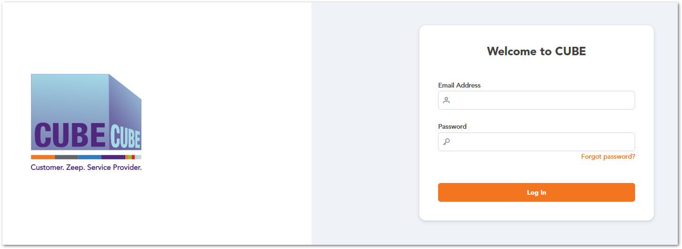

Forgot Password
The Forgot Password option allows users to recover access to their CUBE account if they are unable to log in due to a forgotten password. When this option is selected, the system prompts the user to enter the email address associated with their account. After submitting the request, the system sends a password recovery email containing instructions to reset the password.
Password Recovery Process
- On the Login Page, click Forgot Password.
- Enter the email address associated with your CUBE account.
- Click Send Recovery Mail.
- Check your email inbox for the password recovery message.
- Follow the instructions provided in the email to reset your password.
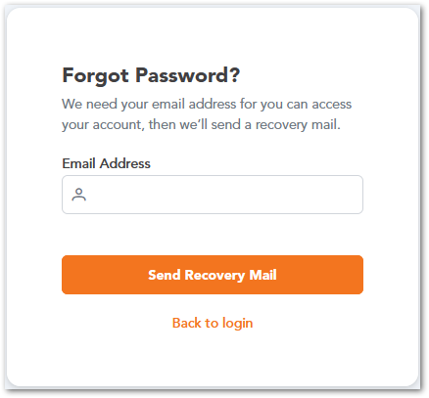
After completing the password reset process, the user can return to the Login Page and access the CUBE platform using the newly created password.

Dashboard
The Dashboard is the main landing page displayed after a user successfully logs into the CUBE platform. It provides an overview of system activity and quick access to frequently used features.
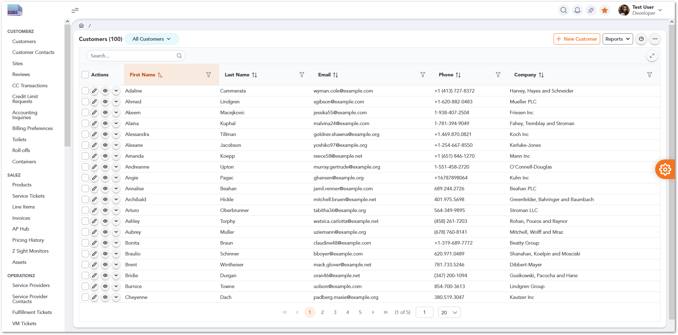

Sales Management
The Sales Management section in the left navigation sidebar provides quick access to the main modules used to manage customers, service locations, and service-related resources within the CUBE platform.
Module | Description
 | Manage customer records, including contact information, associated companies, and account details.
 | Manage service locations where equipment or services are delivered or installed.
 | Configure billing settings for customers, including invoicing preferences and payment details.
 | Maintain records of vendors or service partners responsible for delivering services.
 | Manage portable toilet inventory, configurations, and assignments to service sites.
 | Manage roll-off container services used for waste collection and disposal.
 | Manage storage containers and related equipment available for customer services.

Users Management
The Users Management section in the left navigation sidebar provides tools for administrators to manage user accounts and control access to the CUBE platform. This section allows authorized users to create and manage system users, define roles and permissions, and organize users into groups for easier administration.
Module | Description
 | Allows administrators to create, view, edit, and manage individual user accounts that can access the CUBE platform.
 | Defines sets of responsibilities or job functions that determine what actions users can perform within the system.
 | Specifies the detailed access rights assigned to roles, controlling which features or resources users can access or modify.
 | Organizes users into logical groups to simplify user management, role assignments, and access control.

Bonus Points
The Bonus Points section provides tools for managing the internal rewards and recognition system within the CUBE platform. This module allows administrators and managers to track team participation, manage reward points, review redemption requests, and configure recognition badges.
Module | Description
 | Displays an overview of the bonus points program, including summaries of points activity, recent updates, or key program information.
 | Allows administrators to view and manage the users participating in the bonus points program, including tracking points balances and activity.
 | Provides a list of reward redemption requests submitted by team members and allows administrators to review, approve, or reject them.
 | Enables administrators to create and manage recognition badges that can be awarded to team members for achievements or milestones.

Reports
The Reports section provides access to analytical and reporting tools within the CUBE platform. This section allows users to generate, view, and analyze operational and business data through different types of reports.
Module | Description
 | Provides access to predefined reports that display standard system data and metrics generated by the platform.
 | Allows users to create and configure personalized reports based on specific data fields, filters, or business requirements.
 | Uses AI-powered analysis to generate insights, trends, or predictive information based on system data.
 | Provides integration with Microsoft Power BI dashboards for advanced data visualization and business intelligence reporting.

Interface Settings Panel

The Interface Settings Panel allows users to customize the visual appearance and layout behavior of the CUBE platform. This panel can be opened by clicking the settings icon located on the right side of the screen.
Setting | Description
Menu Type  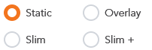 | Defines how the left navigation menu behaves (Static, Overlay, Slim, or Slim+).
Color Scheme   | Allows users to switch between light and dark interface themes.
Layout Theme  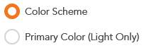 | Controls the color distribution across interface components.
Themes   | Allows users to select the primary color theme used throughout the interface.
Scale | Adjusts the overall size of interface elements for better readability.
Input Style   | Changes the visual style of form input fields.
Ripple Effect   | Enables or disables the ripple animation when interacting with interface elements.
These settings help improve usability and allow users to adapt the platform interface to their personal preferences.

Header Controls
The Top Navigation Bar is located at the upper-right section of the CUBE interface and provides quick access to commonly used system functions and user-related options. These controls allow users to perform actions such as searching within the system, viewing notifications, accessing system utilities, and managing their user profile.
Icon / Element | Name | Description
 | Search | Allows users to quickly search within the application.
 | Notifications | Displays system alerts, updates, or important notifications.
 | Quick Actions | Provides access to additional system tools or quick actions.
 | Favorites | Allows users to bookmark or access frequently used items.
 | User Profile | Displays the logged-in user information and provides access to account-related options such as profile settings or logout.

Profile
Description of the user profile

Inbox
Description of user inbox

Settings
Description of settings section

User Roles
Role assignation for the application users. It could be presented in a table as follows:
Description | Account Manager | Customer Success Specialist | Cube Admin
Access Sales Management – Customers | 
Access Sales Management – Sites
Access Sales Management – Billing Preferences
Access Sales Management – Service Providers
Access Sales Management – Toilets
Access Sales Management – Roll-offs
Access Sales Management – Containers
Access Users Management – Users
Access Users Management – Roles
Access Users Management – Permissions
Access Users Management – Groups
Access Bonus Points – Home
Access Bonus Points – Team Members
Access Bonus Points – Redemption Requests
Access Bonus Points – Badges
Access Reports – Static Reports
Access Reports – Custom Reports
Access Reports – AI Reports
Access Reports – Power BI Reports

Note: This section is mandatory for all applications with role-based access.

WORKING PROCEDURES
Workflows (including diagrams if applicable) for different options within the application.

Account Manager Working Procedures

Create and Manage a Customer Record

Purpose
This procedure describes how an Account Manager creates and manages customer records within the CUBE platform. Customer records store essential information such as contact details and company association, enabling the organization to manage customer relationships and related operational activities.

Roles and Responsibilities
Role | Responsibility
Account Manager | Creates and manages customer records
Cube Admin | Maintains system configuration and user access if required

Preconditions
Before starting this procedure:
- The user must be logged into the CUBE platform.
- The user must have an Account Manager or Cube Admin role.
- The required customer information must be available (name, contact information, company details).
- The user must have access to the Sales Management → Customers module.

Process Diagram
Warning: Pending Diagram

Procedure Steps
Step | Action
1 | Log in to the CUBE platform.
2 | From the left navigation menu, select Sales Management.
3 | Click Customers to open the Customers management page.
4 | Click the New Customer button located at the top of the page.
5 | Enter the required customer information (such as first name, last name, email, phone number, and company).
6 | Review the entered information to ensure accuracy.
7 | Click Save to create the customer record.
8 | Verify that the new customer appears on the Customers list.

System Behavior
Action | System Behavior
User opens Customers module | The system retrieves the list of existing customers from the database and displays them on the customer table.
User clicks New Customer | The system opens the customer creation form and initializes required input fields.
User enters customer information | The system performs input validation (required fields, data format such as email or phone number).
User clicks Save | The system validates the entered data and checks for potential conflicts (e.g., duplicate entries if applicable).
Record is accepted | The system stores the customer record in the customer database table.
Record creation completed | The system refreshes the customer list and displays the newly created record.

Results
After completing this procedure:
- A new customer record is created in the CUBE system.
- The customer appears on the Customers table.
- The record becomes available for future operations, such as linking service sites or managing customer-related services.

Exceptions / Erro Handling
Scenario | System Response
Required fields are missing | The system displays a validation error and prevents the record from being saved.
Duplicate customer information | The system may prevent record creation or request confirmation depending on system configuration.
User lacks required permissions | The user cannot access the Customers module or create new records.

Register and Manager a Service Site

Purpose
This procedure describes how an Account Manager registers and manages a service site within the CUBE platform. A service site represents a physical location where services such as containers, roll-offs, or portable toilets may be delivered or maintained. Registering service sites ensures that operational activities are properly associated with a customer's location.

Roles and Responsibilities
Role | Responsibility
Account Manager | Creates and manages service site records associated with customers
Cube Admin | Maintains system configuration and access permissions if necessary

Preconditions
Before starting this procedure:
- The user must be logged into the CUBE platform.
- The user must have the Account Manager or Cube Admin role.
- A customer record must already exist in the system.
- The user must have access to the Sales Management → Sites module.
- Required site information must be available (site name, location, and associated customer).

Process Diagram
Warning: Pending Diagram

Procedure Steps
Step | Action
1 | Log in to the CUBE platform.
2 | From the left navigation menu, select Sales Management.
3 | Click Sites to open the Sites management page.
4 | Click the New Site button located at the top of the page.
5 | Enter the required site information (such as site name, location, and associated customer).
6 | Review the entered information to ensure accuracy.
7 | Click Save to create the site record.
8 | Verify that the new site appears in the Sites list.

System Behavior
Action | System Behavior
User opens the Sites module | The system retrieves and displays the list of existing service sites.
User clicks New Site | The system opens the site creation form and initializes required fields.
User enters site information | The system performs validation checks on required fields and data formats.
User clicks Save | The system validates the data and verifies that required associations (such as customer) are present.
Record is accepted | The system stores the new site record in the site database.
Record creation completed | The system refreshes the Sites list and displays the newly created site.

Results
After completing this procedure:
- A new service site record is created in the CUBE system.
- The site is associated with a specific customer.
- The site becomes available for future operational activities such as assigning services or equipment.

Exceptions / Erro Handling
Scenario | System Response
Required fields are missing | The system displays a validation error and prevents the record from being saved.
Customer not selected | The system prompts the user to associate the site with a valid customer.
User lacks required permissions | The user cannot access the Sites module or create new records.

Process Bonus Points Redemption Request

Purpose
This procedure describes how a Customer Success Specialist reviews and processes a redemption request submitted through the Bonus Points system in the CUBE platform.
Team members may submit redemption requests to exchange accumulated bonus points for rewards. The Customer Success Specialist is responsible for reviewing these requests and approving or rejecting them based on the program guidelines.

Roles and Responsibilities
Role | Responsibility
Customer Success Specialist | Reviews and processes redemption requests
Cube Admin | Maintains configuration of the bonus points program if necessary
Team Member | Submits redemption requests

Preconditions
Before starting this procedure:
- The user must be logged into the CUBE platform.
- The user must have the Customer Success Specialist or Cube Admin role.
- A redemption request must have been submitted by a team member.
- The user must have access to Bonus Points → Redemption Requests.

Process Diagram
Warning: Pending Diagram

Procedure Steps
Step | Action
1 | Log in to the CUBE platform.
2 | From the left navigation menu, select Bonus Points.
3 | Click Redemption Requests to open the list of submitted requests.
4 | Locate and select the redemption request to review.
5 | Review the details of the request, including the requesting team member and the number of points being redeemed.
6 | Verify that the request complies with the bonus points program rules.
7 | Choose to Approve or Reject the redemption request.
8 | Confirm the selected action.
9 | Verify that the request status has been updated in the system.

System Behavior
Action | System Behavior
User opens Redemption Requests module | The system retrieves and displays all pending and processed redemption requests.
User selects a redemption request | The system displays the details of the selected request.
User reviews request information | The system allows the user to evaluate the request details before taking action.
User approves or rejects the request | The system updates the request status in the database.
Request status updated | The system refreshes the request list and displays the updated status.
Process completed | The system stores the decision for record keeping and future reference.

Results
After completing this procedure:
- The redemption request is approved or rejected.
- The request status is updated in the Redemption Requests list.
- The system records the decision for tracking and reporting purposes.

Exceptions / Erro Handling
Scenario | System Response
Request information is incomplete | The system prevents the request from being processed until the required information is available.
User lacks required permissions | The user cannot access the Redemption Requests module or process requests.
System error during processing | The system displays an error message and the request status remains unchanged.

Customer Success Specialist Working Procedures

Admin Working Procedures

APPROVAL SIGNATURES
Digital signature blocks below are formatted for DocuSign / Adobe Sign.
Name | Role | Digital Signature Block | Date (dd/mm/aa)
Anthony Bures | Digital Development Manager |  | 16/03/2026

--- END OF THE DOCUMENT ---

