<zsight> zsight tech user guide (ugu)



Document ID | DigDev_ZSight_User_Guide_(UGU)_v1.0
Product | ZSight
Environment | QA
Confidentiality Level | Internal / Restricted

Contents
1 DOCUMENT INFORMATION 4
1.1 Validation 4
1.2 Document Distribution 4
1.3 Version Control 4
2 PREFACE 5
2.1 About this document 5
2.2 Related documents 5
2.3 Who should read this document 5
2.4 Terminology 5
2.5 Conventions Used 5
3 USER GUIDE 7
3.1 Overview 7
3.2 User Interface 7
3.2.1 Login Page 7
3.2.2 Dashboard 8
3.2.3 Containers 8
3.2.4 Daily Feed 14
3.2.5 Notifications 14
3.2.6 Customers 16
3.2.7 Vendors 16
3.2.8 Device Management 16
3.2.9 Settings 17
3.3 Admin Options 19
3.3.1 Admin Dashboard 19
3.3.2 Accounts 19
3.3.3 Customers 19
3.3.4 User 19
3.3.5 Contracts 19
3.3.6 Subscriptions 19
3.3.7 Inventory 19
3.3.8 Installers 19
3.3.9 Reports 20
3.4 Overall System Functionalities 20
3.4.1 Filter 20
3.4.2 Search 20
3.4.3 Export 20
3.4.4 Show/Hide Columns 20
3.5 User Roles 21
4 WORKING PROCEDURES 22
4.1 Working Procedure 1 22
4.2 Working Procedure 2 22
4.3 Working Procedure 3 22
5 APPROVAL SIGNATURES 23

DOCUMENT INFORMATION

Validation
Name |  | Role | Date (dd/mm/aa)
Issued by | Oscar Rondon | Technical Writer | 20/04/2026
Verified by
Approved by | Anthony Bures | Digital Development Manager | 20/04/2026

Document Distribution
Normal | Role
Oscar Rondon | Technical Writer
Anthony Bures | Digital Development Manager
Ezequiel Garcia | ZSight Developer
Gabriela Romero | QA Engineer

Version Control
Version | Date | Author | Description of changes
1.0 | 20/04/2026 | Oscar Rondon | 1st version of the ZSight user guide (UGU) document

PREFACE

About this document
This User Guide (UGU) provides an overview of the ZSight application, including its interface, main features, and operational capabilities. It is intended to help users understand how to navigate the platform and use its functionalities to monitor and manage smart trash containers. The document includes descriptions of key modules, user interactions, and supporting workflows.

Related documents
All documents or elements used for reference are presented in the following table:
Title | Reference | Author | Version

Who should read this document
This document is intended for ZTERS team members, customers, and service providers who interact with the ZSight application. It is particularly useful for users responsible for monitoring container status, reviewing operational data, and coordinating service activities. New users can use this guide as a reference to understand the system, while experienced users can use it for feature clarification.

Terminology
Term Used | Description
ZSight | ZTERS application used to monitor and manage smart trash containers with camera-based insights.
Container | A physical waste container equipped with a camera to track fullness and activity.
Fullness Level | Measurement indicating how full a container is, based on image analysis.
Customer | Organization or client using ZSight to monitor their containers (e.g., McDonald's).
Vendor | Service provider responsible for collecting or servicing containers.
Device | Camera or hardware installed inside a container to capture images and data.
Daily Feed | Visual timeline of images and events captured for containers.
Monitoring | System capability to track container status, activity, and operational events.
Admin User | User with elevated permissions to manage accounts, configurations, and system data.

Conventions Used
The following structures are used as recommendations.
Info: Supplementary Information

Tip: A recommendation or useful advice

Warning: A warning or important notice

Note: A notice.

USER GUIDE

Overview
ZSight is a management application designed to monitor and manage smart cameras installed in residue containers. It allows customers to visualize the fill level of each container, review captured images, and track container status in real time. The system provides operational visibility to support timely collection and service planning. ZSight also facilitates collaboration between customers and service providers by centralizing container data in a single platform.

User Interface
The user interface starts with the ZSight logging page, and then multiple options show up for customers to keep track of their containers.

Login Page
The Login Page allows users to securely access the ZSight application by entering their registered email address and password.
Tip: Access to the application is restricted and requires connection through the ZTERS VPN.

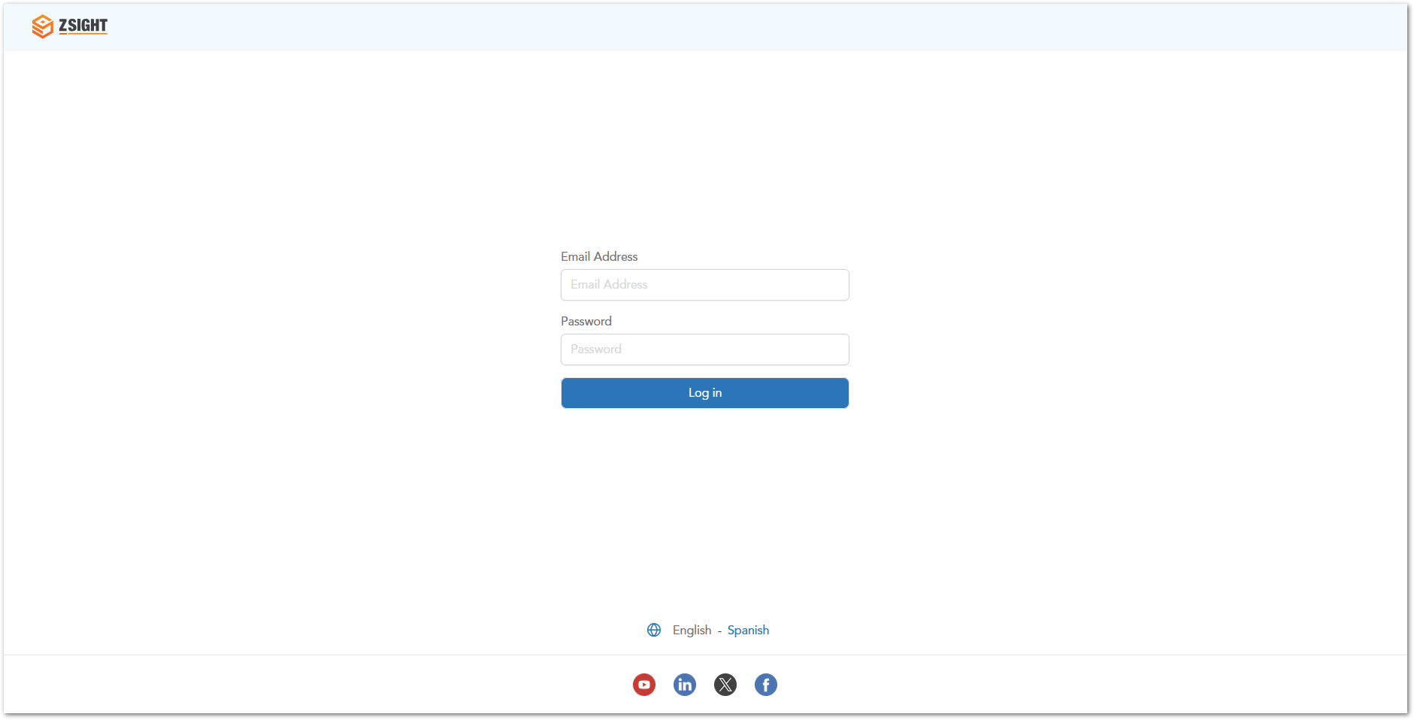

Dashboard
The Dashboard provides a high-level overview of container activity and key operational metrics. It allows users to quickly understand the overall status of their containers and identify areas that require attention.
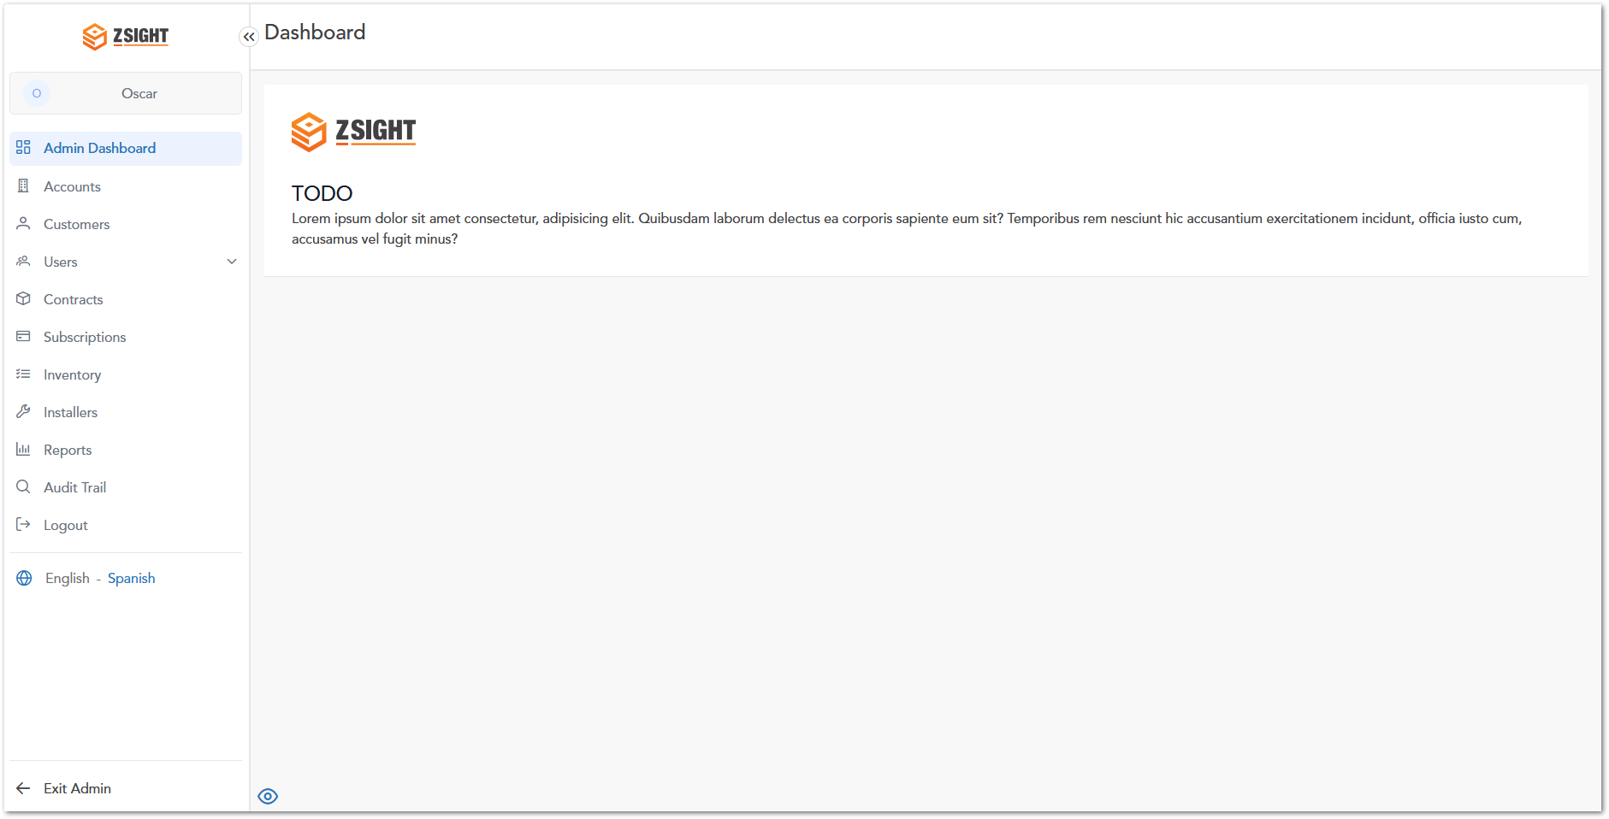

Containers
The Containers module allows users to view and monitor all registered containers within the system. It provides real-time visibility into container status, including fullness levels, recent activity, and service history. Users can access detailed information for each container, enabling better decision-making for waste collection and operational planning.

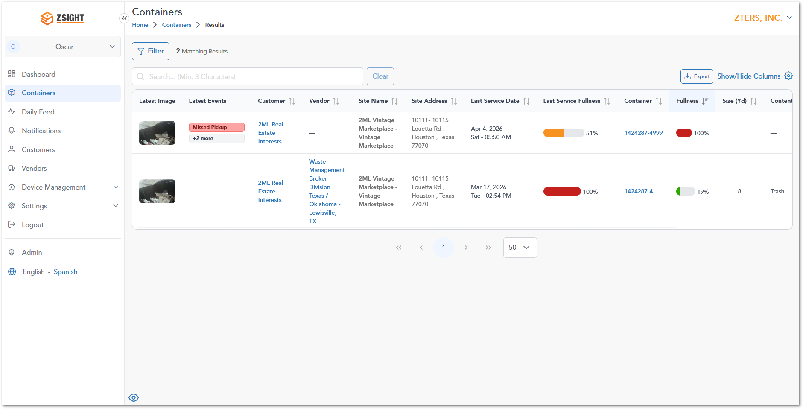

Containers Column Description
Name | Preview | Description
Latest Image |  | Displays the most recent image captured inside the container.
Latest Events | 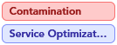  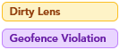  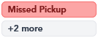 | The Latest Events column displays recent activity or alerts related to the container. These events help users quickly identify issues, operational updates, or system notifications.  Event Types:  - Contamination: Non-allowed or mixed waste detected inside the container.  - Service Optimization: Suggests adjustments to service timing or frequency.  - Tilted Camera: Camera is not properly positioned.  - Dirty Lens: Camera lens may be obstructed or dirty.  - Geofence Violation: Container has moved outside its designated location.  - Device Offline: Device is not transmitting data.  - Missed Pickup: Scheduled pickup did not occur.  - High Temperature: Abnormal temperature detected inside the container.  - Pickup Detected: A pickup service has been successfully completed.  - Installation: Device or container has been installed.  - +X more: Additional events exist but are not displayed in the preview.
Customer | Koepp-Hahn | Customer associated with the container.
Vendor | Johns-Gislason | Service provider responsible for servicing the container.
Site Name / Address | 84866 Abel Creek, Hahnmouth, MS 98157 | Physical location where the container is installed.
Last Service Date | Mar 19, 2026Thu - 01:42 PM | Date and time of the most recent service performed on the container.
Last Service Fullness |  | Fullness level recorded during the last service.
Container | 931-White7 | Unique identifier assigned to the container.
Fullness |  | Current fill level of the container, typically represented with a smaller visual indicator.
Size (Yd) | 2, 6, 8 cubic yards | Capacity of the container measured in cubic yards.
Content Type | Recycle | Types of waste contained in the container:  - Recycle  - Trash  - Compost  - Cardboard
Service Frequency | 2x/week•M/S | Container pickup service frequency per week, which includes the day(s) of the week in which the service is scheduled.  - 1x/week•Su  - 2x/week•M/S  - 3x/week•M/W/Th  - 4x/week•M/W/Th/Su  - 5x/week•M/T/Th/F/Su  - 6x/week•M/T/W/F/S/Su

Container Details – Preview Panel
When a user clicks on the Latest Image in the Containers module, a preview panel opens on the right side of the screen. This panel provides a quick overview of the container without leaving the main view.
Key Information Displayed
- Latest update: Enlarged view of the most recent image captured inside the container.
- Current Fullness: Visual indicator showing the current fill level percentage.
- Container Information: Container name, Size (Yd), Content type, Service frequency, Last Service.
- Pickup History: Summary metrics such as average, minimum, and maximum fullness.
- Content Composition: Breakdown of waste types (e.g., trash, recyclable, organic).
- Location & Vendor: Contact and service provider information.
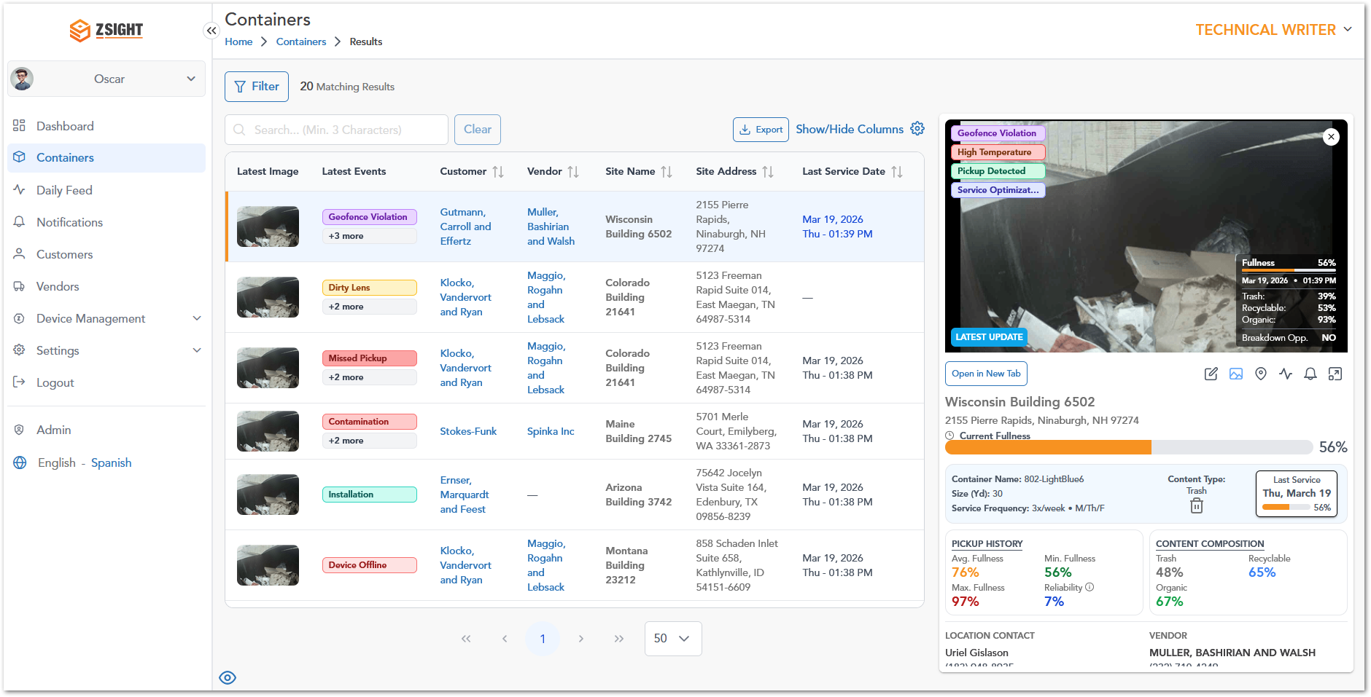

Container Details – Full View
By selecting Open in New Tab, the system opens the Container Details in a dedicated page. When scrolling down in the Container Details Full View, users can access additional operational and analytical information related to the container. This section provides deeper insights into device data, service performance, and optimization opportunities.
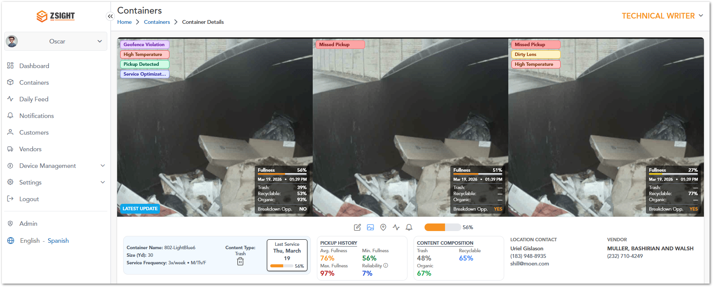
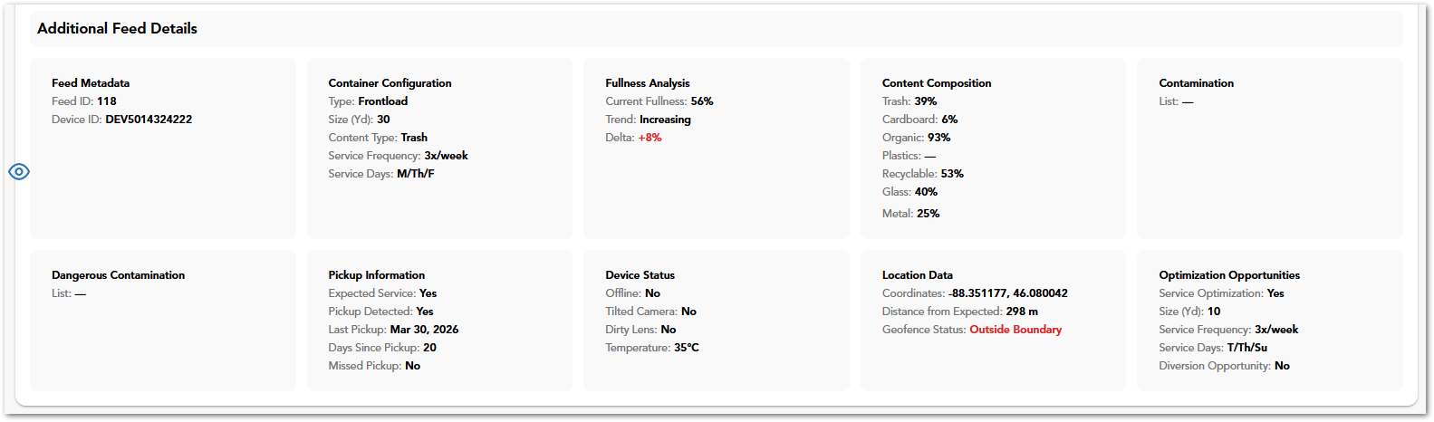
Sections Included
- Feed Metadata: Displays identification details such as Feed ID and Device ID associated with the container.
- Container Configuration: Provides configuration details including container type, size, content type, and scheduled service frequency and days.
- Fullness Analysis: Shows current fullness percentage, trend (e.g., increasing or decreasing), and variation over time.
- Content Composition: Breaks down the detected waste types (e.g., trash, recyclable, organic, glass, metal) with corresponding percentages.
- Contamination: Lists any detected contamination within the container (if applicable).
- Dangerous Contamination: Highlights any hazardous materials detected that may require special handling.
- Pickup Information: Includes service-related data such as expected service status, pickup detection, last pickup date, days since last pickup, and missed pickup indicators.
- Device Status: Displays operational status of the device, including connectivity, camera position, lens condition, and temperature.
- Location Data: Provides geolocation details such as coordinates, distance from expected location, and geofence status.
- Optimization Opportunities: Suggests potential improvements such as service optimization, recommended container size, service frequency, and diversion opportunities.

Container Details – Full View Menu
In the Container Details – Full View, users can access additional actions and views through a sub-menu located below the image section. To access these options:
- Navigate to the Containers module.
- Select a container to open the Container Details – Full View (using Open in New Tab).
- Locate the sub-menu bar positioned below the container images.
- Click on any of the available icons to switch between views or perform actions.
Name | Preview | Description
Edit container |  | Allows the user to modify container configuration details such as ID, type, size, content type and service settings.
Gallery Mode |  | This is the main page within the full view window for container details.
Map Mode |  | Shows location-related information and spatial context of the container.
Open Daily Feed |  | Redirects the user to the Daily Feed module filtered for the selected container
Open Notifications |  | Redirects the user to the Notifications module filtered for the selected container.
Container Fullness |  | Displays the current fill level of the container using a visual progress indicator.

Container Details – Full View Edit Container
The container edit option allows the user to modify container configuration details such as type, size, and service schedule.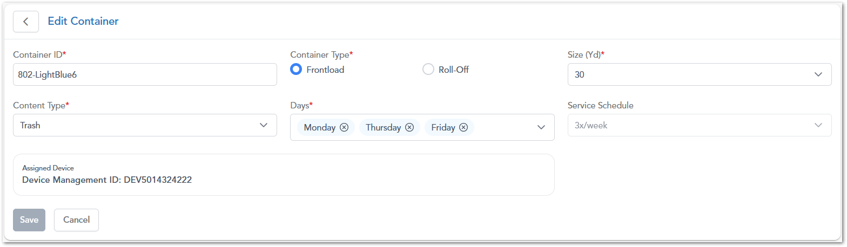

Container Details – Full View Container Location
The Location view displays the geographical position of the container on an interactive map, allowing users to visualize its placement and proximity to surrounding areas.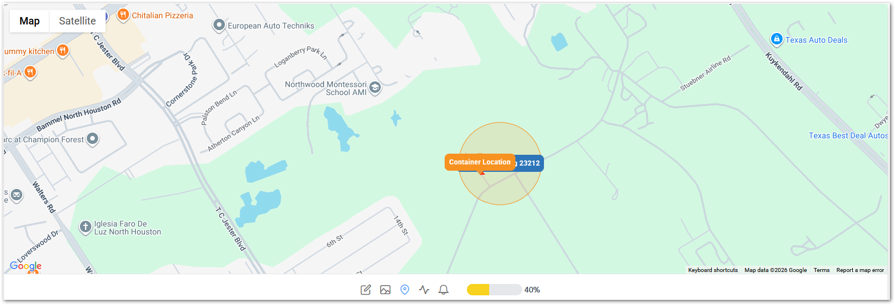

Daily Feed
The Daily Feed displays a chronological stream of images and events captured from containers, allowing users to review recent activity and monitor changes in container status over time. The module presents information using a table structure similar to the Containers module, as it reflects the operational status of containers for a given day. Additionally, it includes extra fields related to the type of content being collected, providing more context for daily operations.
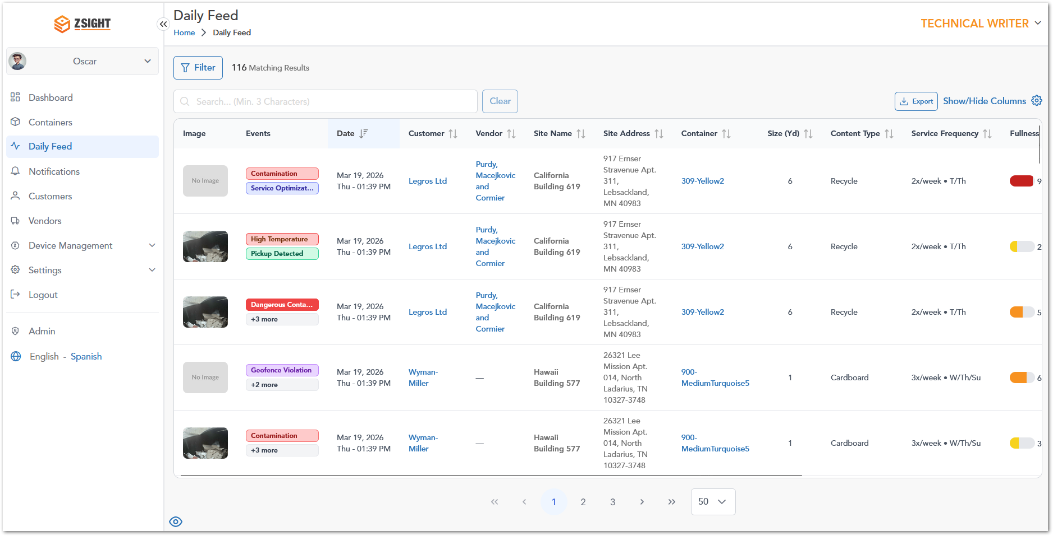

Daily Feed Extra Column Description
Name | Preview | Description
Trash |  | Indicates the % of general (non-recyclable) waste detected inside the container.
Organic |  | Indicates the % of organic waste (e.g., food or biodegradables) inside the container.
Recyclable |  | Indicates the overall % of recyclable materials detected inside the container.
Cardboard |  | Indicates the % of recyclable cardboard material detected inside the container.
Plastics |  | Indicates the % of recyclable plastic waste detected inside the container.
Glass |  | Indicates the % of recyclable glass material detected inside the container.
Metal |  | Indicates the % of recyclable metal waste detected inside the container.

Notifications
The Notifications module provides a centralized view of system-generated alerts related to containers, devices, and operational events. It allows users to track issues, monitor their status, and review their lifecycle from detection to resolution.
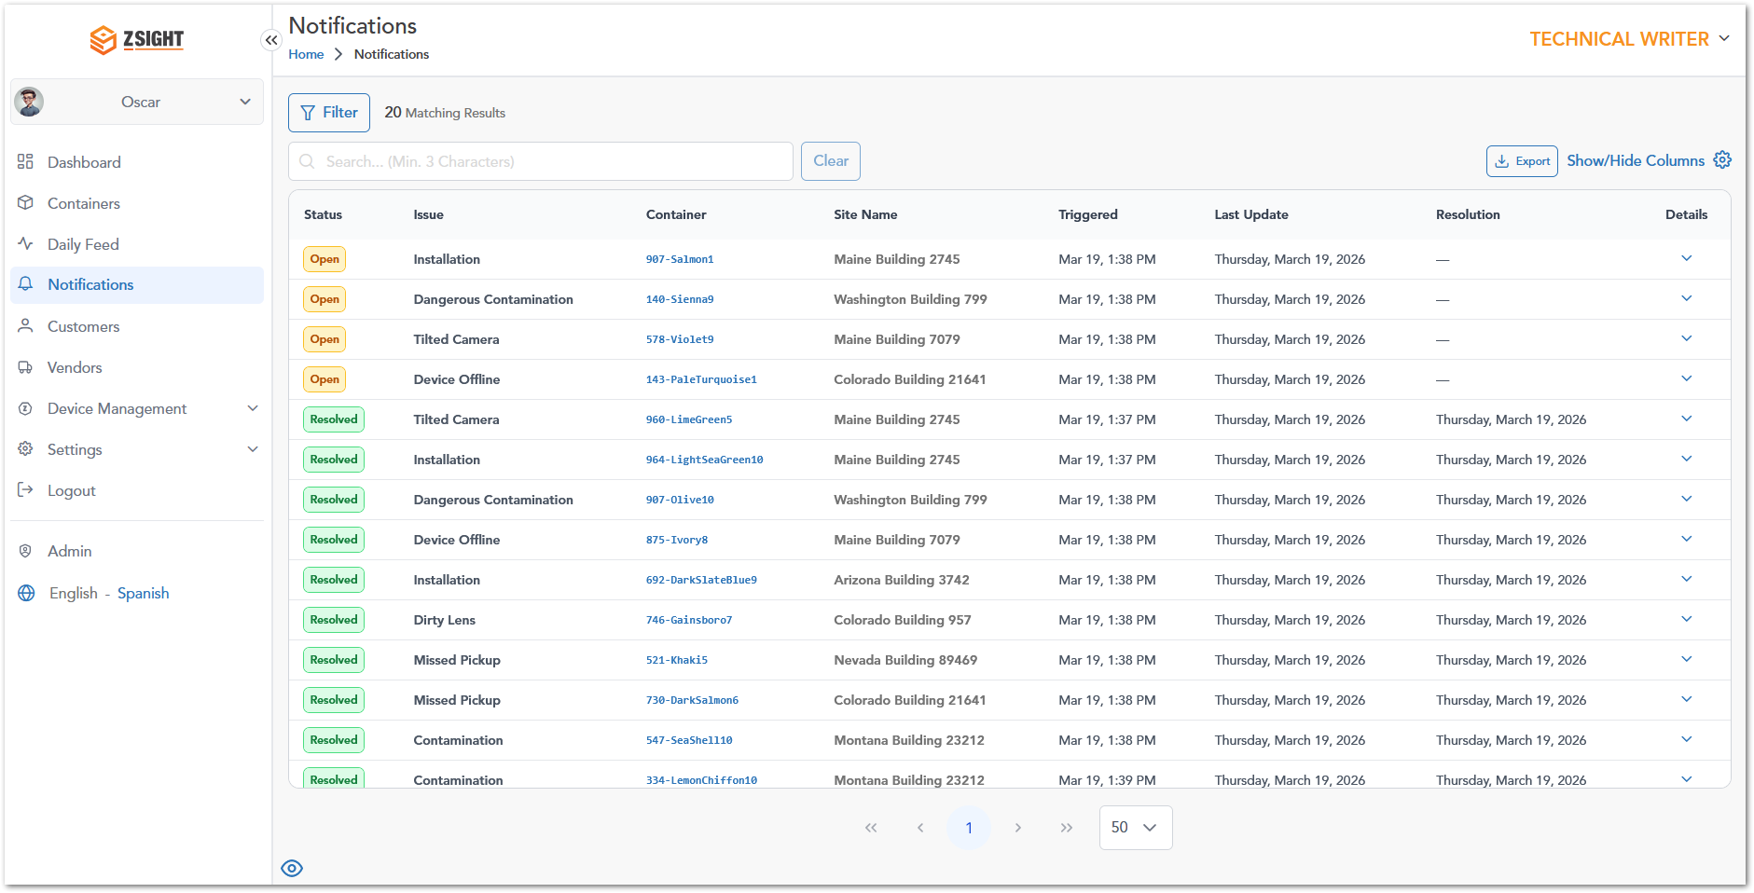

Notifications Column Description
Name | Preview | Description
Status | 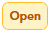   | Current state of the notification:  - Open: Indicates that the issue is active and requires attention.  - Resolved: Indicates that the issue has been addressed and closed.
Issue | Installation | Type of event or problem detected (e.g., contamination, device offline).
Container | 907-Salmon1 | Identifier of the container associated with the notification.
Site Name | Maine Building 2745 | Location where the container is installed.
Triggered | Mar 19, 1:38 PM | Date and time when the notification was generated.
Last Update | Thursday, March 19, 2026 | Most recent update related to the notification.
Resolution | Thursday, March 19, 2026 | Date when the issue was resolved (only resolved issues have dates).
Details | Koepp-Hahn | Expandable option to view additional information.

Notifications – Open Issue Details
When an Open notification is expanded, the system displays detailed information about the active issue, including the number of days since it was triggered and any related events. It also provides Linked Feed Records, which represent the sequence of events captured in the Daily Feed that led to the alert. These records include timestamps, fullness indicators, and event labels (e.g., trigger), allowing users to understand the context, progression, and current state of the issue.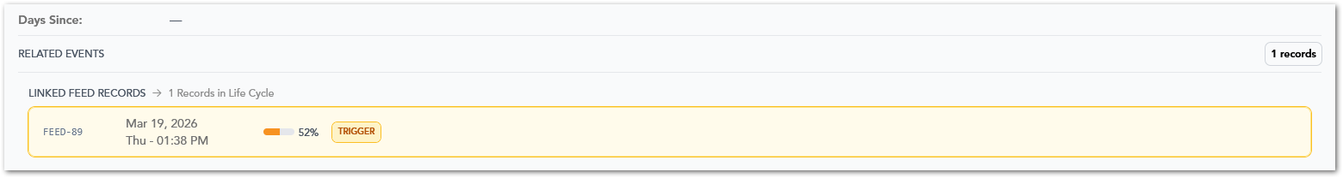

Notifications – Resolved Issue Details
When a Resolved notification is expanded, the system displays detailed information about the issue, including device-related data (such as intended and actual device serial numbers), installation details, and the total number of days since the issue was triggered. It also includes Linked Feed Records, which show the full lifecycle of events associated with the issue—from the initial trigger to its resolution. These records include timestamps, fullness indicators, and event labels (e.g., trigger and resolution), allowing users to understand how the issue progressed and when it was successfully resolved.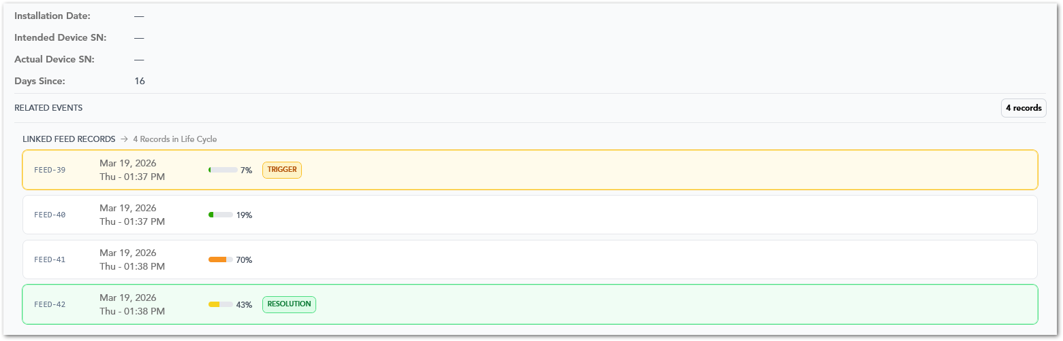

Customers
The Customers module provides a centralized view of all customers managed within the system, allowing users to access, monitor, and maintain customer-related information. From this module, users can review key operational data such as service locations, assigned containers, contact details, account ownership, and customer status.
It also enables efficient data management through search, filtering, sorting, column customization, and export functionalities, supporting both day-to-day operations and reporting needs.

Customers Column Description
Name | Description
Customer Name | Displays the name of the customer; clickable to access detailed customer information.
Customer ID | Unique identifier assigned to each customer in the system.
Service Locations | Indicates the number of service locations associated with the customer.
Containers | Shows the total number of containers assigned to the customer.
Contact Name | Name of the primary contact for the customer account.
Contact Phone Number | Phone number of the primary contact.
Contact Email | Email address of the primary contact.
Account Manager | Account manager responsible for managing the customer account.
Date Added | Date when the customer was created in the system.
Status | Indicates whether the customer is active or inactive.
Actions | Provides available actions for the record, such as editing the customer.

Vendors
The Vendors module provides a centralized view of all service providers associated with the system, allowing users to manage vendor-related information and monitor their operational involvement. From this module, users can review key details such as vendor contact information, service coverage, associated containers, and optimization activity.
It also supports efficient data management through search, sorting, column customization, and export functionalities, enabling users to easily access and maintain vendor records.

Vendors Column Description
Name | Description
Vendor Name | Displays the name of the vendor; clickable to access detailed vendor information.
Vendor ID | Unique identifier assigned to each vendor in the system.
Address | Physical address associated with the vendor.
Contact Phone Number | Phone number of the vendor’s primary contact.
Contact Email | Email address of the vendor’s primary contact.
# Containers | Indicates the number of containers associated with the vendor.
# Service Optimization | Shows the number of service optimization instances related to the vendor.
Actions | Provides available actions for the record, such as editing the vendor.

Device Management
The Device Management module allows users to manage cameras and hardware installed in containers. It includes device status, configuration, and maintenance-related information.

Devices
This section provides a detailed view of all registered devices, including their status, association with containers, and operational performance.
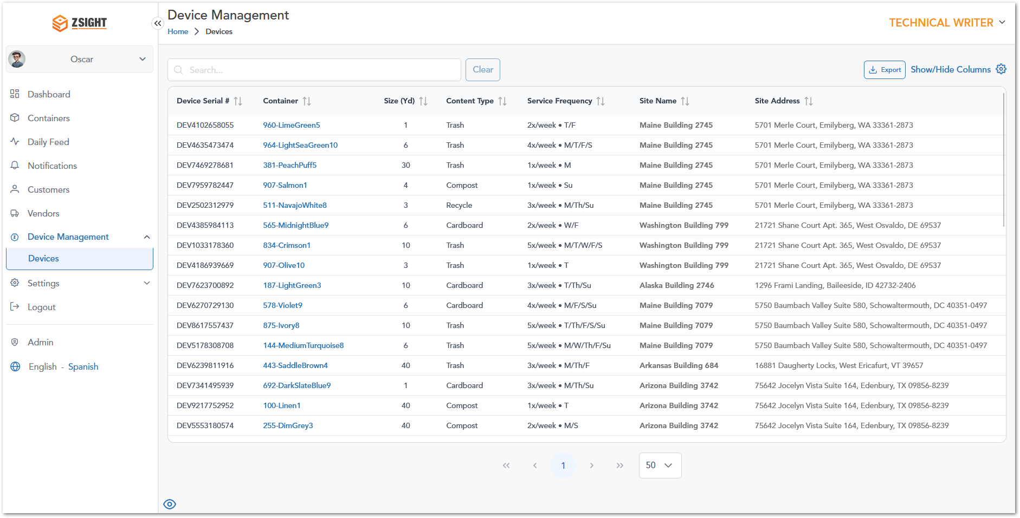

Settings
Description of section 2

My Profile
Description of section 2
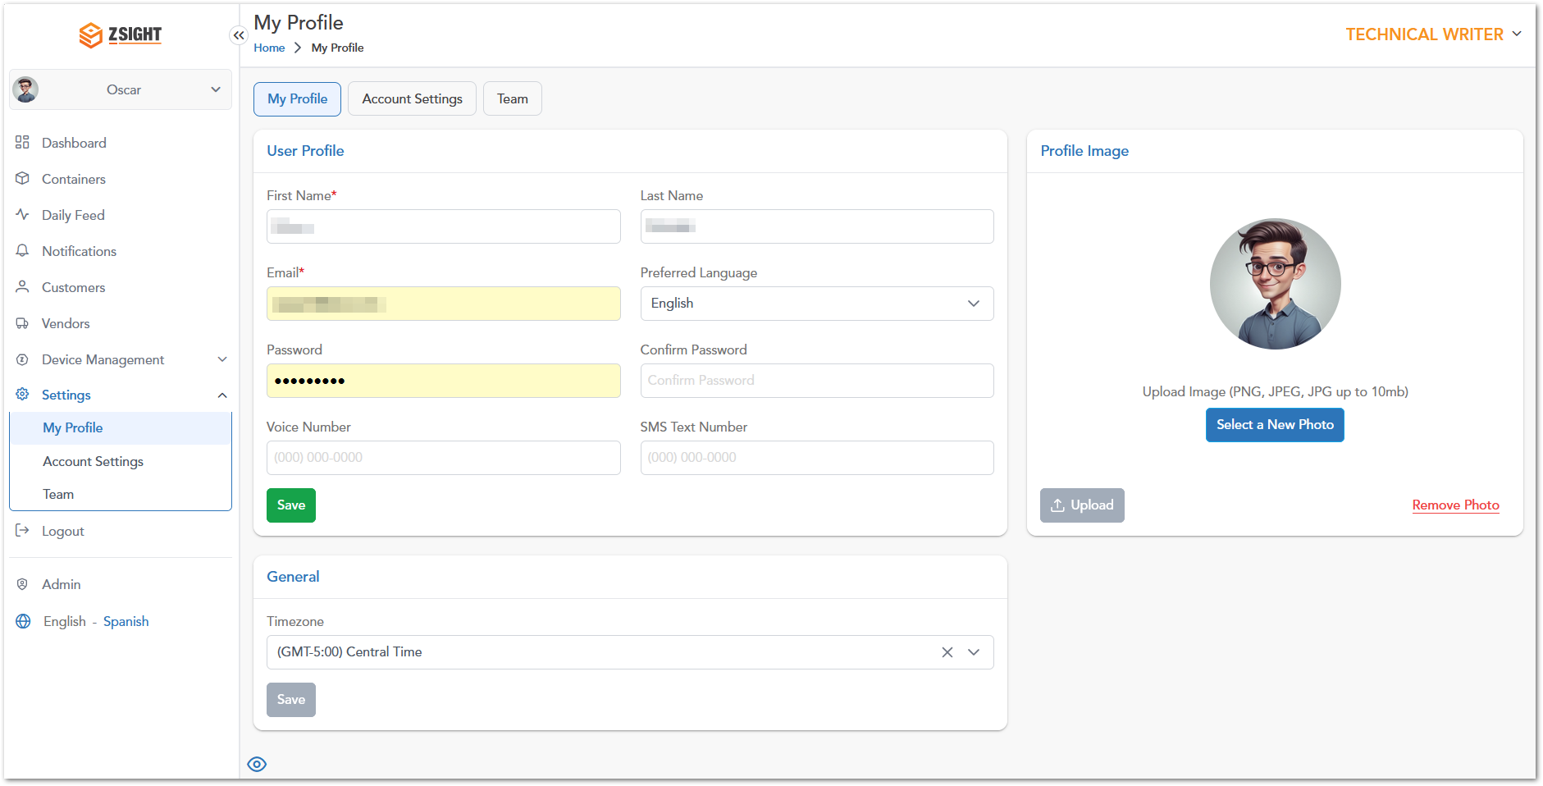

Account Settings
Description of section 2
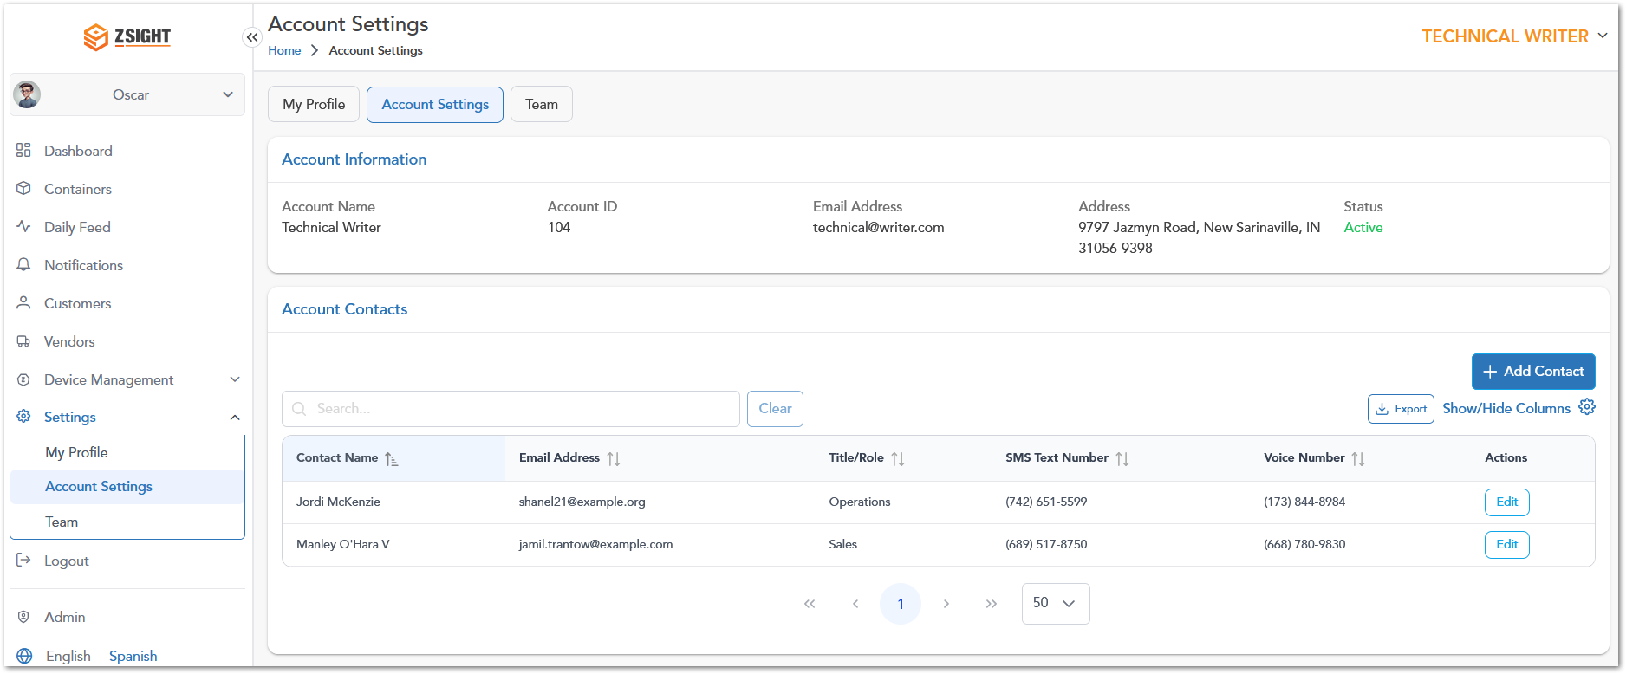

Team
Description of section 2
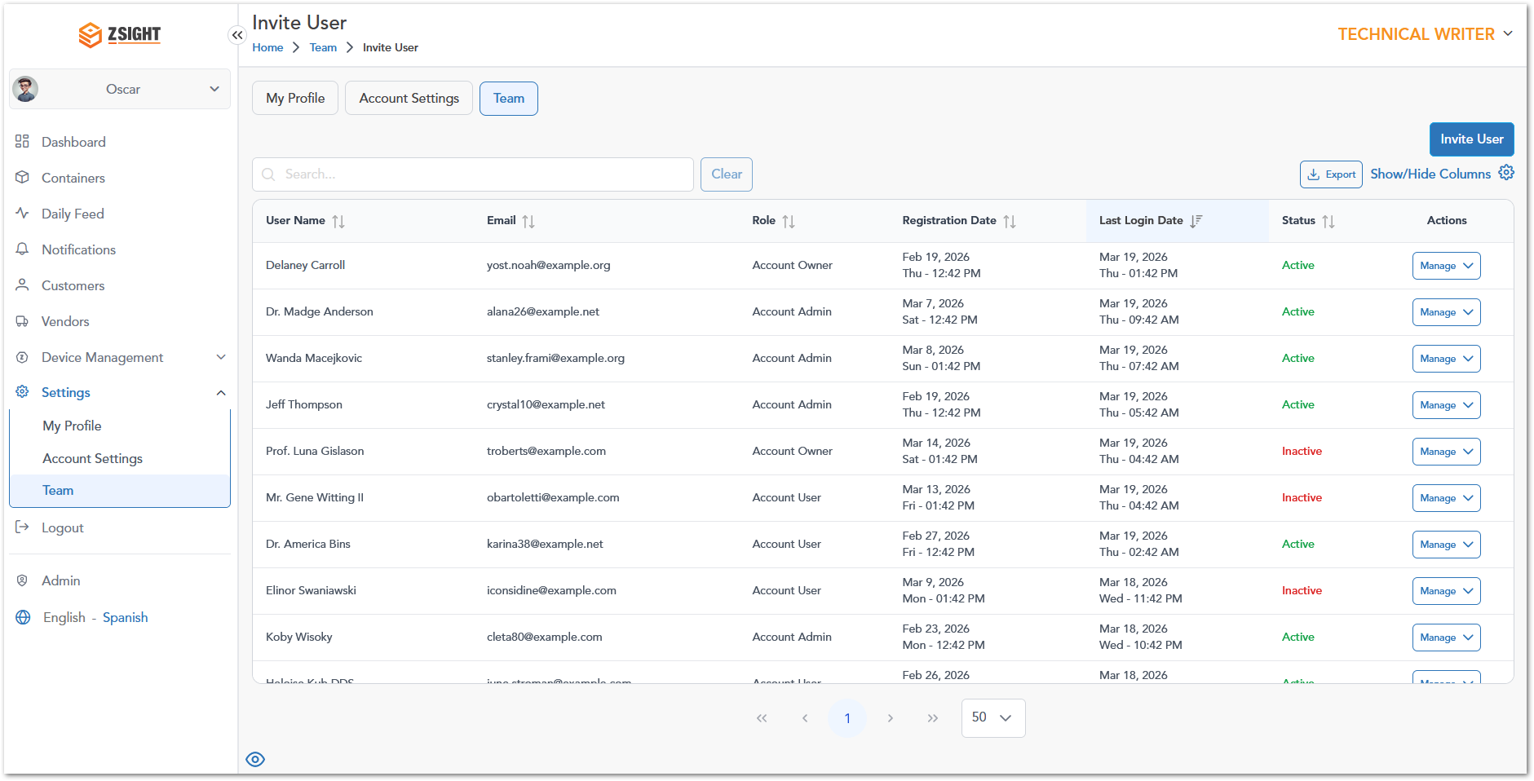

Admin Options
Screenshots, descriptions, and other important information about the application’s interface and functionalities.

Admin Dashboard
The login page for the website is presented here:

Accounts
The login page for the website is presented here:

Customers
The login page for the website is presented here:

User
The login page for the website is presented here:

Contracts
The login page for the website is presented here:

Subscriptions
The login page for the website is presented here:

Inventory
The login page for the website is presented here:

Installers
The login page for the website is presented here:

Reports
The login page for the website is presented here:

Overall System Functionalities
Screenshots, descriptions, and other important information about the application’s interface and functionalities.

Filter
The login page

Search
The login page

Export
The login page

Show/Hide Columns
The login page

User Roles
Role assignation for the application users. It could be presented in a table as follows:
Description | User 1 | User 2 | Admin User
Access to the invoice summary interface 1 | 
Access to the invoice summary interface 2
Access to the invoice summary interface 3

Note: This section is mandatory for all applications with role-based access.

WORKING PROCEDURES
Workflows (including diagrams if applicable) for different options within the application.

Working Procedure 1
Working Procedure 1 (e.g. “Create invoice…”)

Working Procedure 2
Working Procedure 2. (e.g. “Approve request…”)

Working Procedure 3
Working Procedure 2. (e.g. “Generate Report…”)

APPROVAL SIGNATURES
Digital signature blocks below are formatted for DocuSign / Adobe Sign.
Name | Role | Digital Signature Block | Date (dd/mm/aa)
Approval’s name | Approval’s role |  | 20/04/2026

--- END OF THE DOCUMENT ---

