zsight tech user guide



Document ID | DEV-ZSG-UGU-001-v1.0
Product | ZSight
Department | Digital Development
Confidentiality Level | Public

CONTENTS
1 DOCUMENT INFORMATION 4
1.1 Validation 4
1.2 Document Distribution 4
1.3 Version Control 4
2 PREFACE 5
2.1 About this document 5
2.2 Related documents 5
2.3 Who should read this document 5
2.4 Terminology 5
2.5 Conventions Used 5
3 USER GUIDE 6
3.1 Overview 6
3.2 User Interface 6
3.2.1 Loggin Page 6
3.2.2 Dashboard 6
3.2.3 Containers 7
3.2.4 Daily Feed 10
3.2.5 Customers 10
3.2.6 Vendors 11
3.2.7 Device Management 11
3.2.8 Settings 13
3.2.9 Monitoring 14
3.2.10 Contact & Help 15
3.3 Admin Options 15
3.3.1 Admin Dashboard 16
3.3.2 Accounts 16
3.3.3 Customers 16
3.3.4 User 17
3.3.5 Contracts 17
3.3.6 Subscriptions 17
3.3.7 Inventory 17
3.3.8 Installers 17
3.3.9 Reports 17
3.4 User Roles 18
4 WORKING PROCEDURES 19
4.1 Working Procedure 1 19
4.2 Working Procedure 2 19
4.3 Working Procedure 3 19
5 APPROVAL SIGNATURES 20

DOCUMENT INFORMATION

Validation
Name |  | Role | Date (dd/mm/aa)
Issued by | Oscar Rondon | Technical Writer | 14/01/2026
Verified by

Document Distribution
Normal | Role
Oscar Rondon | Technical Writer
Anthony Bures | Digital Development Manager

Version Control
Version | Date | Author | Description of changes
1.0 | 14/01/2026 | Oscar Rondon | First version of the ZSight Tech UGU document

PREFACE

About this document
This user guide (UGU) displays all the different interfaces / option for the ZSight application.

Related documents
All documents or elements used for reference are presented in the following table:
Title | Reference | Author | Version
SOP | SOP about the guide. | Name of the author | 1.0

Who should read this document
Intended for ZTERS team members or customers who interact with this application

Terminology
Term Used | Description
Term 1 | Definition / description 1
Term 2 | Definition / description 2
Term 3 | Definition / description 3

Conventions Used
The following structures are used as recommendations.
Tip: A recommendation or useful advice

Warning: A warning or important notice

Note: A notice.

USER GUIDE

Overview
ZSight is a management application designed to monitor and manage smart cameras installed in residue containers. It allows customers to visualize the fill level of each container, review captured images, and track container status in real time. The system provides operational visibility to support timely collection and service planning. ZSight also facilitates collaboration between customers and service providers by centralizing container data in a single platform.

User Interface
The user interface starts with the ZSight logging page, and then multiple options show up for customers to keep track of their containers.

Loggin Page
The login page asks for the email address and password.
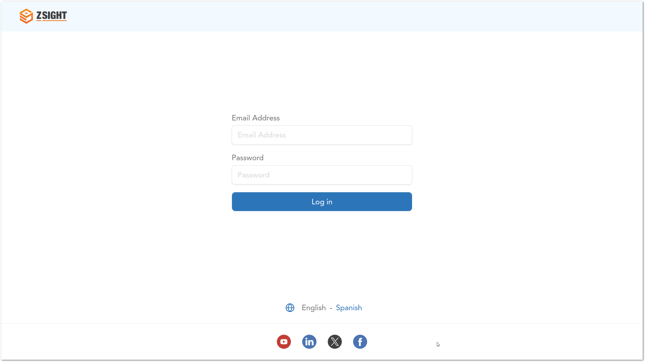

Dashboard
The dashboard is in progress and will show different metrics for the customers.
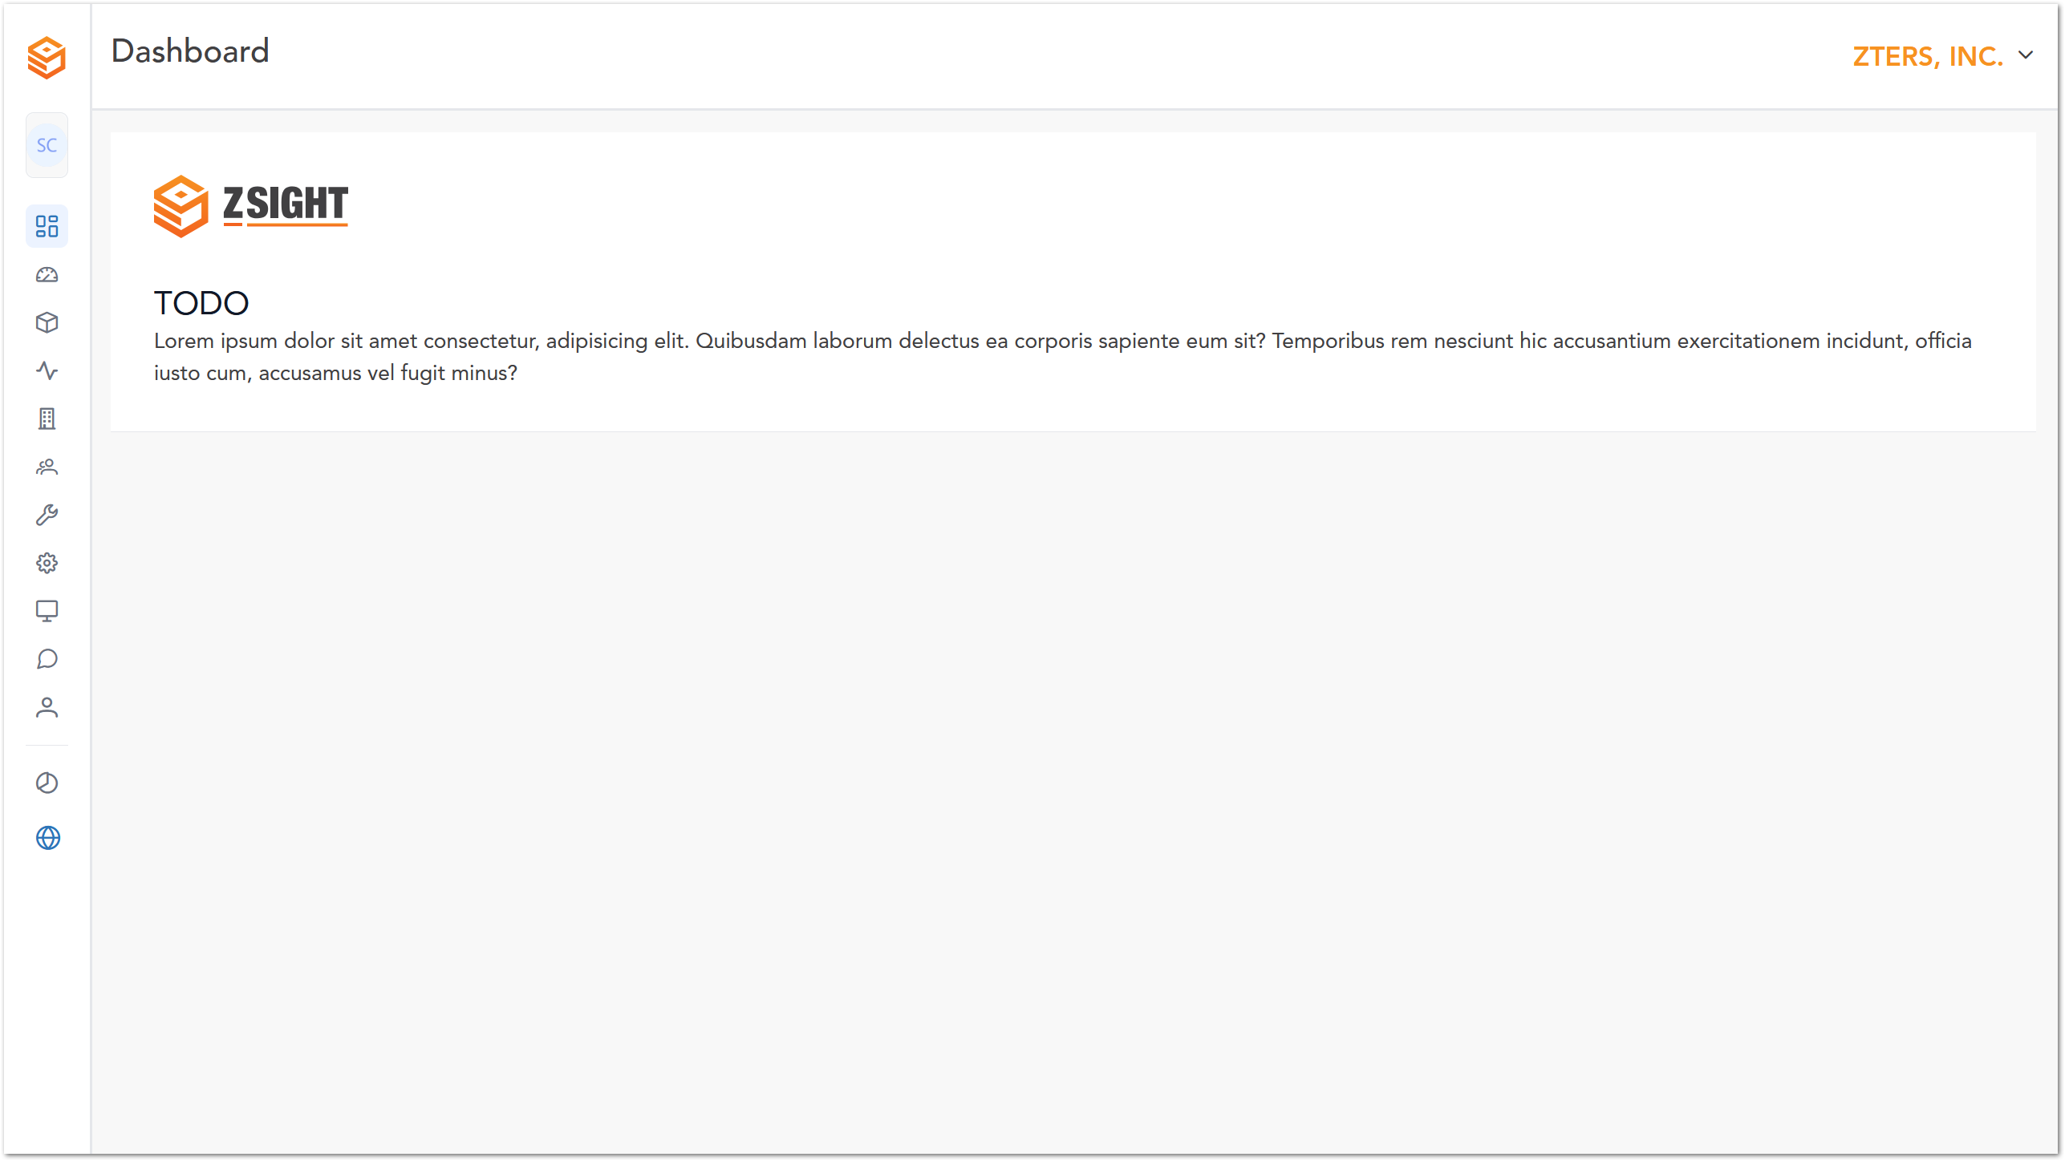

Containers
Description of section 2
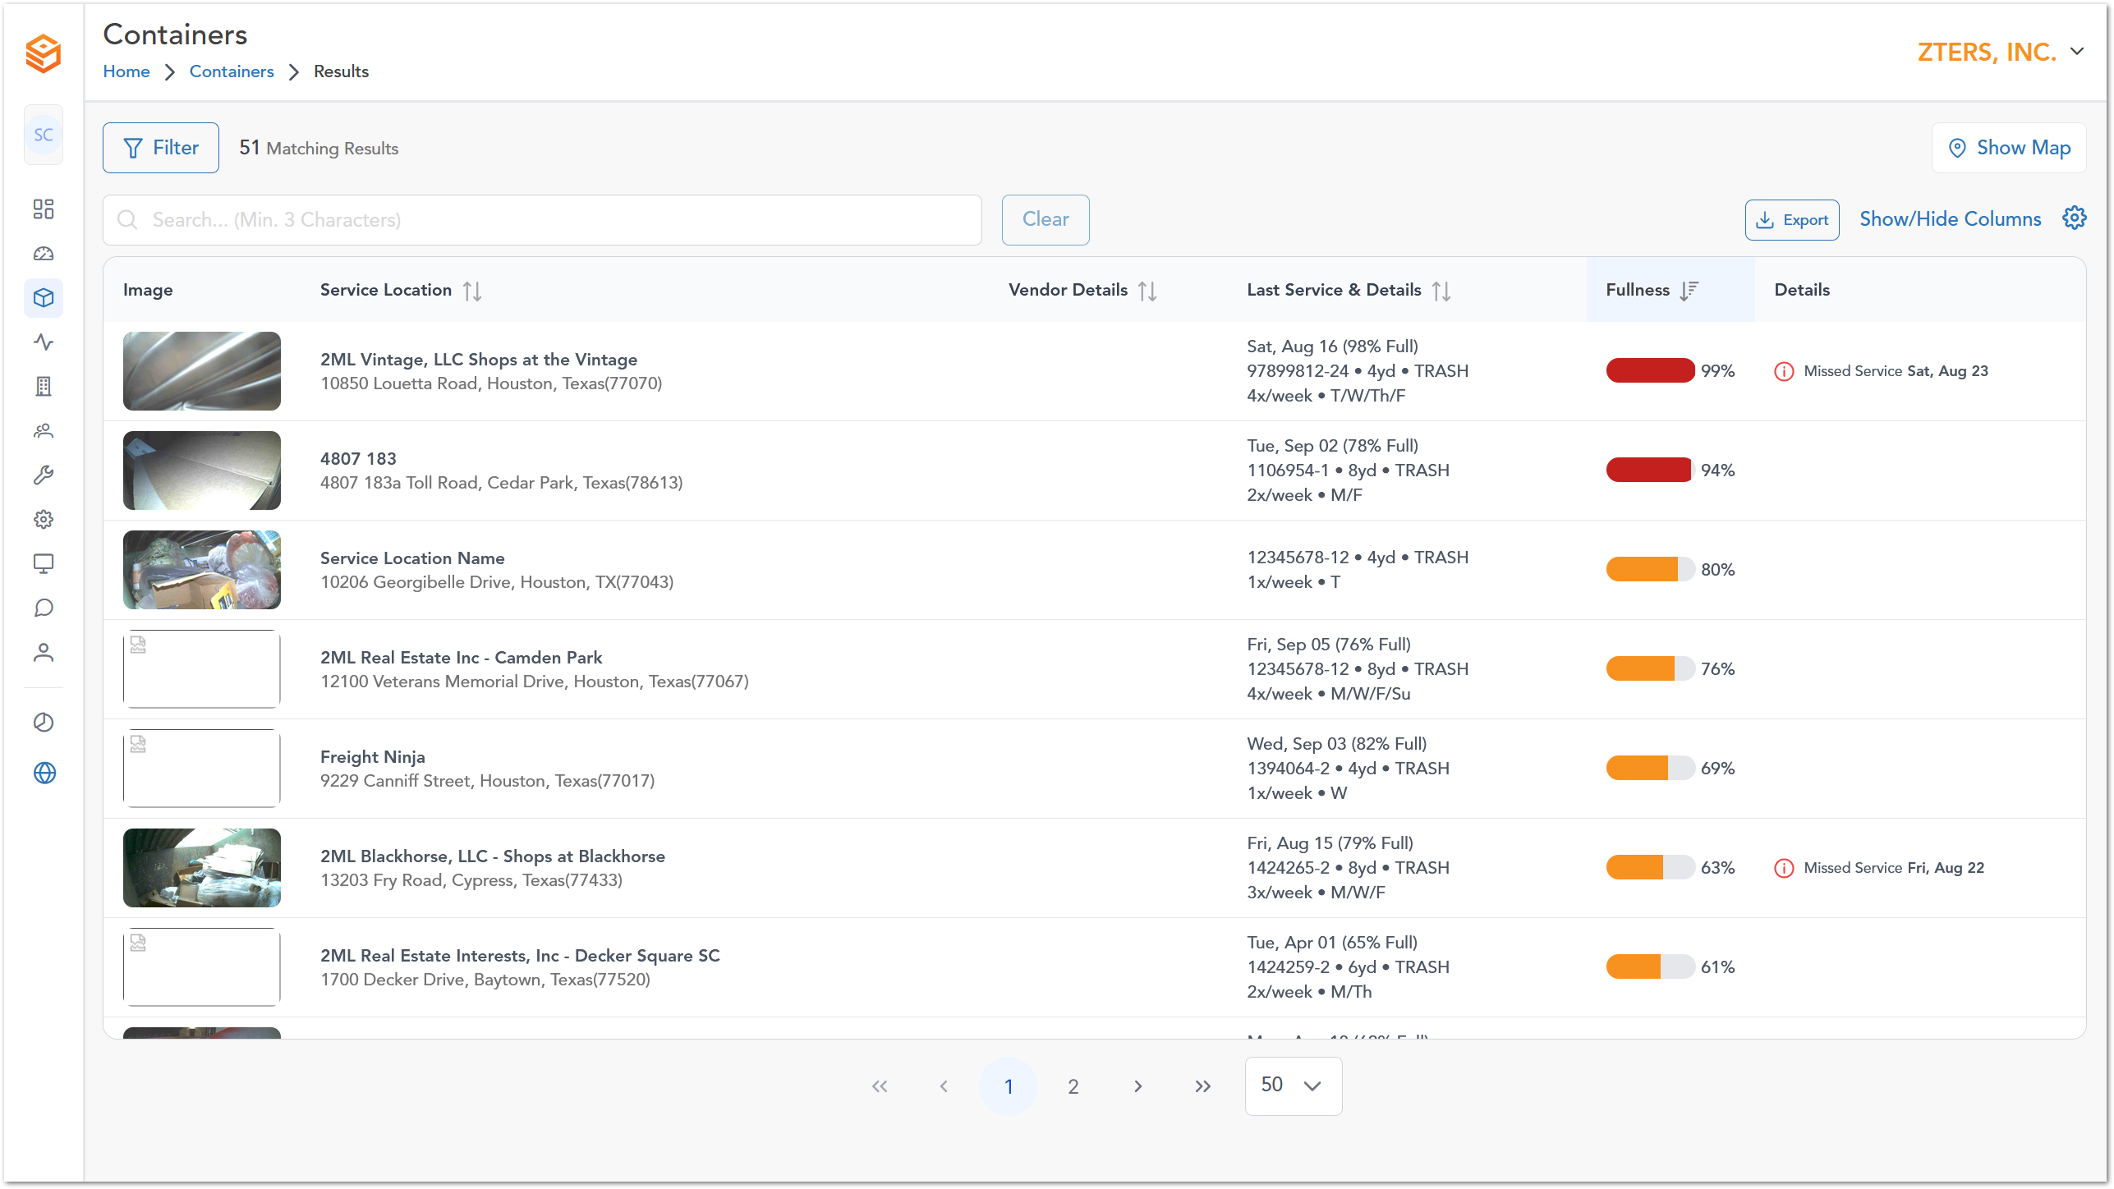
If you select an image, it will show more details about the container:
- Avg. Fullness
- Max. Fullness
- Last service time
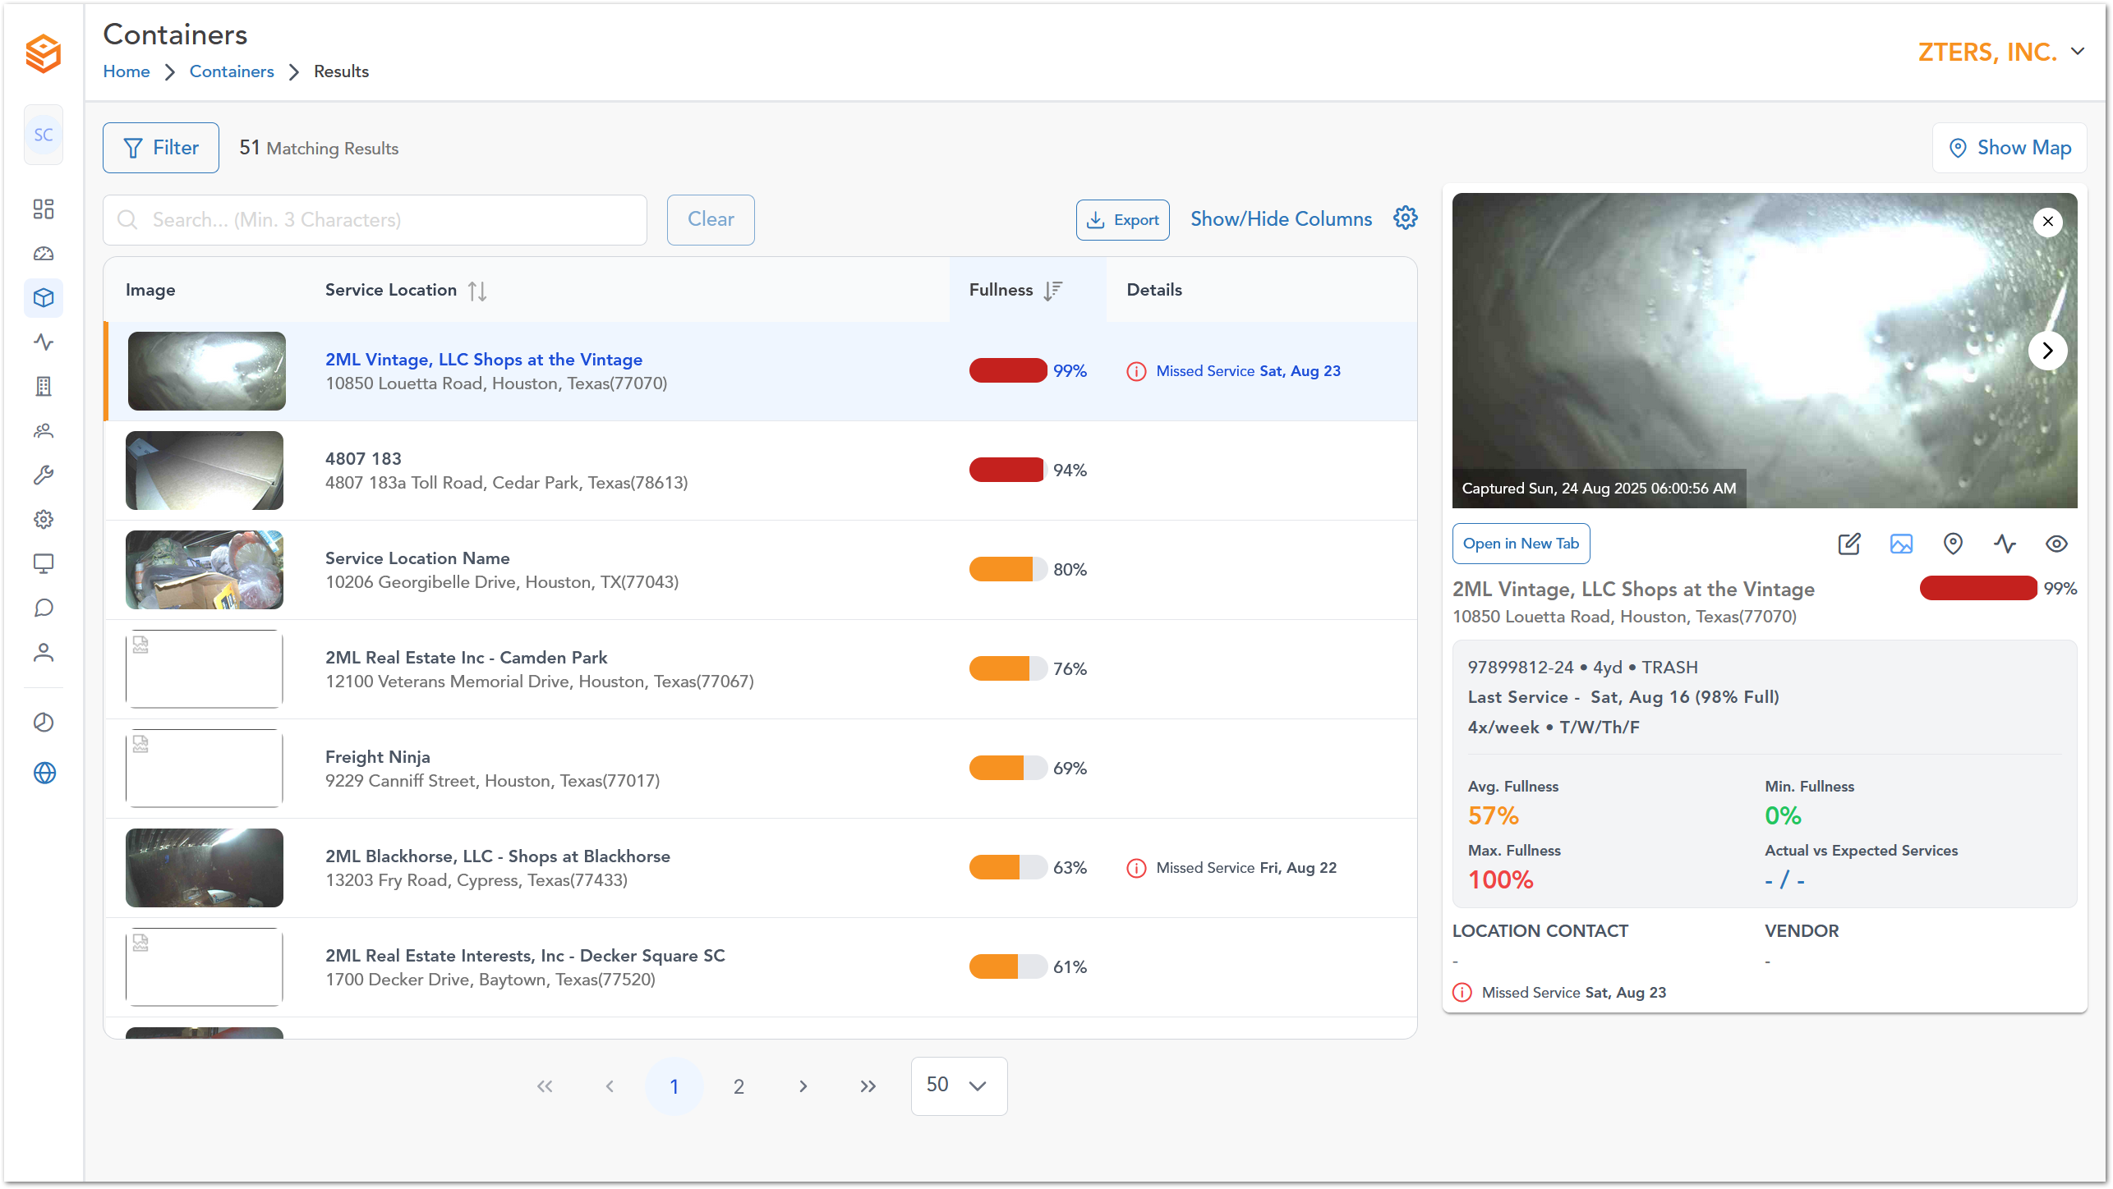

Container Details
This menu displays the last 3 pictures taken inside the container.
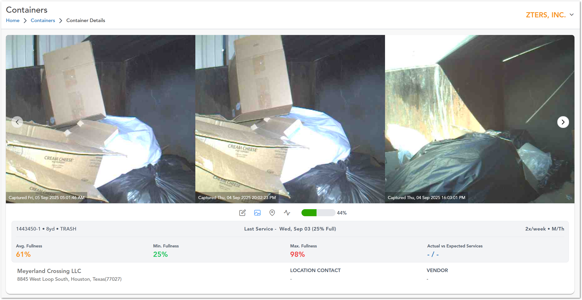

Menu
This menu displays the last 3 pictures taken inside the container.
Icon | Description
 | Edit container
 | Container Details
 | Container
 | Daily Feed
 | Container Fullness

Edit Container
This menu displays the last 3 pictures taken inside the container.
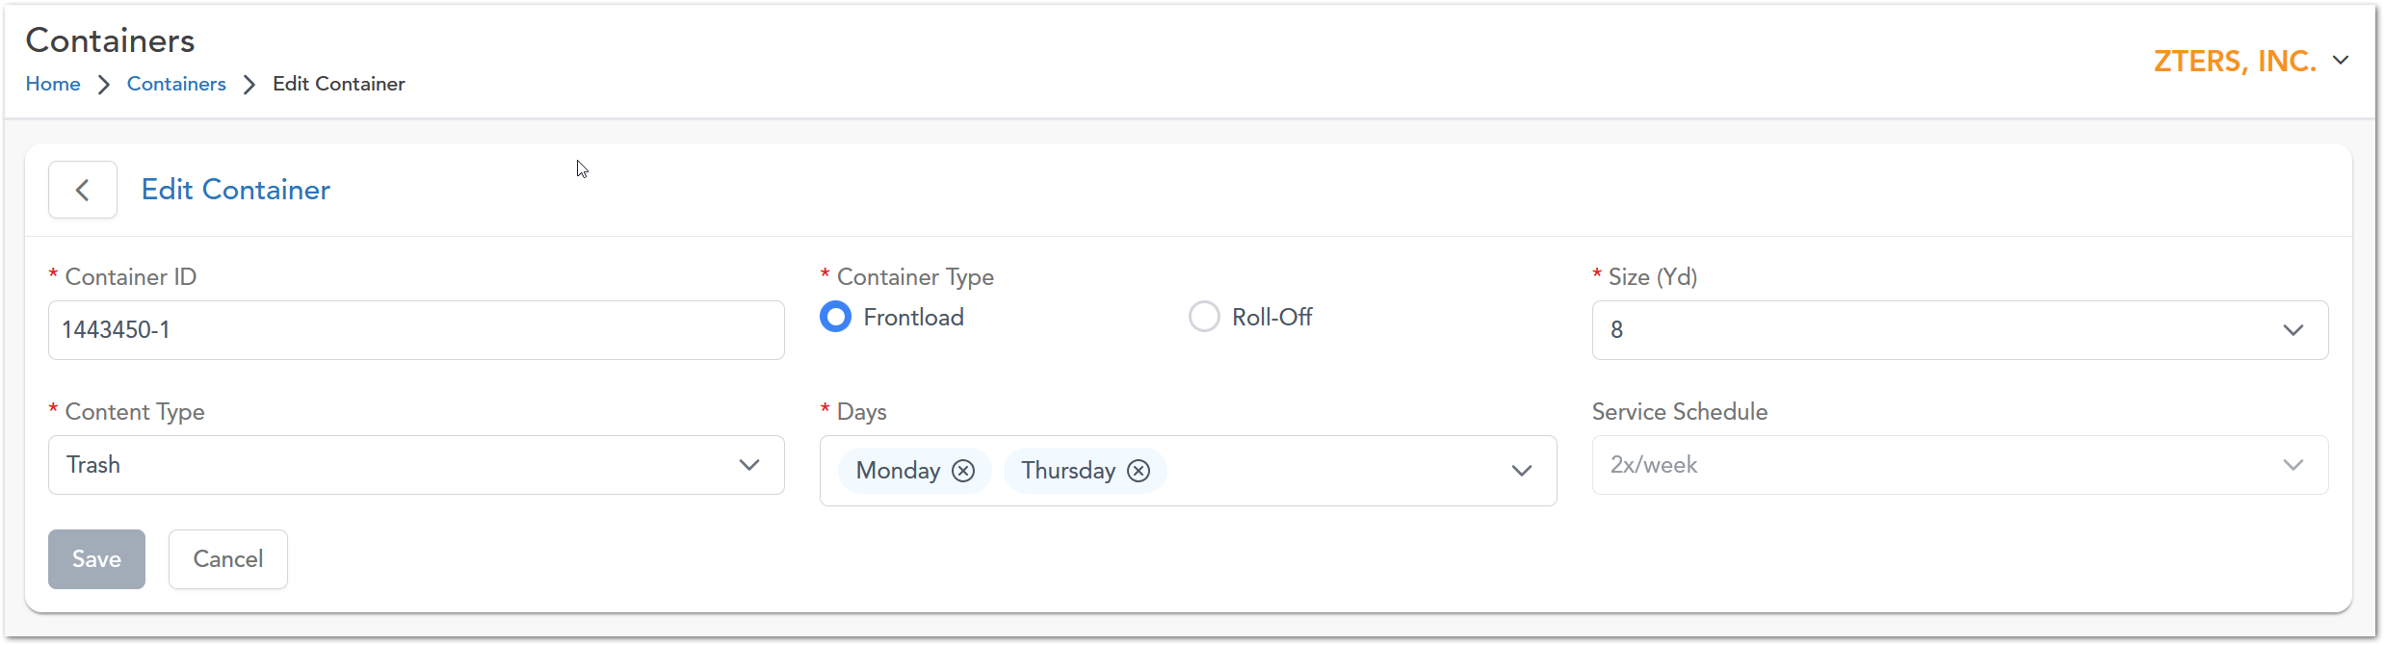

Container Location
This menu displays
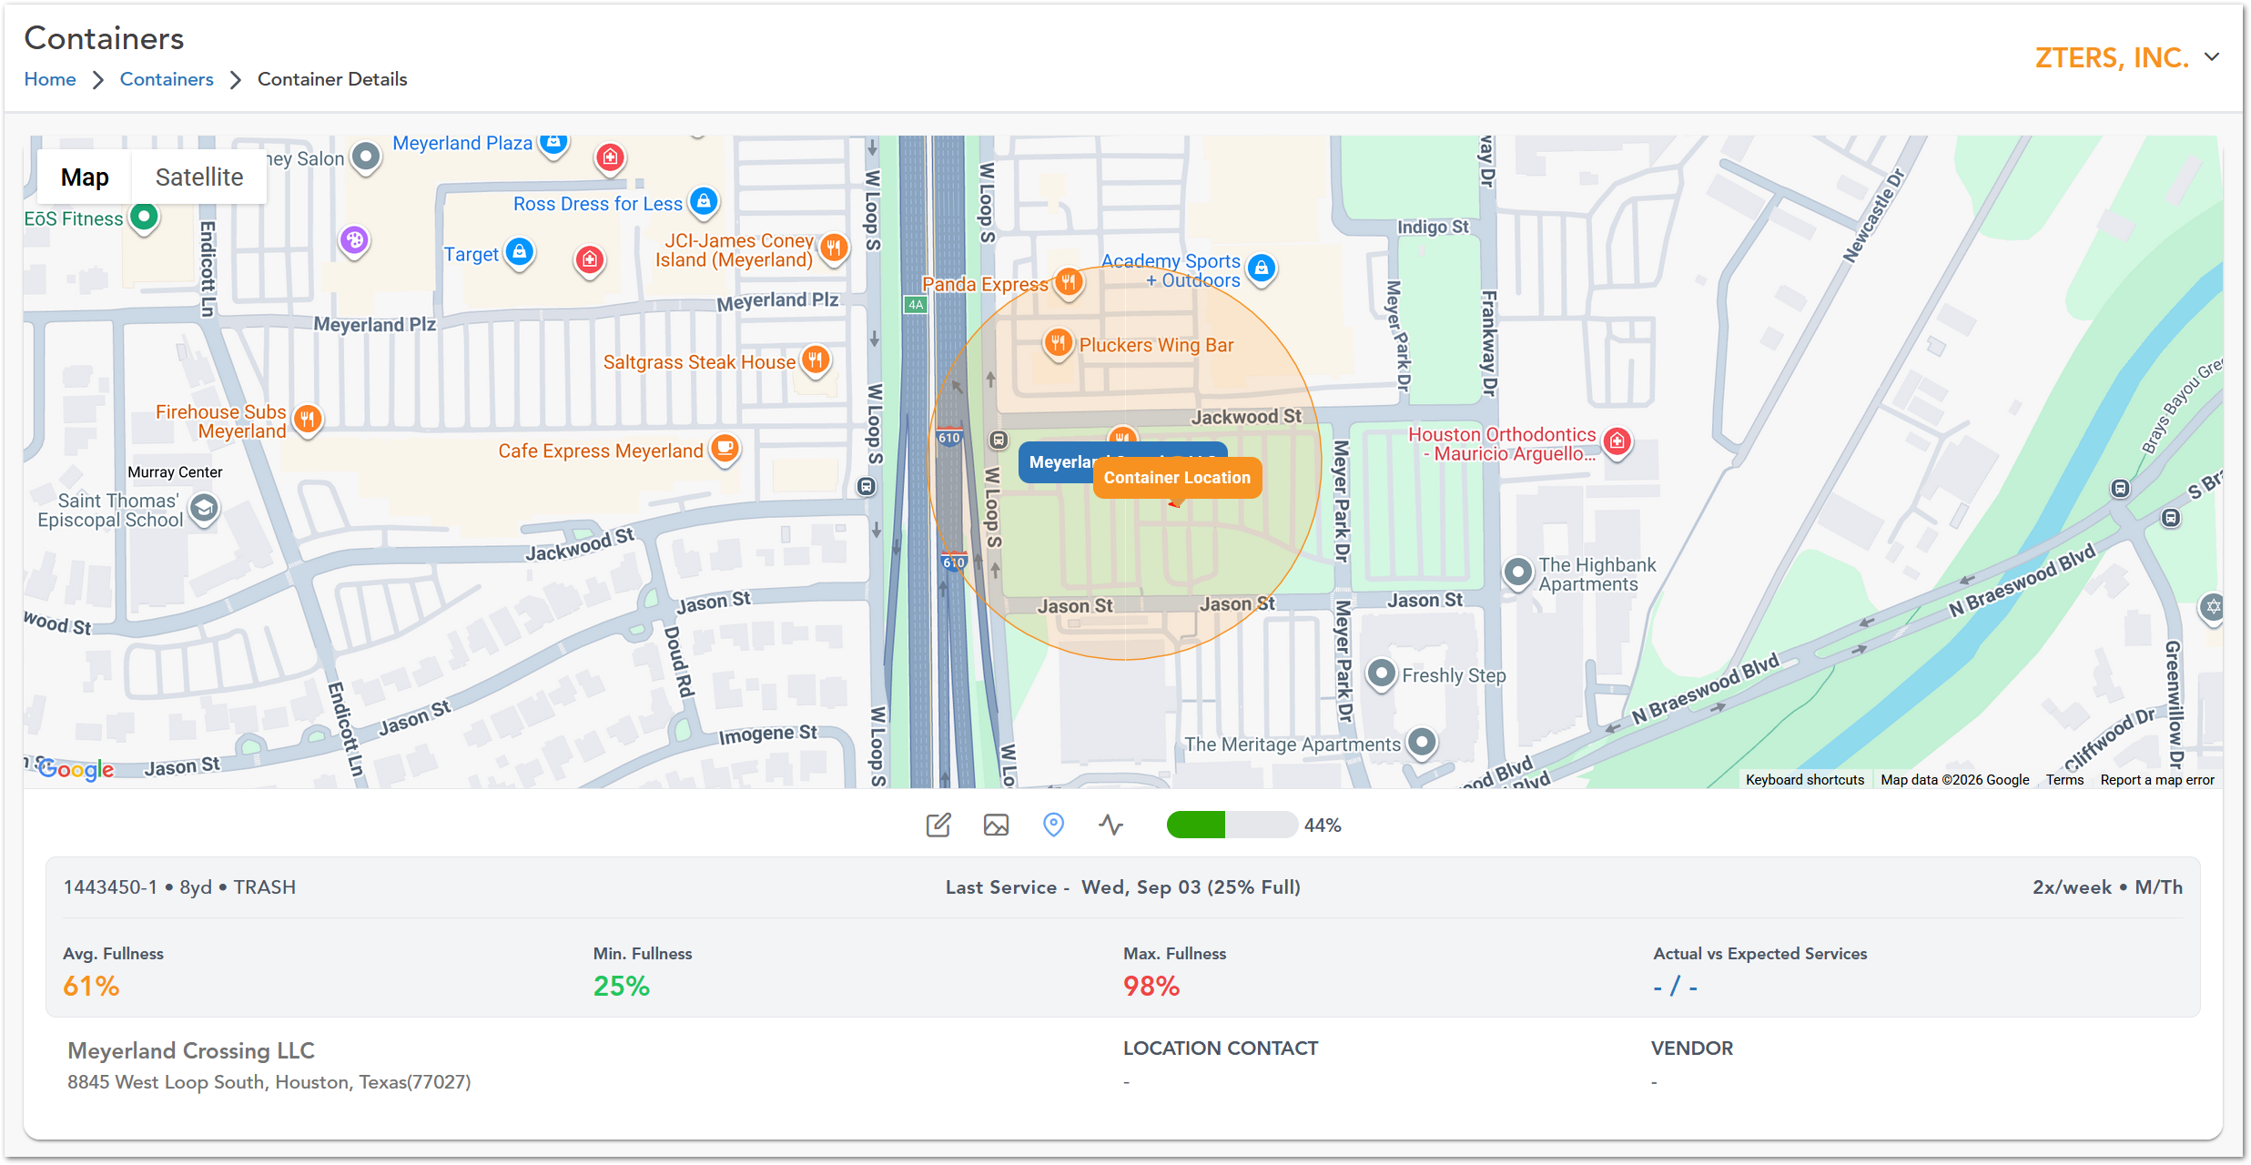

Daily Feed
This menu displays
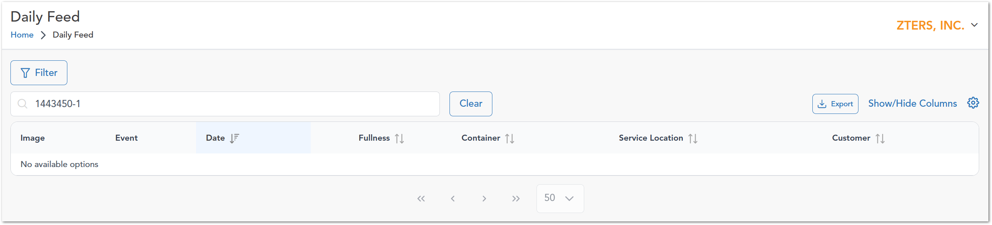

Daily Feed
Description of section 2
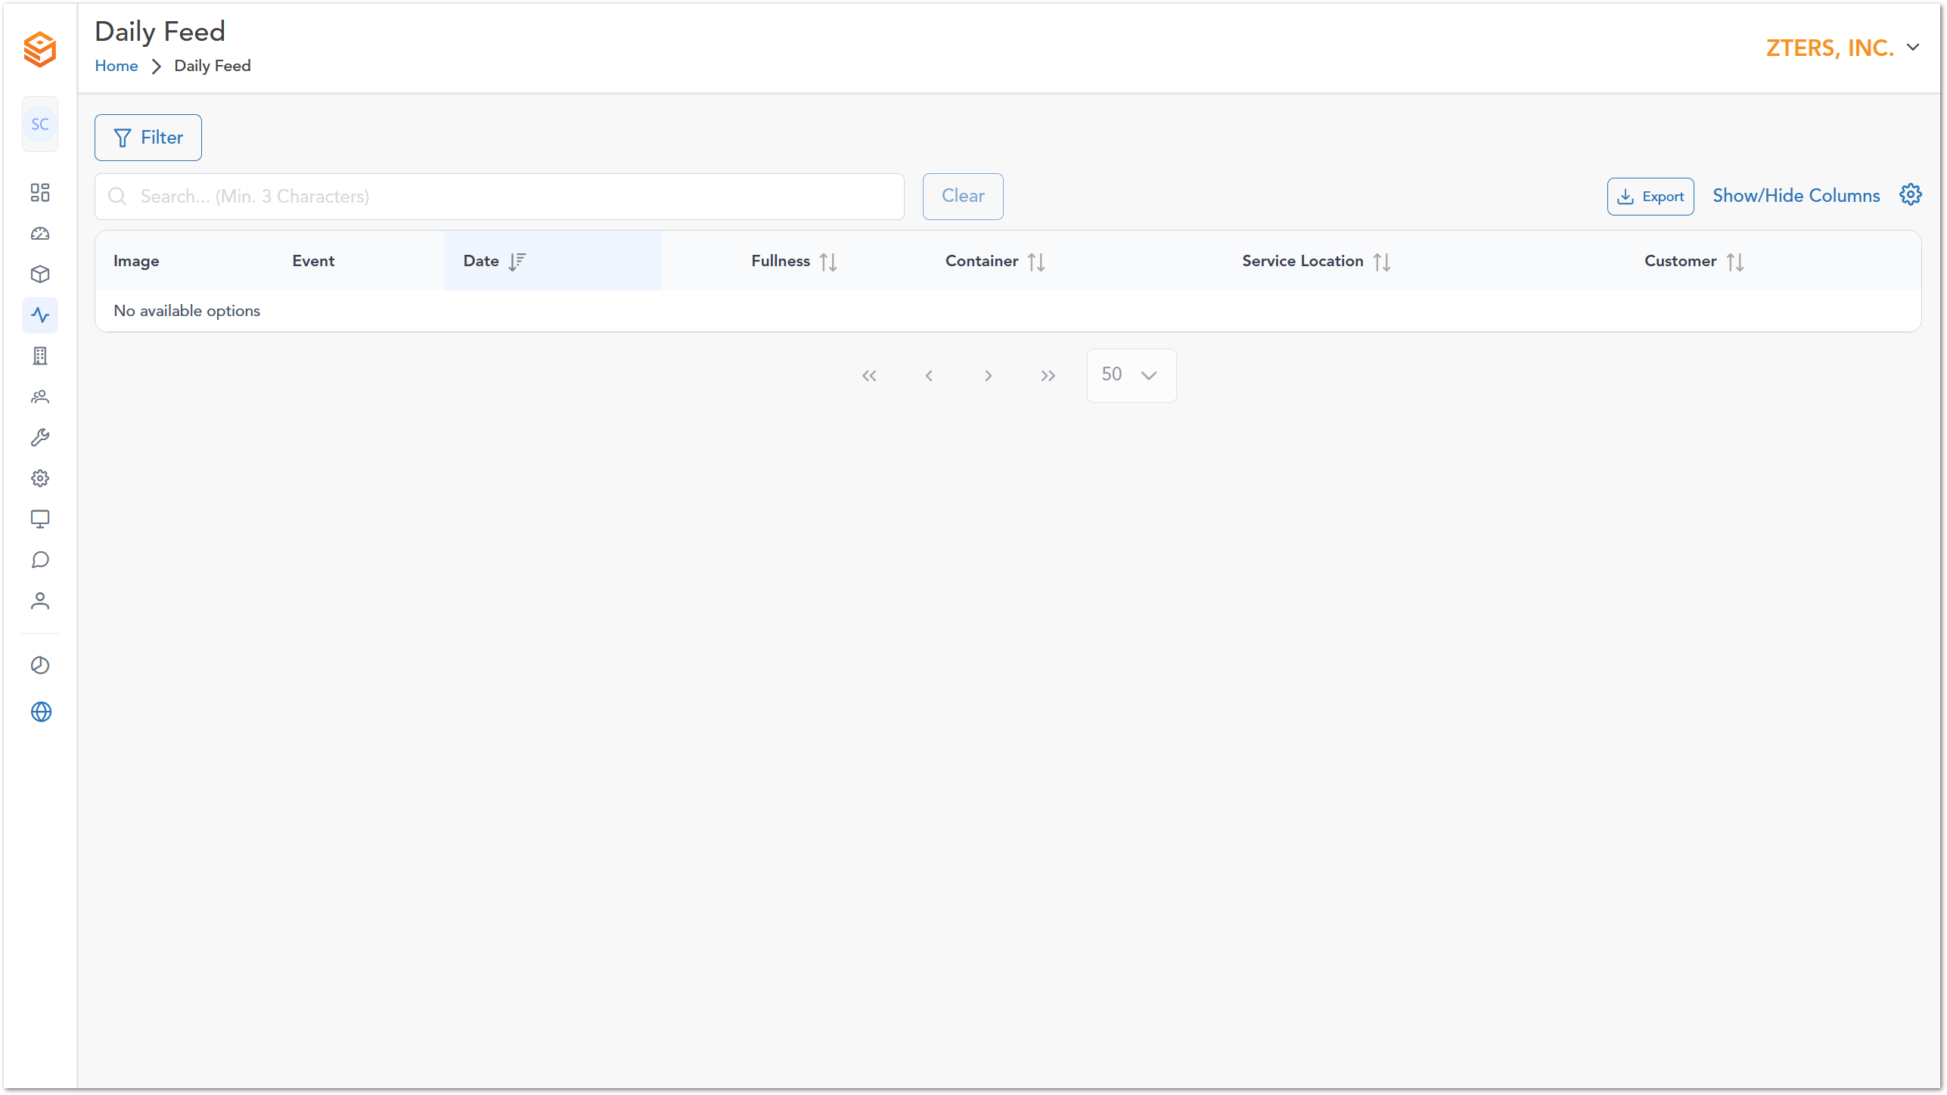

Customers
Description of section 2
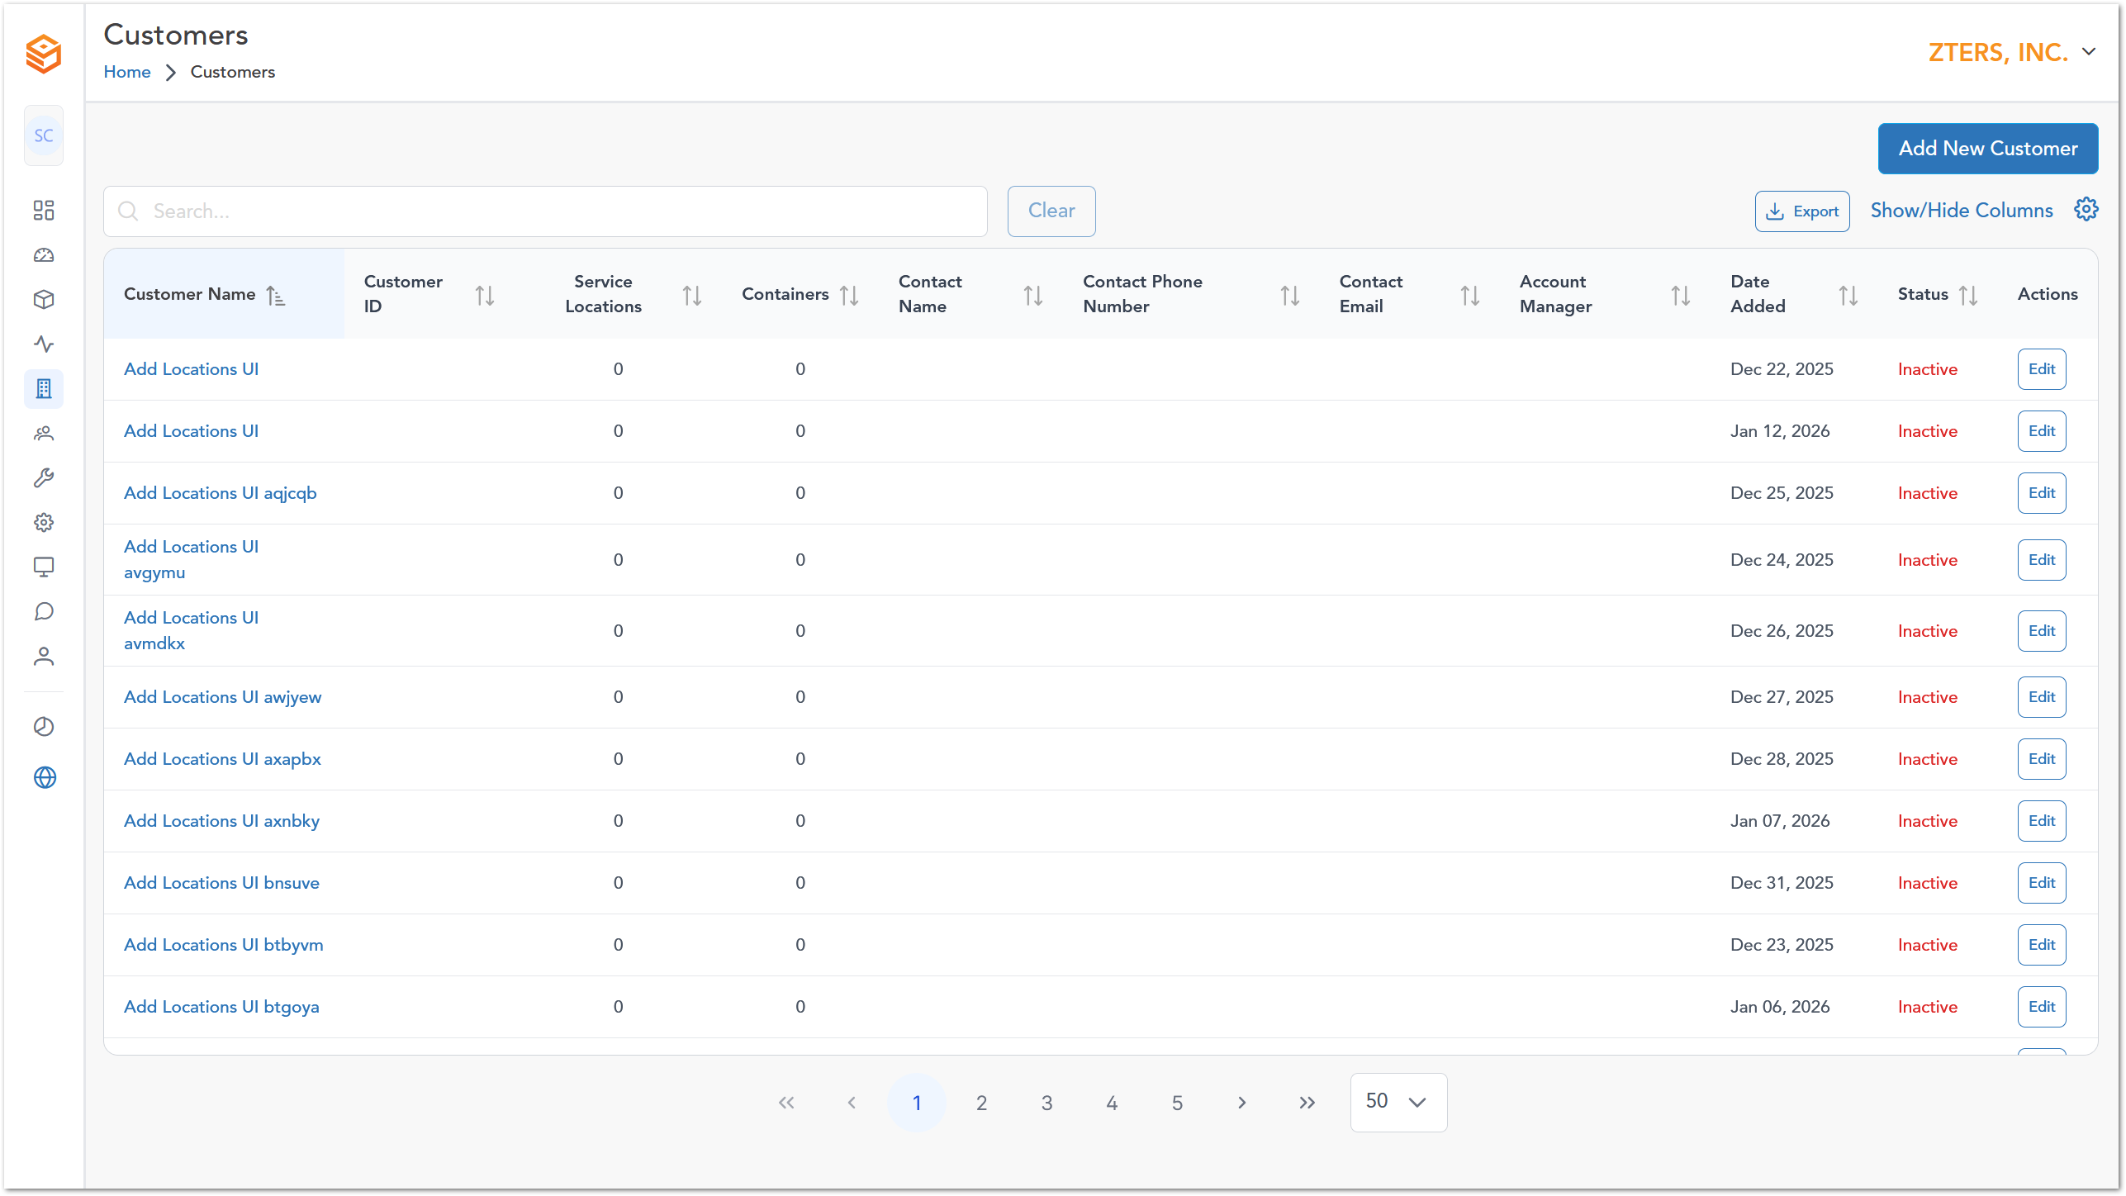

Vendors
Description of section 2
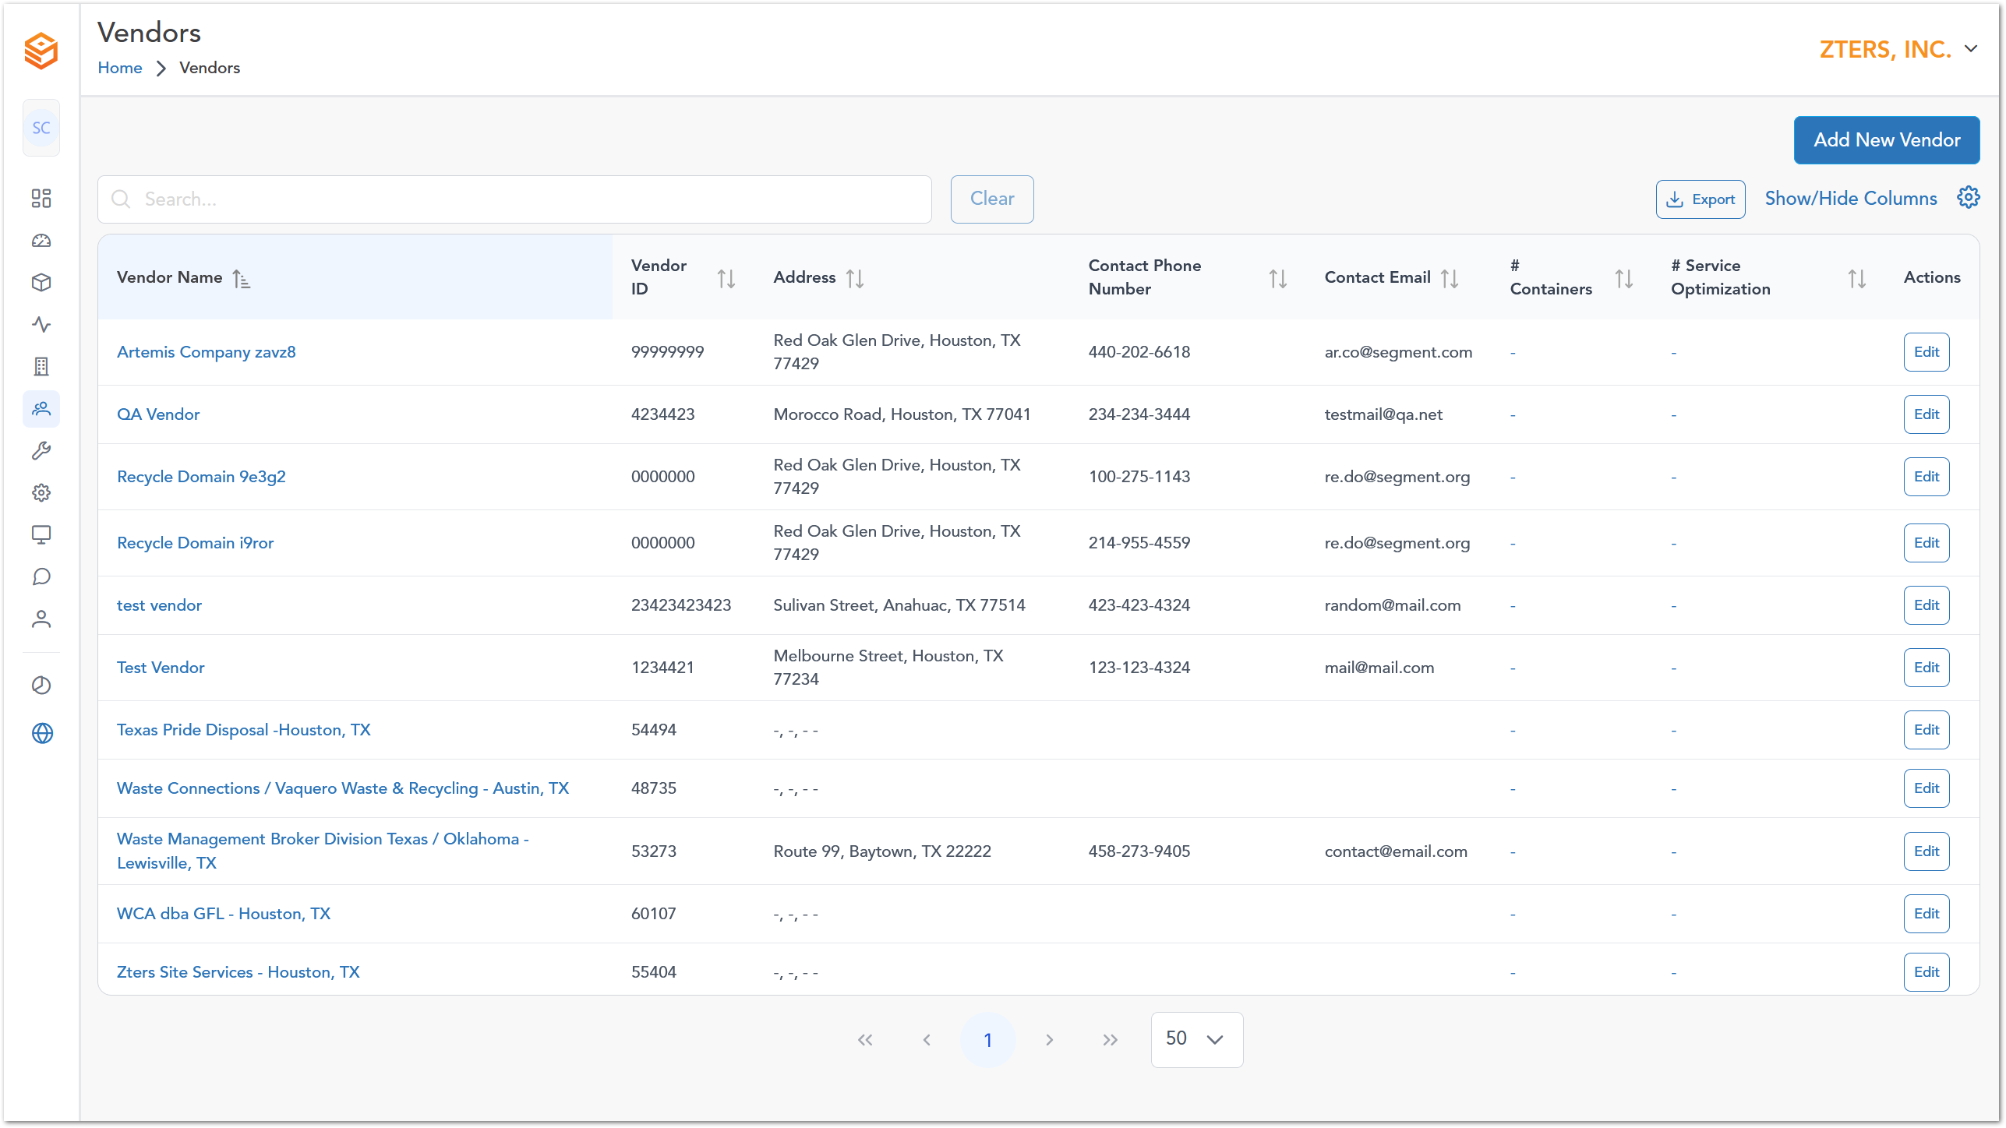

Device Management
Description of section 2

Action Needed
Description of section 2
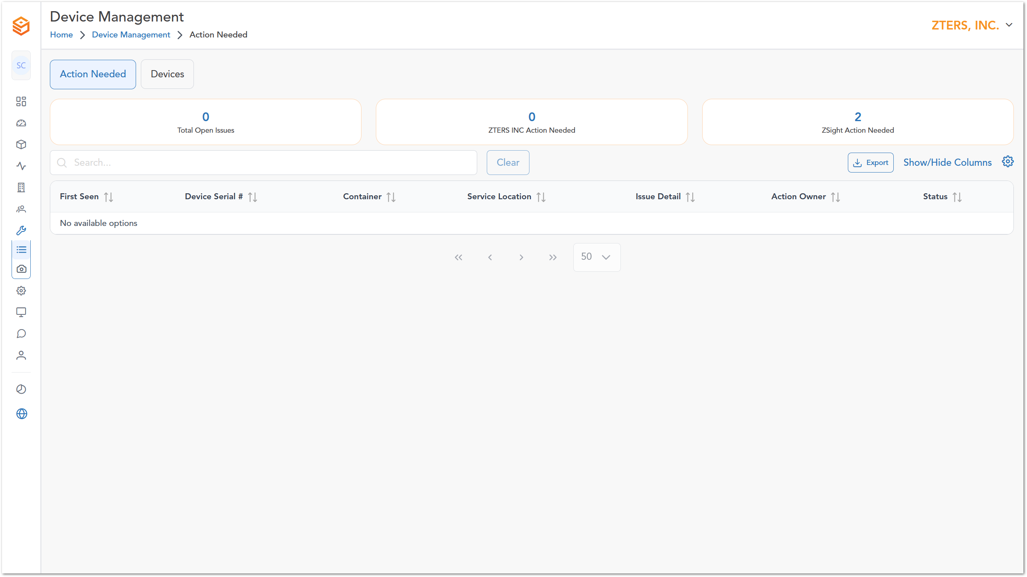

Devices
Description of section 2
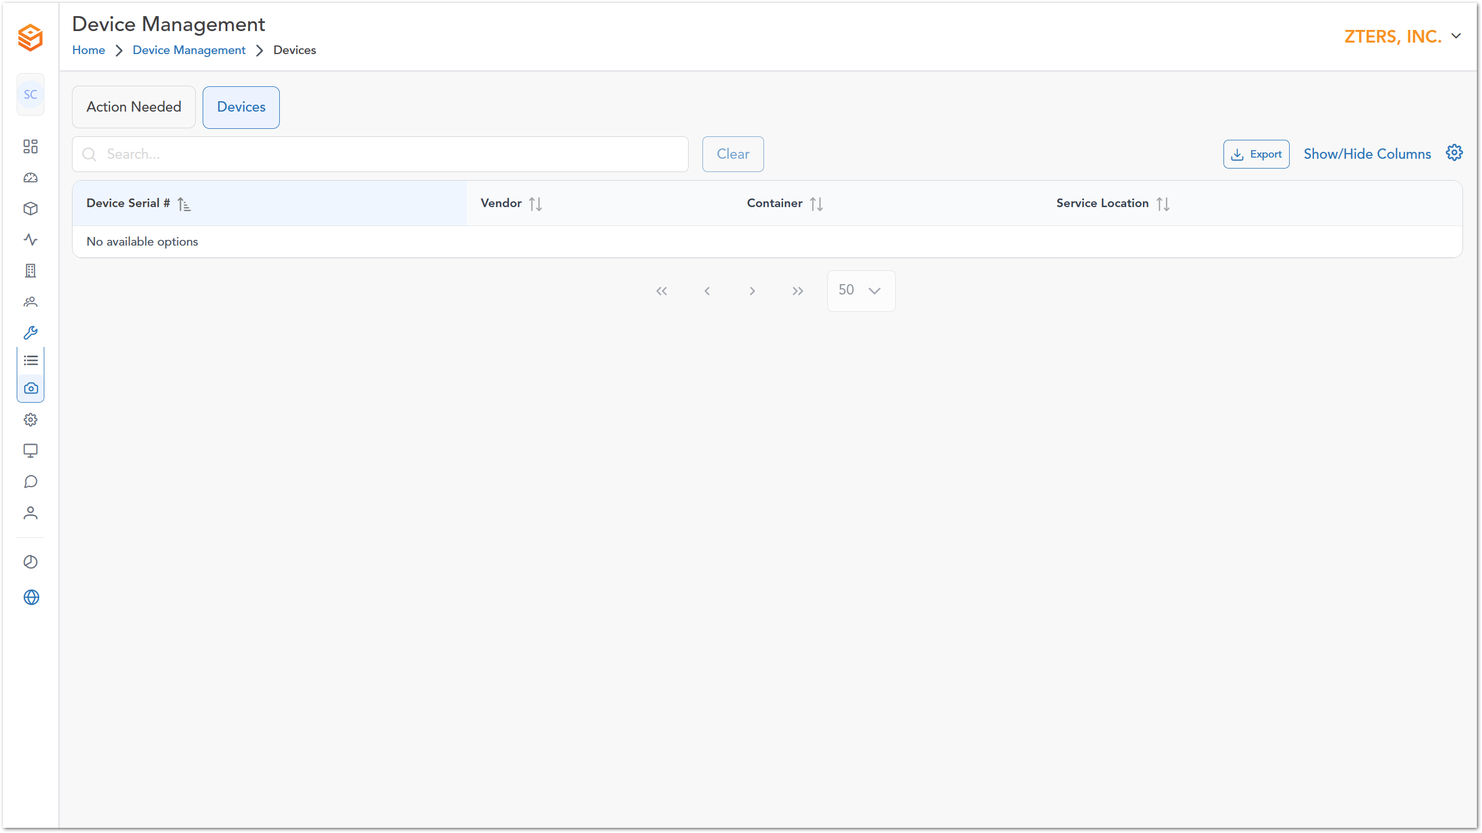

Settings
Description of section 2

My Profile
Description of section 2
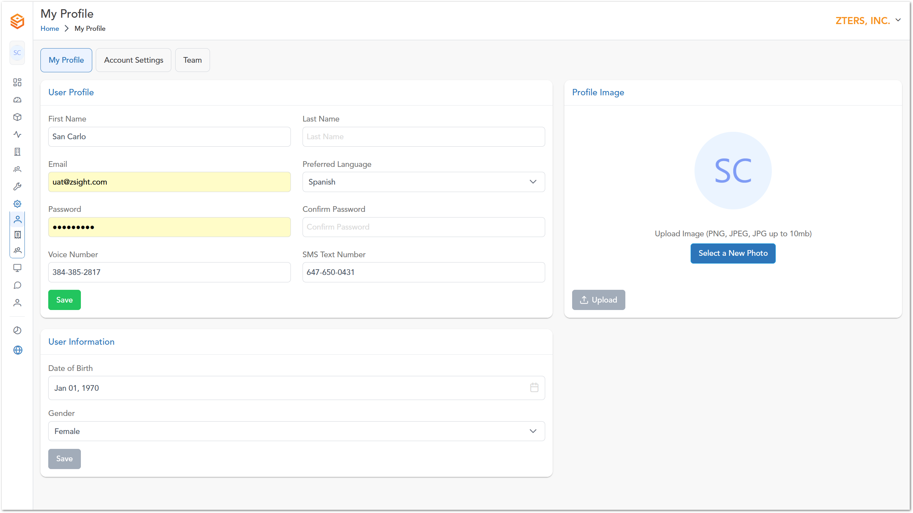

Account Settings
Description of section 2
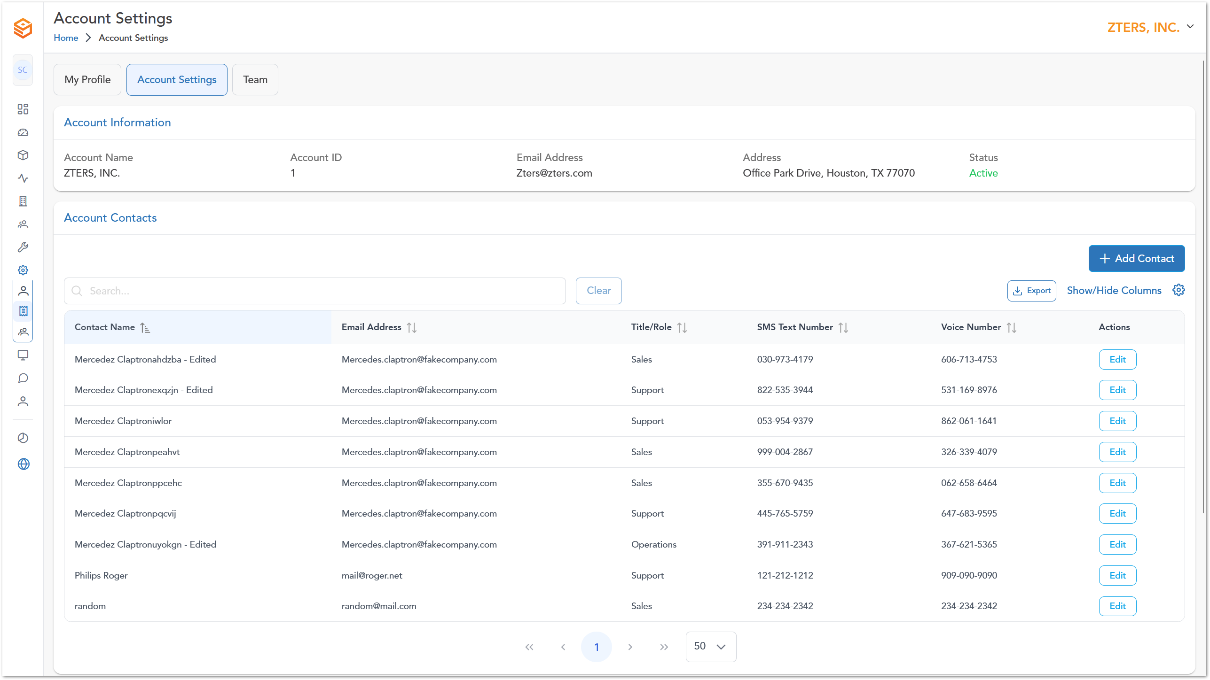

Teams
Description of section 2
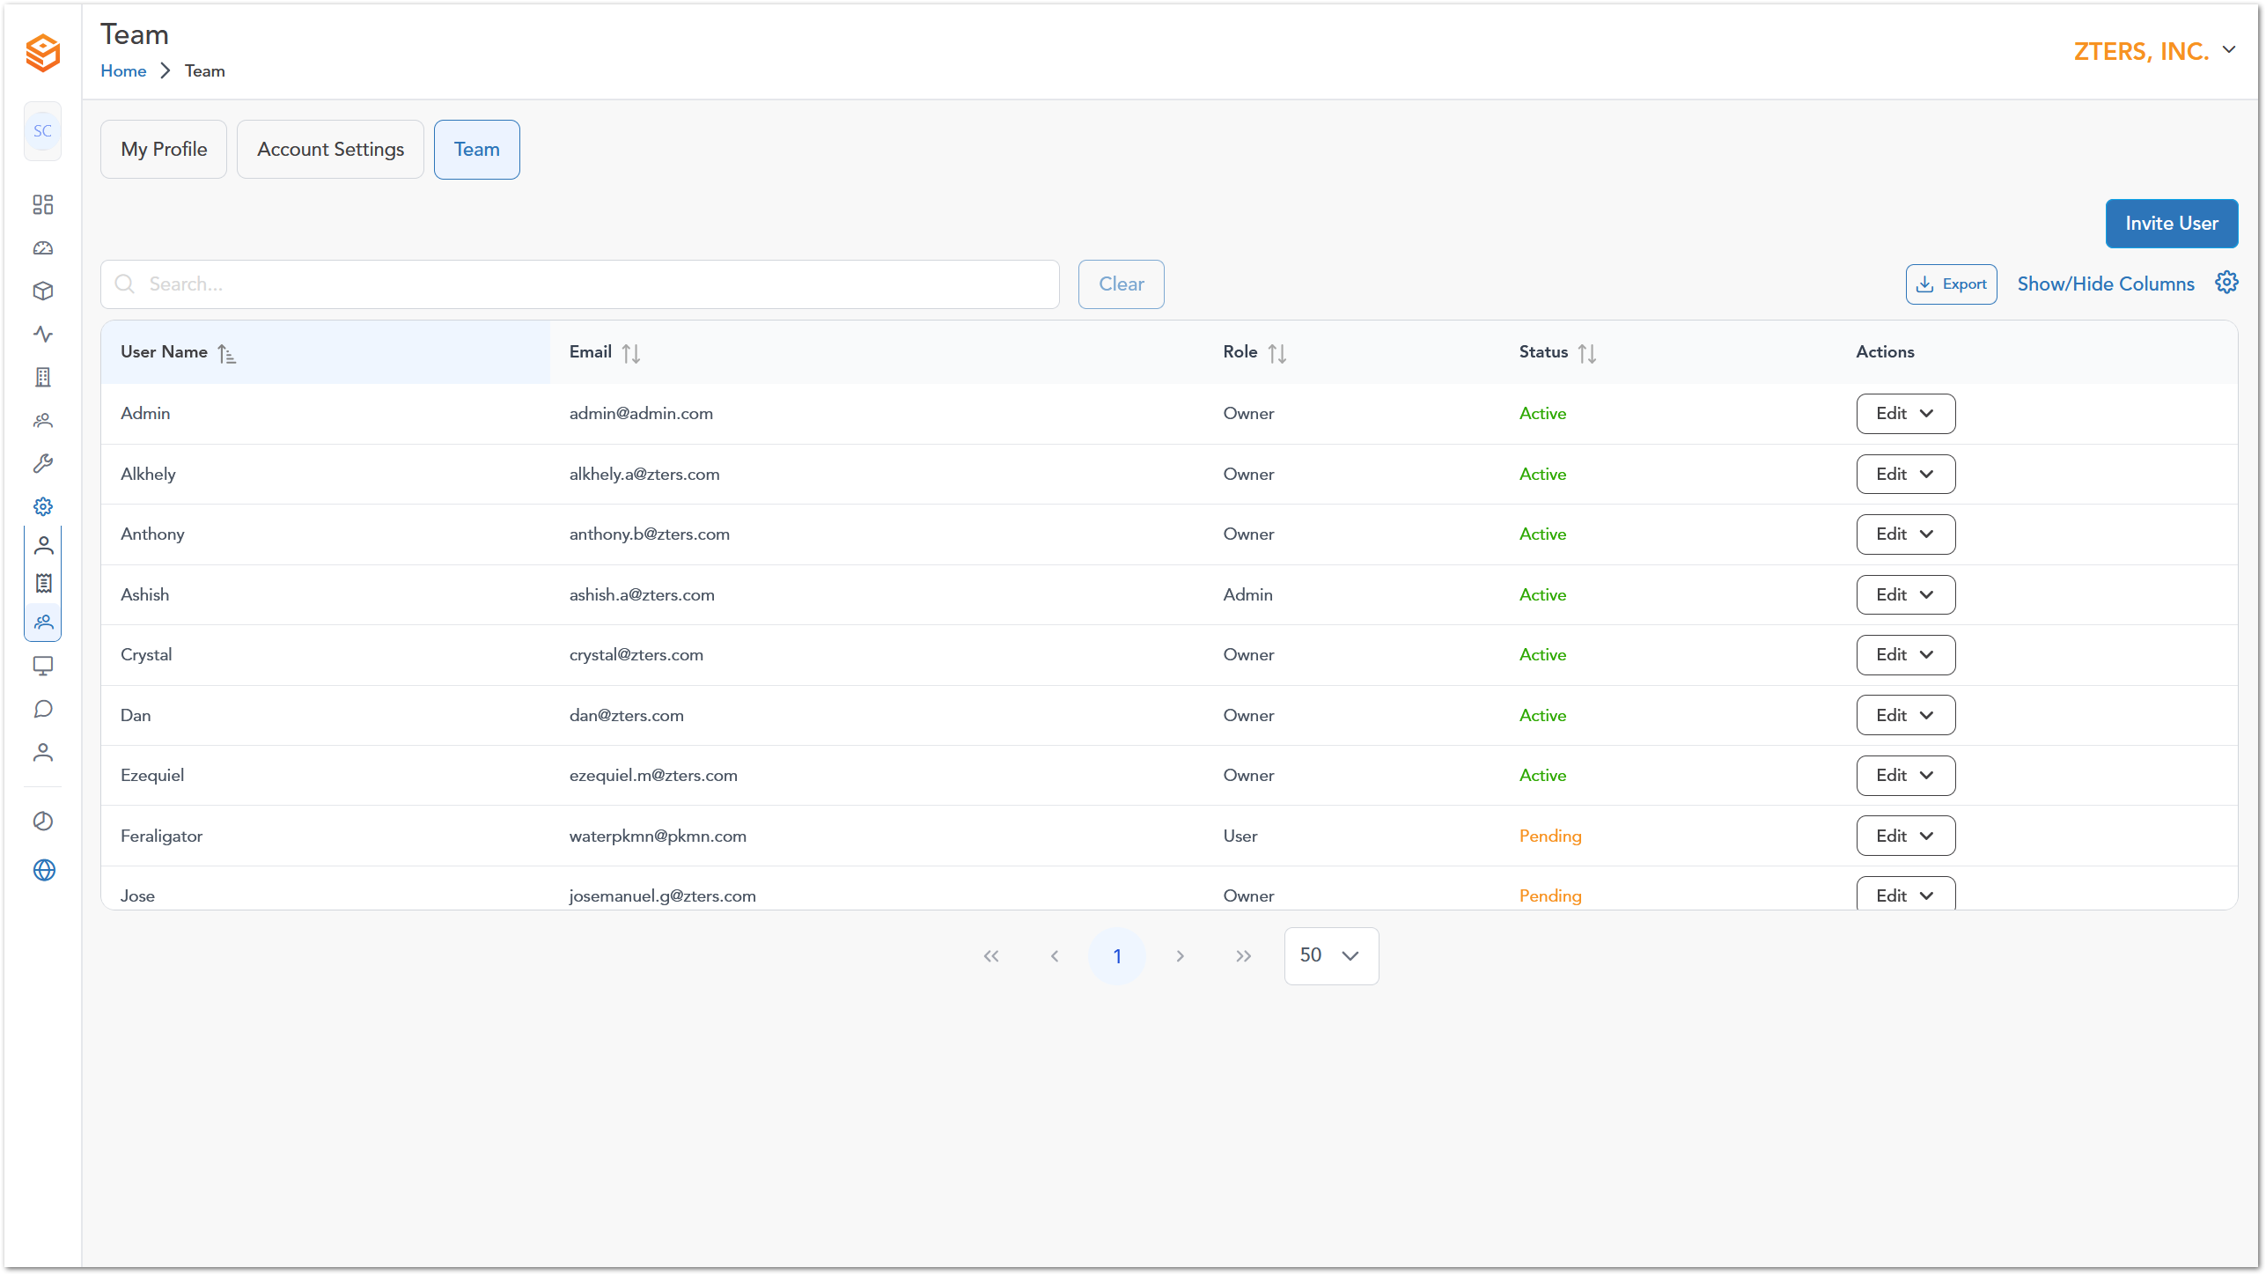

Monitoring
Description of section 2

Audit Trail
Description of section 2
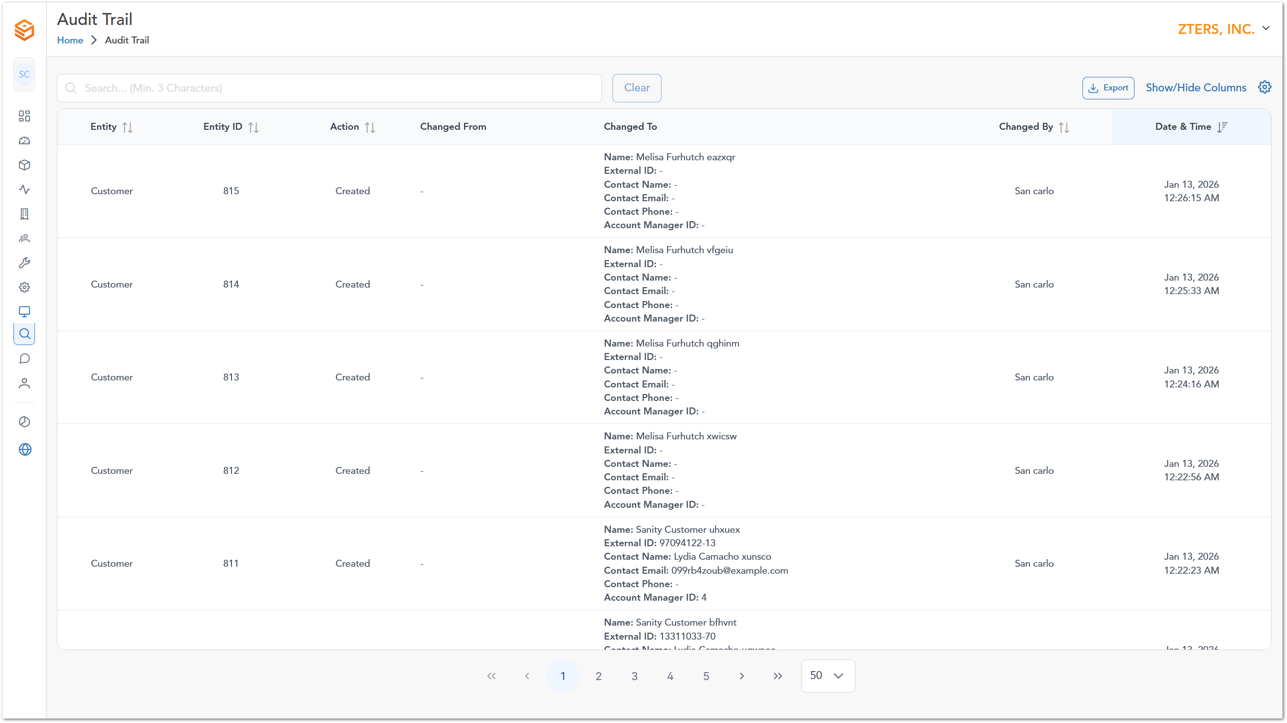

Contact & Help
Description of section 2
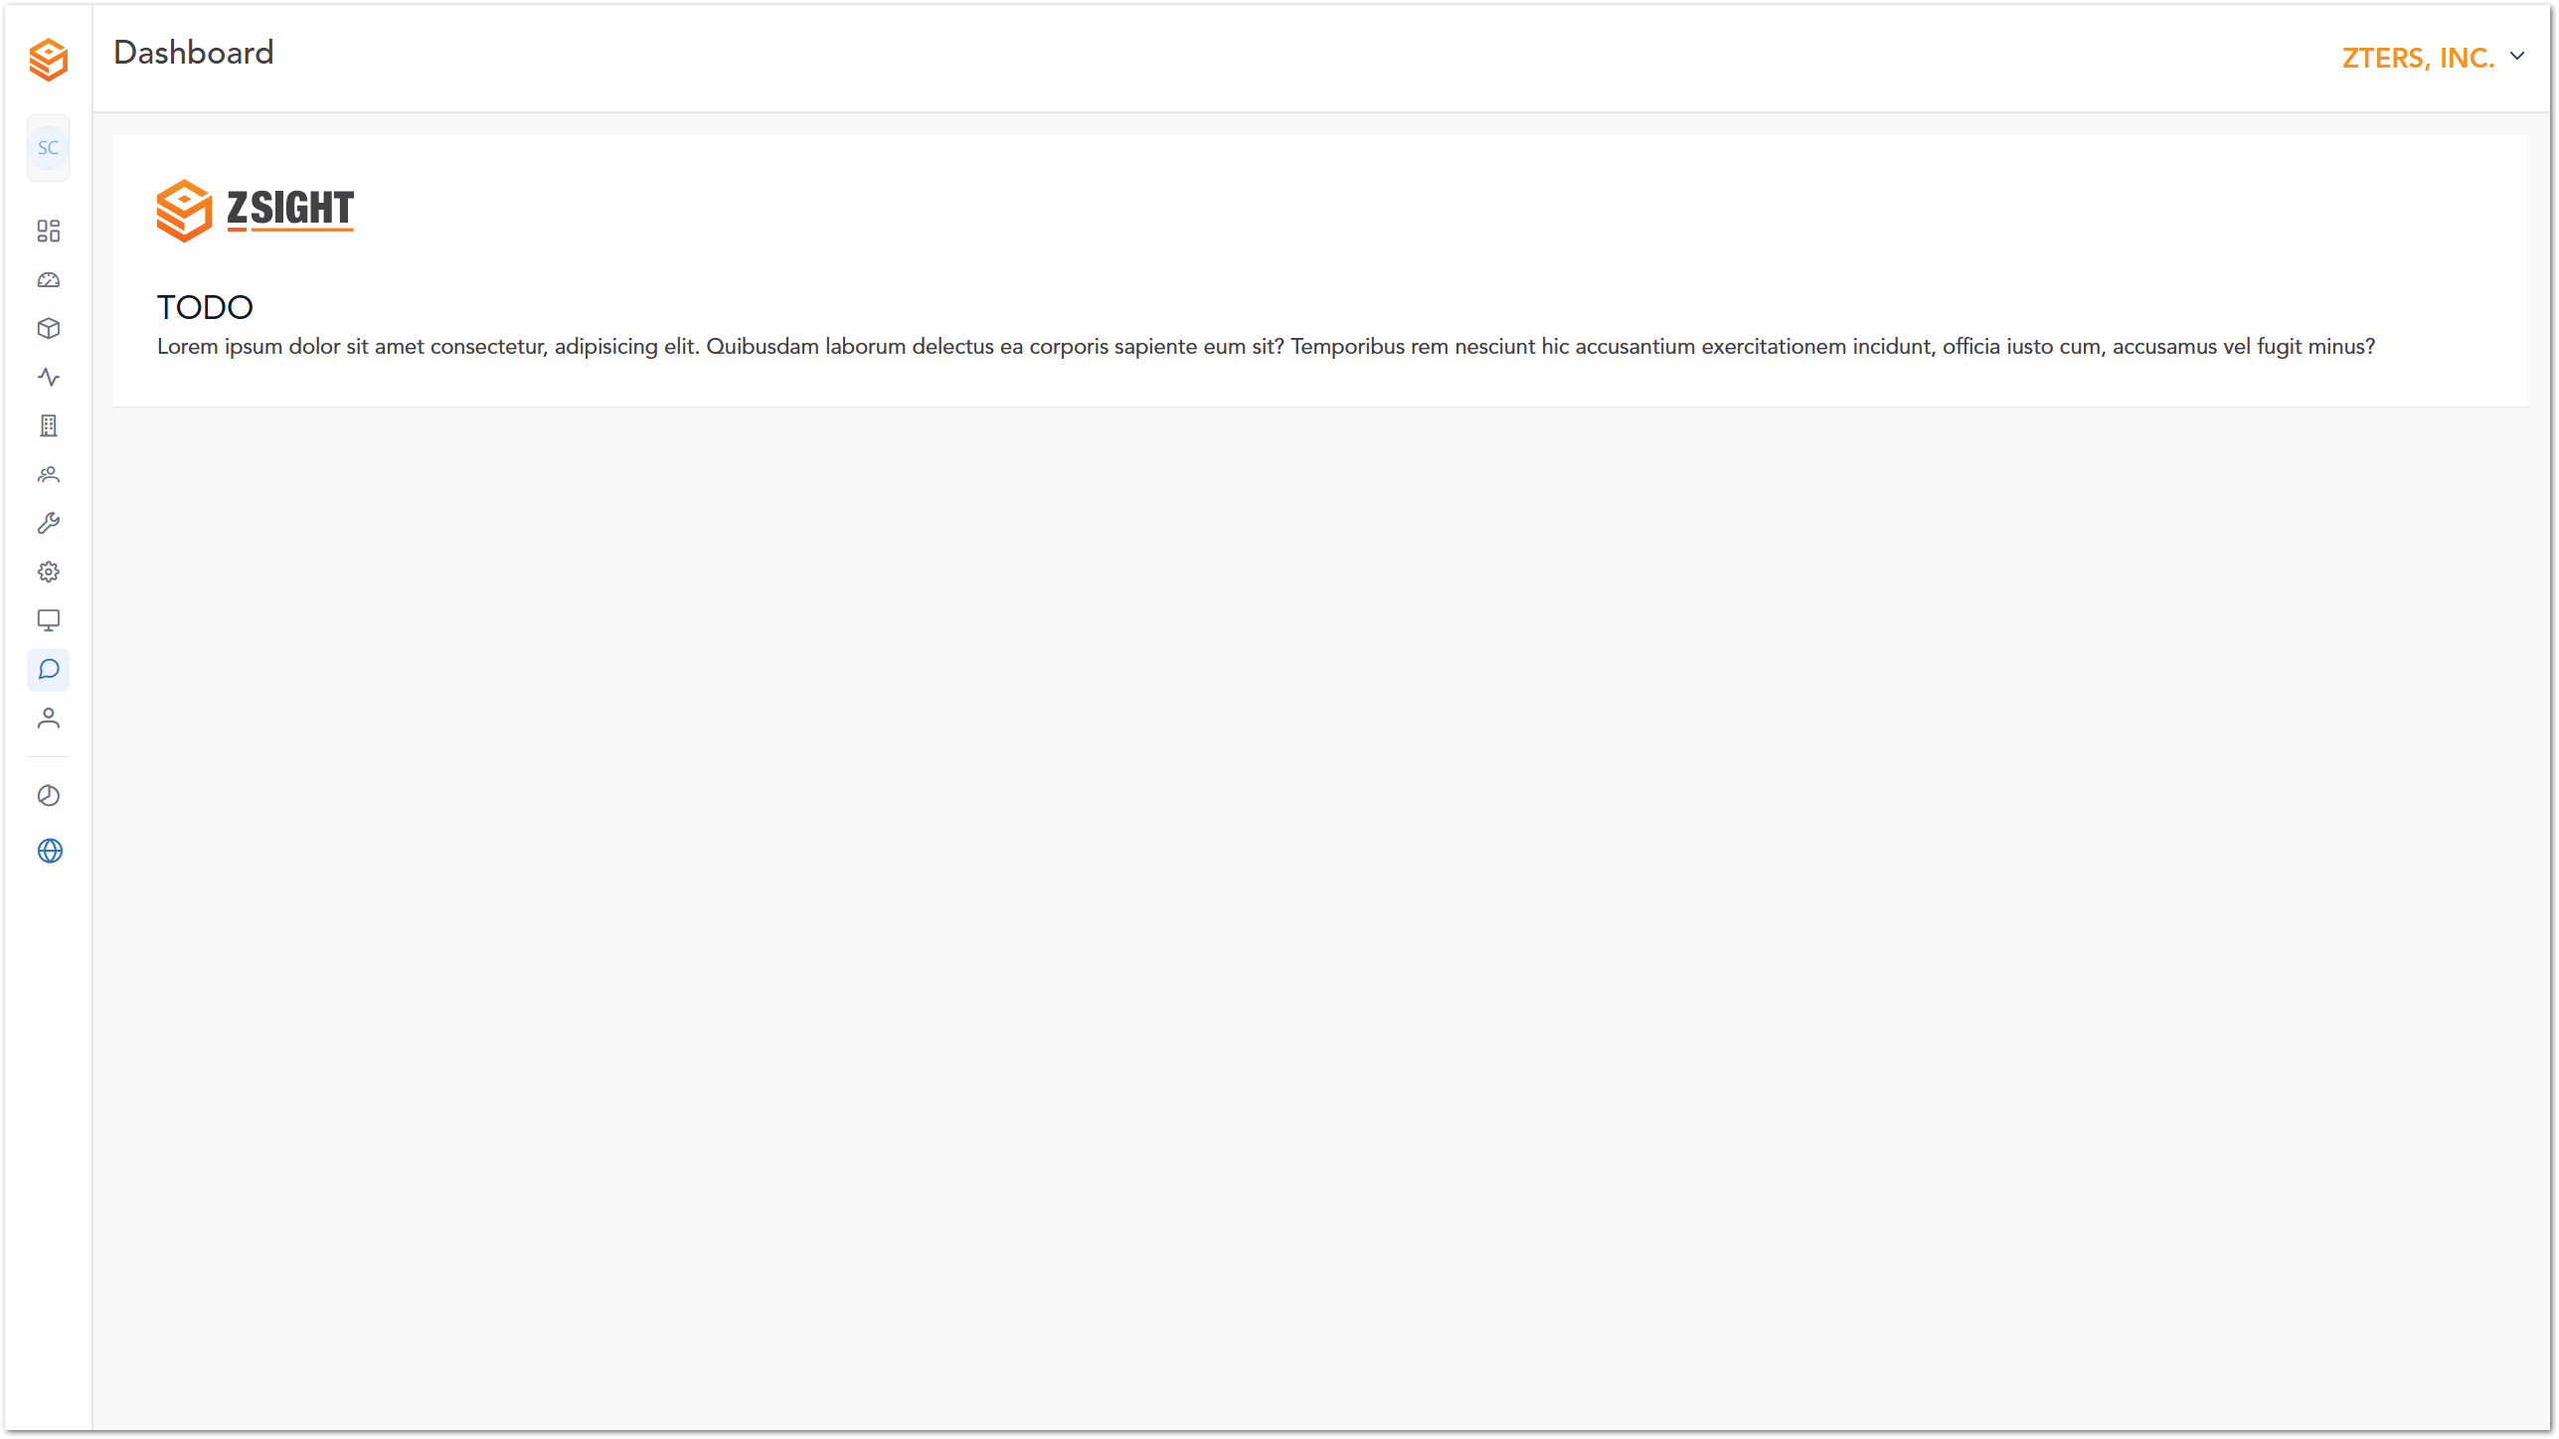

Admin Options
Screenshots, descriptions, and other important information about the application’s interface and functionalities.

Admin Dashboard
The login page for the website is presented here:

Accounts
The login page for the website is presented here:
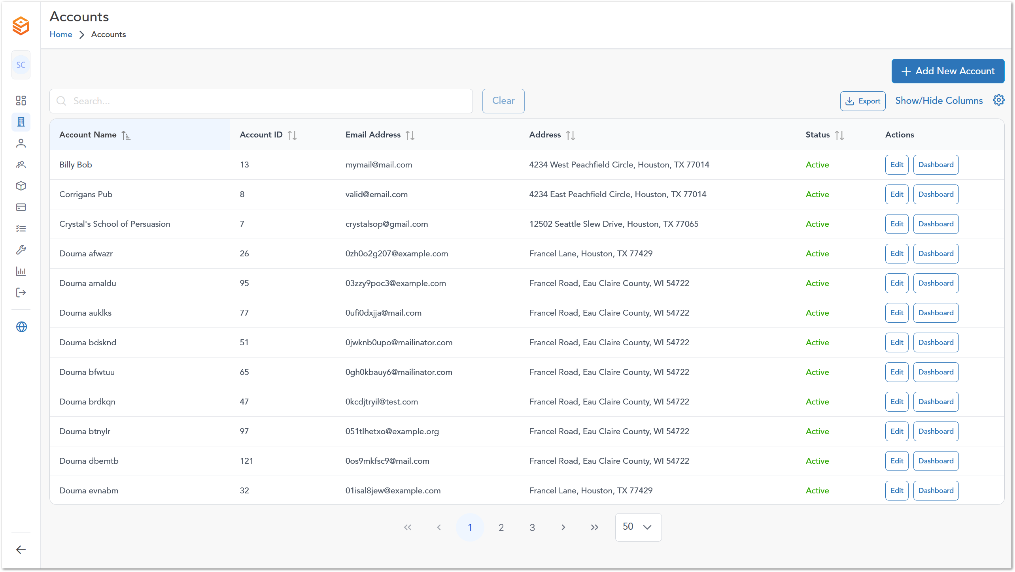

Customers
The login page for the website is presented here:
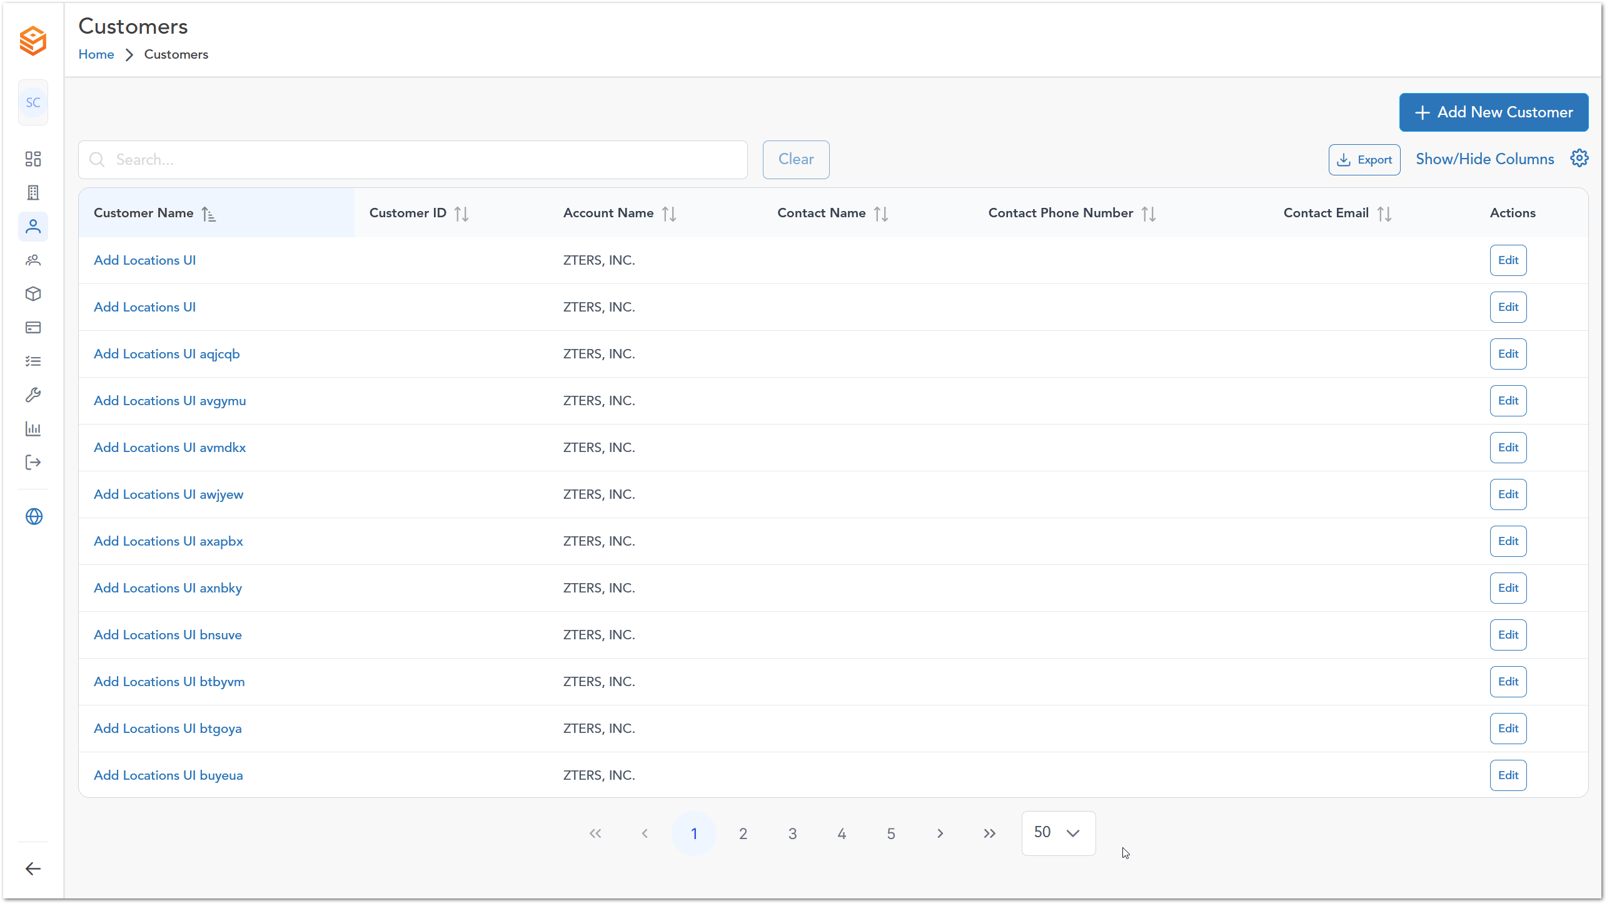

User
The login page for the website is presented here:

Contracts
The login page for the website is presented here:

Subscriptions
The login page for the website is presented here:

Inventory
The login page for the website is presented here:

Installers
The login page for the website is presented here:

Reports
The login page for the website is presented here:

User Roles
Role assignation for the application users. It could be presented in a table as follows:
Description | User 1 | User 2 | Admin User
Access to the invoice summary interface 1 | 
Access to the invoice summary interface 2
Access to the invoice summary interface 3

Note: This section is mandatory for all applications with role-based access.

WORKING PROCEDURES
Workflows (including diagrams if applicable) for different options within the application.

Working Procedure 1
Working Procedure 1 (e.g. “Create invoice…”)

Working Procedure 2
Working Procedure 2. (e.g. “Approve request…”)

Working Procedure 3
Working Procedure 2. (e.g. “Generate Report…”)

APPROVAL SIGNATURES
Digital signature blocks below are formatted for DocuSign / Adobe Sign.
Role | Name | Digital Signature Block | Date (dd/mm/aa)
Approval’s role | Approval’s name |  | 05/01/2026

--- END OF THE DOCUMENT ---

